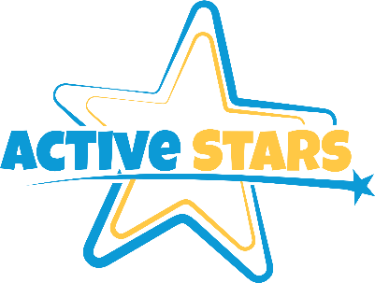

Early Years Foundation Stage Policy

Active Stars is committed meeting the requirements of the Statutory Framework for the Early Years Foundation Stage 2023 (EYFS). EYFS applies to all children from birth through to the end of their reception year. More information about EYFS is available from the Department for Education’s website.
The designated EYFS coordinator at the Club is William Drury who is responsible for:
- Identifying EYFS children when they join the Club, and informing the other staff
- Determining the primary EYFS provider (typically, the school) for each child
- Assigning a key person for each EYFS child
- Implementing a communication link via Whatsapp, so that the parents and Club can easily exchange information
- Agreeing information sharing policies with the primary EYFS provider and gaining parental consent for this where necessary
- Liaising with the primary EYFS provider to discuss what support the Club offers to EYFS children
The Club provides a mix of adult-led and child-initiated activities. The Club always follows the playwork principles, allowing children to choose how they occupy their time, and never forces them to participate in a given activity.
We recognise the four overarching principles of EYFS:
- A Unique Child: Every child is constantly learning and can be resilient, capable, confident and self-assured. We use positive encouragement and praise to motivate the children in our care.
- Positive Relationships: Children learn to be strong and independent through positive relationships. We aim to develop caring, respectful, professional relationships with the children and their families.
- Enabling Environments: Children learn and develop well in environments in which their experiences respond to their individual needs and where there is a strong partnership between practitioners and parents/carers. We observe children in order to understand their current interests and development before planning appropriate play-based activities for them.
- Children develop and learn in different ways and at different rates. The EYFS framework covers the education and care of all children in Early Years provision, including children with special educational needs and disabilities. We tailor the experiences we offer the children in our care according to their individual needs and abilities.

This policy was adopted by: Active Stars | Date: 01/09/2023
To be reviewed: 01/09/2024 | Signed:: W.Drury
Written in accordance with the Statutory Framework for the Early Years Foundation Stage (2023): Before/after school care and holiday provision [3.41] and Safeguarding and Welfare Requirements: Information for parents and carers [3.74] and The Learning and development requirements, Footnote 5, p7

