Wawa to Fairfield Inn & Suites by Marriott Cumberland - Google Maps
0930: Link up at Wawa, 510 Frost Ave, Warrenton, VA 20186
1145: Gas stop at Sheetz, 192 W Main St, Hancock, MD 21750
1300: Lunch at R&J’s Tavern, 537 E Pitt St, Bedford, PA 15522
1530: Visit Flight 93 National Memorial, 123 Ring Road, Stoystown, PA 15563
1700: Arrive Fairfield Inn, 21 Wineow St, Cumberland, MD 21502
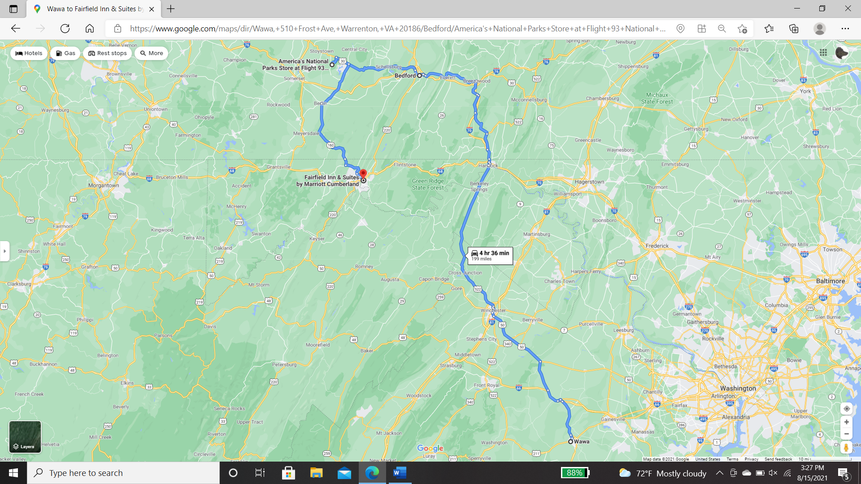
1830: Dinner at Dig Deep Brewing Company, 2 Howard St, Cumberland MD 21502

19 September
Fairfield Inn & Suites by Marriott Cumberland to Wawa - Google Maps
0930: KSU
1030: Gas Stop at Liberty, 4241 Union Hwy, Mt Storm, WV 26739
1130: Gas Stop at Maxville Mart, 22413 Mountaineer Dr #7002, Seneca Rocks, WV 26884
1330: Lunch at Jalisco Mexican, 9403 S Congress St, New Market, VA 22844
1600: Arrive Wawa, 510 Frost Ave, Warrenton, VA 20186
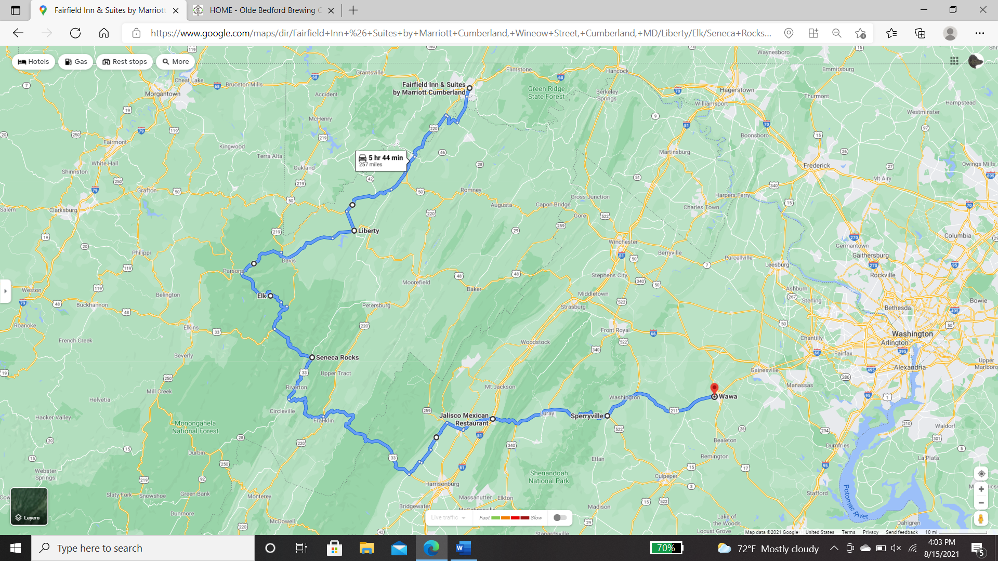

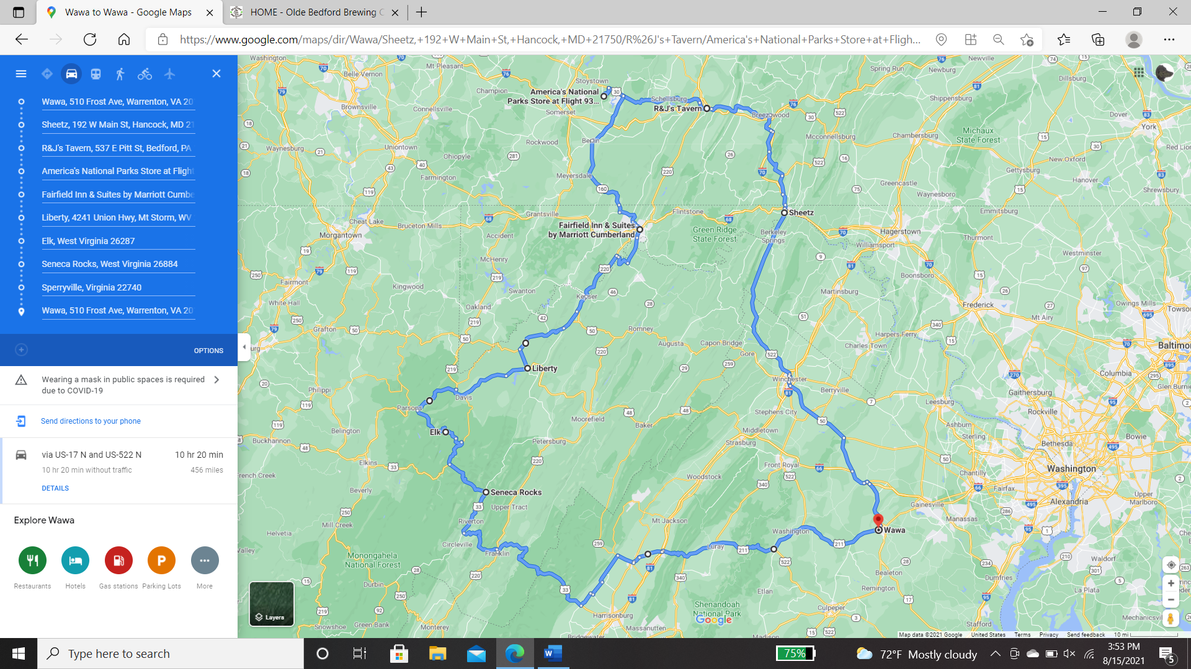
Route Overview
Wawa to Wawa - Google Maps

