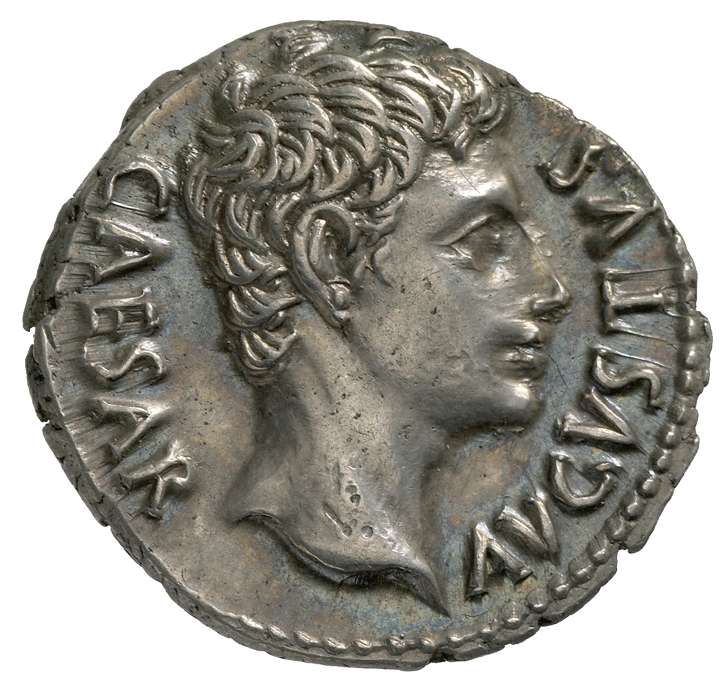
Latin Story Telling
44 B.C. Julius Caesar murdered; Octavian becomes his heir
43 B.C. Octavian, rules alongside Antony and Lepidus.
40 B.C. The treaty at Brundisium between Antony & Octavian
37 B.C. Antony marries Cleopatra
31-30 B.C. Octavian declares war on Cleopatra and Antony.

29 B.C. Virgil begins composing the Aeneid

27 B.C. Octavian takes the name Augustus
19 B.C. Death of Virgil

Book 1: The Storm  The goddess Juno, angry at the Trojans sends a storm to delay them as they flee Troy. | Book 2: Fall of Troy  Shipwrecked at Carthage Aeneas’ mother Venus sends him to the queen, Dido. Aeneas tells Dido the story of Troy’s fall. | Book 3: Wanderings  Aeneas tells Dido of his wanderings with his men and their failed attempts to settle in Antander, Thrace, Delos, Crete, Strophades, Leucata & Buthrotum. | Book 4: Dido  Venus sends Cupid to make Queen Dido fall in love with Aeneas. The god Mercury convinces Aeneas to leave Dido in order to found a new kingdom.
Book 5: Funeral Games  Aeneas reaches his companion Acestes in Eryx, where Aeneas sets up athletic competitions to commemorate the death of his father. | Book 6: The Underworld  Aeneas reaches Cumae and meets the Sibyl, a priestess. The Sibyl helps Aeneas enter the underworld so he can seek advice from his father’s ghost. | Book 7: War in Latium  Aeneas reaches Latium, where he will fight to marry princess Lavinia. Juno sends a fury named Allecto to enrage Lavinia’s suitor Turnus. | Book 8: Evander  Aeneas goes to ask King Evander in Arcadia for troops to fight Turnus. Meanwhile the goddess Venus begs her husband Vulcan to forge divine armour for Aeneas.
Book 9: Nisus & Euryalus  Aeneas leaves his military camp and Turnus burns the Trojan ships. Trojan soldiers Nisus and Eurylaus raid the Latin camp at night. Both are killed and war breaks out. | Book 10: Death of Pallas  Turnus kills king Evander’s son Pallas. Aeneas is enraged and kills many Latin soldiers. | Book 11: Pamilla  Aeneas mourns the death of Pallas, he returns to fight. Turnus enters battle with Camilla, the woman warrior. When Camilla is killed the Latins lose momentum. | Book 12: Death of Turnus  Aeneas is wounded in battle and healed by Venus. Juno agrees with Jupiter that Aeneas can seize Latium if the Trojans take on the Latin name and language. Aeneas kills Turnus.

English Grammar
 | Singular | Plural
1st person | I
2nd person
3rd person |  | They
Fill in the gaps to show what you know.

Term | Definition
Noun
Verb
Object
Pronoun
Subject
Gender

Verbs
 | Singular | Plural
1st person | amo | amamus
2nd person | amas | amatis
3rd person | amat | amant
Different verb families keep different vowels before their endings.
amare- re= ama+ endings
This is first conjugation.

The main thing to look out for is the endings on the storyboard.
o/s/t/
mus/tis/nt
They stay the same in the present tense and tell you who is doing what!
Vocab
aedificō, aedificāre = to build
festinō, festināre= to hurry
navigō, navigāre= to sail
vocō, vocāre= to call
laborō, laborāre= to work
cantō, cantāre= to sing
amō, amāre= to love

Nouns
In English we use word order to show which noun is the subject and which is the object.

Subject Verb Object

In Latin, the noun endings change to show which noun is the subject and which is the object. The ending change is called a ‘case’

The subject is the noun in the nominative case.
The object is the noun in the accusative case.
The verb is usually at the end of the sentence.
More important than word order, endings are.
vir reginam amat.
The man loves the queen.

virum regina amat.
The queen loves the man.

inimicus pinum navigat.
The enemy sails the ship.

inimicum pinus navigat.
The ship sails the enemy.
What Do Latin Nouns Look Like?

First Declension (Feminine) -a ending
 | Singular | Plural
Nominative | regina | reginae
Accusative | reginam | reginas

 | Singular | Plural
Nominative | confuga
Accusative |  | confugas

 | Singular | Plural
Nominative | regina | reginae
Accusative | reginam | reginas

Second Declension (masculine) -us ending

 | Singular | Plural
Nominative | inimicus | inimici
Accusative | inimicum | inimicos

 | Singular | Plural
Nominative | filius
Accusative |  | filios
 | Singular | Plural
Nominative | pater | patri
Accusative | patrum | patros
Second Declension (masculine) -r ending

 | Singular | Plural
Nominative | vir
Accusative |  | viros
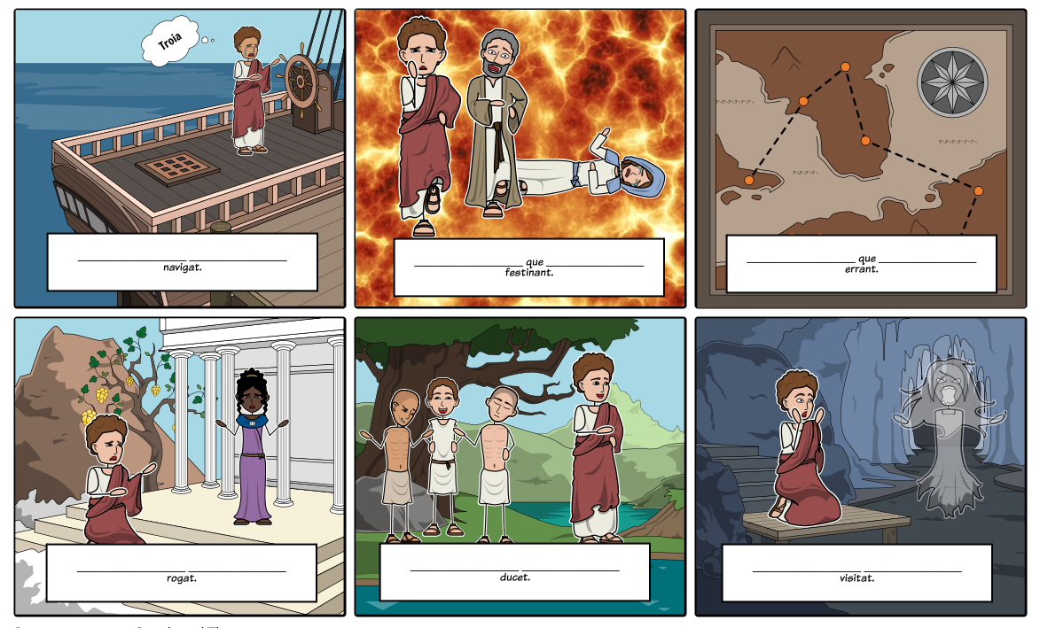
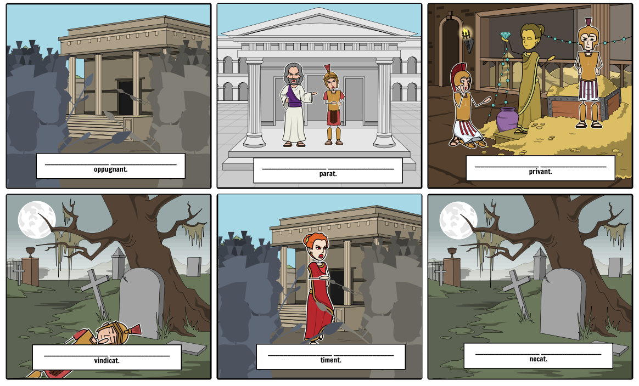
Latium, -um (n.) = Latium *looks the same in the nominative and accusative*
filius, -I (m)= son
praeda, -ae (f)= booty
inimicus, -I (m) = enemy
femina, -ae (f)= woman
ducit.
Nouns you will need:
Aeneas= vir, -i (m)= man
Anchises/ Evander= pater, -i (m)= father
confuga, -ae (c)= refugee
Dido = regina, -ae (f) = queen
pinus, -i (f)= ship
Tartarus, -um (m. singular only)= the underworld

