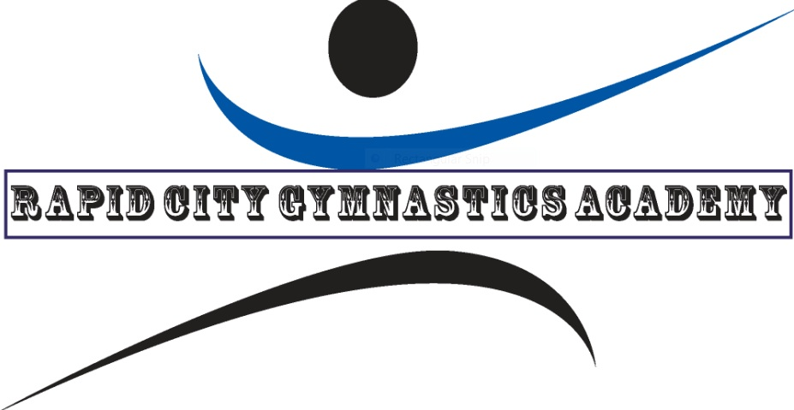
2022 RAPID CITY INVITATIONAL SCHEDULE
December 10th and 11TH, 2022 @ RCGA
SATURDAY, DECEMBER 10TH
SESSION 1- XCEL BRONZE, SILVER AND GOLD
12:00 PM OPEN STRETCH
12:20 PM INTRODUCTION OF TEAMS
12:30 COMPETITION

SESSION 2- LEVELS 5,6,7,8 AND XCEL PLATINUM
4:00 PM OPEN STRETCH
4:20 PM INTRODUCTION OF TEAMS
4:30 PM COMPETITION

SUNDAY, DECEMBER 11TH
SESSION 3- LEVELS 2, 3 AND 4
8:00 AM OPEN STRETCH
8:20 AM INTRODUCTION OF TEAMS
8:30 AM COMPETITION

