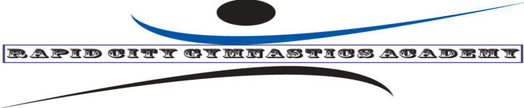
RCGA GYMNASTICS AT THE POWERHOUSE!!!
The Rapid City Gymnastics Academy will be offering gymnastics classes at the Power House in Wall, starting Friday, September 15th, 2023 and continuing on Fridays until Friday, May 19th, 2024. Kids 4 through 6 years old will check in at 9:00 am on Fridays and practice from 9:00 am-10:00 am. Kids 7 through 18 yrs. old will check in at 10:00 am on Fridays and practice from 10:00 am- 11:00 am. We can be flexible on placement if the exact age split doesn’t fit your child/children.
The 10 week punch card cost is $165 and they can be shared by siblings or $20 per drop-in student. Payments can be made by credit card via phone (605-791-2151), cash or check made to RCGA .
We will need a one-time registration form and waiver when you come to your first session. You can go to our website and print these forms at www. Rapidcitygymnastics.com and we will also have these forms available on site.
This will be a great opportunity for boys and girls to receive an introduction to basic gymnastics and continue progress on their already established basics or work toward their competitive goals.
Classes will be held every Friday except on the Fridays that Wall has school or scheduled Powerhouse activities. Any updates or changes will be posted on The Rapid City Gymnastics Academy Face Book page as well as The WKP Gymnastics Face Book page.

Sincerely,
Tim Trimble
Owner /Head Coach
Rapid City Gymnastics Academy
2025 Samco Rd.
Rapid City, SD 57702
605-791-2151

