2. Data Analysis Scaffolding Sheet – Making your Graph

If you choose Option 1…. Is there a significant difference in [dependent variable] between [this] and [that]?

Use this little book of statistics to give you an idea of what the answer to your research question and the graph will look like. It will be a column graph.

- Open an excel spreadsheet. Add your data to the spreadsheet.
- Calculate the mean for [this] using the formula =AVERAGE( : ) or simply highlight your data
- Calculate the mean for [that] using the formula =AVERAGE( : ) or simply highlight your data
- Create a column graph by clicking on the ‘insert’ tab. Select column graph.
- Edit the graph by clicking on the ‘+’ or right-click on the axis to format axis.

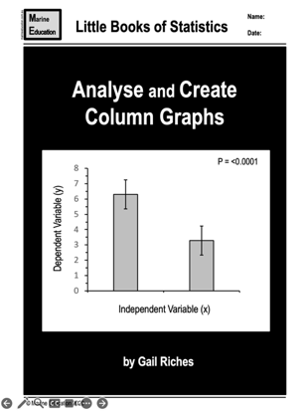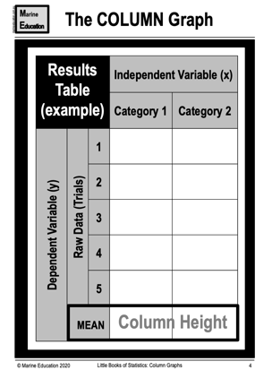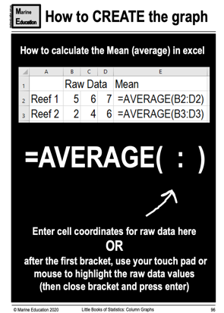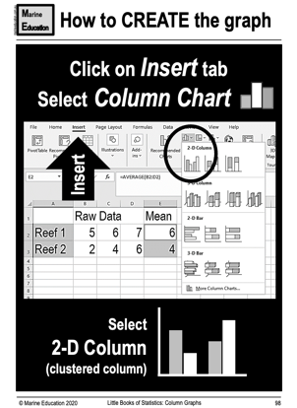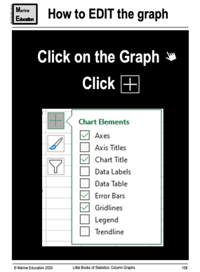
_______________________________________________________________________________________________
If you choose Option 2…. Is there a linear relationship between [dependent variable] and [independent variable]?

Use this little book of statistics to give you an idea of what the answer to your research question and the graph will look like. It will be a scatterplot graph.

- Open an excel spreadsheet. Add your data to the spreadsheet.
- Highlight raw data (do not include headings).
- Create a scatterplot graph by clicking on the ‘insert’ tab. Select scatterplot graph.
- Click on graph, then chart design tab, then add chart element, click on trendline, then ‘more trendline options’.
- Select ‘linear’ and change it to a black solid line.
- Add EQUATION & r-value to the trendline. EDIT the graph, and email to your teacher for marking & feedback.

