3. Data Analysis Scaffolding Sheet – Statistics to Answer your Research Question

If you choose Option 1…. Is there a significant difference in [dependent variable] between [this] and [that]?

Use this little book of statistics to give you an idea of how to answer your research question using a t-test and a P value.

- Google ‘t-test calculator’. Open GraphPad. Enter data. Click ‘Calculate Now’.
- Find the P-value. If the P value is less than 0.05 there IS a significant difference between the two groups.

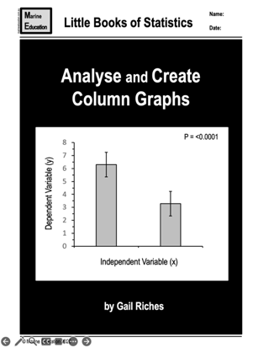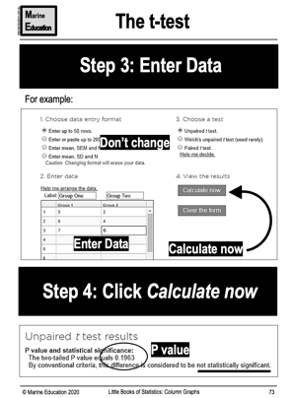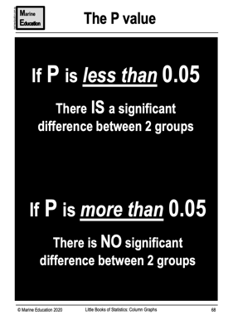
_______________________________________________________________________________________________
If you choose Option 2…. Is there a linear relationship between [dependent variable] and [independent variable]?

Use this little book of statistics to give you an idea of how to answer your research question using an r or R² value.

- The r (or R²) value tells you if a relationship exists (answers your RQ) as well as the strength of the relationship (if it exists). The r value is based on the proximity of the dots to the trendline.
- When r is close to 1 (or -1) the dots are ON the line (the relationship is strong). When r is close to zero, there is NO relationship.
- The r value multiplied by itself is R². And, the square root of R² is r. Thus, they can be used interchangeably.
- R² indicates the strength of your prediction based on the percent of data (as a decimal) closest to the trend line.

