IPCC Report Break Down by Gernot Wagner
@GernotWagner, Climate Economist, broke down the latest IPCC report on Twitter (5th April 2022) making it so much easier to understand. Here is the post as copy/paste.

New IPCC report on mitigating climate change was out yesterday. It's 2,913 pages. The summary is 145 pages. The 'high-level' summary for policymakers, the one that's negotiated, with governments able to veto each line, is still 64 pages. Some highlights as I read the report.

Everything is neatly collected here: http://ipcc.ch/report/ar6/wg3 This is the 3rd in the trilogy, focused on how to cut CO₂ and other greenhouse gases. First off: skip the summary for policymakers. At the very least, go straight to the 145-page technical summary.

The simple reason: The 64-page summary is the one that's negotiated line by line by governments. You'll hear all sorts of heroic stories about scientists saving important bits. The fact that sort of 'saving' is necessary tells you all you need to know. Skip it. So, here goes:

Bad news first (PDF p. 16 from the technical summary): despite all those net-zero goals, emissions of CO₂, CH₄, N₂O et al are all still pointing up and up. And yes, that's emissions, what we add every year. Stabilizing them isn't enough. They need to be cut to zero.

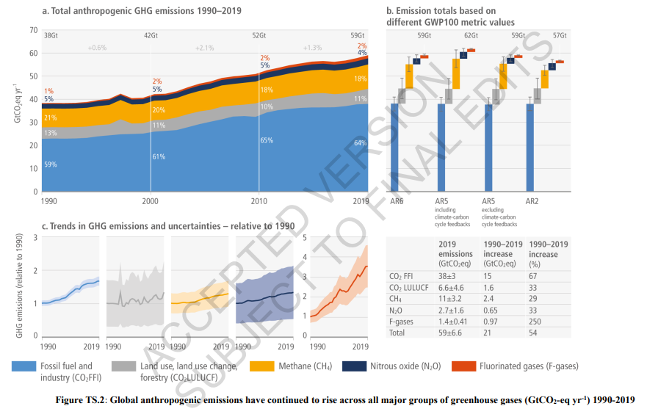

As a side note, yes, most of my graphs here will have issued watermarks saying "accepted version subject to final edits" The Summary for Policymakers has slightly different graphs, sans watermarks. Same info, no line-by-line government vetoes.

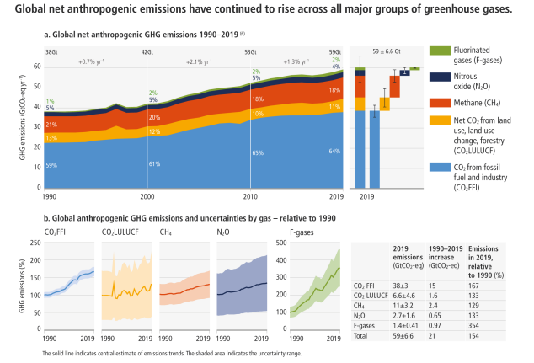

As another aside, that emissions graph looks awfully close to the German flag floating on top of ever-increasing CO₂ levels. Funny how Germany let this one slide. Also: how is the black-red-yellow an improvement over the colors sed in the actual report? But I digress.

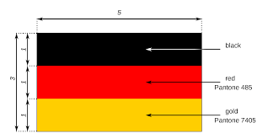

Hard to summarize almost 2,913 pages with lots and lots of details in just 2 points, but here goes, my 2 main takeaways: (1) The world isn't anywhere close to where it needs to be. *A lot* more needs to happen. (2) A lot more can happen, at *much* lower costs than often assumed

The first point seems obvious by now. Look at this doozy: Current policies (red) barely stabilize emissions. Country commitments through 2030 (navy) do a bit better, but barely. Meanwhile, the world needs to cut emissions to near zero by 2050. PS: good luck!

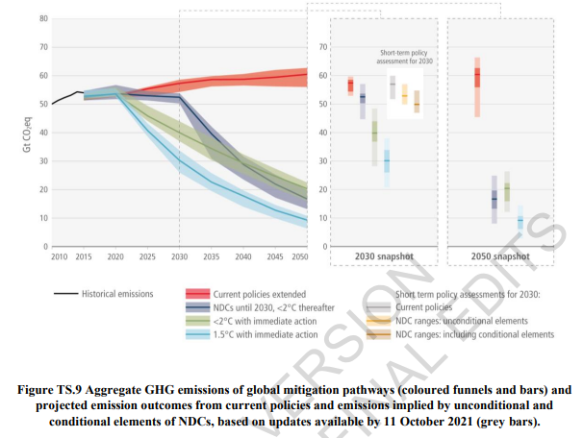

There are lots and lots of views of just that point, all pointing to the need for much more action. Perhaps *the* key point: it's worth it.

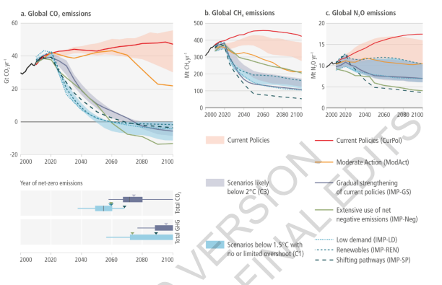

First off, yes, getting emissions to (net) zero stops temperatures from going up. Surprisingly, that's actually one of the newer scientific insights — though it isn't in the direct purview of this report.
That's the prior report released this past Feb: https://twitter.com/GernotWagner/status/1498276860987326467…

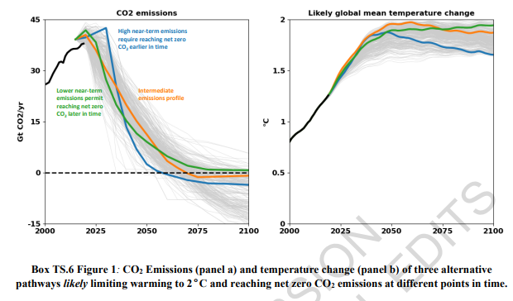
So yes, those umpteen "net-zero" climate goals have a solid scientific foundation.

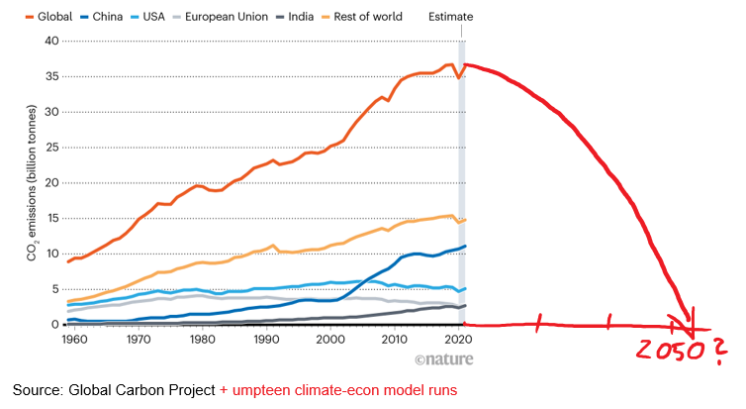

That first point around how hard things are isn't exactly new. Now, a lot depends on how you frame things. Here's @hausfath & @Peters_Glen arguing forcefully to "Stop using the worst-case scenario" — "more-realistic baselines make for better policy." http://go.nature.com/3r3Fwdb

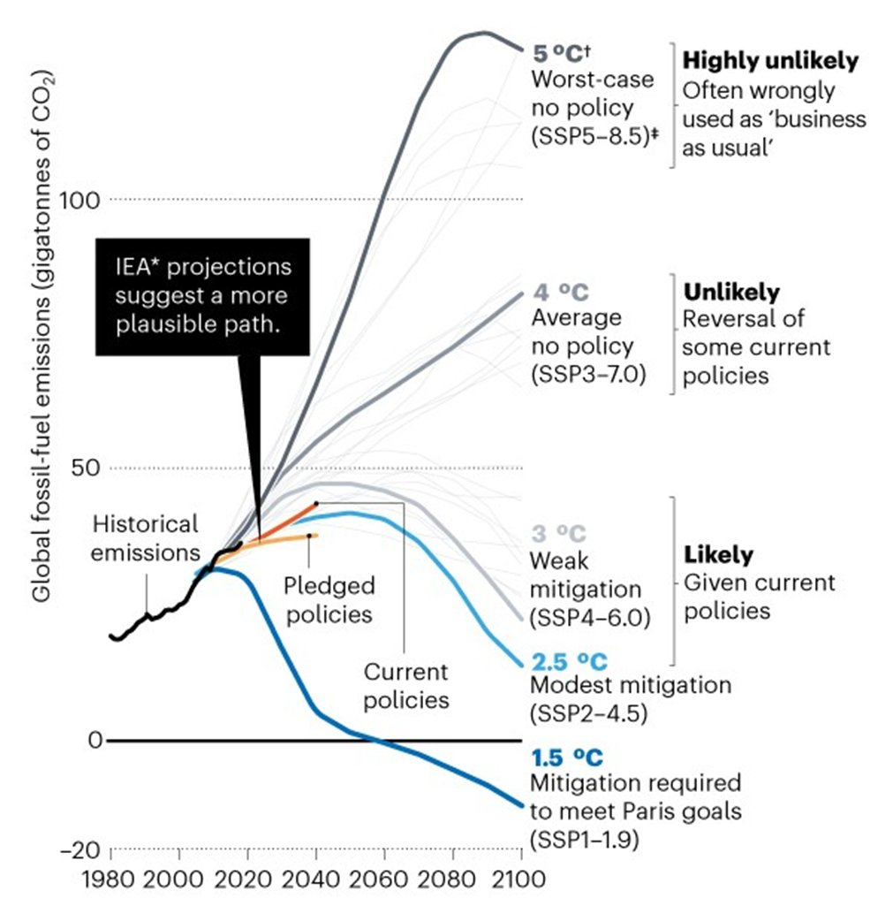
OK, so where's the good news? Costs of mitigation are coming down, fast, and are probably much lower than you (or anyone) thinks. Move over McKinsey Marginal Abatement Cost Curve, here's the new killer graph to show just that. (TS on left, SPM right.)

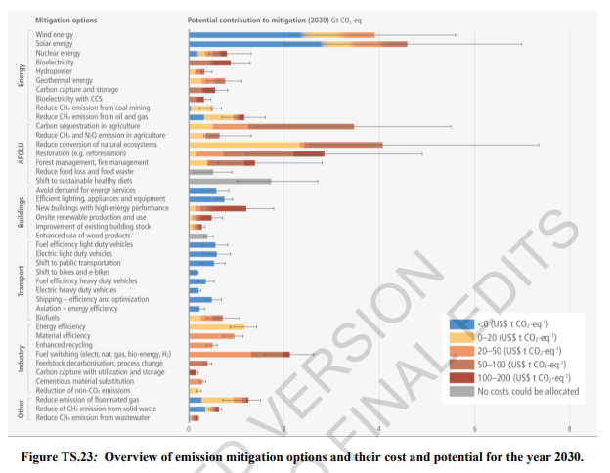

A lot of work has gone into getting that graph just so, and it's a good one. For one, low-carbon energy sources have gotten a lot cheaper, 100x cheaper for solar PV in just 40 years, 10x in 10 years!

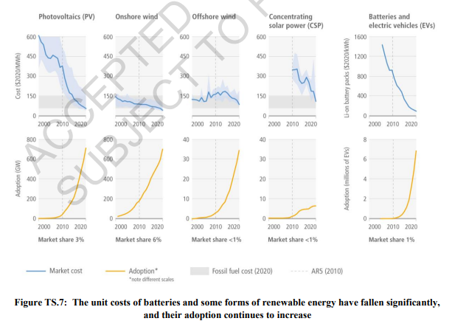

Key point: yes, there are costs to mitigation. But: costs = investments. I know I've kissed the McKinsey abatement cost curve good-bye just now, but their recent "net zero" report is instructive. It's about upfront investments to cut fuel costs later. http://gwagner.com/risky-climate-mckinsey…

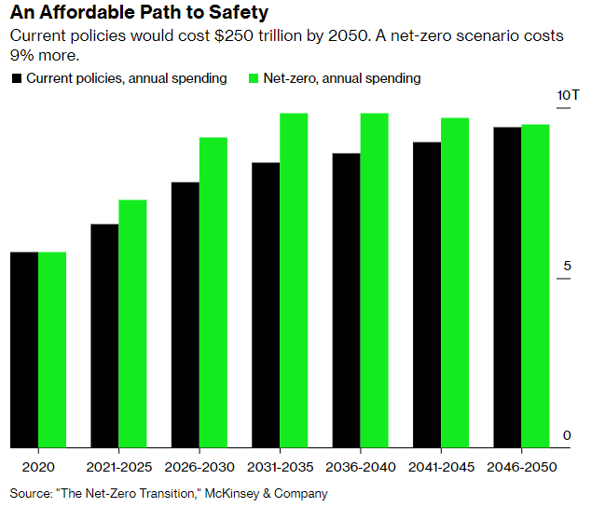
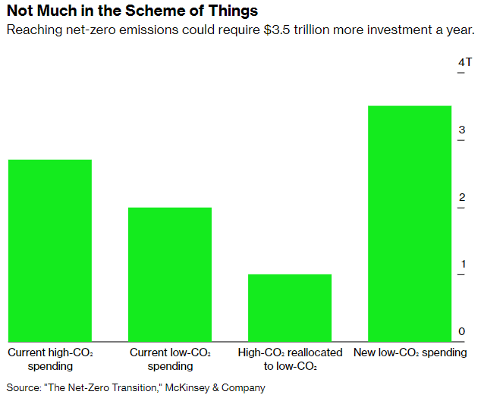

The IPCC report doesn't quite go there, at least not consistently. For some helpful framing on the (rapidly declining) costs, see: Köberle et al (@CelineGuivarch, @tavoni_massimo, @JoeriRogelj) http://go.nature.com/3NIO96y Their @CarbonBrief explainer:

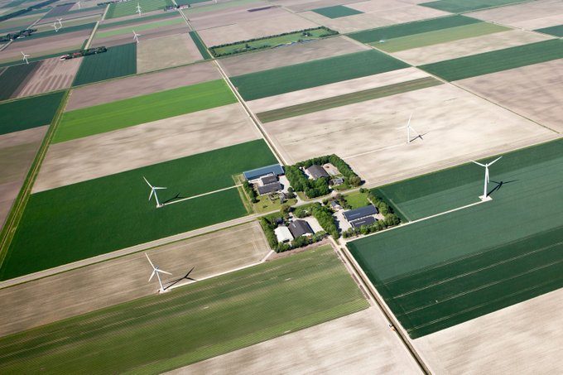

https://www.carbonbrief.org/guest-post-why-estimates-cost-climate-action-are-overly-pessimistic-mitigation-expensive

Of course, it isn't just about the costs/opportunities. It's also about who pays. IPCC here goes into quite a bit of detail around stranded assets, "just transition," etc.

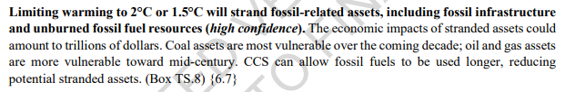

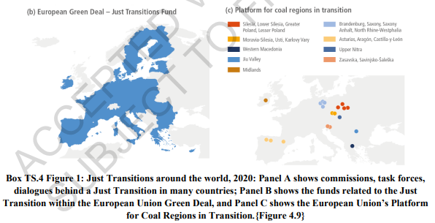

Plenty more detail, of course, in those (almost) 3,000 pages. Lots on systems (energy, food, transport, buildings, etc).
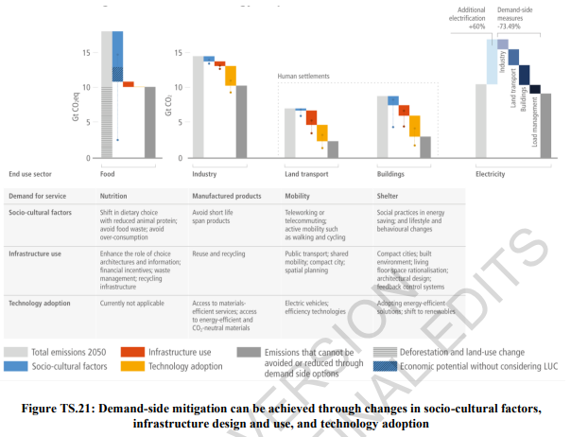

Expect to hear lots of stories coming out how "The IPCC says that X is key." Yes, it all is. Well, almost all. What's striking, though, even in complex exercises like this one, overlaying climate goals onto SDGs: energy is key! Clean energy, that is.

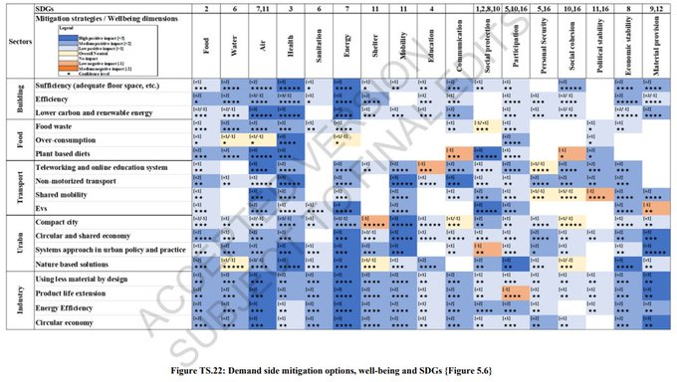

So yes, I'll stick to my guns here and go back to the 2 key bits: It's late. Acting is cheap. And this graph will be with us for a while:

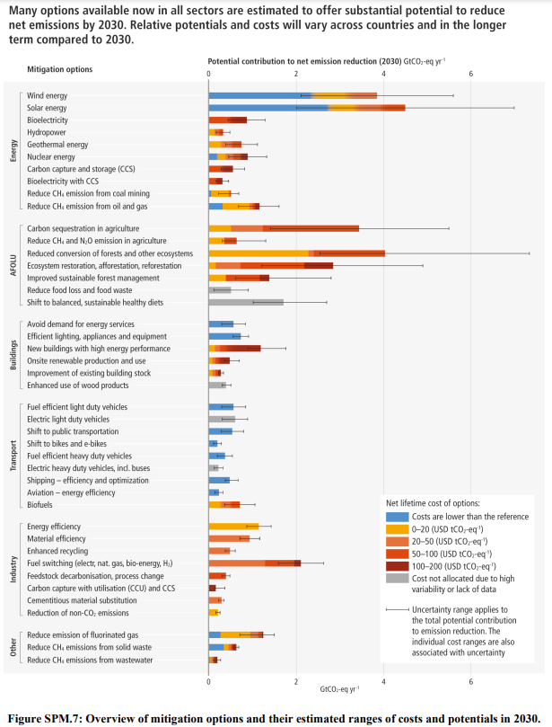

Leave it to the NYT headline writers to nail the framing, down to the "margin for error" quip http://nyti.ms/37h4COr

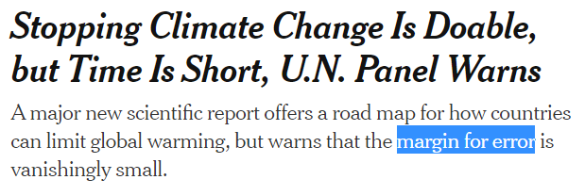

Good comprehensive take on carbon removal in the IPCC report:

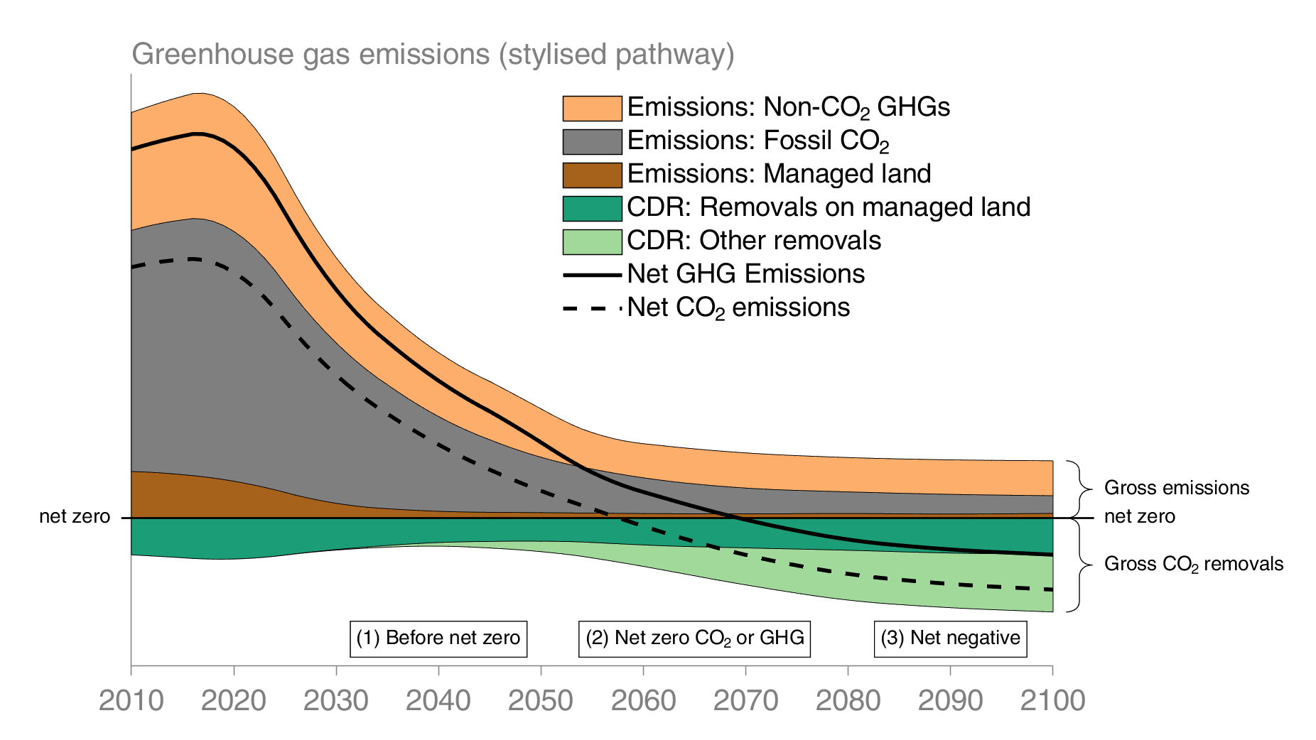

If only technology could do it all. Stepping back a bit from the details of this IPCC report, that's perhaps the biggest of big points here: it takes it all. New tech is key, and costs are coming down fast. So are behavior, financial & business models, and policy/politics.

