**TITLE**



NAME :

CLASS :

TEACHER :

DUE DATE :

PARTNERS :

STATEMENT OF AUTHORSHIP

The report presented is the sole work of the author. None of this report is plagiarised (in whole or part) from a fellow student’s work, or from any un-referenced outside source.

Student signature:

# Rationale

The rationale should provide background topic information enabling the reader to understand the analysis and conclusion sections. It should also present to the reader how and why the author developed their specific research question. The rationale must show application of scientific concepts and theories relevant to the research question **(R&P).**

**Content relevant to the topic of your rationale may include (in this general sequence):**

* A description of relevant topics in coastal dune biodiversity or dynamics to YOUR RESEARCH QUESTION, **possibly** including;
  + Importance of coastal dunes
  + Zonation in coastal dunes
  + Biotic and abiotic variables and their effect on coastal dunes
  + Introduce your independent variable:
    - Background information on the species being investigated in this experiment (if you’re focusing on 1 species)

OR

* + - Species richness on a coastal dune
* Connect these topics with the development of your research question to justify your direction of study.
* Include your research question in the final paragraph.

# Research Question

# Develop a specific (identifying the Independent Variable and Dependent Variable, as well as the context or major control variable) and relevant (must be related to your experiment) research question. Must relate back to the rationale (R&P).

# You will choose 1 abiotic factor and determine its effect on 1 biotic factor

Once you have identified the abiotic and biotic factor you would like to focus on, identify your independent and dependent variables and place it in a research question. Use the template below:

“Can/Does/To what extent does x affect y in z?”

X – Independent variable Y – dependent variable X – context

Example:

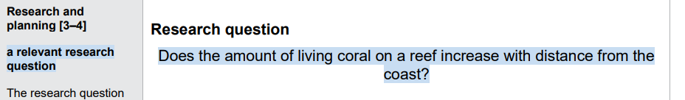

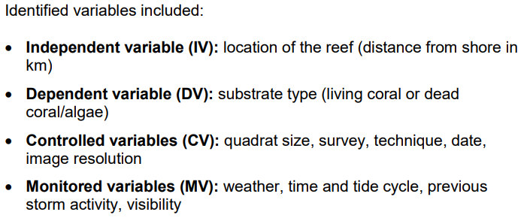

# Original Experiment

Outline of original experiment. Use the practical linked in the assessment.

1. Provide a Hyperlink to the original experiment

2. Briefly discuss the original methods used and the results gathered.

Aim for 2 paragraphs maximum.

# Management of Risks

1. Attach the risk assessment as **Appendix 1** and reference it in this section.
2. Write a paragraph that summarises the risks involved. Should show careful and deliberate identification and planning to handle risks **and ethical or environmental issues** in the experiment **(R&P).**

**Can also be presented in a table:**

**Table 1: Management of risks**

|  |  |
| --- | --- |
| **Risk Identified** | **Management Strategy** |
|  |  |
|  |  |

# Processed Data

This section will involve - tables, calculations, and line graphs/bar graphs (whichever is appropriate for the task) **(AOE).**

**Table headings go ABOVE**

**Figure/graph headings go BELOW**

You must ensure that you have appropriate application of algorithms, visual and graphical representations of data, that follow scientific genre conventions **(AOE)**.

Should include the following tables:

**Table 2: Sample calculations**

|  |  |
| --- | --- |
| **Calculation** | **Example** |
| Range | The range was calculated using the following formula: $$range=x_{max}-x_{min}$$ Therefore, the range is… |
| The Mean of (insert variable). | The mean was calculated using the following formula: $\tilde{x}=\frac{∑ x}{n} or mean=\frac{sum of all scores}{number of scores }$     Therefore, the mean of… |
| Standard Deviation | The Standard deviation of the sample was calculated using the descriptive statistics data pack in excel. The values of (insert variable) are:  Standard Deviation of: |
| Standard Error | The standard error was calculated using the following formula: $$SE=\frac{σ}{\sqrt{n}}$$ Therefore, the standard error for the (insert variable) is….. |

**Table 3: Processed data table including descriptive statistics of (insert variable)**

|  |  |  |  |  |  |  |
| --- | --- | --- | --- | --- | --- | --- |
|  | **E,g. Distance from Swash Zone (start of primary dune) (independent variable)** | | | | | |
|  | 1 | 2 | 3 | 4 | 5 | 6 |
| **Transect** | **E.g. Species richness (dependent variable)** | | | | | |
| 1 |  |  |  |  |  |  |
| 2 |  |  |  |  |  |  |
| 3 |  |  |  |  |  |  |
| 4 |  |  |  |  |  |  |
| 5 |  |  |  |  |  |  |
| 6 |  |  |  |  |  |  |
| 7 |  |  |  |  |  |  |
| 8 |  |  |  |  |  |  |
| 9 |  |  |  |  |  |  |
| 10 |  |  |  |  |  |  |
| **Descriptive Statistics:** |  |  |  |  |  |  |
| Mean |  |  |  |  |  |  |
| SD |  |  |  |  |  |  |
| SE |  |  |  |  |  |  |
| Range |  |  |  |  |  |  |

* Ensure processed data is consistent with raw data and expressed to the correct number of significant figures.Your response, should use units and symbols correctly **(C) (Table 3)**
* You will need to manipulate your raw data accurately to provide evidence that is applicable to the research question **(AOE)**.
* Although there is a section where you will discuss trends, patterns and relationships, accurate graphical representation of the data provides thorough identification of relevant trends, patterns or relationships **(AOE).** This can be done through the use of graphs and tables. Each of these should have a title (table titles before the table and graph titles after the graph), which should include a brief explanation of its contents and a figure/table or graph number for each **(Figure 1).**

*Exmaple of a graph (ensure there is a relevant title and y and x axis title):*

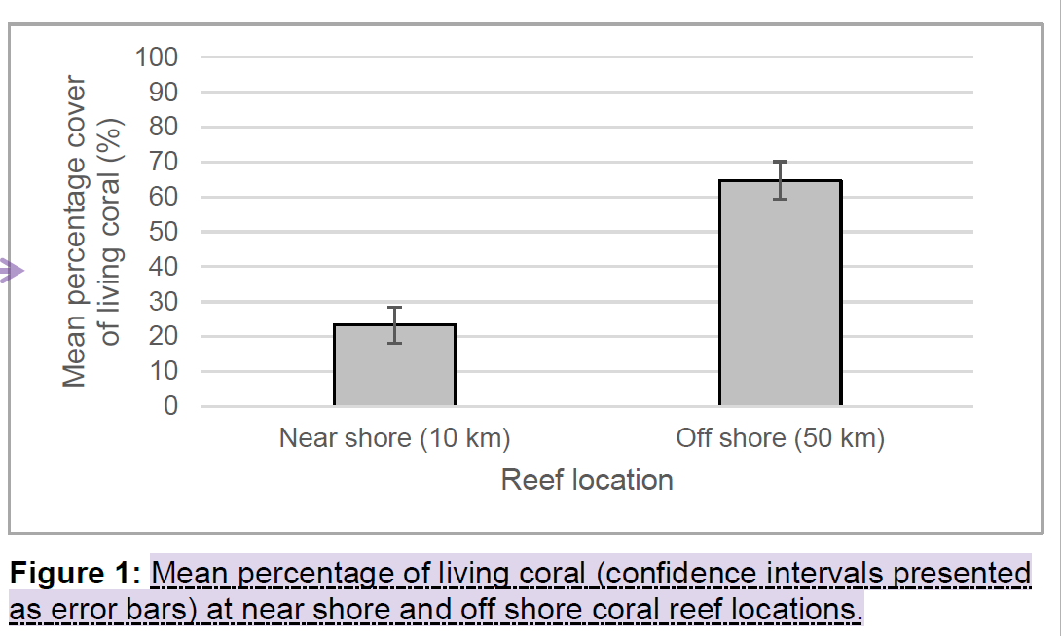

# Interpretation and Analysis

In this section, you will analyse your processed data and identify trends, patterns and relationships that are not superficial (not just those that are clearly apparent) and allow a justified conclusion to the research question to be drawn. See below for an example of structure and wording.

Example:

*“Graph 1 indicates….This is a ______ relationship….”*

*“Graph 2 supports the… The shape of the graph suggests…”*

*Graph 3 produced… this supports the relationship between ….”*

What do the results and observations mean?

Using scientific terminology, concepts and principles, explain the relationships identified in the data

Elucidate, and make links between, the primary data collected and secondary data/theory

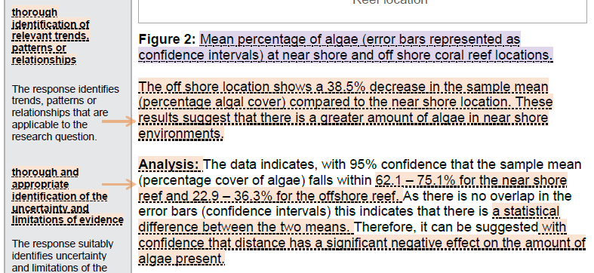

# Evaluation

# Limitations of evidence and reliability and validity of the experimental process:

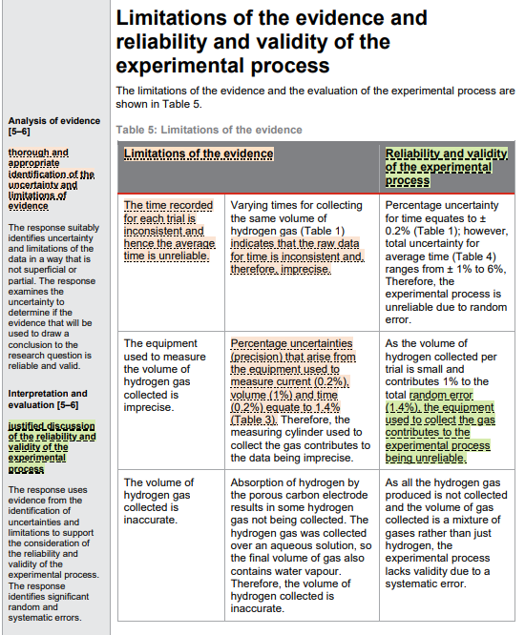In this section, you will need to provide a thorough and appropriate identification of the uncertainty and limitations of evidence. Your response must suitably identify uncertainty and limitations (using Standard Error and Standard Deviation) of the data in a way that is not superficial or partial (must go into detail). By examining the uncertainty, you can determine if the evidence is reliable and valid. If it is reliable evidence, you can accurately draw conclusions to the research question **(AOE)**

**Can also be presented in a table:**

**Table 4: Limitations of the evidence**

|  |  |  |
| --- | --- | --- |
| **Limitation** | **Evidence of the limitation** | **Reliability and validity of the experimental process** |
|  |  |  |
|  |  |  |
|  |  |  |

Justified discussion of the reliability and validity of the experimental process **(I&E).**

You can use evidence from the identification of uncertainties and limitations to support the consideration of the reliability and validity of the experimental process. Your response should identify significant random and systematic errors **(I&E).**

# Sources of error and improvements and extensions:

In this section you need to identify the sources of error that may have led to the limitations and uncertainty observed in the experiment. This should be broken into those features of the methods that effect reliability and those that effect validity.

Your improvements should be clear and explicitly linked to sources of experimental error referred to in the previous section. You must provide reasoning as to why you have arrived at these improvements and extensions. Your suggestions must improve the reliability and validity of the experimental process by reducing the impact of the identified random and systematic errors **(I&E)**

Example:

* **Effecting Reliability**

Reliability of the data is the degree to which the result of a measurement, calculation, or specification can be depended on to be accurate.

* **Effecting Validity**

**VALIDITY** is an indication of how sound your **research** is. More specifically, **validity** applies to both the design and the methods of your **research**. **Validity** in data collection **means** that your findings truly represent the phenomenon you are claiming to measure.

**Can also be presented in a table:**

**Table 5: Source of error and suggested improvement or extension**

|  |  |
| --- | --- |
| **Source of error** | **Suggested improvement or extension** |
|  |  |
|  |  |

# Conclusion

Your conclusion should provide reasons and supporting evidence to support a conclusion that directly responds to the research question **(I&E).**

An insightful interpretation is one that includes a deep understanding of the topic. Support any statement that you make with evidence and discuss why the results are accurate / inaccurate. In doing so, you provide an analysis of the evidence and support statements made **(I&E)**

Your response should use detailed evidence and concepts, supported by scientific literature, to support the conclusion and relate results to the research question **(I&E).**

By supporting your statements with scientific literature, you are acknowledging sources of information through appropriate use of referencing conventions **(C).**

* State your conclusion – that is, summarise the investigation, its results and conclusions, in narrative form
* How confident of this conclusion do you feel you can be, based on the results of both the primary data collected and the secondary data/researched info?
* What has been learned about the topic of this investigation? Was the outcome different from the predictions? Why do you think this was/was not the case?
* Include some information about how the results/observations could be used to develop future investigations, that is, suggest how the investigation could be expanded to include a greater depth/breadth of data
* Fully justify all conclusions and recommendations by presenting the evidence you are basing the conclusions and recommendations on, including primary and secondary data collected, as well as analysis, interpretation and comparison of this data.
* Conclude Report by answering your Researchable Question.

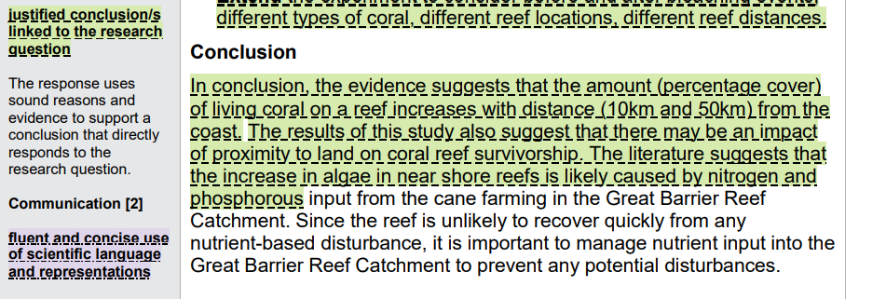

# Reference List

In this section, you will acknowledge sources of information you reviewed, through appropriate use of referencing conventions **(C).**

Need to use APA referencing system.

You may wish to use the website: citethisforme.com