Coral reef distribution 2

- recall the different types of reef structure (e.g. fringing, platform, ribbon, atolls, coral cays)
- recognise the zonation within a reef cross-section (e.g. reef slope, reef crest/rim, lagoon/back reef).
Define:

Reef slope
Reef flat
Lagoon
Reef crest

A fringing reef has which 3 main zones?
Explain the difference between:
Atoll | Coral cays

How has sea level change affected the Great Barrier Reef formation?

Coral cays

Define the following terms:

Barrier Reefs

Ribbon Reefs

Fringing Reefs

Platform Reefs

How has plate tectonics helped us understand and model reef formation?

Answer the following questions:
Which zone is the furthest from shore?  Which is the closest?  Which zone experiences the greatest wave action? | Which zone has the greatest diversity of corals?  Which zone contains the greatest diversity of organisms?

Label the zones on this reef section:

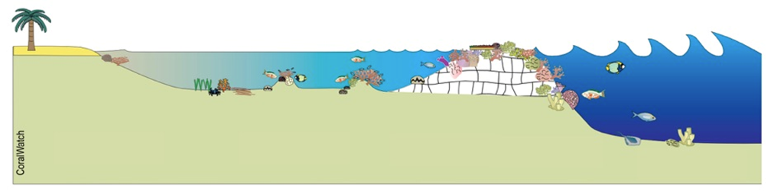
Atoll

Identify the following reef types. Give reasons

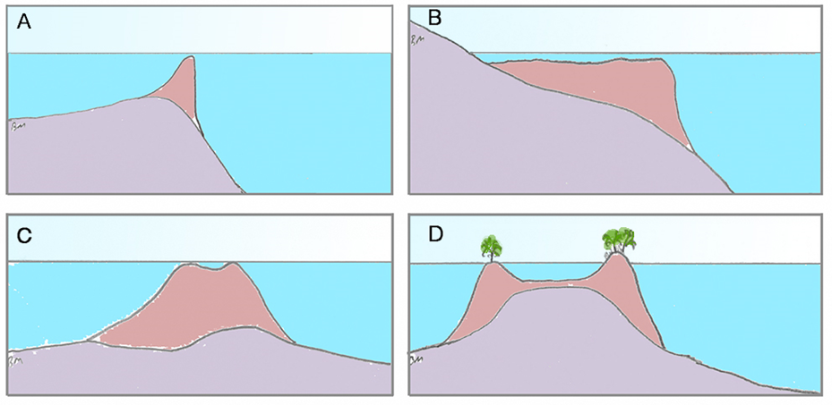
A:

B:

C:

D:

