Label the diagram of a coral polyp. Use the word list:
coelenteron, coral polyp, corallite, mouth, nematocyst, skeleton, tentacles, zooxanthellae
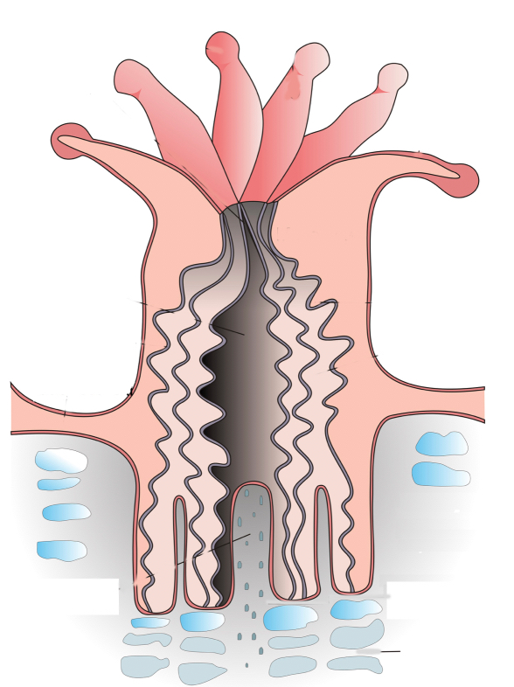
Coral reef development 1

- recall the following groups of coral: Alcyonacea ‘soft corals’ and the two morphological groups within Scleractinia ‘hard corals’ — reef-forming/hermatypic and non-reef forming/ahermatypic
- classify a specific coral to genus level only, using a relevant identification key
- identify the anatomy of a typical reef-forming hard coral including skeleton, corallite, coelenteron, coral polyp, tentacles, nematocyst, mouth and zooxanthellae
- recall that the limestone skeleton of a coral is built when calcium ions [Ca2+] combine with carbonate ions [CO32–]

What is the function of a nematocyst? Where are they located on a coral polyp?
Explain the difference between:
Hexacorals | Octocorals

How is a limestone skeleton of a coral built?

Tentacles

Define the following terms:

Coral skeleton

Corallite

Coelenteron

Coral polyp

Describe how soft and hard corals are different:
Alcyonacea – soft corals | Scleractinia – hard corals

Comparing Scleractinia hard corals. List key features and distinguish differences.
Hermatypic | Ahermatypic

How do zooxanthellae provide energy to the coral polyp?
Nematocyst

Describe the following coral growth forms. Include a diagram.

Boulder:

Plate:

Branching:

Soft:
What is the chemical formula for calcium carbonate?

