TO EAT OR NOT TO EAT
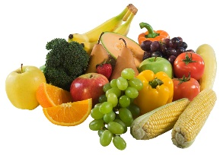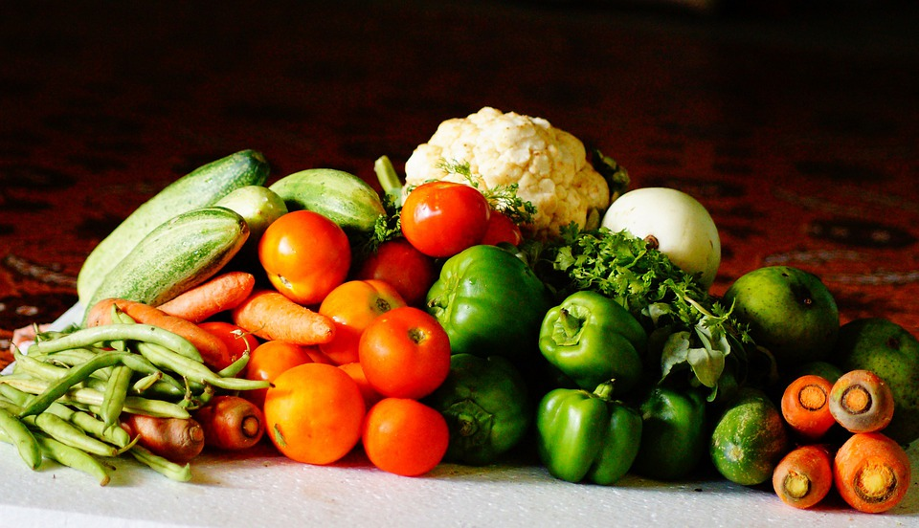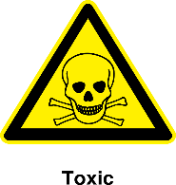

HEALTHY vs. HARMFUL
Ok to Eat Toxic
__________________________________________________________
Apples Milk Almonds
Bananas Oranges Apple Seeds
Blueberries Peaches Apricot Pits
Broccoli Peanut Butter Asparagus
Brussel Sprouts Pears Avocado
Cantaloupe Peas Cherries
Carrots Pineapple Cherry Pits
Celery Pork Cinnamon
Coconut Pumpkin Garlic
Corn Quinoa Grapes
Cranberries Raspberries Ice Cream
Cucumbers Salmon Macadamia Nuts
Eggs (raw) Strawberries Mushrooms
Fish Tuna Onions
Grains Turkey Tomatoes
Green Beans Watermelon Walnuts
Honey Wheat Yeast Dough
Mango Yogurt

