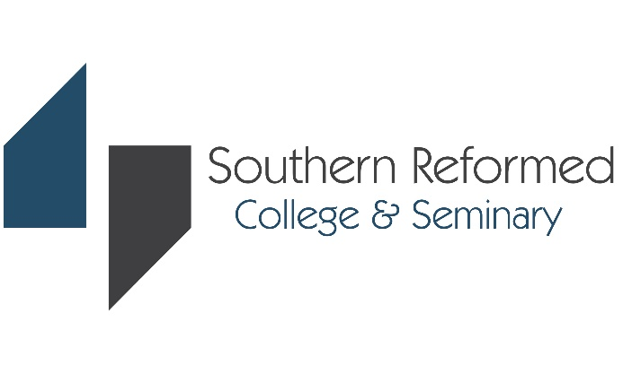

Application & Registration Checklist
입학 및 수강신청 체크리스트

Greetings from Southern Reformed College and Seminary!
남부개혁에서 인사드립니다.
Throughout the college admissions process, there are many steps to complete, so we have tried to make that process as simple as possible for you. Our 3 A’s of Admissions are Apply, Accept, and Attend. By following the 3 A’s outlined below, you will be set up for success as you navigate the admission process.
대학 입학 절차 전반에 걸쳐 완료해야 할 많은 단계가 있으므로 해당 절차를 가능한 한 간단하게 만들려고 노력했습니다. 입학의 3A는 지원 (Apply), 수락 (Accept) 및 참석 (Attend)입니다. 아래에 설명된 3A를 따르면 입학 절차를 성공적으로 진행할 수 있습니다.
Use the following chart to keep track of your applications and to make sure you submit all of the required information
다음 차트를 사용하여 응용 프로그램을 추적하고 필요한 모든 정보를 포함했는지 확인하십시오.

 | Application Item | Important Consideration | Status | Submitted Date
APPLY  지원 | Application deadline  입학원서 마감 | What is the application deadline? | Fall Applications (가을학기)  미주거주자  - Domestic Applicants:  Apply by June 30  유학생  - International Applicants:  Apply by May 30  Spring Applications (봄학기)  미주거주자  - Domestic Applicants:  Apply by November 30  유학생  - International Applicants:  Apply by October 31
 | Application 입학원서 제출 | Did I submit my application?
 | Application fee  입학원서비 제출 | Did I write a check or pay online at school website with credit card for the application fee?
 | Photograph  사진 | Did I submit a recent photograph (size 2” x 2”)?
 | Passport copy  패스포트 복사 | Did I submit a copy of passport?
 | Two Character Reference Forms  추천서 2통 | Have I asked the individuals well in advance of my application deadlines to write are commendation letter?  - From Pastor or Leader/Mentor  목사/영적지도자  - One from someone not a family member  가족 외 추천인
 | Personal Statement  간증문 | Did I write a statement of my faith?
 | Official Transcript  공식 성적증명서 | Did I submit my requests to the guidance/academic office to send my transcripts to SRCS?  All transcripts must be sent from the respective institution directly to SRCS. Unofficial copies are NOT acceptable.
Once all the above documents are submitted, your application folder is considered complete and the review of the application begins. After reviewing the application, additional information or documents maybe requested by the admission committee.
위의 모든 문서가 제출되면 지원 폴더가 완료된 것으로 간주되고 입학원서 검토가 시작됩니다. 지원서를 검토한 후 입학위원회에서 추가 정보 또는 서류를 요청할 수 있습니다.
 | Enrollment Item | Important Consideration | Status | Submitted Date
Accept  수락 | Once you receive your acceptance decision from Southern Reformed College & Seminary, you may apply for I-20 after signing the Intent to Enroll form and paying the enrollment deposit.  본교로부터 입학허락 결정을 받으면 등록의도서 (Intent to Enroll) 양식에 서명하고 등록 보증금 ($100)을 지불한 후 I-20을 신청할 수 있습니다. 등록보증금은 수강신청서 제출시 학비로 반영됩니다.
 | Intent to Enroll  등록의도서 | Did I sign and submit the form?
 | Enrollment Deposit  등록 보증금 | Did I submit my $100 enrollment deposit?
 | Certificate of Eligibility  I-20신청원서  (International Students ONLY  유학생에 한함) | Did I submit a Certificate of Eligibility (Form I-20/DS-2019)?
 | Registration Item | Important consideration | Status | Submitted Date
 | Student Handbook & Academic Integrity Policy  학생핸드북 및 학업정직성 정책서 서명 | Did I review and sign the Student Handbook and Academic Integrity Policy?
Attend  참석 | Course Registration  수강신청서 제출 | Did I register for courses?
 | Registration Fee & Tuition  업대이트된 I-20발급 전 등록비 및 학비 지불 필수 | Did I write a check or provide credit card information for the registration fee and tuition?  *Tuition must be paid before an updated I-20 is issued by the ISO.
If you are a transfer student with over 12 credit hours, you will need to speak with one of our professional advisors from the academic office for acceptance of credits and course inventory.
12 학점 이상의 학점을 transfer한 편입생인 경우 transfer이 가능한 학점 및 졸업에 필요한 코스 목록 (course inventory)에 대해 교무실 (Academic Office)과 상의하여야 합니다.

2/2022

