Title; Proper Scaling of Transmitter Analog Output___________________________________

Contact Person: (Optional) __Tyler Eck__________________________________________________
Contact Details: (Optional)_ _Tyler Eck__________________________________________________

Background/Problem:
The control room operator reported that Finish Mill 2 had been operating poorly for the past 8 hours. The mill system would cycle from not having enough material in the system to being overloaded. He could not get the system to stabilize whether he ran the mill fresh feed controller in manual or automatic. He suspected there was an issue with the grinding aid.

Investigation:
Production personnel verified the grinding aid system was operating and that the filters were not clogged. While verifying the accuracy of the flow meter, the display on the flow meter was showing 1400 ml/min and the manual measurement of grinding aid was 1400 ml/min. The control room operator reported he was seeing 650 ml/min on his screen. The 4-20 ma output scaling for the transmitter was checked and found to be 0 to 650 ml/min.

The flow rate setpoint for the grinding aid (GA) is calculated based off of the fresh feed going into the mill. The previous shift the lab increased the ratio of grinding aid to fresh feed. When the grinding aid setpoint went over 650 ml/min, the process variable for the pump’s PID controller could never go over 650 ml/min causing the pump to go to 100% output. This caused the mill system to flush and become underloaded. Once the grinding aid flow rate setpoint went back below 650 ml/min, the mill circuit would overload, as seen in the below figure.

Solution:
The scaling for the transmitter’s 4-20 ma output was changed to 0 to 1500 ml/min. The pump is capable of pumping 1400 ml/min at 100% output. Best practice is to scale transmitters to the capabilities of the system rather than the expected operating conditions.

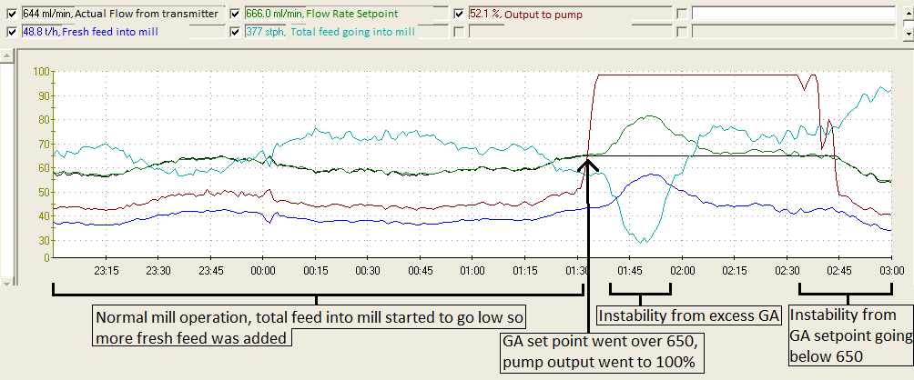
Photo / Diagram:

