LEMKO Vatra and Danube river cruise

july 9-22, 2024

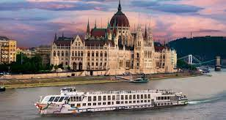  Danube River Cruise  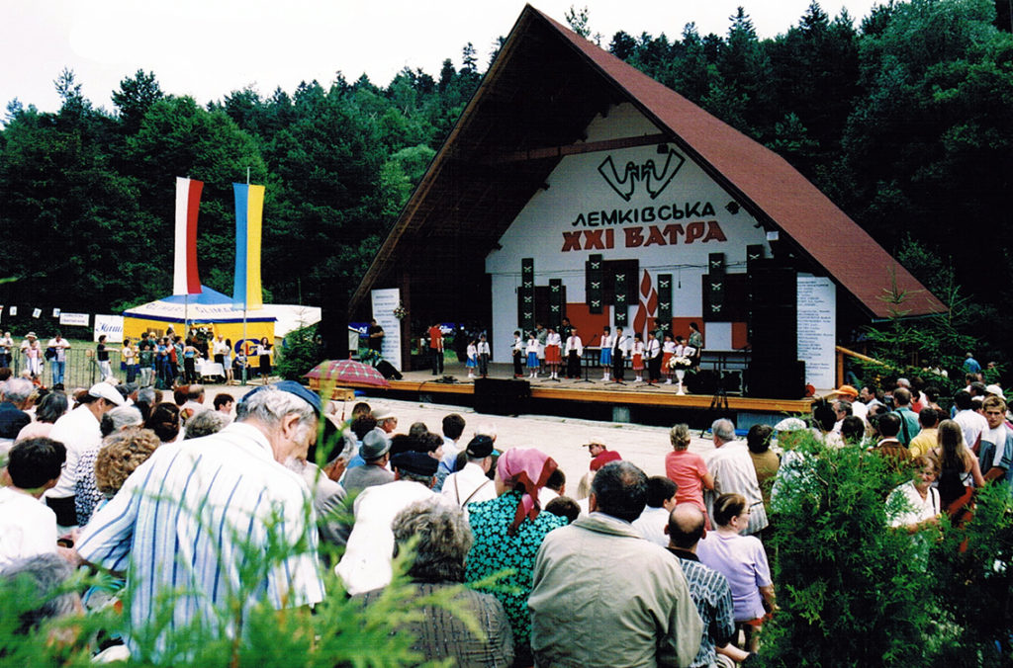 |  | Join us and experience this unforgettable trip on the Danube River and Lemko Vatra in Zdynia  Package includes:  - 7 nights river cruise from Vienna aboard the MS Fidelio.  - Stops include Melk, Linz, Bratislava, Budapest, Esztergom. Daily excursions included.  - All meals aboard cruise.  - 2 nights Krakow  - 2 nights Krynica Zdroj  - Transportation to Zdynia for Lemko Vatra events on Friday and Saturday July 19, 20  - 1 nights Zakopane  - Airfare from JFK on Austrian Airlines
For pricing and detailed itinerary, please visit www.dunwoodietravel.com. Prices start at $2950 per person, based on two sharing a main cabin/hotel room.
Airfare from JFK-Vienna, Vienna-Krakow, Krakow-JFK $1550.00 per person. Total package $4500.

Dunwoodie Travel Bureau, Ltd
Lesia Kozicky
914-969-4200 alesia@dunwoodietravel.com | www.dunwoodietravel.com

