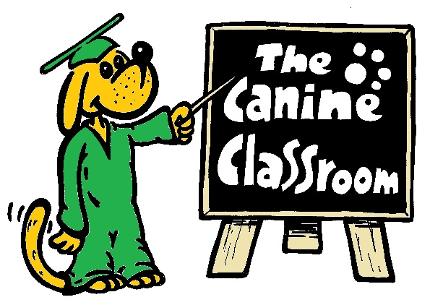

The Canine Classroom
Providers of Professional Dog Training
Website www.thecanineclassroom.co.uk
Email: info@thecanineclassroom.co.uk
Facebook The Canine Classroom
07956534487
One to one Behaviour Session

One to one training sessions are tailored around your needs and the behaviour your dog is displaying.
The sessions last for approximately one hour, the number of sessions needed vary greatly and depend on the behaviour your dog is displaying and how much training you do at home.

You will need to bring with you
- Plenty of tasty treats, we recommend sausage, chicken, ham or anything your dog absolutely loves.
- A favourite toy, that will just be used for training.
- Any walking equipment you may have, collar, lead, head collar, harnesses.
- Any videos you have taken displaying your dog’s behaviour.
- If a severe behaviour issue we may ask you to complete a questionnaire.
It may be useful to write a few notes before coming on your first appointment just so you don’t forget anything.

Appointments
We offer appointments Monday-Friday 9am – 4pm and occasional weekends and evenings.

Sessions costs
The sessions cost £35 each time you come, however if we think you are going to need 5 sessions or more the cost will be reduced to £30 a session.
We will require a non-refundable deposit of £10 before confirming your first appointment. If you cancel any other appointments made after this we ask for a payment of £15 if cancelled with less than 48 hours notice
Payments can be made either by cash or BACS
BACS details are Canine Classroom
Account number 55538960
Sort Code 30-91-92
We do ask if you need to cancel or rearrange you let us know as soon as possible, all our contact details are on the top of this page.

Many Thanks
Sam, Becky, Maz & Roger
The Canine Classroom Team

