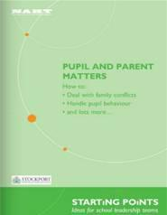
13.02.12 - National Association for All School Leaders (NAHT) on Pupil and Parent Matters
To read the publication online please click the image.

- The advice given is that "all parents" should be given access to information, copies of reports etc and have the right to be involved in decisions AND that a parents can only be denied these if there is a court order in place to that effect.
- The relevant information covered on page 3-9 of the actual booklet is well written and very clear and may assist in situations where NRPs are struggling to access information about their children from schools.
Copies of 'Pupil and Parent Matters' are available from NAHT by sending a cheque for £10 (members) or £15 (non-members) to:
Publications, NAHT, 1 Heath Square, Boltro Road, Haywards Heath, West Sussex. RH16 1BL

BOOKS
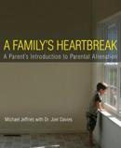
A Family's Heartbreak: A Parent's Introduction to Parental Alienation by Michael Jeffries and Joel Davies
A message of hope from Mike Jeffries the author of A Family's Heartbreak: A Parent's Introduction to Parental Alienation (http://www.afamilysheartbreak.com) His blog may help alienated parents this holiday season. Please feel free to share the link http://afamilysheartbreak.com/blog/.
BUY NOW

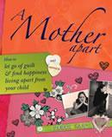
A Mother Apart: How to let go of guilt and find happiness living apart from your child.' Sarah Hart, long-term MATCH Member, author and counsellor
BUY NOW
www.sarahhart.co.uk

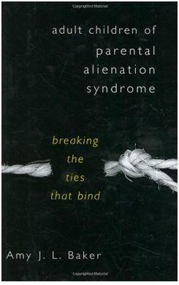
Adult children of parental alienation syndrome: breaking the ties that bind Amy J L Baker
BUY NOW on wordery
BUY NOW on Amazon

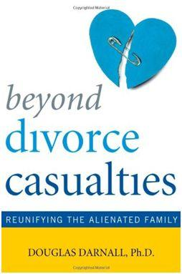
Beyond Divorce Casualties – Reunifying the Alienated Family by Douglas Darnall, Ph.D
Beyond Divorce Casualties is a workbook for severely alienated children and their parents. The book describes the how and why of unification therapy, how to prepare for reunification, how to effectively work with attorneys, mediators, parent coordinators and counsellors, and even how to say "goodbye" if reunification is not possible. This book also provides many real life examples of alienating behaviour, exercises, and specific instructions for how to change your feelings and behaviour. Importantly, the book's underlying assumption is that you have the power to change even if you have no power to change the other parent.
ISBN 978-1-58979-415-3

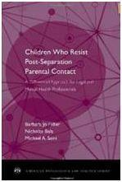
Children Who Resist Postseparation Parental Contact: A Differential Approach for Legal and Mental Health Professionals (American Psychology-Law Society) by Barbara Jo Fidler, Nicholas Bala and Michael A. Saini (Aug 29, 2012)
BUY NOW

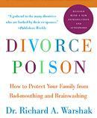

Divorce Poison: How to Protect Your Family from Badmouthing and Brainwashing [Paperback] by Richard A. Warshak (Author)
BUY NOW

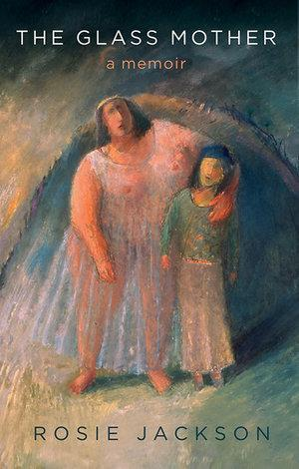
The Glass Mother: Memoir of literary life at famous University of East Anglia, estrangement from son, and personal search for meaning leading to Indian spiritual master Meher Baba by Rosie Jackson (Author)
BUY NOW on Kindle

In Our Hearts : Stories and wisdom of mothers who live apart from their children.
The launch of the book will be held at the University of Huddersfield on 23rd October. To buy this book click here.

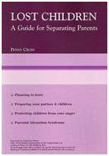
Lost Children: A Guide for Separating Parents, by Penny Cross
BUY NOW

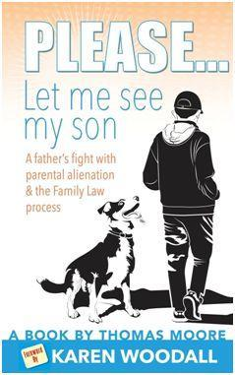
Please Let me See my Son : Thomas Moore foreward by Karen Woodall
Based upon case studies of work with alienated children, Understanding Parental Alienation contains practical information and easy to understand approaches to helping children affected by alienation.
ISBN 978-1-78148-616-0

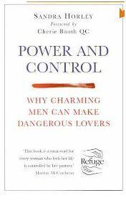
Power And Control: Why Charming Men Can Make Dangerous Lovers by Sandra Horley
BUY NOW

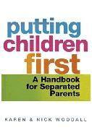
Putting Children First - a handbook for separated parents by Karen and Nick Woodall
BUY NOW

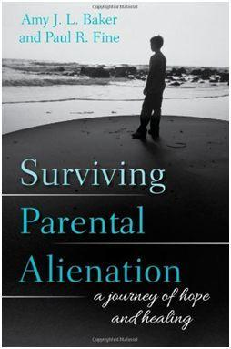
Surviving Parental Alienation – A journey of hope and healing : by Amy J L Baker & Paul R Fine
ISBN 978-4422-2677-7

Taken - An inspirational story of one mother’s epic fight for the return of her children and her chilling encounters with Social Services: by Sue O'Callaghan
BUY NOW

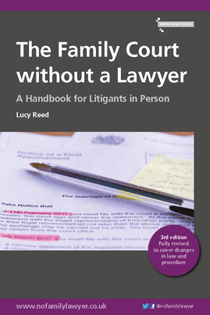
The Family Court without a Lawyer By Lucy Reed
A Handbook For Litigants In Person
​The Family Court without a Lawyer is the book you need if you have to go to court to sort out issues over separation, money or children and do not have a lawyer to represent you.
BUY NOW

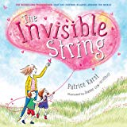The Invisible String By Patrice Karst
BUY NOW - via amazon

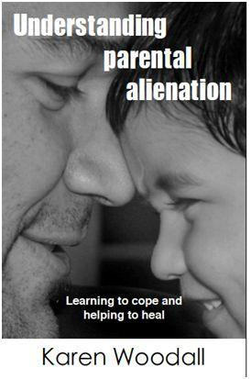
Understanding parental alienation: Written by the leading UK alienation practitioner and family therapist, Karen Woodall.
Publication date: tba
Price £12.99

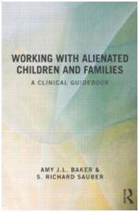
Working With Alienated Children and Families: A Clinical Guidebook by Amy J. L. Baker and S. Richard Sauber (1 Feb 2013)

