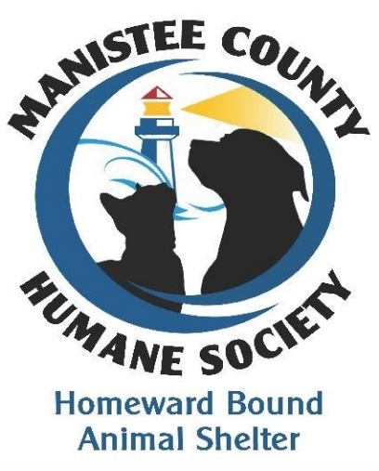
Manistee County Humane Society’s
Homeward Bound Animal Shelter
JOIN US!
June is membership month for the Manistee County Humane Society (MCHS). MCHS operates Homeward Bound Animal Shelter, a non-profit 501(c)3 no-kill shelter that helps homeless animals in Manistee County. Your membership helps provide food, medical treatment (including spay and neutering), vaccines, and a clean, safe haven for homeless pets waiting for their forever home. Your membership is very important and vital to the Homeward Bound’s success. As a member of MCHS, you will receive our newsletter with updates on the shelter activities, adoptions, and upcoming events. Become a new member or renew your membership by completing & mailing the attached form.
I want to become a member of the Manistee County Humane Society
and support Homeward Bound Animal Shelter.
Name: ____________________________________________________________ Date: _________________
Address: _________________________________________ City: _________________ State: ______ Zip: _________
Phone: (_______) _______________ Email Address: _____________________________________________
2018-2019 Yearly Membership Levels You must check one to become a member.
Single: _____$25 Family: _____$50 Patron: _____$75 Other: ______$ 75+

Golden Paw: _____$1,000 Platinum Paw_____$5,000 Diamond Paw_____$10,000

Donations of $1,000 or more are permanently recognized with your name on our Paw Plaque displayed in our lobby. You can also make your Golden, Platinum, and Diamond membership in memory or in honor of a special person or pet. If in memory of or in honor of- circle one: In Memory of or In Honor of
Name to appear on the plaque: _____________________________________________________________ *************************************************************************************Make check to: Manistee County Humane Society. Return to: P.0. Box 144, Manistee, MI 49660

