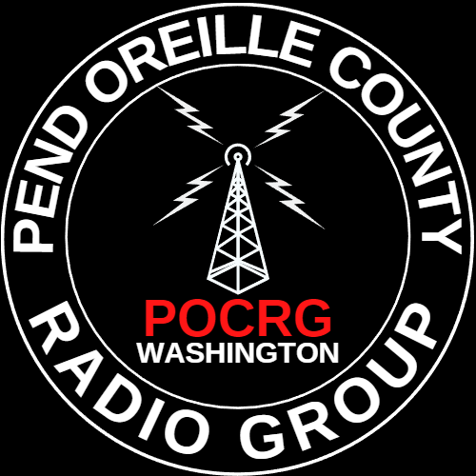
Pend Oreille County Radio Group Meeting Minutes
December 16, 2023 10:00 AM, South Pend Oreille Fire Fire and Rescue
www.pocrg.org
http://bit.ly/POCRG

1. Call to order
Jack KJ7YMO, Vice president, called the meeting to order at 10:00. The Pledge of Allegiance was recited, followed by the invocation.

2. Roll Call
Dec 16 ’23 Meeting 26 signed in out of 41 local members, 6 Guests.
Barry WRNP208
Cameron KK7GUQ
Chad
Cody WRXT298
Dale KD7BMJ
Dennis KG7YTC
Dennis KJ7KMZ
Don N8YF
Gary KK7HEI
Geoff KK7ALF
Jack KJ7YMO
James KJ7OTF
Jennie KE2CEI
Jim N1REZ
Kevin WRZR465
Lance WRXT298
Lilynne KJ7YMP
Linda KK7LKR
Pat KK7KPB
Rhonda
Richard KI7LFB
Sandy KB5OZY
Saundra KK7DBD
Shannon W6SPY
Sue KD7BUL
Terry KF7YKK

GUESTS
Nina P
Donna M
Sunni J
Jonathan M
Sheryle T
Nik K7EFR

3. Approval of minutes from last meeting
Minutes from the previous meeting were emailed and to be posted to the webpage.

4. Financial Report Treasurer November Meeting to December Meeting

5. Membership Report - Dale W. KD7BMJ

6. Club Leadership Sworn In
Shannon K6SPY President
Jack KJ7YMO Vice President
Jennie WRXT298 Secretary
Dale KD7BMJ will remain the Treasure

7. Christmas Party

Jez

