Open doors, open hearts, a welcome for all just as you are!

Hly Humr Sunday April 7, 2024 11:00

From an old Easter custom called “Risus Paschalis” – the Easter laugh!

PRELUDE James, the Farmer in O’Dell

GATHERING SONG Christians We are Made for Laughter
(Tune #611, words Jo Cassidy-Maloney)

Christians, we are made for laughter, born to giggle and guffaw!
Even in the great hereafter mirth is interspersed with awe.
Don’t hold back, let it fill you, let your muscles do their thing.
Don’t you worry, we won’t drill you! Just let go and laugh and sing.

Christ was dead and now he’s risen! Isn’t that a cause for glee?
Love has shattered all the prisons we have built so carefully.
Now unfettered, free as breezes, giggles, snorts and glee abound!
Even when our laughter wheezes, we praise God with every sound.

WELCOME Rev. Janet DeH20

CALL TO WORSHIP
Smile, Children of God! Let your faces be transformed. Radiate joy!
It’s great to be alive!
Laugh, Children of God! Let tears of joy baptize your eyes. Give thanks and celebrate!
It’s great to be alive!
Dance, Children of God! Lose yourself in the choreography of the Spirit!
It’s great to be alive!
Let the festival of worship begin,
for we are God’s people, gathered as one, and Christ is risen! Alleluia!

*HYMN #157 I Danced in the Morning

*PRAYER OF CONFESSION
Unfortunately…
Fortunately…God still loves and forgives us!

*WORDS OF INSURANCE
God’s love and mercy for us is free and overflowing. As we turn to God, God, through the grace of Jesus Christ, welcomes us home into new life.

We are forgiven! Thanks be to God! Yippee!!

*SONG OF RESPONSE #591 Halle, Halle, Hallelujah!

TIME WITH OUR CHILDREN

PASSING OF THE PIECE
Children: The Peace of Christ be with you. Congregation: And also with you.

PRAYER FOR ILLUMINATION

SCRIPTURE READINGS Genesis 18:9-15, Psalm 47:1-2a w/response #616
John 20:19-31

SERMON

*AFFIRMATION OF FAITH
God’s love frees me to be the person that I am without having to become more attractive, more intelligent, more popular. God’s love frees me to live in confidence, not needing to be self-absorbed, but ready to listen and to hear the stories of others. God’s love frees me to take risks, to surprise even myself with courage, sometime to fall flat on my face – but always to move onward with the knowledge that God is encouraging me. God’s love frees me to view the world not from the standpoint of wealth gains or ambition achieved, but from the perspective of relationships live and human love shared. Thanks be to God!

*HYMN #526 Let Us Talents and Tongues Employ

THE SACRAMENT OF THE LORD’S SUPPER
Invitation – All are welcome at this table

The Great Thanksgiving
The Lord be with you. And also with you.
Christ is risen. He is risen indeed. Alleluia!
Let us give thanks to the Lord our God. It is right to give our thanks and praise.
Sung Response #572 (screen)

Prayer After Communion
God of love and joy and laughter, by your Spirit sustain us and move us to feed others as we have been fed this day. Help us to spread, in word and deed, the good news that Christ is risen. Amen.

THE OFFERING
Offertory
*Doxology #606

*Offertory Prayer
God of laughter and joy, with the offering of our gifts, help us to spread light and love in the name of Christ, our risen Savior. Amen.

*HYMN #254 That Easter Day with Joy Was Bright

*CHARGE AND BENEDICTION

*RESPONSE #539 We will Go Out with Joy V. 1, sung twice

*POSTLUDE

A warm welcome to all this morning! If you are visiting a special welcome to you! We hope you find the worship service to be a blessing. We invite you to fill out the visitor card located in the pew racks and place it in the offering plate. We would love to get better acquainted, and we invite your participation in the worship, fellowship and mission of this church. If you wish to connect with the pastor please email Janet at jdewater@fpcmountholly.com

Children are always welcome in worship, wiggles, giggles and all! We value their presence with us as we worship God, knowing that this is how they experience the loving community of Christ and how they learn to worship. We have a “Worship and Play” room available downstairs for children, and the service is streamed down there as well.

The Offering The offering to support our ministry and mission is
Gratefully received during the offertory, or your contributions can be
made by using the provided QR code or the Paypal option available
on the church website fpcmountholly.com Thank you.

Thoughtful Thursday Program - April 18, 6:00 – 7:30 – Join us for the next of our thoughtful and respectful conversations about challenging topics. Come learn about “allyship” and how it applies to issues such as abortion. Dinner provided.

Outdoor Earth Day Worship Service, Lunch and Concert April 21 – We will gather on the front lawn at 11:00 for worship, followed by a cookout lunch and concert by the group “Trinity,” with Jonathan Brackett and our choir. Mark your calendars!

Holy Humor Sunday – Thank you for laughing with us today as we observe an old Easter custom begun in the early centuries of Christianity. The custom is rooted in the musings of early church theologians, like Augustine, Gregory of Nyssa and John Chrysostom, that God played a practical joke on the devil by raising Jesus from the dead.
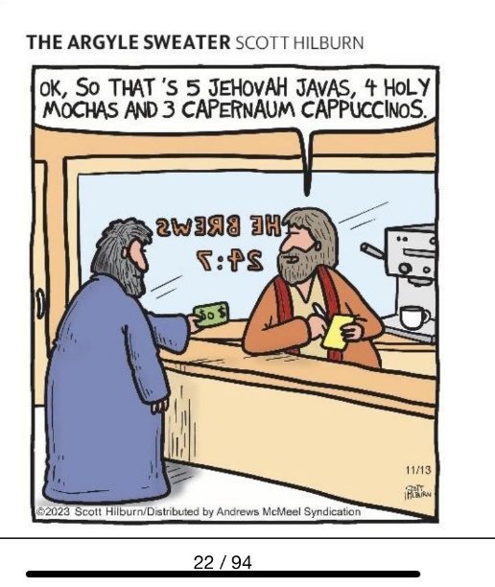

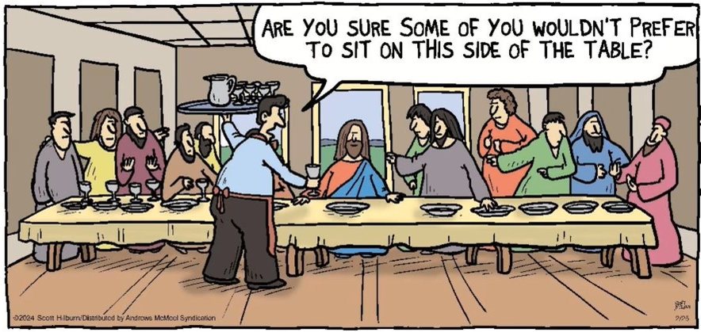

FIRST PRESBYTERIAN CHURCH

PO BOX 687 133 S. Main St Mount Holly, NC 28120 704-827-0521 FPCMountHolly.com

