**2022 Coast League Gross Playoffs**

**Divisional (updated 6/9/22)**  **FINAL Coast League Gross Champion**

**(1) Coto de Caza**

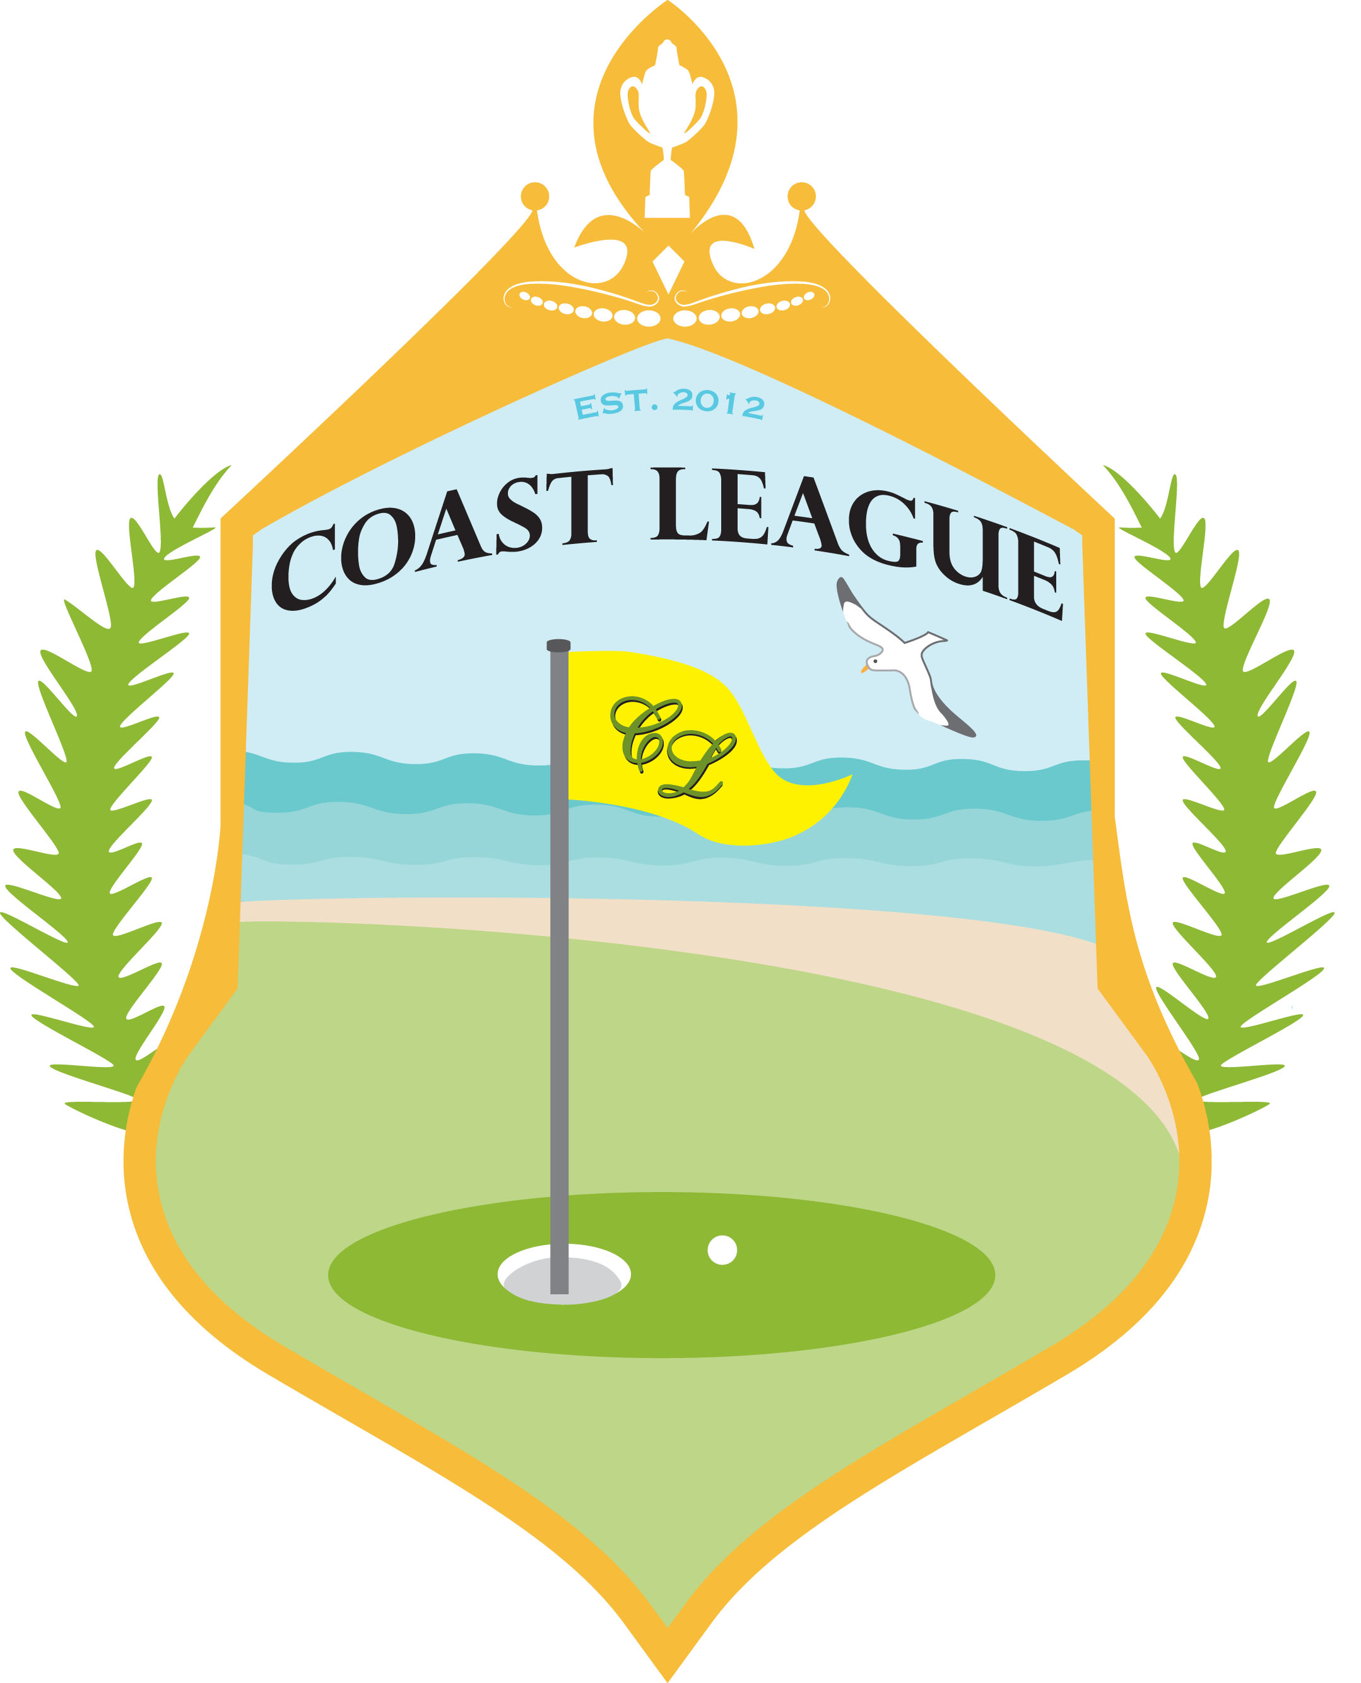

**(Gross Match Points**

**Over 2 days)**

**157 Match points**

**Coto de Caza**

**(4) Newport Beach**

**122.5 Match points**

**16 Gross Match Points**

**Coto de Caza**

**(2) Mesa Verde**

**14.5 Gross Match Points**

**Mesa Verde**

**(3) Huntington Club**

**125 Match points**

**139 Match points**