Deparü•rwrt cf B-:smss and ueulatim Deputy Agency Clerk
CLERK Brandon Nichols
9/19/2011
STATE OF FLORIDA

DEPARTMENT OF BUSINESS AND PROFESSIONAL REGULA
DIVISION OF FLORIDA CONDOMINIUMS, TIMESHARES, AND MOB'
IN RE: PETITION FOR DECLARATORY STATEMENT
Docket No. 2011035222
L.V. MANUFACTURED HOMEOWNERS
ASSOCIATION, INC. & LAMPLIGHTER
VILLAGE HOME OWNERS ASSOCIATION, INC.

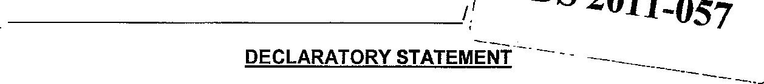DS 2011-057
The Department of Business and Professional Regulation, Division of Florida Condominiums, Timeshares, and Mobile Homes issues this Declaratory Statement under section 120.565, Florida Statutes (2010).

PRELIMINARY STATEMENT
On July 14, 201 1, the division received a Petition for Declaratory Statement from
Susan N. Leahy, President of LV Manufactured Homeowners Association, Inc. (LV
Manufactured) and Harry Cohn, President of Lamplighter Village Home Owners

Association, Inc. (Lamplighter Village), seeking an opinion on whether two mobile homeowner associations in Lamplighter Village would lose their rights of first refusal to purchase phases of the mobile home park if they merged under sections 723.075 and
723.076, Florida Statutes, and under In re: Petition Declaratory Statement., 723 Homeowners Association at Strawberry Ridge, Inc., Docket No. DS1999075, DS 99009, BPR-99-04132 (July 26, 1999). No hearing was requested or held.
The division acknowledged receipt of the petition on July 18, 2011 , informing the petitioners that a declaratory statement is a limited administrative proceeding and that a statement cannot be issued without the production of relevant governing documents. The division asked the petitioners to produce the prospectuses that govern the parks, the articles of incorporation and bylaws of the associations, and copies of the notices
In L. recorded by the associations in the county public records that establish their right of first refusal under the act. The division received all requested documents on July 29, 2011.
The division also informed the petitioners that it may not issue a statement that affects the rights of third persons; in this case, the rights of the park owner, Cal-Am Properties, Inc. (Cal-Am), are substantially implicated. Accordingly, the division sent a letter to Cal-Am on August 4, 2011, informing the park owner that it had the right to intervene or otherwise respond in this matter within twenty-one (21) days of the date of the division's letter. The division received a response from Cal-Am on August 25, 2011. Notice of receipt of the petition was published in Florida Administrative Weekly on July 29, 2011.

FINDINGS OF FACT
The following findings of fact are based on information submitted by LV Manufactured, Lamplighter Village, and Cal-Am. The division takes no position as to the accuracy of the facts, but merely accepts them as submitted for purposes of this final order.
1, Lamplighter Village HOA purports to be the chapter 723 mobile homeowners' association for Lamplighter Village, a mobile home park originally developed with 442 lots in the 1980's. ^{l}
2. - - -L.-V. Manufactured purports to be the chapter 723 mobile homeowners'
association for Lamplighter Village Il, a mobile home park with 197 lots deve}oped on an adjacent parcel to Lamplighter Village in the late 1980's and early 1990's?
3 Cal-Am, as the park owner and operator for both Lamplighter Village and
Lamplighter Village Il, has intervened in this administrative proceeding.3
4. Although geographically adjacent to each other, the two properties are separately licensed as mobile home parks.⁴
See SS 723 075, 723 0751, Fla Stat (2011), see also Motion To Intervene, at 2 (Aug 25, 2011) ² Id
- 723.003(7), (9), Fla. stat (2011)
- Pet for Decl Stmt at 1 (June 30. 2011) The dtvtslon has approved two prospectuses for Lamplighter
Village PRMZ000569 PI and PA The division has approved three prospectuses for Lamplighter Viltage PRMZ000630 PI, PA, and P2
  - Each of the mobile home parks receive separate property appraisals from the county and are taxed independently of each other.
  - The two properties share a portion of the road network and the large meeting hall. The meeting hall was built long after development of both communities was complete. The developer constructed the large meeting hall to encourage the park residents to meet and socialize.6

CONCLUSIONS OF LAW
- The division has jurisdiction to enter this order pursuant to sections 723.005 and 120.565, Florida Statutes.
- Section 120.565, Florida Statutes, provides:
- Any substantially affected person may seek a declaratory statement regarding an agency's opinion as to the applicability of a statutory provision, or of any rule or order of the agency, as it applies to the petitioner's particular set of circumstances.
- The petition seeking a declaratory statement shall state with particularity the petitioner's set of circumstances and shall specify the statutory provision, rule, or order that the petitioner believes may apply to the set or circumstances.
9. Rule 28-105.001, Florida Administrative Code (2007), provides:
A declaratory statement is a means for resolving a controversy or answering questions or doubts -concerning- the applicability of statutory provisions, rules, or orders over which the agency has authority. A petition for declaratory statement may be used to resolve questions or doubts as to how the statutes, rules, or orders may apply to the petitioners particular circumstances. A declaratory statement is not the appropriate means for determining the conduct of another person.
- Section 723.005, Florida Statutes, provides that the division has jurisdiction over "mobile home parks," defined in section 723.003(6), Florida Statutes, as a use of land in which lots or spaces are offered for rent or lease for the placement of mobile homes and in which the primary use of the park is residential.
- As mobile homeowners' associations, Lamplighter Village and L.V. Manufactured have standing to petition for a declaratory statement. ⁸
- As the park owner and operator for both Lamplighter Village and Lamplighter
Village Il, Cal-Am has the right to intervene in this administrative proceeding.9
- Section 723.002(1), Florida Statues, states in pertinent part:
The provisions of this chapter apply to any residential tenancy in which mobile home is placed upon a rented or leased lot in a mobile home park in which 10 or more lots are offered for rent or lease.
- Section 723.003(6), Florida Statutes, states:
The term "mobile home park" or "park" means a use of land in which lots or spaces are offered for rent or lease for the placement of mobile homes
and in which the primary use of the park is residential.
- Section 723.01 1(1 )(a), Florida Statutes, states in pertinent part::
In a mobile home park containing 26 or more lots, the park owner shall file a prospectus with the division. Prior to entering into an enforceable rental agreement for a mobile home lot, the park owner shall deliver to the homeowner a prospectus approved by the diyision.
- The provisions of chapter 723, Florida Statutes, apply to all mobile home parks as defined under section 723.003(6), Florida Statues, regardless of the particular type of homeowners association that may or may not represent the homeowners.
17. The particular circumstances addressed in the Petition, however, relate -to the application of section 723.075(1 ), Florida Statutes, and states:
In order to exercise the rights provided in s. 723.071, the mobile home owners shall form an association in compliance with this section and ss. 723.077, 723.078, and 723.079, which shall be a corporation for profit or not for profit and of which not less than two-thirds of all of the mobile home owners within the park shall have consented, in writing, to become members or shareholders. Upon such consent by twothirds of the mobile home owners, all consenting mobile home owners in the park and their successors shall become members of the association and shall be bound by the provisions of the articles of incorporation, the bylaws of the association, and such restrictions as may be properly promulgated pursuant thereto. The association shall have no member or shareholder who is not a bona fide owner of a mobile home

located in the park. Upon incorporation and service of the notice described In s. 723.076, the association shall become the representative of the mobile home owners in all matters relating to this chapter. (Emphasis added).
- Thus, section 723.075(1), Florida Statutes, as excerpted above, specifically provides the requirements a mobile homeowners association must fulfill to exercise the rights provided in section 723.071, Florida Statutes—primarily the right of first refusal if the park owner offers the park for sale. Two-thirds of the mobile home owners within the park must consent in writing to become members of the association. The association shall have no member who is not a bona fide owner of a mobile home located in the park. Once formed, the association also becomes the association that negotiates rent increases, changes in park rules and reductions in service on behalf of the owners in the park. ^{Il}
- A mobile home owners association may notify the park owner of its right to purchase the park if the park owner offers the park for sale. The association has the power to purchase the park, and to offer subscriptions to home owners in the park to pay the purchase price.
- Mobile home owners have an interest in the park in which their home is located through the prospectus and lot rent agreement with the park owner. This

contract identifies the specific real property, the. mobile home park, in which the home owners reside and in which they have a contractual interest. They do not have the same property interest, if any, in a park in which their home is not located. The purpose of a nght of first refusal for mobile home owners is to enable them to buy the land on
which they reside to protect their property interest. It is not to allow them an opportunity
to bid on other parks in which they do not have a direct contractual and property interest that may be offered for sale. The purpose of the Mobile Home Act is to equalize the bargaining positions of the mobile home tenants in the park and the owner of the park. ¹⁵ Allowing persons who are not mobile home owners in the park to become members of the association changes the balance of the bargaining positions of the parties and the shared interests of the mobile home owners—those with a direct interest in the park and those without—which may affect the association's ability to collect subscriptions to purchase the park and to get financing for the purchase.
- Both of these parks were developed separately and have changed ownership independently. ¹⁶ The park owner may offer one of the parks but not both if it chooses to do so. If so, the merged association would have members who do not have a property interest in a home in the park or a contractual interest in the tenancy in the park to determine whether a right of first refusal would be exercised. To allow LV
Manufactured owners to decide to purchase or not purchase the land under the
Lamplighter Village owners homes would allow persons who do not have a property interest in their park to determine if the right of first refusal will be exercised or lost. The right of first refusal may only be exercised by bona fide homeowners in the park. This ensures that only those homeowners with an interest in the park may exercise the right.
If the-two association's merge, the merged association would not meet this requirement.
- In In re: Petition Declaratory Statement, 723 Homeowners Association at Strawber,y Ridge, Inc., Docket No. DS1999075, DS 99-009, BPR-99-04132 (July 26,
1999) the division declared that:
For the rights provided in section 723.071, Florida Statutes, to be enforceable, the provisions of section 723.075(1), Florida Statutes, must be met. A homeowners association that has members who do not own a mobile home located in that park does not comply with section 723.075(1 ), Florida Statutes.
- see v Green, 300 so 2d 889, 891 (Fla 1974) (uphold,ng S 83.69, Fla stat , repealed but substantially reenacted as S 723.061, Fla. Stat In 1984) S 723 004(1), Fla Stat
- See "History of Homeowners' Association" filed as a supplement to the petition on July 29, 201 1 (disk
23. Petitioners, In an effort to draw this petition outside the scope of Strawberry
Ridge, argue that the existence of two independent mobile homeowner associations (planning to merge) IS legally different from the facts in Strawberry Ridge whereby one association sought to offer membership to mobile home owners in an adjacent park. But this is a distinction without a difference. In both cases, the fundamental principles of section 723.075(1), Florida Statutes, are not met. Like the single association in Strawberry Ridge, the merged organization here would include members who are not the owners of mobile homes located in each of the separate and distinct parks. Therefore, accessibility to the rights under section 723.071, Florida Statutes, would extinguish upon merger.
For the reasons stated above it is hereby:
ORDERED that if L.V. Manufactured Homeowners Association, Inc. and Lamplighter Village Home Owners Association, Inc. merge, the associations would lose
their rights of first refusal to purchase the parks under sections 723.075 and 723.076,
Florida Statutes, and In re: Petition for Declaratory Statement: 723 Homeowners'
Association at Strawberry Ridge, Inc., Docket No. DS 1999075, DS 99-009, BPR-9904132 (July, 26, 1999) because the merged association would have members who are not bona fide owners of both parks.
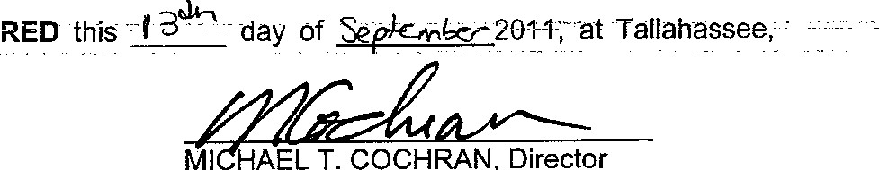
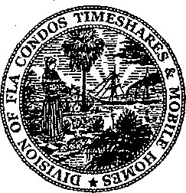
DONE and ORDERED this
Leon County, Florida.
Ml HAEL T. COCHRAN, Director
Department of Business and
Professional Regulation
Division of Florida Condominiums, Timeshares, and Mobile Homes
Northwood Centre
1940 North Monroe Street
Tallahassee, FL 32399-1030

NOTICE OF RIGHT TO APPEAL
THIS FINAL ORDER CONSTITUTES FINAL AGENCY ACTION AND MAY BE
APPEALED BY PETITIONER PURSUANT TO SECTION 120.68, FLORIDA

STATUTES, AND RULE 9.110, FLORIDA RULES OF APPELLATE PROCEDURE BY
FILING A NOTICE OF APPEAL CONFORMING TO THE REQUIREMENTS OF RULE
9.110(c), FLORIDA RULES OF APPELLATE PROCEDURE BOTH WITH THE APPROPRIATE DISTRICT COURT OF APPEAL ACCOMPANIED BY APPROPRIATE FILING FEES AND WITH THE AGENCY CLERK, 1940 NORTH MONROE STREET, NORTHWOOD CENTRE, TALLAHASSEE, FLORIDA 32399-2217 WITHIN THIRTY
(30) DAYS OF THE RENDITION OF THIS FINAL ORDER.

CERTIFICATE OF SERVICE
I HEREBY CERTIFY that a true and correct copy of the foregoing has been furnished by U.S. mail to Harry Cohn, President, Lamplighter Village Home Owners Association, Inc., 608 Waveside, Melbourne, Florida 32934, and Susan N. Leahy,
President, L.V. Manufactured Homeowners Association, Inc., 249 S. Westwind Court,
Melbourne, Florida 32934, and David D. Eastman, Esq., attomey for Cal-Am Properties, 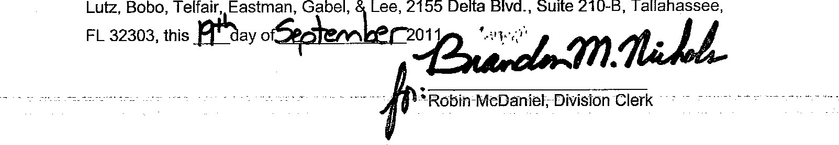Lutz, Bobo, Telfair, Eastman, Gabel, Lee, 2155 Delta Blvd., Suite 210-B, Tallahassee,
Copies furnished to:
Janis Sue Richardson
Chief Attorney

Motton To Intervene, at 2
S 723 003(6), Fla stat (2011)
s 120 565, Fla stat (2011) ⁹ 723 003(7), (9), Fla stat (2011)
Section 723 071 requires a mobile home park owner to give tenant mobile home owners the right to buy the property If the park owner "offers a mobile home park for sale " Harris v Martrn Regency. Ltd , 576 So 2d 1294, 1297-98 (Fla 1991 ). It does not extend the nght of first refusal to a park owner's receipt of an unsolicited offer to purchase the park S 723.071 (2), Fla Stat But notice IS required See also Brate v Chulavlsta Mobile Home Park Owners Ass'n Inc., 559 So.2d 1190 (Fla. 2d DCA 1990) (park owner not required to give association first right of refusal when he accepted unsoltated offer for purchase from third party because park owner had not "offered" the park for sale to the public) S 723 037, Fla stat
S 723 076(3), 723 071, Fla stat
S 723 079(5), Fla stat
S 723 079(9), Fla stat of8

