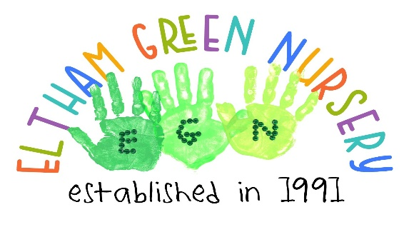
Teynham House
41 Alderwood Road
Eltham
SE9 2LR
020 8850 4720
elthamgreennursery@outlook.com
Parent Information
Eltham Green Nursery is a limited company run by a management committee consisting of interested parties, mainly parents of the nursery children.
The nursery is term time only open thirty -nine weeks of the year. The nursery was originally set up by the governors of the old Eltham Green School to provide childcare for the teachers of children in the London Borough of Greenwich and the surrounding boroughs. We now cater for the local community offering childcare funded places for together for two’s, universal 15 hours and 30 hours extended.
Hours for 15 hours places are offered across 2 days from 8.30-4.00pm.
Although this is a funded place, we do ask for a small contribution of £3.00 a day towards the cost of the meals and snacks. You are welcome to provide a packed lunch instead for your child.
Hours for 30 hour funded places are offered across 3 full days from 7.45am – 5.50pm. We also ask for a small contribution of £6.00 per day to cover the three meals daily.
An AGM is held annually, and new parents are welcomed onto the committee. The annual accounts are presented at the AGM along with the Chair’s report. The management committee usually meets once every term.
The nursery has two main working rooms – one for the babies and toddlers called Mini Explorers The other room – pre-school children is split into ages 3 and 4 which are called Little and Big Explorers.
We also have an outside area attached to the nursery with trees and bushes, and soft surfaces. We have access to Alderwood Primary School’s Forest School site.
We are registered for 30 children per day.

The Nursery Staff
The experienced Eltham Green Nursery staff are all fully qualified Early Years Practitioners, and all hold a current DBS and Paediatric first aid certificates It is imperative that staff keep up with current early years training. For us to achieve this there are 4 inset days within the term. We also have staff meetings where parents are asked to collect their child by 4:15pm.
The ethos of the nursery is CHILDREN FIRST
We aim to work in a respectful and co-operative relationship with the parent/carers and encourage your ideas and suggestions for the nursery. Good communication is an essential part of the partnership between parent/carer and the staff. All our staff are professional caring individuals whose paramount aim is the welfare of your child. We are also available to talk to you during the day and at our parent’s evening held during the year. We keep various confidential development records and observations on your children that you can see at any time.
Through the provision of our daily activities, we encourage the children who attend our nursery to:

- Make decisions and work collaboratively with adults and peers.

- Develop self-discipline.

- Identify personal goals and to complete chosen tasks.

- Develop self-expression through language communication, art, and dance.

- Develop an enquiring mind, listen to other points of view, and behave appropriately.

Settling into the Nursery
When you accept a nursery place you will be offered an initial first visit for approximately 45mins talking to the child’s key person and letting your child experience the environment. They will go through your child’s routine, likes, dislikes, allergies etc. From then additional visits will be made over a two -week period.

Curriculum
Our planning for our children is guided by the Early Years Foundation Stage curriculum. We endeavour to reach each child’s individual potential by offering age appropriate and stimulating activities. Each child is unique and develops at their own pace and we offer support and guidance in every area. The aim is to have fun whilst learning not forgetting that they are young children, so we consider each child’s interests and individual needs.
We believe in promoting positive role models to our children not only from the nursery staff but from the local community and we welcome visitors to the setting.
All the children are encouraged to work individually and in small groups to build on what each child already knows and can do to promote self-confidence, independence, and their social skills. Within the Early Years Foundation Stage Curriculum, the children have daily access to a variety of activities such as messy play, sand, water, mark making, books and stories, role-play, construction, and imaginative play. They also have music, rhymes, and of course outside play.
The children are encouraged to initiate their own ideas and access the activities that are self -chosen.
The staff record the children’s developmental progress by observation, planning and assessment and a ‘Learning Journey’ of the children’s time at nursery is available for you to keep when they leave the setting.
They also have planned activities according to their interests with interaction in the form of songs, rhymes, stories, and games.
We look forward to welcoming you and your child to our nursery.

Company number: 2666215

