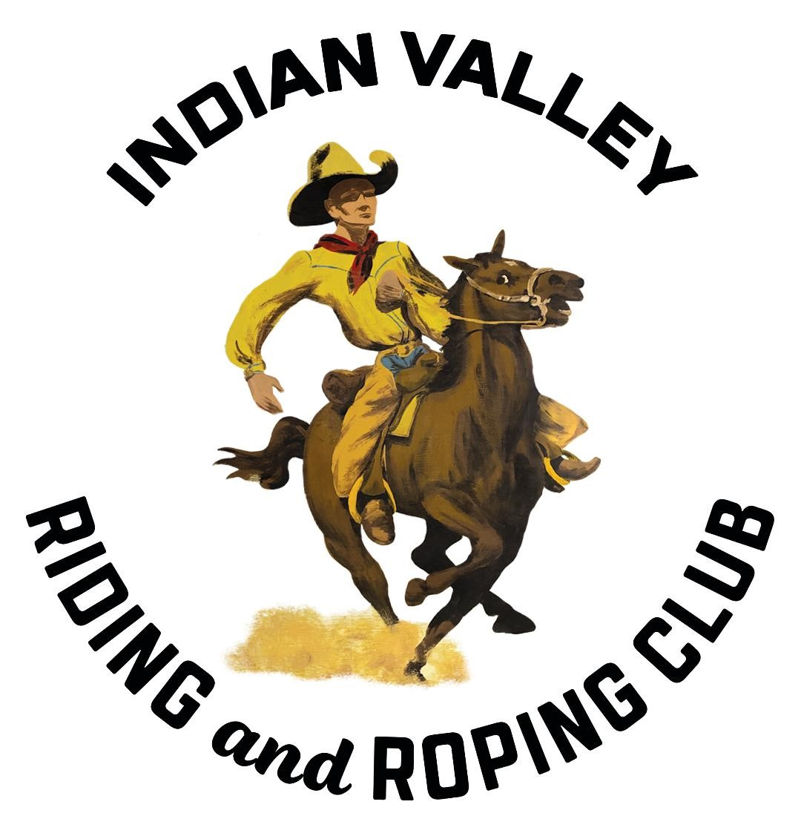
Silver Buckle Rodeo Royalty Contest Information
- The Queen Contestant must be 16-19 years old as of January 1, 2024. In order to advance to the Miss CCPRA contest, you must be 17 years old to compete.
- Princess Contestant must be 10-15 years old as of January 1, 2024.
- Junior Princess Contestant must be 6-9 years old as of January 1, 2024.
- Contestants must have resided in Plumas County for at least 6 months prior to the application deadline.
- Contestants must be un-married and have no dependents.
- Contestants must provide their own contest horse and transportation.
- Contestants must become a member of the Indian Valley Riding & Roping Club to enter the contest and use the Indian Valley Riding & Roping arena.
- Contestants are allowed to secure sponsors to offset the costs of competing. Sponsor payments are to be made directly to contestants.
- Contestants must use the same horse for all phases of the contest including practices, horsemanship contest, parade, and grand entry. Exceptions are only given with a letter from a certified veterinarian or by permission of the contest coordinator.
- Contestants must assist with a fundraiser to offset prizes offered. Contestants are to sell a minimum of 30 raffle tickets.
- Contestants must dress appropriately during all official functions while representing the Indian Valley Riding & Roping Club. (Western Attire, Cowboy Hat with Crown, Chaps Sash) Contestants may elect to use a cowboy hat helmet, if desired, for added safety.
- The 2024 Silver Buckle Rodeo Queen, Princess and Junior Princess will be expected to represent the Indian Valley Riding & Roping Club at the following events in full dress.
  - Indian Valley Riding and Roping Royalty Rodeo Contest, May 5, 2024
  - Plumas Sierra County Fair Parade 2024
  - Taylorsville Junior Rodeo 2024
  - Gold Digger Days Parade 2024
  - Scholarship Presenter Greenville High School Graduation 2024
  - IVRRC Christmas Party 2024
  - Taylorsville 4th of July Parade & Rodeo 2024 & 2025
  - Rodeo Royalty Contest 2025
  - any other events where IVRRC is asked to sponsor or present.
- The Rodeo Queen, Princess and Junior Princess are each awarded a buckle.
- Contestants must meet with Indian Valley Riding & Roping Rodeo Queen Contest Coordinator, Jill Simon for rules and regulations of the Rodeo Royalty contest.

Rodeo Royalty applications are due May 1, 2024. The Rodeo Royalty competition will be held on May 5, 2024, 3pm, IVRRC Rodeo Grounds.
Please mail, hand deliver or email applications to:
Jill Simon, Indian Valley Riding & Roping Rodeo Queen Contestant Coordinator
PO Box 134 Taylorsville, CA 95983 mustangjill@comcast.net
(530) 514-0429

