AUTO RELATED ACCIDENT

MR. MRS. MS. DR. MISS
Patient Name:_________________________________________________________________________________
Last First MI
Birthdate:____/____/______Age:_______SS#:______________-_____________-_______________
Address:______________________________________________________
City:_____________________________________State:_________________________Zip:_______________
Home Phone # (_____)______________________Cell Phone # (______)______________________________
Employer:________________________________
Have you retained an Attorney: _____YES _____NO
IF YES WHOM?___________________________________________________________________
HIS/HER PHONE NUMBER: (______)________________-_____________________

AUTO RELATED ACCIDENT
DATE & TIME OF ACCIDENT________________________________________ A.M. P.M.
WERE YOU THE: _____ DRIVER _____ FRONT PASSENGER _____ REAR PASSENGER
IF A TRAFFIC VIOLATION WAS ISSUES, TO WHOM WAS IT ISSUED?
______________________________________________________________________________________________________________________________________________________________________________
NUMBER OF PEOPLE IN ACCIDENT VEHICLE?__________________________
DID THE POLICE COME TO THE ACCIDENT SITE? _____YES _____NO
WAS A POLICE REPORT FILED? _____YES _____NO
WERE THERE ANY WITNESSES? _____YES _____NO
WERE YOU WEARING YOUR SEAT BELT? _____YES _____NO
WAS THIS VEHICLE EQUIPPED WITH AIRBAGS? _____YES _____NO
IF YES, DID IT/THEY INFLATE? _____YES _____NO
WHAT DID YOUR VEHICLE IMPACT? _____ANOTHER VEHICLE? _____OTHER
IF OTHER, PLEASE DESCRIBE:__________________________________________________________
______________________________________________________________________________________
DID ANY PART OF YOUR BODY STRIKE ANYTHING IN THE VEHICLE? _____YES _____NO
IF YES, PLEASE DESCRIBE:_________________________________________________________________
________________________________________________________________________________________________________________________________________________________________________________________
PLEASE CONTINUE TO NEXT PAGE

- NECK PAIN
- NECK STIFF
- JAW PROBLEMS
- ARM/SHOULDER PAIN
- NUMB HANDS/FINGERS
- BACK PAIN
- LOWER BACK PAIN
- BACK STIFFNESS
- LEG PAIN
- NUMB FEET/TOES
AFTER INJURY
DID YOU GO TO THE HOSPITAL OR SEE ANY OTHER DOCTOR? _____YES _____NO
WHEN DID YOU GO? ____JUST AFTER ACCIDENT_____THE NEXT DAY_____2 DAYS PLUS
DESCRIBE ANY TREATMENT YOU RECEIVED: _____________________________________
_________________________________________________________________________________
WERE XRAYS TAKEN? _____YES _____NO
WAS MEDICATION PRESCRIBED? _____YES _____NO
HAVE YOU BEEN ABLE TO WORK SINCE THIS INJURY? _____YES _____NO
ARE YOUR WORK ACTIVITIES RESTRICTED AS A RESULT OF THIS INJURY?
_____YES _____NO
CHECK THE SYMPTOMS THAT ARE A RESULT OF THIS ACCIDENT:
- DIZZINESS OTHER:
- MEMORY LOSS PLEASE EXPLAIN
- HEADACHE (S) _____________
- BLURRED VISION ______________
- BUZZING IN EAR ______________
- EARS RINGING
- DIFFICULTY SLEEPING
- IRRITABILITY
- FATIGUE
- TENSION

PLEASE CONTINUE TO NEXT PAGE
WHAT WAS THE APPROX. SPEED OF YOUR VEHICLE: _________MPH
WHAT WAS THE APPROX. SPEED OF THE OTHER VEHICLE: _________MPH

WHERE DID THE IMPACT OF THE VEHICLE COME FROM :
_____FRONT _____REAR _____RIGHT SIDE _____LEFT SIDE _____OTHER

IN YOUR OWN WORDS, PLEASE DESCRIBE THE ACCIDENT:
____________________________________________________________________________________________________________________________________________________________________________________________________________________________________________________________________________________________________________________________________________________________________________________________________________________________________________________________________________________________________________________________________________________________________________________________________________________________________________________________________
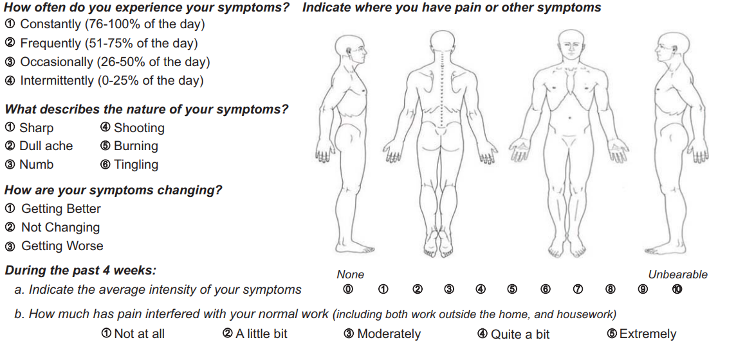

DISCLOSURE & CONSENT
CHIROPRACTIC ADJUSTMENTS AND CARE

TO THE PATIENT: You have a right as a patient to be informed about your condition and the recommended chiropractic adjustments and other chiropractic procedures to be used so that you may make the decision whether or not to undergo the procedure after knowing the potential risks and hazards involved. This disclosure is not meant to scare or alarm you; it is simply an effort to make you better informed so you may give or withhold your consent to the procedure.

I hereby request and consent to the performance of chiropractic adjustments and other chiropractic procedures, including various modes of physical therapy and diagnostic X-rays, on me (or the patient named below, for whom I am legally responsible) by the Doctor of Chiropractic named below and/or other licensed Doctors of Chiropractic or those working at the clinic or office who now or in the future treat me while employed by, working or associated with, or serving as a backup for the Doctor of Chiropractic named below.

I have had the opportunity to discuss with the Doctor of Chiropractic named below, my diagnosis, the nature and purpose of chiropractic adjustments and other procedures and alternatives. I understand and I am informed that, in the practice of chiropractic there are some risks to exam and treatment including, but not limited to, fractures, disc injuries, strokes, dislocations, sprains and increased symptoms and pain or no improvement of symptoms or pain. I do not expect the doctor to be able to anticipate and explain all risks and complications, and I wish to rely on the doctor to exercise judgment during the course of the procedure which the doctor feels at the time, based on the facts then known, is in my best interest. I further acknowledge that no guarantees or assurances have been made to me concerning the results intended from the treatment.

I have read, or have had read to me, the above consent. I have also had an opportunity to ask questions, and all my questions have been answered fully and satisfactorily. By signing below, I consent to the treatment plan. I intend this consent form to cover the entire course of treatment for my present condition and for any future condition(s) for which I seek treatment.

To be completed by the patient:

________________________________________
Print name
________________________________________
Signature of patient/or Representative
_________________________________________
Date signed
_________________________________________
Doctor’s Signature
_________________________________________
Member of doctor’s staff
_________________________________________
Date signed

