January 22, 2024

Regarding the purchase of VMCA merchandise, Penny Smelser started an email communication with the Executive Board of the Virginia Mosquito Control Association on January 22, 2024 at 7:21am.

The VMCA members included in the email communication were Past President Wes Robertson, President Elect (Acting President) Karen Akaratovic, Vice President Lauren Lochstampfor, First Vice President Addie Weddle, Secretary/Treasurer Jay Kiser, Industry Representative Interim Zach Cohen, and MAMCA Representative Tim DuBois.

Penny’s email communication stated:
As chair of the merchandise committee, I would like to request approval to spend up to $1000 on merchandise to be sold at 2024 Annual Meeting and by request thereafter. We are looking to order a t-shirt for sale this year, the cart image is attached as well as a link to the design if you would like to review. Cost for the shirts should be approximately $930 with tax.
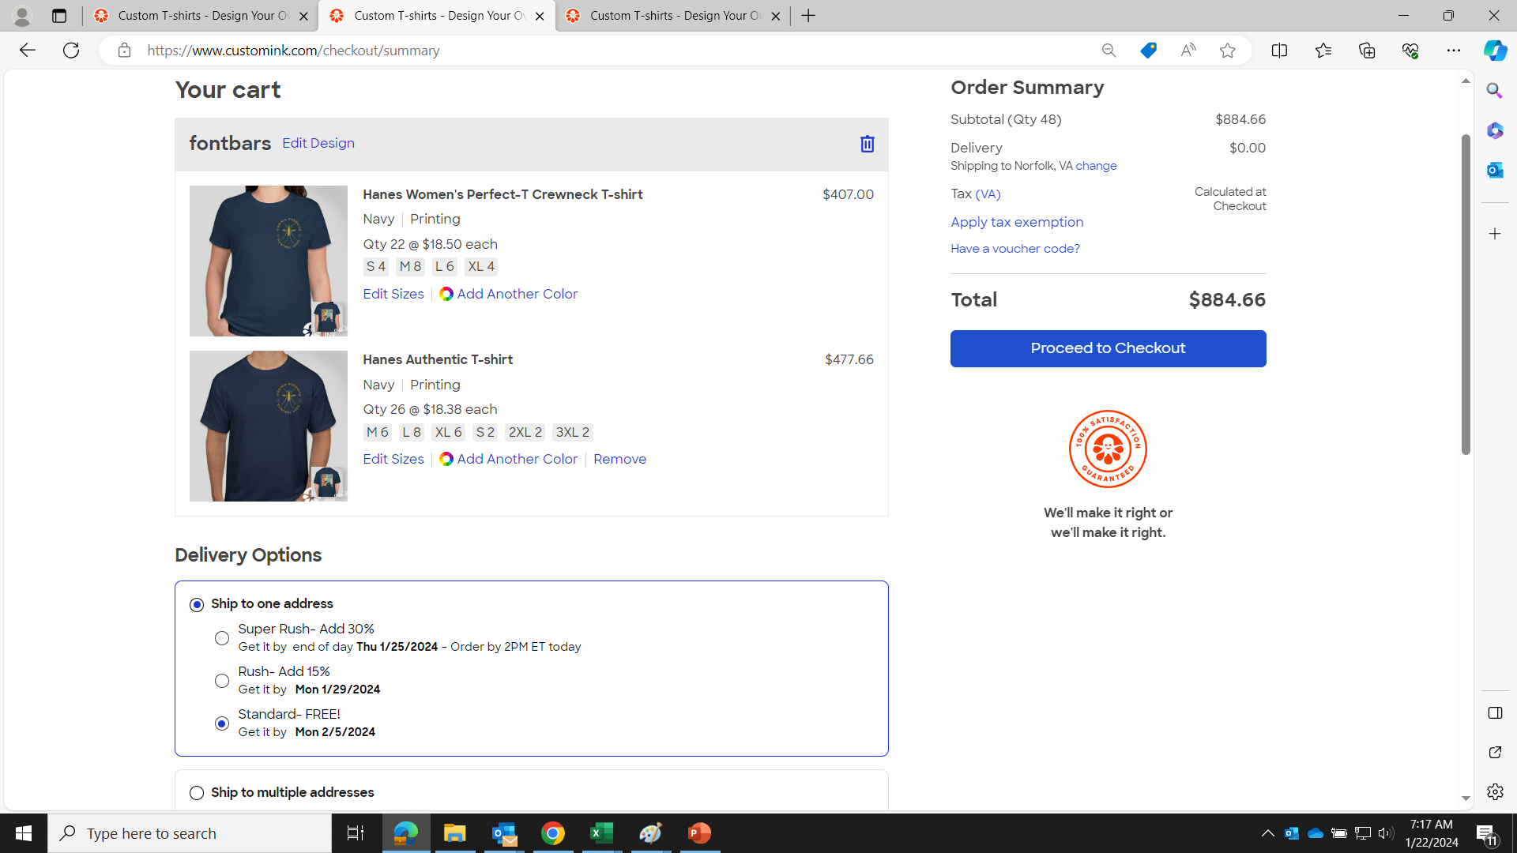
Jay Kiser made a motion, seconded by Lauren Lochstampfor, to allow the merchandise committee to spend up to $1,000 on the shirts Penny provided information on to the board. There was no discussion, no response from Zach Cohen. All other voting members in favor, none opposed. Motion carried 1/23/2024 at 10:37am.

Respectfully Submitted,

Jay Kiser
Secretary/Treasurer VMCA

