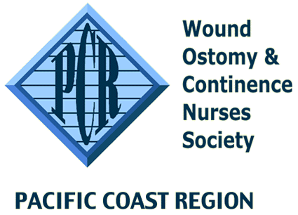
PCR WOC Scholarship Application
Attachment A

Fund Application
All information will be kept confidential, LEAVE NO BLANKS and do not abbreviate terms or names. Incomplete applications will not be reviewed. Applications must be received by March 31st yearly.
Return the completed application, attachments and letters of recommendation to:

Carey Webster – Scholarship Chairperson
careycwebster@gmail.com
(530) 277-0535

Accredited Eligibility Criteria

- Seeking education in wound, ostomy and/or continence care.
- Proof of one of the following:
- Acceptance to a WOCN-accredited Wound, Ostomy and/or Continence Education Program (WOCNEP).
- Current enrollment in a WOCN-accredited WOCNEP.
- Certification of completion from a WOCN-accredited WOCNEP within 1 year of graduation.
- Reside in Pacific Coast Region area

NOTE: It is advisable that you keep a copy of your completed application packet. Email submission is required. The application should be emailed no later than midnight March 31st of each calendar year.

Applicant Information
1. Name: _________________________________________________________________________
Mailing Address: ___________________________________________________________________
City/State/Zip: _____________________________________________________________________
Phone: Home ( ) _______________________ Work ( ) ____________________________________
Email: ____________________________________________________________________________
2. WOCN Member # if applicable: _____________________________________________________
3. For which scope(s) of WOC practice are you applying? Wound ( ); Ostomy ( ); Continence ( ).
4. Attach a copy of your resume.
5. Attach proof of acceptance into/or completion from a WOCN-accredited Wound, Ostomy or Continence Education Program for the Accredited Scholarship.
6. Attach three satisfactory letters of recommendation from professional associates who have known you for at least one year (one from current employer is preferred).
7. Attach letter of 500 words or less discussing your reasons for pursuing education in a WOCN-accredited Wound, Ostomy or Continence Education Program and how you plan to use the education.
8. Attach signed Attachment B (Release & Agreement).
9. Attach a copy of your current nursing license.
10. Please make sure your name is on every document.

Updated: January, 2022 by Carey Webster

