Please Fill out the form below with as much information as possible.
Date
Name
Mailing Address
Owner’s Phone Number
Owner’s Email
Serial Number
Manufacture
Model Year
Frame Colors
Type

Optional |  |  |  | Amount
Frame Material
Handlebar Type
Other Defining Features
Photos Attached (Circle One) | Yes/No (Please email eastcentralcrimeprevention@gmail.com if  you need photos taken)
Sticker Required  (Circle One) | Yes/No

East Central Crime Prevention Association Use Only
Date Entered |  | Sticker Issued |  | Entered By:

Return By:
Mail Email
1106 24 Street eastcentralcrimeprevention@gmail.com
Wainwright AB
T9W 1W4

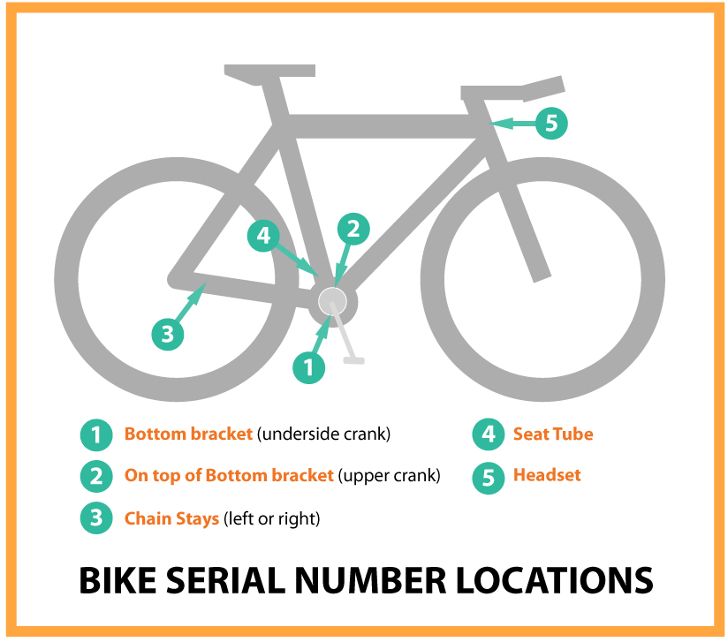

Type

