The Ted Lewis Centre, Charity 1199771, was formed in June 2020, details of which are set out on The Charity Commission’s website. A national heritage centre, its formal objects are as follows “The advancement in education, art, culture and understanding of the artist, novelist and musician Mr Alfred Edward Lewis (Ted Lewis). In particular to promote a public awareness and understanding of the life, times, art, literary, graphic and musical skills of Ted Lewis. To establish, maintain, manage and run premises consisting of an archive, museum and art gallery in Barton upon Humber, North Lincolnshire or such other place as shall be deemed appropriate and convenient for education and the storage, display and public research in respect of relevant artefacts.”

The Centre is governed by Trustees, who are members appointed to be legally responsible for its management, development and activities and to which our Chief Executive Officer reports.

The Charity, which was formed in June 2022, opened to the public on 1st September 2020 and is registered with HMRC, National Archives and is currently applying for National Museum status. Our Patron is Mr Anthony Klinger, son of Get Carter’s inspired producer, Michael Klinger.

The Centre is open each Sunday during the year and parties are welcomed. We also provide a Ted Lewis Barton Town Trail which can be self-conducted or knowledgably guided on appointed dates. Further details are available on www.thetedlewiscentre.org

The Ted Lewis Centre, Ferriby Road, Barton upon Humber, North Lincolnshire, DN18 5LE admin@tedlewiscentre.com 07933422534

The Ted Lewis Centre Membership

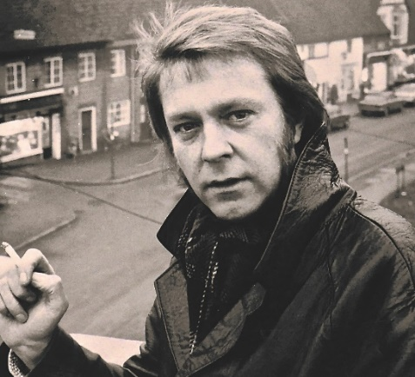
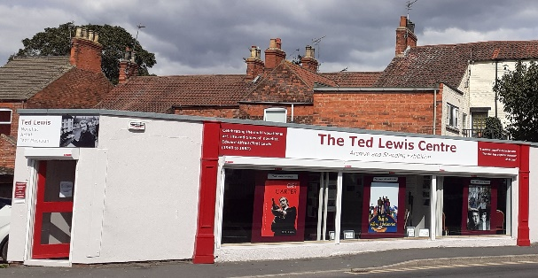

Membership of the Ted Lewis Centre entitles you to:
- Vote in elections for the management committee and AGM;
- Attend at the Annual General Meeting;
- View the Centre archive, exhibits and artefacts at any reasonable time;
- View Centre films by arrangement;
- Receive Membership Newsletters;
- Notification direct for our events and outreach.

Our membership year is from 16th to 15th January the following year. The next full membership year starts on 16th January 2023 so if you sign up now, that membership will last from now until 15th Jan 2024

Centre Membership Application
Please complete and send with the fee or standing order to The Ted Lewis Centre, Ferriby Road, Barton upon Humber, DN18 5HG
Are you a UK taxpayer? If so, every £1 you give could be worth £1.25 to us, helping to fund vital work at no cost to you. All you need to do is tick the declaration at the foot of this form

I apply to become a member of The Ted Lewis Centre
Full Name
Address and Postcode
E mail
Telephone
Signature

I would like the Ted Lewis Centre to reclaim the tax on this and any other eligible donations or membership subscriptions that I may make in the future or have made in the past 4 years. I understand that I need to pay enough Income Tax or Capital Gains Tax in each tax year to cover the Gift Aid claimed on all my donations otherwise it is my responsibility to pay any difference.

We prefer payments by Standing order for administrative savings but you may also pay by:
(Tick one of these if you prefer to pay other than by standing order)
PayPal or
Cheque payable to The Ted Lewis Centre or
Bank transfer to HSBC Sort Code 40-25-50 Account 00237795 in the name of The Ted Lewis Centre (a business account)

Standing order

My Bank
Bank address
Please pay by bankers’ standing order, cancelling any previous instructions to this recipient, to HSBC Sort Code 40-25-50 Account 00237795 in the name of The Ted Lewis Centre for the sum of £10.00 (ten pounds), the first payment to be made forthwith, the second payment on the 15th January 2024 and thereafter on the 15th day of January in each year following until further notice and debit my account:
Name of my account
My account’s Sort Code
Number of my account
I hereby authorise my bank to set-up this standing order payment from my account

My Signature
My full name
My address
Telephone
E Mail

