Recovery Plan Form
What thoughts or considerations do you believe your teen is currently having about their behavior regarding substance use? Stages are defined in the Transtheoretical Model (TTM) in Module 2.
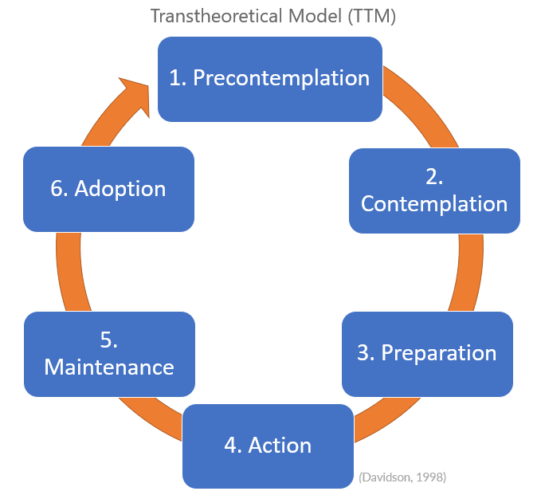
What stage do you consider your teen to be in at this moment?
- Precontemplation Stage
- Contemplation Stage
- Preparation Stage
- Action Stage
- Maintenance Stage
- Termination or Adoption Stage

The Transformational Mindset Instructional Design (TMID) in Module 2 defines why we use the following steps.
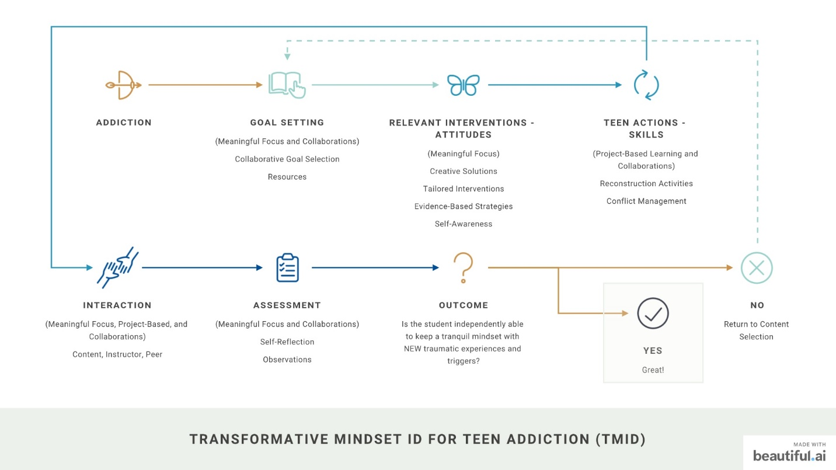

Module 1: Goals
- Round Table
  - Who will be at the table to create the Recovery Plan?
- Primary and Secondary Recovery Goals:
  - Identify the primary recovery goals for your teenager.
- Secondary Recovery Goals:
  - List any additional or secondary goals supporting the recovery journey.
- Achievements:
  - How will you know when the goals are achieved?
- Acknowledgment and Recognition:
  - How will each achievement be recognized?
- Boundaries:
  - What boundaries will be put in place?
- Consequences:
  - What happens when boundaries are crossed?

Module 2: Interventions
- Interventions Implemented:
  - Describe the interventions or strategies put in place to support your teen's recovery.
- Relevant Support Services:
  - List any specific support services or external resources utilized for interventions.

Module 3: Practice Actions
- Practical Actions Taken:
  - Outline the practical actions or behavioral changes initiated to aid recovery.
- Parental Engagement Activities:
  - Describe any activities or engagements undertaken by parents to support the recovery.

Module 4: Interactions
- Family and Peer Interactions:
  - Explain how family and peer interactions have contributed positively to the recovery journey.
- Community Involvement:
  - Describe any involvement or interactions within the community that supported recovery efforts.

Module 5: Self-Reflection
- Personal Reflection:
  - Reflect on personal experiences or insights gained throughout your teen's recovery.
  - How will your teen self-reflect on their progress?
- Parental Self-Evaluation:
  - Assess and evaluate your own role and contributions to the recovery process.
  - How will your teen assess and evaluate their role and contributions to the recovery process?

Module 6: Outcomes Achieved
- Achieved Milestones:
  - List the milestones or goals successfully accomplished during the recovery.
- Progress Evaluation:
  - Evaluate the progress made by your teenager in the recovery journey.

Respond with how you will align your actions with each supportive arch:
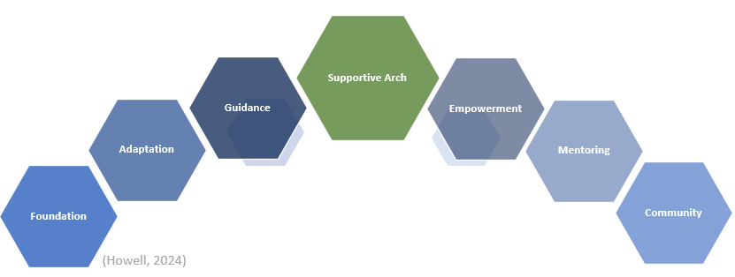

1 - Foundation
How can the family actively cultivate a non-judgmental environment this week, fostering open communication and trust while reducing any fear of stigma or rejection related to the recovery journey?

2 - Guidance
In what ways can consistent guidance, empathy, and boundary-setting be integrated into the family dynamics this week to reinforce accountability and trust in supporting your teen's recovery?

3 - Adaptation
How can the family adapt its parenting styles this week to offer more support, nurture hope, and provide encouragement that directly impacts the motivation and progress of your teen during their recovery?

4 - Community
What steps can be taken this week to utilize local support services or strengthen connections with peer networks, creating a supportive community essential for crisis management and ongoing recovery support for your teen?

5 - Empowerment
How can the family implement positive reinforcement techniques, celebrate milestones your teen achieves, and seek professional therapy to repair familial bonds and equip themselves with effective communication tools this week?

6 - Mentoring
In what ways can the family and parents specifically exhibit mentorship qualities this week, providing well-intentioned examples and fostering a positive role model dynamic to support the teenager's recovery journey within the family dynamic?

