The United Religious, Military and Masonic Orders of the Temple
and St. John of Jerusalem, Palestine, Rhodes and Malta
in England and Wales and Provinces Overseas

King Arthur of Avalon Preceptory No. 551
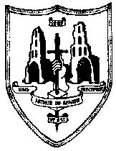

Certificate of Honorary Membership
Awarded to

Eminent Knight David Barry Platten
Past Great Herald
Provincial Marshal

“In recognition of the outstanding services you have demonstrated to the Masonic Craft and Knights Templar masonry in particular. Your dedication and abilities have been recognized locally and nationally. And have been instrumental in ensuring the highest standards of the United Religious Military and Masonic Orders of the Temple have been maintained. As Marshal you have proved inspirational to your Brother Knights across the Province of Somerset and you are a credit to your Preceptory. In consequence, your Brother Knights on 23rd. September 2020 have conferred upon you the high distinction of Honorary Membership of:

King Arthur of Avalon Preceptory No.551”

……………. …………… ……………
D. Nicholson R.F. Deane T.D. Hayes
Eminent Preceptor Registrar Treasurer

