The Spirit of God in you
Romans 8:9, “You, however, are not in the flesh but in the Spirit, if in fact the Spirit of God dwells in you. Anyone who does not have the Spirit of Christ does not belong to him.”
Romans 15:13, May the God of hope fill you with all joy and peace in believing, so that by the power of the Holy Spirit you may abound in hope.
Jesus told us, “If you love me, you will keep my commandments. And I will ask the Father, and he will give you another Helper, to be with you forever, even the Spirit of truth, whom the world cannot receive, because it neither sees him nor knows him. You know him, for he dwells with you and will be in you.” John 14:15-17
Ephesians 3:16-19, He may grant you to be strengthened with power through his Spirit in your inner being, so that Christ may dwell in your hearts through faith—that you, being rooted and grounded in love, may have strength to comprehend with all the saints what is the breadth and length and height and depth, and to know the love of Christ that surpasses knowledge, that you may be filled with all the fullness of God.
2 Corinthians 3:17-18, Now the Lord is the Spirit, and where the Spirit of the Lord is, there is freedom. And we all, with unveiled face, beholding the glory of the Lord, are being transformed into the same image from one degree of glory to another. For this comes from the Lord who is the Spirit.
1 Corinthians 6:19-20, Or do you not know that your body is a temple of the Holy Spirit within you, whom you have from God? You are not your own, for you were bought with a price. So, glorify God in your body.
Galatians 5:22-23, But the fruit of the Spirit is love, joy, peace, patience, kindness, goodness, faithfulness, gentleness, self-control; against such things there is no law.
1 John 4:13, By this we know that we abide in him and he in us, because he has given us of his Spirit. And we have seen and testify that the Father has sent his Son to be the Savior of the world. Whoever confesses that Jesus is the Son of God, God abides in him, and he in God.
Acts 2:1-4, When the day of Pentecost arrived, they were all together in one place. And suddenly there came from heaven a sound like a mighty rushing wind, and it filled the entire house where they were sitting. And divided tongues as of fire appeared to them and rested on each one of them. And they were all filled with the Holy Spirit and began to speak in other tongues as the Spirit gave them utterance.
John 4:23-24, But the hour is coming, and is now here, when the true worshipers will worship the Father in spirit and truth, for the Father is seeking such people to worship him. God is spirit, and those who worship him must worship in spirit and truth.
Galatians 5:25, If we live by the Spirit, let us also keep in step with the Spirit.
2 Timothy 1:7, For God gave us a spirit not of fear but of power and love and self-control.
Luke 11:13, If you then, who are evil, know how to give good gifts to your children, how much more will the heavenly Father give the Holy Spirit to those who ask him!
1 Corinthians, 3:16-17, Do you not know that you are God's temple and that God's Spirit dwells in you? If anyone destroys God's temple, God will destroy him. For God's temple is holy, and you are that temple.
Isaiah 61:1, The Spirit of the Lord GOD is upon me, because the LORD has anointed me to bring good news to the poor; he has sent me to bind up the brokenhearted, to proclaim liberty to the captives, and the opening of the prison to those who are bound.
Romans 8:26, Likewise the Spirit helps us in our weakness. For we do not know what to pray for as we ought, but the Spirit himself intercedes for us with groanings too deep for words.
Romans 5:5, Hope does not put us to shame, because God's love has been poured into our hearts through the Holy Spirit who has been given to us.
Romans 8:5-6, For those who live according to the flesh set their minds on the things of the flesh, but those who live according to the Spirit set their minds on the things of the Spirit. For to set the mind on the flesh is death, but to set the mind on the Spirit is life and peace.
Romans 8:14, For all who are led by the Spirit of God are sons of God.
Zechariah 4:6, “This is the word of the LORD to Zerubbabel: Not by might, nor by power, but by my Spirit, says the LORD of hosts.
Ezekiel 36:27, And I will put my Spirit within you, and cause you to walk in my statutes and be careful to obey my rules. You shall dwell in the land that I gave to your fathers, and you shall be my people, and I will be your God.
Acts 1:8, But you will receive power when the Holy Spirit has come upon you, and you will be my witnesses in Jerusalem and in all Judea and Samaria, and to the end of the earth.”
Psalm 143:10, Teach me to do your will, for you are my God! Let your good Spirit lead me on level ground!
1 John 4:1-6, Beloved, do not believe every spirit, but test the spirits to see whether they are from God, for many false prophets have gone out into the world. By this you know the Spirit of God: every spirit that confesses that Jesus Christ has come in the flesh is from God, and every spirit that does not confess Jesus is not from God. This is the spirit of the antichrist, which you heard was coming and now is in the world already. Little children, you are from God and have overcome them, for he who is in you is greater than he who is in the world. They are from the world; therefore, they speak from the world, and the world listens to them. We are from God. Whoever knows God listens to us; whoever is not from God does not listen to us. By this we know the Spirit of truth and the spirit of error.
Ephesians 1:17, The God of our Lord Jesus Christ, the Father of glory, may give you the Spirit of wisdom and of revelation in the knowledge of him, having the eyes of your hearts enlightened, that you may know what is the hope to which he has called you.
Romans 8:16-17, The Spirit himself bears witness with our spirit that we are children of God, and if children, then heirs—heirs of God and fellow heirs with Christ, provided we suffer with him in order that we may also be glorified with him.
Galatians 5:17-18, The desires of the flesh are against the Spirit, and the desires of the Spirit are against the flesh, for these are opposed to each other, to keep you from doing the things you want to do. But if you are led by the Spirit, you are not under the law.
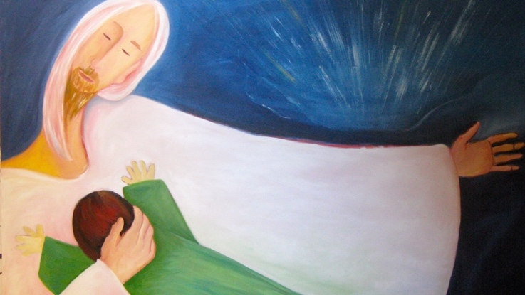
Prayer is communion with God. It is a continuous process in which the human spirit, indwelt by the Spirit of God, is in continuous interaction with Him.

