Loving County Clerk’s Office

Elections
Voting By Mail
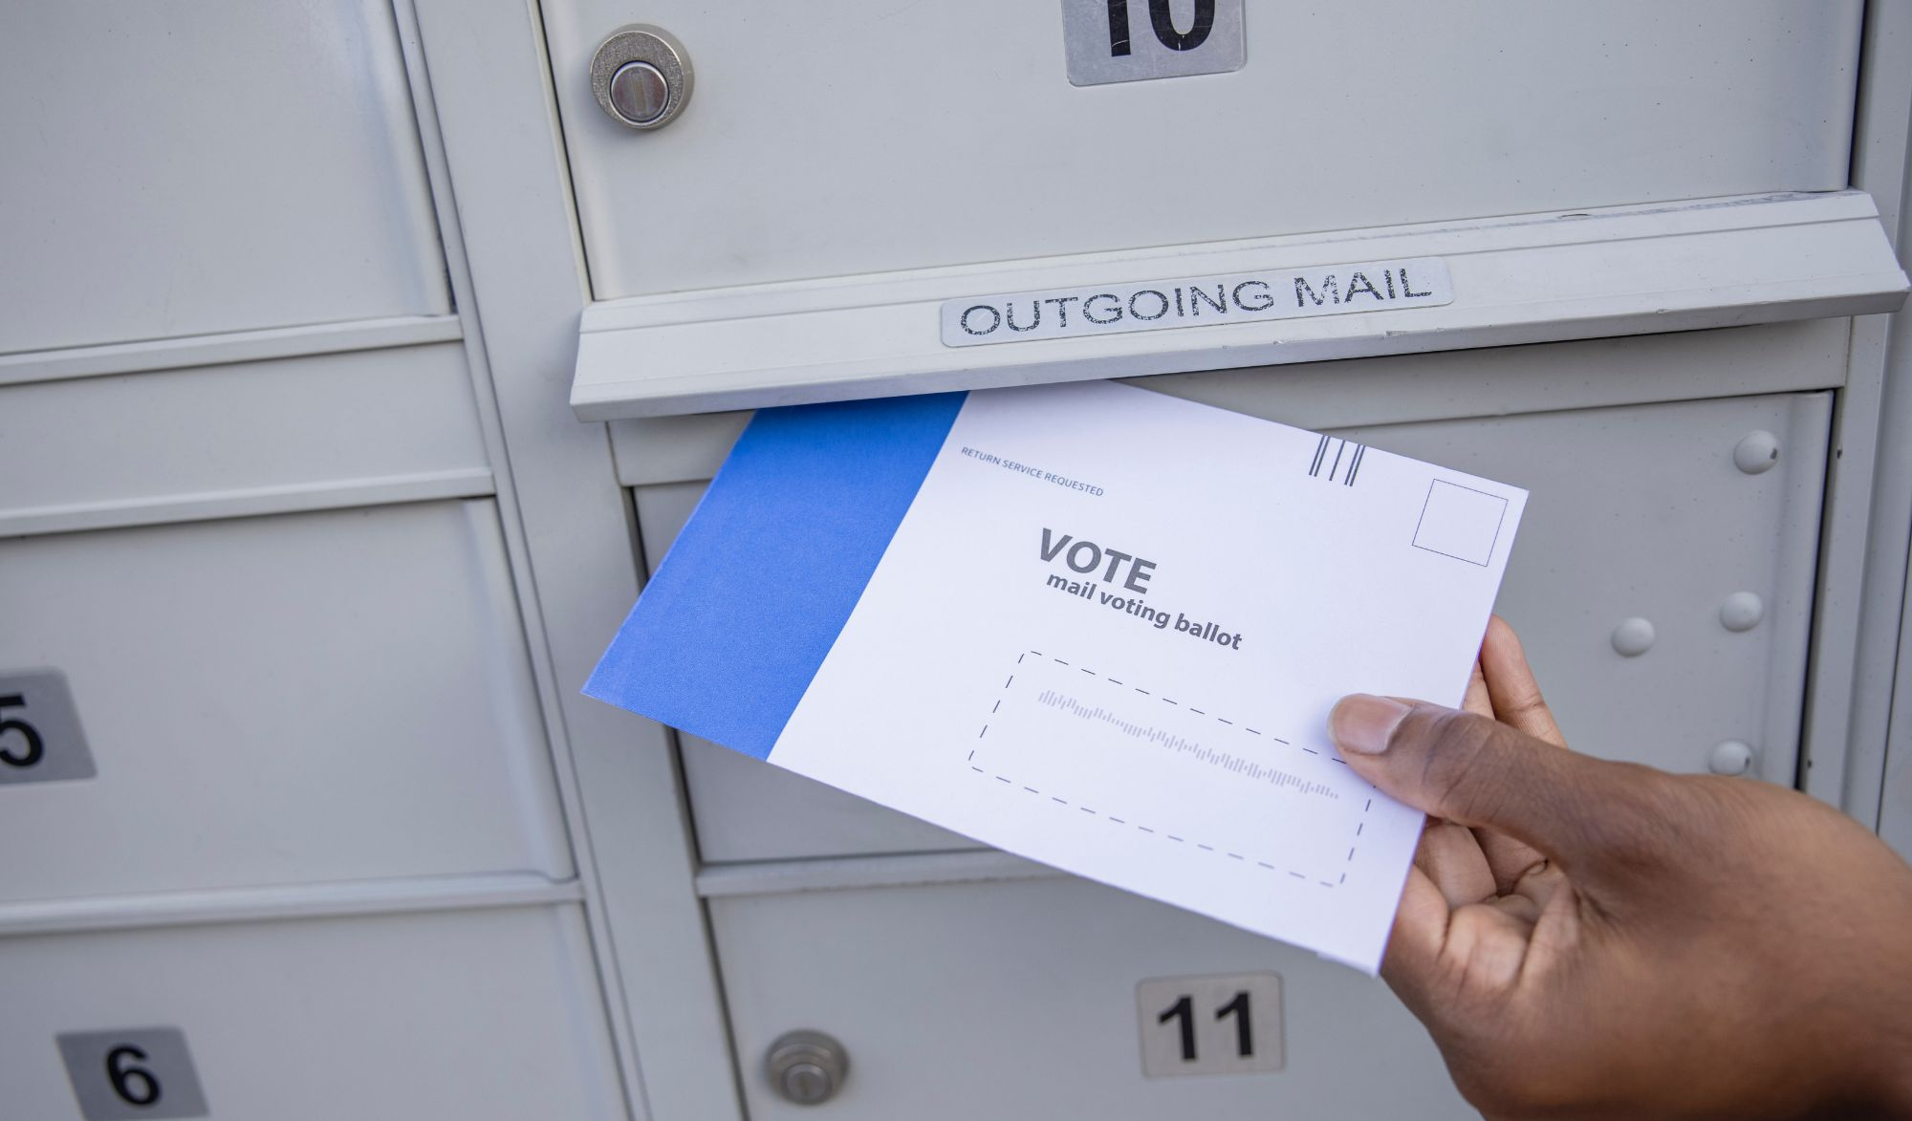
In Texas, voters who are 65 years of age or older or are disabled may submit an annual ballot by mail application to the early voting clerk starting on the first day of a calendar year.
In Texas, voters who are 65 years of age or older or are disabled may submit an annual ballot by mail application to the early voting clerk starting on the first day of a calendar year.

Mail Ballot Information
Eligibility Requirements for A Mail Ballot
Only specific reasons entitle a registered voter to vote early by mail (no longer called absentee voting).
You may vote early by mail if:
• You are 65 years of age or older on Election Day;
• You are sick or disabled (as defined in Texas Election Code 82.002(a));
• You expect to give birth within three weeks before or after Election Day;
• You are out of your county on Election Day and during early voting hours;
• You are confined in jail or Involuntary Civil Commitment, but eligible to vote.
Voters who are absent from the county or confined in jail/civilly committed may only apply for one election and its resulting runoff.
How to Apply for Ballot by Mail

Download and print the Application for a Mail Ballot
English - Spanish

Return the completed and signed application
Mail via USPS: Loving County Clerk's Office - P.O. Box 194 Mentone, TX 79754-9000
Common or contract carrier: Loving County Clerk’s Office – 100 Bell Ave., Mentone, TX 79754
Fax: Send to 432-789-2194 by the mail ballot deadline. THE ORIGINAL APPLICATION MUST BE RECEIVED BY THE ELECTION'S OFFICE WITHIN FOUR (4) BUSINESS DAYS OF YOUR FAX.
E-Mail: Send a scanned copy of your application as an attachment to lovingea@co.loving.tx.us by the mail ballot deadline. THE ORIGINAL APPLICATION MUST BE RECEIVED BY THE ELECTION'S OFFICE WITHIN FOUR (4) BUSINESS DAYS OF YOUR E-MAIL.

Tips to avoid your application being rejected
Your application must be signed! You must provide either your Driver’s License/Personal ID Number (issued by DPS) or the last 4 digits of their Social Security Number. Your number must match what is on file with your voter registration, so we encourage you to provide both numbers if you are unsure of what you registered with. If you’re eligible and are requesting a ballot for each of the elections this year, mark the box next to “Annual Application” and the reason you’re eligible. For Primaries (held during even years), you must indicate the political party you wish to receive a ballot for.
How To Apply for An Annual Mail Ballot Application
Applicants who are 65 years of age or older or are disabled qualify to apply for Annual Application for Ballot By Mail (ABBM). Choosing the "annual" option ensures these applicants will receive a mail ballot for all elections held during a calendar year. Annual applications may be submitted starting the first day of a calendar year (January 1) and not later than the 11th day before Election Day.

HOW VOTERS CAN ENSURE THAT THEIR MAIL BALLOT IS COUNTED
In the process of voting and returning your mail ballot, make sure to follow the steps below:
Read all the instructions.
1. Use BLACK or BLUE ink to mark your choices on the ballot.
2. Place voted ballot in the Ballot Envelope and seal it.
3. Place Ballot Envelope in the enclosed pre-addressed carrier envelope.
4. Provide your identification number underneath the flap.
5. Seal the carrier envelope and sign where indicated exactly as you signed your mail ballot application.
6. Place appropriate postage and return it.

HOW SHOULD VOTERS RETURN THEIR MAIL BALLOT
Your mail ballot MUST be returned to the Loving County Clerk’s Office in the official envelopes provided to you.
It may be returned in any of the following manners:

Regular residential mail via United States Postal Service; Common or contract carrier; such as personal courier, or FedEx or UPS, or other contracted mail service
• Ballot must be received by 7:00 PM on Election Day

• If the carrier provides a receipt mark indicating a time before 7:00 PM on Election Day, it may be received by 5:00 PM on the first mail delivery day after Election Day.
• Ballot must be postmarked by 7 PM on Election Day and must be received in the Loving County Elections Administrator's Office by 5 PM on the next business day after Election Day.

In-person drop off at TBD on Election Day ONLY from 7 AM – 7 PM.
• You must present an acceptable form of photo identification.
• If a voter does not possess and cannot reasonably obtain an acceptable form of photo identification, the voter may show a List B identification and complete a Reasonable Impediment Declaration (RID).
• Only the voter may deliver their Mail Ballot in person

DATES AND DEADLINES FOR APPLYING AND SUBMITTING A MAIL BALLOT
When to apply for Annual Ballot by Mail: January 1 or 60 days before an election scheduled in January or February. For other elections, no later than the 11th day before Election Day.
Deadline to submit a completed Mail Ballot: The ballot must be received by the close of polls on Election Day.
Deadline to submit Overseas Ballots: Last mail delivery on the fifth day after Election Day.
Deadline to submit Military Ballots: Last mail delivery on the sixth day after Election Day.

CONTACT US: CALL US AT: 432-309-9560 x6

EMAIL US YOUR MAIL BALLOT QUESTIONS: cclerk@co.loving.tx.us

