d

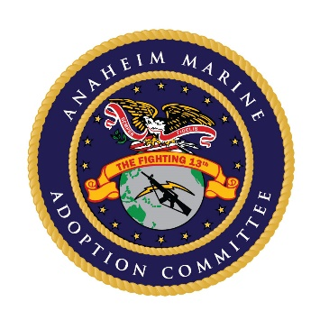

**Anaheim 13th *Marine Expeditionary Unit* (MEU) Adoption Committee**

*Dedicated to serving our Marines and their families.*

Emergency Assistance

Commissary Food Cards

Spouse & Children Deployment Events

Welcome Home Comfort Bag & Room Preparations

Newborn Baby Baskets

Christmas Party

Single Marine Christmas Party

Easter Celebration & Baskets

Thanksgiving Dinner Boxes

Ladders Program, Dinner & Childcare (Family Deployment Preparedness)

Family Summer Beach Bash

Single Marine Events

Marine Birthday Ball

MEU Departing Gifts (RUDIS Award)

Spouse & Children Scholarship Fund

**P.O. Box 6098, Anaheim, CA 92816**

**Ph.: 714-868-6801 Anaheim13MEU.org Anaheim13thMEU@gmail.com**

*This is a non-federal entity. It is not a part of the Department of Defense or any of its components and it has no governmental status.*

Hello,

Please allow me to introduce you to the **Anaheim 13th Marine Expeditionary Unit (MEU) Adoption Committee**. Our mission is a simple one: to generate support for and encourage mutually beneficial interaction between the residents of Anaheim and the Marines, Sailors and families of the 13th MEU, both at their home base at Camp Pendleton and/or when the unit is deployed. On the left side lists how your support will benefit the Marines, Sailors and their families throughout the year.

Again to raise awareness and support, the Adoption Committee is planning our **7th Annual Race and Finish Line Expo**, the **Anaheim Semper 5K & 10K**, being held at **Riverdale Park** in **Anaheim** on **May 21, 2022**.

Many people would like to show their support for members of the Military but aren’t sure where to go or how to do it. The **Anaheim Semper 5K & 10K** is a fun and easy way to show your support, especially when you consider what they do for us.

We would like to present an opportunity for you to partner with us in support of the brave men and women who represent the very best of this country. **We are currently looking for sponsorship, exhibitors, and restaurants to pass out food samples to the race participants. We are also seeking donated items for our fantastic Silent Auction.** We are expecting between 500 and 600 participants to be at our event, and this is a great way to showcase your business or restaurant as well as your community spirit. There are various levels of sponsorships available for you to choose.

Please review the attached flyer and sponsorship opportunities. In addition, we invite you to visit our websites [Anaheim13thMEU.org](http://www.anaheim13thmeu.org/) and [Semper5k.org](https://semper5k.org/) and our Facebook pages - **Facebook.com/Anaheim Semper 5K&10K** and the Adoption Committee's page at **Facebook.com/13thMEU**. If you should have any questions, please don’t hesitate to contact us.

We appreciate your time in considering our request. We hope to see you at what will most certainly be a fabulous community event. Please note we have a new phone number and address.

Sincerely,

Gina Wilson

Gina Wilson

Vendor/Exhibitor Coordinator

Anaheim Semper 5K & 10K Committee

[auntgina@gmail.com](mailto:auntgina@gmail.com) 714-926-7018