Appetizer Platters – 15 Person Minimum
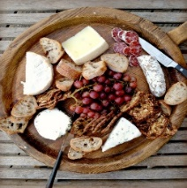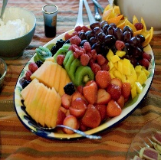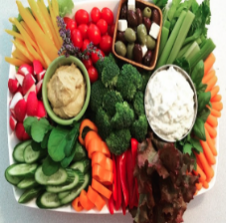

Crudité Platter $ 4.00 pp
A Variety of Fresh Locally Sourced Vegetables Beautifully Arranged with our Homemade Buttermilk Ranch Dip

Grilled Farmers Market Vegetable Platter $ 5.00
A Variety of Grilled Locally Sourced Vegetables Portobello Mushrooms, Bell Peppers, Eggplant, Zucchini, Squash and Rainbow Carrots Served with Pesto Aioli

Hummus Platter 5.00 pp
Pita Chips, Sliced Cucumbers, Cherry Tomato’s, Carrots,
House made Roasted Red Pepper Hummus or Roasted Garlic Hummus

Mediterranean Platter $7.50 pp
Hummus, Feta Cheese Garlic Dip, Pita Bread, Pita Chips, Fresh Mozzarella Balls, Carrots, Artichoke Hearts, Kalamata Olives, sun dried tomatoes, and garnished with Grilled Lemon Slices

Domestic Cheese Platter $ 5.00 pp
Sliced Swiss, Cheddar, Pepper jack and Provolone Served with Baguettes and Table Water Crackers

Gourmet Cheese Platter $7.00 pp
Gruyere Reserve, Buttermilk Bleu , Fontina, Aged Cheddar, Gouda, Brie, Goat Cheese, Fig Spread, Served with Baguettes and Table Water Crackers

Pinwheel Bite Sandwich Platter $ 5.50 2 per order
Pinwheel Sandwiches Wrapped in Sun-Dried Tomato, Spinach and Chipotle Tortillas. Meat Varieties: Oven Roasted Turkey, Roast Beef, Smoked Ham. Thin Sliced Tomatoes, Spring Greens and Herb Cream Cheese
Vegetarian: Roasted Peppers, Sprouts, Thin Sliced Tomatoes and Herb Cream Cheese

Fresh Fruit Platter $5.00 pp
Sliced Watermelon, Honeydew, Cantaloupe, Strawberries, Oranges, Garnished with Blueberries, Strawberries and Fruit Art

Fresh Organic Tropical Fruit Platter 6.00
Sliced Pineapple, Mango, Kiwi, Strawberries, Oranges, Garnished with Blueberries, Strawberries and Fruit Art

Antipasto Platter $ 8.00 pp
Marinated Artichokes, Marinated Mushrooms, Cherry Peppers, Pepperoncini, Provolone Cheese Cubes, Kalamata Olives.

Artisan Charcuterie Platter $9.00 pp
Soppressata Salami, Coppa, Prosciutto, Gherkin Pickles, Cocktail Onions, Assorted Olives, Dijon Mustard, Served with Sliced Baguettes and Crostinis

Large Chilled Prawn Platter 3 pp $5.50
Large Chilled Jumbo Prawns served on a bed of Lettuce with our Homemade Cocktail Sauce
Guacamole and tortilla chips 5.50
Chips and Salas 4.50
7 Layer Dip served with Tortilla Chips 7.00 pp
Refried Beans, Sour Cream, Cheddar Cheese, Green Onions, Olives, Tomatoe
Veggie: Roasted Peppers, Sprouts,
Thin Sliced Tomatoes and Herb Cream Cheese

Prices Subject to Change without notice 15 % Service Charge and Tax will be added

