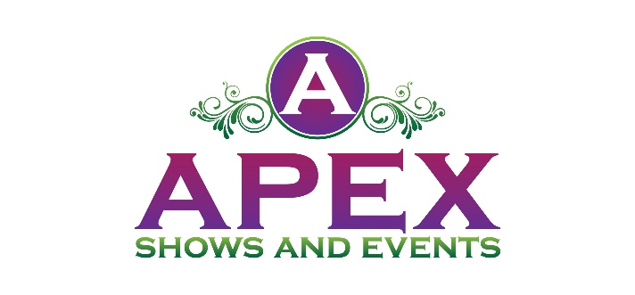

IF YOU ARE A HOT DOG CONNEISSEUR THEN YOU CAN’T MISS THE
2nd ANNUAL HOT DIGGITY DOGS FEST!
Sponsorship
Community Maritime Park
301 W Main Street Pensacola Fl 32501
October 27th from 10 a.m. - 5 p.m.

$5 Entry Fee (12 AND UNDER ARE FREE)
FOOD TRUCKS – VENDORS – LIVE MUSIC – ADULT BEVERAGES – BOUNCE HOUSE

HOT DOG EATING CONTEST WITH PRIZES!
ALL FOOD TRUCK VENDORS WILL INCLUDE 1 SPECIALTY HOT DOG ITEM ON THEIR MENU IN ADDITION TO THEIR REGULAR MENU FOR SALE

Benefits of Being a Sponsor

Your brand will be in front of a large crowd of kids and families.
Sponsorship Opportunities

GOLD PACKAGE
$750.00
The Gold Package is our premier level of Sponsorship. This is available to five Sponsors. This package includes the following:
- Sponsor logo will be on the entrance banner at the event
- Sponsor logo will be included in print media and social media marketing
- Logo will appear on Apex Shows and Events website
- 2 individual social media posts two weeks before event
- Sponsor name on vendor maps
- 12x12 Vendor Booth Space

SILVER PACKAGE
$300.00

The Silver Package is our entry level of Sponsorship plans. This package includes the
following:
- Sponsor logo will be included in print media and social media marketing
- Logo will appear on Apex Shows and Events website
- 1 individual social media post one week before event

- LEVEL II: Gold Package
- LEVEL III: Silver Package

Please accept my payment of $ ________ by: Check ____ Money Order ____

Signature _____________________________________
Today’s date___________________________________
Company Name ________________________________
Contact Name _____________________________________
Address________________________________________________________________
City / State / Zip Code ________________________________________________________________
Telephone ___________________________
Email Address ___________________________________

www.apexshowsandevents.com
• 850-376-9350
christie@apexshowsandevents.com

