The PINK Charity Softball Tournament  July 6 – 8th, 2018 – Dorval  “10 X 10”  YOU CAN DO THIS…. | 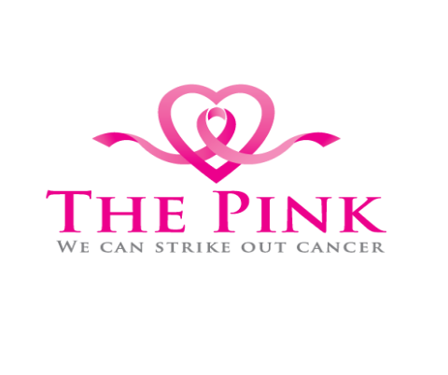

Donation for:

MUHC – Breast Center ULTRASOUND MACHINE

Help us support the MUHC Breast Center by donating today. Join us for a fun-filled, informative weekend.

Name | Address | Phone Number | Donation
1.
2.
3.
4.
5.
6.
7.
8.
9.
10.
11.
12.

