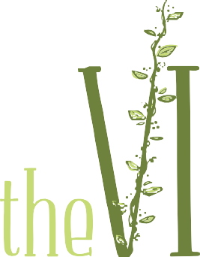

Love Is…Gala
Sponsorship Level Opportunities

Title Sponsor:
This will be the Primary Named sponsor, which will be mentioned on all advertisements as the presenting sponsor Ex: The Love Is …. Valentine’s Day Gala presented by….

Additional benefits:
- Name mentioned in all radio promotional spots on The Promise/KLOVE ($2,575 value)
- Full page advertisement in the event program ($200 value)
- 2 tickets (two couples) to the Love Is…Valentine’s Day Gala ($250 value)
- Display presence at the event
- Opportunity to place advertisement in swag bag
- Logo included in any print advertisements
- Web site link on the Vine.co website
$2,000 donation*
Also guarantees the first right of refusal for next year at the same price.

Silver Level Sponsor:
Benefits:
- Logo included in any print advertisements
- Display presence at the event
- Half page advertisement in the event program ($125 value)
- 2 ticket (2 couples) to the Love Is…Valentine’s Day Gala ($250 value)
- Web site link on the Vine.co web site
$500 donation*

Bronze Level Sponsor:
Benefits:
- Half page advertisement in the event program ($125 value)
- 1 ticket (1 couple) to the Love Is…Valentine’s Day Gala ($125 value)
- Web site link on the Vine.co website
$225 donation*

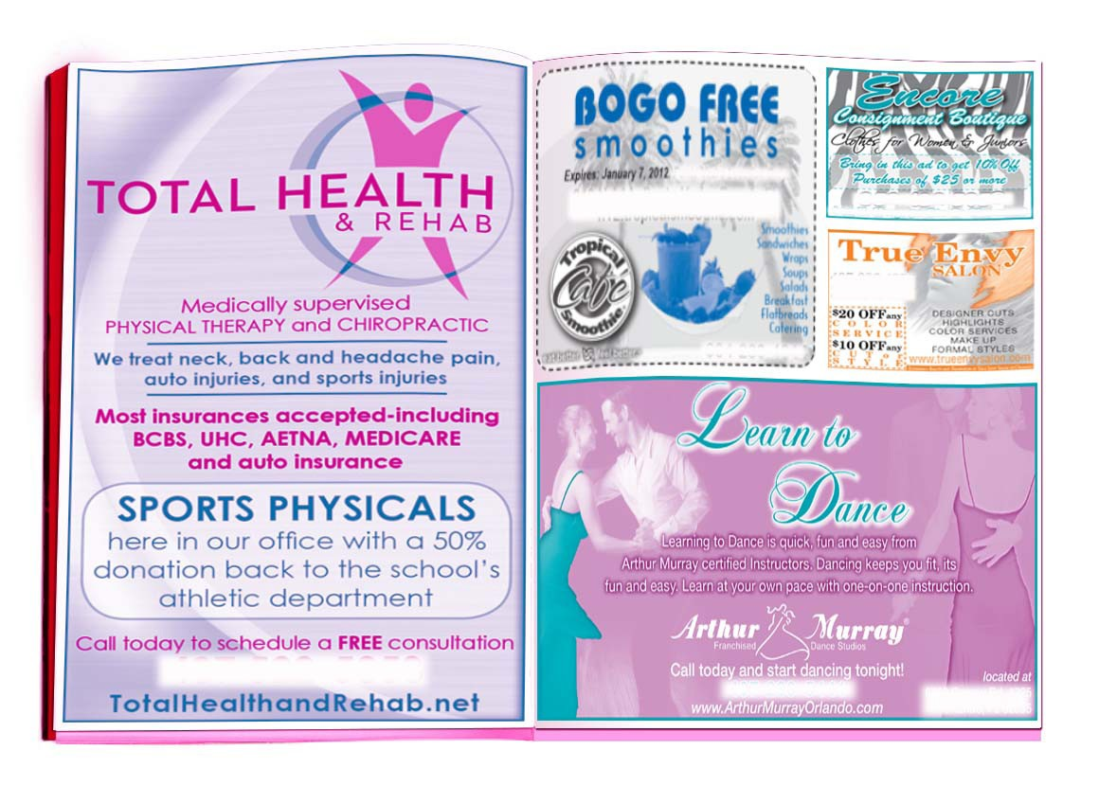
FULL PAGE AD: $200
1/2 PAGE AD: $125
1/4 PAGE AD: $70
1/8 PAGE AD: $40
EXAMPLE

Love Is…Valentine’s Day Gala Program Advertising Opportunities: 1/8 page………………………………………………... $40
1/4 page………………………………………………… $70
1/2 page………………………………………………. $125 Full page……………………………………………..... $200

*ALL DONATIONS ARE TAX DEDUCTIBLE

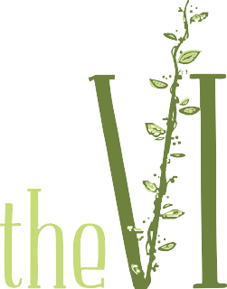
ADVER TISEMENT
I N S T R U C T I O N S

d e s i g n @ t h e v i n e . c o
w w w . t h e v i n e . c o

Thank you for supporting the Vine. Our designer will work with you to create the perfect ad for your company.

PLEASE EMAIL: design@thevine.co
Let us know what you would like to include in your advertisement:

  - Information to include (Address, Phone Number, Website, Services Provided, Special Offers or Coupons, etc.) You may type directly in an email or attach a word document.

  - Logo: This must be a print-quality logo; vector image (eps, pdf, ai) or a high resolution image at 300 dpi (jpg, psd, pdf, tif).

  - Additional Photos or Graphics: Any files provided must be high resolution/print quality to be included in the publication.

  - Is your art department creating the ad? If so, have them contact our designer with any questions or information about specifications. Please provide the Ad with attached files and ALL TEXT OUTLINED.

Ad Sizes:
- Full Page: 8.5 inches tall by 5.5 inches wide
- Half Page: 4.25 inches tall by 5.5 inches wide
- Quarter Page: 4.25 inches tall by 2.75 inches wide
- Eighth Page: 2.125 inches tall by 2.75 inches wide

An ad proof will be provided to your email for your review and approval. Please contact us with any questions.

Deadline: for The Vine to create your ad, Friday, February 1st. Submission of your own ad no later than February 5th with final approval that same day.

The Harvest is Plenty but the workers are few. All sales, events and programs are for the sole purpose of raising money for Mission and Outreach work locally and around the world. The Vine.co is a non for profit that has no administrative over head so your donations are tax deductible and will go directly to help oth-ers.

