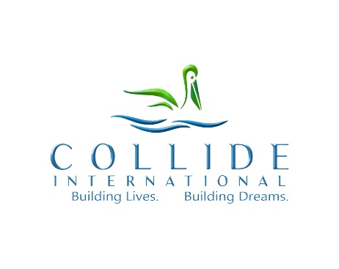

~ Early Education Electives, Field Trips & Nature Therapies ~

“ Waldorf-Inspired ”
~ for Children & Youth ~

* Eurythmy for JK – Grade 4 - $245
-Eurythmy not only supports the development of each individual child, it provides the opportunity for children to grasp their academic subjects, including math, science, language arts and cultural studies, through full-body experiences.

* Handwork, (knitting, crocheting, fiber arts, etc.) - $245
- Requires increasing accuracy of finger movements and thus fine-motor skills are gradually improved. Knitting, for example, inculcates the ability to think logically and the importance of mine motor skills, develops literacy and numeracy.

* Courage and Bravery Development $245
- Through games children learn the courage to keep going, to find a different way, and of course the courage to try in the first place and as well, teaching children to be brave.

* Yoga & Meditation in Nature -$245
-Shown to improve both physical and mental health in children. Yoga improves balance, strength and endurance, while Yoga and mindfulness offer psychological benefits.

* Nature Walk, Herbology - $245
- Nature based experiences improve self-esteem, self-efficacy, resilience and academic and cognitive performance. In addition, when exposed to nature, children tend to increase their social and behavioral skills.

* Singing/Rhymes - $245
- This strengthens children’s language skills and builds listening skills

* Nature Crafts - $245
- Children learn new vocabulary and have opportunities to observe and explore various textures, shapes, weights and scents, when designing and creating their treasures

* Nature Scavenger Hunt - $245
* Wildlife Spotting Nature Therapy - $245
* Forest Bathing - $245

Psychotherapy

* Animal Therapy - $245
- Known to have many positive effects on patients of all ages. Animal therapy lowers stress and anxiety levels, improves blood pressure, increases mobility and provides an alternative focus from pain.

* Art Therapy - $245
- Allows children to process things that have happened to them and helps reduce stress and anxiety as they work through these challenges. Art therapy has been shown to improve a child’s mental, emotional and physical well-being.

* All Elective Programs, Field Trip and Therapies can be done individually or over days, weeks or months and can always be incorporated into your Educational Lesson Plans or Seasonal Lesson Plans.
* All can be purchased individually or purchased in bulk at a discount.
* Therapies are designed to sooth the mind and instill peace, calm, kindness and beauty.
* All field trips and therapies are fun, educational and age-appropriate.
~ Therapies ~ $245 hourly, for any number of participants ~
~ Minimum 2 hours for groups ~

All Electives, Programs and Therapies can be had individually or at a reduced cost when purchased in bulk:
- $1750 (8 hours over a week) 10% Savings
– $6,900 (32 hours over a month) 15% Savings
- $19,200 (98 hours over 3 months) 20% Savings

All programing is brought with love and warmth, in an environment that nourishes the senses; creates artistic experiences; meaningful adult activity to be imitated; free, imaginative play; protection of the forces of childhood; gratitude, reverence, and with wonder; joy, humor, and happiness.
~~~~~~~~~
Presented by,
Jennifer Heintz, c.c., i.m.f.t., f.t.
Psychotherapist, Trauma Expert, Waldorf Teacher
Vancouver – Toronto - Halifax
604.799.7456

