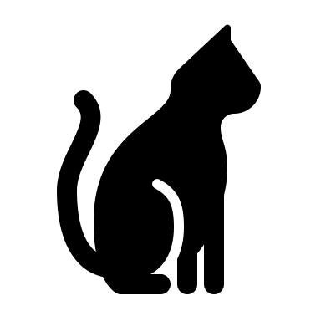
The Pampered Pet Grooming Salon Policies!!!

Vaccinations/Vet Information
When booking your appointment you are agreeing your pets are up to date on their Rabies, Distemper and Bordetella. We require proof from your vet with expiration date. Simply having a Rabies tag will not suffice for obvious reasons. If you fail to show proof at your time of appointment, you will be turned away and charged for your appointment. This is for the safety of all the Pampered Pet staff and most importantly your pets.

Health/Medical/Senior Pets
The grooming process can sometimes be stressful, especially for a senior pet. It can expose hidden medical problems and aggravate current ones during the grooming process. In this agreement for the safety of your pet you give us permission to obtain immediate medical help if necessary. All veterinary expenses will be the owners responsibility, unless agreed it was caused by their time at The Pampered Pet. I will always notify you first, but in case we can’t get ahold of you we just need to cover our bases.

Fleas and Ticks
I strive very hard to keep the salon a flea free salon. We do NOT offer any flea dips, baths or treatments. If your pet has fleas you need to reschedule your appointment within 24 hours until the flea problem is resolved. If your pet comes in with fleas there will be a $30 fee for the cost of bombing the shop to rid of any fleas brought in. Fleas can cause so many problems, risk of anemia, infections, tapeworms and other health issues. A monthly preventative is the best solution. Nexgard, Advantage, Comfortis are your best options. Do NOT buy the cheap ones at the store they do not work and have caused dangerous side effects.

Accidents
There is always the possibility an accident can occur. Grooming equipment is sharp and even with the most safe ways using extreme caution accidents can happen. Cuts, nicks, scratches, cutting the quick of the nails. In most cases this happens because of a pet moving or wiggling around.

Matted Coats
If your pets coat is severely matted it will require special attention and extra time. I will not cause stress or pain to a pet to dematt for the simple fact the owner doesn’t want them shaved. Once it gets to a certain point there is NO choice. If you find a groomer who will do it they don’t care about the pain your pet will go through. If your pet is matted and ends up getting shaved, there is the risk of nicking moles, warts and folds of skin trapped in the Matts. Obviously, we can’t see under the Matt that’s why they need to be shaved. Heavy matting can also trap moisture and urine near the pets skin allowing fungus, bacteria to grow, and even mold, causing skin irritations and infections. This is brought on by the matting not the grooming process, we are helping to fix the problem. After effects can include skin redness, itchiness, self-inflicted irritations and possible failure of hair to regrow the same. Your pets can also get sunburned so you have to be observant of that. Scheduling regular grooming appointments is the best way to prevent this from happening. Matting will cause the price to increase for the extra time.

Pick up and Drop off times and No Shows
I am the only groomer and I like to know my hands and time are all on my pampered pets. That being said I book as best as I can to not overwork myself or rush my pets. If you have a scheduled pick up time Please be on time. If you are late we will have to charge you additional for daycare. Which is $20. The salon closes at 4:00 so all pets needs to picked up before that. If you do not cancel your appointment within 24 hours there is a $50 fee. All pets are to be dropped off in the window of 9-9:30 AM. If you arrive past 9:30AM you will need to be rescheduled. We start our grooming day at 9:30AM and its not fair to have to stop and it ends up pushing everyone and everything back.

Scheduling appointments
We do our absolute best to get your pet in as soon as possible. However, due to our high demand we suggest booking at least 3 appointments in advance to make sure you have a spot. We DO Not do same day appointments and its very likely we are booked a month out.

With this Policy agreement you have assumed responsibility for the above pet/pets above and consent to have him or her groomed by The Pampered Pet.
In case of an emergency you authorize The Pampered Pet to seek medical care if deemed necessary. In the absence of our negligence, you hold The Pampered Pet free of any responsibility or liability. You realize you are responsible for payment of all services performed at the Vet.

Lastly, The Pampered Pet has the right to refuse any animal based on aggression, stress on the animal that can cause them harm, owner negligence, which includes open wounds, lethargy, seizures, rotting teeth causing pain and skin issues. We will guide you the best way to help with whatever problem they are having. My main goal is to make the pet feel amazing. With that being said, if its not going to be a safe experience we will have to discuss other options.

Please sign and date

