SPONSORSHIP OPPORTUNITY
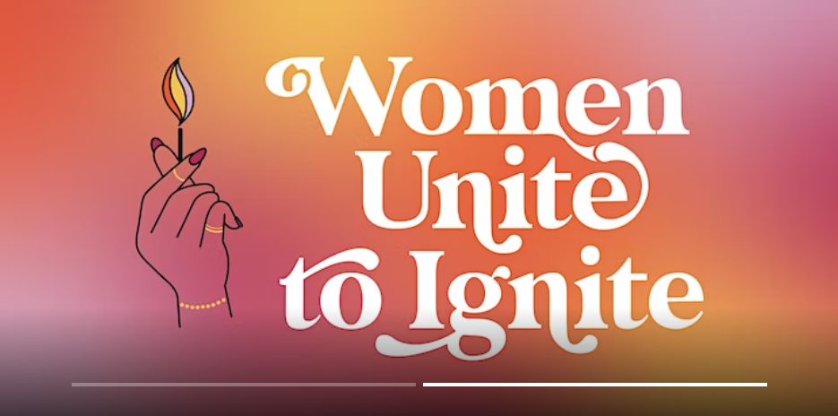
Women Uniting to Ignite…
LEARNING | UNITY | SUPPORT| MENTORSHIP | SPONSORSHIP | RELATIONSHIPS
An Immersive & Supportive One Day Retreat
Women Unite to Ignite (WUTI)
www.womenunitetoignite.com
Cofounders: Rhoda Banks & Shannon Norman

THE EXCULSIVE!
The story behind how Women Unite to Ignite came to be, is centered around connections. Women, helping other women is a powerful movement and benefit for our community. Women Unite to Ignite is designed to work at the intersection of connecting women with purpose and on purpose. It’s a movement and an experience intentionally designed to foster and nurture supportive relationships.

On Friday, October 13th, 2023, women from around the region, some near and far will converge in the Boundary at the Cheshire Hotel for one action-packed and experiential day, featuring the following topics:
- Overcoming Trauma & Practicing Self Care
- Gaining Self-Awareness & Self-Reflection Through Vision Boards
- Personal Branding & Image Control
- The Power of Mentoring & Sponsorship

As a progressive and mission focused organization in the community, we’re inviting you to join us in the inaugural year of this exciting day based on learning, engagement, connection and inspiration.

ABOUT THE WOMEN UNITE TO IGNITE ONE DAY RETREAT

Women are excited to nurture other women, extending an olive branch and helping them to reach their full potential. We’re designing an experience, which allows women to immerse themselves in a supportive environment and gain valuable insights from industry leaders and successful mentors. Participants will leave this event with a renewed sense of purpose, meaningful connections, and a clear plan for achieving their goals. It’s an opportunity for women to pour into other women, through sharing knowledge on topics geared towards self-development and self-care.

To nurture this promising movement, Women Unite to Ignite will host the first-ever Retreat this October. The event will bring together 150 women throughout St. Louis connecting early, mid and late career oriented and passionate women.

This day-long immersion of learning, training, and networking will emphasize how women can support one another more intentionally. Panelists and keynote speakers are a mix of women with diverse backgrounds and experiences, but all with one shared common goal and desire and that is to support, uplift and help other women.

SPONSORSHIP LEVELS
We look to our passionate hometown community to help us make this event a success. By becoming a sponsor, you show your company’s alignment with the values Women Unite to Ignite is based on: Care for Self & Others through authentic and intentional connection.

LEADERSHIP SPONSOR | $2,000
First-tier positioning of logo on materials; Standing banner at event;
Mention recognizing your company in radio, television, and print media / PR;
On-stage mention of your company as Leadership Sponsor;
5 Social Media mentions leading up to event; and 4 VIP* tickets to the event.

SUPPORTING SPONSOR | $1,000
Second-tier positioning of logo on materials;
Mention as sponsor in PR materials;
On-stage mention of your company; 2 Social Media mentions leading up to event; and 2 VIP* tickets to the event.

COMMUNITY SPONSOR | $500
Third-tier positioning of logo on materials;
Mention as sponsor in PR materials;
On-stage mention of your company;
Social Media mention leading up to event; and 1 VIP* ticket to the event.

*VIP ticket includes a reserved seat at the front of the room.

Add On to Any Sponsor Level
Drop in the Bag - Add items to the diva bag that all women will be given the day of the event. - $150
Website Sponsor - Your company name will show as the sponsor of the event on our website. - $500
Happy Hour Sponsor - On stage mention of your company as sponsor of the happy hour event and sign displayed. - $500

In addition to the aforementioned sponsor benefits, the founders are passionate about gifting a select number of tickets to help support women who otherwise may not have the financial means to purchase a ticket. Let us know if you have someone in mind.

PRODUCED BY COFOUNDERS RHODA BANKS & SHANNON NORMAN: Founded in St. Louis Missouri, Women Unite to Ignite is a grassroots initiative, with plans to transition to a Non-Profit organization, to expand beyond the St. Louis boarders working to empower, educate, inspire, uplift, and connect other likeminded women.

To inquire and/or donate, contact:
Shannon Norman | shannonnormancoaching@gmail.com | (573) 239.3443 or donate via the WUTI website: www.womenunitetoignite.com

