Advanced DC Magnet Install Directions

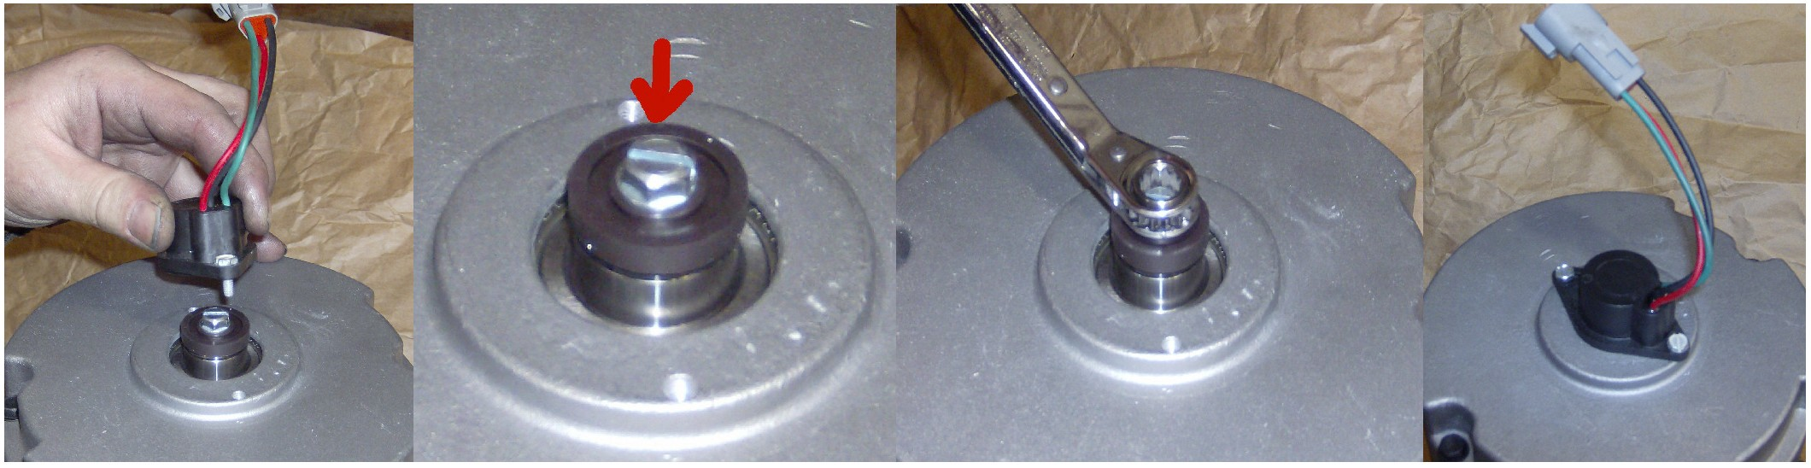
Remove speed 2) The magnet is screwed to the 3) Remove (3/8th) screw, 4) Attach speed sensor

sensor by loosening screws.
armature shaft under speed sensor.
replace old magnet with to original position. new magnet and hand
tighten screw.

GE Magnet Install Directions

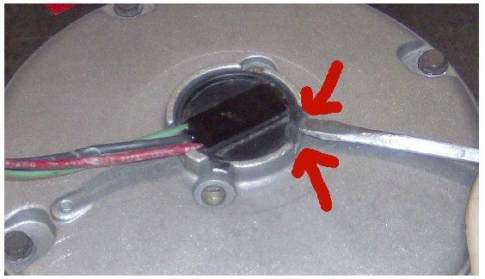

  - 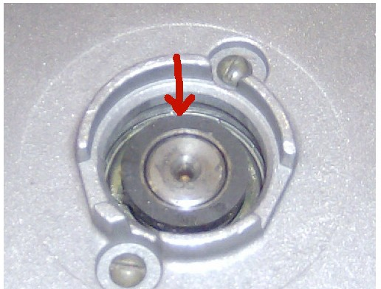Use a large flat screwdriver to remove the speed sensor at the spot indicated in photo.
- The magnet, located
under the speed sensor, is attached to a washer that encircles the armature shaft.

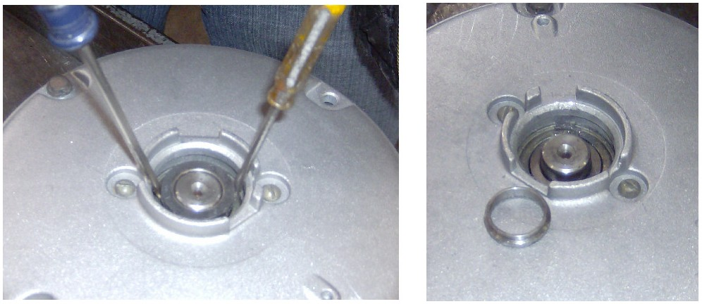

- 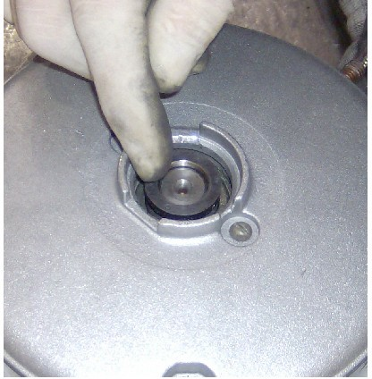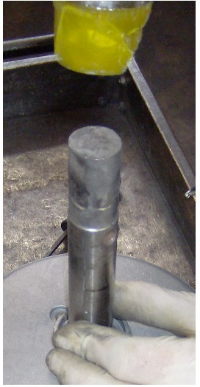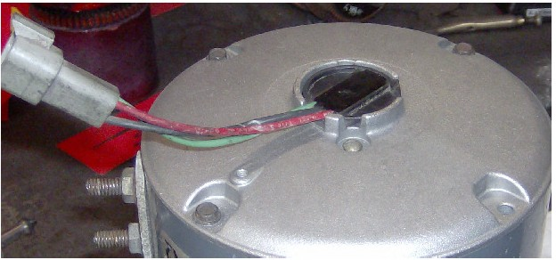Use two small screw drivers to pry the magnet & washer off the shaft. (Sometimes the original magnet will
- Position the new magnet on armature shaft. Use a dowel to gently tap the magnet until it is flush with the end of the shaft.
- Install the speed sensor to original position.

break apart. Remove any pieces and (It is best to use a wooden dowel the same
remove the washer from armature shaft.) diameter as the magnet. Tap lightly on the dowel to apply magnet.)

