- Nickster AQHA #5444898
2024– AI ON SITE
Stallion Fee - $2500 – includes Booking Fee and Breeding Fee
This certifies that ___________________ (recorded owner of mare at time of breeding) herein referred to as the Mare Owner, has engaged one breeding to Nickster for the 2024 breeding season for the following mare:
Registered name:____________________Registration#_______________________
Chelsea Driedger, owner of the above named stallion, will herein be referred to as breeder. This service is engaged subject to the following:
1. This contract is good for only one foal.
2. Stallion fees for the 2024 early bird breeding season will be $2500 (plus 5% gst for Canadian Mares) A non-refundable booking fee of $500 must be returned with this contract to ensure your mare will be added to stallion’s roster. Mare owners will have to pay an additional $5/day mare care. If two cycles are required, it will be an additional $500 Chute Fee.
3. To notify us of mare arrival call or text 204-851-0331
4. Stallion Owner will make every attempt to provide semen in a timely manner and in good condition; however, Mare Owner acknowledges the Stallion Owner cannot guarantee breeding within a specific time period due to any reason. Stallion Owner cannot guarantee fertility of cycle. However, stallion owner does agree to try to inseminate and take proper protocols.
5. Release/Hold Harmless: Breeder, Stallion Owner, its agents, employees, representatives, or guests, shall not be responsible for any disease, illness, theft, accident, loss, or death to the mare or foal. Mare Owner agrees to hold Stallion Owner blameless if Mare fails to settle for any reason.
6. Live foal guarantee accompanies this contract. Live foal described as a foal that stands and nurses within 24 hours of foaling. Mare owner must provide a written notification from a licensed veterinarian of foal’s death. This transaction is not transferable with the sale of mare without prior consent from breeder.
7. Mare owner should administer appropriate vaccinations to the mare at various stages of her pregnancy. In the result of a lost pregnancy, if the mare owner does not provide adequate evidence that the vaccinations were administered; the stallion owner may refuse to honor the live foal guarantee.
8. Third year rebreeds are subject to an additional booking fee, plus any increases in shipping or collection charges. No live foal guarantee on third year rebreeds.
9. Should the above named stallion die, or become unfit for breeding, mare owner will be refunded all fees except unpaid board bills, booking fees, and medical expenses incurred on behalf of the mare. BOOKING FEES ARE NON-REFUNDABLE.
10. Should above mare die or become unfit for breeding a substitute mare will be accepted.
11. The mare’s health condition is the responsibility of the Mare Owner. If requested by Stallion Owner Mare Owner’s vet will examine and test mare and provide Stallion Owner with a negative uterine culture/cytology verification 30 days prior to arriving.
12. When mare owner, or authorized representative, signs and returns copy of this contract to stallion owner, it will then be a binding contract on both parties subject to the above terms and conditions.
13. Breeding Season: For purposes of this agreement, unless otherwise specified, the breeding season shall begin April 1st and close July 1st of 2024 on this agreement.
14. Breeder’s Certificate: A Breeder’s Certificate will be issued after confirmed pregnancy and all fees are paid.
15. Please make cheques payable to Chelsea Driedger.
16. All NSF cheques will be subject to a $50.00 fee and the retaining of Breeders Certificate and or pending Shipments until fee is paid.

Mare owner information
Owner/Agent: _ _________________________________________________
Address: ________________________________________________________
City/State or Province/Zip Code or Postal Code ______________________________________________________
Home Phone ________________________________________________________
Other Phone _____________________________________________
Email _____________________________________________
Signature of Mare Owner:__________________________________
Date ___________________________________________________
Return Contracts To: Nicksteraqha@gmail.com or
Chelsea Driedger
Box 822
Virden Manitoba Canada
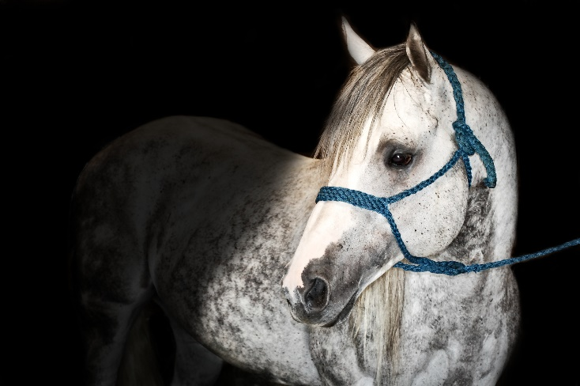
R0M 2C0

