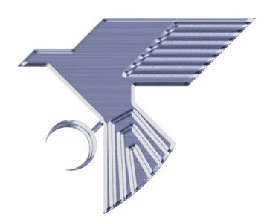
Fatigue

It is well documented in the technical literature that aluminum based MMCs have improved fatigue behavior compared to conventional aluminum alloys. The fatigue performance improves with added vol.% of reinforcement up to ~20 vol.% above which the fatigue performance begins to decrease. This is a direct result of the excellent bonding between the ceramic and molten alloys. The fatigue performance of TALBor can be tailored to meet specific design requirement by a combination of ceramic content and heat treatment.

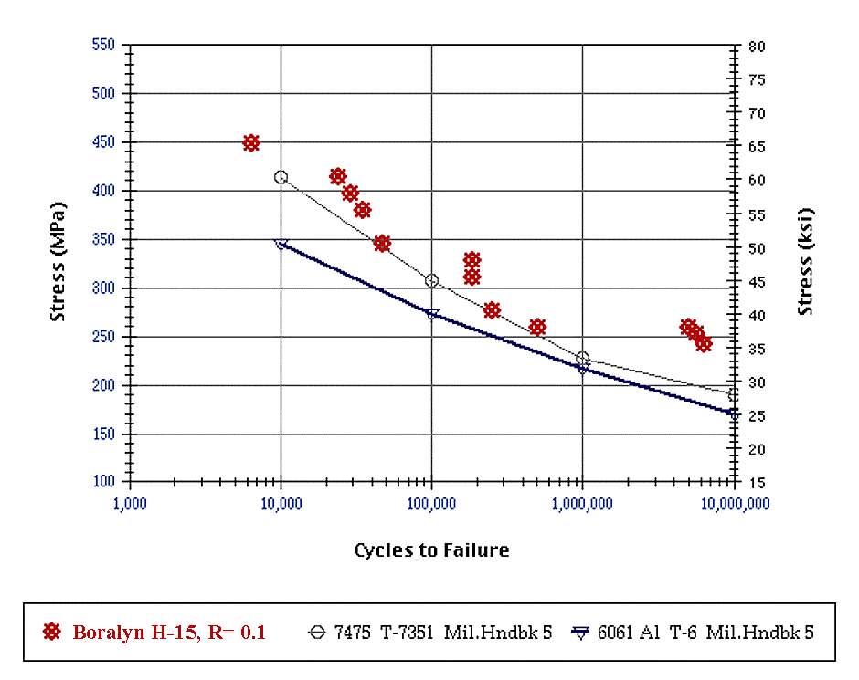
Talbor

