ARC WELDING GUIDELINES
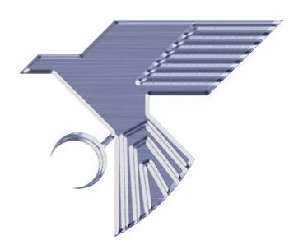
for TALBOR
General
The ceramic particles (boron carbide) in Metal Matrix Composites improve the materials' mechanical properties, but they can also lead to changes in the arc welding process. Fortunately, the problems can be minimized with some simple precautions and modifications to the standard arc welding practices for Aluminum. Because the weld pool contains up to 15 volume percent boron carbide particles, its fluidity is reduced. This can result in a rough appearance of the weld bead.

Equipment Required
Standard Aluminum welding equipment can be used without modification. Filler wire of ER4043 or ER5356 have been successfully used. GTAW, gas tungsten arc welding, is preferred for thin sections, less than 1/8 inch (3 mm) and GMAW, gas metal arc welding, is preferred for thicker sections.

Joint Preparation
Due to the presence of the ceramic particles in the composite, conventional tungsten carbide tools can be used for joint preparation but will wear down at an increased rate. As with Aluminum welding, joints must be clean prior to welding. Solvent degreasing and vigorous scrubbing with a clean stainless steel brush are important for obtaining clean welds.

The following procedure is typical of the GTA welding practice for welding bicycle frames.

Power Supply Miller Sycronous 250
MachineSetting 150 A
Metered Current Varies with joint geometry
Arc Cleaning 70/30 for maximum penetration
High Frequency Continuous
Electrode 3/32-in. W-2% thoria
Filler wire 3/32-in or 1/8-in. ER5356
Gas cup Weldcraft #5
Shielding gas 100% Ar, 20 cfh

The above parameters are typical for one machine in a specific shop. The welding of MMC composites is similar to welding Aluminum with the precautions outlined above.

