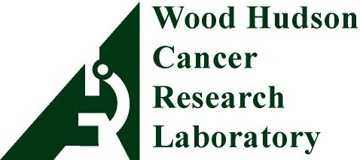
19th Annual
Fort Thomas Corvette Club
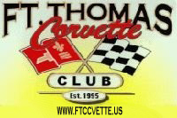
Cancer Research Benefit Car Show
931 Isabella St,
Newport, KY 41071
(859)581-7249
woodhudson.org

Hofbräuhaus in Newport, Kentucky
Saturday August 10th, 2019

DONOR NAME: _______________________________________________________________________
MAILING ADDRESS: _________________________________________________________________
CITY: _____________________________ STATE: __________________ ZIP CODE: ________________ PHONE: ( ) _____________________ EMAIL:________________________________________

SPONSOR OF CAR SHOW TROPHY:

Number of trophies sponsored @ $125 for a total of $ _________
(Please make all checks payable to Wood Hudson Cancer Research Laboratory) check #__________
How should the trophy name plate read? (30 characters max, including spaces)
_ _ _ _ _ _ _ _ _ _ _ _ _ _ _ _ _ _ _ _ _ _ _ _ _ _ _ _ _ _
SILENT AUCTION DONOR:

Description of Item(s):
_________________________________________________________________________________
_________________________________________________________________________________
_________________________________________________________________________________
_________________________________________________________________________________
_________________________________________________________________________________

Does this gift have any restrictions or expiration dates? _____ Yes ____ No
If so, please list:

Who is the contact person for this gift and best number to contact with any questions?

________________________________________________________________________________________

Value: $ ____________

Wood Hudson is a 501(c)(3) charitable organization (Tax ID # 34-1336975). Donors’ names will be acknowledged on Wood Hudson’s website, print and online newsletters. All donations will receive a thank you letter acknowledging the gift for donors to keep for tax purposes.

Completing this visit for WHCRL and FTCC is Date

