03/04/2022 NEWS -Don’t miss Shorashim Insights – Link:
https://madmimi.com/p/4a2a931?pact=102868-166842882-1683292940-e9d55cdb77dfb361d8afea74acb55e5956d6980b

יובל טייב - אין עוד מלבדו Youval taieb - Ein Od Milvado
https://www.youtube.com/watch?v=cOqv32WlxvU
Get up every morning and do not forget to just thank for the existing  Yes for bad and good for life for being the Creator of the world.  Get in the car and turn around and forget about everything that is happening today  The radio is playing at volume alone and suddenly starts singing  Oh oh oh There is no more but another besides him  Oh oh oh All there is is thanks to him | Morning coffee and again traveling to solitude by the sea  Creator of the world of heaven azure prayer in the heart and how hot?  Warm warm in warm heart in soul ahh what a country  Yes all the people of Israel are brothers and how much love

"The victim to too severe a law is considered as a martyr rather than a criminal."
-- Charles Caleb Colton (1780-1832) English cleric, writer and collector
Read the Prophets & PRAY WITHOUT CEASING!
That is the only hope for this nation!
Please  Remember  These  Folks  In  Prayer-  Check often  They  Change! | Pray that the world would WAKE UP! Time for a worldwide repentance!  ALL US soldiers fighting for our freedom around the world  Pray for those in our government to repent of their wicked corrupt ways.  Pray for BB – Severe sciatic needing procedure.  Pray for EL – Had clot embolized to brain – successful ‘clot buster’ but long road to go.  Pray for BB – Severe West Nile Fever –still not mobile- improving!  Pray for RBH – cancer recurrence  Pray for Ella – Child with serious problems  Pray that The Holy One will lead you in Your preparations for handling the world problems. – Have YOU made any preparations?
Exodus 9:³⁰But as for thee and thy servants, I know that ye will not yet fear the LORD God.' - ³¹And the flax and the barley were smitten; for the barley was in the ear, and the flax was in bloom. ³²But the wheat and the spelt were not smitten; for they ripen late. -

$$$ Hidden Camera: FDA Exec Reveals Future COVID Policy
‘Biden Wants to Inoculate As Many As Possible’ $$$$$
https://www.redvoicemedia.com/video/2022/02/hidden-camera-fda-exec-reveals-future-covid-policy-biden-wants-to-inoculate-as-many-as-possible
6 minutes PLEASE WATCH

Candace Owens - (Prepare Yourself!!) "This Is JUST THE BEGINNING”
https://www.youtube.com/watch?v=pv9Rljt5zQk&t=169s
This is 8 minutes of TRUTH – how we got here and where we are going

Russian forces open fire, attack nuclear plant in Zaporizhzhia
Europe's largest nuclear power plant on fire • Belarus forces receive order to enter Ukraine • At least 33 killed in Russian airstrikes on Chernihiv residential area
By TZVI JOFFRE, REUTERS Published: MARCH 3, 2022 14:28 Updated: MARCH 4, 2022 04:36
The Zaporizhzhia nuclear power plant in Ukraine, the largest of its kind in Europe, was on fire early on Friday after an attack by Russian troops, the mayor of the nearby town of Energodar, where the plant's workers live, said in an online post.
The Associated Press reported an unnamed Ukrainian government official as saying elevated radiation levels had been detected near the plant. A US official, however, said the latest information does not indicate elevated radiation levels.
The fire reportedly broke out in a training building outside the plant's perimeter after Russian troops attacked.
US President Joe Biden spoke with a nuclear security official at the US Energy Department to receive an update on the situation at the plant, the White House said. Biden also reportedly spoke with Ukrainian President Volodymr Zelensky on Thursday evening.
Russian forces opened fire on Thursday in Energodar, next to Europe's largest nuclear power plant after entering in tanks, Ukrainian interior ministry adviser Anton Herashchenko said in online posts.
At least two Energodar residents were injured by shelling after Russia entered the town, mayor Dmitry Orlov wrote in his Telegram channel. MORE - https://www.jpost.com/international/article-699218

Russian forces open fire, prepare to take nuclear plant in Zaporizhzhia
Belarus forces receive orders to enter Ukraine • No bunker can protect Putin from good, Zelensky says
By TZVI JOFFRE, REUTERS Published: MARCH 3, 2022 14:28 Updated: MARCH 3, 2022 20:39
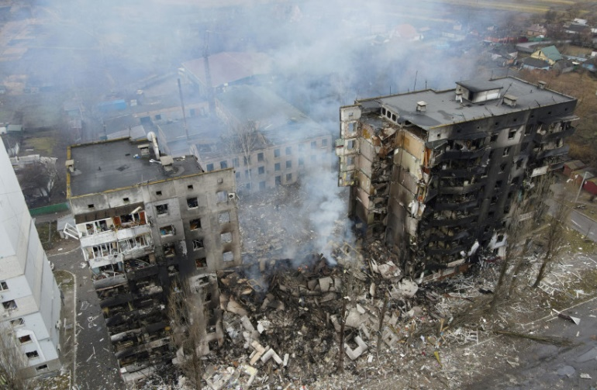
An aerial view shows a residential building destroyed by shelling, as Russia's invasion of Ukraine continues, in the settlement of Borodyanka in the Kyiv region, Ukraine (photo credit: REUTERS/MAKSIM LEVIN)
Russian forces have opened fire in the Ukrainian town of Energodar next to Europe's largest nuclear power plant after entering in tanks, Ukrainian interior ministry adviser Anton Herashchenko said in online posts on Thursday.
Herashchenko said Russian troops were stepping up efforts to seize control of the Zaporizhzhia nuclear power plant in southeastern Ukraine. The plant's workers live in the nearby town of Energodar.
Earlier on Thursday, three Zaporizhzhia residents were killed in the shelling of a hospital in the city by Russian forces, the civil administration of Zaporizhzhya said on Telegram. Four more were injured, the administration stated.
The Ukrainian military said on Thursday it believed that Belarusian troops have already received the order to cross Ukrainian border. Ukraine has said Russia is using Belarusian territory for missile attacks on Ukrainian cities and Minsk allowed Russian troops to enter Ukrainian territory.
At least 33 bodies have been recovered from the rubble in the wake of Russian airstrikes in Ukraine's Chernihiv region, the Ukrainian emergency services said in an online post.
It said rescue work was ongoing, without specifying where exactly the attack took place. Earlier the regional governor said at least nine people had been killed by an airstrike on two schools and private houses.
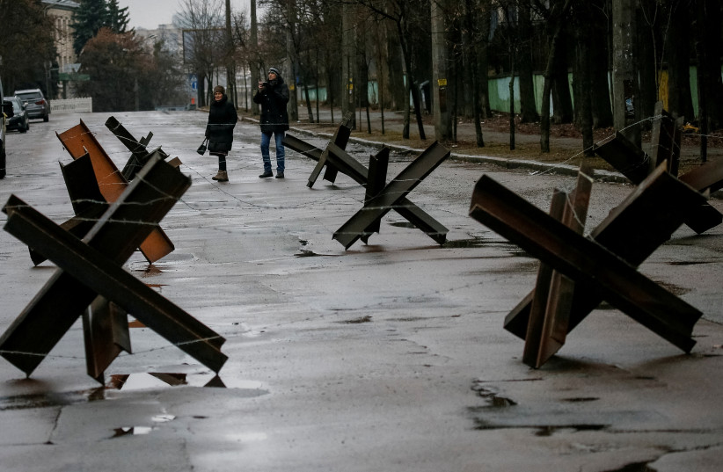
Anti-tank constructions are seen in Kyiv, Ukraine, March 3, 2022 (credit: REUTERS/GLEB GARANICH)
Civilians under fire
The UN human rights office said on Thursday that it had confirmed 249 civilians have been killed and 553 injured in Ukraine during the first week of the conflict following Russia's invasion.
The toll, through midnight on Wednesday, rose from the 227 deaths and 525 injured in its previous report a day ago.
"Most of the civilian casualties recorded from 4 a.m. on 24 February 2022 until 12 p.m. midnight on 2 March 2022 were caused by the use of explosive weapons with a wide impact area, including shelling from heavy artillery and multi-launch rocket systems, and missile and airstrikes," it said in a statement.
Air raid sirens were activated a number of times overnight Wednesday throughout Ukraine, with multiple explosions reported in Kyiv overnight.
The city council of Mariupol announced on Thursday that Russian forces had been disrupting the supply of electricity, food, water and heat to the city, and had also damaged rail lines into the city, comparing the situation to the Siege of Leningrad in World War II.
The city council added that it is working to restore critical infrastructure and to establish a humanitarian corridor. "At the same time, Mariupol remains under fire, women, children and the elderly are suffering. We are being destroyed as a nation. This is the genocide of the Ukrainian people."
Eight people, including at least two children, were killed in a Russian airstrike on Izyum, south of Kharkiv, on Wednesday night, according to the deputy chairman of the Izyum city council. A police department building was also hit in the strike.
The deputy mayor of Izyum warned residents to remain in shelters, as Russian forces were bombing the city every 90 minutes, according to Ukrayinska Pravda.
A person was killed and another was injured in a Russian shelling in the village of Hatne near Kyiv on Thursday, according to Ukraine's State Emergency Service.
In Sumy, the area's Regional Military Administration reported that five people were injured in a missile strike on the military department of the Security Service of Ukraine (SBU), the 27th Rocket Artillery Brigade and the cadet corps.
The Ukrainian Defense Ministry reported on Thursday morning that four large Russian landing vessels and three missile boats had been seen in the Black Sea heading towards Odessa.
A million people have fled Ukraine in a week after Russia invaded the country, the head of the United Nations refugee agency said on Twitter.
"In just seven days we have witnessed the exodus of one million refugees from Ukraine to neighboring countries," UNHCR head Filippo Grandi posted.
"For many millions more, inside Ukraine, it's time for guns to fall silent, so that life-saving humanitarian assistance can be provided."
A missile or bomb hit a Bangladeshi-owned cargo ship in the Ukrainian Black Sea port of Olvia, killing one of its crew members, and efforts were underway to rescue the others from the vessel, its owner said on Thursday.
"The ship came under attack and one engineer was killed," Pijush Dutta, executive director of Bangladesh Shipping Corp, told Reuters. "It was not clear whether it was a bomb or missile or which side launched the attack. The other 28 crewmen are unharmed," he said, without providing further details.
The Bangladesh-flagged Banglar Samriddhi had been stuck in the port of Olvia since Russia's invasion of Ukraine began on Feb. 24, and was hit by a missile on Wednesday evening, a Bangladeshi foreign ministry official said earlier on Thursday.
In the Bangladeshi capital Dhaka, the Russian Embassy said in an English-language statement on its Facebook page that the circumstances of the incident were “being established”.
" We express deep condolences to the near and dear ones of the deceased. The Russian side bends every effort to ensure safe departure of the Bangladeshi ship from the port,” it said.
Ukrainians claim successes in fight against Russian invaders
Secretary of Ukraine's National Security and Defense Council, Oleksiy Miacheslavovych Danilov, wrote on Facebook that servicemen of the 5th Border Guard Detachment and units of the Armed Forces of Ukraine took control of the state border line in the Sumy region on Thursday.
The Ukrainian Armed Forces claimed on Thursday morning that they had downed a Russian SU-30 fighter jet over Irpin. A Russian SU-34 fighter jet was also shot down over Volnovakha on Thursday, according to the Ukrainian Armed Forces. MORE - https://www.jpost.com/international/article-699218 [it is most unfortunate that the situation has deteriorated to this when it could have all been avoided by simply acknowledging that Russia had a legitimate right to object to NATO and US arms on its border. Remember that the 2014 coup de tête against a pro-Russian Ukrainian leader was enabled by NATO and the US because they had definite designs on Russia. The West has a great part in this situation deteriorating to the point that it has. Putin is essentially a dictator but no worse than a lot of those who have been dictating over the past two years. – rdb]

Zelensky says he’s disappointed by Bennett: ‘I don’t feel he is wrapped in our flag’
Ukraine leader tells reporters relations
By TOI staff Today, 7:43 pm
Ukrainian President Volodymyr Zelensky indicated Thursday he feels Prime Minister Naftali Bennett isn’t doing enough to support his country as it tries to fend off Russia’s invasion, saying that unlike a group of Jews he saw photographed at the Western Wall, Bennett does not seem to be “wrapped in our flag.”
During a press conference from an undisclosed location in Kyiv, Zelensky said his relations with Bennett are “not bad at all,” but then expressed “candid” reservations.
“As a Jewish man, do you have expectations of the Jewish state,” he was asked by Itai Engel, a reporter for Israel’s Channel 12.
Zelensky first said he had seen “a very nice picture today of Jews praying at the Western Wall — hasidim, all sorts of people, all wrapped in [Ukraine’s] blue and yellow flag. That picture amazed me. I say all credit to the people who did that. They prayed [for us].”
Moving on to Bennett, he said: “I spoke to the prime minister of Israel. And I’m telling you candidly, and this might sound a little insulting, but I do think I have to say it: Our relations are not bad, not bad at all. But relations are tested at times like these, at the hardest moments, when help and support are needed. And I don’t feel that he [Bennett] is wrapped in our flag.” [Zelensky needs to remember that Bennett represents Israel and the existence of Israel is his responsibility, not the existence of Ukraine. Russia is on Israel’s border with their people in Syria and Putin has already made it clear that you shall not cross him or undermine what he is doing. This shows very little understanding on Zelenksy’s part. – rdb]
Bennett has refrained from personally condemning Russia over its offensive in Ukraine, in an apparent bid to maintain Israel’s ability to operate against Iranian proxies in Syria, where Russia controls the skies. Foreign Minister Yair Lapid and Israel’s UN mission have more directly censured Moscow, but both American and European officials have expressed dissatisfaction with Jerusalem’s cautious line.

Kyiv’s ambassador to Israel, Yevgen Korniychuk, Ukrainian citizens and supporters attend a special prayer session at the Western Wall in Jerusalem’s Old City on March 2, 2022, amid Russia’s invasion of Ukraine. (Yonatan Sindel/Flash90)
Bennett himself has spoken twice with both Zelensky and Russian leader Vladimir Putin since the invasion began last Thursday, and has offered to mediate between the sides, in line with a request from the Ukrainian leader.
Ukraine has also asked Israel to provide military assistance, however, a request Jerusalem has not granted. Bennett reportedly demurred when Zelensky directly asked for “assistance with military implements and weapons” in a phone conversation on Friday, according to a Sunday report.
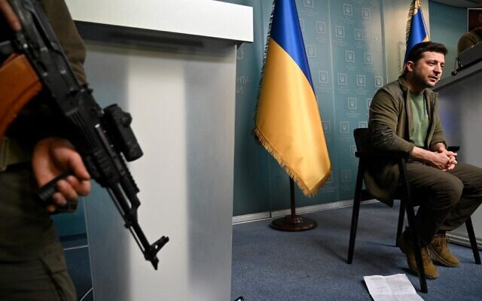
A report last week also said Israel stopped the US from transferring Israel’s Iron Dome defense system to Ukraine last year to preserve Israel’s ties with Russia.
Israel has sent multiple shipments of humanitarian supplies for Ukrainians under attack.

Ukrainian President Volodymyr Zelensky speaks during a press conference in Kyiv, on March 3, 2022. (Sergei Supinsky/AFP)
Israel had refused to cosponsor a resolution condemning Russia last week at the Security Council, provoking a rebuke from US Ambassador to the UN Linda Thomas-Greenfield, an official familiar with the matter told The Times of Israel.
However, in recent days the air appears to have been cleared somewhat, as US Ambassador to Israel Tom Nides tweeted out his thanks to Israel “for helping rally more members to stand with Ukraine” in the General Assembly vote on Tuesday. He did not provide details.
Also Thursday, Bennett warned that Ukraine faces “total destruction” if world leaders don’t act quickly amid Russia’s invasion of the country.
“Things are looking bad on the ground right now, but it’s important to understand that if world leaders don’t act quickly, it can get much worse,” he said at Tel Aviv’s CyberTech conference. “I’m talking about untold loss of life, total destruction of Ukraine. Millions of refugees. And it’s not too late.”
“It’s the responsibility of the major players in the world to get the two sides out of the battlefield and on to the negotiation table,” he added.
Zelensky addressed reporters Thursday from a stage at a secret location, as several armed guards stood close by amid fears of Russian assassination attempts targeting the Ukrainian leader.
Zelensky called on the West to increase military aid to Ukraine, saying Russia would advance on the rest of Europe otherwise.
“If you do not have the power to close the skies, then give me planes!” Zelensky told a press conference. “If we are no more then — God forbid — Latvia, Lithuania, Estonia will be next,” he said, adding: “Believe me.”
He called for direct talks with Putin, saying it was “the only way to stop this war.”
“We are not attacking Russia, and we do not plan to attack it. What do you want from us? Leave our land,” he said, addressing Putin.
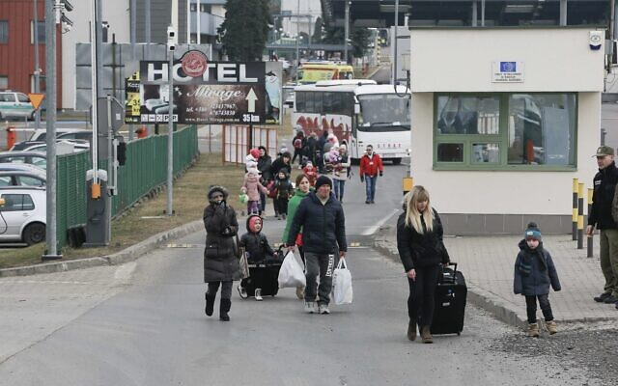
“Sit down with me. Just not 30 meters away like with [French President Emmanuel Macron],” the Ukrainian leader said, referring to Putin receiving world leaders at a now-famous enormously long table, apparently due to his fears of COVID-19.

People arrive at a border crossing in Medyka, Poland, on Thursday, March 3, 2022, as they flee the Russian invasion. (AP Photo/Visar Kryeziu)
Zelensky, who just weeks ago had sought to calm Ukrainians over US allegations that Russia was planning to invade his country, said: “Nobody thought that in the modern world a man can behave like a beast.” [He obviously made a very bad call on that one. – rdb]
Russia says it is not targeting civilian areas, despite widespread evidence otherwise. Ukraine’s emergency service announced on Wednesday night that over 2,000 civilians had been killed so far in Russia’s invasion of the country.
https://www.timesofisrael.com/zelensky-signals-he-expected-greater-israeli-support-ties-tested-in-times-of-need/

Ukraine, Russia agree on humanitarian corridors to evacuate civilians
Announcement follows 2nd round of talks since invasion; Putin insists military offensive ‘going to plan’; 33 Ukrainian civilians reported killed in Russian bombardment on Chernihiv
By AFP and TOI staff 3 March 2022, 9:53 pm
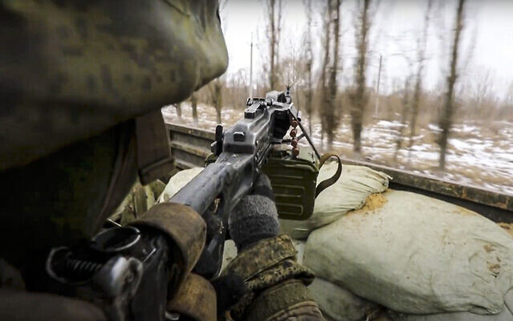
A Russian soldier points a gun from a Russian military truck as it drives through an undisclosed location in Ukraine, on March 3, 2022. (Russian Defense Ministry Press Service via AP)
Russia and Ukraine agreed Thursday to create humanitarian corridors for civilians fleeing intensifying fighting as Russian President Vladimir Putin said Moscow’s advance was “going to plan” and to schedule.
The agreement was the only tangible progress from a second round of talks between Moscow and Kyiv, according to an adviser to Ukrainian President Volodymyr Zelensky, and it was not immediately clear how they would work. A Russian negotiator, nationalist lawmaker Leonid Slutsky, confirmed the initiative and said it would be implemented soon.
The two sides met after the fall of the first major Ukrainian city to Russian forces, with Putin apparently unwilling to heed a global clamor for hostilities to end as the war entered its second week.
Putin again said Russia was rooting out “neo-Nazis,” adding during the televised opening of a national security council meeting that he “will never give up on [his] conviction that Russians and Ukrainians are one people.”
He earlier told French President Emmanuel Macron that Moscow “intends to continue the uncompromising fight against militants of nationalist armed groups,” according to a Kremlin account of their call. MORE - https://www.timesofisrael.com/ukraine-russia-agree-on-humanitarian-corridors-to-evacuate-civilians/

Putin vows ‘uncompromising fight’ as 1st Ukrainian city falls, war enters 2nd week
Russia announces takeover of city of Kherson, population 280,000; heavy fighting on outskirts of strategic port city of Mariupol; Russia’s 40-mile -long convoy stalled outside Kyiv
By Agencies Today, 5:10 pm
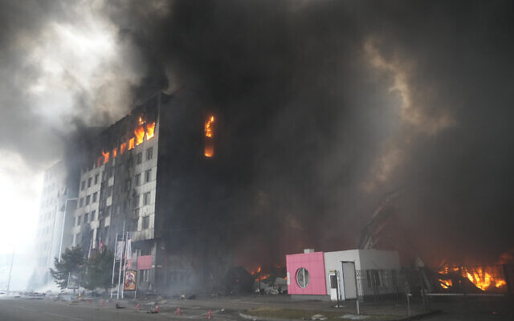
A building burns after shelling in Kyiv, Ukraine, Thursday, March 3, 2022. (AP Photo/Efrem Lukatsky)
KYIV — Russian President Vladimir Putin vowed no let-up in his invasion of Ukraine on Thursday, even as the warring sides met for ceasefire talks and Kyiv appealed for relief supplies to reach battered cities.
The Russian military announced Thursday that it had taken control of Kherson, and local Ukrainian officials confirmed that Putin’s forces have taken over local government headquarters in this Black Sea port of 280,000 people, making it the first major city to fall since the start of the war.
Elsewhere, the Russians pressed their offensive on multiple fronts. Heavy fighting continued on the outskirts of another strategic port city on the Azov Sea, Mariupol, plunging it into darkness, isolation and fear. Electricity and phone connections were largely down, and homes and shops are facing food and water shortages.
Overnight explosions heard by Associated Press reporters in the capital, Kyiv, were missiles being shot down by Ukraine’s air defense systems, according to the city’s mayor. Russia’s 40-mile-long (64-kilometer-long) convoy of tanks and other vehicles remains stalled outside Kyiv, which has been struck by deadly shelling.
Russian forces have also been bombarding the country’s second-biggest city, Kharkiv.
After the fall of a first major Ukrainian city to Russian forces, Putin appeared in no mood to heed a global clamor for an end to hostilities as the war entered its second week.
Borodyanka. ???????? pic.twitter.com/d04f5kkzH2
— Visegrád 24 (@visegrad24) March 2, 2022
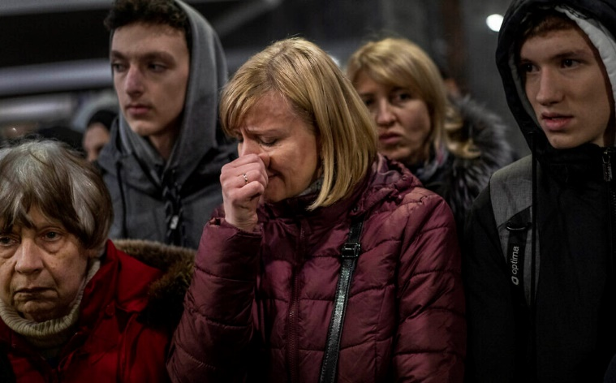
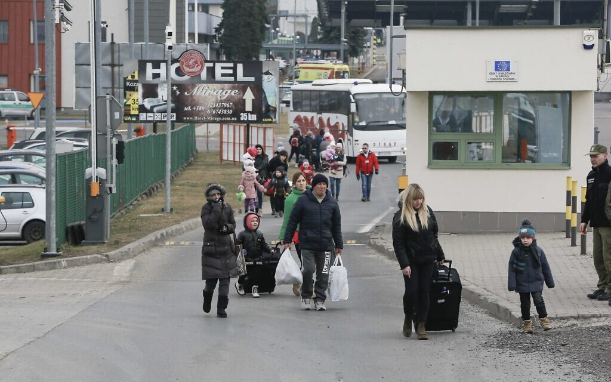
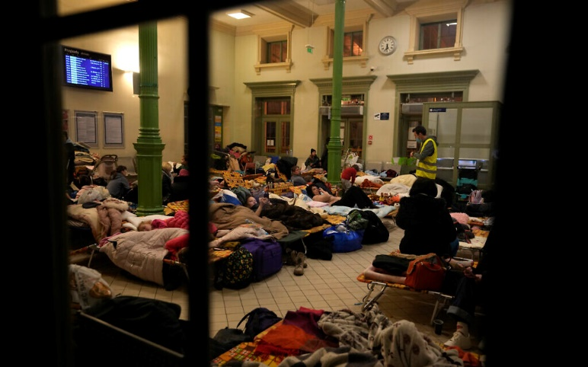
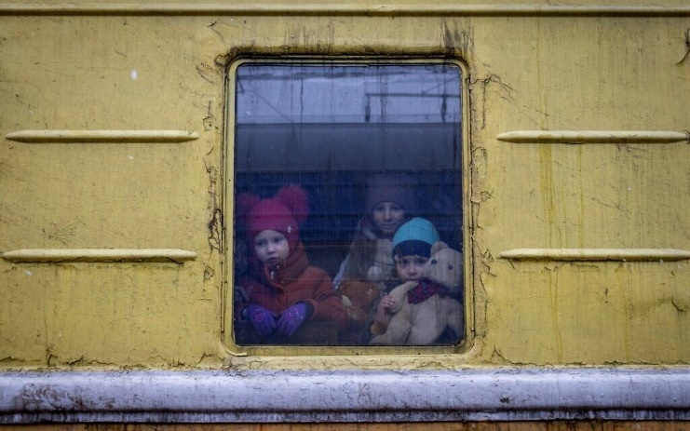
“Russia intends to continue the uncompromising fight against militants of nationalist armed groups,” Putin said, according to a Kremlin account of a call with French President Emmanuel Macron.
But Ukraine insisted that corridors for medical and other supplies were the bare minimum it expected, as negotiators arrived for the talks at an undisclosed location on the Belarus-Poland border.
A first round of talks on Monday yielded no breakthrough, and Kyiv says it will not accept any Russian “ultimatums.”
Putin, however, said any attempts to slow the talks process would “only lead to additional demands on Kyiv in our negotiating position.”
For his part, Macron said he feared that “worse is to come” in the conflict and condemned Putin’s “lies,” according to an aide.
The invasion, now in its eighth day, has created a refugee exodus and turned Russia into a global pariah in the worlds of finance, diplomacy and sports.
The UN has opened a probe into alleged war crimes, as the Russian military bombards cities in Ukraine with shells and missiles, forcing civilians to cower in basements.
“We will restore every house, every street, every city and we say to Russia: learn the word ‘reparations,'” Ukrainian President Volodymyr Zelensky said in a video statement.
“You will reimburse us for everything you did against our state, against every Ukrainian, in full,” he said.
‘Just like Leningrad’
Zelensky claims thousands of Russian soldiers have been killed since Putin shocked the world by invading Ukraine, purportedly to demilitarize and “denazify” a Western-leaning threat on his borders.
Moscow says it has lost 498 troops and Kremlin spokesman Dmitry Peskov said Putin would praise their sacrifice at a meeting with his security chiefs.
“It’s a huge tragedy,” Peskov told reporters in Moscow.
“But we also admire the heroism of our soldiers. Their exploits will enter into the history books, their exploits in the struggle against the Nazis.”
The Kremlin has been condemned for likening the government of Zelensky, who is Jewish, to that of Germany in World War II.
But Russian Foreign Minister Sergei Lavrov kept up a verbal barrage, accusing Western politicians of fixating on “nuclear war” after Putin placed his strategic forces on high alert.
While a long military column appears stalled north of Ukraine’s capital Kyiv, Russian troops seized Kherson, a Black Sea city of 290,000 people, after a three-day siege that left it short of food and medicine.
Russian troops have been advancing elsewhere on the southern front and are besieging the port city of Mariupol east of Kherson, which is without water or electricity in the depths of winter.
“They are trying to create a blockade here, just like in Leningrad,” Mariupol mayor Vadym Boichenko said, referring to the siege of Russia’s second-largest city, since renamed Saint Petersburg, by Nazi Germany’s invading army in World War II.
A displaced Ukrainian woman cries as she waits to get on a train to Poland, at the Lviv railway station, in Lviv, western Ukraine, Thursday, March 3, 2022. (AP Photo/Bernat Armangue)
Ukrainian military authorities said residential and other areas in the eastern city of Kharkiv had been “pounded all night” by indiscriminate shelling, which UN prosecutors are investigating as a possible war crime.
Oleg Rubak’s wife Katia, 29, was crushed in the rubble of their family home in Zhytomyr, west of Kyiv, by a Russian missile strike.
“One minute I saw her going into the bedroom. A minute later there was nothing,” Rubak, 32, told AFP, standing stunned and angry amid the ruins in the bitter winter chill.
“I hope she’s in heaven and all is perfect for her,” he said, adding through tears, “I want the whole world to hear my story.”
Junk status
The war has displaced more than one million people, according to the United Nations. The body’s aid chief pleaded on Thursday for civilians in Ukraine to be protected and for humanitarian aid to enter unhindered. “Protect civilians, for God’s sake, in Ukraine; let us do our job,” emergency relief coordinator Martin Griffiths told AFP in Geneva.
The UN’s International Atomic Energy Agency urged Russia to “cease all actions” at Ukraine’s nuclear facilities, including the site of the 1986 Chernobyl disaster.
Putin now finds himself an international outcast, his country the subject of sweeping sanctions that sent the ruble into further freefall on currency markets on Thursday.
People arrive at a border crossing in Medyka, Poland, Thursday, March 3, 2022, as they flee the Russian invasion. (AP Photo/Visar Kryeziu)
Russia’s central bank — whose foreign reserves have been frozen in the West — imposed a 30 percent tax on all sales of hard currency, following a run on lenders by ordinary Russians.
The unfolding financial costs were underlined as ratings agencies Fitch and Moody’s slashed Russia’s sovereign debt to “junk” status.
Turmoil deepened on markets more broadly. European stocks slid and oil prices approached $120 per barrel.
Swedish furniture giant Ikea became the latest to halt operations in Russia as well as Belarus.
Russia’s sporting isolation worsened as it lost the right to host Formula One races. And the International Paralympic Committee, in a U-turn, banned Russians and Belarusians from the Beijing Winter Games.
The UN General Assembly voted 141-5 to demand that Russia “immediately” withdraw from Ukraine. Only four countries supported Russia — Belarus, Eritrea, North Korea and Syria. China abstained.
Europe stepped up practical support as well as diplomatic. The German government is planning to deliver another 2,700 anti-aircraft missiles to Ukraine, a source said.
Women and children, fleeing from Ukraine, sleep at a makeshift shelter in the train station in Przemysl, Poland, Thursday, March 3, 2022. (AP Photo/Markus Schreiber)
Leaving everything behind
Many Ukrainians have now fled into nearby countries, according to the UN refugee agency’s rapidly rising tally.
“We left everything there as they came and ruined our lives,” refugee Svitlana Mostepanenko told AFP in Prague.
Nathalia Lypka, a professor of German from the eastern Ukrainian city of Zaporizhzhia, arrived in Berlin with her 21-year-old daughter.
“My husband and son stayed… My husband already served in the army, and he had to return to duty,” she said, before boarding a train for Stuttgart where friends were waiting.
Putin’s invasion has appeared hamstrung by poor logistics, tactical blunders and fierce resistance from Ukraine’s outgunned military — as well as its ever-swelling ranks of volunteer fighters.
Scores of images have emerged of burned-out Russian tanks, the charred remains of transporters and of unarmed Ukrainians confronting bewildered occupation forces.
Children Vlada, left, Katrin and Danilo look out from a window of an unheated train carriage of an emergency evacuation train which is travelling from Kharkov to Lviv, as it stopped in the Kyiv railway station in Kyiv, Ukraine, Thursday, March 3, 2022. (AP Photo/Andriy Dubchak)
US officials say the massive column of Russian military vehicles amassed north of Kyiv has “stalled” due to fuel and food shortages.
Russian authorities have imposed a media blackout on what the Kremlin euphemistically calls a “special military operation.”
The Ekho Moskvy radio station — a symbol of new-found media freedom in post-Soviet Russia — said it would shut down after being taken off air over its invasion coverage.
But Russians have still turned out for large anti-war protests across the country, in a direct challenge to Putin’s 20-year rule. Thousands of anti-war demonstrators have been detained.
“I couldn’t stay at home. This war has to be stopped,” student Anton Kislov, 21, told AFP. https://www.timesofisrael.com/putin-vows-uncompromising-fight-as-1st-ukrainian-city-falls-war-enters-2nd-week/ [It is very difficult to actually know how much of this is accurate and how much is propaganda. Both sides have very active propaganda machines working on this. It was most interesting to listen to the Jen Psaki press conference complaining bitterly about how Russia was limiting the media and the social media so that only the ‘approved narrative” could be projected to their people. I was thinking well do tell, isn’t that exactly what has been going on in the US and around the world for the past two years. What is good for the goose is good for the gander. Those are tactics that all dictatorial governments take and the US is no different and not a lot less dictatorial than any other. rdb

‘These people have lost everything’: Israeli medics, supplies head to Ukraine border
40-strong team, 15 tons of aid arrive in Romania on 1st leg of journey to Moldovan field hospitals for refugees fleeing Russian invasion; plane will return to Israel with refugees
By Naomi Lanzkron Today, 12:33 pm
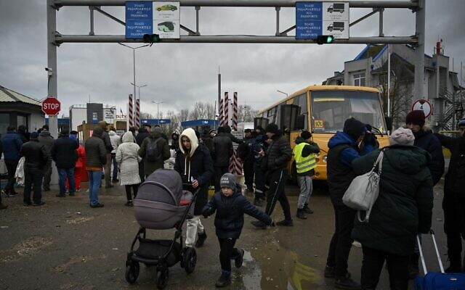  People fleeing the conflict in Ukraine after crossing the Moldova-Ukraine border checkpoint near the town of Palanca, on March 2, 2022, seven days after Russia's military invasion of Ukraine. (Nikolay DOYCHINOV / AFP) | Team from United Hatzalah en route to Moldova, March 3, 2022 (Times of Israel)
Humanitarian aid being sent for Ukrainian refugees from Ben Gurion Airport, March 2, 2022 (United Hatzalah of Israel) | A pile of aid being sent with United Hatzalah to the Moldova-Ukraine border. (Courtesy of United Hatzalah of Israel)
IASI, Romania — A 40-strong team of medical personnel from Israel’s United Hatzalah organization landed in Romania on Thursday morning on the first leg of their journey to staff three field hospitals on the Moldovan border for Ukrainian refugees fleeing the Russian invasion.
~The team is made up of volunteer EMTs, paramedics and doctors, as well as members of the organization’s Psychotrauma and Crisis Response Unit, which provides aid in the field for people who are undergoing trauma.
Dr. Einat Kaufman, who is heading up the Psychotrauma and Crisis Response Unit, said her team will help anyone who needs their assistance at the border, no matter their nationality.
“These people have lost everything all of a sudden. Their lives, their identities – all in one day,” she said.
“There are so many different layers of trauma that these people can be suffering, and the closer they are to a traumatic event, the more likely they are to suffer from PTSD,” she added, explaining that the psychotrauma team will often be the first volunteers encountered by those in need, sometimes even before they receive care for any physical injuries.
Many of the medics expect to be deployed for around two weeks, but the fast-moving crisis means that some could be away from home for longer.
“When you volunteer in this unit, you know that you always need to be ready with a suitcase,” Kaufman said.
Kaufman has volunteered for emergency trauma work for a number of years, but this trip is the first time she is deploying with her daughter, 24-year-old Lynn Rogovski, a medic with the organization.
“For years [my mother] has done this, flying to different places,” Rogovski said. “And finally I can go with her. It’s exciting.”
Miri Shvimmer, another medic working with the trauma unit, said she feels a connection to the refugee crisis due to her own family history.
“Several decades ago it was us,” she said. “It’s disturbing to see it still happening, to innocent people, so it’s important to act.”
“My grandparents were in Auschwitz. We were always told that there were some people who helped, but so many didn’t,” she said. “And by going to help now, it demonstrates that we are a country and a people who come and want to help.”
Dr. Einat Kaufman and her daughter, Lynn Rogovski, part of a United Hatzalah delegation heading to aid Ukrainian refugees in Moldova on March 3, 2022. (Times of Israel)
Shvimmer said she believes that many of those they help will be dealing with emotional trauma after their lives were turned upside down.
“We can help them by giving them strength, help them to feel their feet on the ground again,” Shvimmer said.
Tens of thousands of refugees are crossing the borders from Ukraine on a daily basis into neighboring countries to the west — Poland, Romania, Slovakia, Hungary and Moldova.
Many arrive at the border with little more than their paperwork and bags they can carry. Some are wounded and others are sick, contributing to a growing humanitarian crisis made worse by the bitter cold.
The specially chartered plane that departed Israel on Thursday also carried 15 tons of humanitarian aid, much of it medical equipment for the field hospitals.
They also shipped food, warm clothing, blankets, heat pads, diapers, formula and feminine hygiene products.
“We’re taking anything we can think of that they could possibly need,” a spokesperson for the aid organization said.
In a move that distinguishes the team from other aid organizations, they are also transporting three Torah scrolls for use by the observant members of their teams on the ground.

One of the Torah scrolls being transported by United Hatzalah for its teams on the ground in Moldova, March 3, 2022. (Times of Israel)
The plane will return to Israel later in the day carrying some 160 refugees with Israeli citizenship back to Israel.
“The complexity of this operation is immense. It involves travel permits, diplomatic relations, and travel between three countries by land and by air,” said Eli Beer, president of United Hatzalah.
The United Nations High Commissioner for Refugees (UNHCR), the international body’s refugee agency, said Thursday that more than a million people have been made refugees as a result of the fighting in Ukraine, with concerns that the figure could continue to climb exponentially.
The airlift is the latest in a number of deliveries sent from Israel this week to Ukraine and its neighboring countries to deal with the growing humanitarian crisis, with 100 tons sent by the government in three planes on Wednesday.
Officials have said the humanitarian assistance could be widened if necessary, while refusing to send military aid to Ukraine due to Israel’s delicate relationship with Russia over security operations in Syria. https://www.timesofisrael.com/these-people-have-lost-everything-israeli-medics-supplies-head-to-ukraine-border/ Keep in mind that this is all going on as the UN CHR (human rights) is constantly censuring Israel for what are claimed human rights violations. The first to show up on almost every crisis regardless of the race or religion of the country is normally Israel. This is so ludicrous . – rdb]

Amid Ukraine invasion, Jerusalem court nixes transfer of Old City property to Russia
Judge rules only the government is able to decide on ownership of Alexander’s Courtyard, due to matter’s political and religious considerations
By TOI staff Today, 5:01 pm
The Jerusalem District Court on Thursday annulled a decision giving the Russian government control of the prominent Alexander’s Courtyard church compound in the capital city, the Globes newspaper reported.
The verdict was given following a petition by the Orthodox Palestine Society of the Holy Land, which owned the property until last year.
The complex is located near the Church of the Holy Sepulchre in Jerusalem’s Old City.
In 1859, Czar Alexander II purchased the land on which Alexander’s Court — also known as the Alexander Nevsky Church — was built. Until the Russian Revolution of 1917, the area was under the control of the Russian Imperial government.
Former prime minister Benjamin Netanyahu approved giving Alexander’s Courtyard to Russia in 2020. The move was seen as a goodwill gesture following Russia’s release of Naama Issachar, an Israeli woman who was imprisoned after a small quantity of marijuana was found in her backpack during a layover in Moscow.
After the Russian government was registered as the rightful owner of the church, the Land Registry Commissioner responded to a string of appeals against the move, explaining that the Russian Federation had been recognized by international bodies and by the State of Israel as a “continuing state” of the Russian Empire.
In his ruling on the appeal Thursday, Judge Mordechai Kaduri ruled that since Netanyahu had designated Alexander’s Courtyard as a “holy site,” the only body able to decide on the matter is the Israeli government, given various religious and political considerations.
Prime Minister Naftali Bennett set up a panel on the issue last July, but it has yet to convene.
The court decision comes amid Russia’s invasion of Ukraine. Israel, which enjoys close ties with both countries, has largely refrained from condemning Moscow, apparently due to concerns Moscow could limit the IDF’s ability to act against Iranian-linked targets in Syria, where Russia maintains a military presence. https://www.timesofisrael.com/amid-ukraine-invasion-jerusalem-court-nixes-transfer-of-old-city-property-to-russia/

Interior minister predicts tens of thousands of new immigrants from Ukraine, Russia
Ayelet Shaked orders 3-month suspension of need for a police background check on those fleeing the conflict, says wave of arrivals will be sent to boost Negev communities
By TOI staff Today, 3:42 pm
Interior Minister Ayelet Shaked said Israel believes a huge number of Jewish refugees fleeing the war in Ukraine could immigrate to Israel and instructed her office on Thursday to allow them to move to Israel without the need for a police background check.
“We think tens of thousands if not hundreds of thousands of immigrants will arrive from Russia, Ukraine, and former Soviet states,” Shaked said Thursday during a conference with local council leaders at the Golan Regional Council.
The interior minister said that next month the government will make a decision to set up seven to 12 new communities in the southern Negev region of the country.
Shaked said the new communities will bolster the Negev and will be necessary to absorb the expected wave of new immigrants.
Noting that there is a national housing crisis, she asked: “What will happen when new immigrants reach us from Ukraine and Russia?”
“Even though we’re at full throttle now, we’ll need [to build] even more [homes]” requiring “aggressive and rapid” construction to accommodate the mass arrivals, she said.
Shaked later tweeted that she had ordered a three-month suspension on the requirement for a notarized police background check for immigrants from Russia and Ukraine to ease their immigration to Israel.
“Whoever wants to immigrate to Israel can do it fast,” she wrote.
The Ministerial Committee for Immigration and Absorption is slated to hold a meeting about the situation in Ukraine on Monday, Army Radio reported.
Diaspora Minister Nachman Shai told Army Radio on Thursday that so far 350 Ukrainians have reached Israel, six of whom were rejected due to some aspect of their past.
He said the government needs to formulate a proper policy “in order to bring in those people without relatives or friends in Israel as well.”
The Jewish Agency has received thousands of inquiries from Ukrainian citizens in recent days about immigrating to Israel after Russia invaded Ukraine last week, setting off a conflict that has cost at least hundreds of lives, likely thousands.
The Jewish Agency, a semi-governmental body that is responsible for encouraging and overseeing immigration to Israel, or aliyah, has been working to facilitate the expected wave of migration from Ukraine to Israel in light of the Russian offensive, including setting up emergency hotlines to answer questions about the immigration process.
Ukraine has about 43,300 people who self-identify as Jews and about 200,000 eligible to immigrate to Israel under its Law of Return for Jews and their relatives, according to a 2020 demographic study of European Jewry.
Shortly before Russia’s invasion, dozens of new immigrants from Ukraine arrived in Israel.
Some 300 new Jewish immigrants who had fled from Ukraine are scheduled to reach Israel on Sunday.
According to Israel’s Law of Return, Jews and their children, grandchildren, and spouses are eligible for citizenship.
Israel tried to send back 14 Ukrainian immigrants saying they were not eligible to enter under the Law of Return, Channel 12 News reported Monday.
Israel has rarely granted refugee status to non-Jews in the past, and has not granted it to thousands of asylum seekers from Africa who arrived in the mid to late 2000s.
Tens of thousands of Ukrainian asylum-seekers came to Israel following the 2014 war with Russia. Most came as tourists and tried to stay as refugees, but few were actually granted refugee status. https://www.timesofisrael.com/interior-minister-predicts-tens-of-thousands-of-new-immigrants-from-ukraine-russia/

Tel Aviv University offers full scholarships to Ukrainian students, academics
TAU says that as an institution that raises ‘the banner of academic freedom,’ it must offer assistance to ‘our Ukrainian colleagues’
By Tobias Siegal Today, 2:25 pm
Tel Aviv University is offering dozens of scholarships to Ukrainian academics whose studies and research have been compromised due to the Russian invasion of Ukraine that has so far displaced over 1 million people.
The university announced the plan, totaling about NIS 1 million, on Thursday, as the conflict in Ukraine entered its eighth day with no end in sight.
The initiative invites Ukrainian students and researchers to spend the coming semester in Israel and continue their academic work at Israel’s largest university.
The scholarships offered by TAU include tuition as well as living expenses in Israel.
“TAU will soon contact the embassies in both Israel and Ukraine, as well as their academic colleagues, to facilitate the researchers’ arrival in Israel within the next few days,” read a statement issued by the university.
The academic institution referred to the Russian invasion of Ukraine as a “red flag requiring all of us to make an all-out effort to help the Ukrainian people, many of whom have become homeless refugees overnight.”
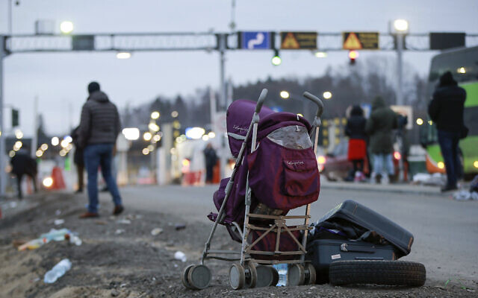
Deserted suitcase and a baby cart are left beside the road as Ukrainian refugees flee Russian invasion at a border crossing in Medyka, Poland, March 2, 2022. (AP Photo/Visar Kryeziu)
The university noted that as an institution that raises “the banner of academic freedom,” it is its responsibility to provide “our Ukrainian colleagues with immediate assistance.”
The UN refugee agency said late Wednesday that more than 1 million people have fled Ukraine since Russia invaded the country on February 24, the swiftest refugee exodus seen this century. The agency predicted that up to 4 million people could eventually leave Ukraine.
“The steps we are taking are admittedly modest,” said TAU President Prof. Ariel Porat. “However, we hope that other academic institutions, both in Israel and worldwide, will follow our example, and lend a helping hand to the Ukrainian people in this dire situation.”
Official Israeli efforts to facilitate the arrival of Ukrainian refugees to Israel have mostly focused on Ukrainian Jews. The Jewish Agency said last week that it has received thousands of inquiries from Ukrainian citizens about immigrating to Israel.
A group of Ukrainians travel to Poland before immigrating to Israel, on February 26, 2022. (Jewish Agency)
Israel’s official stance on the conflict has been a delicate maneuver between providing humanitarian aid and quietly condemning Russia, attempting to balance between its warm relations with Kyiv and sensitive ties with Moscow, primarily due to Russian activity in Syria and the need to coordinate Israeli operations in the region with the Kremlin.
On Tuesday, Prime Minister Naftali Bennett said that Israel has “sent three planes full of humanitarian aid, mostly medicines, and we will send more, as needed. We are also preparing to provide humanitarian assistance on the ground and, of course, to facilitate the immigration of Jews, from all relevant places.” https://www.timesofisrael.com/tel-aviv-university-offers-full-scholarships-to-ukrainian-students-academics/

Ben & Jerry’s Israel distributor sues ice cream maker, parent company over boycott
Israeli licensee says the company unlawfully terminated business relationship by making demands that are illegal in Israel and the US, and then ended contract
By Luke Tress Today, 6:41 pm
The Israeli manufacturer and distributor for Ben & Jerry’s said Thursday that it is suing the ice cream maker, and its parent company Unilever, for unlawfully terminating their business relationship.
Last summer, Ben & Jerry’s announced that it will no longer sell its products in the “Occupied Palestinian Territory,” apparently referring to West Bank settlements and East Jerusalem.
Its Israeli distributor refused to comply, saying the move was illegal in Israel and the US, so Ben & Jerry’s said it will not renew the Israeli licensee’s agreement at the end of 2022 — effectively ending the business relationship.
The boycott announcement came after a heavy pressure campaign from anti-Israel and progressive activists. The decision sparked an uproar in Israel and among some US Jewish groups, many of whom called it antisemitic, since the company has no boycotts against any other area of the world.
The new lawsuit requests a US federal court deem Unilever’s move illegal, and enable the Israeli company American Quality Products (AQP), and owner Avi Zinger, to keep selling Ben & Jerry’s products throughout Israel and the West Bank. It also seeks a jury trial and damages.
The lawsuit argues that the boycott of the West Bank violates US and Israeli law, and since there is no legal mechanism to continue business while violating those laws, the move amounts to an illegal boycott of the entire Jewish state.
“I refused Ben & Jerry’s and Unilever’s illegal demands, and as a result, they are threatening to close my business, affecting hundreds of Israeli and Palestinian workers and distributors,” Zinger said in a statement.
The lawsuit was filed over the defendants’ “unlawful demand that plaintiffs violate Israeli law by boycotting parts of Israel,” the lawsuit reads.
“The demand was in and of itself a violation by defendants of Israeli law, US anti-boycott policy” and the laws and policies of many US states, it says.
The firm filed the lawsuit in the US District Court of New Jersey, the state where Unilever’s American branch is headquartered. It was also filed against Conopco, Inc., another US branch of Unilever, a UK-based multinational.
AQP and its owner Zinger are requesting an injunction from the US court to let AQP continue its Ben & Jerry’s operations in all of Israel.
The lawsuit alleges Unilever directed AQP to violate two Israeli laws — Israel’s non-discrimination law, which includes a ban on discrimination based on residence and place of origin; and an Israeli law prohibiting a boycott against Israel, or an area under Israeli control.
The company also violated several US laws that block anti-Israel boycotts, plus numerous state laws, the lawsuit claims.
“We expect the court to prevent Unilever from terminating my contract, since the only reason it’s doing so is that I refused to break the law,” Zinger said. MORE - https://www.timesofisrael.com/ben-jerrys-israel-distributor-sues-ice-cream-maker-parent-company-over-boycott/

UN atomic watchdog assesses Iran has doubled stockpile of 60% enriched uranium
In a report to member countries, IAEA estimates figure at 33 kilograms; total stockpile assessed at 3,197, though it could not verify exact size due to limitations on inspectors
By EMILY SCHULTHEIS Today, 7:52 pm
VIENNA (AP) — The United Nations’ atomic watchdog said Thursday that it believes Iran has significantly increased its stockpile of highly enriched uranium in breach of a 2015 accord with world powers.
The International Atomic Energy Agency told member nations in its confidential quarterly report that Iran has an estimated 33.2 kilograms (73.1 pounds) of uranium enriched to up to 60% fissile purity, an increase of 15.5 kilograms (34.2 pounds) since November.
Such highly enriched uranium can be easily refined to make atomic weapons, which is why world powers have sought to contain Tehran’s nuclear program. The 33.2-kilogram figure brings Iran closer to having enough weapons-grade uranium to produce a nuclear weapon.
In a report to member states about its work in Iran seen by The Associated Press, IAEA estimated that as of February 19, Iran’s stockpile of all enriched uranium was 3197.1 kilograms (7048.4 pounds), an increase of 707.4 kilograms (1559.6 pounds).
The Vienna-based agency said it was unable to verify the exact size of Iran’s stockpile of enriched uranium due to limitations Tehran imposed on UN inspectors last year. IAEA’s monitoring and verification activities in Iran continue to be “seriously affected” by Iran’s decision to stop letting inspectors access the agency’s monitoring equipment, the report states.
Senior diplomats from Britain, China, France, Germany and Russia have been meeting with Iranian officials in Vienna since November to discuss bringing Tehran back into compliance with the 2015 Joint Comprehensive Plan of Action. The pact eased sanctions on Iran in return for curbs on its nuclear program.
The United States pulled out of the accord under former president Donald Trump and reimposed sanctions on Iran, prompting Tehran to resume its uranium enrichment.
The IAEA announced earlier Thursday that Director-General Rafael Mariano Grossi would travel to Tehran for meetings with senior Iranian officials on Saturday.
Asked to characterize the cooperation with Iranian officials and whether there had been any progress, Grossi said at a Wednesday press conference in Vienna, “We are working very hard.” https://www.timesofisrael.com/un-atomic-watchdog-assesses-iran-has-doubled-stockpile-of-60-enriched-uranium/

Palestinian man arrested over pair of stabbing attacks near Jerusalem
20-year-old resident of Shuafat refugee camp taken in for interrogation, hours after latest knifing in Palestinian town of Hizme
By Emanuel Fabian Today, 5:33 pm
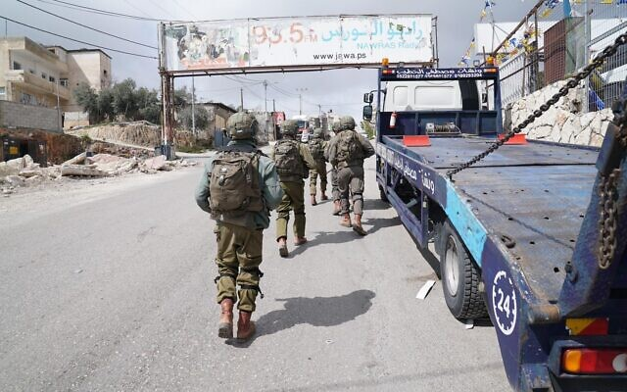
Israeli troops are seen in the Palestinian town of Hizme, northeast of Jerusalem, March 3, 2022. (Israel Defense Forces)
Israeli security forces arrested a Palestinian man on Thursday afternoon for allegedly carrying out two stabbing attacks in the West Bank town of Hizme outside Jerusalem.
Police said the 20-year-old suspect was arrested in his home in the Shuafat refugee camp by Border Police and Israel Defense Forces troops, after they received information from the Shin Bet security agency.
On Thursday morning and on Wednesday afternoon two Jewish Israeli men in their 40s were separately stabbed in a store in Hizme under near-identical circumstances.
Both men were taken to a hospital in Jerusalem in moderate condition, according to medics.
According to the IDF and police, both stabbings appeared to be terror attacks, and were allegedly carried out by the suspect.
He was taken for further questioning by the Shin Bet, law enforcement officials said.
جيش الاحتلال يعتقل فلسطيني من مخيم شعفاط بالقدس المحتلة بزعم تنفيذه لعمليتي طعن خلال ٢٤ ساعة لمستوطنين في بلدة حزما شمال شرق مدينة القدس. pic.twitter.com/D7fuQ44IIO
— حسن التميمي ???????? (@HassanTamimi_) March 3, 2022
The suspect was not immediately identified.
The Hizme checkpoint, northeast of Jerusalem, has been the site of numerous attacks by Palestinians in recent years, mainly against Israeli security forces. https://www.timesofisrael.com/palestinian-man-arrested-over-pair-of-stabbing-attacks-near-jerusalem/

Saudi Crown Prince: Israel a potential ally but should solve conflict with Palestinians
Prince says Israel must resolve Palestinian statehood quest; says Saudi Arabia conducts 'detailed talks' in hope to reach agreement with Iran in the background of nuclear talks
Reuters | Updated: 03.03.22, 20:43
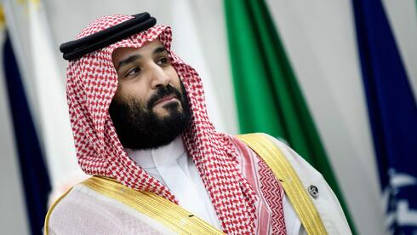
Saudi Crown Prince Mohammed Bin Salman says Israel was a potential ally of his country.
Speaking to "The Atlantic" and carried by Saudi state media on Thursday Bin Salman said Israel was not an enemy of the Saudis.

Saudi Arabia's Crown Prince Mohammed bin Salman (Photo: AFP)
"We do not look at Israel as an enemy but as a potential ally in various interests that we could seek to achieve together. But it should solve its problems with the Palestinians," Prince Mohammed was cited by the state news agency.
Saudi Arabia, home to Islam's two holiest sites, has conditioned any eventual normalization with Israel on addressing the Palestinians' quest for statehood on territory captured by Israel in the 1967 Six Day War.
He said the Gulf nation intends to continue "detailed talks" with Iran in order to reach a satisfactory agreement for both, while stressing the need for a strong nuclear deal between Tehran and world powers at talks in Vienna, and that direct talks with Iran would enable reaching "a good situation and mark a bright future" for the region's Sunni Muslim and Shi'ite powers, which have been locked in a rivalry playing out in conflicts across the Middle East.
His comments come as indirect U.S. - Iran talks in Vienna move closer to reviving a 2015 nuclear pact which curbed Tehran's nuclear program in exchange for sanctions relief.
"We do not want to see a weak nuclear deal because the result will be the same in the end," the prince said.
Saudi Arabia's foreign minister said last month the kingdom was looking to schedule a fifth round of talks despite a "lack of substantive progress" so far, and urged Tehran to change its behavior.
Shared concerns over Iran saw Riyadh's Gulf allies the United Arab Emirates and Bahrain forge ties with Israel in 2020 to create a new regional axis at a time of uncertainty over the commitment of key security ally the United States.
"We do not look at Israel as an enemy but as a potential ally in various interests that we could seek to achieve together. But it should solve its problems with the Palestinians," Prince Mohammed was cited by the state news agency.
Saudi Arabia, home to Islam's two holiest sites, has conditioned any eventual normalization with Israel on addressing the Palestinians' quest for statehood on territory captured by Israel in the 1967 Middle East war. https://www.ynetnews.com/article/skkddwrx9 [This would have been unthinkable 4 years ago. My how things change as the prophetic timeline continues to lay out. – rdb]

After Ukraine, Moldova fears being Putin’s next target
Neighbor’s invasion brings back painful memories of its own conflict with Moscow-backed separatists in Transnistria, where Kremlin still keeps a military presence
By Mihaela RODINA 3 March 2022, 10:42 pm
CHISINAU, Moldova (AFP) — For Moldovans, watching Russia’s invasion of neighboring Ukraine brings back painful memories of the country’s own conflict involving Moscow-backed separatists 30 years ago — and is stirring fears that the country might become Russia’s next target.
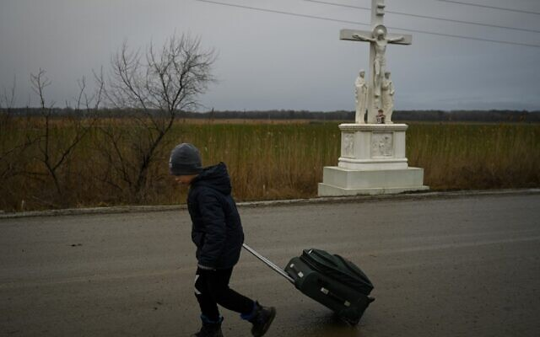
A boy fleeing the conflict in Ukraine walks past a crucifix with a suitcase after crossing the Moldova-Ukraine border checkpoint near the town of Palanca, on March 2, 2022, seven days after Russia's military invasion of Ukraine. (Nikolay Doychinov/AFP)
In the town of Palanca, “everyone is scared,” 23-year-old Alexio Mateev told AFP.
He is volunteering to provide tea and coffee to the stream of Ukrainian refugees who have been pouring across the border since Russia’s attack on their country began.
In a sign of the heightened tensions, Western diplomats have been showering Moldova with an unusual amount of attention.
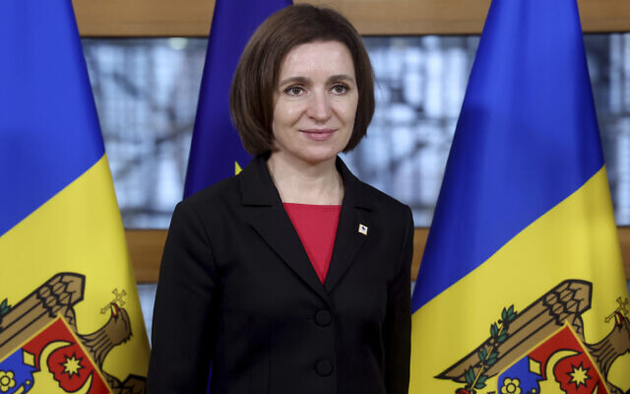
The country of 2.6 million people, one of Europe’s poorest, played host to EU foreign policy chief Josep Borrell on Wednesday and Thursday and this weekend will welcome US Secretary of State Antony Blinken.
Borrell told reporters on Wednesday of his concern at the “instability at the border” that the conflict could generate.

Moldova’s President Maia Sandu poses prior to a bilateral meeting with European Council President Charles Michel on the sidelines of an Eastern Partnership Summit in Brussels, on December 15, 2021. (Kenzo Tribouillard, Pool Photo via AP)
Alongside him was Moldovan President Maia Sandu, elected in 2020 on a pro-Western program.
“The security risks for Moldova are serious,” she said, stressing that from the capital Chisinau “you can hear the noise of the bombs across the border.”
Frozen conflict, vivid memories
Around 80 kilometers (80 miles) to the east of Chisinau is the Russian-backed breakaway region of Transnistria, which seceded in 1990.
Not recognized by the international community, Moscow still has a military base there as well as a stockpile of some 20,000 tons of munitions.
Chisinau’s longstanding demand for the troops to leave has been in vain.
While the conflict over Transnistria has been frozen since 1992, the Russian aggression in Ukraine has revived painful memories of the fighting which claimed hundreds of lives. MORE - https://www.timesofisrael.com/after-ukraine-moldova-fears-being-putins-next-target/

Surgeon general demands Big Tech turn in publishers of COVID 'misinformation'
Dr. Vivek Murthy says it's 'about protecting the nation’s health'
By Art Moore Published March 3, 2022 at 4:14pm
President Biden’s surgeon general on Thursday demanded that the major social media companies submit detailed information about the COVID-19 "misinformation" on their platforms.
The surgeon general, Dr. Vivek Murthy, wants to know "exactly how many users saw or may have been exposed to instances of Covid-19 misinformation." In his notice, he also asked for aggregate data on demographic groups that may have been disproportionately affected by the misinformation, the New York Times reported.
With a deadline of May 2, Murthy also demanded the Big Tech companies provide information about the major sources of COVID-19 "misinformation," including those selling "unproven" products, services and treatments. [This dude is an idiot. He needs to go back to medical school and it wouldn’t hurt if he learned something about the law and freedom of speech as well. The surgeon general is not the arbitrator of everything that is correct or not correct in medicine. Flog the buzzard and send him packing. – rdb]
"Technology companies now have the opportunity to be open and transparent with the American people about the misinformation on their platforms," Murthy said in an emailed statement to the Times.
"This is about protecting the nation’s health." [More leftist lies. It has nothing to do with the Nation’s health and everything to do with carrying out the vile and evil JAB on everyone so they can mess with your DNA and control you. – rdb]
The Times noted that denying a request for information "does not carry a penalty, but the notice represents the first formal request from the Biden administration of the tech companies to submit Covid-19 misinformation data, according to the surgeon general’s office."
The White House has stepped into the controversy over top-rated podcaster Joe Rogan's interviews with prominent medical scientists Dr. Robert Malone and Dr. Peter McCullough, essentially calling for censorship. Press secretary Jan Psaki has declared that flagging "misinformation" contrary to the government's narrative is not enough, and social media platforms must do more.
In an interview with MSNBC in January, Murthy said the social media "platforms still have not stepped up to do the right thing, and do enough, I should say, to reduce the spread of misinformation."
Six months ago, Murthy issued a first formal advisory accusing Big Tech of failing to do its public duty, calling misinformation "an urgent threat to public health."
In February, as WND reported, the Department of Homeland Security issued a bulletin naming "proliferation of false or misleading narratives" regarding COVID-19 and the 2020 election as among the top terror threats. The National Terrorism Advisory System Bulletin warned of a heightened threat of terror due in part to "an online environment filled with false or misleading narratives and conspiracy theories, and other forms of mis- dis- and mal-information (MDM) introduced and/or amplified by foreign and domestic threat actors."
When 'misinformation' becomes consensus
The Times on Thursday reported Murthy's request for information is part of Biden's Covid National Preparedness Plan, which the White House detailed on Wednesday after the State of the Union address.
Murthy also is seeking information from health care providers and the public on how COVID-19 "misinformation" has influenced patients and communities.
"We're asking anyone with relevant insights — from original research and datasets, to personal stories that speak to the role of misinformation in public health — to share them with us," he said. [The only misinformation is that which has been coming from the CDC and FDA. They are crooked as dogs hind legs and have been lying to the American public from the onset. There isn’t one of them that shouldn’t be tried before a military tribunal for treason and genocide. – rdb]
The charge of spreading "misinformation," however, has come as top health officials and scientists walk back their stances on masks, lockdowns, vaccines and other efforts to combat COVID-19, confirming the claims of esteemed scientists they have dismissed as "fringe" and conspiracy theorists."
In November, for example, Pfizer CEO Albert Bourla charged people are spreading "misinformation" about the vaccines, calling them "criminals" who have cost "millions of lives." However, Bourla acknowledged in January that two doses of his vaccine "offer very limited protection, if any" against the dominant omicron variant. And he said the mRNA vaccines "don’t have the safety profile that we hoped we can achieve with this technology."
The FDA approved the Pfizer shot for kids one week after an FDA advisory panel voted to recommend it despite acknowledging the lack of safety data and the nearly 100% survival rate for children from infection.
Michael P Senger, an attorney who has published books on the pandemic, observed Thursday on Twitter, "Virtually everything the US Surgeon General has labeled 'misinformation' has been proven true."
He wrote:
- Lockdowns saved no one from COVID
- Mass testing led to a permanent "pandemic"
- Cloth masks don't work
- Vaccines don’t prevent infection or transmission
Florida Surgeon General Dr. Joseph Ladapo, at a news conference Thursday, recounted the evidence that wearing masks does not save lives.
See Ladapo's remarks:
https://www.wnd.com/2022/03/surgeon-general-demands-big-tech-hand-data-covid-misinformation/ [Go to the website for the links for videos. – rdb]

Truckers aiming to arrive in Washington D.C. on Saturday
Calling for Joe Biden to end COVID mandates, national 'emergency'
By Bob Unruh Published March 3, 2022 at 5:34pm
People's Convoy trucker supporters March 2022 (video screenshot)
The People's Convoy, a miles-long string of trucks and other vehicles that left California last week and is expecting to arrive in Washington, D.C., Saturday – meeting up with other truckers from other parts of the country – wants Joe Biden to end those COVID mandates and his self-proclaimed national "emergency."
Truckers were traveling on Thursday through Ohio and their convoy was described as more than eight miles long.
Kris Young, who runs a Facebook page about the campaign, said, "The rally in Monrovia was a huge success! The layover allowed for others from across the country to join us! We are bigger now than when we arrived."
The estimate for attendance at the rally in Indiana, called the Shifting Gears Rally, was estimated in the thousands.
Brian Brase, an organizer of the events, said, "It's time for truckers around the world to stand up for your rights now!"
The activism has been modeled after the Freedom Convoy in Canada that started on its West Coast and traveled to Ottawa, where truckers closed down streets in civil disobedience that prompted Prime Minister Justin Trudeau to declare martial law and use violence against the peaceful protesters who were arrested by the hundreds.
The government also confiscated trucks when it chose.
The Daily Mail reported on the American movement: "The People's Convoy - which has raised more than $1.5million in donations made through its own website - embarked from California last week on an 11-day trek to Washington D.C. The group plans to hold a peaceful protest near the capital city on Saturday and has sworn not to disrupt roads or bridges like their Canadian counterparts did. Organizers have promised a '100% safe, lawful and peaceful journey' that will 'terminate in the vicinity of the D.C. area, but will NOT be going into D.C. proper.'"
The report said at least 25 other convoys reportedly were en route to Washington from other parts of the nation. Some of those have been small, some larger, and it remains unclear how many will congregate on Saturday.
The size has been fluid because of the distance of the convoy's trip, and the expense of the travel, with fuel approaching $4 a gallon because of several factors, including Biden's insistence on shutting down fossil fuels industry components and pursuing wind power.
One of the other groups was called the Southeast American Freedom Convoy.
Federal officials in Washington had put law enforcement on high alert, and have arranged for the presence of hundreds of National Guard troops to confront the peaceful truckers.
And officials have rebuilt a security fence around the U.S. Capitol.
The convoy, no matter its ultimate number of participants, already has seen significant success as many states and even federal officials have been dropping COVID mandates right and left in recent days.
While the truckers' message undoubtedly was heard, it's also fact that Democrats who had imposed those restrictions on Americans' constitutional rights now are gearing up for re-election campaigns for the 2022 midterms.
Also, COVID infections have been plunging, with only 52,000 reported on day this week, down more than 90% from the 800,000 case per day in January.
The Centers for Disease Control and Prevention just last week released new coronavirus guidelines that mean mask recommendations now are gone for 70% of Americans.
In Canada, reports from the Associated Press reveal citizens have lost faith in their government following its crackdown on rights, and Trudeau's image has been hurt by the handling of the protests.
"Approval among Canadians about the Trudeau-led Liberal Party is near a 12-month low as of last week, according to polling from Ottawa-based Nanos Research. A separate Nanos poll, gathered after Mr. Trudeau cleared a nearly monthlong trucker-led demonstration that had choked the capital, indicates almost half of Canadians say their impressions of the prime minister had worsened during the protest, which called for the end of Covid-19 restrictions," that report said.
"The prime minister has recently drawn criticism from many Canadians, and even members of his own Liberal caucus, for what they say were polarizing and dismissive comments toward those who disagree with his tough public-health measures during the Covid-19 pandemic," it said.
John Wright of Maru Public Opinion said Trudeau now faces a divided nation, with evidence in surveys of a "sharp anger" he hasn't seen in many years.
Trudeau had derogatorily labeled the thousands of truckers involved in the protest there a "fringe" group. And he said their views on freedom were "unacceptable." In the U.S., those who have opposed COVID mandates have been labeled domestic terrorists and threatened by government officials. https://www.wnd.com/2022/03/truckers-aiming-arrive-washington-saturday/ [Trudeau is a leftist globalist turkey with a pea sized brain. He was a spoiled child of a previous spoiled Canadian PM. Trudeau has been on a power trip from the beginning and needs to be thrown under the bus. – rdb]

Supremes release ruling in Kentucky abortion law fight
Justices to allow defense of new statute after Democrat governor tried to kill it
By Bob Unruh Published March 3, 2022 at 2:24pm
The U.S. Supreme Court has ruled in a Kentucky abortion law fight that the state's attorney general is allowed to defend the statute in court.
The state's Democrat governor, Andy Beshear, had tried to kill the law by refusing to support the state's advocacy for its own abortion limits.
The result is that Attorney General Daniel Cameron, a Republican, will be calling the shots in the state's defense of the law that was adopted in 2018 but has been halted by various court rulings for the benefit of the abortion industry.
"We thank Attorney General Cameron for taking this fight all the way to the Supreme Court. We're encouraged by this affirmation of the right of attorneys general to defend their states’ pro-life laws," explained Susan B. Anthony List President Marjorie Dannenfelser.
"Brutal live-dismemberment abortions on babies with fully formed arms, legs, fingers and toes, even after the point when they can feel pain, show the true extremism of our nation’s status quo on abortion. Acting on the will of the people, Kentucky lawmakers passed legislation to stop this inhumane practice with overwhelming bipartisan majorities.
"As we await a decision in the Dobbs case that could restore the right of all states to protect countless unborn children and their mothers, pro-life champions in the states like Daniel Cameron are not waiting to lead and are more important than ever."
The dispute in the Kentucky case at this point was procedural.
MSN reported the technical decision now allows Cameron to intervene in the case and defend it after Beshear imposed his pro-abortion will and announced he was dropping the state's advocacy for its own law.
That was allowed by lower courts, but the Supreme Court ruled 8-1 that Cameron can step in.
When the law was adopted, Republican Matt Bevin was governor. In a lawsuit from abortion industry representatives, a judge ruled against the law, and that decision was adopted by a panel of the 6th U.S. Circuit Court of Appeals.
But Cameron noted that a Supreme Court ruling in an unrelated Louisiana law cast doubt on the validity of the ruling in the Kentucky case. His defense, however, was blocked in the courts, so he took it to the Supreme Court.
At this point, Cameron now could ask the full appeals court to review the case, or he can take it back to the Supreme Court on the issue of the abortion restrictions.
The fight is separate from the case already pending before the Supreme Court, Mississippi's Dobbs challenge to the constitutionality of Roe v. Wade, the nearly 50-year-old decision that created out of the implications of the Constitution a "right" to abortion nationwide.
The issue has literally separated the United States into an "us" and "them" battle, with multiple states proceeding with plans to ban most abortions once that decision is released. MORE - https://www.wnd.com/2022/03/supremes-release-ruling-kentucky-abortion-law-fight/

Commentary:
Ukraine Arms Its People; Americans Say 'Way Ahead of You'
Kurt Schlichter Posted: Mar 03, 2022 12:01 AM
Imagine you’re a Democrat for a minute – to fully experience the effect, invent some pronouns and forget which bathroom to use – then think of the cognitive dissonance you would experience watching the TV showing your new bestest buddies the Ukrainians handing out AK-47s to regular civilians. Normal people, with guns? And intending to use them to defend their freedom? But but but guns are bad! Your mind would be spinning – it’s got to be a manifestation of white supremacy, right? “Ohhhhhhh,” you moan, swooning and dizzy at the thought of men (and women) standing up to personally undertake the solemn duty of citizenship that is defending your country.
Seeing this, liberal sissies are confused and frightened. Normal Americans are all “One rifle? Well, that’s a start. I guess.”
We have 400 million gats out here in Americaland already. Issuing us more guns – while awesome – would be repetitive yet redundant. We’re already ready to smoke any invader, crook, or tyrant who dares step to us. And this is why we are awesome.
Guns are an essential element of American freedom. And, as I explain in my upcoming non-fiction book from Regnery, We'll Be Back: The Fall and Rise of America, this heavily armedness is a key reason why America is likely to survive the trials and tribulations we are facing from the wokesters, SJWs, and other communist dirtbags who want us normals dead or enslaved.
To be truly free, one must personally have the capacity to make himself truly free. And as we have seen in Ukraine, there are some really bad people in the world who only understand the business end of a rifle. The Russian conscripts getting caps popped off at them by angry grannies are learning that tough but fair lesson right now.
Putin expected to walk in and walk over the Ukrainians. His mechanized forces were designed to smash through military formations – the old Soviet-style tactics they still use are about as subtle as a sledgehammer. And the smaller Ukrainian forces were pushed back under the pounding. But there were a couple factors Putin did not seem to anticipate.
The first is that his forces were not as good at combined arms operations as he expected. After a few smaller wars in Georgia, Chechnya, and Syria, he probably expected his army to meld maneuver, fires, and other battlefield operating systems together better (Americans were very good at this once upon a time, and hopefully still train on it if there is time between sessions on trans awareness). The Russian attack appears unsynchronized and poorly supported, with piecemeal and uncoordinated attacks squandering much of the Russian size advantage. But there was another factor Putin apparently did not factor in.
Armed Ukrainians.
Anyone with some experience around Ukrainians would understand that those wacky cats would transition into unconventional (think “guerilla”) warfare if their formal military formations disintegrated. Let me put it in nerd terms. Remember the dwarves in Lord of the Rings? Tough, pugnacious, often drunk dudes who liked to mix it up with the orcs? That’s the Ukrainians. They hid out in forests and swamps for a decade fighting Stalin. This time, all they needed was a rifle.
Americans are like that too, generally minus the vodka. And we already have the guns.
I discuss some of the practical issues facing the bad guys trying to use force to oppress us patriots here in America in We'll Be Back. There’s a gun everywhere. If you were one of the bad guys, you would have to assume everyone is a guerilla. Everyone is a threat. Want to buy a coffee? Would you like lead with that? So you aren’t walking around. Now you ride along on your armored vehicle with your head out of the hatch and some guy used to taking down a deer with his .30-06 removes it from 300 meters and vanishes into the woods he’s hunted in his whole life before your convoy can react. So the bad guys button up and rumble through occupied territory unable to interact with the locals. Except counter-insurgency requires you mingle with the locals. See the problem?
Americans govern themselves, and the government operates only with our consent, in large part because, as a practical matter, there’s really no other way to govern 330 million people with 1.21 guns each.
Now, this is the very reason the left is so dead set on disarming us. The fact we have a veto on tyranny makes us uppity, and we maintain an intolerable defiance of our betters because, in our gun safes or hanging above our mantles, are the means of manifesting that defiance. To disarm us is less about eliminating the mercifully remote possibility that we would ever have to use our weapons – as bad as things are now, we are many, many miles from anything that might justify armed revolt – than about depriving us of the knowledge that we could. Australians gave up their weapons and their kangaroo kops were entirely too uncircumspect about the atrocities they inflicted on their own citizenry. Our left wants us to understand that we can’t ever resist, no matter what. That’s why it wants us gun-free – because it wants us to know we are at its mercy.
You saw how quickly the regime media moved on from the footage of Ukrainian citizens arming themselves to fight against tyranny. It is afraid that seeing that will give us ideas. But we’ve already got something better than ideas – we’ve already got our guns. https://townhall.com/columnists/kurtschlichter/2022/03/03/ukraine-arms-its-people-americans-say-way-ahead-of-you-n2603992

The Biden Inflation Octopus
Victor Davis Hanson Posted: Mar 03, 2022 12:01 AM
The Democrats will suffer historic losses in the November midterms.
This disaster for their party will come about not just because of the Afghanistan debacle, an appeased Russian President Vladimir Putin's invasion of Ukraine, the destruction of the southern border, the supply chain mess, or their support for critical race theory demagoguery.
The culprit for the political wipeout will be out-of-control inflation - and for several reasons.
First, the Biden Administration is in such denial of inflation that it sounds to Americans simply callous and indifferent to the misery it has unleashed.
Biden officials have scoffed at price spikes as "transitory." Or they have preposterously claimed spiraling costs are a concern only to the elite. They blame the Ukraine crisis. Or they fault the out-of-office bogeyman, former President Donald Trump.
The administration assures us that consumer prices are only rising at an annualized rate of 7.5% - as if the steepest increase in 40 years actually is not all that bad.
Yet the middle class knows that inflation is far worse when it comes to the stuff of life: buying a house, car, gas, meat, or lumber.
Second, inflation is an equal opportunity destroyer of dreams. It undermines rich and poor, Democrats and Republicans, conservatives and liberals. It unites all tribes, all ideologies, all politics against those who are perceived to have birthed the monstrous octopus that squeezes everything and everyone it touches.
The conservative passbook holder sees his meager life savings eaten away. The liberal teacher's car payments stretch from six to 10 years.
The prospective Republican home buyer sees his hard-earned potential down payment eaten away each month. The Democratic carpenter feels his new higher wages buy even less.
Third, inflation is ubiquitous, inescapable, omnipotent - and humiliating. It destroys personal dignity. And its toxicity is insidious, sort of like seeping, odorless, colorless, but nevertheless lethal carbon monoxide.
Unlike now-unpopular critical race theory, it cannot be avoided for a day. You cannot tune it out like one does the mess in Afghanistan or the now nonexistent southern border. Inflation attacks everyone in 24/7, 360-degree fashion.
It belittles you at the gas station. It downsizes you at the food market. It humiliates you in the obscene real estate market. It makes you look stupid when you are paying for a new car. It ridicules you when you buy lumber. Suddenly you apologize that you really cannot afford your child's braces.
Fourth, inflation undermines a civil and ordered society. It unleashes a selfish "every man for himself" mentality, the Hobbesian cruelty of a "war of all against all."
Inflation is the economic and emotional equivalent of smash-and-grab or carjacking. It is a brazen robber in broad daylight that so infuriates Americans by its boldness. It convinces them their very civilization is dying.
One day a friendly, hard-to-find plumber announces that he will work for cash only to avoid taxes that all others must pay. You notice at your neighborhood Walgreens suddenly lots of once inexpensive stuff is now pricey - and locked up because of shoplifting fears.
You sense that price stickers are mysteriously glued on top of older, original, and cheaper price stickers.
In warranted paranoia, you begin to wonder if you are being price-hiked by the car salesman, the barber, or the mechanic, and conclude that in order to survive, you too should price-hike others.
The noble fool who won't play the inflation roulette game is reduced to the clueless standing naif victim of musical chairs - with nowhere to sit once the music ceases.
Fifth, Americans know that our current inflation is self-induced, not a product of a war abroad, an earthquake, or the exhaustion of gas and oil deposits.
Biden ignored the natural inflationary buying spree of consumers who were released from being locked down for nearly two years unable to spend.
Instead, he encouraged gorging that huge demand by printing trillions of dollars of funny money for all sorts of new redistributionist entitlements, green projects, and pet congressional programs.
The Biden Administration eroded the work ethic. It kept labor non-participation rates high by subsidizing with federal checks those staying at home.
It nihilistically slashed gas and oil production by canceling federal leases, oilfields, and pipelines while pressuring banks not to lend for fracking.
In just a year, Biden reduced America from the greatest producer of gas and oil in the history of civilization to an energy panhandler begging the Saudis and Russians to pump more of the oil that America needs but will not tap for itself.
Americans know the inflation octopus was willfully birthed. They are confused only whether Team Biden unleashed it out of incompetence - or a neo-socialist idea of eroding the value of money for those who had it while gifting cash to those who didn't.
Or was Biden deluded by crackpot "modern monetary theory," the fool's gold that claims printing money ensures prosperity?
In the end, it doesn't matter whether Biden was deluded or diabolical. Come November, Americans will rightfully blame him for willfully damaging their lives. https://townhall.com/columnists/victordavishanson/2022/03/03/the-biden-inflation-octopus-n2604065

The Weak Horse
Larry O'Connor Posted: Mar 03, 2022 5:30 PM
"When people see a strong horse and a weak horse, by nature, they will like the strong horse." – Osama Bin Laden, 2001
It brings me no joy to quote an evil, satanic, mass murderer to raise commentary about America's current role in world affairs, but if you take a moment to reflect where things stand right now under the lack of cohesive vision and leadership from President Accident Joe Biden, you'll see that the parallels to the climate that opened the door to the 9/11 terror attacks are unnerving and uncanny.
Let's be clear... on the world stage, right now, under Joe Biden, America is, regrettably, the weak horse.
Call it "leading from behind," call it "deferring to our NATO allies," call it flat-footed incompetence, whatever you call it, America's voice is either non-existent or even worse, heard but ignored as we face this very real Ukrainian crisis.
Although Joe Biden devoted the lion's share of his State of the Union address to the Eastern European battlefield (one wonders what he would have talked about had Putin not invaded just days before the speech), nothing the "leader of the free world" said in his globally viewed address projected power, leadership or even competence in this time of crisis.
Other than the typical platitudes that any president could have and would have delivered, there was nothing really memorable coming from America's president at a time when major proclamations and stalwart resolve would have been welcomed.
In fact, the one Ukraine-related "headline" coming out of the sad excuse for a SOTU projected a lemming-like mentality more properly suited to a Canadian address to Parliament rather than America's long-standing role as the tip of the spear for freedom around the globe.
"Tonight, I'm announcing that we will join our allies in closing off American airspace to all Russian flights, further isolating Russia and adding additional squeeze on their economy," the president read while squinting at his teleprompter.
The declaration that we are closing American airspace to all Russian flights will impact only the select few Russians who travel to our country to do business in New York, Washington, or the West Coast. It in no way impacts the travel of Russians who are trekking to other parts of the world, considering we are literally on the other side of the planet than the giant, Eurasian nation.
But even more significant than the insignificance of the policy is the statement announcing it.
"Tonight, I'm announcing that we will join our allies in closing off..."
Joining our allies. In other words, even in this shallow, barely significant measure, American is following. We are joining our allies, not leading them against Russia.
It's so bad that even Canada's feckless Fidel wannabe Justin Trudeau announced the same policy for the Great White North ahead of Biden's speech. We're not just leading from behind... we're leading from behind Canada.
But this feckless and meandering foreign policy in the face of Russian aggression against our ally impacts not just our standing in Europe and the projection of our instability when it comes to defending a friend on the world stage. Sure, Taiwan is probably realizing that they might need to rely on Japan and Korea before they see a US carrier fleet cruising into the Taiwan Straight went the inevitable Beijing offensive is launched.
But the danger is much deeper than that.
Biden is the weak horse. Therefore, our enemies perceive America as the weak horse.
Yes, there is a danger for Ukraine, Taiwan, and other US allies around the world, but there is also a palpable danger for America and her homeland.
The 9/11 attacks occurred after eight years of benign neglect at the hands of the mediocre presidency of Bill Clinton. Slick Willy only saw the use of American might on the world stage as a means to impress interns eager to help relieve the Commander-in-Chief's stress during a missile strike on Afghanistan or, subsequently, as a way of distracting from his sexual scandals by launching a military intervention in the Balkans.
Clinton set the stage for the terrorists to blindside us because we were the weak horse. And we are the weak horse again.
No matter where you stand on Ukraine or Russia or the role of NATO or our obligations (or not) to our allies who were promised our protection when they gave up their nuclear arsenal... one thing is for certain: Joe Biden and his team of "grown-ups" have made America appear indecisive, un-moored and incapable in the face of the greatest international threat since the al Qaeda attacks.
And that weakness makes us vulnerable for the next 9/11 attack that could very well be in the planning stages as we speak.
Say what you will, Trump, Pence, Pompeo, O'Brien, and Grenell exuded more confidence and strength than the gang of Ivy Leaguers hiding under their desks right now.
Oh, what we wouldn't give for a few mean tweets right about now. https://townhall.com/columnists/larryoconnor/2022/03/03/the-weak-horse-n2604113
THE SHORASHIM BIBLICAL GIFT CATALOG 005
http://mad.ly/7f9f64?pact=20013931524&fe=1
Support Shorashim!

ARUTZ SHEVA
US: We're close to a deal with Iran
State Department spokesperson says a nuclear deal with Iran is close, but unsolved issues remain.
Elad Benari 04.03.22 00:09
The US said on Thursday that an agreement on reviving the 2015 Iran nuclear deal is close.
“We are close to a possible deal,” Jalina Porter, the US State Department’s principal deputy spokesperson, told reporters, according to Reuters.
She cautioned, however, that unsolved issues remained and that time was of the essence given the pace of Iran’s nuclear advances.
Porter’s comment came as an International Atomic Energy Agency (IAEA) report showed Iran’s stock of uranium enriched up to 60% fissile purity had almost doubled to 33.2 kg (110 pounds). A senior diplomat said this was around three-quarters of the amount needed, if enriched further, for a nuclear bomb according to a common yardstick.
The UN nuclear watchdog report was seen by Reuters as negotiators seek to resurrect the deal between world powers and Iran.
Iran has gradually scaled back its compliance with the 2015 deal, in response to former US President Donald Trump’s withdrawal from the agreement in May of 2018.
However, it has held several rounds of indirect talks with the US on reviving the deal. The talks, held in Vienna, have been mediated by the European parties to the 2015 deal.
US, Iranian and European officials all said on Thursday an agreement had not yet been struck even as some participants were upbeat.
“There are some issues that need to be finalized … the outstanding issues are relatively small, but not yet settled,” said Russia’s envoy, Mikhail Ulyanov.
Ulyanov told reporters that he did not believe the talks would now collapse and a ministerial meeting – typically where a deal would be blessed – was likely but he could not say if it would be on Saturday, Sunday or Monday.
An Iranian foreign ministry spokesperson said more work was needed, however, and a White House official said there was “no change” from Wednesday, when it had said all sides were working to clarify the most difficult issues.
Thursday’s report comes before a visit to Tehran by IAEA Director-General Rafael Grossi.
Grossi, who will travel to Tehran on Saturday, is hoping to agree on a process that would lead to the end of the IAEA’s investigation of Iran’s nuclear program.
Prime Minister Naftali Bennett spoke with Grossi on Thursday ahead of Grossi’s trip to Tehran.
In their conversation, the Prime Minister emphasized Israel's positions regarding the nuclear talks in Vienna, as well as regarding the open cases in the IAEA relating to the Iranian weapons program.
The Prime Minister also emphasized Israel's expectation that the IAEA would act as a professional and impartial supervisory body. The two agreed to stay in regular contact. https://www.israelnationalnews.com/news/323263 [How can the US be close to a dealwith Iran when they won’t even allow you in the negotiations face to face? That is stupid. – rdb]

PA organizations call for riots on Friday
Palestinian Arab organizations announce plan to escalate violence against IDF and residents of Judea and Samaria.
Dalit Halevi 04.03.22 01:14
The Monitoring Committee of the National and Islamic Forces, the highest coordination body of the Palestinian Arab organizations, has declared Friday to be a day of escalation and confrontation with the "occupation" at all points of friction, in support of the Palestinian Arab residents of Sheikh Jarrah (Shimon Hatzadik) neighborhood in Jerusalem and the fight of the terrorists imprisoned in Israel.
In a statement issued on Thursday, the Monitoring Committee praised the daily fight of "the heroes of the popular resistance and the young rebels in the West Bank and Jerusalem" and called for Friday to be "a great uprising in the face of the occupation and a fight against its crimes."
The importance of the use of mosques and churches, and in particular the Al-Aqsa Mosque and the Church of the Holy Sepulcher, as well as the city centers as gathering points before heading to areas of conflict with the "occupation", was also noted in the statement.
The Monitoring Committee also called for an escalation of the “Intifada” by various means, including the establishment of a united national leadership to expand the fight against Israel. https://www.israelnationalnews.com/news/323264

Israeli hospital ranked 10th best in the world
Sheba Tel Hashomer Medical Center ranks 10th on Newsweek's magazine annual list of top 250 hospitals in the world.
Nissan Tzur 03.03.22 01:58
Sheba Medical Center Flash 90
US magazine Newsweek published its annual list of the top 250 hospitals in the world, with Israel’s Sheba Tel Hashomer Medical Center ranking in the 10th spot.
This is the fourth year in a row that Sheba Tel Hashomer Medical Center maintains its spot at the top of the rankings of the best hospitals in the world. The selection in the last two years is of special significance, given the challenge the hospital has had to face due to the COVID-19 pandemic.
Sheba Tel Hashomer came in 10th on the list of the 250 best hospitals in the world in both 2019 and 2021, and in 2020 it ranked as high as ninth.
Ichilov Medical Center in Tel Aviv also appears on the list and ranks 96th.
Mayo Clinic in Rochester Minnesota once again claimed the top spot on the list, followed by the Cleveland Clinic in Cleveland, Ohio and Massachusetts General Hospital in Boston.
“Many medical institutions struggled with these and other challenges over the course of the pandemic but what has set the world's leading hospitals apart is their continued ability to deliver the highest-quality patient care and conduct critical medical research even as they focused on battling COVID. Indeed, as the fourth annual ranking of the World's Best Hospitals by Newsweek and Statista shows, consistency in excellence is the hallmark of these institutions, with familiar names dominating the list and top spots,” https://www.israelnationalnews.com/news/323198
To be removed from this News list, Please click here and put "Unsubscribe" in the subject line.

03/03/2022 NEWS
יניב בן משיח - בשורות טובות | קליפ yaniv ben mashiach
https://www.youtube.com/watch?v=Om67W8UOofY
To you the sun will rise in a blessed light, whatever you touch it will turn to gold  Get up every morning with a smile on your face, because Heavenly Father loves you  Get up every morning with a smile on your face, because Heavenly Father loves you  ditty:  In the good news in the good news you will know only happiness and success  Good news Good news will win you a thousand beautiful years | May your blessings be blessed, multiplied by your loving side  In front of you will open doors, also remember to praise and thank  In front of you will open doors, also remember to praise and thank  ditty:  In the good news in the good news you will know only happiness and success  Good news Good news will win you a thousand beautiful years

"I consider trial by jury as the only anchor yet devised by man, by which a government can be held to the principles of its constitution."
-- Thomas Jefferson (1743-1826), US Founding Father, drafted the Declaration of Independence, 3rd US President
Read the Prophets & PRAY WITHOUT CEASING!
That is the only hope for this nation!
Please  Remember  These  Folks  In  Prayer-  Check often  They  Change! | Pray that the world would WAKE UP! Time for a worldwide repentance!  ALL US soldiers fighting for our freedom around the world  Pray for those in our government to repent of their wicked corrupt ways.  Pray for BB – Severe sciatic needing procedure.  Pray for EL – Had clot embolized to brain – successful ‘clot buster’ but long road to go.  Pray for BB – Severe West Nile Fever –still not mobile- improving!  Pray for RBH – cancer recurrence  Pray for Ella – Child with serious problems  Pray that The Holy One will lead you in Your preparations for handling the world problems. – Have YOU made any preparations?
Exodus 9:²⁷And Pharaoh sent, and called for Moses and Aaron, and said unto them: 'I have sinned this time; the LORD is righteous, and I and my people are wicked. ²⁸Entreat the LORD, and let there be enough of these mighty thunderings and hail; and I will let you go, and ye shall stay no longer.' ²⁹And Moses said unto him: 'As soon as I am gone out of the city, I will spread forth my hands unto the LORD; the thunders shall cease, neither shall there be any more hail; that thou mayest know that the earth is the LORD'S.

$$$ Hidden Camera: FDA Exec Reveals Future COVID Policy
‘Biden Wants to Inoculate As Many As Possible’ $$$$$
https://www.redvoicemedia.com/video/2022/02/hidden-camera-fda-exec-reveals-future-covid-policy-biden-wants-to-inoculate-as-many-as-possible
6 minutes PLEASE WATCH

Candace Owens - (Prepare Yourself!!) "This Is JUST THE BEGINNING”
https://www.youtube.com/watch?v=pv9Rljt5zQk&t=169s
This is 8 minutes of TRUTH – how we got here and where we are going

Bennett holds back-to-back calls with Ukraine’s Zelensky, Russia’s Putin
Israel has sought an elusive middle ground on Ukraine, hoping to maintain ties with both West and Russia; Bennett has offered to mediate between Kyiv and Moscow
By Aaron Boxerman Today, 6:45 pmUpdated at 8:18 pm
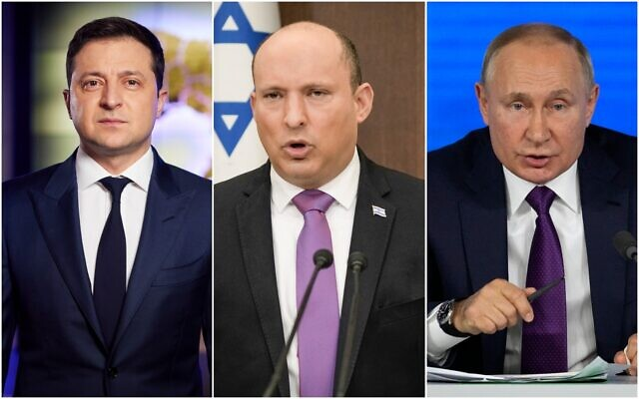
Ukrainian President Volodymyr Zelensky, Prime Minister Naftali Bennett and Russian President Vladimir Putin. (Composite/AP)
Prime Minister Naftali Bennett spoke with both Ukrainian President Volodymyr Zelensky and Russian President Vladimir Putin within a few hours of each other on Wednesday, his second set of public phone calls with the two leaders since Russia invaded Ukraine last week.
According to the Kremlin, Israel had asked for the call with the Russian leader. Putin told Bennett the key to ending the crisis in Ukraine was an agreement that would protect Russia’s defensive interests, the Russian presidency said.
Earlier on Wednesday afternoon, Bennett spoke with Zelensky to discuss “Russian aggression,” the Ukrainian premier wrote on Twitter.
Bennett’s office produced a similarly short statement, saying that the phone call was a follow-up “to their conversation last Friday, in which they agreed to maintain continuous communication.”
According to a longer readout of the conversation carried by Hebrew media, the two leaders discussed Israeli humanitarian aid to Ukraine as well as the country’s needs. The two also reportedly addressed a Russian missile attack that damaged the Babyn Yar Holocaust memorial site in Kyiv. A source briefed on the call told Haaretz that Zelensky reiterated his request for military aid from Israel, which Bennett has thus far withheld.
Since Russia invaded Ukraine last Thursday, Israel has sought an elusive middle ground in the conflict: siding with its Western allies while avoiding a rift with Moscow. Russian forces control the airspace in neighboring Syria, where Israeli planes often operate against militias affiliated with Iran; Israel sees Iran as an existential threat. [That is like dancing on the head of a pin and you have to be careful because you could fall off and really injure yourself doing that. – rdb]
Israel has offered on several occasions to mediate talks to end the invasion. Ukrainian officials have also said they support the idea, but the initiative has not yet gone any further.
Ukraine and Russia held a round of talks on the border between Ukraine and Belarus on Monday night, even as Russian forces advanced in an attempt to encircle major Ukrainian cities. The negotiations concluded without success.
Other Western countries have provided direct military aid to embattled Ukraine. Germany decided to provide Ukraine with 1,000 anti-tank weapons and 500 surface-to-air missiles on Monday, breaking with decades of established German policy. Israel has limited its aid shipments to humanitarian purposes.
On Tuesday, Bennett said that Israel was seeking to “help quietly” while maintaining its own strategic interests. Israel has expressed its support for the Ukrainian people and has sent a shipment of 100 tons of humanitarian aid. Foreign Minister Yair Lapid condemned the invasion as a “breach of the international order.”
But Bennett has avoided calling out Putin by name, refused Ukrainian requests for military equipment, and vowed to stake out a cautious policy. Israel also declined to co-sponsor a United Nations Security Council resolution condemning the Russian assault.
“From the beginning, the State of Israel has taken a measured and responsible approach, which allows us not only to protect our interests but also to be useful. To be a reliable player, one of the few that can communicate directly with both parties, and assist as required,” Bennett said in a Tuesday speech.
The fragile balancing act has aroused the ire of some European diplomats, The Times of Israel reported on Wednesday morning.
“Israel can’t decide not to be on the side of the European countries and the United States,” said an EU diplomat who spoke on condition of anonymity. https://www.timesofisrael.com/bennett-zelensky-speak-for-second-time-since-start-of-ukraine-crisis/

Russians shell Kharkiv, besiege Mariupol as Ukraine says over 2,000 civilians killed
Moscow says some 500 of its troops killed and nearly 1,600 wounded, in first official casualty figures since the beginning of the war
By Agencies and TOI staff Today, 8:30 pm
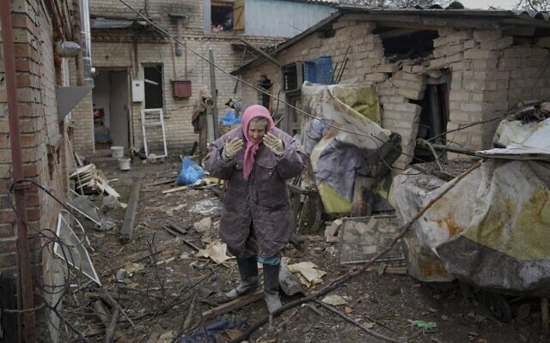  A woman stands in the backyard of a house damaged by a Russian airstrike, according to locals, in Gorenka, outside the capital Kyiv, Ukraine, Wednesday, March 2, 2022 (AP Photo/Vadim Ghirda) | 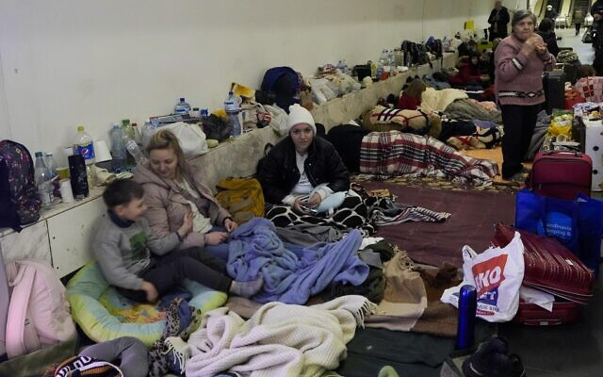  People gather in the Kyiv subway, using it as a bomb shelter in Kyiv, Ukraine, Wednesday, March 2, 2022. Russian forces have escalated their attacks on crowded cities in what Ukraine's leader called a blatant campaign of terror. (AP Photo/Efrem Lukatsky)
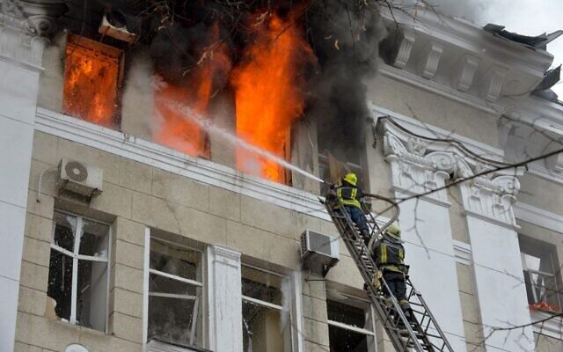  Firefighters work to contain a fire in the complex of buildings housing the Kharkiv regional SBU security service and the regional police, allegedly hit during recent shelling by Russia, in Kharkiv on March 2, 2022. (Sergey BOBOK / AFP) | 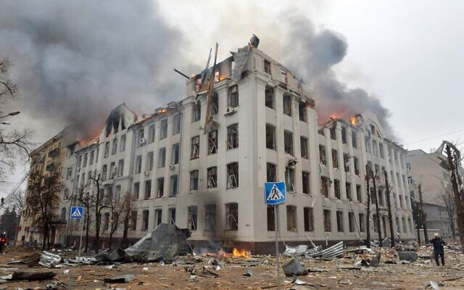  Firefighters work to contain a fire at the Economy Department building of Karazin Kharkiv National University, allegedly hit during recent shelling by Russia, on March 2, 2022. (Sergey BOBOK / AFP)
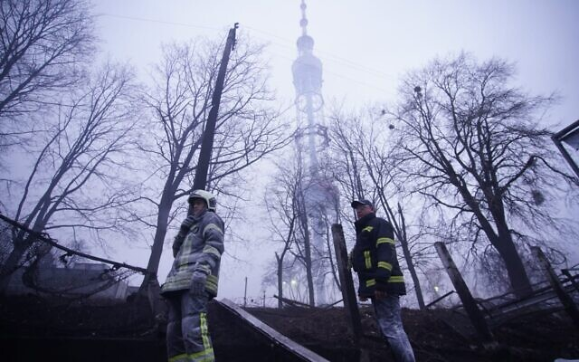  Ukrainian firefighters stand beneath a television broadcast tower in the Jewish cemetery located in Kyiv's Babi Yar Holocaust memorial site on March 1, 2022. (State Emergency Service of Ukraine) | 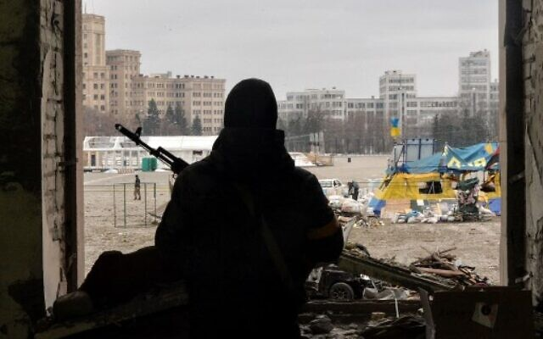  A view of the square outside the damaged local city hall of Kharkiv on March 1, 2022, destroyed as a result of Russian troop shelling. (Sergey BOBOK / AFP)
Russian troops continued to besiege major Ukrainian cities on Wednesday night, shelling the northeastern city of Kharkiv and encircling the southern cities of Mariupol and Kherson, as casualties on both sides continued to rise.
Ukraine’s emergency service announced on Wednesday night that over 2,000 civilians have been killed so far in Russia’s invasion of the country, as the war neared the end of its seventh day, according to the Reuters news agency.
Meanwhile, Moscow said that 498 Russian troops have been killed in Ukraine, in the first death toll Russian authorities have published since the invasion began. Another 1,597 have been wounded, a Russian defense ministry spokesperson said. [This number is much below anything that the media was putting out over the past few days. You have to be very careful about believing much of anything about this conflict because it is as much about the perceptions the various governments and their main stream media groups want to project as it is about the actual truth concerning what is happening on the ground. In reality as one OP ED commented take everything you read with a mountain of salt. That will include the photographs and the videos that are shown on the web and in the MSM. There have been documented episodes of the Media putting on fake news from other battle encounters and also using the same victims over and over again in different makeup. – rdb]
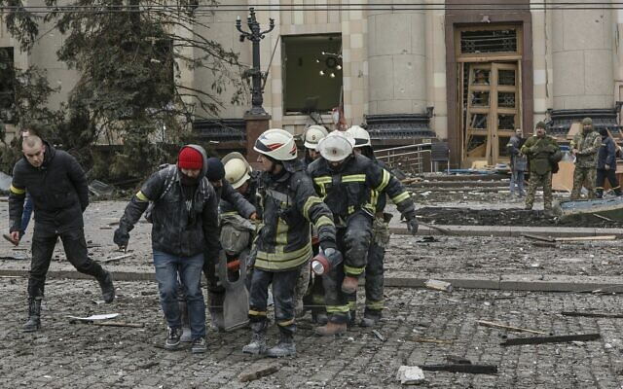  Ukrainian emergency service personnel carry a body of a victim out of the damaged City Hall building following shelling in Kharkiv, Ukraine, March 1, 2022. (AP/Pavel Dorogoy) | 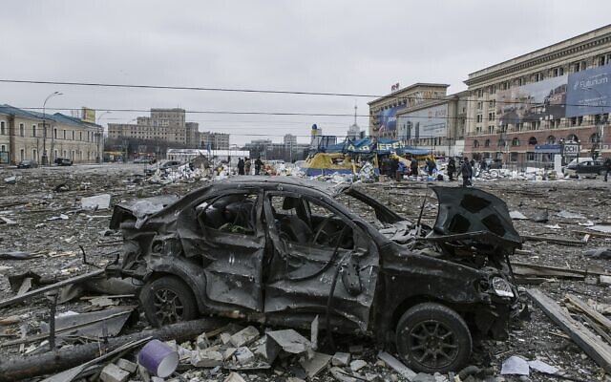  A view of the central square following shelling of the City Hall building in Kharkiv, Ukraine, March 1, 2022. (AP Photo/Pavel Dorogoy)
Ukraine has claimed the toll is far higher, at nearly 6,000 dead soldiers. The Russian Defense Ministry failed to publish any figures on the matter for several days, despite reports of a rising death count following Russian President Vladimir Putin’s decision to invade.
Russian Maj. Gen. Igor Konashenkov rejected reports of “incalculable losses” among the Russians as “disinformation.” He claimed that more than 2,870 Ukrainian troops have been killed and some 3,700 more sustained injuries, while 572 others have been captured by the Russians.
Ukrainian officials did not comment on the claim and it could not be immediately verified.
Fighting has raged across Ukraine, while miles-long convoys of Russian troops have sought to encircle and besiege major Ukrainian cities. Nearly 836,000 refugees have fled to neighboring countries, according to the United Nations.
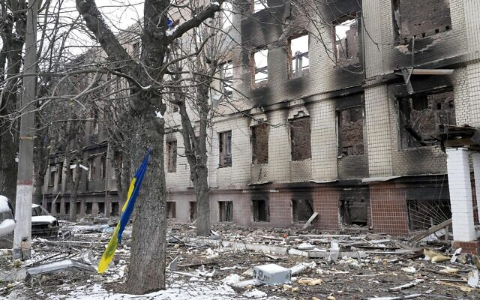
A Ukrainian national flag swings on a tree by a destroyed accommodation building near a checkpoint in Brovary, outside Kyiv, Ukraine, March 1, 2022. (AP Photo/Efrem Lukatsky)
So far, Ukrainians have succeeded in denying Russians the lightning victory they apparently sought in the opening hours of the war. Although Russian forces have heavily bombarded Ukrainian cities, they have yet to conquer a major city.
According to Ukraine’s emergency service, hundreds of buildings have been destroyed, among them hospitals, homes, kindergartens and more.
“Children, women and defense forces are losing their lives every hour,” the service said.
Russian forces shelled several Ukrainian cities as troops battled in the streets of the country’s second-largest city, Kharkiv, all day on Wednesday. Airborne Russian forces landed in the city at dawn in an attempt to win the Russians their first major prize.
Kharkiv, a largely Russian-speaking city near the Russian border, has a population of around 1.4 million.
After a day of battle, Ukrainian officials said on Wednesday night that the advance of Russian troops in Kharkiv had been stopped. In response, Russians had shelled the city with heavy rocket launchers and air attacks.
Explosions thundered on Kharkiv’s Constitution Square, near the buildings of the City Council and the Palace of Labor. A missile attack also destroyed the building of the regional police department and the university building, which is located across the street.
Oleg Sinehubov, head of the Kharkiv regional administration, said that over the past 24 hours 21 people were killed and at least 112 were injured by Russians.
“Kharkiv today is the Stalingrad of the 21st century,” said Oleksiy Arestovich, an adviser to Ukraine President Volodymyr Zelenskyy.
The Russians used Iskander missile systems to bombard Ukrainian cities, including Kharkiv, Kyiv, Zhytomyr and Chernihiv, according to AFP.
“There is nowhere in Kharkiv where shells have not yet struck,” said Anton Gerashchenko, an adviser to Ukraine’s interior minister. MORE - https://www.timesofisrael.com/russians-shell-kharkiv-besiege-mariupol-as-ukraine-says-over-2000-civilians-killed/

Ukraine War: Fake News Everywhere
https://rumble.com/vw8amb-ukraine-war-fake-news-everywhere.html
2 minutes

Russia claims it captured Ukrainian city of Kherson; fighting in Kharkiv renews
Airborne Russian forces land in Ukraine’s second-largest city, sparking fierce street battles; Kyiv says more than 350 civilians, including 14 children, killed since invasion began
By Agencies and TOI staff Today, 12:45 pm
The Russian army claimed on Wednesday it had taken control of the southern Ukrainian city of Kherson as Moscow’s invasion of the pro-Western country entered its seventh day.
“The Russian divisions of the armed forces have taken the regional center of Kherson under full control,” defense ministry spokesman Igor Konashenkov said in televised remarks.
He claimed that public services and transportation were operating as usual.
“The city is not experiencing shortages of food and essential goods,” he added.
He said talks were underway between the Russian army and local authorities on maintaining order, protecting the population and keeping public services functioning.
Kherson’s mayor Igor Kolykhaiev said in a post on Facebook: “We are still Ukraine. Still firm.”
Russian military hardware parked in the center of Kherson tonight. Looks like the Russians captured the city. pic.twitter.com/dmr6kciFBp
— CaucasusWarReport (@Caucasuswar) March 1, 2022
Apparently contradicting the Russian army’s claims, he said he needed to find a way to “collect the (bodies of the) dead” and “restore electricity, gas, water and heating where they are damaged.”
“But I warn you right away: to complete these tasks today means to perform a miracle,” he added.
The Ukrainian Defense Ministry denied that Russian forces have managed to capture the city, according to a spokesperson quoted by CNN.
“According to the info from our brigade the battles are going on now,” a spokesperson for the ministry said. “The city is not captured totally, some parts are under our control.”
Kherson’s Chief Rabbi Yosef Yitzhak Wolf said he was worried for the safety of his congregation, adding that he was looking into options to evacuate the community from the southern Ukrainian city. [Sounds to me that the Russian narrative may be more correct than that of the Kherson mayor – rdb]
“We’re in a new reality and we are worried for the well-being of Jews,” he told the Ynet news site.
All in all, the Russian military damaged more than 1,500 military facilities in Ukraine, Konashenkov, the spokesman, said on Wednesday, adding that 58 planes, 46 drones and 472 tanks and other armored vehicles had been destroyed.
Russian forces continued to target cities throughout Ukraine, with heavy fighting reported in Kharkiv as Russian paratroopers landed in Ukraine’s second-biggest city.
The airborne operation came as US President Joe Biden branded Vladimir Putin a “dictator,” warning the sanction campaign to cripple Russia’s economy would escalate and its oligarchs were being targeted. [Well you might want to put that into some kind of perspective and consider what the leadership in Canada and New Zealand and Australia as well as the demon-rats in DC have been doing over this past year or so. It seems Dictatorial leadership seems to be the vogue now. – rdb]
In Biden’s first State of the Union address, he hailed the resolve of the Western alliance and voiced solidarity with Ukraine as lawmakers in the US Congress gave a standing ovation to the Ukrainian people.
“A Russian dictator, invading a foreign country, has costs around the world,” Biden told lawmakers in his annual State of the Union address, promising “robust action to make sure the pain of our sanctions is targeted at Russia’s economy.”
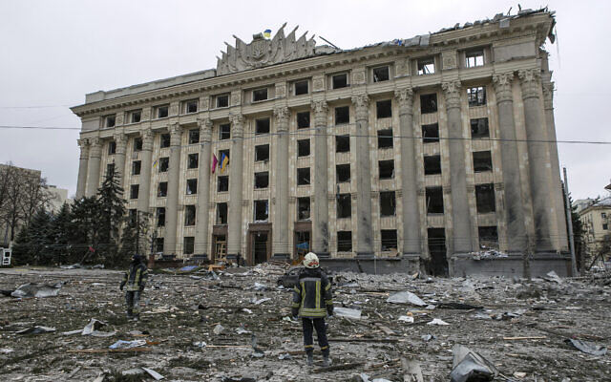
A member of the Ukrainian Emergency Service looks at the City Hall building in the central square following shelling in Kharkiv, Ukraine, March 1, 2022. (AP Photo/Pavel Dorogoy)
But as he spoke a Russian escalation was reported to be underway in Kharkiv, an apparent bid by Moscow to capture its first major Ukrainian city of the invasion.
Since Russian troops rolled into Ukraine last week to achieve Putin’s mission of overthrowing the pro-Western government of President Volodymyr Zelensky, hundreds of civilians have been reported killed.
Russian forces have carried out a massive bombing campaign and encircled urban centers, but Ukraine insists no major city has yet been overtaken.
“Russian airborne troops landed in Kharkiv… and attacked a local hospital,” the Ukrainian army said in a statement on messaging app Telegram. “There is an ongoing fight between the invaders and the Ukrainians.”
Russia hit a residential building in the city on Tuesday, killing eight people and drawing comparisons to the massacres of civilians in Sarajevo in the 1990s and condemnation for what Zelensky called a “war crime.”
Reportedly the main police security headquarters in Kharkiv has been hit in a Russian missile strike pic.twitter.com/pX35qfZqgQ
— ELINT News (@ELINTNews) March 2, 2022
A fire broke out on Wednesday in the barracks of a flight school in Kharkiv following an airstrike, according to Anton Gerashchenko, adviser to the Ukrainian Interior Minister.
“Practically there are no areas left in Kharkiv where an artillery shell has not yet hit,” he was quoted as saying in a statement on Telegram.
Kharkiv, a largely Russian-speaking city near the Russian border, has a population of around 1.4 million
MORE - https://www.timesofisrael.com/russia-claims-it-captured-ukrainian-city-of-kherson-fighting-in-kharkiv-renews/

Holding Torah scroll, Kyiv rabbi curses Russians standing by amid Ukraine invasion
Contentious St. Petersburg-born Rabbi Azman accuses Russia of attacking indiscriminately, unlike Israel; another chief rabbi compares Putin to Hitler, calls to destroy tank convoy
By Judah Ari Gross Today, 8:00 pm

Ukrainian Chief Rabbi Moshe Azman is seen in a video statement, March 2, 2022. (Screenshot: Twitter)
A prominent Kyiv-based rabbi on Tuesday issued a fiery condemnation of Russian people, and specifically Russian Jews, for standing idly by as Moscow pummels Ukraine for the sixth straight day in an attempted invasion.
“Remember that he who does not care and he who agrees silently — that is an accomplice to a crime. A war crime! A crime against humanity!” said the St. Petersburg-born Rabbi Moshe Azman, one of several men who claim to be Ukraine’s chief rabbi.
“I never thought, even in my worst nightmare, that I might have to perish under the shells of Russia, where I was born, where I went to school, where I have many friends, who are silent. Basically, no one has called and asked [how I’m doing]. People call from all over the world. From all over the world. Jews and non-Jews. Even Arabs call me from Israel and support me,” he said, speaking in Russian, in a video statement shared on social media late Tuesday night.
In addition to his disputed status as Ukraine’s chief rabbi — at least three other men also claim the title — Azman made waves last year when he came out in support of the storming of the US Capitol building. He also maintained close ties with several of former US president Donald Trump’s associates involved in the so-called Ukrainegate scandal, in which Trump attempted to withhold military aid to Ukraine unless Kyiv announced it was investigating US President Joe Biden’s son.
In his video, Azman accused the Russian military of indiscriminately bombing Ukraine using Grad rockets, simple 122-mm rockets fired from a truck-mounted launcher, which he contrasted with the Israeli military’s use of “high accuracy missiles” to kill terrorists “so as to not, God forbid, hurt the peaceful population.”
“Here? Look. Look at the videos. Maybe you’re not shown this. They shoot with Grad. Gras are not high-accuracy weapons. Grads, tanks, ballistic rockets, planes. What’s going on? War. War! War!” he said.
Holding a Torah scroll, Azman said he “curses” those who are “silent accomplices in this horrible crime.”
“I’m standing with the holy Torah. This Torah has been given to us by the Almighty. And I’m telling you on the Torah,” he says.
Good Lord! Stunning and powerful words of Ukraine's Chief Rabbi.
With ENGLISH SUBTILES.
[Special thanks for the efforts of my Ukrainian friend for transcribing this]
Please make sure your friends and loved ones see this. ????️☮️???? pic.twitter.com/SG1IAYtO83
— Ali ???????????? (@aliostad) March 1, 2022
In a no less bellicose interview, another chief rabbi of Ukraine, Yaakov Bleich, who is recognized as such by the World Jewish Congress and European Jewish Congress, told CNN that he considered Vladimir Putin to be a Nazi and called for the world to intervene.
“From Friday it went from a war against the Ukrainian army to a war against the people,” Bleich told the outlet. “I’m not gonna call it a genocide because he’s just killing everybody indiscriminately, he doesn’t care about what their genetics are or where they’re coming from.
“He’s killing those people that he said he wants to protect. He’s bombing Kharkiv, which has many Russian-speaking people. Wasn’t he coming to save the Russian-speaking people?”
JUST NOW: "“The Nazi who should be de-Nazified is one man, and his name is Vladimir Putin. He’s killing those people he said he wanted to protect.”
Ukraine Chief Rabbi Yaakov Bleich on Russian attack that hit Babyn Yar…site of a Nazi massacre of Jews.pic.twitter.com/RgSVkDlP68
— John Berman (@JohnBerman) March 2, 2022
On Putin’s claim that he seeks to “de-Nazify” Ukraine with the offensive, Bleich says: “The Nazi that should be de-Nazified — his name is Vladimir Putin.”
Bleich said he’s calling on the entire world to act: “Let’s get up and do something. We can still stop him. We couldn’t stop Hitler in World War II — well maybe we could have but we didn’t — but now we could stop [Putin].
“The world can stop him, NATO can stop him, the United States can stop him. And we can save millions of lives, just by destroying his echelon, 37 miles long of tanks and armored vehicles, where he’s going to destroy the capital of Ukraine and the people that live there. It’s time for the world to do something,” he said.
Last Thursday, following months of build-up, Putin ordered troops to invade the increasingly pro-Western Ukraine to “de-militarize” and “denazify” the country, which has a democratically elected Jewish president.
Ukraine says more than 2,000 civilians have been killed in the conflict as of Wednesday. The International Criminal Court has opened a war crimes investigation against Russia. https://www.timesofisrael.com/holding-torah-scroll-kyiv-rabbi-curses-russians-standing-by-amid-ukraine-invasion/ [Are you getting the idea that this entire process is one of western globalism (NATO EU etc) versus an anti-globalist regime? From what I have been reading it is sounding that way. – rdb]

Sanctions highlight money flow from Russian Jewish billionaires to Jewish nonprofits
Targeted oligarchs include prominent Jewish philanthropists, whose giving is vital to the organizations they support but may get ensnared as West bids to isolate Putin over Ukraine
By Asaf Shalev Today, 11:51 am
Left to right: Mikhail Fridman (Mikhail Svetlov/Getty Images via JTA), Boris Mints (Jason Kempin/Getty Images for World Chess Championship via JTA), Moshe Kantor (Menahem Kahana/AFP via Getty Images via JTA), Roman Abramovich (Ian Walton/Getty Images via JTA).
JTA — Jewish communities in Ukraine received a $10 million gift from a perhaps unlikely source Monday: a charitable organization founded by three Russian Jewish oligarchs who are being accused of having supported the regime of Russian President Vladimir Putin.
The donation is small for the three billionaires behind Genesis Philanthropy Group — Mikhail Fridman, Petr Aven and German Khan — who are together worth $21 billion. But it is significant in part because it signals daylight between them and Putin, who on Thursday invaded Ukraine and plunged the region into crisis.
The gift is also significant because it comes as the West determines whether and how to penalize Putin’s allies by targeting their wealth. A day after the gift’s announcement, the European Union added Fridman, Aven and several other Russian businessmen to its sanctions blacklist as part of its response to Russia’s invasion of Ukraine.
“With these additional sanctions, we are targeting all who are having a significant economic role in supporting Putin’s regime, and benefit financially from the system,” EU foreign policy chief Josep Borrell said in a statement. “These sanctions will expose the wealth of Putin’s elite. Those who enable the invasion of Ukraine will pay a price for their action.”
The billionaires who face sanctions include a number of prominent Jewish philanthropists, whose giving is vital to the organizations they support but may get ensnared by financial sanctions as the West seeks to isolate Putin and his supporters.
Fridman and Aven, as well as Khan, appear among 210 names of prominent Russians on a list of possible targets for sanctions that was released by the US Treasury Department in 2018.
Dubbed “Putin’s list,” the names represent top political figures and so-called oligarchs who have amassed wealth and influence under Putin’s administration of the Kremlin. They are seen as potential targets for sanctions that would prevent them from participating in global commerce, in hopes of pressuring Putin to end the invasion of Ukraine.
At least 18 of the figures on “Putin’s list” are oligarchs with Jewish backgrounds, many of whom, as with the men behind the Genesis Philanthropy Group, have ramped up donations to Jewish charities around the world in recent years. Their giving has shaped efforts to commemorate the Holocaust, inculcate Jewish identity and fight antisemitism. Many have also given to Chabad, the Hasidic Jewish outreach movement, in Russia, and to Moscow’s Jewish Museum and Tolerance Center.
In addition to simply allowing people with wealth to assert their values and strengthen the organizations they favor, philanthropy can be understood as a form of “cultural diplomacy” when practiced by people close to leaders like Putin. It can also be useful in enhancing the reputation of people who accumulated wealth in an environment plagued by corruption.
Overall, charitable giving has risen substantially among wealthy Russians in recent years. And with the coming of age of a generation of Jews who were raised in the former Soviet Union, some who have made fortunes are starting to give back to their communities and are becoming an important force in Jewish philanthropy in recent years, according to Andres Spokoiny, CEO of the Jewish Funders Network.
“There’s also a trend among Russian-speaking Jewry of rediscovering a sense of Jewish identity that was denied to them when they were growing up and feeling a commitment towards it,” Spokoiny said.
Possibly the best-known Russian Jewish oligarch is Roman Abramovich, who made his billions in oil, steel and mining following the breakup of state-owned businesses after the fall of the Soviet Union. The owner of the elite Chelsea Football Club in England’s Premier League, he has reportedly donated more than $500 million to Jewish nonprofits in Israel and around the world.
Abramovich stepped back from Chelsea this week in anticipation of sanctions. But so far, Western sanctions have been concentrated on Putin himself, Russian Foreign Minister Sergey Lavrov and Russian financial institutions. These add to sanctions on a limited number of Putin cronies imposed in 2014 following Russia’s annexation of Crimea and in 2016 amid revelations of Russian interference in the US presidential election.
The potential for new sanctions targeting oligarchs brings attention to the flow of money from Russia’s Jewish billionaires to Jewish nonprofits.
The $10 million donation announced by Genesis Philanthropy Group is going to support the Jewish Agency for Israel, Joint Distribution Committee, Federation of Jewish Communities of Ukraine, and regional and local Jewish community organizations to pay for evacuation and security efforts, food distribution and relief for elderly homes and orphanages.
During normal times Genesis also gives to mainstay Jewish causes like Hillel, Moishe House, Birthright, and Limmud, according to its website. The organization is perhaps best known for establishing the Genesis Prize, an annual $1 million award, dubbed “the Jewish Nobel,” given to prominent Jewish figures.
Asked by the Jewish Telegraphic Agency to comment on how the threat of sanctions is affecting the decisions being made by Genesis Philanthropy Group, the organization’s CEO Marina Yudborovsky released a statement: “Genesis Philanthropy Group has a long history of making independent grants and this follows that tradition. Our work is needed now more than ever, and we will continue to support Jewish communities around the world.”
On Sunday, Fridman, Genesis co-founder and trustee and one of Russia’s richest people, became the first Russian oligarch to speak out against the war, calling it a “tragedy,” according to the Financial Times. In a letter he reportedly wrote to employees of his London-based private equity firm, he said he was “convinced … war can never be the answer.”
Fridman is the controlling owner of Alfa-Bank, a major Russian financial institution that the United States and European Union last week placed under sanctions, limiting its ability to operate internationally.
Fridman’s statement was followed by a similar one from a second Jewish oligarch, Oleg Deripaska. “Peace is very important! Negotiations must begin as soon as possible!” Deripaska, an outspoken Putin supporter who has been under US sanctions, wrote on Telegram, according to the Financial Times. MORE - https://www.timesofisrael.com/sanctions-highlight-money-flow-from-russian-jewish-billionaires-to-jewish-nonprofits/

Doctors in Israel care for Ukrainians 2,000 km away, as tech shrinks world
Using computerized systems built in Israel, physicians examine refugees on the Ukraine-Moldova border, check lungs, blood stats and even conduct prenatal ultrasounds
By Nathan Jeffay Today, 8:01 pm
In an office near Tel Aviv, a doctor checks the lungs of a Ukrainian refugee who is 2,000 kilometers away. It’s part of a new “virtual hospital” that has Israeli medical staff caring for people injured or displaced in Russia’s onslaught.
They are seeing patients using a range of tech solutions, many of them Israeli-built, that provide the refugees with telemedicine physical examinations, prenatal ultrasounds, health vitals monitoring, blood sample analysis and a range of other checks.
The medical professionals are located at Sheba Medical Center, Israel’s largest hospital, while the patients are in Chisinau, the Moldavan capital. In this city, near the Ukraine border, Sheba has one doctor and several volunteers helping patients to interact with the doctors in Israel.
The Sheba team is part of a delegation sent by United Hatzalah of Israel, the Jerusalem-based rescue organization.
“I have been treating everyone. There have been pregnant mothers and elderly men and women suffering from a range of ailments caused by the long and incredibly stressful journey to cross the border,” Prof. Gadi Segal, head of internal telemedicine at Sheba, told The Times of Israel.
“And there have been children and chronic patients in need of urgent advanced blood tests. And all of them are given care from my office in Sheba.”
Pregnant patient and Ukrainian refugee Sarah Misk using Sheba Beyond’s telehealth technology in Moldova to talk to doctors in Israel, March 2, 2022. (Sheba Medical Center) | A doctor at Sheba Medical Center provides care for a Ukra Sarah Misk using Sheba Beyond’s telehealth technology in Kishinev, Moldova, March 2, 2022. (Sheba Medical Center)
He said that Israeli telemedicine advanced during the coronavirus crisis, adding: “We learned during the pandemic how telemedicine can revolutionize medicine, and it’s moving to be able to use it to treat the refugees virtually from Israel.
“The limits of geography and distance are being abolished. We can execute the best clinical judgment and the best professional consultations for patients in a war zone and even on the front lines.”
One of the systems in use, Pulsenmore, is a portable prenatal ultrasound device that takes images anywhere and sends them for analysis to Sheba’s obstetrics and gynecology department in Israel.
Computerized footage of an ultrasound device in development by Israeli startup PulseNmore. (Screen capture: Hadashot)
TytoCare checks refugee children’s lungs, heart, mouth, ears, skin, temperature and oxygen saturation levels, while units by Biobeat Medical Technologies monitor vital signs and displays them on the remote physician’s dashboard in real time.
Sarit Lerner, chief technology for Sheba Beyond, her hospital’s telemedicine program, said that her team acted as soon as it recognized the opportunity.
“We felt we had a moral obligation to provide the technology and expertise of Sheba’s clinicians and specialists to be on the ground to help these refugees,” she said. https://www.timesofisrael.com/doctors-in-israel-care-for-ukrainians-2000-km-away-as-tech-shrinks-world/ [Once again Israel leads the way with their ability to use their technology to transform the care of patients. – rdb]

Bennett tells Scholz leaders must bring about an end to bloodshed in Ukraine
In his first official visit to Israel, Scholz says he was moved after the Babi Yar memorial was damaged in a Russian missile strike and by his visit to Yad Vashem; Bennett once again avoids explicit condemnation of Russia
Itamar Eichner, Einav Halabi | Published: 03.02.22, 14:00
Prime Minister Naftali Bennett said on Wednesday that he and visiting German Chancellor Olaf Scholz had a lengthy conversation.
"You insisted on coming although you had to cut your visit short under the circumstances," Bennett said referring to the Russian invasion of Ukraine.
Sholtz is in Jerusalem on his first official visit to Israel since taking office.
"It is our duty as leaders to do everything possible to end the bloodshed and bring the warring sides to the negotiating table, "Bennett said in a press conference following the joint visit to Yad Vashem.
Bennett once again chose not to explicitly condemn Russia for its invasion of Ukraine.
"Israel sent 100 tons of humanitarian assistance, most of it medical supplies and we are determined to continue that effort and even increase it," Bennett said.
When a journalist asked the prime minister why Israel was refusing to impose sanctions on Russia, Bennett attempted to avoid the question.
"We have a measured and responsible policy aimed at assisting the Ukrainian people. We will do whatever we can," he said.
Scholz said it was important for him to come to Israel despite the complicated situation in Europe.
German Chancellor Olaf Scholz and Naftali Bennett during a press conference on Tuesday (Photo: Alex Gamburg) | German Chancellor Olaf Scholz with Naftali Bennett and Yad Vashem president Dani Dayan (Photo: GPO)
"The news from Ukraine is terrible," the chancellor said. "We are concerned by the evolving conflict and must do everything possible to change the situation. We already see the number of refugees forced to flee. Many of them arriving in Europe and their number will only grow."
" We are trying to bring about an end to the fighting and to peace talks. Every day of battles causes destruction of infrastructure, loss of civilian and military lives on both sides and we must end it," he said.
When asked about his view of Israel's seemingly hesitant response to the war Scholz said the danger associated with war cannot be understated.
"Our stance was clear. We do not attack militarily. That is up to NATO. There will not be military intervention because that is not appropriate now," the chancellor said.
"We support a number of economic options. That is the decision we have taken and what we can do now. Sanctions will have their effect and the steps we have taken were right. We all agree persecution of people cannot be accepted."
For long weeks, Germany refused to send lethal weapons to Ukraine basing the decision on its dark Nazi past but had changed course recently when Scholz announced he would invest 100 billion euros in his country's defense this year, "to protect democracy and freedom."
Scholz said he was moved by the damage caused to the Babi Yar memorial in Kyiv on Tuesday, and by his visit at Yad Vashem. https://www.ynetnews.com/article/h1ezca3x9

Israel says outreach to Turkey won't come at Cyprus' expense
President Herzog says aware his Turkey visit has touched a raw nerve in ethnically-split ally but reaffirms Cypriot counterpart 'nothing... will be on the account of this strategic relationship with your country'
Reuters | Published: 03.02.22, 20:58
Any bid by Israel to improve strained ties with Turkey won't come at the expense of its "strategic relationship" with neighboring Cyprus, President Isaac Herzog said Wednesday.
Speaking after talks with his Cypriot counterpart Nicos Anastasiades, Herzog said he's aware next week's visit to Turkey has touched a raw nerve in ethnically-split Cyprus, which accuses Ankara of trying to place the entire island under its control.
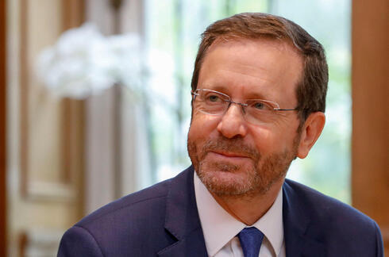
President Isaac Herzog (Photo: Reuters)
Herzog reaffirmed Cypriot President Nicos Anastasiades that "nothing in my visit and what would ensue will be on the account of this strategic relationship with your country."
Herzog delineated that Israel seeks to strengthen relations and pursue dialogue with all nations and all faiths, including Turkey, which he called "a very important neighbor of ours, which has a huge impact on our lives in many fields.
"We have to...if possible to lower the tension and move on in a true dialogue that would definitely include issues of climate and the economy", said Herzog.
Cyprus was divided in 1974 when Turkey invaded following a coup aiming at union with Greece. Only Turkey recognizes a Turkish Cypriot breakaway north where it keeps more than 35,000 troops. Numerous rounds of peace talks over nearly five decades have failed to reunify the island.
Herzog's visit to Turkey comes as the two countries try to mend once close relations that frayed under Turkish President Recep Tayyip Erdogan, an outspoken critic of Israel's policies toward the Palestinians.
Erdogan's support of the militant group Hamas which controls the Gaza strip has previously angered Israel.
Both countries pulled out their ambassadors after the death of nine Turkish activists in 2010 when Israeli commandos stormed a Turkish ship trying to break an Israeli blockade of Gaza to deliver humanitarian aid. In 2018, Turkey again recalled its ambassador to Israel following the U.S. decision to relocate its embassy to Jerusalem.
Herzog said he would convey to Erdogan a message of "collaboration between peoples and all faiths for the well-being of humanity".
Cypriot-Israeli ties blossomed over the last decade following sizeable natural gas deposits in east Mediterranean waters. The two countries have joined with Greece to look for ways to build on the energy-based cooperation, including joint projects to harness the region's gas potential.
Isaac Herzog and Greek PM Kyriakos Mitsotakis (Photo: AP)
One such project is a pipeline to convey Israeli and Cypriot gas to Europe via Greece. Although some have cast doubt on whether the project is economically viable and environmentally sound, Anastasiades said it could still be an option that allows Europe to diversify from Russian gas sources.
Turkey doesn't recognize the island's Greek Cypriot-dominated government and decries its "unilateral" gas search, claiming it ignores Turkish Cypriot rights to potential mineral wealth and claims of Cyprus' exclusive economic zone as its own. https://www.ynetnews.com/article/bjggjxpx5

Israel, US ink new cybersecurity collaboration deals to combat threats, bolster R&D
Israeli cyber directorate, US Homeland Security deepen ties on joint research of cyber technologies and protection
By Ricky Ben-David and Carrie Keller-Lynn Today, 5:31 pm
DHS Under Secretary for Strategy, Policy and Plans Robert Silvers, left, with Israel National Cyber Directorate Director-General Gaby Portnoy on March 2, 2022 in Jerusalem, after signing new cybersecurity collaboration agreements. (Eleonoa Shilova / Israel National Cyber Directorate)
Israel and the US finalized a series of cybersecurity collaboration agreements this week aimed at deepening and expanding ties between the two countries on the cyber front.
The areas of cybersecurity cooperation include Israel-US collaboration on combating terrorist financing, creating an institutional vehicle to enable cyber-specific research and development, and collaborating on transportation cybersecurity.
On Wednesday, Israel National Cyber Directorate Director-General Gaby Portnoy and US Department of Homeland Security (DHS) Under Secretary for Strategy, Policy and Plans Robert Silvers signed an agreement to enhance cyber cooperation between the two countries on protecting their respective economies and critical infrastructure, increasing collaborative risk management of cyber threats, countering ransomware attacks, and promoting bilateral cyber R&D and partnerships between the public and private sectors.
The Israel National Cyber Directorate said the purpose of the agreement was to promote advanced technologies for cyber protection and strengthen information sharing on the ground and expert exchanges in fields like artificial intelligence, quantum computing, homomorphic encryption, and navigation technology.
The directorate also signed a separate agreement with the Transportation Security Administration (TSA) — housed under DHS — to enhance cybersecurity collaboration in the realm of transportation.
The memorandum of understanding aims to advance cyber defense coordination between Israel and the US in the transportation sector with an emphasis on civil aviation security, the directorate said. The agreement will enhance information sharing, joint exercises, and research and development related to securing air and ground transportation.
The agreements were signed Wednesday on the sidelines of the annual Cybertech conference in Tel Aviv, a cyber technology summit that brings together government officials, industry executives, entrepreneurs, investors, and cyber researchers.
Silvers arrived in Israel on Sunday and on Tuesday signed a memorandum of understanding to collaborate on financial crime with the Defense Ministry’s National Bureau for Counter Terror Financing. The MOU was signed on behalf of DHS’ Homeland Security Investigations.
In November, US Deputy Secretary of the Treasury Wally Adeyemo traveled to Israel to announce a partnership targeting financial crime. The new MOU is separate but expected to be complementary to the Treasury initiative.
U.S. DHS Under Secretary for Strategy, Policy and Plans Robert Silvers (R) signs a Memorandum of Understanding with an Paul Landes, Head of the Defense Ministry’s National Bureau for Counter Terror Financing in Tel Aviv, March 1, 2022. (David Azagury/U.S. Embassy Jerusalem)
Silvers told The Times of Israel in an interview in Jerusalem on Sunday that the joint commitments with the Cyber Directorate were part of a framework agreement to provide enabling infrastructure, rather than specific in their technological or goal details.
“What we’re doing is setting up a framework,” he said. “And then what we do is we put the engineers in the room together and they determine what are the right priorities to jointly pursue. I know we’ve talked about things over time, like Internet of Things, cybersecurity in the aviation and other transportation sectors. This creates a vehicle for the experts to go pursue [those areas of interest].”
In a commitment to joint research and development, the parties plan to expand the Binational Industrial Research and Development (BIRD) program, which is a jointly funded initiative running since 1977 for scientific collaboration between Israel and the United States.
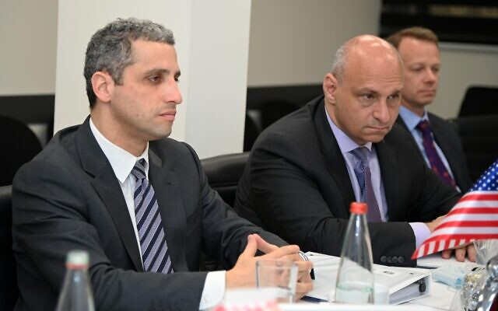
Silvers said the new instantiation will add the Cyber Directorate to the BIRD program, which has previously been run between DHS and the Public Security Ministry. The Cyber Directorate’s version of BIRD is expected to focus on cybersecurity and emerging technologies, particularly related to ransomware and securing critical infrastructure, a US Embassy source told The Times of Israel Monday.

U.S. DHS Under Secretary for Strategy, Policy and Plans Robert Silvers (L) attends a meeting at the Defense Ministry’s National Bureau for Counter Terror Financing in Tel Aviv, March 1, 2022. (David Azagury/U.S. Embassy Jerusalem)
“What we’re actually doing now is adding the Israel National Cyber Directorate to [the BIRD] agreement because we want to be able to go deeper on cybersecurity research and development,” Silvers said. “We have a dedicated science and technology center within our Department of Homeland Security, and we bring them to the table and their expertise, their engineers to advance those kinds of priorities.” MORE - https://www.timesofisrael.com/israel-us-ink-new-cybersecurity-collaboration-deals-to-combat-threats-bolster-rd/

Israeli man stabbed in Palestinian town of Hizme, moderately hurt
Police say background of incident unclear; 48-year-old claims to have been attacked while shopping in East Jerusalem area
By Emanuel Fabian Today, 7:35 pm
Medics are seen at Hizme checkpoint in the West Bank, north of Jerusalem, on March 2, 2022. (Rescuers Without Borders)
A 48-year-old Jewish Israeli man was moderately hurt after apparently being stabbed in the Palestinian town of Hizme on Wednesday afternoon, police and medics said.
Police said the man, a resident of Jerusalem, arrived at a nearby checkpoint and claimed he was stabbed while in a store in the area.
The background of the incident was not immediately clear, police said, meaning they weren’t ruling out the possibility the stabbing was a terror attack.
It added that an investigation has been launched.
The man was taken by medics to Shaare Zedek Medical Center in Jerusalem.
Hizme checkpoint has been the site of numerous attacks by Palestinians in recent years, mainly against Israeli security forces. https://www.timesofisrael.com/israeli-man-stabbed-in-palestinian-village-of-hizme-moderately-hurt/

Russian FM warns World War 3 will be 'devastating nuclear war'
Moscow Exchange suspended for third day in a row * Russian troops land in Kharkiv
By TZVI JOFFRE, REUTERS Published: MARCH 2, 2022 08:20 Updated: MARCH 2, 2022 16:11
Russian Foreign Minister Sergey Lavrov warned on Wednesday that "World War III will be a devastating nuclear war," during an interview with Al-Jazeera and as Russia's invasion of Ukraine entered its seventh day.
Lavrov additionally stressed that US President Joe Biden had stated that the alternative to the sanctions imposed by the West on Russia would be a third world war.
The foreign minister had warned on Tuesday that Russia finds it "unacceptable" that American nuclear weapons are located in Europe, saying it is "high time to return them to the US," according to TASS. Lavrov repeated claims that Ukraine is planning to acquire nuclear weapons on Wednesday, saying Russia would act to prevent this.
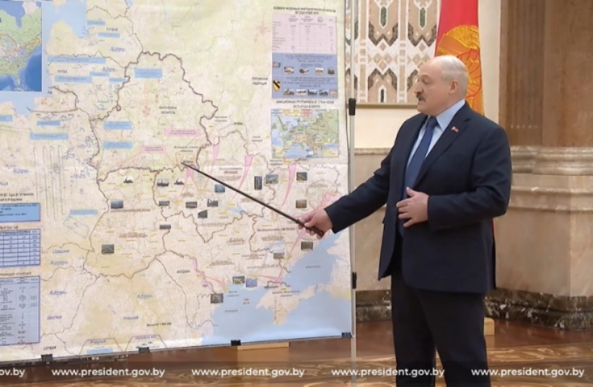
On Sunday, Russian President Vladimir Putin ordered his military command to put Russia's deterrence forces - a reference to units which include nuclear arms - on high alert in response to "aggressive statements" from NATO members.
Belarusian President Alexander Lukashenko recently warned that Western sanctions were pushing Russia towards a "third world war."
Belarusian President Alexander Lukashenko gestures at a map which seems to represent the Russian invasion of Ukraine at a meeting of the Belarusian Security Council (credit: Screenshot/Video from Press Service of the President of the Republic of Belarus)
Ukrainians fight to protect nuclear power plant
Thousands of Ukrainians worked on Wednesday to form a barricade to hold back Russian forces nearing Enerhodar, where Europe's largest nuclear power plant is located, according to the city's mayor.
Anton Herashchenko, an advisor to the Ukrainian Internal Affairs Ministry, warned that the fighting near the nuclear power plant in Enerhodar could cause damage to equipment necessary for the safety of the plant. He added that this could cause an incident like the one at Chernobyl or at Fukushima.
"Radiation does not know nationalities," wrote Herashchenko on Facebook, calling on Russian forces to bypass the area.
The Russian Defense Ministry had claimed in recent days to have captured the Zaporizhzhia Nuclear Power Station in Enerhodar, although an update on Wednesday from the IAEA stated only that Russian forces had taken control of the territory around the plant and that the power plant was still under the control of the Ukrainian national operator.
Civilians killed as Russian bombardment continues
The Russian Defense Ministry claimed on Wednesday that Russian forces managed to take control of the Ukrainian city of Kherson, according to TASS. The Defense Ministry added that Russian forces have destroyed 1,502 Ukrainian military facilities and systems.
An intelligence update by the UK Defense Ministry on Wednesday morning stated that while Russian forces had reportedly moved into Kherson, overall gains across the country have been limited in the past 24 hours.
Russian forces continued to target cities throughout Ukraine, with heavy fighting reported in Kharkiv as Russian paratroopers landed in the Ukrainian city and proceeded to attack the Kharkiv Military Medical Center.
Советник главы МВД Антон Геращенко опубликовал кадры, на которых, по его информации, наносят удар по зданию областного Управления полиции в Харькове. Здание горит. Минобороны России утверждает, что не ведет огонь по гражданским целям.https://t.co/W55myZ8CAm pic.twitter.com/dDjIxeJKSd
— Новая Газета (@novaya_gazeta) March 2, 2022
The police department in Kharkiv was reportedly hit by a Russian attack on Wednesday morning, with video reportedly from the scene showing the building on fire. The Faculty of Sociology at Kharkiv National University was also reportedly hit.
At least 21 people were killed and 112 wounded in shelling in the eastern Ukrainian city of Kharkiv in the last 24 hours, regional governor Oleg Synegubov said on Wednesday.
Ukraine's State Emergency Service reported on Wednesday that three people were killed and 16 others were injured in a Russian air strike in Zhytomyr overnight. The strike reportedly damaged a maternity hospital.
The Ukrainian state Ukrinform news agency reported that a senior official from the Pentagon stated that over 80% of Russia's combat potential had already been introduced into the conflict in Ukraine, with preparation to attack Kyiv and Kharkiv.
Ukraine's Armed Forces claimed on Wednesday that over 5,800 Russian soldiers had been killed and that Russia had lost 211 tanks, 862 armored vehicles, nine air defense systems, 30 planes, 31 helicopters and three UAVs.
The Ukrainian Armed Forces stated on Wednesday morning that Russian troops were attempting to surround the cities of Sumy, Lebedyn and Okhtyrka and to block Kyiv from the northeast. The military added that Russian troops were preparing for a landing operation from the Black Sea as well. MORE - https://www.jpost.com/international/article-699089

The IDF is studying the war in Ukraine
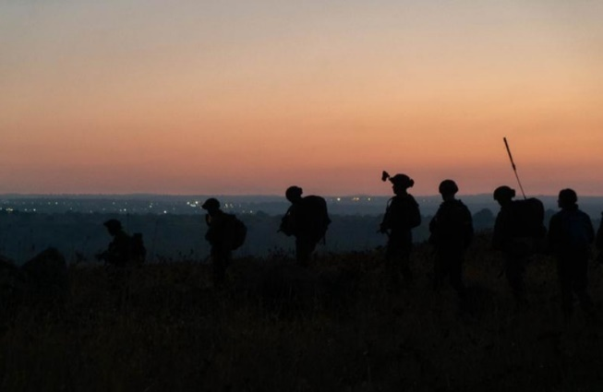
The teams will gather information and intelligence in the fields of combat methods, air defense, anti-tank, cyber and electronic warfare and more.
By ANNA AHRONHEIM Published: MARCH 2, 2022 17:39 Updated: MARCH 2, 2022 17:50

IDF soldiers are seen taking part in military drills in Israel's North to simulate a war with Hezbollah.(photo credit: IDF SPOKESPERSON'S UNIT)
The Israel Defense Forces have set up teams to track and learn from the Russian invasion of Ukraine, The Jerusalem Post has learned.
According to Walla News, the teams will gather information and intelligence for the Israeli military in the fields of combat methods and doctrine, ground maneuvers, logistics, air defense, anti-tank, cyber and electronic warfare, psychological warfare and more.
As the war in Ukraine enters its second week, thousands of videos are being posted on social media, making it possible for the Israeli military to gather mounds of critical intelligence that could help troops in future wars.
The IDF is undoubtedly looking at the chaos surrounding issues with logistics that have forced a 40-mile long convoy to stall outside of the capital of Kyiv. According to a US defense official, the convoy has made little headway toward the city since Monday because some elements “are literally out of gas” and troops have run out of food.
The Israeli military faced logistics problems during several wars, including during the Second Lebanon War in 2006, when the military had difficulty getting supplies to troops on the ground. During the 2012 Operation Pillar of Defense against terrorist groups in the Gaza Strip, reservists and troops complained of food shortages.
The IDF will also be looking at how Russian troops maneuver their tanks and heavy armored vehicles and face Ukrainians who have taken up arms to repel invading forces.
No Israel tank has maneuvered into dense urban areas since the Second Lebanon War in Lebanon and the 2014 Gaza War, the IDF knows that in any future combat scenario, troops will have to maneuver deep into enemy territory and face guerrilla and urban tactics.
Though the IDF has been investing in precision munitions that can be fired from standoff ranges in order to reduce the risk to ground forces, tanks and armored fighting vehicles remain a central aspect of any battle in which the IDF engages.
The Ukrainian response to Russian tanks – which currently is mostly anti-tank weapon systems like the Javelin and NLAW – will also be studied by Israel. Israel watched closely as Russia tested various platforms in Syria and is watching even closer to see if they can take on the Western arms provided to Ukraine.
Though heavily outnumbered by Russia, the Ukrainians have been able to hold out thus far and inflict severe damage to the forces of the nuclear superpower.
The threats by Russian President Vladimir Putin to use his nuclear weapons will also likely be studied by the Israeli military as well, especially to see how the West responds to such threats. Israel is trying to stop Iran’s nuclear program in order never to find itself in a situation where it is threatened by Iranian nuclear bombs. But should it happen, Israel would like to have the support of the West to prevent Tehran from using them.
While the war in Europe is far different from a war that Israel would face in the future, the IDF is a military that praises itself for its in-depth investigations and its ability to incorporate battlefield lessons.
Israel’s military is watching closely and learning from Ukraine’s war. https://www.jpost.com/israel-news/article-699130

Official data: Fully vaccinated people account for 9 of 10 COVID deaths
England report demolishes last remaining argument for getting shots
By Art Moore Published March 2, 2022 at 12:09pm
The fully vaccinated account for 9 of every 10 deaths from COVID-19 in England and 4 of 5 deaths among the triple-vaccinated, according to the latest data published by the U.K. Health Security Agency.
The independent British news site The Exposé reported the government report, published Feb. 22, includes a table on page 41 confirming the vast majority of deaths were among the vaccinated.
About 73.5% of the population of England has been fully vaccinated, and 56.9% have received a booster shot, as of Feb. 28.
See the table from the UKHSA report:
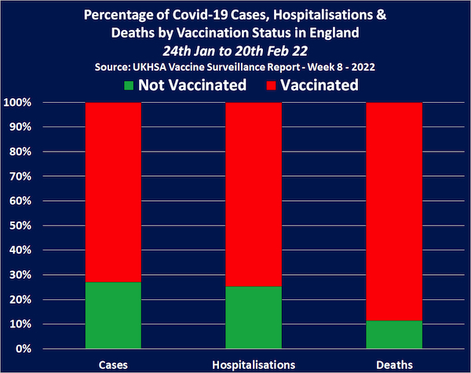
Top health officials around the world, including in the U.S., have acknowledged that the COVID-19 vaccines have not stopped infection or transmission amid the omicron wave – the premise for vaccine mandates – but have insisted the shots prevent hospitalization and death.
However, between Jan 24 and Feb. 20, there were 9,230 COVID-19 hospitalizations in England. The fully vaccinated accounted for 6,689 of them, the triple vaccinated 4,936 and the unvaccinated 2,341.
During that period, there were 4,861 COVID-19 deaths, with the triple vaccinated population accounting for 3,120 of them. The unvaccinated population accounted for only 559.
Overall, the vaccinated population accounted for 89% of all COVID-19 deaths during the four-week period.
The Expose said it's most concerning that while the rate of hospitalizations and deaths has declined for the unvaccinated, it's increased for the vaccinated and boosted.
Between Nov. 22 and Dec. 19, the vaccinated population accounted for 77% of COVID-19 deaths. The latest figures represent a 48% increase. Meanwhile, COVID-19 deaths among the unvaccinated have decreased by 37%.
In the United States, newly published CDC data shows a massive increase in COVID-19 infections and hospitalizations since the emergence of the omicron variant among those who have been fully vaccinated.
Dr. Peter McCullough, a cardiologist and epidemiologist who is one of the leading critics of the COVID vaccines, pointed out that "reductions in hospitalization and death were never demonstrated" in randomized controlled studies.
"Now, (there is) disappointment as the data come in to support what everyone has known for months," he wrote on Twitter. https://www.wnd.com/2022/03/official-data-fully-vaccinated-people-account-9-10-covid-deaths/ [Once again the CDC and friends are demonstrated to be the liars. – rdb]

Targeted doctor tells how government suppressed COVID treatments
Dr. Meryl Nass forced to undergo psychiatric exam for helping patients recover
By Art Moore Published March 2, 2022 at 7:47pm
Dr. Meryl Nass
Dr. Meryl Nass, who been a board-licensed internal physician in Maine for more than 40 years, has had her license suspended while a Maine board conducts an investigation that includes a psychological examination for allegedly spreading "misinformation" about COVID-19 and administering effective treatments such as ivermectin and hydroxychloroquine.
In an article published by Robert F. Kennedy Jr.'s Children's Health Defense, she tells "The Extraordinary Story of How Governments Suppressed Effective COVID Treatments and Targeted Physicians Who Prescribed Them."
She points out that health authorities knew about chloroquine, the milder derivative hydroxychloroquine and other treatments for COVID-19 before there was a COVID-19.
That's because they documented its effectiveness during the 2003 SARS the 2012 MERS epidemics.
"But they hushed it up," she wrote.
Nass has compiled a "stunning collection" of more than 50 ways authorities and pharmaceutical companies in multiple countries stopped the use of chloroquine drugs for COVID.
"'Avoiding the Trump drug' served as a great cover story. Taking hydroxychloroquine for COVID was equated to drinking bleach," she wrote.
WND reported in January that Nass, along with her clinical practice, is a biological warfare epidemiologist who has developed a model for analyzing epidemics to assess whether they are natural or man-made. She has testified to Congress six times and to several state legislatures on bioterrorism, Gulf War syndrome and vaccine safety. She has consulted for the World Bank, the Government Accountability Office and the U.S. Director of National Intelligence regarding the prevention, investigation and mitigation of chemical and biological warfare and pandemics.

In her article, she pointed to a 2005 paper published by the CDC showing chloroquine was an effective drug against SARS coronaviruses. European scientists came to a similar conclusion in 2004.
The CDC study found "chloroquine has strong antiviral effects on SARS-COV infection ... suggesting both prophylactic and therapeutic advantage."
And in 2014, scientists at Dr. Anthony Fauci's National Institute of Allergy and Infectious Diseases came to the same conclusion. Further, the NIAID study found a total of 66 screened drugs were effective at inhibiting either MERS-CoV or SARS-CoV infection in vitro. And 27 of the compounds were effective against both MERS-CoV and SARS-CoV.
"I have to repeat myself because the information is so shocking and I don’t want you to miss it: Our governments already knew of options for treating COVID before it appeared — but instead of immediately trying these already identified, safe, cheap and available drugs, and offering early treatments, they did everything they could to stop people from obtaining the chloroquine drugs," Nass wrote. MORE - https://www.wnd.com/2022/03/targeted-doctor-tells-government-suppressed-covid-treatments/

Afshine Emrani MD FACC
Follow @afshineemrani
Mar 1 • 13 tweets • 4 min read
Pfizer vaccine data. Pfizer wanted you to wait till 2085 to know that the vaccine you took has 9 PAGES of side effects. Start with page 30. I've never seen anything like it. I can't even get my head around this.
phmpt.org/wp-content/upl…
1223 reported fatalities during a 3-month period, out of 42K reports? Was this covered up? I am really confused. This is not what we see in real life. Oy.
n a large new set of data cited by the New York Times, Pfizer’s COVID vaccine showed negative vaccine effectiveness (VE) in children age 5 to 11 after 35 days, with children age 5 to 11 over 40% MORE likely to test positive 42 days after vaccination.
Pfizer Shot Is Far Less Effective in 5- to 11-Year-Olds Than in Older Kids, New Data Show While protection against hospitalization is still strong, the vaccine offered almost no protection against infection, even just a month after full vaccination. https://nytimes.com/2022/02/28/health/pfizer-vaccine-kids.html
Pfizer's Covid-19 vaccine was highly effective at reducing the risk of severe disease (which is extremely low) in children 17 years and younger during the Omicron surge but didn’t work as well at preventing infection
Why was Pfizer FORCED to release safety data?
Pfizer wanted this info delayed 75 years.
9 (NINE!) pages of recorded adverse vaccine events.
In a 3 month period, 1223 out of 42k died after getting injected, or roughly 1 in 35 people.
The government paid for this vaccine. 🤦🤷
Large German health insurance company analyzed data from 10.9 million insured individuals regarding vaccination complications.
The new data is "alarming," says BKK board member Schöfbeck in a report by WELT.
@mentions thoughts?
Dear @lexfridman in light of the release of this data please have a follow discussion on this
@mentions what say you
This is really Outrageous.
Doctors/ pediatricians silent on the vaccine.
Robert Malone still banned after he correctly warned us.
The Pfizer vaccine side effects not trending!
Where is the CDC on this?
Meanwhile mandating our children to get more boosters?!
@mentions
please review this data?
Given
1-the vaccine has little efficacy in children.
2-potential for harm- many!
3-children are at extremely low risk
4- long covid is extremely low in children
WHY MANDATE VACCINES IN CHILDREN?
@mentions how did we bypass informed consent?
At this time I am convinced that Omicron is much safer and more efficacious than the Pfizer vaccine against Covid for healthy children and young adults.
Prove me wrong.
https://threadreaderapp.com/thread/1498796849116823556.html

Anti-vax protesters clash with police outside parliament
The activists have been camped out in the parliament’s grounds for nearly four weeks
2 Mar, 2022 16:38
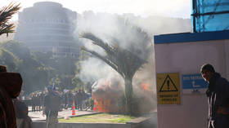
A fire burns near New Zealand's parliament. © Lynn Grieveson / Getty Images
Footage from outside New Zealand’s parliament building showed violent clashes on Wednesday between police and anti-vax protesters, who have been demonstrating there for nearly four weeks.
Hundreds of officers in riot gear moved in on the camp where protesters had gathered, destroying tents, removing vehicles and making 38 arrests. Authorities responded using tripwires, plywood shields, pitchforks and fire extinguishers in a bid to repel police.
#New Zealand Violent clashes between citizens wanting to end vaccination mandates and police in front of Parliament House in #Wellingtonpic.twitter.com/54G3OCUg27
— World News (@ne23614114) March 2, 2022
MORE POLICE BRUTALITY TODAY AGAINST PEACEFUL PROTESTORSPolice continue to use excessive force against peaceful protestors in Wellington. pic.twitter.com/iGRRXoMdg5
— Ali Jan 🇵🇰 (@AliJan_Pk) March 2, 2022
Jacinda Ardern's minions destroy freedom camp in front of Parliament House in Wellington where thousands had gathered against covid tyranny. pic.twitter.com/mmYrjekUKe
— 🏴󠁧󠁢󠁥󠁮󠁧󠁿 PCDoc 🏴󠁧󠁢󠁥󠁮󠁧󠁿 (@PCDoc_Bolton) March 2, 2022
Fire on parliament’s lawn pic.twitter.com/TUJieM8zdB
— Katie Scotcher (@katiescotcher) March 2, 2022
Addressing the situation in parliament on Wednesday, New Zealand Prime Minister Jacinda Arden stated that “police expected there would be hostility, resistance and violence” but what was happening was “another thing entirely to witness.”
She confirmed that a number of police officers had been injured in the clashes but did not specify the exact figure. “I was both angry and also deeply saddened to see parliament, your parliament, our parliament desecrated in that way,” the New Zealand leader said.
At one point, multiple blazes were visible in the grounds of the parliament, including one at a public playground, with smoke and explosions rising from the fire. Protesters were reportedly throwing material on the fire to keep it burning. Ardern later confirmed the blaze had been extinguished by authorities.
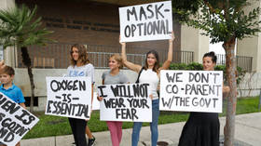
“In the last week, we have seen a changing mix in the makeup of the crowd, in particular we have become concerned that those with good intentions have become outnumbered by those with a willingness to use violence to affect their means,” police commissioner Andrew Coster said ahead of the clashes.
Police moved in to clear the demonstrators as the protest entered its 23rd day on the parliamentary grounds, where activists have been objecting to the imposition of a temporary vaccine mandate by the government on some elements of the workforce.
The protest sprung up in the wake of global demonstrations against vaccine mandates, including, most notably, the ‘Freedom Convoy’ truckers who had blockaded areas near Canada’s parliament to oppose requirements affecting workers moving back and forth between Canada and the US. https://www.rt.com/news/551083-new-zealand-clashes-anti-vax/

Commentary:
Take Anything You Hear About This War with a Mountain of Salt
Kurt Schlichter Posted: Mar 02, 2022 7:50 AM
Let me tell you how wars work. The first report is always wrong and nobody knows nothing.
The battle in Ukraine seems to be one of the most covered and worst covered events in history. You cannot spend more than two minutes on social media without crossing paths with a snippet of shaky cell phone footage of a Russian tank burning or some heroic story of sturdy Ukrainian resistance. You have experts on TV trying to tell you what’s happening but no one is actually giving you any real information. Maybe you think the Ukrainians are winning, that their counterattacks are driving out the Russian invaders. There are plenty of sources saying 2800 or 5300 or some other oddly large and specific number of Russian soldiers are dead. All hail the coming victory!
Well, we’ll see.
Don't believe a damn thing you see or hear right now. I’d like to. I want the Ukrainians to win. But I understand that I, like you, am a target of information operations by Ukrainians, Russians, and even Americans. Get woke to it.
All that exciting footage? What do you know about where it was shot, or when? Nada. Zip. Zero. We’ve seen people trying to pass off simulator footage as real battle footage. We’ve seen explosions and fires without context. What caused them? Who knows when all you have is the label on the video? All those Russian tanks on fire? Well, guess what kind of equipment the Ukrainians use.
I don’t know if the Ukrainians are winning or losing, but I know that a lot of people in the media want them to win. So do I, but simply because I would prefer they send the Russkies packing does not mean that I am blind to what is an obvious and effective propaganda campaign designed to keep the West in Ukraine’s corner. And it has worked, with a few sketchy, wacky exceptions. I am impressed by the information operation designed to get resonant stories out there, like the defiant guardians of Snake Island, the “Ghost of Kyiv,” or that Ukrainian marine who was forced to blow himself up to take out the bridge. It’s like they were designed to appeal to us.
Let’s look at those stories. A remote island protected by a 13-soldier garrison is called upon to surrender but tells a Russian fleet to pound sand (well, technically to pound themselves) and they all die heroically. But luckily, the tape of the glorious exchange is not only available but is provided to the media. That’s pretty convenient. We have a compelling narrative that reinforces the image of brave Ukrainians defiant before the Bear, and we have proof that can be played, and it’s made quickly available to the world in a few hours. It’s a great story - almost too great. And it was – reports are the guys who gave their lives actually gave up and are still breathing.
From the beginning, I wondered why a couple warships decided they would focus their efforts on little Snake Island. Why bother? Those of us who were in the Cold War are familiar with Russian tactics - they tend to bypass strong points. Why would several ships, which presumably had better things to do, stop to take this glorified atoll? And why would they shell it into dust? That takes time (presumably the garrison had bunkers). Of course, the Russians had their own response - they showed some prisoners in Ukrainian uniforms and insisted that the defenders had actually hoisted the white flag. That could be a lie; it could all be a lie. We don’t know, but we do know this is an information operation by both sides to have an effect on us.
Remember the “Ghost of Kyiv?” That was the plucky fighter pilot who allegedly shot down several Russian fighters over the capital. Leave it to that dummy Adam Kinzinger to retweet an obvious photoshopped troll tweet about it. Still, the media was enamored with this supersonic stalwart. Except maybe it was not true. I have grave doubts a Ukrainian plane is going to survive multiple sorties within Russia’s integrated air defense umbrella. Moreover, the various jets we have seen shot down on video (to the extent they are real) sometimes get labeled “Russian” on one account and “Ukrainian” on another.
And then there is the heroic marine as the bridge. Maybe it happened, but then I’m not understanding how he came to not detonate it remotely. You would think that it occurred to the Ukrainians over the last couple months that maybe they need to prep the bridges on the main avenues of attack (everyone knows exactly where the Russians would have to come). It seems unlikely that a bunch of marines suddenly said “Hey, let’s rig this bridge - wait, someone’s got to stay on the bridge to push the plunger.” That’s not how it works (and it’s usually combat engineers, not sea soldiers, who blow up infrastructure). There’s plenty of reason to believe it’s not exactly, you know, true.
But maybe it is. I know a bit about Ukrainians and I could totally see one blowing a bridge while standing on it (especially after a goodbye swig of Hetman vodka, the best vodka I’ve ever had). And even if it is true in whole or part, the story did not get out there because it’s interesting. It got out there because you are supposed to see the iron will and determination of the Ukrainian people.
I have zero heartburn with Ukrainians running their information operation on us. They are doing a pretty good job of achieving their objective with it, and it seems to me that it was clearly planned out well in advance. But that does not mean that you need to let it affect you. Understand that you are being manipulated.
What is harder to understand it the truth. The whole fight is opaque, and it is hard to know whether the Russians are winning or running out of steam. The Russians’ objective was probably to make bold movements to smash Ukrainian formations and go hard to take or surround key objectives like the capital and then force a negotiated settlement that leaves a Putin puppet in charge. But they do not seem to be moving as fast as they probably hoped. Their first-rate forces would lead the attack, and if they are mauled then the follow-on forces are likely to be less capable. A stalemate short of taking the objections that Putin needs for leverage has to be his nightmare.
On the other hand, for all we know we could see a sudden and complete collapse of the Ukrainian Army formations. We hear that they are holding and even counterattacking, but we really do not know. We are watching this war through distorting lens that probably does not give us a real picture of what is happening. In the end, we will probably only find out the truth after it ends - if then. https://townhall.com/columnists/kurtschlichter/2022/03/02/take-anything-you-hear-about-this-war-with-a-mountain-of-salt-n2604010

Biden's 'Capitulation' To Iran Endangers Arabs, Middle East, U.S.
by Khaled Abu Toameh March 2, 2022 at 5:00 am
As the world's attention is focused on the Russia-Ukraine war, the Arabs are continuing to express fear about the possibility that the Biden administration and the world powers will revive the 2015 nuclear deal with Iran.
The Arabs are warning that the appeasement of the extremist and terrorist regime in Tehran would allow Iran's proxy militias to continue their attacks on America's Arab allies and massively destabilize the Middle East. Dr. Ibrahim al-Nahhas, a prominent Saudi political analyst and academic, wrote on February 23:
"The parties of the international community that are negotiating with Iran, especially the P5+1 (the US and the other permanent members of the UN Security Council: China, France, Russia, Britain, and Germany), must realize that the extremist Iranian regime has not, and will not, abide by international laws, regulations and agreements, even if it swore and signed or pledged to abide by and implement them... The Iranian regime was founded on the [former supreme leader of Iran Ayatollah] Khomeini ideology that adopts terrorism and believes in exporting chaos and destruction."
Nahhas cautions that if Iran obtains a nuclear agreement that prioritizes economic, commercial and investment interests at the expense of the security interests of the Arab countries, "the destructive capabilities and extremism of the Khomeini ideology that exported terrorism, chaos, havoc and destruction to the countries of the region will be enhanced."
The Khomeini ideology, Nahhas pointed out, has already brought destruction to Arab countries, including Lebanon, Yemen, Iraq and Syria.
Those who signed the 2015 nuclear deal made "major mistakes," the Saudi political analyst argued.
"They agreed to sit with a regime that explicitly declares its support and sponsorship of terrorism and extremism; they agreed to enter into secret talks [with Iran] without the knowledge of the countries that are negatively affected by the terrorism and extremism of the Iranian regime; and they signed an agreement that did not take into account the interests and concerns of the countries and peoples of the region."
By reaching that deal with Iran, Nahhas added, the US and the other world powers "implicitly accepted extremist political regimes and terrorist and destructive practices. They also accepted Iranian intervention in the internal affairs of other countries, the development of destructive weapons, and acquiring nuclear technology for military purposes."
Nahhas said that he believes that the talks in Vienna between Iran and the US and the world powers will lead to a deal that is worse than the previous agreement.
"The P5+1 group is once again moving towards rewarding the extremist Iranian regime for its terrorist and destructive policies, practices and behavior... This group works without realizing the direct harm to global security, peace and stability. This group needs to take into account the great danger that the extremist Iranian regime poses to global security, peace and stability. It needs to be aware of the great suffering caused by the Iranian regime's terrorism and extremism. It is necessary for this group to listen to the fears and concerns of the countries of the region about the continuation of Iran's nuclear program and to actually learn about the suffering of the peoples affected by the terrorism and extremism of the Iranian regime. The ambitions and policies of the extremist Iranian regime will cause further destabilization of security, peace and global stability if it is given more privileges in the nuclear and armaments fields. If the group does not acknowledge these facts, it will notice them when Iranian terrorism and extremism reach the countries (that are currently negotiating with Iran). The [Iranian] terrorism and extremism, however, will be more violent and destructive, given the nuclear and armaments benefits it will obtain from a new agreement.
Alarmed by reports of an imminent deal with Iran, Syrian political analyst and commentator Rami Al-Khalifa Al-Ali asserted on February 23 that the world will be less safe after the signing of a new nuclear accord with the mullahs in Tehran. Al-Ali wrote:
"Although the Biden administration pledged upon its arrival at the White House that it would not be a third term for former President Barack Obama, it is following him step by step... This is evident in the Biden administration's position on the Iranian nuclear issue. This position seems to be weak, hesitant and subject to Iranian blackmail."
Al-Ali pointed out that the Arabs have repeatedly called to make the Middle East free of weapons of mass destruction.
"But is the nuclear agreement pushing the region a step in this direction? The answer is no. On the contrary, the new agreement will increase tension and push for an arms race and perhaps a race towards possessing nuclear technology. In the end, the countries of the region will not accept being hostage to Iranian nuclear technology."
The Syrian analyst said that according to various leaks, the emerging agreement with Iran does not address the "negative points" of the 2015 agreement that prompted then US President Donald Trump to withdraw from deal in 2018.
"The duration of the agreement is still a negative point," Al-Ali pointed out. "The question is, what will happen after the end of this period? Will Iran be free to reach the nuclear bomb?"
The most dangerous point, he warned, is that the US administration "has ignored other issues in which Iran poses a threat to the region, including the ballistic missile program."
"This program is dangerous in two respects. The first is the ability of Iranian missiles to carry nuclear warheads, and therefore ballistic missiles are part of the nuclear program, and there is no sense in any arrangements that do not take into account placing restrictions on it... The second issue is the spread of these ballistic missiles in the region and the provision of them to terrorist organizations. These missiles are now posing a threat to international trade routes, as well as to neighboring countries that are supposed to be allies of Washington."
Al-Ali also noted that the negotiations held in Vienna did not address Iran's support for terrorist militias.
"This is not a secondary or marginal issue, but it rather directly affects security and stability in the entire region... These militias are Iran's arm in the region and they intend to spread chaos and destruction wherever they are. The [new] agreement is expected to unleash Iran's hand in the region, as what happened during the Obama era, which led to an increase in violence in the region."
The US and its Western allies, Al-Ali said, are mistaken if they think that a new agreement will achieve progress in the region.
"Instead, we expect an increase in the pace of terrorist acts and the growth of conflicts in the region... The threat will reach Western societies. If an agreement is reached with Iran, this will be similar to the Munich Agreement, which released Hitler's hand in Europe and wreaked unprecedented havoc on Europe."
Veteran Lebanese journalist Kheirallah Kheirallah wrote on February 16 that the Biden administration seems ready to cave in to the mullahs in Tehran.
The Ukraine crisis, Kheirallah said, "exposed the weakness of the Biden administration, which appears ready to submit to the Islamic Republic."
"It is not surprising that Vladimir Putin went to the end in Ukraine after discovering that he faced an American administration that could not be more than an extension of Barack Obama's administration. The Biden administration can yell and threaten as much as it wants."
The US, according to the Lebanese journalist, has revealed its "impotence" everywhere in the world.
"Perhaps the most important thing Putin has noticed is that US allies do not trust it... The Russian president must have paused for a long time on American behavior towards what is happening in Yemen and Iran's aggression towards the Arab Gulf states. Whoever discovers all these American weaknesses can only work to benefit from them. There is no doubt that Vladimir Putin is a shrewd man who has manipulated Obama and is currently playing Biden."
Dr. Huda Raouf, an Egyptian political science teacher and researcher in regional and Iranian affairs, wrote that the Iranian regime has understood that the Middle East is no longer a priority for the Biden administration's policy. The Biden administration, according to Raouf, limited its view of the threats to American security to only China and Russia.
"With the sudden and uncalculated withdrawal from Afghanistan, we find that the Middle East is no longer a priority for American policy, which is what Iran finally understood... By looking at the developments of the Vienna talks, we find that the US intends to reach a reduced copy of the original 2015 agreement. So far, the Biden administration does not appear to have a comprehensive approach towards Iran. As long as the US does not negotiate with Iran about its regional behavior, it may have to build a framework with its partners and allies on their concerns regarding Iran even after the nuclear deal is revived."
Raouf noted that Iran feels that it is not being held accountable for its meddling in the internal affairs of the Arab countries.
"So far, it seems to Tehran that there is really no price to pay, as it has not been pressured about its actions in Iraq and its involvement in the wars in Yemen, Lebanon and Syria. These are the most important challenges that may face the region, and there must be a mechanism for solving them. Reviving the [Iran nuclear] agreement will not change Iran's regional positions, including its support for groups such as Hezbollah, Shiite militias in Iraq, the Assad regime in Syria and the Houthis in Yemen."
Lebanese editor and political activist Mustafa Fahs also expressed concern over the impending agreement. In his view, not reaching any agreement would be better than reaching a new one.
"The [upcoming] agreement seems to be a new factor of tension in the region, and not a factor of stability... The neighboring countries, especially the Arab Gulf states, cannot accept a nuclear agreement without restrictions on Iran's ballistic project and its regional influence, as fears that the agreement will be confined to the nuclear issue will lead to an escalation of regional tensions and push Tehran to invest more in its foreign projects."
In such a scenario, Fahs said, the lack of an agreement would be less harmful than reaching a new one.
"The lack of agreement will keep the conflict with Iran confined to the great powers," he added. The lack of agreement may also suit Tehran if it refuses to back down from some of its basic demands. The lack of agreement removes the specter of a confrontation [between Iran and the US]. The proposed agreement will open the door wide to crises."
Sayed Zahra, deputy editor of the Bahraini Akhbar Al-Khaleej newspaper, also asked whether US President Joe Biden has decided to "acquiesce" to Iran.
"Any follower of developments and current events and the positions and policies of the Biden administration will inevitably arrive at the fundamental fact that Biden has decided to acquiesce in Iran; he has decided to yield to its expansionist project, which ultimately aims to impose Iranian hegemony in the region...
"This project is linked to the terrorist and subversive role played by Iran and the forces, militias and groups affiliated with it in the Arab countries, especially Iraq, Lebanon and Yemen. Through these terrorist forces and groups, Iran represents a direct threat to the security and stability of Arab countries. It is sufficient for us to see terrorist attacks on Saudi Arabia and the United Arab Emirates by the Houthis [Iran-backed terrorist militia in Yemen]. This is the danger facing the Arab countries. What is important is that the issue of Iran's terrorist role in the region and the danger of its ballistic missiles is not at all on the table in the negotiations and does not receive any serious attention from America and other countries participating in the negotiations."
Zahra noted that the Gulf states had previously demanded to be partners in the negotiations, but their request was ignored by the US and the world powers.
"This simply means that there is an undeclared American message to Iran that the issue of Tehran's role in the region is not of much concern to Americans... In other words, it means that Iran and its proxies feel at liberty to do whatever they want. It is clear that the US administration has decided to succumb to the reality of Iranian being a nuclear power. It is clear that the US administration no longer cares much about the destructive terrorist role Iran is playing in the region and the capabilities it possesses that allow it to threaten Arab countries through its agents. We should expect that reaching a new agreement with Iran will mark the inauguration of a new era of escalation of the Iranian terrorist threat in the region. The Arab countries must prepare for this."
Clearly, many in the Arab world are aware of the dangers that derive from the Biden administration's anemic attitude towards Iran. These Arabs have alerted the world to the fact that they feel mortally threatened by Biden's perceived capitulation to the mullahs in Tehran and the destabilizing consequences for the region.
Most disturbing is what a growing number of Arabs are trying to warn the Biden administration about: that striking a new deal with Iran would not only embolden Iran and its terrorist proxies and endanger America's friends in the Middle East, but create calamitous turmoil, including a nuclear arms race "on steroids" in the region -- all of which would justifiably be blamed on the Biden administration. It appears that the Biden administration has chosen to ignore the likelihood of this terrifying scenario. It is a decision that is causing irreparable damage to America's credibility in the Middle East.
Moreover, as Arab analysts are saying in no uncertain terms, America and its Western allies are themselves in the sights of the mullahs in Tehran.
Worse, as with Biden's generosity to Russian President Vladimir Putin in extending the new START treaty and gifting him the Nord Stream 2 pipeline (which yesterday filed for bankruptcy), it will not buy goodwill. It will only appear as weakness and accelerate aggression against the West. https://www.gatestoneinstitute.org/18284/biden-capitulation-iran

The Experts, Science, Medicine—All Amazing, All Fallible
By Joan Swirsky|March 1st, 2022
For thousands of years, going back to the Bible, women have wept and grieved and pleaded to God over their miscarriages. Indeed, it took all these millennia for modern-day pharmaceutical companies to develop solutions to this ongoing nightmare.
In the 1940s, they were happy to offer doctors the ability to prescribe diethylstilbestrol (DES) to prevent miscarriage. “You can tell them you would give it to your wife,” the marketing mavens from Big Pharma suggested to physicians.
And with good reason. This “miracle drug” worked! Women who had experienced no trouble conceiving but were plagued by constant miscarriages were now able to carry their babies to term and deliver quite “perfect” bundles of joy!
But then disaster hit with unspeakable horror. After one or two years of watching their beautiful babies smile and roll over and teethe and then walk and speak and thrive, the little girls began developing hideous vaginal cancers, and those who survived to adulthood experienced higher-than-normal premature births, miscarriages, and ectopic pregnancies.
The little boys, too, had horrible anomalies in their urogenital tracts and are still being watched for higher-than-average cases of testicular and prostate cancers.
In 1971, the Food and Drug Administration (FDA) took DES off the market.
So much for the science!
SECOND TIME’S A CHARM
In 1957, another miracle medication, originally marketed as a sleeping pill but also found to prevent miscarriages,was developed in West Germany, and soon found its way to America, where women eagerly took the drug––approved by the FDA––and, again, were thrilled to carry their babies to term.
But unlike DES, where the monstrous effects took months to years to develop, the grotesque and tragic effects of the new drug––Thalidomide––were obvious from the moment of birth: children born with missing arms and legs, eye and urinary tract anomalies, heart problems, et al. The list of horrors went on and on.
So much for the science!
FEMINIST PROGRESS
In 1960, the FDA approved the medication developed by Dr. John Rock, a Harvard professor and obstetrician-gynecologist with five children––along with Drs. Gregory Pincus, C.M. Phang, and Selzo Garcia––that was perhaps the most world-changing medication in history––the Pill (aka the birth-control pill), where for the first time ever women could control reproduction.
But some women––either through negligence or forgetfulness––still got pregnant while on The Pill, and so it was not long before scientists developed intrauterine devices (IUDs) that could be implanted in the cervix and provide absolute sexual freedom with no anxiety about forgetting to take a pillor getting pregnant.
Among the most highly touted IUDs was the FDA-approved Copper 7. But because of the horrific incidences of sterility, pelvic inflammatory disease, ectopic pregnancies and perforations of the uterus, the much-vaunted Copper 7 was taken off the market in January of 1986.
So much for the science!
PLEASE, DOCTOR, STOP THOSE HOT FLASHES!
As the ‘60s progressed, newly empowered women did not politely request but quite assertively demanded help for the tortures they experienced during menopause, when estrogen slowly diminishes in the female body, resulting in hot flashes, mood swings, loss of interest in sex, depression, et al.
Pharmaceutical companies were more than happy to accommodate and promptly offered estrogen-rich Hormone Replacement Therapy, although even the National Institutes of Health acknowledges the controversial history of HRT.
It took decades, but sure enough––after almost 40 years––a Wall St. Journal article reported on the frighteningly high correlation between HRT and breast cancer. Within days, in 2002, one of the most popular medications in the world––Premarin––was taken off the market.
So much for the science!
NOT JUST A WOMAN THING
Indeed, dozens of FDA-approved medications––for both women and men––have been widely prescribed but ultimately taken off the market. They include the antihistamine Seldane, the anti-inflammatory Vioxx, the anti-heartburn/acid reflux Zantac, et al.
In fact. dozens of drugs have been pulled from the market because of their horrific if not catastrophic side effects, including cancers, strokes, heart attacks, and death! Here is a partial list.
So much for the science!
WHAT WE HAVEN’T BEEN TOLD
Well, whaddaya know? Only three months into 2020, just when science and medicine were at the apogee of their evolution, when practically every body part––retina, heart, lung, knee, hip, skin, fingers, et al.––can be replaced, when the fastest-growing segment of our population is between 90 and 100, and when there are more individuals over 100 in America than ever before, along comes a virus from China that in a matter of weeks shuts down the world!
But not to worry! We in America have “experts” to rely on, to guide us, to reassure us that it would only take. a matter of weeks to “flatten the curve” on the frightening escalation of what,in no time, the same experts labeled a genuine pandemic.
As it turned out, every one of their models and projections and pronouncements and reassurances were wrong!
What they didn’t tell us about were the ineffectual-but-fanatically-enforced mask mandates and the non-FDA-approved “vaccines” that all “the experts” insisted every member of society––including infants––must be injected with, as well as the second vaccine, the booster, and the third and even fourth boosters––all of which did not flatten the curve or keep fully-vaccinated and boostered people out of the hospital with Covid!
What they also failed to tell us, as journalist and author Devvy Kidd reports, is that the FDA’s PCR test to determine the presence of Covid is not a diagnostic test and not reliable, as the CDC now admits.
It turned out that the Mt. Everest of information the “experts” withheld from the public, aided and abetted by their lapdogs in the media, were startling facts about the vaccines themselves––all scrupulously documented by writer Kelleigh Nelson––including the prediction that “because of the jabs, the immune system is dying. The result will be high incidences in various countries of tuberculosis where it is now dormant. Tumor cells are no longer under control causing increased numbers of cancers––as evidenced by pathologist Dr. Ryan Cole of Idaho––as well as viruses, herpes, Epstein-Barr, cytomegalovirus (CMV) which kills babies in the womb, toxoplasmosis, and a horrifying number of other illnesses.”
And is it true, as asserted by Sen. Scott Jensen (R-MN), who is a medical doctor, that hospitals get $13,000 per patient if they write that the diagnosis is Covid-19 on the patient’s chart, and $35,000 for each patient if they are on a ventilator? According to FactCheck.org, “The figures cited by Jensen generally square with estimated Medicare payments for COVID-19 hospitalizations, based on average Medicare payments for patients with similar diagnoses.”
And is this simply a coincidence? “Possibly as a reward for their efforts to conceal the true origin of SARS-CoV-2,” Janet Levy details in-depth, the scientists who went along with Dr. Fauci’s ‘natural origins’ narrative “received over $50 million in NIAID funding in 2020- 2021.”
Mmmm….isn’t it always about following the money?!
Then, to insult our intelligence even further, we have dictatorial, egomaniacal martinets like Dr. Anthony Fauci telling us: “The attacks on me are attacks on science.”
So much for the science!
THAT’S NOT ALL WE HAVEN’T BEEN TOLD
As journalist Tim Brown spells out, only two massive entities own all of the media we see and hear every minute of every day. These powerful and immensely wealthy forces believe in a globalist vision in which they––the Masters of the Universe––run the world, and we––mere grains of sand on the vast beaches of life––are expected to admire, believe, comply with and be grateful for whatever they’re doling out.
These moguls, including economic and big-tech powerhouses, hire media whores––I wrote about them here––to disseminate their messages, and, as we’ve all witnessed, to censor or often destroy the lives of all those who disagree with them.
Nevertheless, TRUTH has a way of insinuating its way or erupting its way into the public’s consciousness. This is what happened when contradictory or negative data from the Centers for Disease Control (CDC), from the World Health Organization (WHO), and from “experts” like Dr. Fauci himself were published by courageous media outlets, and frightening information by the Vaccine Adverse Event Reporting System (VAERS) made its way to the larger public.
And what was that frightening information?
THIS IS THE VERY VERY VERY SHORT LIST
Airline and military pilots falling ill or dropping dead mid flight after being vaccinated.
Last year, 400 athletes collapsing unexpectedly with heart problems, the Covid vaccine being the greatest common denominator.
Attorney Tom Renz made worldwide headlines after disclosing explosive data from the Department of Defense DMED database at Senator Ron Johnson’s Second Opinion Hearing. DMED is the official database of the 1.4-million active-duty DoD servicemen and it showed shocking increases in medical conditions from the mRNA “vaccines” after the military demanded injections for all service members: Here are the data:
279% SPIKE in Miscarriages
487% SPIKE in Breast Cancer
1048% SPIKE in the Nervous System
155% SPIKE in Birth Defects
350% SPIKE in Male Infertility
369% SPIKE in Testicular Cancer
2181% SPIKE in Hypertension
664% SPIKE in Malignant Neoplasms
680% SPIKE in Multiple Sclerosis
551% SPIKE in Guillain-Barre Syndrome
468% SPIKE in Pulmonary Embolism
302% SPIKE in Tachycardia
452% SPIKE in Migraines
471% SPIKE in Female Infertility
437% SPIKE in Ovarian Dysfunction
269% SPIKE in Myocardial infarction
291% SPIKE in Bell’s palsy
467% SPIKE in Pulmonary Embolism
You are the science, Dr. Fauci? God help us all!
PERSONAL NOTE
I am a longtime Registered Nurse, with years of clinical experience and a lifetime of writing about science-and-medical issues; the author and co-author of 12 books (most of them about health-and-medical issues); and a longtime health-and-science writer for The New York Times (for over 20 years) as well as many other publications. There are no people on earth I respect and admire more than medical doctors and research scientists. I know the education and training they undergo before attaining their degrees and well-deserved status. But there are always bad apples in every profession, hence my contempt expressed in this article for the frauds––including in the media––and fraudulence inflicted on America during the Covid-19 pandemic. https://newswithviews.com/the-experts-science-medicine-all-amazing-all-fallible/
THE SHORASHIM BIBLICAL GIFT CATALOG 005
http://mad.ly/7f9f64?pact=20013931524&fe=1
Support Shorashim!

ARUTZ SHEVA
To be removed from this News list, Please click here and put "Unsubscribe" in the subject line.

03/02/2022 NEWS
MORDECHAI SHAPIRO - Hakol Mishamayim
https://www.youtube.com/watch?v=JN5AVdAzmzU
Sometimes His plan ain’t so easy to see
But I know that He’s taking care of me
So I do away with my vision for today
And I let things play out in a G-dly way
My little human eyes just don’t get the picture here but I got no reason to fear

"They who most loudly clamour for liberty do not most liberally grant it."
-- Dr. Samuel Johnson (1709-1784) English author, poet, essayist, moralist, literary critic, biographer, editor and lexicographer
Read the Prophets & PRAY WITHOUT CEASING!
That is the only hope for this nation!
Please  Remember  These  Folks  In  Prayer-  Check often  They  Change! | Pray that the world would WAKE UP! Time for a worldwide repentance!  ALL US soldiers fighting for our freedom around the world  Pray for those in our government to repent of their wicked corrupt ways.  Pray for BB – Severe sciatic needing procedure.  Pray for EL – Had clot embolized to brain – successful ‘clot buster’ but long road to go.  Pray for BB – Severe West Nile Fever –still not mobile- improving!  Pray for RBH – cancer recurrence  Pray for Ella – Child with serious problems  Pray that The Holy One will lead you in Your preparations for handling the world problems. – Have YOU made any preparations?
Exodus Exo 9:²⁴So there was hail, and fire flashing up amidst the hail, very grievous, such as had not been in all the land of Egypt since it became a nation. ²⁵And the hail smote throughout all the land of Egypt all that was in the field, both man and beast; and the hail smote every herb of the field, and broke every tree of the field. ²⁶Only in the land of Goshen, where the children of Israel were, was there no hail.

Ukraine-Belarus border: Russia preparing 300 tanks to enter Ukraine
Russia is expected to carry out a deliberate provocation to justify the planned attack by Belarusian troops, Ukrainian Intelligence stated.
By JERUSALEM POST STAFF Published: MARCH 1, 2022 18:24 Updated: MARCH 1, 2022 21:23
A view shows the Gozhsky training ground during military exercises held by the armed forces of Russia and Belarus in the Grodno region, Belarus, February 12, 2022. (photo credit: Ramil Nasibulin/BelTA/Handout via REUTERS)
Russia is preparing a provocation to justify the introduction of Belarusian troops, which are now concentrated on the Ukrainian border. The forces include about 300 tanks, according to the Foreign Intelligence Service of Ukraine's Facebook page.
"According to available intelligence, there are now about 300 Belarusian tanks near the Belarusian-Ukrainian border.
The convoy has not yet crossed the border and is waiting on the route of Pinsk-Ivanovo-Drahichyn (approximately 30 km from the State Border of Ukraine).
"Russia is expected to carry out a deliberate provocation to justify the planned attack by Belarusian troops," the agency added.
This is a developing story. https://www.jpost.com/international/article-699038 [There is no indication that Pootie Poot has any intent on slowing down his battle with Ukraine. It seems that the incessant US intervention in the Ukraine’s recent past with the bioterrorism labs and the financial issues related to the corrupt central Fed system has finally gotten to the point that Putin recognizes that his nation is at risk from being overtaken by the West. – rdb]

Putin 'moves family members to Siberian 'underground city' designed to survive a nuclear war', says Russian professor who also claimed Vladimir is suffering from secret illness
By Will Stewart for MailOnline Published: 04:49 EST, 1 March 2022 | Updated: 08:55 EST, 1 March 2022
Vladimir Putin has in recent days hidden his family members in an 'underground city' in Siberia, according to a Russian professor.
The luxury hi-tech bunker is located in the Altai Mountains and was designed for protection in the event of nuclear war, said political scientist Valery Solovey, 61.
Formerly a professor at Moscow State Institute of International Relations (MGIMO) - attended by future top diplomats and spies, Solovey has previously alleged Putin suffers medical problems hidden from the Russian public, and has taken part in bizarre secret shamanic rituals alongside his defence minister Sergey Shoigu.
Some in Moscow dismiss Solovey as a conspiracy theorist or hoaxer, but just last week he was interrogated for seven hours by Russian authorities due to allegations he made about Putin's medical and mental condition on a Telegram site he operates.
His home was also searched and multiple electronic items were seized. Solovey was subsequently released but the case is not closed.
The claim comes as Russia pounds Kyiv and Kharkiv with missile strikes, leading to accusations that Putin is committing war crimes by deploying devastating cluster bombs on helpless civilians. https://www.dailymail.co.uk/news/article-10563727/Putin-moves-family-members-Siberian-underground-city-designed-survive-nuclear-war.html I can’t verify any of this but if it is true this is not a particularly good sign. – rdb]

Russia strikes Kyiv TV tower, killing 5 and damaging Babi Yar Holocaust memorial
Head of memorial site calls attack on area where 34,000 Jews were murdered ‘symbolic,’ as Putin is ‘seeking to distort and manipulate the Holocaust to justify an illegal invasion’
By Agencies and Judah Ari Gross Today, 6:37 pm
An apparent Russian airstrike hit Kyiv’s main television tower in the heart of the Ukrainian capital on Tuesday, knocking out some state broadcasting but leaving the structure intact.
After a blast sounded around the city and smoke was seen rising in the Babi Yar district, the interior ministry said equipment had been damaged and “channels won’t work for a while.”
At least five people died and five were injured in the missile strike, the Ukrainian emergencies service said.
Images from the scene showed charred bodies and cars damaged in the apparent Russian attack, which knocked out some broadcasts.
The attack on the television tower also struck a major Holocaust memorial in Kyiv, according to Ukrainian authorities and the board of the site. A spokesperson for the memorial said most of the damage to the Babi Yar site was to the Jewish cemetery located in the complex but a security team was still making assessments.
The Babi Yar memorial rests on a mass grave containing 34,000 Jews who were slaughtered there in 1941 when the city was under Nazi occupation. The massacre was carried out by SS troops along with local collaborators. [This was a very poor maneuver by the Russians. To damage a memorial of this stature is bad business. – rdb]
“To the world: what is the point of saying ‘never again’ for 80 years, if the world stays silent when a bomb drops on the same site of Babyn Yar? At least 5 killed. History repeating,” Ukrainian President Volodymyr Zelensky, who is Jewish and had family members die in the Holocaust, wrote in a tweet.
“Once again, these barbarians are murdering the victims of Holocaust!” said Andriy Yermik, the Ukrainian president’s chief of staff.
Russians are destroying the Kyiv TV Tower.
They are trying to cut us off from communications. pic.twitter.com/ppi264K5Jf
— Illia Ponomarenko (@IAPonomarenko) March 1, 2022
Natan Sharansky, the chairman of the Babi Yar Holocaust Memorial Center and former head of the Jewish Agency, said in a statement: “[Russian President Vladimir] Putin seeking to distort and manipulate the Holocaust to justify an illegal invasion of a sovereign democratic country is utterly abhorrent. It is symbolic that he starts attacking Kyiv by bombing the site of Babi Yar, the biggest of Nazi massacres.”
Sharansky was referring to claims by Putin ahead of the Russian invasion of Ukraine that he was doing so, in part, to “denazify” the country.
“We, at the Babi Yar Holocaust Memorial Center, built on Europe’s largest mass grave of the Holocaust, work to preserve historical memory following decades of Soviet suppression of historical truth, so that the evils of the past can never be repeated. We must not allow the truth to — once again — become the victim of war,” said Sharansky, who was born in Ukraine.
Earlier in the day, the Babi Yar Holocaust Memorial Center issued a statement, heavily criticizing Putin and his invasion and calling for him to be investigated by the International Criminal Court for war crimes.
People with Ukrainian and Israeli flags approach a memorial to victims of the 1941 Nazi massacre of Jews in Babi Yar in Kiev, Ukraine, Friday, April 13, 2018. (AP Photo/Efrem Lukatsky)
The strike followed the Russian defense ministry’s warning that Russian troops would carry out an attack on what they said was the infrastructure of Ukraine’s intelligence services in Kyiv and urged residents living nearby to leave.
“In order to suppress information attacks on Russia, the technological infrastructure of the SBU (Ukraine’s Security Service) and the 72nd main PSO (Psychological Operations Unit) center in Kyiv will be hit with high-precision weapons,” Russian defense ministry spokesman Igor Konashenkov said.
“We call on… Kyiv residents living near relay nodes to leave their homes,” Konashenkov added.
The statement came as Russian troops ramped up efforts to take Kyiv, with a 40-mile convoy of hundreds of Russian tanks and other vehicles advancing on the capital in what the West feared was a bid to topple Ukraine’s government and install a Kremlin-friendly regime.
Ukrainian authorities have accused the Russian army of carrying out strikes on residential areas in several cities, including the country’s second-biggest city of Kharkiv, where fierce fighting is taking place.
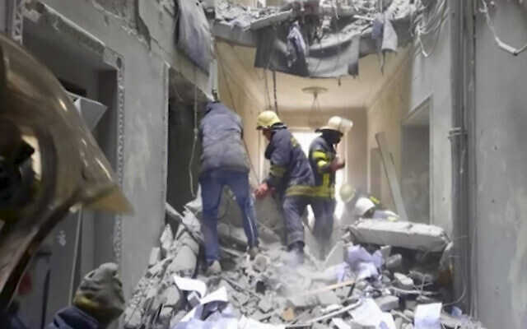
Ukraine says up to 350 civilians have been killed since Russia invaded.

In this frame from footage released by the State service of special communication and information protection of Ukraine, firemen work inside the regional administration building in the city’s central square of Kharkiv, Ukraine, after Russian shelling, on March 1, 2022. (State service of special communication and information protection of Ukraine via AP)
The warning to Kyiv residents also came as Russian strikes pounded the central square in Kharkiv and other civilian sites. Putin’s forces also pressed their attack on other towns and cities across the country, including the strategic ports of Odessa and Mariupol in the south.
Konashenkov said that Russian troops and pro-Moscow rebels have linked up in a key region along the Azov Sea coast in eastern Ukraine. Russian troops annexed the Crimean peninsula from Ukraine in 2014 and have used the region to launch attacks since Thursday, when Moscow began its invasion.
The rebels had “joined the military units of the Armed Forces of the Russian Federation, which took control of the regions of Ukraine along the coast of the Sea of Azov,” Konashenkov said in a statement.
Pro-Kremlin separatist fighters in east Ukraine have been pushing west as part of the offensive. A defense official in the Donetsk breakaway region earlier Tuesday said forces intended to surround a key port city separating the annexed peninsula and rebel territory.
Electricity has been cut off in Mariupol on the Azov Sea following attacks from advancing Russian forces, the head of the region Pavlo Kyrylenko said earlier in the day.
Video from Melitopol, a city in southeastern Ukraine located on a river that flows into the Azov Sea, showed a group of Ukrainians standing in the middle of a road to block a Russian military convoy and shouting at the troops, one of whom fired his rifle into the air.
An armored Russian vehicle can then be seen advancing, as the Ukrainian citizens stood in its path.
Amazing footage from Melitopol of Ukrainians stopping the onward advance of a Russian convoy and chanting “Occupants!” and “Murderers!” The jittery Russians are firing into the air pic.twitter.com/j3jypGJdgz
— Matthew Luxmoore (@mjluxmoore) March 1, 2022
Day 6 of the biggest ground war in Europe since World War II found Russia increasingly isolated by tough economic sanctions that have thrown its economy into disarray and left the country practically friendless, apart from China and Belarus.
In Kharkiv, with a population of about 1.5 million, Ukrainian authorities said 10 people were killed when the region’s Soviet-era administrative building was hit. Explosions tore through residential areas, and a maternity ward was moved to an underground shelter.
Kharkiv’s Freedom Square — Ukraine’s largest plaza, and the nucleus of public life for the city — was struck with what was believed to be a missile, in an attack seen by many Ukrainians as brazen evidence that the Russian invasion wasn’t just about hitting military targets but also about breaking their spirits.
Ukraine’s emergency service said eight people were also killed in a Russian airstrike on a residential building in Kharkiv.
Russian shelling killed at least 11 civilians in the city on Monday.
Zelensky called the attack on Kharkiv’s main square “frank, undisguised terror,” blaming a Russian missile and calling it a war crime. “This is state terrorism of the Russian Federation,” he said.
In an emotional appeal to the European Parliament later, Zelensky said: “We are fighting also to be equal members of Europe. I believe that today we are showing everybody that is what we are.”
He said 16 children had been killed on Monday, and he mocked Russia’s claim that it is going after only military targets.
“Where are the children, what kind of military factories do they work at? What tanks are they going at, launching cruise missiles?” Zelensky said.

An armed man is seen inside the damaged city hall of Kharkiv, Ukraine, on March 1, 2022, destroyed as a result of Russian shelling. (Sergey Bobok/AFP)
In a worrying development, Human Rights Watch said it documented a cluster bomb attack outside a hospital in Ukraine’s east in recent days. Local residents have also reported the use of the munitions in Kharkiv and the village of Kiyanka, though there was no independent confirmation.
If confirmed, that would represent a worrying new level of brutality in the war and could lead to even further isolation in Russia.
The Kremlin denied Tuesday that it has used such weapons and insisted again that its forces only have struck military targets — despite evidence documented by Associated Press reporters of shelling of homes, schools and hospitals.
The International Criminal Court’s chief prosecutor said earlier this week that he plans to open an investigation into possible war crimes. MORE - https://www.timesofisrael.com/russia-strikes-tv-tower-in-heart-of-kyiv-damaging-babi-yar-holocaust-memorial/

Ukraine envoy ‘disappointed’ by Israel detaining refuge-seekers, wants defensive aid
Yevgen Korniychuk says tens of Ukrainians who came to stay with family and friends are being held at Ben Gurion Airport; thanks Israel for assistance but says helmets are needed
By Ca rrie Keller-Lynn Today, 5:05 pm
Ukrainian Ambassador to Israel Yevgen Korniychuk hosts a briefing at the Embassy's Cultural Center in Tel Aviv, March 1, 2022. (Carrie Keller-Lynn/Times of Israel)
Ukrainian Ambassador to Israel Yevgen Korniychuk said Tuesday he was “disappointed” that some Ukranian refuge-seekers were being detained upon arrival in Israel, and expressed dismay that Israel continues to refuse to provide much-needed helmets and military vests for military and civil protection.
He also brought up Ukrainians who assisted Jews during the Holocaust, saying Israel should now be helping his countrymen too.
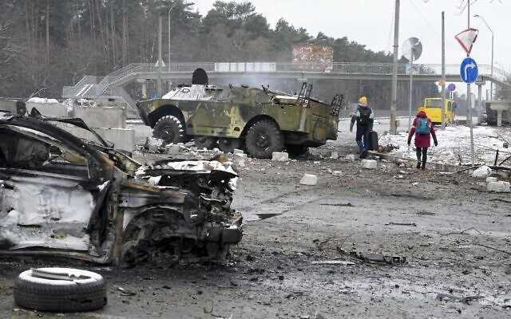
“We were disappointed yesterday with a decision of the interior minister [Ayelet Shaked] that explained that [Israel] will not allow Ukrainian refugees to come to Israel,” Korniychuk said at a press conference in Tel Aviv.
Several Ukrainians who fled the fighting but who lack legal status in Israel are being detained at Ben Gurion Airport. According to Korniychuk and a lawyer representing the refugees, they came to Israel to stay with family, but the state is requesting a deposit of several thousand shekels before they are allowed to enter.

People walk by a damaged vehicle and an armored car at a checkpoint in Brovary, outside Kyiv, Ukraine, March 1, 2022. (AP Photo/Efrem Lukatsky)
The deposit is held in guarantee that the Ukrainians will eventually leave Israel.
“Tens of cases are known to us,” the legal representative said.
According to the attorney, the Ukrainian shelter-seekers are currently held in a section of the airport before passport control, such that Israel considers them to not yet have formally entered the country.
Hebrew-language media reports have noted that the individuals could have been admitted as tourists. However, because family members formally invited them, the state suspects they may overstay their welcome, and is requesting a monetary commitment to stop them from becoming illegal residents or formal refugees.
A spokeswoman for the Population and Immigration Authority did not respond to requests for clarification, but the move appeared to be a recent change in policy.
Ukrainians have a three-month visa waiver in Israel and Interior Minister Ayelet Shaked said on Saturday that she had instructed her ministry to approve tourist visa extensions to Ukrainians already in Israel, in light of the ongoing war.
“This is the decision of the State of Israel and we could not intervene with it,” said Korniychuk. “But we are asking for your humanity to understand our people’s needs. They are not choosing where to stay and some of them are coming… because of their having relatives here or friends that are willing to take care of them. We are not talking about illegal workers.”

Workers load packages of Israeli humanitarian aid to assist people caught up in the fighting in Ukraine, in Ben Gurion airport, March 1, 2022 (AP Photo/Tsafrir Abayov)
Explaining why he believes Israel has a moral imperative to admit Ukrainian refuge-seekers, Korniychuk recalled Ukrainians who helped save Jewish lives during the Holocaust.
“You will remember the times of the Second World War when the Ukrainians were saving massively the Jewish lives during the Holocaust,” said Korniychuk.
He mentioned the fact that Ukraine has the fourth-most Righteous Among the Nations — non-Jews who saved Jewish lives during the war.
“We saved the Jewish lives at that time, we are [asking] you to help the Ukrainians to overcome this strategy [of monetary deposits] now. This is why the issue of the bail of NIS 10,000 or NIS 20,000 is not acceptable. This is a humanitarian catastrophe and I want you to consider that seriously.”
While it is true that Yad Vashem registers 2,673 Ukrainians as Righteous Among the Nations, many Ukrainians collaborated with the Nazis and were complicit in many atrocities against Jews in the country during the Holocaust.
Of the 100 tons of humanitarian aid that Israel sent to Ukraine in the past day, Korniychuk said he was happy to receive certain antibiotics and medical equipment that his country’s health ministry had requested. However, much of the equipment sent, while a nice gesture — such as water treatment systems — was not a priority, he said.
“We provided the Israeli government with a specific list of antibiotics and medical equipment that was needed,” Korniychuk said, of cooperation between the Ukrainian and Israeli health ministries.
“Most of what was provided was water purifiers and things that the Ministry of Health of Ukraine wasn’t asking for, but still we thank you from all our hearts.”
However, Korniychuk said what the country most needs is helmets and tactical vests, and that they first asked European allies but were told their stocks were empty.
“We definitely need more help and we’re getting this help much more from the rest of the world than from Israel,” he said.
A source at the Foreign Ministry said helmets and tactical vests are considered military equipment and therefore will not be provided, in line with Israel’s policy to not supply Ukraine with military aid in order to maintain good ties with Russia.
Due to Russia’s military presence in Israel’s northern neighbor Syria, the Israeli government has walked a tightrope to both support Ukraine and not endanger its own security interests with Russia.
Regarding ongoing talks on the Belarusian border between Ukraine and Russia, Korniychuk said they are not expected to yield fruit.
“We understood that the talks in Belarus are another trick by Putin in order to use the time to restructure his military forces,” said Korniychuk. “But our delegation decided to take part of it in order to not be accused of not taking it seriously.”

Demonstrators carry placards and flags during a protest against the Russian invasion of Ukraine, outside the city hall in Jerusalem, on February 28, 2022 (Olivier Fitoussi/Flash90)
On Sunday, Prime Minister Naftali Bennett acceded to a Ukrainian request to call Russian President Vladimir Putin and offer Israel as a mediator. Korniychuk said previously that Putin was not amenable to the offer, but remained hopeful that the Russian president may reconsider should the current Russian-Ukrainian talks on the Belarussian border collapse.
Korniychuk met with Bennett’s adviser Shimrit Meir on Monday, but did not share details. https://www.timesofisrael.com/ukraine-envoy-disappointed-by-israel-detaining-refuge-seekers-wants-defensive-aid/ [Israel is between a rock and a hard place. If it sides too strongly with one side or the other it will totally alienate the opposite side. To incite the ire of Putin is very unwise for Israel because he could quickly send a most difficult message to the via Syria which could be deadly. At this point in time Putin really doesn’t have a lot to lose. He has been branded a pariah by much of the west who subscribes to the WEC globalist agenda and has been wanting to get him out of leadership for some time since Putin is an inveterate nationalist. – rdb]

To keep lower profile, Israel will only send deputy envoy to UN session on Ukraine
Though Jerusalem will vote to condemn Moscow, Lapid, reportedly mistrusting Erdan, is said to want Israel’s representative in debate to stick to text and avoid a diplomatic spat
By Jacob Magid and TOI staff Today, 6:44 pm
Israeli Ambassador to the UN Gilad Erdan will not address the General Assembly debate on the Ukraine invasion, following orders from Foreign Minister Yair Lapid who wants Israel to keep a lower profile ahead of its vote in favor of a resolution condemning Russia, an Israeli official told The Times of Israel Tuesday.
Instead, deputy ambassador Noa Furman will address the General Assembly in a debate scheduled to take place Tuesday evening.
In a swipe at Erdan, a Jerusalem-based source familiar with the matter told The Times of Israel that Lapid wants to be sure that whoever addresses the plenum will stick to the Israeli government’s messaging, as the foreign minister wants to avoid a diplomatic spat.
Erdan had sent reporters a video clip of him embracing his Ukrainian counterpart Sergiy Kyslytsya in the General Assembly plenum on Monday evening. It is unclear if this was related to Lapid’s decision to exclude him from Tuesday’s debate.
But the Foreign Ministry reportedly has not taken to a number of Erdan’s recent steps, namely interviews he gave to the Israeli press without the government’s consent, contact with Likud activists and a decision to rip up a human rights council report criticizing Israel in a speech at the plenum, which some in Jerusalem felt caused more attention to the matter than deserved.
The General Assembly resolution is almost certain to pass, with many of its 193 member states having publicly expressed support in Ukraine. Israel is set to back the motion.
Earlier Tuesday, Russian Foreign Minister Sergey Lavrov was met with a cold shoulder at the United Nations. Scores of diplomats walked out of two meetings at the UN in Geneva in which Lavrov was beamed in for a video statement.
Ukrainian President Volodymyr Zelensky, on the other hand, received a huge round of applause after addressing the European Parliament by videolink, with EU Parliament President Roberta Metsola vowing that Europe “will stand up” and support Ukraine.
Israel has so far been careful in its comments on the conflict and Prime Minister Naftali Bennett has avoided criticizing Moscow publicly. Last week, Israel declined a US request to co-sponsor a Security Council resolution condemning Russia.
On Monday, however, Jerusalem seemed to change course, with Lapid saying that Israel would support a UN resolution condemning the Russian invasion of Ukraine, saying it had a moral responsibility to both condemn Russia for its actions and provide humanitarian assistance to the Ukrainians.
“Israel will join and vote in favor, along with the overwhelming majority of nations,” Lapid said.
He added that the US understands Jerusalem’s need to be “careful and discretionary” in its delicate relations with Moscow, due to the presence of Russian forces in Syria that coordinate with Israel, as well as the large number of Jews in Ukraine. https://www.timesofisrael.com/to-keep-lower-profile-israel-will-only-send-deputy-envoy-to-un-session-on-ukraine/

Zelensky applauded by EU parliament; diplomats walk out on Lavrov at UN
Ukrainian president urges Europe to ‘prove’ it’s with Ukraine and accept it as a member state; In Geneva, 100 diplomats leave room in protest during Russian FM’s address
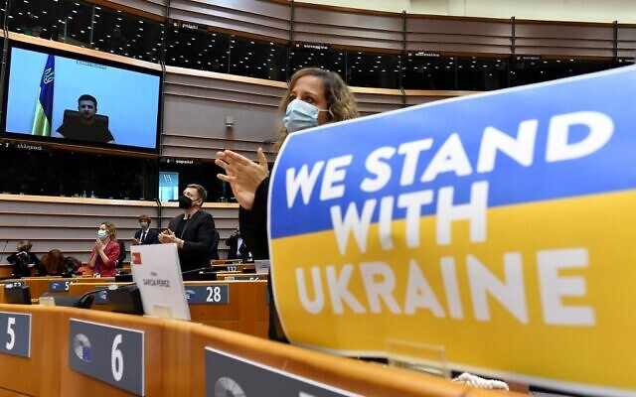  Members of the European Parliament applaud Ukrainian President Volodymyr Zelensky who appears on a screen as he speaks in a video conference during a special plenary session of the European Parliament focused on the Russian invasion of Ukraine at the EU headquarters in Brussels, on March 01, 2022. (JOHN THYS / AFP) | 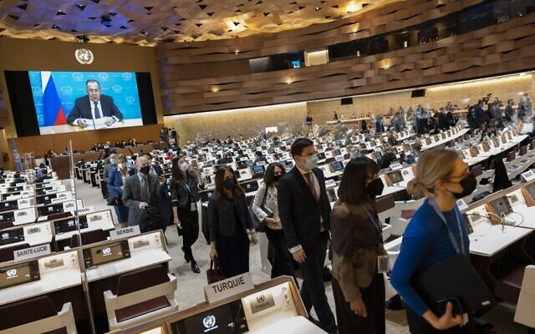  Ambassadors and diplomats leave while Russia's foreign minister Sergei Lavrov (on screen) speaks via a pre-recorded video message at the 49th session of the UN Human Rights Council at the European headquarters of the United Nations in Geneva, Switzerland, March 1, 2022. (SALVATORE DI NOLFI / POOL / AFP)
By TOI staff and Agencies Today, 5:47 pm
Ukrainian President Volodymyr Zelensky received a huge round of applause after addressing the European Parliament by videolink on Tuesday as his country battles to hold back invading Russian forces.
The address by Zelensky — who has become a global icon of defiance in the face of Moscow’s aggression — comes as Kyiv pushes for fast-track membership in the bloc, a request that is sure to infuriate Russian President Vladimir Putin and one that many EU lawmakers seem ready to support.
Zelensky called on EU member states to prove their loyalty to Ukraine and its citizens, who he said were “paying the ultimate price to defend freedom.”
In his stirring address, the Ukrainian leader said that “for some people, this is their last day,” hailing the courage and dedication of his “incredible” nation.
“We’re giving away our best people. The strongest ones,” he said.
“This morning was a very tragic one for us, two cruise missiles hit Kharkiv,” he added, referring to what he earlier called an act of “undisguised terror” and a “war crime” by Russia, which reportedly led to at least 10 civilian deaths.
“Without you, Ukraine is going to be alone. We have proven our strength. We have proven that, at a minimum, we are exactly the same as you are.
“Do prove you are with us, do prove that you will not let us go,” he urged lawmakers. “Do prove that you are indeed Europeans and then life will win over death and light will win over darkness.”
Zelensky argued that the EU would benefit from accepting Ukraine as a member state.
“The European Union is going to be much stronger with us, that’s for sure. Without you, Ukraine is going to be lonesome,” he said.
He also expressed gratitude for the unprecedented measures Brussels has deployed against Russia and in support of his armed forces, including the funding of arms deliveries.
Zelensky’s speech was met with an overwhelming sense of support.
“The message from Europe is clear. We will stand up, we will not look away when those fighting in the street for our values stand down Putin’s war machine,” EU Parliament President Roberta Metsola said.
In stark contrast to the response Zelensky received from EU lawmakers, Russian Foreign Minister Sergey Lavrov was met with a cold shoulder at the United Nations.
Scores of diplomats walked out of two meetings at the UN in Geneva in which Lavrov was beamed in for a video statement.
Ukraine’s President Volodymyr Zelensky acknowledges applause after an address via video link to an extraordinary session on Ukraine at the European Parliament in Brussels, March 1, 2022. (Screenshot) | 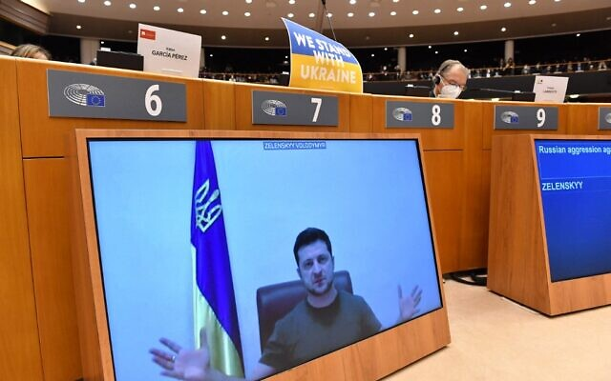  Ukrainian President Volodymyr Zelensky appears on a screen as he speaks in a video conference during a special plenary session of the European Parliament focused on the Russian invasion of Ukraine at the EU headquarters in Brussels, on March 01, 2022. (JOHN THYS / AFP)
Lavrov spoke by video to the Conference on Disarmament and the Human Rights Council, which he had planned to attend before the closure of airspace to Russian planes by several European countries prevented his travel to the Swiss city.
“What you have seen is strong support for Ukraine,” said Bonnie Jenkins, US undersecretary of state for arms control and international Security, after the walkout from the disarmament meeting.
Shortly afterward, in a conference room two floors higher, scores of diplomats — including Ukraine’s ambassador in Geneva and the foreign ministers of Canada and Denmark — poured out of the Human Rights Council chamber.
A spokesman for the council said about 100 people left the room.
Representatives of the European Union left the hall during Sergei Lavrov's speech on disarmament at the UN Conference. pic.twitter.com/LelHffS54c
— KyivPost (@KyivPost) March 1, 2022
US Secretary of State Antony Blinken has suggested Russia should be stripped of its membership in the UN Human Rights Council.
And yet, under heavy sanctions that have crippled its economy, Russia on Tuesday clarified that it currently has no intention of ending the war.
Russia will continue the offensive in Ukraine until its “goals are achieved,” Defense Minister Sergei Shoigu said, almost a week into Moscow’s invasion.
At a press conference aired on state television, Shoigu said Moscow aims to “demilitarize and de-Nazify” Ukraine, as well as protect Russia from a “military threat created by Western countries.”
Satellite photos showed a convoy of Russian forces north of Ukraine’s capital stretching for 40 miles. The vast convoy of armored vehicles, tanks, artillery and support vehicles was nearing Kyiv, according to satellite imagery from Maxar Technologies. https://www.timesofisrael.com/zelensky-applauded-by-eu-parliament-diplomats-walk-out-on-lavrov-at-un/ [There are reports that the Ukraine was offered a substantial sum from Mr. Soros to play the patsy against Russia. – rdb]

Israeli hands out food to Kyiv residents amid dwindling supplies
Businessman Ofer Krezner collected $ 1 million donations from the Israeli business community and others to provide for the city's elderly, infirmed or otherwise in need as Russian forces close on the Ukraine's capital
Ron Ben-Yishai | Updated: 03.01.22, 20:02
Meals, medication, and water supplies were distributed to Kyiv residents by the hundreds in the last two days, thanks to an Israeli humanitarian projects in Ukraine.
Kyiv is bracing for a siege that imposed by the Russian army with its forces moving in on the capital.

Ofer Krezner in Kyiv
Residents are already feeling the dwindling of supplies and there is a real fear of a looming humanitarian crisis.
The Israeli donners who financed the purchase of basic products were brought together by well known Israeli businessman and philanthropist Ofer Krezner, the owner of "City Capital Group" in Kyiv.
After coordination with Kyiv's Mayor Vitali Klitschko, Krezner set out to obtain products that the city's residents would need.

Empty supermarket in Kyiv (Photo: EPA)
The initiative set out to help elderly residents, those who are ill and single-parent families, who making up about three million residents in need.
Most of these people are currently in shelters and are either too afraid to leave or unable to buy essentials.
Within less than one day, Krezner got together close to one million dollars worth of donations from Israeli companies and business men, amongst them the well-known high-tech company Playtika.
Krezner himself donated about half a million dollars out of pocket.
Empty bread shelves in Kyiv (Photo: Reuters) | Ofer Krezner food distribution supply in Kyiv
Refali Yochai, Field Manager of "City Capital Group", and more of Krezner's partners organized all the necessary supplies, including diapers, food, and personalized prescriptions. The initiative is continuing to prosper as many Israelis in Ukraine show readiness to donate to the cause. https://www.ynetnews.com/article/bkxfbrol5 [And we think we have empty selves. Pity those people. Pray unceasingly– rdb]

Another 2 leading Israeli blockchain pioneers named as suspects in vast crypto scam
Yaron Shalem, ex-Singulariteam VP and former CFO of Celsius, and Saga founder Ido Sadeh Man among 10 suspects nabbed for aggravated fraud, money laundering, embezzlement
By Simona Weinglass Today, 12:29 pmUpdated at 1:28 pm
After a three-month court battle by The Times of Israel, together with Britain’s The Financial Times, and separately, the Haaretz newspaper, an Israeli judge has lifted a gag order on two more of ten suspects arrested on November 18 as part of an alleged crypto scam that defrauded victims worldwide of colossal sums of money. Their names are Yaron Shalem and Ido Sadeh Man.
Neither responded to a request for comment from The Times of Israel. Shalem was a vice president at the venture capital firm Singulariteam, and until recently the CFO of Celsius Network, a multibillion-dollar cryptocurrency lending platform. Sadeh Man is the founder of the Saga cryptocurrency company.
Lawyers for Shalem told the Financial Times he “acted in accordance with the law and strongly and utterly rejects any attempt to associate him with any act of fraud.” They added: “Our client is certain that at the end of the investigation, it will be found that he had committed no wrongdoing.”
Celsius Network has stressed that Shalem’s alleged offenses are unrelated to his period with the firm; it said he was suspended when Celsius learned that he was being investigated and is no longer employed by the firm.
The two men, whose names were barred by the courts from publication prior to Tuesday, are suspected along with the other eight of “carrying out investor fraud through a number of cryptocurrency enterprises” and pocketing tens of millions of shekels. The charges facing the ten include fraud, aggravated fraud, embezzlement, conspiracy to commit a crime, money laundering and tax violations.
The arrest of the 10 suspects on November 18, in a case that has been dubbed “The Big Game” by police investigators, was an unprecedented event as Israeli police have only rarely investigated large-scale digital fraud cases. Only two of the names were made public on the day of the arrest — those of Beitar Jerusalem owner Moshe Hogeg and former Singulariteam CEO Adi Sheleg — while the name of a third suspect, Avishai Ziv, was made public on February 10.
But after a three-month court battle, invoking the Open Court Principle that is a foundational Israeli law, judges in the case agreed to lift the gag order on Shalem and Sadeh Man. Five names still remain under gag order.
The ten arrested men are among the most well-known, and in some cases internationally lauded, Israeli pioneers of distributed ledger technology, more commonly known as blockchain technology. Hobnobbing with the global rich and famous, some have run companies whose dollar valuations run in the 8, 9 or 10 figures, and been consulted by leading international regulators and government ministers.
Moshe Hogeg (left) and Ido Sadeh Man in 2015 (Facebook screenshot)
Their arrests are unparalleled in terms of the sums they are alleged to have stolen and the fact that their alleged crimes were internet-based and largely targeted investors abroad. Over the past 15 years, Israel has become a hub of investment fraud against overseas victims, targeting both sophisticated and mom-and-pop investors through forex, binary options and crypto fraud, with most of these alleged crimes going uninvestigated and unprosecuted.
According to their arrest warrants, all ten of the men are suspected of raising vast sums of money for a series of unnamed cryptocurrency ventures during an unspecified time period. Instead of using the money to develop a product, the arrest warrants allege, they used it for their personal expenses or their own private business ventures.
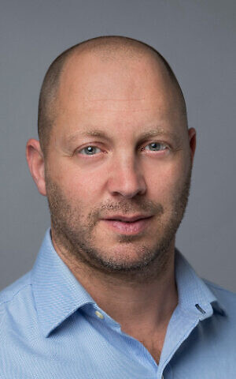
Yaron Shalem (Linkedin)
“Investors were presented with an orderly plan for investing money and developing the ventures, including false advertising of purported investments by public opinion shapers,” police alleged in several of the arrest warrants. “In this way, investors were persuaded to put millions of dollars into those ventures. In reality, their money was thrown away, as it was not invested in accordance with the plan that was presented, but was stolen and transferred to the pockets of the suspects, who used this money for their personal use or their personal business.”
Hogeg and the other nine “Big Game” suspects are alleged to have worked together to solicit hundreds of millions of dollars in investments from the public over the internet and through other means.
Most of the suspects are linked to Hogeg, 40, the famously flamboyant owner of the Beitar Jerusalem soccer team, who is also suspected of sex trafficking and statutory rape. The other men are suspected of financial crimes but not sexual offenses.
A law enforcement source, who spoke on condition of anonymity, told The Times of Israel that internet fraud is increasingly becoming a top source of money for criminals but that it has taken police in Israel and around the world a while to catch on. MORE - https://www.timesofisrael.com/another-2-leading-israeli-blockchain-pioneers-named-as-suspects-in-vast-crypto-scam/ [And then you have the group that always works the system. – rdb]

Eight year term limit for Prime Minister set to pass tomorrow
The opposition is planning a 16 hour filibuster.
By GIL HOFFMAN Published: MARCH 1, 2022 19:44 Updated: MARCH 1, 2022 19:59
The Knesset is set to vote on Wednesday on the final readings of a bill that would limit prime ministers to eight years in office.
The vote will be preceded by a 16-hour filibuster by the opposition that started at 7:30 p.m. on Tuesday.
Justice Minister Gideon Sa’ar’s decided to bring the bill to a vote now, as there are currently no coalition MKs who are ill with corona. Because it would change a Basic Law, it would need the support of an absolute majority of all 120
Knesset members, 61 MKs, and not just those who vote.
Joint List faction head Ahmad Tibi said his faction also supports the bill, however, Sa’ar does not want to rely on the Joint
The bill is not retroactive and would not apply to opposition leader Benjamin Netanyahu, the only living Israeli prime minister who has served eight years.
There is also a vote set for Wednesday on dispersing the Knesset. Because it lacks a majority, however, it is likely to be withdrawn from the agenda by the opposition. https://www.jpost.com/israel-news/politics-and-diplomacy/article-699044

High Court says 4 Palestinian families can stay in Sheikh Jarrah homes, for now
Palestinian lawyer says decision ‘preserves presence of Palestinians in their homes’; justices say families can’t be evicted before government resolves their ownership claims
By Aaron Boxerman Today, 5:06 pm
The High Court of Justice ruled on Tuesday that four Palestinian families in the flashpoint East Jerusalem neighborhood of Sheikh Jarrah will not be evicted until the Justice Ministry settles their ownership claims to the property.
According to the left-wing Ir Amim nonprofit, some 300 Palestinians are currently under threat of eviction in Sheikh Jarrah, mostly in private cases filed by right-wing Jewish groups. The case involving these four families could set a precedent for other proceedings making their way through the courts, experts say.
For decades, courts have held that Nahalat Shimon, the Jewish organization seeking to evict the four families, was the rightful owner of the land. The Palestinians claimed the Jordanians had been in the process of issuing them deeds to the property before Israel conquered East Jerusalem in 1967.
In an unprecedented move, the High Court ruled that the Palestinians could not be evicted unless the Justice Ministry examined the Palestinians’ claim to the homes. The Justice Ministry is responsible for sorting out land registration and issuing titles to property but has effectively frozen the process in much of East Jerusalem, citing political and logistical difficulties.
In the meantime, the Palestinian families will deposit a symbolic amount of rent — NIS 2,400 ($740) per year — in a bank account belonging to both sides’ lawyers. If the Justice Ministry rules against them, the funds will be transferred to Nahalat Shimon.
Sami Irsheid, an attorney for the Palestinians, hailed the ruling as “preserving the presence of the Palestinians in their homes.”
“There’s no eviction, and the ownership of the land will be revisited. From the 1970s until today, the courts have always held that the Jewish organizations were the owners. This is a very positive development,” said Irsheid.
The evictions in Sheikh Jarrah have become a global symbol of the Palestinian cause, sparking raised tensions in Jerusalem that helped touch off the May war between Israel and the Hamas terror group. Israeli officials have warned that the tense situation in the neighborhood could lead to another escalation between Israel and the Palestinians. MORE -
https://www.timesofisrael.com/high-court-says-4-palestinian-families-can-stay-in-sheikh-jarrah-homes-for-now/

Palestinian shot dead by Israeli soldiers in West Bank under unclear circumstances
Palestinian health officials say Ammar Shafiq Abu Afifa, 21, was killed by soldiers at entrance to Beit Fajjar, south of Bethlehem; IDF does not say what he was suspected of
By Aaron Boxerman and Emanuel Fabian Today, 7:28 pm
A Palestinian man was shot dead by Israeli soldiers in the West Bank on Tuesday afternoon, the Palestinian Authority Health Ministry and the Israeli military said.
Palestinian health officials identified the man as Ammar Shafiq Abu Afifa from the al-Aroub refugee camp near Hebron. They said he was shot on the outskirts of Beit Fajjar, near Bethlehem.
Officials said that they had received the report from the PA branch that handles ties with Israel, meaning that Abu Afifa’s body was likely in Israeli custody.
Nearly four hours after the incident occurred, the Israel Defense Forces said in a statement that soldiers operating security cameras identified two “suspects” approaching a lookout point near the settlement of Migdal Oz.
Troops dispatched to the scene chased the two men, and opened fire toward them according to open-fire procedures, the military said. Such procedure includes shouting at a suspect to halt, firing into the air, and only using deadly force if the soldier feels threatened.
The IDF did not detail what the two men were actually suspected of doing. It said the army was investigating the matter.
ما حدث على مدخل بيت فجار هو عملية اعدام، نفذها جيش الاحتلال بحق الشاب عمار ابو عفيفة، جيش الاحتلال اطلاق النار على رأس عمار من نقطة صفر، مما تسبب باستشهاده على الفور. لم يكتف الجيش بتفجير راسه وقتله بل وقام باحتجاز جثمانه الطاهر. pic.twitter.com/yxGwVJo3ai
— Malik Al Qadi (@MalikAlQadi) March 1, 2022
Earlier Tuesday, security officials said a battle in the northern West Bank left two Palestinian gunmen dead.
The Israel Police said undercover Border Police officers came under fire while arresting a terror suspect in the Jenin refugee camp. The suspect, Emad Abu al-Heija, is a son of an imprisoned senior Hamas commander.
Palestinian media identified the two fatalities as 19-year-old Shadi al-Najm and 22-year-old Abdullah al-Housri. The Islamic Jihad terror group immediately claimed al-Housri as one of its fighters. Al-Najm was later claimed by the loosely Fatah-affiliated Al-Aqsa Martyrs’ Brigade as a “fighting member.”
The West Bank has seen a rise in violent confrontations between Israeli soldiers and Palestinians in recent weeks, leaving at least six Palestinians dead. In an increasing number of cases, soldiers entering Palestinian areas to conduct routine arrests have been fired upon by armed terror group members, prompting gun battles.
Israeli soldiers have also opened fire in more contested circumstances. Israeli soldiers shot and killed 22-year-old Nihad al-Barghouti in Nebi Saleh as he allegedly threw stones, an account contested by Palestinian witnesses.
In another controversial case, 14-year-old Mohammad Shahada Salah was killed by Israeli forces in his hometown of Al-Khader last week. The Israeli military said Salah had sought to hurl Molotov cocktails at Israeli cars on nearby Road 60. Palestinian town residents claimed he was nearly 100 meters (328 feet) from the security barrier, too far to throw Molotov cocktails. https://www.timesofisrael.com/palestinian-authority-says-man-shot-dead-by-israeli-soldiers-in-west-bank/

Israel drops almost all COVID health rules as it exits Omicron wave
Only three restrictions remain: face masks in indoor public spaces, Green Pass to enter old age homes, and PCR tests upon arrival for Israelis returning from abroad
By TOI staff Today, 10:55 am
Israel on Tuesday rolled back almost all of its COVID-19 health rules as a recent wave of infections receded, leaving in place just a handful to prevent a reversal of the positive development.
As the country transitions to the more relaxed status, the most notable rule to remain is a requirement to wear a face mask in indoor public spaces. The current requirement for masks in some large outdoor gatherings is canceled.
In addition, the Green Pass certificate, granted to those who are vaccinated, recovered, or recently tested negative for the coronavirus, will only be needed to enter old age homes.
Also, under the new guidelines, both vaccinated and unvaccinated tourists of all ages will be allowed into the country, as long as they submit a negative PCR test before boarding the flight and take another one after landing in Israel. Citizens will no longer need to test before returning home (though it’s suspected that some airlines will still insist on a test), but will still need to test upon arrival.
A Green Pass was previously needed to attend almost any public event and many venues, but the rules of its use have been gradually rolled back as infections dropped, leaving only the care home requirement still in place.
Existing Green Pass certificates will be extended until May 31 for those who have had at least three vaccine doses or a shot in the previous six months. Those who have recovered from COVID-19 can obtain a Green Pass for six months following their recovery, valid also until May 31.
A requirement for children in middle school and high school to take regular twice-weekly antigen tests at home ended, and it will be canceled for younger children on March 10.
The changes come as the count of new daily cases has ebbed to barely a ninth of what it was a month ago.
Back then, when the latest wave was at its height, the moving average of new daily diagnoses was about 75,000. Health Ministry figures released Tuesday showed there were 8,372 new cases diagnosed the previous day.
At points in January there were more than half a million people infected — 1 in 20 Israelis — but the new numbers showed there are 72,270 active patients in the country.
The number of seriously ill patients has more than halved since February 6, from 1,242 to 582, the lowest it has been since January 19.
The death toll since the start of the pandemic is 10,204. https://www.timesofisrael.com/israel-drops-almost-all-covid-health-rules-as-it-exits-omicron-wave/ [Finally, NOW if they would stop the JABS because they don’t work anyway. It is still unfathomable that they keep pushing something that is useless and costing them a bundle Unless of course they were able to get them for zip since they are being the Guinea pigs for the world, which is in itself a reprehensible act.l . – rdb]

France's Macron comes out against claims of Israeli apartheid
President Macron to French Jewish umbrella: "How dare we talk about apartheid in a state where Arab citizens are represented in government and positions of leadership and responsibility?"
By ZVIKA KLEIN Published: FEBRUARY 28, 2022 18:45 Updated: FEBRUARY 28, 2022 23:37
French President Emmanuel Macron came out last week against the description of Israel as an apartheid state recently by human rights groups like Amnesty International.
Macron was supposed to deliver a speech at the annual dinner of the Representative Council of Jewish Institutions in France (CRIF) but had cancel to an important meeting. Instead, Prime Minister Jean Castex was asked to deliver his speech instead and he read the president's speech.
“Like you, I am concerned about the United Nations resolution on Jerusalem which continues to deliberately and against all evidence remove Jewish terminology from the Temple Mount. You know my attachment to Jerusalem, where I went several times as President or before becoming one. Jerusalem is the eternal capital of the Jewish people, I have never stopped saying that. This in no way precludes recognizing and respecting the attachment of other religions to this city, and it is in this spirit that I myself walked through the Old City in 2020 and visited each of the Holy Places."
"Erasing Jerusalem's Jewishness is unacceptable, just as it is unacceptable that in the name of a just fight for freedom, associations misuse historically shameful terms to describe the State of Israel," Castex said in Macron's name.
He added that "where all citizens, whatever their religion, have understood that their only hope is peace together. It is not by affirming such untruths that associations that claim to pursue an objective of peace can claim to fulfill their vocation. How dare we talk about apartheid in a state where Arab citizens are represented in government, in parliament, in leadership positions and in positions of responsibility?"
Castex added in the name of the president: “As I promised you, the definition of antisemitism of the International Holocaust Remembrance Alliance has been adopted by the Republic. MORE - https://www.jpost.com/diaspora/antisemitism/article-698925 [HUMMMM? Did Macron have some sort of an epiphany? He is usually not so conciliatory of Israel and Jerusalem. Rdb]

Study: Pfizer COVID shot converts into DNA in human cells
Findings conflict with CDC's claim that vaccine never enters nucleus
By Art Moore Published March 1, 2022 at 5:36pm
Contrary to the CDC's claim that the mRNA COVID-19 vaccines do not "change or interact with your DNA in any way," a new Swedish study finds Pfizer's shot goes into liver cells and converts to DNA.
It's the first time that researchers have shown in vitro – or inside a petri dish – how an mRNA vaccine is converted into DNA on a human liver cell line, the Epoch Times reported.
It's precisely what health experts and fact-checkers said for more than a year could not occur.
Dr. Peter McCullough, an internist, cardiologist and epidemiologist who is one of the leading critics of the COVID vaccines, said the findings have "enormous implications of permanent chromosomal change" that could drive a "whole new genre of chronic disease."
The CDC assures Americans that the mRNA and the spike protein it produces in COVID-19 vaccines to create an immune response "don't last long in the body." On its website, the agency states: "Our cells break down mRNA and get rid of it within a few days after vaccination. Scientists estimate that the spike protein, like other proteins our bodies create, may stay in the body up to a few weeks."
Further, the CDC says on a web page titled "Myths and Facts about COVID-19 Vaccines" that the "genetic material delivered by mRNA vaccines never enters the nucleus of your cells."
However, the researchers at Lund University in Malmö, Sweden, found that the mRNA vaccine enters human liver cells and triggers the cell’s DNA in the nucleus to increase the production of the LINE-1 gene expression to make mRNA.
The whole process occurred rapidly, within six hours, concluded the study, which was published by the university's Department of Clinical Sciences.
Pfizer did not comment on the study's findings, the Epoch Times reported, stating only that its mRNA vaccine does not alter the human genome.
"Our COVID-19 vaccine does not alter the DNA sequence of a human cell," a Pfizer spokesperson told paper in an email. "It only presents the body with the instructions to build immunity."
Earlier this month, as WND reported, a peer-reviewed study published in the prestigious journal Cell by researchers at Stanford University found that the spike protein created by the COVID vaccines remains in the body much longer than believed and at levels higher than those of severely ill COVID-19 patients.
The Stanford researchers tested the duration of the protein in the body for 60 days and found that it lasted at least that long.
Dr. Robert Malone, the key inventor of the mRNA technology platform that later was used in the Pfizer-BioNTech and Moderna vaccines, described the implications of the Stanford study as a potential "health public policy nightmare" in an analysis on his Substack page.
The Swedish researchers also concluded the spike proteins expressed on the surface of the liver cells through the vaccine could target the immune system and possibly cause autoimmune hepatitis. They noted "case reports on individuals who developed autoimmune hepatitis" after getting the Pfizer shot.
The authors of the study cited the case of a healthy 35-year-old female who developed autoimmune hepatitis a week after her first dose of the Pfizer COVID-19 vaccine. The researchers said there is a possibility that "spike-directed antibodies induced by vaccination may also trigger autoimmune conditions in predisposed individuals." https://www.wnd.com/2022/03/study-pfizer-covid-shot-converts-dna-human-cells/ [Once again the CDC and NIH have lied to the world. This is unconscionable and these people are heinous criminals. – rdb]

T-Mobile blocked link to WND interview with Dr. Robert Malone
'Evidently speaking about censorship and scientific fraud is considered too dangerous'
By Art Moore Published March 1, 2022 at 5:11pm
T-Mobile prevented some users from texting a link to a WND article featuring a video interview with COVID vaccine critics Dr. Robert Malone and Dr. Ryan Cole.
J ust the News reporter Greg Piper confirmed the wireless carrier was blocking a link to the article, which was posted Feb. 22. In the WND interview, Malone, the key inventor of the mRNA technology used in the Pfizer and Moderna vaccines, and Cole, an Idaho pathologist, discussed the New York Times report of CDC officials acknowledging they hid COVID-19 data from the public for fear it would be misinterpreted by critics of the agency's policies and guidance.
Malone featured the WND interview on his Substack page in a post titled "Scientific Fraud and the CDC."
"Note: the above link is not being allowed to be forwarded by T-mobile and probably other cell phone services," wrote Malone, who has been banned from Twitter and LinkedIn. "Evidently speaking about censorship and scientific fraud is considered too dangerous by our government.
Malone's wife and business partner, Jill Glasspool Malone, told Just the News that the censorship wasn't happening with every T-Mobile customer who tried to forward the link. But it was "happening to enough people, for it to be very suspicious."
Piper, a T-Mobile customer, said he texted the WND article to another T-Mobile customer and a Verizon customer to test Malone's claim. "Neither received the text with the article link, but they did get texts with the WND.com home page, showing the domain itself is not blocked," he wrote.
Just the News reported the Rumble video of the interview, embedded in the WND article, was not itself blocked by T-Mobile.
A T-Mobile spokesman insisted the blocking of the link was not intentional.
"We checked into this with our technical team," T-Mobile wrote in an email to Just the News. "We haven’t heard about this issue. We can share that T-Mobile is not intentionally blocking this, and would not. Without further context, it's hard to say what the actual issue is." https://www.wnd.com/2022/03/t-mobile-blocked-link-wnd-interview-dr-robert-malone/

SIX More Trucker Convoys Plan on Merging With ‘The People’s Convoy’ When It Reaches Indianapolis – Organizers Expect Over 10,000 Vehicles to Join the Already 3,000-Strong Group (VIDEO)
By Julian Conradson Published February 28, 2022 at 9:59pm
The American truckers are gearing up for a massive protest in Washington DC in opposition to tyrannical COVID mandates.
Similar to the truckers in Ottawa, the US Convoy plans to disrupt traffic in DC over the coming days and weeks, beginning around the time of Joe Biden’s upcoming State of the Union Address that’s scheduled for Tuesday, March 1st.
Thousands of protesters are expected to arrive for the demonstration, with several groups departing from across the country daily.
One of the largest of these groups – The Peoples Convoy – is rapidly growing as it finishes day six of eleven of its cross-country journey to the DC swamp. On Monday morning, the convoy had grown to around 3,000 vehicles as it reached the
Just like the other states on this journey, the truckers were greeted with a warm welcome in Missouri, with countless supporters showing up at several overpasses to demonstrate their support.
Watch, from El American:
HAPPENING NOW: | Day 6 of The Peoples Convoy, with OVER 3,000 vehicles headed to Washington D.C.
We are approaching Springfield MO. This is what the overpasses have looked like: pic.twitter.com/tfn5MvcOLm
— El American (@ElAmerican_) February 28, 2022
After picking up several more additions throughout the day, the convoy made camp for the night in Cuba, Missouri. Once again, a crowd was waiting to greet them when they arrived, bringing another round of donations, food, drinks, and supplies with them to be used in the upcoming protest.
The support that Americans have shown for the convoy has been overwhelming everywhere they have gone.
The Peoples Convoy arrives at It’s final destination in Cuba, MO for day 6.
Tomorrow, convoy heads to Indianapolis, IN where it will meet up with SIX other convoys, where the convoy is expected to triple.
Following is ==> @ElAmerican_ pic.twitter.com/LjdLroixqM
— El American (@ElAmerican_) March 1, 2022
Tomorrow, the people’s convoy will depart Missouri and make its way to Indianapolis, where several other groups of vehicles are expected to merge with the convoy as it enters the last leg of its journey to Washington DC. Convoy Organizers who spoke with El American explained that they have been speaking with at least SIX other convoys that are planning on meeting up with the main group on Wednesday.
When the groups merge, the convoy is expected to be over 10,000 vehicles strong.
EPIC!
🚨 BREAKING REPORT: ‘The Peoples Convoy’ organizer has told @ElAmerican_ that there are SIX more convoys on their way to Indianapolis to meet with The Peoples Convoy on Wednesday March 2nd.
Over 10,000+ vehicles expected.
Follow us ==> @ElAmerican_ pic.twitter.com/aVju3XS63Y
— El American (@ElAmerican_) February 28, 2022
If this keeps up like this, Biden and the DC Swamp won’t know what hit them – the convoy is already 3,000 strong, and that’s without the reinforcements from the other groups who are planning to join. This protest is gearing up to be something truly historic. https://www.thegatewaypundit.com/2022/02/six-trucker-convoys-plan-merging-peoples-convoy-reaches-indianapolis-organizers-expect-10000-vehicles-join-already-3000-strong-group-video/

Hungarian PM warns tyranny 'greater than this pandemic' is coming
'Ownership is obsolete, privacy is non-existent, and globalist organizations achieve complete control'
By Bob Unruh Published March 1, 2022 at 10:52am
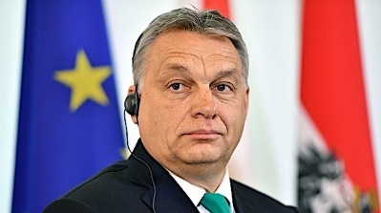
Hungarian Prime Minister Viktor Orban addreses a press conference with his Austrian counterpart at the Chancellery in Vienna on January 30, 2018. (Photo by JOE KLAMAR/AFP/Getty Images)
Hungarian Prime Minister Viktor Orban long has been recognized as a renegade – the leader not willing to submit to a globalist agenda or mandates from the established power structure.
He began his career objecting to Russian troops in Hungary, and they were removed a short time later. He moved his nation toward a free-market economy, led its entry into the North Atlantic Treaty Organization, urged the adoption of a constitution outlining conservative moral themes and defended national sovereignty.
He further outraged the establishment by erecting a fence on his nation's border to disrupt the flow of illegal aliens coming from the Middle East and Africa.
And even while fighting COVID, his nation enacted legislation that banned school content "deemed to promote homosexuality and gender change."
Now he's warning that the COVID-19 pandemic was just a prelude to a "serious stress test" that will be coming from the United Nations and the World Economic Forum.
His comments were captured and translated by the RAIR Foundation, whose name represents "Rise Align Ignite Reclaim."
He cited the U.N.'s Agenda 2030 campaign and charged that it is nothing less than global government tyranny that enslaves all humanity.
His comments came during a state-of-the-nation speech in Budapest to the Chamber of Commerce on Feb. 19.
The foundation report said he was "spot-on" about private property, traditional culture, and the need to resist and withstand the next crisis.
He said the Agenda 2030 plan, formerly called Agenda 21, combined with the WEF's Great Reset plan, would force the world into a society where "ownership is obsolete, privacy is non-existent, and … globalist organizations achieve complete control."
That, he said, is a "serious stress test, much greater than this pandemic."
"By that time in 2030, our nation, our national community including its economy, must be in a condition [that enables us] to withstand those challenges there and then, and even use them to prosper!" he said. "This is what is ahead of us…"
The RAIR Foundation describes itself as a "grassroots activist organization comprised of everyday Americans leading a movement to reclaim our Republic from the network of individuals and organizations waging war on Americans, our Constitution, our borders and our Judeo-Christian values."
During his speech, Orban cited an agreement that was signed between the Chamber and the government, and said he is confident it will help "our great national strategic goal of economic growth of two to three percent above the European Union rate every year, and when European economies are stagnating and going downwards, we must move on an upward trajectory; and around 2030 when there will be all sorts of big shifts in the world, which I don’t have time to talk about now, but from America to the European Union, a lot will happen."
The foundation report explained, "Most media ignored the portion of PM Orbán’s speech, which alludes to the UN’s 'Agenda 2030', a corporate-government fascist scheme. In the 1990s, the United Nations drafted 'Agenda 21', their so-called plan for defeating 'climate change.' In 2015, it was re-branded by socialists into 'Agenda 2030,' neither had anything to do with 'global warming' and everything to do with reshaping our world according to their socialist vision. Then last year, the push for Agenda 2030 wasn’t just about climate change but a blueprint for so-called 'sustainable development' worldwide."
The foundation report charged that the U.N. document actually describes "nothing less than a global government takeover of every nation across the planet. The 17 stated 'goals' of Agenda 2030 are code words for a corporate-government fascist agenda that will imprison humanity in a devastating cycle of poverty while enriching the world’s most powerful globalist corporations and individuals."
Orban's messages resonate with the Hungarian population because, RAIR's report said, "Hungary has had to fight off the Islamic Ottoman Turks, the Nazis, and the communists in the last century. As a result, Hungarians are generally not fond of the idea of sacrificing themselves to Globalists aiming to change societal norms and customs."
Orban said his nation "first and foremost" must fight "any socialist economic policy."
There is where private property is important, he said.
"I believe that private property has the power to create culture. And it creates a good culture, a culture on which a good life can be built, and on which, a nation can build its own future. Therefore, our basis remains private property. We want people to have their own homes, their own savings, their own land, their own gardens, their own tools. We are convinced that this is not only good for the economy, but it also reinforces the culture of taking care of things and therefore of our own lives."
He explained there is "different cultural behavior" when people are "living in someone else's house, living off someone else's money…" https://www.wnd.com/2022/03/hungarian-pm-warns-tyranny-greater-pandemic-coming/ [This man’s warning is absolutely right on target. The world who wants freedom must wake up and take a stand. Go to site for video of speech. – rdb]

U.S. soldiers undergoing gender training while nation faces threat of WWIII
'Part of a larger push by Biden to make the military more welcoming to transgender people'
By Bob Unruh Published March 1, 2022 at 3:15pm
An investigative report by the Washington Free Beacon has documented how – while the world faces the possibility of a World War III given Russia's deadly invasion of and attack on Ukraine – U.S. soldiers are getting training in pronouns.
Specifically how to address a man in the ranks who says he's a woman. And when to suggest the body mutilations that are available through taxpayer funding under the description of transition surgery.
The report said the publication obtained confirmation of the agenda from a whistleblower "who was ordered to undergo the training as a high-ranking officer in the Army Special Forces."
Parts of the training presentation also was provided by the whistleblower.
The first slide published revealed the Army's practice on transgenders – that they are allowed to "serve openly" and will be treated with "dignity and respect."
Also, that they shall not be "involuntarily separated, discharged, or denied reenlistment or continuation of service" for being transgender.
The Free Beacon explained the title of the training is "Policy on the Military Service of Transgender Persons and Persons with Gender Dysphoria."
"An Army spokesman confirmed to the Free Beacon that the slides in question are part of 'mandatory training' and come from an official program 'used to train Army personnel on the recent changes to the DoD and Army transgender service policy,'" the report said.

The demand is that all military members will be require to complete the lessons by the end of September.
It was only last summer that the military, under Joe Biden, demanded that transgender soldiers be given special consideration in the ranks.
"The shift in policy is part of a larger push by the Biden administration to make the military more welcoming to transgender people," the report said.
The announcement has created considerable backlash from Republicans in Congress who see it as an unwise diversion of time and talent into making the military "woke," when a military's mission should be focused on protecting the nation.
The lessons describe various scenarios and provide instructions on how to treat those with gender dysphoria.
Many of the recommendations are that an officer should suggest a soldier see a military medical provider, because that is the origination point for any case that involves a gender transition.
"We remain committed to treating all soldiers with dignity and respect while ensuring good order and discipline," an Army spokesman told the Free Beacon. "Soldiers who meet those standards can serve openly in their self-identified gender."
"Every soldier is different," Maj. Gen. Douglas F. Stitt, military personnel management director, said when the military announced last year it was recognizing the special status of transgenders in the ranks.
"When a military medical provider gives a diagnosis of gender dysphoria, that soldier will need to sit down with their chain of command and medical provider to determine what is medically necessary for an effective transition."
But Dakota Wood, a Marine Corps veteran who specializes in defense issues at the Heritage Foundation think tank, told the Free Beacon the language being used by the military is the same as that used by leftists and progressives who promote alternative sexual lifestyle choices.
"A telling phrase in the presentation—'assigned (male or female) at birth'—reveals that whoever developed the presentation material, and the policy being implemented, accepts the argument that gender is an artificial construct rather than a biological reality," Wood told the publication. "This is a highly controversial argument promoted by the progressive left and rejected by the conservative right." https://www.wnd.com/2022/03/u-s-soldiers-getting-gender-training-nation-faces-threat-wwiii/ [Do you feel safer now? I don’t. This is just garbage trash from the US military leadership and they should be run out on a rail. – rdb]

GOP Slams Biden for Not Halting Russian Oil
Tuesday, 01 March 2022 06:18 PM
Republican politicians across the U.S. are criticizing President Joe Biden over his domestic energy policies and urging his administration to do more to embrace domestic production.
The sanctions imposed by the U.S. and its allies on Russia for its war with Ukraine so far do not include oil and gas exports from the country, a step that would have severely hurt Russia’s ability to generate revenue.
Oklahoma Gov. Kevin Stitt and U.S. Sen. Rob Portman of Ohio both urged Biden on Tuesday to take steps to stop Russian oil imports to the U.S.
“The recent events in Ukraine are yet another example of why we should be selling energy to our friends and not buying it from our enemies,” Stitt wrote to Biden.
Portman said it doesn’t make sense to import Russian oil at the same time the Biden administration shut down the Keystone XL Pipeline, which would have transported tens of thousands of barrels each day from Canada to U.S. refineries.
Cutting off Russian oil and gas imports could drive prices at the pump higher and have even more serious consequences for U.S. allies in Europe, which relies on natural gas from Russia for a third of its fossil fuel consumption.
Biden has not taken energy sanctions "off the table" as pressure mounts to cut Russian oil imports amid the country's invasion of Ukraine under President Vladimir Putin, White House press secretary Jen Psaki said Tuesday.
"They have serious financial problems on the ground in Russia that is impacting President Putin and the circle around him," Psaki told Fox News, in discussing sanctions that already have been implemented. "What he also looks at, though, and we were very cognizant of, is minimizing the impact on the global markets and the American people."
She added: "So we have not taken options off the table, including the one you mentioned, but that is something the president looks very closely at." https://www.newsmax.com/finance/streettalk/russia-ukraine-war-the-latest/2022/03/01/id/1059149/ [To continue to import oil from Russia and not increase our production and authorize the pipelines is one more criminal act by this group. They have a huge number of things to answer for when it finally gets to the day of judgement. – rdb]

Commentary:
America’s Descent Into Darkness
By Kelleigh Nelson|March 1st, 2022
A nation that is afraid to let its people judge the truth and falsehood in an open market is a nation that is afraid of its people. —John F. Kennedy
It is imperative that worldwide administration of the mRNA vaccinations be stopped immediately until further studies are conducted to determine the extent of the potential pathological consequences outlined in this paper. —Dr. Peter McCullough
Fear kills more people than death. —George S. Patton
Pay insufficient attention to the frightening scenario of a comprehensive cyber-attack, which would bring a complete halt to the power supply, transportation, hospital services, and our society as a whole. The COVID-19 crisis would be seen in this respect as a small disturbance in comparison to a major cyber-attack. —World Economic Forum founder Klaus Schwab
Have the last two years brought it home to Americans just what has happened to our once glorious nation?
One need only open the 38-page document co-authored by Dr. Peter McCullough, entitled, Innate Immune Suppression by SARS-CoV-2 mRNA Vaccinations: The role of G-quadruplexes, exosomes and micro RNAs.Three physicians and one scientist explained the dangers inherent in the COVID-19 jab and what it does to our immune system. Others including Drs. Sucharit Bhakdi, Vladimir Zelenko and Michael Yeadon, state that Acquired Immune Deficiency Syndrome (AIDS) results after taking these injections. After the jabs, your body loses the natural ability to fight off foreign invaders.
Rhodes Scholars, Skull and Bones Society, Council on Foreign Relations, the18 members of the intelligence community, Big Pharma, the HHS ,NIH, CDC, FDA, AMA, the unelected public health officials in each county, the New World Order, the World Economic Forum’s Great Reset and ultimately United Nations Agenda 21/30…all of these consortia are controlled by those who hate America, her people,and her hard fought liberty and freedom.
The countless deaths and adverse effects are most likely the tip of the iceberg of what these evil entities have planned for us, and for the entire world.
Smart Health Cards
Up next…are digital health cards for a virus with a 99.8% recovery. The goal is total control despite Pravda’s porn fear that it’s, “for your protection.” Remember, “we’re all in this together.” Yeah, like hell we are. Nursing home residents were exterminated for lack of proper care and their families weren’t even allowed to be with them when they were dying.
Our Pravda media is thrilled with the benefits of a new digital health card. A National Vaccine Pass Has Rolled Out Unnoticed Across America – Even in Some Red States.
From Forbes:
While the United States government has not issued a federal digital vaccine pass, a national standard has nevertheless emerged. To date, 21 states, the District of Columbia and Puerto Rico offer accessibility to the SMART Health Card, a verifiable digital proof of vaccination developed through the Vaccination Credential Initiative (VCI), a global coalition of public and private stakeholders including Microsoft, Salesforce, Oracle, the Mayo Clinic and other health and tech heavyweights
And very soon, at least four more states will be rolling out access to SMART Health Cards. “We’ve seen a notable uptick in states that have officially launched public portals where individuals can get verifiable vaccination credentials in the form of SMART Health Cards with a QR code,” says Dr. Brian Anderson, co-founder of the VCI and chief digital health physician at MITRE.
Notice that IBM links with Salesforce to offer digital COVID-19 vaccine passports just as they did when IBM Hollerith machines significantly advanced Nazi efforts to exterminate Jewry during WWII. (IBM and the Holocaust by Edwin Black)
Isn’t that just lovely…everything about your medical history can be on a smart health card for anyone to access every time you visit a healthcare provider or travel. Your papers please!
Thanks, but no thanks.
How long will it be before these cards are obsolete because people have lost them or they’ve been stolen and the government decides a miniature capsule with all your information should be injected in your hand or forehead…. including information used to buy or sell. Without it, you starve.
And how many times did you have the thermometer aimed at your forehead to read your temperature? Refuse it! Make them use the inside of the wrist which is a more effective reading anyway.
Mask Nazis
How easily our fellow Americans caved to fear, women being the most cataclysmic in failing to understand the mass delusional psychosis. I heartily suggest everyone purchase and read the 101-page book by Dr. Mark McDonald entitled, United States of Fear: How America Fell Victim to a Mass Delusional Psychosis. Dr. McDonald is a psychiatrist who treats both children and adults. He recently wrote a letter to his client’s banning child masking in his office. Some mothers rebelled.
Throughout the last two years, I have never worn a mask to go anywhere. If I was refused entrance, I walked away. When I had to make a doctor’s visit, I would sit in my van until they called for me, don the mask, walk through the lobby and remove the mask once I was in the room. Only one physician told me to put it back on and I will not see him again.
When I read the chapter in Dr. McDonald’s book about women being so frightened of the virus, and fearful of people who were not covering their faces, it really resonated with me. Of the five encounters of people angry that I hadn’t covered my face, four of them were women!
My husband and I were in a paint store in a separate room from the main lobby and a woman actually stopped and glared at us because we didn’t have our faces covered. I didn’t realize at first why she was doing so and just smiled at her…I wasn’t used to such overt hostility.
In a favorite high-end grocery, I had a woman scream at me that I was infecting everyone in the store by not covering my face. I asked her why she was worried about me since she was wearing a mask, but she told me in high octave that I was an inconsiderate human being who didn’t care if other people died. Oy vey! I told her to go tell that to the great big tall black man who also had his face open to others. Bet she didn’t.
Another time in that same store, a woman in front of me in line turned around and said, “They just made an announcement that you have to have a mask on.” I told her they’d still take my money whether or not my face was covered. She wasn’t very pleased.
My thrice vaxxed neighbor across the street told me that I needed to wear a mask if I was going out, and said, “Don’t forget, put it on now.” Yeah right, I’m alone in my car and I’m going to put a mask on my face. I told her I had natural immunity and didn’t need a mask. She hasn’t spoken to me since.
As for the chubby middle-aged fellow, I was in another grocery when he screamed across the dairy section that I was murdering my fellow citizens and how could I be so cruel and inconsiderate. He went so far as to follow me around the store yelling invectives at me. Finally, I called him a male donkey, and one of the managers heard me, started laughing and had to duck into the back room. A few days later, the manager saw me and apologized for the rude gentleman.
This used to be unusual behavior for our citizens. Courtesy and kindness were the rule, but now people have become overtly critical of those who are not obeying the dictates and are coloring outside the lines.
Maxine Waters extolled the virtues of getting in the faces of anyone who was a Trump supporter and screaming at them even in public places. Her hatred for our 45th President was spread far and wide and it created a class of vulgar and ill-mannered individuals. I’ve had a neighbor my same age utter the most vile things to me because we had Trump signs in our yard.
The factor for all of this is fear, fear of something that the media has propagandized as threatening and evil. As for the virus, it is less dangerous than seasonal flu! Every time I am in stores, I’m astonished at the number of lemmings who’ve fallen prey to the lies and have covered their faces with cloths that do absolutely nothing to protect them.
In these same food marts, I’ve spoken to others without masks and many of us think alike. We are embarrassed that our fellow Americans are so easily led by propaganda that is totally unscientific. I am tempted to print multiple copies of the 45 years of mask studies proving they are worthless and keep copies in my purse for interactions with others. Added to those studies is the latest one by Stanford and their conclusion is exactly the same, masks are worthless AND, they are dangerous to your health and well being. Even some of the leftist media are now reporting masks are worthless and absolutely dangerous on children, after the damage to America’s children has been done.
Our fellow Americans have been lied to about actual science, and they’ve done no research on their own…they’ve bought the propaganda.
Just Facts states the following: In a terse essay titled “Science and Dictatorship,” Albert Einstein warned that “Science can flourish only in an atmosphere of free speech.” And on his deathbed, Einstein cautioned, “Whoever is careless with the truth in small matters cannot be trusted in important affairs.”
With reckless disregard for both of those principles, powerful government officials and big tech executives have corrupted or suppressed the central scientific facts about face masks. The impacts of this extend far beyond the issue of masks and have caused widespread harm and countless deaths.
Female Fear
Dr. McDonald’s book has a chapter on women and fear and another on how newly feminized men have failed their women. This conundrum is a result of the feminist movement. He explains how so many mothers of children in his practice have stated what mainstream media has daily regurgitated, and they believe the propaganda of fear. McDonald states the following:
It is a fair conclusion to state that, essentially, feminist indoctrination has wrecked the bond between men and women, consigning men to a state of perpetual confusion and impotence. As feminism exults in its triumph over men, both sexes lose. Authors Suzanne Venker and Phyllis Schlafly describe in The Flipside of Feminism exactly how women have become less happy as they have gained more freedom, more education, and more power. In this view, feminism at its core is actually an anti-female movement founded on grievance ideology that fuels resentment against men while simultaneously exhorting women to discard their femininity in place of more masculine traits such as aggression, competitiveness, and dominance.
In another part of this chapter Dr. McDonald explains how feminists have created an irrational fear of men and refer to attributes of strong men as “toxic masculinity.” Statistics claim that one out of four young women have been raped in college. If this was actually true, why would any parent send their female daughters to universities?!
Feminism seeks to destroy the family as God created it to be and each successive wave has sought to “rewrite the social contract.” Young women have been taught the virtues of competing with men rather than partnering with them as a single unit, side by side. As Dr. McDonald states, “Instead of encouraging women to marry and supporting their natural inclination to raise children, feminists have derided marriage, lauded singledom and single motherhood, and fought for abortion on demand. Where has this taken us?”
I want a man who will protect me, care for me, and open jars for me since I truly am the weaker sex. The feminists have a negative view of the magnificent male species and as such, have created men without chests. Today’s males are afraid to be what God created them to be.
In 1944, C.S. Lewis copyrighted, The Abolition of Man. The pervasive philosophy that was intermingling within the educational systems in those days is just as relevant for today, and now it is right in our faces.
C.S. Lewis looked logically at what happens when faith and tradition are removed from society. “Men Without Chests” is the curious title of the first chapter of C.S. Lewis’ short booklet. He explains that the “The Chest” is one of the “indispensable liaison officers between cerebral man and visceral man. It may even be said that it is by this middle element that man is man: for by his intellect, he is mere spirit and by his appetite mere animal.” Without “Chests” we are unable to have confidence that we can grasp objective reality and objective truth.
The result of such chest-less education, as Lewis warns, is a dystopian and totalitarian future. It is also a feminist created society where women have become far more fearful.
One Hope
Most of our friends can no longer find a place of worship where the pastor/rabbi tells the full truth to their parishioners. True believers often remain at home rather than attending services. It wasn’t this way in the founding era of America.
“If ye be willing and obedient, ye shall eat the good of the land: But if ye refuse and rebel, ye shall be devoured with the sword; for the mouth of the Lord hath spoken it.” Isaiah I:19-20.
This passage from Isaiah was the text of the sermon given December 14, 1786 as a day of Publick (sic) Thanksgiving by Joseph Lathrop to the Congregational Church in West Springfield, Massachusetts. Pastor Lathrop opens with the following:
What was spoken by the prophets to the ancient people of God, is written for our use, that we, through the warnings of scripture, might be moved with fear; and through the comforts of scripture, might have hope.
Our relation to God, as a people redeemed by his hand and preserved by his care, as a people enjoying his oracles and professing obedience to his laws, is so similar to theirs, that we may justly apply to ourselves what was here spoken to them. I shall therefore consider my text in accommodation to our own case: and shall observe,
That the land, in which we are placed, is a good land: and,
That our enjoyment of the good of the land depends on our obedience to God.
After his opening remarks, he speaks of the recent War for Independence.
If we should ever be so unhappy as to fall under a succession of wicked rulers, we must censure our ill choice. We have still wise and good men among us. If the time should come, when there is not a man to be found, who will execute judgment, and seek the truth, how will God pardon us for this! Nothing, but immediate reformation, can prevent the fatal consequences of such woful (sic) depravity. These follow by a divine establishment, and it is not in the power of human government to guard against them.
Perhaps it will be asked, “Is there no case in which a people may resist government?” Yes, there is one such case; and that is, when rulers usurp a power oppressive to the people, and continue to support it by military force in contempt of every respectful remonstrance. In this case the body of the people have a natural right to unite their strength for the restoration of their own constitutional government.
The full text of this amazing sermon by Pastor Lathrop is available here. His doctrine may be different than yours, but his words ring true to scripture and the times albeit 236 years later. May it lift your hearts and minds to draw closer to our Creator and to the wonderful delights of knowing Him. It is a text which extols the virtues of freedom and liberty in this great land, after our success in the Revolutionary War for Independence.
Conclusion
There is but one hope and that hope lies in our nation turning back to God.
Psalm 56:4 In God I will praise his word, in God I have put my trust; I will not fear what flesh can do unto me. https://newswithviews.com/americas-descent-into-darkness/
On Ukraine, Comedians, NATO, America and Environmentalists
Dennis Prager Posted: Mar 01, 2022 12:01 AM
No. 1: The NATO excuse
A widely offered explanation for the Russian invasion of Ukraine is that Russia -- which at this time essentially means President Vladimir Putin -- fears the expansion of NATO to its borders, especially Ukraine. The argument is often presented as an analogy: How would the United States react if Mexico had a mutual defense pact with Russia and received weapons from Russia?
A second explanation is that Russia is "paranoid" as a result of its having been devastated by the invasions of Napoleon's France in the 19th century and Hitler's Germany in the 20th. This was the excuse that many professional excuse makers made for the Soviet Union's shooting down -- without any warning -- Korean Air Lines flight 007 in 1983, killing all 269 passengers and crew.
"The Russians are paranoid" became a widespread explanation. Seymour Hersh, the best-known New York Times investigative reporter for decades, wrote a book on the shooting down of KAL 007. As described in a 1986 New York Times book review, "On the Soviet side, writes Mr. Hersh, there was paranoia."
When I was a graduate student at Columbia University's Russian Institute, I regularly encountered the "paranoid" explanation for Soviet/Russian policies. It struck me then, and even more so now, as pathologic or false, or both. Russia is by far the largest country on Earth, spanning approximately one-ninth of all the world's land surface. When that fact is combined with Russia's vast nuclear weaponry, the "paranoia" explanation for Russian aggression is rendered absurd.
It is even more absurd when one considers the countries Russia allegedly fears will invade them. Which one of their Western-border countries --Latvia, Estonia, Lithuania, Moldova, Belarus, Ukraine -- is likely to invade Russia? Wasn't every one of them invaded by Russia? Shouldn't every one of (SET ITAL) them (END ITAL) be paranoid?
We'll end the "paranoid" discussion with this rule of history: Generally speaking, wars are either between two police states or between a police state and a free state. And the latter are nearly always initiated or provoked by the police state. Russia has nothing to fear from its neighbors. Its neighbors have plenty to fear from Russia.
2. America is watching, not intervening.
I know of no American, on the Right or the Left, who has called for sending the U.S. military into Ukraine. But every American should feel awful -- morally and as an American -- about America sitting by and watching the first major invasion of a peaceful country since Hitler and Stalin. One reason is that since World War II, the weaker nations of the world have all held onto the hope that should they be attacked by a stronger nation, Americans would come to their aid.
America is aiding Ukraine with arms and economic sanctions, but as I watch peaceful Ukraine devoured by aggressive Russia, I can't help but think that it appears that evil will triumph -- and lead to more evil on Earth. I have never agreed with the throwaway line, "America is not the world's policeman." Does the world not need a policeman? And if not America, who? China? Russia? The U.N.?
If the strongest boy in high school, one whom the weakest boys and girls looked to for protection, decided one day to watch rather than to protect them as they were beaten by the school bully, even if there was good reason for the lack of intervention, wouldn't that be a very sad day? And wouldn't it affect the way the protector saw himself?
Most Americans see themselves as protectors of the weak against bully nations. This is the first time in our lifetime that America has abandoned that role.
No. 3: A comedian is the world's most courageous political leader.
By general consensus among the world's media and world's nations, Ukraine's President Volodymyr Zelenskyy is the most courageous leader in the world today.
For many people, this is particularly remarkable since Zelenskyy's professional background is that of a comedian. It strikes most people as amazing that a comedian turns out to be the world's most inspiring leader.
That, of course, was the reason so many dismissed Donald Trump when he ran for president: "He has no political experience, he's just a wealthy real estate developer." However, that real estate developer also turned out to be the most courageous leader in the world. Honest haters of Trump must at least acknowledge his courage -- just as supporters must acknowledge his lack of a filter between his brain and his mouth.
It was Trump who had the courage to demand that our NATO allies live up to their obligations with regard to military spending. Ironically, thanks to Putin, the NATO countries are finally doing so. It was Trump who uncovered a deep state of corruption in nearly every major American governmental institution. It was Trump who took on the mainstream media, regarded by half of America as little better than Pravda, the Soviet newspaper. It was Trump who had the courage to do what president after president and Congress after Congress called for but never acted on: moving the American embassy in Israel to Israel's capital city, Jerusalem. He did this despite the opposition of almost every world leader and his own State Department. If that's not courage, what is?
And it remains a fact that Putin did not invade Ukraine while Trump was president. Putin feared Trump. Neither Putin nor anyone else fears President Joe Biden.
It is therefore not at all surprising that a comedian is the world's most courageous leader. It is surprising that people still think a lifelong political career produces leaders. Biden is a lifelong politician and, as his behavior during COVID-19 showed, may well be the least courageous president in American history.
4. Western environmentalists made the invasion possible.
It is overwhelmingly likely that American and European environmentalists made the Russian invasion of Ukraine possible. Under Trump, America became energy independent and was even able to supply Europe with energy. But the environmental movement, which dominates the Democratic Party and nearly every Western European country, has made Russia the major supplier of natural gas to Europe, and especially to the most important country on the European continent, Germany.
The environmentalist movement uses climate change to achieve its primary objectives: undoing of the West's economic foundations, reshaping the Western way of life, dismantling capitalism and transferring wealth to the Third World. They will pursue these aims at any cost -- whether crippling inflation, energy blackouts, even the strengthening of Russia and China.
If you really believe climate change poses an "existential threat" to human life, there is no price too high to pay in order to eliminate fossil fuel-based energy. That includes empowering and enriching evil men. https://townhall.com/columnists/dennisprager/2022/03/01/on-ukraine-comedians-nato-america-and-environmentalists-n2603946
What to Do When Cancel Culture Comes For You
John Schnatter Posted: Mar 01, 2022 12:01 AM
Cancel Culture can come for anyone, at any time. Whether it’s me, school parents in Virginia, protesting truckers, or media personalities, it will eventually come after everyone who does not believe in the ideology of the Left. They will continue to attack all of us if we don’t stop it. Even those with large and loyal audiences are not immune – Joe Rogan can attest to that.
When it comes for you, there are a number of things you can do – and some that you should definitely avoid doing – to protect yourself before it destroys you personally or professionally.
When the Cancel Culture mob came after me, I was caught completely off guard. I listened to the advice of the people around me – people who I thought had my best interests, or at least the best interests of my company, at heart. I received a lot of bad advice from people who either didn’t know what they were talking about or who really had no interest in my survival.
Being one of the early targets of Cancel Culture, there are things that I wish I had done differently, and things that I’ve learned over the past few years that I wish I had known from the start.
If I could go back in time and give myself advice about how best to respond to Cancel Culture, this would be it:
1. DON’T: APOLOGIZE
Apologizing is a trap. Papa John’s issued an apology attributed to me afterForbesran a hit piece about me using a leaked, deceptively edited transcript from a private media coaching session with me. I knew that I had nothing to apologize for, but corporate media personnel issued the statement, claiming the whole thing would blow over following an apology. Instead, the exact opposite happened. As soon as the statement was issued, the Cancel Culture mob, including the company I founded, took it as an admission of guilt and doubled down on their crusade to hurt me.
2. DO: PROMOTE THE FACTS
Simply denying a false narrative can give credence to the lies being told about you. I knew all along that my words were being twisted in the media, and thanks to the lawsuit I filed against the ad agency that stabbed me in the back, I’m proving it.
3. DO: ACT QUICKLY AND AGGRESSIVELY TO COUNTER THE NARRATIVE
It doesn’t take long for the media to adopt its preferred narrative. Once that happens, it’s almost impossible to change the conversation, even when that underlying narrative is completely dishonest. Every time you see that false narrative repeated, you need to push back immediately. Contact reporters to demand a correction. If that doesn’t work, contact their editors. Use every tool at your disposal, including social media, to promote the truth.
4. DO: RECRUIT THIRD-PARTY ADVOCATES
Cancel Culture operates the way wolves do when they hunt. Wolves hunt as a pack, and they seek out vulnerable and isolated targets. The intolerant Left overwhelms their prey with left-leaning big tech, academia, and mainstream media. If Cancel Culture comes after you, you don’t stand a chance of surviving alone. You need help. The best people to ask are usually friends and colleagues – people who can convincingly speak the truth about you. It took me years to finally ask my friends and associates to goon the recordin defense of my character, and I wish I had done that right away.
5. DO: USE THE MEDIA TO YOUR ADVANTAGE
There’s always a political element to Cancel Culture, especially if you have notoriety or influence. The exploitation of tribalism is part of what makes Cancel Culture so effective – if people think you have a different political perspective, they’re less likely to view you as a person, and more likely to view you as just another opportunity to score political points. The flip side of that, however, is that there will also be reporters who are predisposed to sympathize with you. But they can’t do anything for you unless you tell them the truth of your story. A key part of telling that truth is having good PR representation. I learned the hard way that knowing when to jettison a bad PR team is just as important as having a good one.
6. DON’T: BE DISCOURAGED BY SOCIAL MEDIA CENSORSHIP
Social media can be an extremely helpful tool. Before Cancel Culture came after me, I had virtually no social media footprint, but I’ve found a lot of support on social media since then. Unfortunately, victims of Cancel Culture often find themselves silenced by Big Tech and dominant social media platforms. Fortunately, there are vibrant and growing alternatives available that consider online freedom of speech a core principle. You should establish a presence on them now, so that you have those resources at your disposal right away if you ever need them.
7. DON’T: LET CANCELLATION DEFINE YOU OR DEFEAT YOU
The goal of Cancel Culture is to destroy its targets. Cancel Culture wants to get you fired, wreck your marriage, convince your friends to turn their backs on you, get you audited and investigated – anything to shut you up and punish you for whatever you did that disagrees with their ideology. They might succeed at some or all of those things, but they haven’t really beaten you until they’ve broken your spirit. Remember that you’re not alone. If there was a support group for targets of Cancel Culture, we would likely fill the Rose Bowl with our first meeting. Anyone who has been through the Cancel Culture wringer knows what it’s like and will probably be more than happy to help you out. The key is to never stop believing in yourself. Own your mistakes but remember that you’re worth more than your worst moments.
Cancel Culture may come for you but believe me when I tell you there is a path forward and many ways to counter and cancel Cancel Culture.
Papa John Schnatter is the founder and former Chairman and CEO of Papa John’s International (PZZA). https://townhall.com/columnists/johnschnatter/2022/03/01/what-to-do-when-cancel-culture-comes-for-you-n2603934

THE SHORASHIM BIBLICAL GIFT CATALOG 005
http://mad.ly/7f9f64?pact=20013931524&fe=1
Support Shorashim!

ARUTZ SHEVA
To be removed from this News list, Please click here and put "Unsubscribe" in the subject line.

03/01/2022 NEWS
גד אלבז - כל יכול Gad Elbaz - Kol Yachol
https://www.youtube.com/watch?v=H6BXEAofKy8
In the dark and in silence / I find forgiveness in myself  And waiting / without a word  And in one moment  When the tears come down on me  Washed in comfort  You put a big light in me  Sends me joy  because you  Almighty  You bring back my soul in me / And also illuminate in me my prayer  And when I'm lost / You pick me up  In the dark and in silence / I find forgiveness in myself  And waiting / without a word | And in one moment  When the tears come down on me  Washed in comfort  You put a big light in me  Sends me joy  because you  Almighty  I wanted to grow / know everything  I started to fall  Almost my light went out  And love moved away  I felt like a hero / fell into the pit  Between peace and war / You brought me back joy  And I am yours / always looking for you  Like a star shining in the sky / in the sky  Hugging me relaxing / everything

"... when the struggle seems to be drifting definitely towards a world social democracy, there may still be very great delays and disappointments before it becomes an efficient and beneficent world system. Countless people ... will hate the new world order ... and will die protesting against it. When we attempt to evaluate its promise, we have to bear in mind the distress of a generation or so of malcontents, many of them quite gallant and graceful-looking people."
-- H. G. Wells (1866-1946) English writer
Read the Prophets & PRAY WITHOUT CEASING!
That is the only hope for this nation!
Please  Remember  These  Folks  In  Prayer-  Check often  They  Change! | Pray that the world would WAKE UP! Time for a worldwide repentance!  ALL US soldiers fighting for our freedom around the world  Pray for those in our government to repent of their wicked corrupt ways.  Pray for BB – Severe sciatic needing procedure.  Pray for EL – Had clot embolized to brain – successful ‘clot buster’ but long road to go.  Pray for BB – Severe West Nile Fever –still not mobile- improving!  Pray for RBH – cancer recurrence  Pray for Ella – Child with serious problems  Pray that The Holy One will lead you in Your preparations for handling the world problems. – Have YOU made any preparations?
Exodus 9^{:21}and he that regarded not the word of the LORD left his servants and his cattle in the field. ²²And the LORD said unto Moses: 'Stretch forth thy hand toward heaven, that there may be hail in all the land of Egypt, upon man, and upon beast, and upon every herb of the field, throughout the land of Egypt.' ²³And Moses stretched forth his rod toward heaven; and the LORD sent thunder and hail, and fire ran down unto the earth; and the LORD caused to hail upon the land of Egypt.
$$$ Hidden Camera: FDA Exec Reveals Future COVID Policy
‘Biden Wants to Inoculate As Many As Possible’ $$$$$
https://www.redvoicemedia.com/video/2022/02/hidden-camera-fda-exec-reveals-future-covid-policy-biden-wants-to-inoculate-as-many-as-possible
6 minutes PLEASE WATCH

Candace Owens - (Prepare Yourself!!) "This Is JUST THE BEGINNING”
https://www.youtube.com/watch?v=pv9Rljt5zQk&t=169s
This is 8 minutes of TRUTH – how we got here and where we are going

You might want to look at this – an interview with a media person in Russia on Red Pill:

https://rumble.com/vvsl8i-ukraine-invasion-bioweapons-labs-russian-perspective.html?mref=6zof&mrefc=3

You might also find this most interesting:

https://www.youtube.com/watch?v=fWkfpGCAAuw&t=1s

U.S bio labs in Ukraine?
https://rumble.com/vvzpc8-u.s-bio-labs-in-ukraine.html

Israeli man shot dead as convoy escaping Kyiv comes under mistaken Ukrainian fire
Parents of Roman Brodsky, 37, say their son was heading for Israel and was mistaken for Russian-supporting Chechen forces, blame Putin for his death
By Judah Ari Gross Today, 9:31 pm
Roman Brodsky, an Israeli-Ukrainian who was killed in Ukraine, on February 28, 2022. (Courtesy)
An Israeli citizen was shot dead as a convoy he was traveling in outside Kyiv came under fire, apparently by Ukrainian troops who mistook him for a Chechen militant.
The man’s family identified him as Roman Brodsky, a father of two and DJ who had been living in Ukraine with his family.
He was the first Israeli citizen reported killed in the Russian onslaught against Ukraine, which Moscow launched last Thursday.
The Foreign Ministry said the man was part of a convoy of vehicles traveling to the Moldovan border to leave the country. According to Brodsky’s father, his son was shot dead at a checkpoint.
“[The Ukrainian soldiers] thought he was Chechen or something and killed him,” his father told the Kan broadcaster.
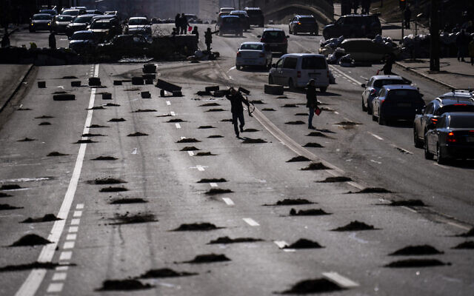
Cars are stopped at a roadblock set by civil defensemen at a road leading to central Kyiv, Ukraine, on Monday, February 28, 2022. (AP Photo/Emilio Morenatti)
Despite Ukrainian soldiers shooting Brodsky, his family told the Channel 12 news outlet that they blame the “dictator” Vladimir Putin for his death. His father told the station that they want help bringing him for burial in Israel, and asked that Israel do more to ensure that people who are still alive can make it safely to the Jewish state.
Brodsky came to Israel at age 13 with his family. He lived in the country for 27 years and had two small children. He returned to Ukraine about 2 years ago to start a business in Kyiv.
The Zaka rescue service gave his age as 37, though some Israeli news outlets identified him as 41 or 42 years old.
Prime Minister Naftali Bennett sent condolences to the family on Monday evening.
“In the name of all Israeli citizens, I want to send my condolences to Roman’s wife, children and family in Israel and in Ukraine. We are doing everything to help Israelis return home,” Bennett said.
The Foreign Ministry said it had informed the man’s wife and child who were still in Ukraine, as well as his parents in Israel. His mother collapsed upon hearing the news and was taken to Ashkelon’s Barzilai Medical Center for care.
Brodsky’s father and stepmother live in the southern city of Arad, while his mother lives in Ashkelon. They were informed of their son’s death by Magen David Adom.
According to the Ukrainian interior ministry, as of Monday, 352 civilians have been killed, 14 of them children, in the Russian offensive, and 1,684 people have been injured, 116 of them minors.
Israel’s Foreign Ministry estimated that several thousand Israeli citizens were still in Ukraine, though many had started making their way to the country’s borders, where Israeli embassy employees were working to get them on flights back to Israel. https://www.timesofisrael.com/israeli-man-shot-dead-as-convoy-escaping-kyiv-comes-under-ukrainian-fire/ [War is Hell –(William Tecumseh Sherman) War is the battle of megalomaniacs in the quest for power. Always remember there are usually inciting circumstances when you look very deep. No one is without blame in these situations. – rdb]

Russia arrests Israeli sailor aboard Ukrainian cargo ship in Black Sea
Yuri Shvidky detained by Russian navy on board Ukrainian-flagged bulk carrier Princess Nicole which was towed to a port on the Crimean Peninsula; Foreign Ministry searching for his whereabouts
Itamar Eichner | Published: 02.28.22, 18:07
Russia has detained an Israeli sailor who was on board a Ukrainian cargo ship that was seized by the Russian navy in the Black Sea over the weekend, his brother told Ynet on Monday.
Semion Shvidky said that his brother Yuri, 51, was on board the Ukrainian-flagged bulk carrier Princess Nicole when it was seized by the Russian navy in the territorial waters of Romania on Saturday and towed to the port of Sevastopol in the Crimean Peninsula.
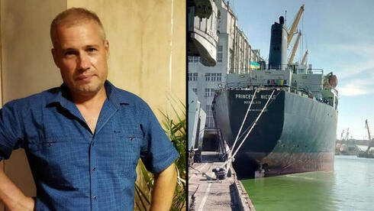
Israeli Ukrainian sailor Yuri Shvidky who was detained by the Russian navy in the Black Sea (Photo: Courtesy of the family)
The Ukrainian government said that Princess Nicole "was approached by Russian warships and made an illogical and sharp change of course while headed to Snake Island."
"My brother texted us that he has been detained by the Russian, that he was taken to land, and he has no clue where he is. He hasn't written us since," Shvidy told Ynet.
He said that Yuri has been a seaman for many years but has been working aboard Princess Nicole for just a few months. The father of two made Aliyah in 2005 and holds dual Israeli-Ukrainian citizenship. He decided to go back to Ukraine several years later to reunite with his family.
"I am worried sick because the Russians are shooting people and we don't know what may happen to him," Shvidky said.
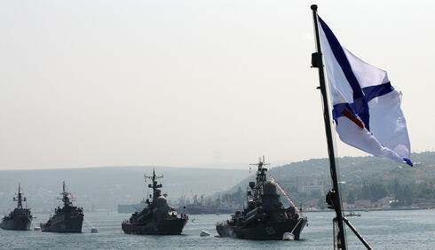
Russian navy warships in the Black Sea off the shores of the Crimean Peninsula (Photo: AFP)
After the incident, Shvidky called the Foreign Ministry in tears asking them to help save his brother, and since then Israeli diplomats have been making tremendous efforts to track Yuri and bring him home.
The Ukrainian state border guard service also reported that another commercial vessel named Athena had been seized by the Russian navy in Russian waters, 22 nautical miles from Ukraine's Snake Island in the Black Sea.
Ukraine accused the Russian navy of violating international law under the guise of a "counter-terrorism operation", adding that there were 50 crew members on both vessels. https://www.ynetnews.com/article/hjfel009lq

Ukraine’s leader signs application to join EU as round of talks with Russia ends
European officials throw cold water on his plea to join bloc amid Russian invasion, citing ‘sensitivities’; Kyiv says further talks with Moscow possible ‘in the near future’
By Agencies Today, 8:22 pmUpdated at 9:06 pm
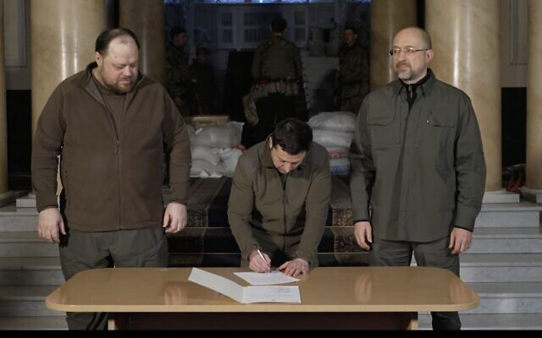
Ukrainian President Volodymyr Zelensky (center) signs an application for Ukraine to join the European Union, on February 28, 2022. (Screenshot/Facebook)
KYIV, Ukraine — An embattled Ukraine moved to solidify its bond with the West on Monday by signing an application to join the European Union, while the first round of Ukraine-Russia talks aimed at ending the fighting concluded with no immediate agreements.
Ukraine President Volodymyr Zelensky posted photos of himself signing the EU application, a largely symbolic move that could take years to become reality and is unlikely to sit well with Russian President Vladimir Putin, who has long accused the West of trying to pull Ukraine into its orbit.
Russian and Ukrainian officials held their meeting on day five of the war under the shadow of Putin’s nuclear threats, and with Moscow’s invasion of Ukraine running into unexpectedly fierce resistance.
Early Monday night, a top adviser to Ukraine’s president said that the first round of talks with Russia had ended and that both delegations had returned home for consultations in their capitals.
Mykhailo Podolyak gave few details except to say that the talks, held near the Ukraine-Belarus border, were focused on a possible cease-fire and that a second round could take place “in the near future.”
At this stage, Ukraine is many years away from reaching the standards for achieving EU membership, and the 27-nation bloc is expansion-weary and unlikely to take on new members any time soon.
Also, any addition to the EU must be approved unanimously, and some member states have complicated approval procedures.
President @ZelenskyyUa has signed application for the membership of #Ukraine in the European Union.
This is a historic moment! pic.twitter.com/rmzdgIwArc
— Verkhovna Rada of Ukraine (@ua_parliament) February 28, 2022
Overall, the consensus has been that Ukraine’s deep-seated corruption could make it hard for the country to win EU acceptance. Still, in an interview with Euronews on Sunday, EU Commission chief Ursula von der Leyen said, “we want them in the European Union.” The country of Ukraine has a very long history of corruption with the west which is why the dolts in DC don’t want to bend because they would lose their cash cow. It isn’t that Ukraine is such a tremendous political ally, it is that they have been a great location to launder money by giving lots of aid and then getting huge kickbacks as we saw with the Bidens. It isn’t just the Bidens whoever who have been using it, if you look deeply there are multiple others over many years that have been the recipient of their corruption. – rdb]
However, several EU officials walked back von der Leyen’s comments, pouring cold water on Zelensky’s plea.
EU officials stressed that the adherence procedure takes years, dampening Ukraine’s hopes that suddenly becoming part of the European club could help it better weather the Russian onslaught and speed up military, financial and political support.
EU foreign policy chief Josep Borrell said that any bid for membership could take “a lot of years.”
Von der Leyen’s spokesman, Eric Mamer, walked back her comments, telling journalists that the EU chief meant that Ukraine “is a European country and we want them in, meaning Europe in general.”
“She then also specified that there is a process [for joining the EU]. And I think that this is the important point,” he added.
The European Commission said that, in any case, it can only negotiate with hopeful candidate countries on the basis of a mandate from the EU’s 27 member states — something it has not received for Ukraine.
“At the end of the day, this is a debate at the highest political level, for the [European] Council,” where the member states take decisions, said a commission spokeswoman, Ana Pisonero.
The president of the European Council, Charles Michel, told a group of journalists that there were already long-standing disagreements among EU countries on enlarging the bloc.
“There are different opinions and sensitivities within the EU on enlargement,” he told a group of journalists.
He said Kyiv would have to submit an official request to join before member states — which would have to greenlight membership unanimously — could come up with a position.
Meanwhile, outgunned Ukrainian forces managed to slow the Russian advance, and Western sanctions began to squeeze the Russian economy, but the Kremlin again raised the specter of nuclear war, reporting that its land, air and sea nuclear forces were on high alert following Putin’s weekend order.
Stepping up his rhetoric, Putin denounced the US and its allies as an “empire of lies.” [If you look at what has been going on for the past couple years, Pootie Poot is Not too far off course on that statement. – rdb]
A tense calm reigned in Kyiv, where people lined up to buy food, water and pet food after two nights trapped inside by a strict curfew, but social media video from Ukraine’s second-largest city, Kharkiv, showed residential areas being shelled, with apartment buildings shaken by repeated, powerful blasts. Authorities in Kharkiv said at least seven people had been killed and dozens injured. They warned that casualties could be far higher.
“They wanted to have a blitzkrieg, but it failed, so they act this way,” said 83-year-old Valentin Petrovich, using just his first name and his Russian-style middle name because of fear for his safety. He described watching the shelling from his downtown apartment.
The Russian military has denied targeting residential areas despite abundant evidence of shelling of homes, schools and hospitals.
Meanwhile, as Russia’s Central Bank scrambled to shore up the tanking ruble, Putin signed a decree governing foreign currency, in a bid to stabilize the ruble.
But that did little to calm Russian fears. In Moscow, people lined up to withdraw cash as the sanctions threatened their livelihoods and savings.
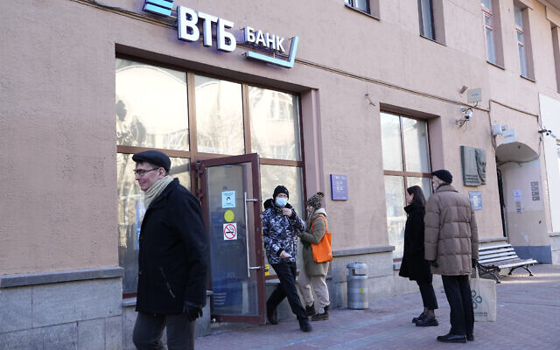
People stand in line to withdraw money from an ATM of VTB Bank in downtown Moscow, Russia, on February 28, 2022. (AP Photo/Pavel Golovkin)
Across Ukraine, meanwhile, terrified families huddled overnight in shelters, basements or corridors.
“I sit and pray for these negotiations to end successfully, so that they reach an agreement to end the slaughter, and so there is no more war,” said Alexandra Mikhailova, weeping as she clutched her cat in a makeshift shelter in the strategic southeastern port city of Mariupol. Around her, parents sought to console children and keep them warm.
The UN human rights chief said at least 102 civilians have been killed and hundreds wounded in more than four days of fighting — warning that figure is probably a vast undercount — and Ukraine’s president said at least 16 children were among the dead.
More than a half-million people have fled the country since the invasion, another UN official said, with many of them going to Poland, Romania and Hungary. And millions have left their homes.
The negotiations Monday were the first face-to-face talks between Ukrainian and Russian officials since the war began. The delegations met at a long table with the blue-and-yellow Ukrainian flag on one side and the Russian tricolor on the other.
Moscow’s Defense Ministry said that extra personnel were deployed to Russian nuclear forces and that the high alert applies to nuclear-capable intercontinental ballistic missiles, submarines and long-range bombers.
A senior US defense official, speaking Monday on condition of anonymity, said the US had yet to see any appreciable change in Russia’s nuclear posture.
US and British officials have played down Putin’s nuclear threat as posturing. But for many, the move stirred up memories of the 1962 Cuban Missile Crisis and fears that the West could be drawn into direct conflict with Russia. https://www.timesofisrael.com/zelensky-signs-application-to-join-eu-as-round-of-talks-with-russia-ends/ [were either the EU or NATO to decide to suddenly breach the rules of acceptance and allow Ukraine to enter into them that would be an open slap in the face to Putin and would likely intensify his efforts and could even precipitate a nuclear event. Pootie Poot has developed some limited strike nukes. There is an EXCELLENT video explain the history of the Ukraine and its military tactical significance for Russia. If you want to understand part of his thinking you would do well to watch this video. His thinking is quite logical and strategic. 30 minute video – play it on 1.5 speed or better
https://www.youtube.com/watch?v=If61baWF4GE&t=7s RDB]

Moscow warns against supplying lethal weapons to Ukraine
Kremlin says suppliers will bear responsibility should arms be used during military campaign in former Soviet republic as Britain and Canada join host of Western countries pledging military aid
Ynet, news agencies | Published: 02.28.22, 23:50
Russia's foreign ministry said on Monday that those supplying lethal weapons to Ukraine will bear responsibility should they be used during Russia's military campaign there.
The ministry added that the steps the European Union has taken against Russia will not be left without a harsh response.
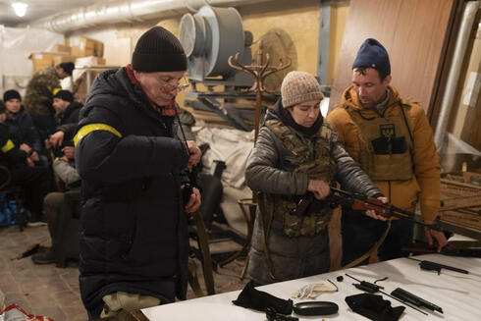
Armed Ukrainian civilians prepare for a nighttime patrol in the capital Kyiv amid a Russian invasion, February 28, 2022 (Photo: EPA)
Earlier Monday, British Prime Minister Boris Johnson told leaders of countries including the United States, France and Germany in a call to continue supplying weapons to Ukraine, a government spokesperson said.
Johnson was joined on the call with other world leaders and representatives of the European Union and NATO.
"The prime minister stressed the need for countries to continue supporting the Ukrainian government, including with the provision of defensive weapons," the government spokesperson said.
"The prime minister welcomed the unity of message and action between countries in recent days in response to Russia's invasion. He stressed the need to continue applying pressure on Putin's regime, including on SWIFT, with sanctions and with trade restrictions."
Meanwhile, Canadian Prime Minister Justin Trudeau said his country will supply anti-tank weapons and upgraded ammunition to Ukraine to support its fight against the Russians as well as ban imports of crude oil from Russia.
"Canada will continue to deliver support for Ukraine's heroic defense against the Russian military," Trudeau told reporters in Ottawa. "We are announcing our intention to ban all imports of crude oil from Russia, an industry that has benefited President Putin and his oligarchs greatly."
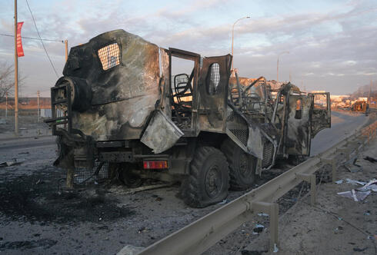
Canada imported C$289 million worth of energy products in 2021, according to Statistics Canada.
Canada has already sent weapons and non-lethal support to Ukraine, and it has backed a number of sanctions, including supporting the removal of Russia from the SWIFT system for international bank payments.

Torched military vehicles in the city of Bucha outside the Ukrainian capital Kyiv (Photo: Reuters)
Canada also played a role in restricting Russia's central bank from being able to access its foreign reserves.
Earlier on Monday, Foreign Minister Melanie Joly said the G7 would bring more sanctions against Russia.
They join a host of Western countries that have already mobilized to supply Ukraine with weapons in an attempt to fend off the Russian invasion, the biggest attack on a European state since World War Two, including Sweden, Denmark and Germany. https://www.ynetnews.com/article/s1r8gtcl5

Zelensky pleased by Bennett’s mediation offer in call with Putin, says Ukraine envoy
Ambassador predicts Putin could yet consider Israeli mediation if talks on Belarus border stall; says invasion ‘won’t succeed’; reveals Netanyahu tried to mediate when he was PM
By TOI staff Today, 7:02 pm
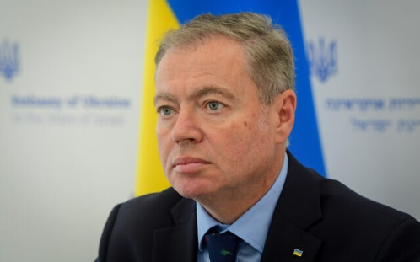
Ukraine's ambassador to Israel, Yevgen Korniychuk, at a press conference in Tel Aviv, on February 25, 2022. (Avshalom Sassoni‎‏/Flash90)
Ukrainian President Volodymyr Zelensky was pleased that Prime Minister Naftali Bennett extended an offer to Russian President Vladimir Putin to mediate between the two Eastern European countries following Russia’s invasion of Ukraine, Kyiv’s envoy to Israel said Monday.
In a briefing with reporters, Ukrainian Ambassador Yevgen Korniychuk claimed that Putin was not thrilled by Bennett’s offer when the two leaders spoke by phone Sunday. However, Korniychuk said Ukraine believed there was still a chance that Russia could take up the Israeli initiative. [I am not sure just how wise it is for Israel to “cross” Russia. Literally in the blink of an eye Putin could send his forces in Syria to Israel and decide they need a lesson. Obviously that would be a real game changer. – rdb]
“At the moment [the Russians] think they can conquer us,” Korniychuk was quoted as saying by Hebrew media, “but of course they won’t succeed.”
The remarks came as Ukrainian and Russian officials met for talks on Ukraine’s border with Belarus, amid high hopes but low expectations for any diplomatic breakthrough to end the biggest land war in Europe since World War II.
Korniychuk predicted Putin could reconsider Bennett’s mediation offer if the talks in Belarus fail to yield a breakthrough.
Ukraine suggested last week that Israel could mediate talks, owing to its close ties with both Kyiv and Moscow. Putin reportedly did not take up Bennett’s mediation offer during their conversation Sunday, which the Israeli premier initiated.
The phone call marked the first time Bennett and Putin have spoken since Russia invaded Ukraine on Thursday. Bennett spoke with Zelensky in a phone call on Friday.
At Monday’s briefing, the Ukrainian envoy said Kyiv has been pushing for the past year for Israel to mediate talks between Zelensky and Putin regarding the years-long war in eastern Ukraine, including when former prime minister Benjamin Netanyahu was still in office.
According to Korniychuk, Netanyahu twice raised the idea with Putin, but to no avail.
“Netanyahu told us that he can mediate between two sides that want to reach an agreement but clarified to us that he only sees one side that wants an agreement, and that is Ukraine,” he said.
Korniychuk also said Jerusalem has not opposed the Ukrainian embassy’s efforts to recruit Israeli volunteers to fight against invading Russian forces and thanked Israel for sending 100 tons of humanitarian aid, the first batch of which is due to be shipped Tuesday.
The Foreign Ministry said the initial shipment would include 17 tons of medication, medical equipment, tens, jackets and water purification systems, among other forms of assistance.
“We appreciate everything Israel has done for us,” Korniychuk said according to the Haaretz daily. “It is difficult to describe how complex it is for me to be the ambassador to Israel when my prime minister is Jewish, because he has high expectations of Israel, more than Israel can provide,” he said.
Unlike many other democracies, Israel has not announced it will supply Ukraine with military assistance and Bennett reportedly turned down a request from Zelensky to do so.
Israel has been careful in its comments on the conflict and Bennett has avoided criticizing Moscow publicly. This is believed to be at least partly due to its need to work with the Russian military presence in neighboring Syria. https://www.timesofisrael.com/zelensky-pleased-by-bennetts-mediation-offer-in-call-with-putin-says-ukraine-envoy/

Lapid: Israel to back UN resolution condemning Russia, be ‘on right side of history’
Foreign minister says Israel has ‘moral duty, historical obligation’ to be part of diplomatic, humanitarian efforts in Ukraine, and vows to ‘leave no Israeli or Jew behind’
By TOI staff and Jacob Magid Today, 4:05 pm
Israel will vote in favor of the United Nations General Assembly resolution condemning the Russian invasion of Ukraine, Foreign Minister Yair Lapid said Monday, days after Jerusalem refused to co-sponsor a similar measure in the Security Council in a move that disappointed the United States.
Lapid said Israel has a moral responsibility to both condemn Russia for its actions and provide humanitarian assistance to the Ukrainians.
Noting that the UN would vote on “a resolution to condemn the Russian invasion of Ukraine,” Lapid said, “Israel will join and vote in favor, along with the overwhelming majority of nations.”
“ Israel was and will be on the right side of history,” Lapid said in a statement. “We have a moral duty and historical obligation to be part of the effort.” [This could well set off some history of Biblical proportions. – rdb]
The General Assembly resolution is almost certain to pass the 193-member body, since individual countries don’t have the power to scuttle such measures on their own.
In an apparent reference to the disagreement over the earlier resolution, Lapid said the US is Israel’s main ally and understands Jerusalem’s need to be “careful and discretionary” in its delicate relations with Moscow, due to the presence of Russian forces in Syria that coordinate with Israel, as well as the large number of Jews in Ukraine.
“Russia is the most significant military force in Syria, and our mechanism of cooperation with them is aiding our determined struggle against the establishment of an Iranian [presence] on our northern border,” Lapid said.
Ukrainian refugees arrive from their homeland at Zahonyi railway station close to the Hungarian-Ukrainian border on February 27, 2022 (Attila KISBENEDEK / AFP)
Lapid said that while approximately 4,000 Israelis have already left Ukraine, there are still thousands of Israelis there and around 180,000 people who are entitled to Israeli citizenship if they choose.
“Ukraine is a difficult battle zone, but we are committed to a sacred principle — we will do everything not to leave any Israeli behind, any Jew behind. This is the reason the Jewish state exists. This is our commitment,” he said. [Obviously Israel doesn’t follow the same philosophy as those currently in command in the US. – rdb]
Lapid also detailed the airlifts of humanitarian aid that are set to leave Israel for Ukraine on Monday and Tuesday, transporting thousands of coats, blankets, sleeping bags, medical equipment, tents and water purification equipment.
Israel is one of the few countries that maintains warm relations with both Ukraine, a fellow Western democracy, and with Russia.
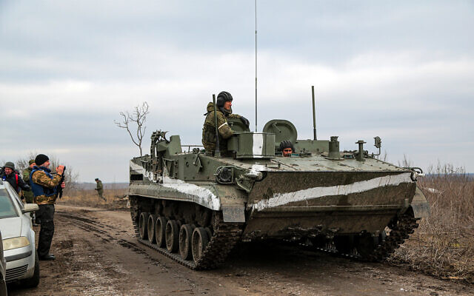
An armored vehicle outside Mykolaivka, Donetsk region, the territory controlled by pro-Russian militants in eastern Ukraine, February 27, 2022. (AP Photo)
Ahead of the Security Council vote on Friday, the US mission reached out to dozens of countries, asking them to back the resolution, a Western diplomat said. Non-Security Council members were still able to co-sponsor the resolution, even though they could not vote on it.
The Israeli mission referred the matter back to Jerusalem for guidance, where a decision was reached shortly before the vote to avoid joining such a strong gesture against Russia, an official told The Times of Israel.
Another Israeli official told The Times of Israel on Sunday that the decision not to co-sponsor that resolution in the Security Council was partially due to the certainty that Russia, which holds veto power, would quash the measure anyway.
A source familiar with the matter confirmed an Axios report that the US expressed its disappointment to Israel after Jerusalem refused to co-sponsor the vote. https://www.timesofisrael.com/lapid-israel-will-support-un-resolution-on-ukraine-be-on-right-side-of-history/

Lapid, British counterpart discuss ‘global consequences’ of war in Ukraine
Foreign minister touts ‘productive’ conversation with UK Foreign Secretary Liz Truss, who has said says she ‘absolutely’ supports Britons joining the fight against Russia
By TOI staff Today, 7:53 pm
Foreign Affairs Minister Yair Lapid held a discussion with his British counterpart, Foreign Secretary Liz Truss, on Monday, to address the ongoing war in Ukraine and its global consequences.
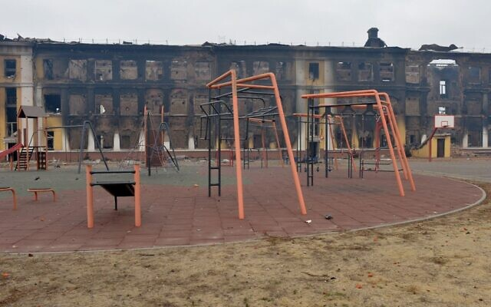
“I just finished a long and productive conversation with the Foreign Secretary of the United Kingdom, Liz Truss,” Lapid tweeted.
“We discussed the situation in Ukraine and the resulting global consequences, and I updated her on the humanitarian aid which Israel will be transferring to Ukraine,” he added, referring to Prime Minister Naftali Bennett’s announcement on Sunday about 100 tons in humanitarian aid that Israel intends to provide to Ukraine in the coming days.
Entering the fifth day of the Russian invasion of Ukraine, a tiny sliver of hope emerged as the first face-to-face talks between Ukrainian and Russian officials since the war began opened Monday.
However, fierce fighting continued in Ukraine’s second-most populated city of Kharkiv, as Russian shelling killed at least 11 civilians and injured dozens more.
“The Russian enemy is bombing residential areas,” Ukrainian Regional Governor Oleg Sinegubov wrote. “As a result of the bombardments that are ongoing, we cannot call on the emergency services.”
This photograph shows a view of a school destroyed as a result of fighting not far from the center of the Ukrainian city of Kharkiv, located some 50 km from the Ukrainian-Russian border, on February 28, 2022. (Photo by Sergey Bobok/AFP)
Lapid has voiced strong criticism of the unprovoked Russian invasion.
Shortly after Russian troops crossed the border into Ukrainian territory on Thursday, Lapid said the invasion was “a grave violation of the international order,” marking Israel’s harshest condemnation of Moscow since.
“Israel is a country that has experienced wars, and war is not the way to resolve conflicts,” he said, calling on both sides to return to the negotiating table.
On Sunday, Lapid reportedly said in a private meeting that Israel must condemn dictators.
“Israel must be on the right side and condemn dictators who attack democracies,” he said in an apparent reference to Russian President Vladimir Putin.
On Monday, announcing that Israel would vote in favor of a UN resolution condemning the Russian invasion, Lapid said Israel “has been and will be on the right side of history.”
Truss has adopted a more forceful tone regarding the situation, saying on Sunday that she would “absolutely” support Britons who choose to go to Ukraine to help fight the Russian invasion.
“Absolutely, if people want to support that struggle I would support them in doing that,” she said.
“The people of Ukraine are fighting for freedom and democracy, not just for Ukraine, but for the whole of Europe,” she added, reflecting the decisive position taken by the UK since the war began.
Earlier on Sunday, Ukraine’s President Volodymyr Zelensky urged foreigners to head to Ukrainian embassies worldwide to sign up for an “international brigade” of volunteers to help fight invading Russian forces.
“All foreigners wishing to join the resistance against the Russian occupiers and protect global security are invited by the Ukrainian leadership to come to our state and join the ranks of the territorial defense forces,” Zelensky said in a statement on the presidential website. https://www.timesofisrael.com/lapid-british-counterpart-discuss-global-consequences-of-war-in-ukraine/

Traditionally neutral Switzerland adopts sanctions against Russia
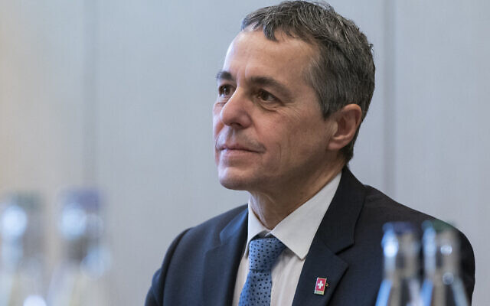
Swiss president calls decision a ‘big step for Switzerland’; Russia’s mission in Geneva says it will not attend a UN Human Rights Council meeting
By Christophe VOGT Today, 8:55 pm

President of the Swiss Confederation, Ignazio Cassis, pauses while speaking during a meeting with US Secretary of State Antony Blinken, on January 21, 2022, in Geneva, Switzerland. (AP Photo/Alex Brandon, Pool)
GENEVA, Switzerland (AFP) — Traditionally neutral Switzerland will adopt all the sanctions already imposed by the EU on Russia over its invasion of Ukraine, including against Russian President Vladimir Putin, Bern said Monday.
“This is a big step for Switzerland,” Swiss President Ignazio Cassis told a press conference, after the Alpine nation had for days hesitated over whether to join the international move to sanction Moscow over the attack on its neighbor.
As the European Union last week slapped Russia with biting sanctions after it launched its full-scale invasion of Ukraine, Bern only said it would ensure that those penalties could not be circumvented via Switzerland.
But following a government meeting Monday, Switzerland announced it was now fully on board with the sanctions.
“Switzerland will implement the sanctions in coordination with the EU,” the government, known as the Federal Council, said in a statement, adding that these were “primarily goods and financial sanctions.”
But they also included the freezing of the assets of persons and companies.
In particular, the government said Switzerland would with “immediate effect” impose the sanctions already imposed by the EU on Putin, Russian Prime Minister Mikhail Mishustin, and Russian Foreign Minister Sergey Lavrov.
“In so doing, Switzerland is responding to the serious violations of international law for which these individuals are responsible,” it said.
The announcement came as Russia’s mission in Geneva announced that Lavrov had been forced to cancel his trip to the United Nations Human Rights Council due to the “anti-Russian sanctions” imposed by EU countries.
Lavrov had been scheduled to travel to the Swiss city on Tuesday to address the body.
The Swiss government said Monday that it would also close Swiss airspace to all flights from Russia and to all movements of aircraft with Russian markings, except for flights for humanitarian, medical, or diplomatic purposes.
Swiss Justice Minister Karin Keller-Sutter meanwhile told reporters that five oligarchs close to the Russian president, and who had strong ties to Switzerland, had been banned from entering the country.
And Bern said it had decided to partially suspend a 2009 agreement on visa facilitation for Russian nationals, although holders of diplomatic passports would still be permitted to enter Switzerland without a visa.
While it is copying the existing sanctions imposed by the EU, the government said Switzerland would examine any further sanctions imposed by the bloc “on a case-by-case basis.”
Switzerland had come under increasing pressure to get in line with the EU and US sanctions against Russia, with nearly all political parties backing the move.
EU foreign policy chief Josep Borrell hailed Monday’s decision, saying it was “very good news” that Switzerland would “fight against corruption and the dark money… of the oligarchs who support Putin and who are being targeted by sanctions.”
“Without the participation of Switzerland, our measures would have been not as effective as needed,” he told reporters.
Russia may only rank 23rd on Switzerland’s list of trading partners, but the Alpine country’s banks are often favored by Russia’s ultra-rich.
According to statistics from the Bank for International Settlements, Swiss banks had in the third quarter last year some $23 billion in Russian holdings, mostly from deposits.
The majority of Russia’s oil business passes through Switzerland, while its cereals and metals are also traded in Geneva.
Before shifting its approach, Bern said it had carefully considered “Switzerland’s neutrality and peace policy considerations,” but that “Russia’s unprecedented military attack on a sovereign European country was the deciding factor.”
Bern stressed though that it remained willing to “actively contribute to a solution to the conflict through its good offices.” https://www.timesofisrael.com/traditionally-neutral-switzerland-adopts-sanctions-against-russia/ [This is MOST unusual for Switzerland . -rdb[

Fleeing city near Belarus border, busloads of Ukraine Jewish orphans look to Israel
Now located in a currently quiet part of southeastern Ukraine, director of the Chabad-run orphanage says many of the almost 100 children are reliving trauma of 2014 war
By Sue Surkes Today, 4:51 pm
Jewish orphans who fled from Zhytomyr, near the Belarus border, play in southwestern Ukraine, February 2022. (Courtesy, Alumim Orphanage) | Jewish orphans who fled from Zhytomyr near the Belarus border, play in southwestern Ukraine. (Courtesy, Alumim Orphanage)
Busloads of Jewish orphans from the Ukrainian city of Zhytomyr near the Belarus border have escaped to southwestern Ukraine, and hope to cross into Romania and from there fly to Israel.
On Sunday, missiles fired from Belarus hit an airport in Zhytomyr, according to Reuters.
Just under 100 children, ages four to 18, are in the care of Chabad’s Alumim orphanage based in Zhytomyr. In a country with serious problems of alcoholism and drug abuse, some have no parents while others are so-called “social orphans,” with one or two parents who, for a range of reasons, are unable to cope with child-rearing.
A number of the children had previously experienced war situations in Donetsk and Lugansk — areas declared independent by Russian-backed separatists in 2014 — and since the Russian invasion of Ukraine five days ago have been reliving the trauma, according to Alumim’s Israel-born director, Malka Bukiet.
All of them are now staying in a hotel in Boiany, near Chernivtsi (Czernowitz), close to the Carpathian mountains.
“They’re suffering from anxiety, all sorts of things,” Bukiet said. “Some say they don’t feel well, or can’t do something, or can’t sleep, or say they can’t get up, or talk about it all the time. I’m in touch with psychologists and we’re trying to keep everyone as occupied as possible all the time.”
“Early on Thursday morning, I woke up to a very loud bang,” Bukiet told The Times of Israel. “I thought it was perhaps a plane. I didn’t get what it was. When I opened my phone and saw that all my friends were experiencing the same noises, I understood that this was something real.
“My rabbi called and told me that there was military activity just a few kilometers away, which is why we heard such a loud explosion. He said, ‘We’re not waiting. We’ll find the places [for you to flee to], you find the buses,'” she recalled. “We just took the children and, with three Chabad families, undertook the journey to a hotel in Boiany, which took 15 hours rather than the usual seven.”
“Here it’s very quiet,” she said of their interim facilities. “You feel the war in that people from all over Ukraine are arriving here all the time. We’re now around 200 Jews, and have opened another place here.”
With refugees flooding to the southwest, Chernivtsi’s population is expected to triple, said Bukiet, who is coordinating with Chernivtsi’s Chabad rabbi.
Bukiet, who has directed the orphanage for 15 years and been in Zhytomyr for 19 years, said, “The big thing is to give the children a feeling of security.”
“They read the news all the time but don’t hear sirens and don’t have to rush to shelters,” she noted. “There are kids worried about their families and friends. It’s not simple. We don’t have the usual counselors and local people. The older children are helping the younger ones and they’re all organizing activities for one another. We wanted other people to come with us, but at that point, they thought we were mad.”
Trying to organize an exit from Ukraine is difficult, she went on. Most of the children do not have passports, and getting permission from their parents is challenging. Some are even proving difficult to find.
“I’m so happy we didn’t wait,” Bukiet added. “Our main goal is to get out of here. We brought some food and are buying whatever kosher food we can find. We brought enough food for 10 days. I hope we’ll be here for less than that.” https://www.timesofisrael.com/fleeing-city-near-belarus-border-busloads-of-ukraine-jewish-orphans-look-to-israel/ [This is really pitiful. Who gets hurt in war? The civilians and children. – rdb]

Amid Ukraine crisis, new German chancellor to visit Israel on Tuesday
Pre-scheduled trip by Olaf Scholz follows his announcement that Germany will boost defense spending in response to Russian invasion, seek to buy Israeli drones
By TOI staff Today, 6:02 pm
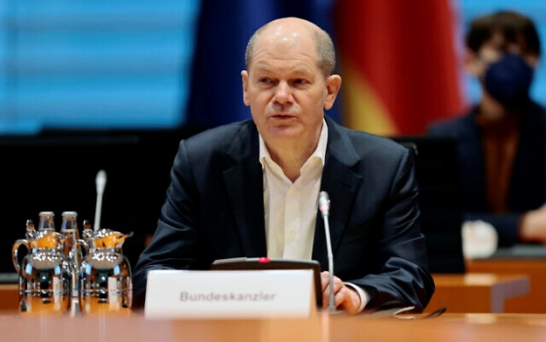
German Chancellor Olaf Scholz arrives for a security cabinet meeting at the Chancellery in Berlin, Germany, February 28, 2022. (AP Photo/Hannibal Hanschke, Pool)
German Chancellor Olaf Scholz will make a short visit to Israel on Tuesday, the Foreign Ministry said, amid a Russian invasion of Ukraine that has prompted Germany to announce a major boost in defense spending.
While in Israel, Scholz is expected to hold meetings with Prime Minister Naftali Bennett, President Isaac Herzog and Foreign Minister Yair Lapid.
Scholz is also due to visit the Yad Vashem Holocaust Memorial with Bennett on Wednesday before departing later that day.
The visit comes amid international efforts to find an end to the Russian invasion of Ukraine. Israel has been suggested by Ukraine as a mediator in the conflict due to its close ties with both nations.
Bennett offered to mediate between Moscow and Kyiv during a phone call Sunday with Russian President Vladimir Putin, though it is believed that the latter declined the offer. Delegations from Russia and Ukraine met for talks Monday on the Belarusian border.
While Israel has so far remained carefully noncommittal on the conflict, Germany has condemned Russia and joined other Western nations in sanctioning Moscow.
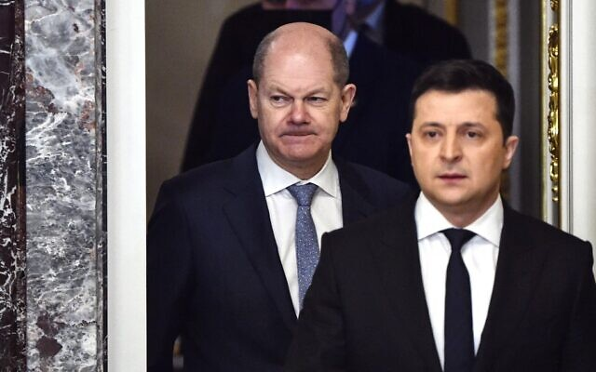
German Chancellor Olaf Scholz (L) and Ukrainian President Volodymyr Zelensky (R) arrive for a joint press conference in Kyiv on February 14, 2022. (Sergei Supinsky/AFP)
Scholz’s trip follows his announcement Sunday that Germany will increase spending on its military to over 2 percent of GDP, in a major shift. Berlin has long fallen short of that spending goal despite pledging to meet it as a member of NATO.
Scholz said Germany would seek to buy advanced Hermes model drones from Israel as part of the new defense spending.
In addition to the increase in defense spending, the German leader announced that Berlin, a major importer of Russian natural gas and oil, would seek to diversify its energy sources.
The visit, Scholz’s first to Israel since becoming chancellor in December, was planned in advance but appeared in jeopardy earlier this month due to a threatened strike by Foreign Ministry workers. https://www.timesofisrael.com/amid-ukraine-crisis-new-german-chancellor-to-visit-israel-on-tuesday/

PM meets Reform, Conservative leaders after 6-year hiatus under Netanyahu
Bennett vows to improve conditions at Western Wall prayer space; MK Alon Tal, who attended sit-down, says he’s optimistic about improving ties between Israel and progressive Jews
By Judah Ari Gross Today, 5:23 pm

Representatives of the Reform and Conservative movements of Judaism from North America and Israel stand outside the Prime Minister's Office in Jerusalem before a meeting on February 28, 2022. (Reform Movement in Israel)
For the first time in six years, the prime minister of Israel met Monday with the heads of the Reform and Conservative movements, in what participants said was a warm and positive discussion during which the premier promised to improve the egalitarian prayer space at the Western Wall.
The meeting was attended by Prime Minister Naftali Bennett and members of his staff and the heads of the Reform and Conservative movements of North America and Israel, as well as Knesset members Alon Tal and Gilad Kariv, the latter of whom is a Reform rabbi.
Tal described the meeting as something of a breakthrough in an impasse that has lasted years between Israel and progressive streams of Judaism.
Tal told The Times of Israel he had come to the meeting prepared with a scathing presentation on the ways in which the government had failed Reform and Conservative Jews, but was so impressed by the level of understanding exhibited by Bennett that he “scrapped it.”
“I felt like Bilam,” Tal said, referring to a biblical figure who was hired to curse the Israelites but ended up blessing them.
The relationship between the government and progressive streams of Judaism has been particularly strained since then-premier Benjamin Netanyahu pulled out of an agreement on the Western Wall that would, among other things, have allowed the building of a permanent egalitarian prayer space on the southern portion of the holy site. In the wake of that pullout, Netanyahu refused to meet with leaders of the Reform and Conservative movements.
“Six years! Six years that the government has turned its back on Reform and Conservative Judaism, which makes up the majority of Jews in the United States,” said Tal, who serves as a sexton in a synagogue affiliated with the Masorti movement, the Israeli version of Conservative Judaism.
Yizhar Hess, the former CEO of the Masorti movement and current head of the World Zionist Congress, told The Times of Israel that he too was optimistic coming out of the 90-minute meeting.
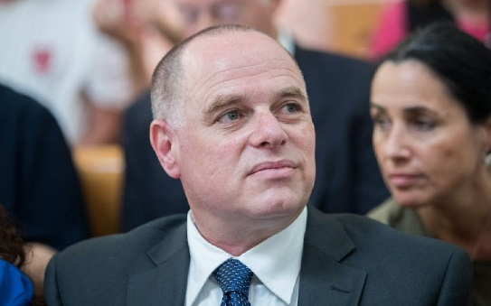
Yizhar Hess, Executive Director and CEO of the Conservative Judaism movement in Israel seen at the Supreme Court in Jerusalem, August 31, 2017. (Yonatan Sindel/Flash90)
“For one, I’m optimistic because this was the first meeting in years. Two, we also spoke about concrete issues. And three, with [Netanyahu], he said lots of things and didn’t do anything. Here we felt there is real intention,” Hess said.
“He was humorous, he was confident, he wasn’t an empty suit,” Hess said of the premier during the meeting.
According to Tal, one of the most significant moments of the meeting came when Union for Reform Judaism President Rick Jacobs said during his remarks to the prime minister that — despite the tensions between progressive streams of Judaism and the government — the connection between the movements and the State of Israel is “not conditional.” Jacobs noted that both his movement and the United Synagogue of Conservative Judaism vocally came out against a recent report by the Amnesty International human rights group accusing Israel of apartheid.
“Our movements expressed our unconditional support for the State of Israel and our expectation that the PM take steps that prove his commitment that the State of Israel is the home for all Jews in Israel and around the world,” the Reform Movement in Israel said in a statement.
Hess said that during the meeting Bennett “spoke with appreciation” for progressive Jewry.
Despite the change in government and promises from several members of the coalition, the Western Wall Compromise, as the deal is known, remains frozen. Though no specific guarantees were made about implementing the deal, Tal said the prime minister did promise to improve the conditions at the Robinson’s Arch, an area of the Western Wall that is already designated for egalitarian prayer. This was confirmed by an Israeli official familiar with the matter.
The area has been riddled with debris, including stones that have fallen off the Western Wall, and has been in a generally poor state for years, which Bennett said he would address. In addition, the prime minister said he would improve security at the site, in light of multiple cases of extremists harassing worshipers there, most notably and violently this summer during Tisha B’av, a day of mourning that marks, in part, rifts within the Jewish people.
“Bennett committed to the need to ensure our right to pray according to our custom at the Western Wall free from violence and interruption,” the Reform Movement in Israel said.
Jacobs told The Times of Israel that despite Bennett not making any specific promises regarding the Western Wall Compromise, he made it clear to the progressive Jewish leaders that reports that he personally was not invested in its implementation were incorrect.
Jacobs added that while the Western Wall issue was important and symbolic, it was only one instance among many in which American progressive Jews have for years felt they “didn’t matter” to the government. Jacobs said he was optimistic that the current Israeli government and Bennett would be able to address some of those issues.
Hess said that despite the lack of concrete progress on the Western Wall issue, he felt the progressive Jewish leaders “justifiably left with an optimistic feeling.”
Bennett was quickly criticized for sitting down with Reform and Conservative Jews by Haredi Knesset member Moshe Gafni, who quoted a passage from the Talmud roughly meaning, “Birds of a feather flock together.” https://www.timesofisrael.com/pm-meets-reform-conservative-leaders-after-6-year-hiatus-under-netanyahu/

Palestinian girl, 11, wounded as worshippers and police clash at Damascus Gate
Muslim Palestinians gathered to celebrate al-Israa wa al-Miraj, the anniversary of Mohammad’s journey to Al-Aqsa holy site; police say Palestinians rioted and threw stones at cops
By Aaron Boxerman Today, 5:47 pmUpdated at 8:28 pm
Palestinians and Israeli police clashed near Damascus Gate on Monday afternoon as Palestinians gathered in Jerusalem for an Islamic holiday, leading to 20 arrests, Israeli police said.
In videos from the scene, police could be seen dispersing groups of Palestinians with stun grenades and blasts of acrid-smelling high pressure water from cannons. Dozens of passersby, including women, children and and a man in a wheelchair, fled for cover.
Around 25 Palestinians were injured during the clashes, according to the Palestinian Red Crescent. An 11-year-old Palestinian girl was rushed to Jerusalem’s Hadassah Ein Karem hospital after her face was smashed in by a police stun grenade, according to a Hadassah spokesperson.
Palestinian media identified her as Manwar Burqan, a resident of the middle-class Shuafat neighborhood in East Jerusalem. Burqan is reportedly deaf and attends a special needs school in the city.
According to police, Palestinians had “chanted incitement and threw stones and bottles at police on the scene.” A spokesperson for Jerusalem police did not immediately respond to a request for comment on the wounded 11-year-old girl.
“Police forces have acted these past few hours to protect public order and prevent rioting,” an Israel Police spokesperson said.
Thousands of Palestinians had gathered in the Old City entryway to celebrate al-Israa wa al-Miraj. The holiday celebrates the miraculous “night journey” of Islam’s prophet, Mohammad, from Mecca to Jerusalem.
המשטרה משתמשת במכת״ז נגד עוברי אורח ואישה על כיסא גלגלים בשער שכם.
המשטרה: ״במהלך השעה האחרונה אירעו במקום הפרות סדר שכללו קריאות הסתה, יידוי אבנים וזריקת בקבוקים לעבר כוחות המשטרה הפועלים במקום.״
10 עצורים עד כה. pic.twitter.com/stHwGpt1eJ
— סולימאן מסוודה سليمان مسودة (@SuleimanMas1) February 28, 2022
According to Islamic tradition, Mohammad ascended heavenwards from the Al-Aqsa Mosque, which Jews also revere as the site of both Biblical temples. Palestinian Muslims often celebrate the holiday by gathering in Jerusalem for festivities and prayer at the shrine.
Cops also appeared to violently slap a Palestinian girl while subduing her on the ground, according to footage from the scene of the clashes. A young girl was also wounded by sound gre
בת 12
pic.twitter.com/yBeUjcvc8G
— بلال يوسف Bilal Yousef (@bilalyousef3) February 28, 2022
In another video, a Palestinian runs after a cop and pushes him onto the ground as the officer grapples with a second Palestinian.
الطفلة منور برقان من ذوي الاحتياجات الخاصة(صماء) تعرضت اليوم لإصابة مباشرة في الوجه بأحداث باب العامود سبب لها كسر في الفك ودخلت غرفة العمليات
هذا هو الإرهاب، احتلال صهيوني منذ أكثر من ٧٤ يتلقى دعم من العالم كي يبيد ويرتكب مجازر بحق الشعب الفلسطيني. pic.twitter.com/f3L031m52P
— ???????? ع يّ |ش✌️ (@3yyash22) February 28, 2022
The stairway leading to Damascus Gate is a popular site for Palestinians to enjoy the holiday cheer before heading to the Al-Aqsa Mosque for prayers. But the gateway has also become one of Jerusalem’s most charged sites.
Clashes between Palestinians and police in the area were part of the buildup to last year’s war between Israel and the Hamas terror group. Israeli police prevented Palestinians from sitting on the steps during Ramadan — a longtime Jerusalem tradition — leading to violent clashes.
https://www.timesofisrael.com/10-arrested-14-injured-in-clashes-at-jerusalems-damascus-gate-on-islamic-holy-day/

Israel to remove dangerous drug classification from cannabis compound CBD
Health Minister Horowitz signs off on removing compound from Israel's Dangerous Drugs Ordinance and paves the way for CBD-based medical products to enter the Israeli market
Adir Yanko | Published: 02.28.22, 19:11
The cannabis compound CBD will be removed from Israel's Dangerous Drugs Ordinance, Health Minister Nitzan Horowitz announced on Monday.
CBD (cannabidiol) and THC are two compounds, or cannabinoids, found in the cannabis plant. As opposed to THC, CBD doesn't possess psychoactive qualities, does not give a high feeling and is not addictive.
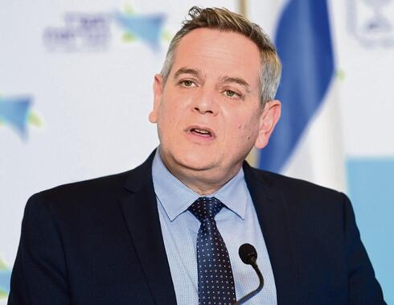
Health Minister Nitzan Horowitz (Photo: Yair Sagi)
Although it has been attempted several times, the ruling to exclude CBD from the list of dangerous drugs was never approved.
Horowitz and Health Ministry Director-General Prof. Nachman Ash announced their intention to remove the compound from the Dangerous Drugs Ordinance and assembled an expert panel to study the possible consequences of changing its classification.
Horowitz signed off on most of the panel's recommendations. However, he raised the amount of THC legally allowed in CBD-based products from 0.2% to 0.3%.
Horowitz further said that his ministry will work to expand research into the compound and establish a regulatory framework so that the Israeli market can enjoy products of the sort.
Cannabis farm in Israel (Photo: Seach Cannabis Farm) | Greenhouse of Israeli medical cannabis company B.O.L Pharma (Photo: AFP)
He called on Prof. Ash to assemble a task force that will monitor regulatory changes on the topic worldwide, and align Israel's policy accordingly.
The panel recommended against adding CBD-based ingredients in foodstuffs, supplements, and cosmetics over the next two years, after which the issue will be reconsidered.
It also proposed the Health Ministry and healthcare providers launch a public service campaign to teach about the possible side effects of products containing CBD and the potential dangers in independently purchasing such products online.
"There's much prejudice regarding everything related to cannabis. Today, we're starting to take steps and release the compound that is widely agreed should not be classified as a dangerous drug," Horowitz said.
"Israel has been lagging behind other countries for several years on this issue and continues to criminalize and prevent the usage of compounds that aren't dangerous to the public health. We are now closing this gap."
Prof. Ash also welcomed the move, which he said was long overdue, and called to further study the compound before adding it to food and cosmetics. https://www.ynetnews.com/health_science/article/bjutxdcgq

Lukashenko warns of 3rd World War, as Belarus prepares to send troops
The president denied that Belarus was taking part in the fighting, adding that no missiles were being fired from Belarusian territory • "Nuclear war is the end of everything"
By TZVI JOFFRE Published: FEBRUARY 28, 2022 08:53 Updated: FEBRUARY 28, 2022 12:03
Belarusian President Alexander Lukashenko warned that Western sanctions were pushing Russia towards a "third world war," as The Washington Post reported that Belarus was preparing to send troops into Ukraine on Sunday.
"In a situation like this, we should be aware that there are such sanctions. A great deal is being said about the banking sector. Gas, oil, SWIFT. It’s worse than war," said Lukashenko at a referendum on changing Belarus's constitution, according to the president's website. "Russia is being pushed towards a third world war. We should be very reserved and steer clear of it. Because nuclear war is the end of everything."
The Belarusian president stated that the retaliatory sanctions by Russia and Belarus would be very sensitive in order to ensure that they do not also impact them.
Lukashenko claimed that America is the "only beneficiary" of the current conflict, saying that the US aimed to "put Europe in its place and remove competitors."
"Today we must stop the war," Lukashenko stated while casting a ballot at the referendum. "I would not even call it ‘war’ right now: It is still a conflict. Another day or two and there will be a war. In three days - a meat grinder." The Belarusian president added that Russia aimed to "restore Ukraine," without specifying what it would be restored to.
Lukashenko denied that Belarus was taking part in the fighting, adding that no missiles were being fired from Belarusian territory, except for "two or three rockets" which were fired on February 23 after Ukrainian missile batteries were allegedly detected near the country's border.
"Russia does not need this. They have ammunition, cartridges, machine guns, and enough people to solve the problems that Russia wants to solve," he said, claiming that Belarusian and Russian people in Ukraine were being beaten and poisoned. "They started beating them, poisoning them. They threaten us with terrorist acts."
On Sunday, almost two-thirds of Belarusians expressed support for adopting a new constitution that would ditch its non-nuclear status, chairman of the country’s Central Election Commission (CEC) Igor Karpenko said, according to TASS.
The Belarusian president stressed that the country would only ask Russian President Vladimir Putin to transfer nuclear weapons to Belarus if such weapons were transferred by the West to Poland or Lithuania.
On Sunday, Putin put Russia's strategic deterrence forces, which includes nuclear weapons, on a "special service regime," according to TASS. The move was made due to "aggressive statements" by NATO leaders, he said.
Lukashenko stated that additional weapons will be transferred from Russia to Belarus in the near future. He warned that Belarusian troops are ready to deploy within a matter of hours, "if necessary."
"In the near future – we already know what additional equipment we need – we will agree with Putin and we will transfer additional appropriate weapons from Russia, which can cause such unacceptable damage that neither the Poles nor the Lithuanians will want to fight with us," warned the Belarusian president.
“It’s very clear" that the Belarusian capital of "Minsk is now an extension of the Kremlin,” said a US administration official who spoke to The Washington Post on condition of anonymity. The official said that Belarusian troops could deploy to Ukraine as soon as Monday. https://www.jpost.com/international/article-698871

ICC prosecutor to proceed with investigation into alleged war crimes in Ukraine
prosecutor Karim Khan said the investigation will look into alleged violations dating back to 2014 when Ukraine recognized the court's jurisdiction.
By REUTERS Published: FEBRUARY 28, 2022 22:25 Updated: FEBRUARY 28, 2022 22:44
The office of the prosecutor of the International Criminal Court on Monday said it will seek court approval to open an investigation into alleged war crimes in Ukraine.
The move comes just days after Russia's invasion of its neighbor and prosecutor Karim Khan said on Friday that the court could investigate alleged crimes arising from the fighting.
Khan said the investigation will look into alleged violations dating back to 2014 when Ukraine recognized the court's jurisdiction.
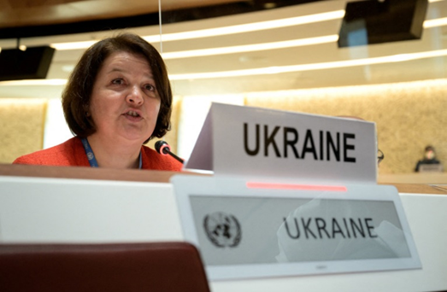
Although neither Russia nor Ukraine are members of the court in The Hague, Ukraine gave it authorization over war crimes and crimes against humanity, following Moscow's annexation of Crimea.
Ukraine's ambassador Yevheniia Filipenko speaks at the opening of a session of the UN Human Rights Council, following the Russian invasion in Ukraine, in Geneva, Switzerland February 28, 2022.(photo credit: FABRICE COFFRINI/POOL VIA REUTERS)
"There is a reasonable basis to proceed with opening an investigation," the statement said. "In particular, I am satisfied that there is a reasonable basis to believe that both alleged war crimes and crimes against humanity have been committed in Ukraine."
"Given the expansion of the conflict in recent days, it is my intention that this investigation will also encompass any new alleged crimes falling within the jurisdiction of my Office that is committed by any party to the conflict on any part of the territory of Ukraine," it said.
The prosecutor will have to first obtain authorization from a pre-trial chamber of the court. https://www.jpost.com/breaking-news/article-698948

The Land Where History Died
by David Stockman Posted on February 28, 2022
In light of the grotesquely one-sided Ukrainian war news on the MSM, it can be well and truly said that America circa February 2022 has become the land where history died.
From the sophomoric coverage of CNN and NBC, for instance, you would think that Ukraine’s borders have been universally agreed upon by one and all for eons; that the government in Kiev has done absolutely nothing to provoke Russian suspicion and anger; and that Uncle Sam, NATO and the European Union have flitted around the neighborhoods on Russia’s borders merely cheer-leading for democracy and selflessly passing out economic aid and cookies to the long-suffering Ukrainian peoples.
Well, no. Today’s hot war eruption in Ukraine would absolutely not be happening save for the violent coup of February 2014 that overthrew Ukraine’s democratically elected pro-Russian President; and which coup was funded, organized and choreographed by Washington-based neocons, busybodies and arms merchants who otherwise had no reason for even existing in the post-Soviet world.
Moreover, by reviewing the voting patterns of the 2010 Ukrainian presidential election we can see exactly how Washington’s blunderbuss intervention in support of the Maidan putsch put the kibosh on stable governance in Kiev and friendly relations with Ukraine’s historic neighbor and suzerain, Russia. That’s because while the 2010 election reflected the stark divisions of the Ukrainian electorate (see map below) it still produced a government that was reasonably acceptable to most of the electorate, and one which proceeded to work toward new arrangements with both Ukraine’s EU neighbors to the west and Russia to the east. MUCH MORE - https://original.antiwar.com/david_stockman/2022/02/27/the-land-where-history-died/ [This is a very long but excellent analysis of the long history of US interference with Ukraine governance and politics and why the current Ukrainian group and those in the US are so anxious to keep their cash cow. – rdb]

US sends delegation to Taiwan amid ‘invasion’ fears
The trip by former Pentagon and national security figures is a show of support for the island claimed by Beijing
28 Feb, 2022 21:11
US President Joe Biden on Monday sent a group of former military and national security figures to Taiwan, where they will meet with officials, including President Tsai Ing-wen. The trip comes amid concerns in the US that Beijing may be enticed to invade the island having observed the US’ unwillingness to commit troops to Ukraine.
The visit was initially reported by Reuters and confirmed shortly afterwards by Taiwanese diplomats. Taiwan’s embassy in the US said the trip is “a sign that relations between Taipei and Washington remain ‘rock-solid’!”
Led by former chairman of the Joint Chiefs of Staff Mike Mullen, the delegation includes Meghan O'Sullivan, a former deputy national security advisor in George W. Bush’s administration, and Michele Flournoy, a former under secretary of defense under Barack Obama. Former National Security Council officials Mike Green and Evan Medeiros also traveled with the group.
The team is expected to arrive in Taipei on Tuesday, and meet with President Tsai on Wednesday.
A similar trip took place under Biden’s direction last April, when a group of former lawmakers and diplomats traveled to Taiwan to assure Taipei that Washington would support the island nation’s defense. While the government in Beijing insists that Taiwan belongs to China, the US has unofficially supported Taiwanese independence, supplying weapons to Taipei even while recognizing China’s claim to the island.
The US is not party to any binding security treaties with Taiwan, and has never pledged to defend the island with force. This non-committal position, coupled with the US’ refusal to commit troops to Ukraine in response to Russia’s military offensive there last week, has led to speculation in the US media that Beijing may be considering “an invasion.”
In an interview last week, former President Donald Trump claimed that China would “absolutely” move on Taiwan during Biden’s presidency.
While there are no signs that such a move is in the works, Taiwan has accused the Chinese military of probing its air defense zone with jets last week.
Speaking to Reuters, an unnamed US official declined to link the delegation’s trip with any increased threat, saying that it instead represented Biden’s “broader commitment to Taiwan.” https://www.rt.com/news/550896-biden-trip-taiwan-invasion/ [It should be no wonder why Taiwan would be worried about the US commitment to their security after watching the US actions over the past year. China doesn’t feel much pressure to stop their takeover of the island because it is obvious that the US military is ‘compromised” – rdb]

Doctors threatened with punishment for disagreeing with official COVID narrative
Lawmakers would make opinions 'unprofessional conduct'
By Bob Unruh Published February 28, 2022 at 5:24pm
Merriam-Webster defines "lese-majeste" as a crime against a sovereign, or violating the dignity of a ruler.
It could be used to cover "any offense" including a "simple breach of etiquette."
While California lawmakers haven't adopted the term, they have adopted the idea, with a new plan to threaten doctors with punishment for disagreeing with the official government propaganda about COVID.
Just the News reports that Democratic Assemblyman Evan Low's AB 2098 would allow doctors' statements, private or public, on COVID be analyzed and treated as "unprofessional conduct."
Interestingly, though, the report documents that the bill "promotes long-outdated information about COVID deaths in unvaccinated vs. vaccinated, however, rather than updated Omicron variant figures."
The punishment would be imposed, under the proposal, for disagreeing with "contemporary scientific consensus" on COVID-19.
The report explained the bill was joined by five other California Assembly and Senate members and opens doctors' comments about COVID to review by the Medical Board of California and the Osteopathic Medical Board of California.
Sanctions could follow.
The legislature's summary states, "Existing law requires the applicable board to take action against any licensed physician and surgeon who is charged with unprofessional conduct."
And the bill would "designate the dissemination or promotion of misinformation or disinformation" about COVID as "unprofessional conduct,"
The state already has begun imposing its views on others. Gov. Gavin Newsom wants money for an office that would spread "accurate scientific information" and counter "false claims." The state also is broadcasting COVID commercials with its view.
The Just the News report explained other states are insisting that their official views of COVID, and only their views, be discussed by physicians.
"Perhaps most prominent is pathologist Ryan Cole, who practices in both Idaho and Washington state and has allegedly prescribed ivermectin. A leader in America's Frontline Doctors, which challenges COVID orthodoxy, Cole was targeted by the Idaho Medical Association after he was appointed to a regional health board, though only Washington state has confirmed an investigation," the report said.
Further, Maine suspended the license of internist Meryl Nass, and order a neuropsychological evaluation, regarding her comments about COVID, which, in fact, later have been repeated up by the CDC.
The state of California already has declared that "misinformation" is a "public health crisis."
The problem is that the medical establishment's comments about COVID, and especially the vaccinations and treatments, often have turned out to be wrong.
The South African doctor who discovered Omicron in November, Angelique Coetzee, said she faced physically debilitating international pressure to characterize the milder variant as more severe than the country's physicians were observing, the report said. And, "Pfizer CEO Albert Bourla admitted in January its two-dose vaccine had hit a brick wall with Omicron, with 'very limited protection if any,' while its booster only provided 'reasonable protection' against hospitalization and death." https://www.wnd.com/2022/02/doctors-threatened-punishment-disagreeing-covid/ [This behavior by government bureaucrats is just unacceptable and stupid. - rdb

Confirmed: 200,000 ballots from 2020 counted with 'mismatched' signatures
Trump: 'We need a full accounting of all of the illegitimate turnout efforts, illegal drop boxes'
By Bob Unruh Published February 28, 2022 at 10:57am
Maricopa County, Arizona, officials admitted after the 2020 presidential election that there were some 25,000 ballots counted with mismatched signatures that weren't reviewed, or in the language of the election industry, "cured."
Actually, the number was more than 200,000.
That's according to a study of the county's mail ballots that year that was commissioned by the Arizona State Senate, explains a new report from Just the News.
The study of signature verification processes is just one of the outcomes of the 2020 presidential election ballot count that now is mired in multiple scandals.
What is known is that several individual influences probably changed the outcome, including the collusion by the legacy and social media organizations to suppress accurate – and damaging – information about the Biden family's overseas businesses profits.
A subsequent survey by the Media Research Center revealed had that information been disseminated, enough voters would have withheld their support for Joe Biden that he would have lost the election.
Secondly, multiple state and local officials simply ignored, or violated, state laws regarding mail-in ballots to "accommodate" the COVID pandemic.
Finally, Mark Zuckerberg handed out nearly $420 million through a couple of foundations to local elections officials mostly with instructions to recruit voters from Democrat districts. A later report on this activity said this move likely "bought" the election for Biden, and those actions, which fell outside of any ordinary election funding regulation, now are being made illegal in multiple states.
Just the News reported the study was done by Shiva Ayyadurai's Election Systems Integrity Institute, after the county claimed 25,000, 1.3%, of the 1,911,918 early voting mail ballots "had signature mismatches that required curing." The county said only 587 were confirmed as mismatched signatures.
The report explained, "Under Maricopa County election rules, a reviewer first compares a signature on an envelope with the signature on file for the voter, which takes about 4-30 seconds. If the signature does not appear to match, the ballot is cured, which takes three or more minutes and includes attempts to contact the voter to determine whether or not the signature is a match."
The study involved three expert forensic document examiners and three novices reviewing 499 images of early voting mail ballots – to check the signature match.
"All the reviewers agreed that 60 of the 499 envelopes, or 12% were signature mismatches," Just the News explained. "The pilot study extrapolated from the sample that more than 204,430 ballots should have been cured, and 5,277 should have been rejected."
Ayyadurai said further reviews are warranted.
Former President Trump, at the CPAC meetings over the weekend, addressed "social media censorship of news harmful to Joe Biden during the 2020 campaign and vast private donations to effectively convert public election offices into Democrat voter turnout engines in carefully targeted swing state districts," the report said.
He charged, "A Republican Congress should launch a select committee ... to get to the bottom of Big Tech’s 2020 interference. Let's find out who made the decision to censor the Joe and Hunter Biden corruption bombshell, which the pollsters said amounted to about 15 points, the largest illegal campaign contribution in American history."
He continued, "And let's do a full forensic audit of the $417 million given by [Facebook cofounder] Mark Zuckerberg, who used to come to the White House and kiss my a**, that they spend to take over local election offices in key Democrat counties. And I believe you're going to be hearing a lot of it."
He said, "We need a full accounting of all of the illegitimate turnout efforts, illegal drop boxes, and ballot harvesting that's taken place. You know, we had drop boxes 97% for Joe Biden."
Just the News documented, "Authorities, including some in GOP-run states, have reported not finding evidence of widespread election-altering voter fraud in the November 2020 election. However, several states have acknowledged serious irregularities or unlawful changes to election rules did occur in 2020." https://www.wnd.com/2022/02/confirmed-200000-ballots-2020-counted-mismatched-signatures/ [So if this process is repeated in multiple states and you find that Trump won what would the process now be??? – rdb]

The secret, shocking truth about Biden's border policy
Exclusive: David Kupelian exposes actual ‘root causes’ of growing immigration nightmare
By David Kupelian Published February 28, 2022 at 7:17pm
When future historians inevitably address themselves to identifying the single most destructive and suicidal policy of the disastrous Biden administration, there will be many contenders to consider:
Policies like racking up unprecedented levels of federal spending while strangling America’s fossil fuel industries, thereby creating ruinous inflation and rendering the entire U.S. population markedly poorer.
Policies like condemning the least racist nation in all of history as irredeemably racist – and then brainwashing the next generation with this Big Lie while branding tens of millions of normal Americans who disagree with such madness as “white supremacists,” “violent extremists” and “domestic terrorists.”
A weak, corrupt and perverse approach to foreign policy, leading directly to America’s catastrophic exit from Afghanistan and then virtually inviting Russia’s Vladimir Putin to ravage Ukraine.
Pandemic policies that include forcing little children with near-zero risk to wear masks all day, while pressuring the entire population to receive repeated injections of a poorly understood experimental medicine that prevents neither infection nor transmission, but has reportedly caused more than one million adverse events including over 24,000 deaths – all while intentionally suppressing cheap, plentiful, effective and safe medications that would have saved hundreds of thousands of Americans from needlessly dying.
All terrible, of course. And yet, in terms of sheer perversity and long-term, irreversible damage to the entire nation in an ever-cascading multiplicity of ways – while demonstrating an unadorned hatred for the very country these leaders pretend to love – one policy arguably rises to the top of the list:
From day one, the Biden-Harris administration has literally engineered a full-scale foreign invasion of the United States of America.
This ongoing assault on the greatest and freest nation on earth is one whose true implications and repercussions are largely unrecognized, and of course unreported by the establishment media, though they are little short of apocalyptic for the country.
Unthinkable as this intentional foreign-invasion policy is, the reason Team Biden is implementing it is every bit as depraved as the policy itself: It’s all so the Democratic Party – which in the current era is led almost entirely by deranged, lying, power-obsessed autocrats – can remain in power in America forever.
After all, every poll, even those emanating from the most liberal establishment outlets, shows the Biden administration has utterly lost middle America. But that presents a problem to Democrats, who are, first and foremost, obsessed with and committed to staying in power. Nothing in heaven or earth is more important to them. How, then, having lost the confidence of the citizens of the nation they rule, can they still hold on to the reins of power?
The Democrats have a two-pronged plan: One, aided mightily by Big Tech and Big Media, is to engage in and encourage massive election rigging and fraud in every conceivable and inconceivable way, as they did in the 2020 presidential election. And two, since they have essentially lost Americans with their clearly insane and anti-American policies, they are resorting to importing an entirely new electorate into the country.
For the sake of clinging to power permanently, Democrats are hell-bent on fulfilling the dream openly expressed by many party strategists of “creating a permanent progressive majority” in America. Therefore, Democrats are enacting this prime directive by importing millions of people who are, first and foremost, beholden to Democrats for encouraging and enabling them to come to America, to cross her border and enter illegally, to stay permanently, and then to be supported by American taxpayers.
This bears repeating: As perverse and suicidal as it sounds, today’s Democrats are illegally importing an entirely new pro-Democrat electorate into America, because actual American citizens can’t stand them anymore. MUCH MORE - https://www.wnd.com/2022/02/secret-shocking-truth-bidens-border-policy/

Commentary:
Senate Republicans Must Oppose Radical Nomination
Jeff Crouere Posted: Feb 28, 2022 12:01 AM
President Joe Biden has failed to deliver on my promise to unify the country or restore our reputation abroad, but he did follow through on his commitment to nominate an African American woman to the United States Supreme Court. In the middle of an international crisis he exacerbated, Biden announced his selection of Ketanji Brown Jackson, a far-left judge with an atrocious record on the bench.
As Biden promised, Jackson was nominated due to her gender and race, not her judicial qualifications. This decision perverts the entire Supreme Court nomination process. Instead of choosing the best-qualified nominee for the most important court in the country, a selection was made due to a judicial affirmative action process and to satisfy a perceived need for a racial and gender quota system on the Supreme Court.
Jackson is a Democratic Party activist masquerading as a judge. EvenNBC Newsadmitted that Jackson “fits well (with) the progressive movement’s agenda.”
She is a former donor and volunteer for the Barack Obama presidential campaign. She also donated to the Hillary Clinton presidential campaign.
According to the Washington Free Beacon, prior to the start of her judicial career, Jackson served as a lawyer for several suspected terrorists, including a Taliban intelligence officer, imprisoned at Guantanamo Bay. Jackson’s support of her clients was described as “ideological cause lawyering, even in her capacity as a public defender. At times, she flirted with unsubstantiated left-wing theories that were debunked by government investigators. On other occasions, she accused Justice Department lawyers of egregious misconduct with little evidence.”
To bolster her left-wing credentials, Jackson filed an amicus brief on behalf of the National Association for the Repeal of Abortion Laws (NARAL) and other “pro-choice” groups in the McGuire v. Reilly case. In her brief, she described pro-life activists who protested outside of abortion clinics as “hostile” agitators who subjected women to a “gauntlet” that was like “labor picketing.”
With her progressive credentials established, Jackson was nominated in 2012 by President Obama for a position on the U.S. District Court in D.C. The following year, she was confirmed by a unanimous voice vote of the U.S. Senate. Obviously, the Republican Senators who supported Jackson either did not research her record or did not care about her liberal activism.
In her eight years as a Judge for the U.S. District Court in D.C., Jackson’s decisions were often supportive of Democratic Party politicians or liberal causes. For example, in 2015, she ruled that a Hillary Clinton aide, Philipe Reines, was justified in using a personal email account for work-related activities.
Often, her partisan decisions were overruled by the liberal U.S. Court of Appeals for the D.C. Circuit. In 2019, Jackson ruled that the Trump administration infringed upon the rights of federal employees to collective bargaining. The appellate court unanimously ruled against Jackson, noting that she did not have jurisdiction in the case.
In another instance in 2019, the D.C. Circuit overruled Jackson in a case involving a decision by the Department of Homeland Security (DHS) to expand the definition of non-citizens. The higher court ruled that Jackson could not rescind this order because the Administrative Procedure Act gave the DHS the required authority to make the decision.
The D.C. Circuit also overruled Jackson’s decision that compelled former White House Counsel Don McGhan to testify before the House Judiciary Committee, which was investigating “meddling” in the 2016 presidential election. In her decision in the case, Jackson used “political” language to denounce President Donald Trump. She wrote that “presidents are not kings.”
Weak-kneed Senate Republicans should take Jackson’s comments to heart. Democrat Presidents are “not kings.” Unfortunately, Senate Republicans have a long history of giving easy treatment to Supreme Court Judges nominated by Democratic Party Presidents. For example, neither of President Barack Obama’s Supreme Court nominations, Justices Elena Kagan, nor Sonia Sotomayor, were subjected to tough questioning or a grueling Senate confirmation process.
In contrast, Republican Supreme Court nominations are often forced to undergo an intense and unfair nomination process. One of the most respected judges in American history, Robert Bork, was rejected by the U.S. Senate after his outstanding record was intentionally misconstrued by Democrats, including Joe Biden, who served as Chairman of the Senate Judiciary Committee.
Biden and his Democratic Party colleagues also delivered a “high-tech lynching” to Supreme Court nominee Clarence Thomas. Fortunately, this outstanding nominee was eventually confirmed by a very narrow margin.
Senate Democrats gave the worst treatment to Trump Supreme Court nominee Brett Kavanaugh. In his confirmation process, Democrats participated in a disgusting attempt to destroy his reputation by highlighting disputed allegations of inappropriate behavior during his college years. The Senate eventually approved Kavanaugh by an extremely close vote, but only after he was brought to tears and his reputation was shattered.
Republicans should not participate in the same underhanded tactics as the Democrats in the Jackson nomination process. However, they should seriously examine her pathetic record and her liberal activism.
Biden’s selection and the process he used should be vigorously challenged by every Republican in the U.S. Senate. Unfortunately, if history is any guide, many moderate Senate Republicans may refrain from criticizing Jackson due to her gender and race. However, if that is the case, such easy treatment is the epitome of racism. She should be held to the same exacting standards and the same questioning as every other Supreme Court nominee.
Based on her record and not the “politics of personal destruction,” every Senate Republican should easily reject Jackson. Along with her history of progressive activism and her record of being overturned by higher courts, Jackson has only served on the D.C. Court of Appeals for a mere eight months, which indicates that she does not have adequate judicial experience for the Supreme Court.
The Republican National Committee (RNC) will “fight this politicized appointment every step of the way” according to Chairwoman Ronna McDaniel. Let us hope Senate Republicans display the same fighting spirit during the confirmation process. https://townhall.com/columnists/jeffcrouere/2022/02/28/senate-republicans-must-oppose-radical-nomination-n2603869

Biden's Political Myopia Endangering Europe: Allow the EastMed Pipeline
by Burak Bekdil February 28, 2022 at 5:00 am
Once again U.S. President Joe Biden's strategic miscalculation is coming with a strategic cost: appeasing NATO's pro-Putin, part-time ally Turkey and jeopardizing Europe's energy security.
The past several years saw the East Mediterranean turning into a slow-fuse time bomb sitting over rich hydrocarbons claimed questionably by Turkey as a stand-alone regional force versus an alliance of Greece, Cyprus and Israel.
In this tug-of-war, Turkey threatened to take military action if the alliance of rival countries went ahead with its plans to bypass Turkey and transport an annual 20 billion cubic meters of natural gas to Europe with a planned underwater pipeline. Turkey alleges that any such pipeline would violate its sovereignty over the Mediterranean and proposes, instead, unsurprisingly, a less costly pipeline carrying natural gas to Europe through Turkish territory.
Other countries in the region such as Egypt, Jordan, Lebanon and the Gulf states supported what later became the EastMed group, also favored by the European Union and United States. Until recently.
Biden recently surprised EastMed partners by abruptly withdrawing U.S. support for the pipeline, thereby effectively killing the project, preventing a diversified energy supply to Europe, and further assuring even greater revenues for Russia and its war machine. The White House said the $7 billion project was antithetical to its "climate goals." Biden presumably hopes no one will actually still be using fossil fuels by 2025, the date for the planned completion of the EastMed pipeline, although alternatives -- apart from energy supplied by adversaries of America -- such as Russia and Iran -- are nowhere near ready. The Biden administration also cited a supposed lack of economic and commercial viability, even though a 2019 study financed by the European Union confirmed that "the EastMed Project is technically feasible, economically viable and commercially competitive."
Few people agreed with Biden's reasoning.
Greek defense analyst Theofrastos Andreopoulos wrote that Biden's decision was a triumph for Turkey and a defeat for Greece:
"In short, this means that Turkey, which supposedly was falling into disfavor with the Americans, got exactly what it wanted: the cancellation of the pipeline.
"The most important parameter in the non-paper justifying the U.S. position, beyond the economic and commercial elements, points out that ​​this pipeline is a source of tension in the Eastern Mediterranean — clearly taking the position of Turkey!
"That is, the Americans do not want the pipeline because Ankara might 'get angry.'"
Also unsurprisingly, the U.S. move further emboldened Turkey's Islamist president, Recep Tayyip Erdoğan, who has never hidden his neo-Ottoman, irredentist ambitions over what once was considered the "Turkish lake": the Aegean and the Mediterranean.
In a January 18 speech, Erdoğan said that, "Without [a pipeline passing through] Turkey, Mediterranean gas cannot be brought to Europe."
Biden's U-turn came at a time when Turkey is flexing muscles in the Aegean and Mediterranean Seas. Ignoring severe budgetary constraints and a punishing economic crisis, the Turkish government is developing and building for the Navy three new frigates, unmanned anti-submarine warfare vessels, submarines, unmanned surface vessels, an intelligence gathering ship, assault boats, an indigenous anti-ship missile and a $1.2 billion landing helicopter dock.
More importantly, Biden's gross miscalculation came only a few weeks before Russia invaded Ukraine and announced its dictates to redraw Europe's energy map.
Shortly after Russia formally recognized two breakaway regions in eastern Ukraine, Donesk and Luhanz, Germany on February 22 announced that it was suspending the Nord Stream 2 Baltic Sea natural gas pipeline project, designed to double the flow of Russian gas directly to Germany and Western Europe, and bypass Ukraine. Nord Stream 2, worth $11 billion and possibly Europe's most divisive energy project, was finished in September, but has stood idle pending certification by Germany and the EU. Germany therefore was "heroically" suspending something that was not operational in the first place.
"Welcome to the brave new world where Europeans are very soon going to pay €2.000 for 1.000 cubic meters of natural gas!" tweeted Dmitry Medvedev, Russia's former president and prime minister, and now deputy chairman of its Security Council -- suggesting that because of the suspension, prices were set to double.
Warnings about the consequences of killing the EastMed Pipeline -- and thereby preventing the diversification of energy supplies to Europe -- arrived shortly before Russia's military incursion. Evidently, it was just another clear message that Biden preferred to ignore. According to a January 24 press release published on the congressional website of U.S. Representative Gus Bilirakis:
"As natural gas is a cleaner energy option when compared to coal, it is a crucial energy source for governments seeking to transition to greener energy sources.. The European Union recognizes this fact and has declared the Eastern Mediterranean Pipeline a 'special project.'
"'The Biden Administration's actions in this matter are particularly objectionable and hypocritical in light of its tacit approval of Russia's Nord Stream pipeline, which will only deepen Europe's energy dependence on a volatile adversary,' said Congressman Bilirakis."
As Biden was busy undercutting three staunch U.S. allies in the Mediterranean to appease Erdoğan and a fantasy of "green energy" -- that is years from being either ready or affordable -- to appease America's Democrat Party, Ankara would once again prove to be only a part-time Western ally.
On February 25 , in response to Russia's invasion of Ukraine, Turkey abstained from voting on suspending Russia's membership in the Strasbourg-based Council of Europe. "During the vote in Strasbourg, Turkey decided to abstain," Turkish Foreign Minister Mevlüt Çavuşoğlu said. "We don't want to break off the dialogue with Russia."
Biden should immediately reverse his decision and permit the EastMed pipeline.
In December 2019, Biden had described Erdoğan as an autocrat and promised to empower Turkey's opposition parties through democratic processes. Was that a joke, or is Biden a crypto-fan of Erdoğan?https://www.gatestoneinstitute.org/18281/biden-europe-eastmed-pipeline
THE SHORASHIM BIBLICAL GIFT CATALOG 005
http://mad.ly/7f9f64?pact=20013931524&fe=1
Support Shorashim!

ARUTZ SHEVA
Russia accused of using vacuum bomb against Ukraine
Russia accused attacking Ukrainians with widely banned cluster bombs and vacuum bombs.
Israel National News 01.03.22 03:59
Human rights groups and Ukraine's ambassador to the United States on Monday accused Russia of attacking Ukrainians with cluster bombs and vacuum bombs, Reuters reported.
Amnesty International and Human Rights Watch both said that Russian forces appeared to have used widely banned cluster munitions against Ukraine.
Oksana Markarova, Ukraine's ambassador to the United States, told reporters after meeting with members of the US Congress that Russia had used a thermobaric weapon, known as a vacuum bomb, in its invasion of her country.
"They used the vacuum bomb today," Markarova said after a meeting with lawmakers. "...The devastation that Russia is trying to inflict on Ukraine is large."
While there has been no official confirmation that thermobaric weapons have been used in the conflict in Ukraine, CNN reported that one of its teams had spotted a Russian thermobaric multiple rocket launcher near the Ukrainian border early on Saturday afternoon.
White House Press Secretary Jen Psaki said she had seen the reports but did not have confirmation that Russia had used such weapons.
"If that were true, it would potentially be a war crime," she told a press briefing, according to Reuters, noting that there are international organizations that would assess that and President Joe Biden's administration "would look to be a part of that conversation."
The Russian embassy in Washington did not respond to requests for comment.
Earlier on Monday, Ukrainian President Volodymyr Zelensky accused Russia of committing war crimes and said it should be brought before an international tribunal.
Those comments came as Zelensky urged the West to consider imposing a no-fly zone for Russian missiles, planes and helicopters in response to Russian shelling of the city of Kharkiv.
The White House reacted coolly to Zelensky’s proposal. White House press secretary Jen Psaki told reporters that US participation in such a move would be tantamount to a direct conflict with Moscow and would be a step toward sending US troops to fight Russia, something Washington seeks to avoid.
"A no-fly zone would require implementation," she said, adding it would require "deploying US military to enforce, which would be ... potentially a direct conflict, and potentially a war with Russia, which is something we are not planning to be a part of." https://www.israelnationalnews.com/news/323074

US expels 12 Russian diplomats at the UN
Washington cites national security concerns as reason for the move. Russian ambassador: We will respond.
Elad Benari 28.02.22 23:36
The United States has expelled 12 Russian diplomats at the United Nations over national security concerns, US and Russian diplomats said on Monday, according to Reuters.
The US mission to the United Nations described the Russian diplomats as "intelligence operatives" who had been "engaging in espionage activities that are adverse to our national security."
"This action has been in development for several months," said US mission spokesperson Olivia Dalton.
Russia's UN Ambassador Vassily Nebenzia told reporters the diplomats had been asked to leave by March 7. He added that Russia would respond to the move "because it's diplomatic practice."
The US has recently sanctioned Russia following its invasion of Ukraine. Earlier on Monday, Washington announced it is taking measures to block American dollar transactions from Russia’s central bank.
The move will also cut off Russia’s direct investment fund from US dollar transactions. CNN reported that the prohibition will deny Russia one of its main methods of working around new sanctions.
This past Friday, the White House announced it would impose sanctions on Russian President Vladimir Putin, Foreign Minister Sergei Lavrov, and other members of the Russian National Security team. https://www.israelnationalnews.com/news/323069

State Department: We are prepared to walk away from Iran talks
State Department spokesperson says US will pursue alternatives if Iran displays intransigence in nuclear talks.
Elad Benari 01.03.22 03:14
State Department spokesperson Ned Price clarified on Monday that Washington is prepared to walk away from the effort to revive the 2015 nuclear deal if Iran displays intransigence. "We are prepared to walk away if Iran displays an intransigence to making progress," Price told reporters, according to Reuters.
He stressed that the United States and its allies and partners will pursue "alternatives" if Iran is "unwilling to engage in good faith."
Earlier on Monday, Iran described attempts to return to the 2015 nuclear deal as succeeding only if the United States agreed to Tehran’s remaining demands.
According to Reuters, Iran’s foreign ministry outlined the remaining hurdles to an agreement as including the degree to which sanctions would be removed, safeguards that the US would not leave the deal again, and the unresolved issue of traces of uranium found at undeclared sites in Iran.
An Iranian diplomat described the current talks, which have been ongoing for 10 months, at a “now or never” impasse. “If they cannot reach a deal this week, the talks will collapse forever.”
Iran’s Foreign Minister Hossein Amir-Abdollahian said on Saturday his country was studying a rough draft of a deal to revive the 2015 agreement which was hammered out during the Vienna talks.
Iran is “seriously reviewing (the) draft of the agreement,” Amir-Abdollahian said on Twitter, adding he had spoken by phone with the European Union’s top diplomat Josep Borrel.
We are “all trying to reach a good deal,” he wrote. “Our red lines are made clear to Western parties. Ready to immediately conclude a good deal, should they show real will.”
Iran has gradually scaled back its compliance with the 2015 deal, in response to former US President Donald Trump’s withdrawal from the agreement in May of 2018.
It has held several rounds of indirect talks with the US under the Biden administration, which have been mediated by the European parties to the 2015 deal.
Amir-Abdollahian said last week that the talks had reached “a critical and important stage”. https://www.israelnationalnews.com/news/323073
To be removed from this News list, Please click here and put "Unsubscribe" in the subject line.

LEV U’NESHAMA (HEART AND SOUL) – TZFAT, ISRAEL
ANNUAL TWO FOR ONE PURIM MITZVAH
Purim: Thursday, March 17, 2022

MITZVAH NUMBER ONE: Send Purim Gift Boxes to family and friends in the US. The attractive gift boxes contain an assortment of strictly kosher holiday treats.

MITZVAH NUMBER TWO: Profit from your order will help provide Passover food to needy families in Tzfat Israel. One gift box is $26 (100 NIS) including postage and handling. (Expensive postage rates and delivery problems prevent our accepting Canadian orders.)

IT’S SIMPLE TO ORDER! (DEADLINE WEDNESDAY, March 2)

Shoppers: First email your recipient list with names, addresses and brief personal messages to: mortsmo@aol.com
Payment for your order with PayPal: use the recipient email address: mortsmo@aol.com
(Tzfat shoppers may leave their cash payments at the Torah Gems Bookstore.)
Or . . . simply go to our website: www.levuneshama.com and use either PayPal or your credit card
(Israeli or US) on the "How You Can Help" page. If you use Zelle, a US to US bank transfer , you may do so by using the email: mortsmo@aol.com
US shoppers: Send checks made payable to Simcha Smolensky.
Send to: Simcha Smolensky, 6933 N Kedzie Ave, Unit 116, Chicago IL 60645
Contact me if you have questions: mortsmo@aol.com

MITZVAH OPTION: If you don’t want to order Gift Boxes, your donation in any amount will be appreciated. Send your check made payable to Simcha in Chicago or use PayPal or go to our web site, as shown above and select PayPal or use your credit card (Israeli or US). Designate on PayPal that the donation is only for the Purim program.

You can help make Passover more joyful for a needy Tzfat family.
Yaffa Smolensky, Volunteer Program Manager
Email: mortsmo@aol.com web site: www.levuneshama.com

02/28/2022 NEWS - Purimis coming - March 17 see below!
גד אלבז - גאולה Gad Elbaz - Geula
https://www.youtube.com/watch?v=r5sizfSDl_U
Home:  Clouds paint over the mountains  Gray sky outside and inside  Want to believe it will be good  And will be good I'm sure  If there are no lies there are no questions  With faith there are no worries  So why wait why wait why  refrain  We are a people under the wings of Shechinah  Above times and zodiac signs between obstacles and shadows  But we have the power with virtue  So why wait let's bring redemption redemption  La la la... | Home:  Generations go through tired eyes  Deserts sands and journeys  Arise that there is no choice  Seasons pass in a second  Without lies there are no questions  With faith there are no worries  So why wait why wait why  refrain  La la la...  bridge:  Now the light is breaking out of the clouds  Lightning and thunder all here sing  La la la la la ... redemption

"Let me get this straight. For the past quarter-century or more, the central government has been stealing hundreds of billions of dollars each year from competent, hard-working, successful people and giving it to incompetent, lazy failures. As a result, middle-class America has increasingly been impoverished while the poor are even poorer. Now come calls for reforming the system, and liberals are denouncing reformers in the vilest language. What planet did you say liberals are from?"
-- Paul Thiel (1964- ) American financial journalist, investment manager
Read the Prophets & PRAY WITHOUT CEASING!
That is the only hope for this nation!
Please  Remember  These  Folks  In  Prayer-  Check often  They  Change! | Pray that the world would WAKE UP! Time for a worldwide repentance!  ALL US soldiers fighting for our freedom around the world  Pray for those in our government to repent of their wicked corrupt ways.  Pray for BB – Severe sciatic needing procedure.  Pray for EL – Had clot embolized to brain – successful ‘clot buster’ but long road to go.  Pray for BB – Severe West Nile Fever –still not mobile- improving!  Pray for RBH – cancer recurrence  Pray for Ella – Child with serious problems  Pray that The Holy One will lead you in Your preparations for handling the world problems. – Have YOU made any preparations?
Exodus 9:¹⁹Now therefore send, hasten in thy cattle and all that thou hast in the field; for every man and beast that shall be found in the field, and shall not be brought home, the hail shall come down upon them, and they shall die.' ²⁰He that feared the word of the LORD among the servants of Pharaoh made his servants and his cattle flee into the houses;
$$$ Hidden Camera: FDA Exec Reveals Future COVID Policy
‘Biden Wants to Inoculate As Many As Possible’ $$$$$
https://www.redvoicemedia.com/video/2022/02/hidden-camera-fda-exec-reveals-future-covid-policy-biden-wants-to-inoculate-as-many-as-possible
6 minutes PLEASE WATCH

Candace Owens - (Prepare Yourself!!) "This Is JUST THE BEGINNING”
https://www.youtube.com/watch?v=pv9Rljt5zQk&t=169s
This is 8 minutes of TRUTH – how we got here and where we are going

Ukrainians claim to slow Russian advances into major cities as talks begin
Mayors of Kharkiv and Kyiv say Moscow’s forces largely repelled on fourth day of invasion
By TOI staff and Agencies Today, 7:41 pm
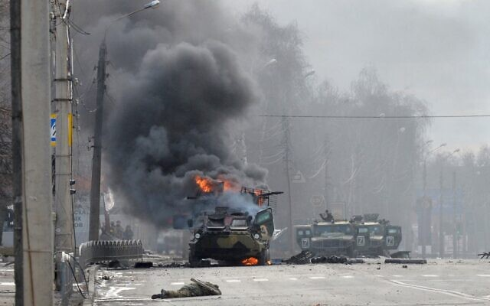
This photograph, taken on February 27, 2022, shows a Russian Armoured personnel carrier (APC) burning next to an unidentified soldier's body during a fight with the Ukrainian armed forces in Kharkiv. (Sergey Bobok/AFP)
Battling in the streets and the skies, Ukraine’s beleaguered army attempted to hold off determined Russian advances into the country’s largest cities Sunday as fighting raged across the country for the fourth day.
The mayor of Ukraine’s second-largest city of Kharkiv in the east of the country claimed that Russian forces had successfully been repelled, after fierce battles in the streets.
“Kharkiv is completely ours,” Oleh Sinehubov wrote on social media. “The city is being completely cleansed of the enemy.”
He posted pictures of what he said were “demoralized” Russian troops that had been captured and advised residents to stay inside as enemy soldiers could be hiding among the populace.
Until Sunday, Russia’s troops had remained on the outskirts of Kharkiv, a city of 1.4 million about 20 kilometers (12.4 miles) south of the border with Russia, while other forces rolled past to press the offensive deeper into Ukraine.
Videos posted on Ukrainian media and social networks had shown Russian vehicles moving across Kharkiv and Russian troops roaming the city in small groups. One showed Ukrainian troops firing at the Russians and damaged Russian light utility vehicles abandoned nearby.
Kyiv, the sight of fierce fighting on Saturday, was mostly quiet Sunday after huge explosions lit up the morning sky and authorities reported blasts at one of the airports.
The rare calm came as Ukrainian President Volodymyr Zelensky’s office said a delegation would meet with Russian officials for talks on the Belarus border.
Ukrainian officials initially rejected the move, saying any talks should take place elsewhere than Belarus, where Russia has placed a large contingent of troops.
But Kyiv said Belarus President Alexander Lukashenko assured Zelensky that “all planes, helicopters, and missiles stationed on Belarus territory will remain on the ground during the travel, negotiations, and return of the Ukrainian delegation.”
North of the city in the suburb of Bucha, near the key airfield of Gostomel, Ukrainian officials claimed a column of Russian vehicles had been destroyed, slowing Moscow’s advance toward Kyiv.
Extraordinary video (and soundtrack) reportedly from Bucha outside Kyiv, near the Hostomel airbase pic.twitter.com/BanGJms3uB
— Shaun Walker (@shaunwalker7) February 27, 2022
Videos showed burning or charred Russian vehicles there and elsewhere, along with what were purported to be aircraft being shot down, though the more powerful Russian military continued to push ahead in other places around the country.
The images underscored the determined resistance Russian troops face while attempting to enter Ukraine’s bigger cities. Ukrainians have volunteered en masse to help defend the capital, Kyiv, and other cities, taking guns distributed by authorities and preparing firebombs to fight Russian forces.
Kyiv Mayor Vitaly Klitschko wrote on Telegram that residential areas of the city were hit by shelling overnight but there were no Russians in the city.
“Our military, law enforcement, and territorial defense continue to detect and neutralize saboteurs,” he wrote. He said 31 people in the capital had been killed, including nine civilians.
Overnight, flames billowed from an oil depot near an airbase in Vasylkiv, a city 37 kilometers (23 miles) south of Kyiv where there has been intense fighting, according to the mayor. Russian forces blew up a gas pipeline in Kharkiv, prompting the government to warn people to cover their windows with damp cloth or gauze as protection from smoke, the president’s office said.
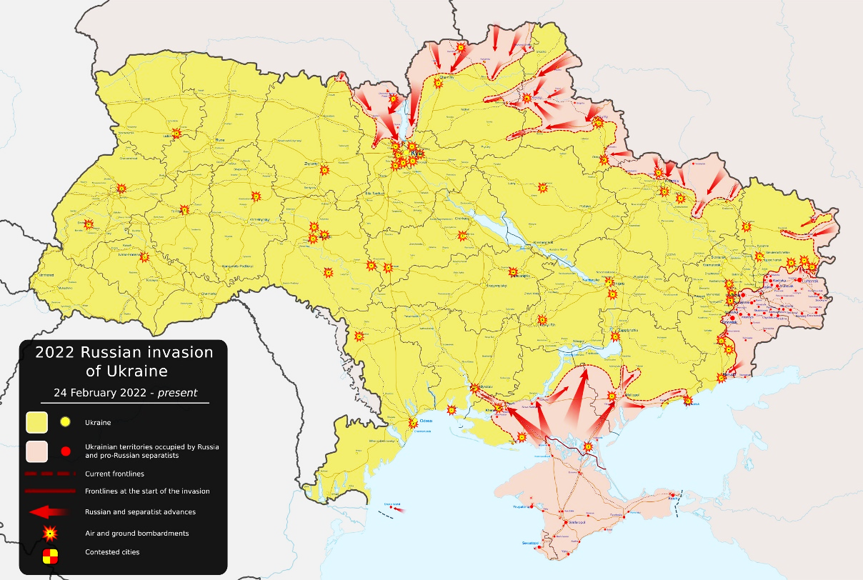
Map of the Russian invasion of Ukraine, as of February 27, 2022. (Viewsridge/Wikipedia commons)
“The past night was tough — more shelling, more bombing of residential areas and civilian infrastructure,” Zelensky said.
In the south, Russia maintained pressure on strategic ports, with the apparent aim of seizing control of the country’s coastline. A Russian Defense Ministry spokesman, Maj. Gen. Igor Konashenkov, said Russian forces had blocked the cities of Kherson on the Black Sea and the port of Berdyansk on the Azov Sea.
He said the Russian forces also took control of an airbase near Kherson and the Azov Sea city of Henichesk. Ukrainian authorities also reported fighting near Odesa, Mykolaiv, and other areas.
Cutting Ukraine’s access to its seaports would deal a major blow to the country’s economy. It could also allow Moscow to build a land corridor to Crimea, which Moscow annexed in 2014 and until now was connected to Russia by a 19-kilometer (12-mile) bridge.
Ukrainian military deputy commander Lt. Gen. Yevhen Moisiuk sounded a defiant note in a message aimed at Russian troops.
“Unload your weapons, raise your hands so that our servicemen and civilians can understand that you have heard us. This is your ticket home,” Moisiuk said in a Facebook video.
The number of casualties so far from Europe’s largest land conflict since World War II remained unclear amid the fog of combat.
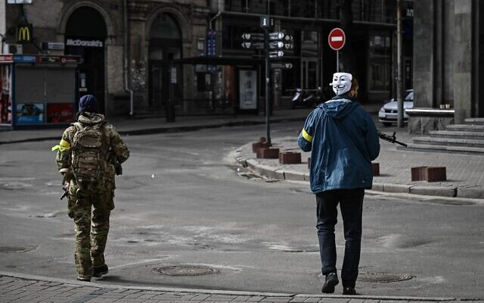
A member of Ukrainian forces, wearing a Guy Fawkes mask (Anonymous mask), patrols downtown Kyiv, on February 27, 2022. (Aris Messinis/AFP)
Ukraine’s health minister reported Saturday that 198 people, including three children, had been killed and more than 1,000 others wounded. It was unclear whether those figures included both military and civilian casualties. Russia has not released any casualty information.
Ukraine’s UN ambassador, Sergiy Kyslytsya, tweeted Saturday that Ukraine appealed to the International Committee of the Red Cross “to facilitate repatriation of thousands of bodies of Russian soldiers.” An accompanying chart claimed 3,500 Russian troops have been killed.
On Sunday, Lithuanian Defense Minister Arvydas Anušauskas tweeted that Russia had suffered 4,300 killed or wounded. He said 27 aircraft and 26 helicopters had been downed and hundreds of tanks and armored vehicles destroyed.
The Russian army on Sunday admitted that there were “killed and injured” soldiers among its troops in Ukraine on the fourth day of its invasion of the country, without specifying how many Russians had died there.
“Russian servicemen are showing courage and heroism while fulfilling combat tasks in the special military operation. Unfortunately, there are killed and injured among our comrades,” Moscow’s army spokesman Igor Konashenkov said on state television.
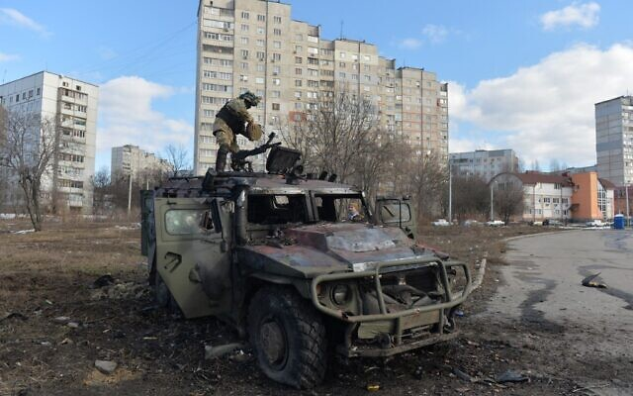  A Ukrainian Territorial Defence fighter examines a destroyed Russian infantry mobility vehicle GAZ Tigr after the fight in Kharkiv, on February 27, 2022. (Sergey Bobok/AFP) | Members of the South African Russian association together with Ukrainian and Lithuanian nationals demonstrate in Mandela Square in Sandton, Johannesburg, on February 27, 2022, against the Russian invasion of Ukraine. (Luca Sola/AFP)
Ratcheting up tensions with the West, Russian President Vladimir Putin ordered Russian nuclear forces to be put on high alert Sunday in response to what he called “aggressive statements” by leading NATO powers.
The order means Putin wants Russia’s nuclear weapons prepared for increased readiness to launch and raises the threat that Moscow’s invasion of Ukraine and the West’s response to it could boil over into nuclear warfare.
Putin, in giving the nuclear alert directive, cited not only the alleged statements by NATO members but the hard-hitting financial sanctions imposed by the West against Russia, including the Russian leader himself.
Speaking at a meeting with his top officials, Putin told his defense minister and the chief of the military’s General Staff to put the nuclear deterrent forces in a “special regime of combat duty.”
“Western countries aren’t only taking unfriendly actions against our country in the economic sphere, but top officials from leading NATO members made aggressive statements regarding our country,” Putin said in televised comments.
NATO Secretary-General Jens Stoltenberg told CNN, in reaction to Putin’s decision to put Russia’s nuclear forces on high alert: “This is dangerous rhetoric. This is a behavior which is irresponsible.”
The practical meaning of Putin’s order was not immediately clear. Russia and the United States typically have land- and submarine-based nuclear forces on alert and prepared for combat at all times, but nuclear-capable bombers and other aircraft are not.
As Russia pushes ahead with its offensive, the West is working to equip the outnumbered Ukrainian forces with weapons and ammunition while punishing Russia with far-reaching sanctions intended to further isolate Moscow.
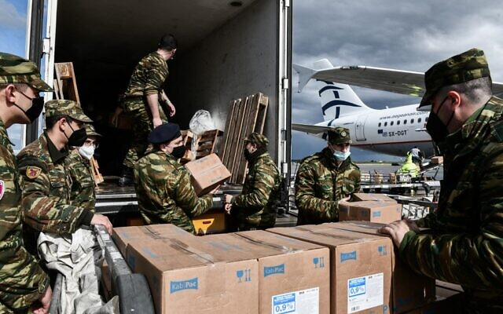
Several EU officials said that EU countries had individually been sending “significant” shipments of weapons to Ukraine.
Germany has said it is sending 1,400 anti-tank rockets and 500 ground-to-air Stinger missiles. The Netherlands announced the dispatch of 200 Stingers and rifles. Belgium said 2,000 machine guns and 3,800 tonnes of fuel were on the way. The Czech Republic is delivering 30,000 pistols, 7,000 assault rifles, 3,000 machine guns, several sniper rifles, and a million cartridges.
Greek soldiers unload humanitarian aid for Ukraine at Eleftherios Venizelos International Airport in Athens, on February 27, 2022, as Greece’s government decided to provide humanitarian aid to Ukraine. (Tatiana Bolari/AFP)
Portugal said it was sending night-vision goggles, grenades, and ammunition. Romania was shipping fuel, bullet-proof vests, helmets, munition, and other military equipment. France and Greece said they were sending unspecified military equipment.

The US pledged an additional $350 million in military assistance to Ukraine, including anti-tank weapons, body armor, and small arms. Germany said it would send missiles and anti-tank weapons to the besieged country and that it would close its airspace to Russian planes.
The US, European Union and United Kingdom agreed to block “selected” Russian banks from the SWIFT global financial messaging system, which moves money around more than 11,000 banks and other financial institutions worldwide, part of a new round of sanctions aiming to impose a severe cost on Moscow for the invasion. They also agreed to impose ”restrictive measures” on Russia’s central bank.
German Chancellor Olaf Scholz, meanwhile, said Sunday that his country was committing 100 billion euros ($112.7 billion) to a special fund for its armed forces, raising its defense spending above 2% of gross domestic product. Scholz told a special session of the Bundestag the investment was needed “to protect our freedom and our democracy.”
Putin sent troops into Ukraine after denying for weeks that he intended to do so, all the while building up a force of almost 200,000 troops along the countries’ borders. He claims the West has failed to take seriously Russia’s security concerns about NATO, the Western military alliance that Ukraine aspires to join. But he has also expressed scorn about Ukraine’s right to exist as an independent state.
Russia claims its assault on Ukraine is aimed only at military targets, but bridges, schools and residential neighborhoods have been hit.
Ukraine’s ambassador to the US, Oksana Markarova, said Ukraine was gathering evidence of shelling of residential areas, kindergartens and hospitals to submit to an international war crimes court in The Hague as possible crimes against humanity. The International Criminal Court’s prosecutor has said he is monitoring the conflict closely.
British Foreign Secretary Liz Truss warned Sunday that Putin could use “the most unsavory means,” including banned chemical or biological weapons, to defeat Ukraine.
“I urge the Russians not to escalate this conflict, but we do need to be prepared for Russia to seek to use even worse weapons,” Truss told Sky News. https://www.timesofisrael.com/ukrainians-claim-to-slow-russian-advances-into-major-cities-as-talks-begin/ [While the State Department folks keep talking about misinformation I can’t help but think of the dreadful lies and misinformation that has been flowing out of the CDC etc for the past 2 years and probably long before that. So when we know that the deep state players have frequently lied and manipulated almost every war we have been related to it would seem prudent to look carefully at ALL available reports concerning the Ukraine. There are multiple ones indicating a very long and perverse relationship of the US deep state groups with them. Check out below which are just a few. – rdb]
You might want to look at this – an interview with a media person in Russia on Red Pill:

https://rumble.com/vvsl8i-ukraine-invasion-bioweapons-labs-russian-perspective.html?mref=6zof&mrefc=3

You might also find this most interesting:

https://www.youtube.com/watch?v=fWkfpGCAAuw&t=1s
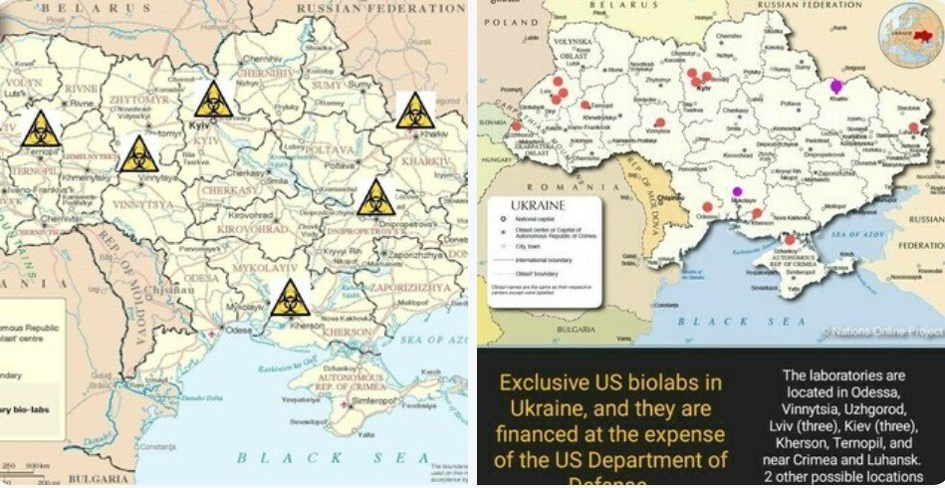
US embassy just REMOVED all their Ukraine BIOWEAPON LAB DOCUMENTS from the website… Here they are…
Feb 27, 2022

Map of US biolabs in Ukraine
There is something fishy going on… Yesterday, the US Embassy removed around 2p.m. all their Ukraine Bioweapon lab documents from their website.
https://ua.usembassy.gov/embassy/kyiv/sections-offices/defense-threat-reduction-office/biological-threat-reduction-program/
Try by yourself… If you go on their website, you will see a bunch of pdfs files on the right side of the page. Now press on one of the links… Just in the last day they removed all the PDF files from the embassy website here:
The good news is they are still archived:
https://web.archive.org/web/20170130193016/https://photos.state.gov/libraries/ukraine/895/pdf/dtro-kharkiv-eng.pdf
https://web.archive.org/web/20210511164310/https://photos.state.gov/libraries/ukraine/895/pdf/dtro-luhansk-eng.pdf
https://web.archive.org/web/20170221125752/https://photos.state.gov/libraries/ukraine/895/pdf/dtro-dnipropetrovsk-eng.pdf
https://web.archive.org/web/20210506053014/ https://photos.state.gov/libraries/ukraine/895/pdf/dtro-vinnitsa-eng.pdf
https://web.archive.org/web/20170221125752/https://photos.state.gov/libraries/ukraine/895/pdf/dtro-dnipropetrovsk-eng.pdf
https://web.archive.org/web/20170207122550/https://photos.state.gov/libraries/ukraine/895/pdf/dtro-kherson-fact-sheet-eng.pdf
https://web.archive.org/web/20170223011502/https://photos.state.gov/libraries/ukraine/895/pdf/dtro-ternopil-fact-sheet-eng.pdf
https://web.archive.org/web/20170208032526/https://photos.state.gov/libraries/ukraine/895/pdf/dtro-zakarpatska-fact-sheet-eng.pdf
https://web.archive.org/web/20170208032526/https://photos.state.gov/libraries/ukraine/895/pdf/dtro-zakarpatska-fact-sheet-eng.pdf
https://web.archive.org/web/20170202040923/https://photos.state.gov/libraries/ukraine/895/pdf/dtro-lviv-dl-eng.pdf
https://web.archive.org/web/20170201004446/https://photos.state.gov/libraries/ukraine/895/pdf/dtro-lviv-rdvl-eng.pdf
https://web.archive.org/web/20161230143004/https://photos.state.gov/libraries/ukraine/895/pdf/dtro-eidss.pdf
https://web.archive.org/web/20210506212717/https://photos.state.gov/libraries/ukraine/895/pdf/dtro-pathogen-asset-control.pdf
https://web.archive.org/web/20170207153023/https://photos.state.gov/libraries/ukraine/895/pdf/dtro-dnipropetrovsk-rdvl_eng.pdf
https://web.archive.org/web/20170211022339/https://photos.state.gov/libraries/ukraine/895/pdf/kiev-ivm-fact-sheet-eng.pdf
These labs are co-run by Fauci’s EcoHealth Alliance and rumor is Russia’s entire military operation right now is unofficially to either secure and/or destroy these labs and gather evidence. MORE - https://strangesounds.org/2022/02/us-embassy-just-removed-all-their-ukraine-bioweapon-lab-documents-from-the-website-here-they-are.html This is more than fishy. A most interesting article. – rdb]

Ukrainians agree to meet for talks with Russia on Belarus border
Move comes after Ukrainian leader Zelensky initially rejected Belarus as meeting location and proposed Israel as a neutral broker, and as Putin orders nuclear forces on high alert
By Agencies and TOI staff Today, 5:21 pm
Ukraine on Sunday said it would hold talks with Russia at its Belarusian border after a phone call between Ukrainian President Volodymyr Zelensky and Belarusian leader Alexander Lukashenko.
“The politicians agreed that the Ukrainian delegation would meet the Russian one without preconditions at the Ukraine-Belarus border, near the Pripyat River,” Zelensky’s office said in a statement.
It did not list a specific location or time for the talks.
In a video address later Sunday, he expressed skepticism over the talks. “I will be honest, as always: I do not really believe in the outcome of this meeting, but let them try,” Zelensky said in a video address later. “No citizen of Ukraine should have any doubt that I, as president, did not try to stop the war, when there was even a small chance.”
He described his talk with Lukashenko as “long” and “substantive.”
The announcement on Sunday came hours after Russia announced that its delegation had flown to Belarus to await talks. Ukrainian officials initially rejected the move, saying any talks should take place elsewhere than Belarus, where Russia has placed a large contingent of troops.
But Kyiv said Lukashenko assured Zelensky that “all planes, helicopters and missiles stationed on Belarus territory will remain on the ground during the travel, negotiations and return of the Ukrainian delegation.”
However, Ukrainian Foreign Minister Dymtro Kuleba claimed that missiles from Belarus were continuing to hit Ukrainian cities, amid reports one that hit an airport in Zhitomyr had been fired from the northern neighbor.
He said Kyiv would not buckle at the talks with Russia over its invasion, accusing Russian President Vladimir Putin of seeking to increase “pressure” by ordering his nuclear forces on high alert.
“We will not surrender, we will not capitulate, we will not give up a single inch of our territory,” Kuleba said at a press conference broadcast online.
News of the meeting came shortly after Putin ordered Russian nuclear forces put on high alert in response to what he called “aggressive statements” by leading NATO powers.
Putin accused Western countries of taking “unfriendly” steps against his country.
The fourth day of fighting Sunday saw street battles break out in Ukraine’s second-largest city, Kharkiv, and Russian troops squeezing strategic ports in the country’s south, advances that appeared to mark a new phase of Russia’s invasion following a wave of attacks on airfields and fuel facilities elsewhere in the country.
The capital, Kyiv, was eerily quiet after huge explosions lit up the morning sky and authorities reported blasts at one of the airports. Only an occasional car appeared on a deserted main boulevard as a strict 39-hour curfew kept people off the streets. Terrified residents instead hunkered down in homes, underground garages and subway stations in anticipation of a full-scale Russian assault.
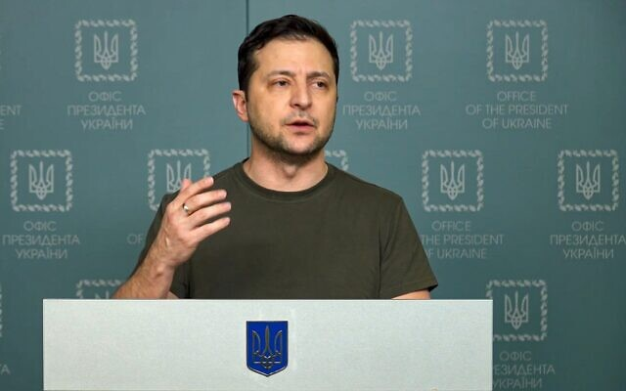
In this photo taken from video provided by the Ukrainian Presidential Press Office, Ukrainian President Volodymyr Zelenskyy speaks to the nation in Kyiv, Ukraine, on February 27, 2022. (Ukrainian Presidential Press Office via AP)
“The past night was tough — more shelling, more bombing of residential areas and civilian infrastructure,” Zelensky said earlier. “There is not a single facility in the country that the occupiers wouldn’t consider as admissible targets.”
Ukraine has reported 198 civilian deaths, including three children, since the invasion began. The UN has put the civilian toll at 64.
Zelensky initially rejected Belarus as a location for talks because it served as a staging ground for the invasion. He said Kyiv had proposed “Warsaw, Bratislava, Budapest, Istanbul, Baku” as options to Russia.
He had also apparently floated Israel as a mediator in a call with Prime Minister Naftali Bennett on Friday.
Bennett spoke with Putin on Sunday about the possibility of Israel brokering peace talks. He told the Russian leader Israel was ready to assist in any way possible in bringing the sides together, in light of its unique relationship with both countries, according to an Israeli official.
Putin told Bennett that he is ready to negotiate, according to the official.
However, the Kremlin said Putin had told Bennett that Russia had already sent a delegation to Gomel in southern Belarus to conduct peace talks with Ukrainian officials.
Israel has attempted to walk a tightrope between supporting Ukraine, where there are thousands of Israelis and tens of thousands of Jews, and maintaining ties with Russia, a major player in Syria to Israel’s north. https://www.timesofisrael.com/ukrainians-agree-to-meet-for-talks-with-russia-on-belarus-border/

Putin puts Russia’s nuclear forces on high alert, citing Western threats
Russian leader says move a response to ‘aggressive statements’ by NATO member countries; UK foreign secretary says world must prepare ‘for Russia to seek to use even worse weapons’
By YURAS KARMANAU, Jim Heintz and VLADIMIR ISACHENKOV Today, 5:22 pm
KYIV, Ukraine (AP) — In a dramatic escalation of East-West tensions over Russia’s invasion of Ukraine, President Vladimir Putin ordered Russian nuclear forces put on high alert on Sunday in response to what he called “aggressive statements” by leading NATO powers.

This photo taken from video provided by the Russian Defense Ministry Press Service on Saturday, Feb. 19, 2022, shows a Russian Iskander-K missile launched during a military exercise at a training ground in Russia. (Russian Defense Ministry Press Service via AP)
The order means Putin has ordered Russia’s nuclear weapons prepared for increased readiness to launch, raising the threat that the tensions could boil over into nuclear warfare. In giving it, the Russian leader also cited hard-hitting financial sanctions imposed by the West against Russia, including Putin himself.
Speaking at a meeting with his top officials, Putin directed the Russian defense minister and the chief of the military’s General Staff to put the nuclear deterrent forces in a “special mode of combat duty.”
“Senior officials of the leading Nato countries also allow aggressive statements against our country, therefore I order the minister of defense and the chief of the general staff [of the Russian armed forces] to transfer the deterrence forces of the Russian army to a special mode of combat duty,” Putin said in televised comments.
The Russian leader earlier this week threatened to retaliate harshly against any nations that intervened directly in the conflict in Ukraine, and he specifically raised the specter of his country’s status as a nuclear power.
The US ambassador to the United Nations responded to the news from Moscow while appearing on a Sunday news program.
“President Putin is continuing to escalate this war in a manner that is totally unacceptable,” Ambassador Linda Thomas-Greenfield said. “And we have to continue to condemn his actions in the most strong, strongest possible way.” [More babbling from the UN group which is essentially impotent. If Pootie Poot gets his panties in a wad and finally has his fill of the actions. He might just blow off some steam somewhere to put the fear in these globalist groups. There is an excellent article in IsraPundit putting explaining a number of other things going on in that region: https://www.israpundit.org/the-truth-about-ukraine/ - - rdb]
The alarming step came as street fighting broke out in Ukraine’s second-largest city and Russian troops squeezed strategic ports in the country’s south, advances that appeared to mark a new phase of Russia’s invasion following a wave of attacks on airfields and fuel facilities elsewhere in the country.
The capital, Kyiv, was eerily quiet after huge explosions lit up the morning sky and authorities reported blasts at one of the airports. Only an occasional car appeared on a deserted main boulevard as a strict 39-hour curfew kept people off the streets. Terrified residents instead hunkered down in homes, underground garages and subway stations in anticipation of a full-scale Russian assault.
“The past night was tough — more shelling, more bombing of residential areas and civilian infrastructure,” Ukrainian President Volodymyr Zelensky said. “There is not a single facility in the country that the occupiers wouldn’t consider as admissible targets.”
Following its gains to the east in the city of Kharkiv and multiple ports, Russia sent a delegation to Belarus for peace talks with Ukraine, according to the Kremlin. Zelensky suggested other locations, saying his country was unwilling to meet in Belarus because it served as a staging ground for the invasion. [But I thought the mayor of Kharkiv said that it was in their hands???? You see we are getting multiple stories concerning the progress of this war. – rdb]
Until Sunday, Russia’s troops had remained on the outskirts of Kharkiv, a city of 1.4 million about 20 kilometers (12.4 miles) south of the border with Russia, while other forces rolled past to press the offensive deeper into Ukraine.
Videos posted on Ukrainian media and social networks showed Russian vehicles moving across Kharkiv and Russian troops roaming the city in small groups. One showed Ukrainian troops firing at the Russians and damaged Russian light utility vehicles abandoned nearby.
The images underscored the determined resistance Russian troops face while attempting to enter Ukraine’s bigger cities. Ukrainians have volunteered en masse to help defend the capital, Kyiv, and other cities, taking guns distributed by authorities and preparing firebombs to fight Russian forces.
Ukraine’s government also is releasing prisoners with military experience who want to fight for the country, a prosecutor’s office official, Andriy Sinyuk, told the Hromadske TV channel Sunday. He did not specify whether the move applied to prisoners convicted of all levels of crimes.
Putin hasn’t disclosed his ultimate plans, but Western officials believe he is determined to overthrow Ukraine’s government and replace it with a regime of his own, redrawing the map of Europe and reviving Moscow’s Cold War-era influence.
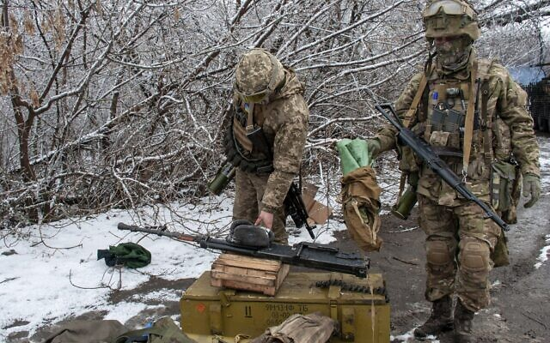
The pressure on strategic ports in the south of Ukraine appeared aimed at seizing control of the country’s coastline stretching from the border with Romania in the west to the border with Russia in the east. A Russian Defense Ministry spokesman, Maj. Gen. Igor Konashenkov, said Russian forces had blocked the cities of Kherson on the Black Sea and the port of Berdyansk on the Azov Sea.
He said the Russian forces also took control of an airbase near Kherson and the Azov Sea city of Henichesk. Ukrainian authorities also have reported fighting near Odesa, Mykolaiv and other areas.

Ukrainian soldiers handle equipment outside Kharkiv, Ukraine, Feb. 26, 2022. (Andrew Marienko/AP)
Cutting Ukraine’s access to its sea ports would deal a major blow to the country’s economy. It also could allow Moscow to build a land corridor to Crimea, which Moscow annexed in 2014 and until now was connected to Russia by a 19-kilometer (12-mile) bridge, the longest bridge in Europe, which opened in 2018.
Flames billowed from an oil depot near an airbase in Vasylkiv, a city 37 kilometers (23 miles) south of Kyiv where there has been intense fighting, according to the mayor. Russian forces blew up a gas pipeline in Kharkiv, prompting the government to warn people to cover their windows with damp cloth or gauze as protection from smoke, the president’s office said. MORE - https://www.timesofisrael.com/putin-puts-russias-nuclear-forces-on-high-alert-citing-western-threats/

‘One hour before midnight’: In call with Putin, Bennett proposes Israeli mediation
PM says ready to help in any way, in light of Israel’s unique ties with Russia and Ukraine; avoids condemning Moscow at cabinet meet; set to send more humanitarian aid to Ukraine
By TOI staff Today, 4:19 pmUpdated at 8:20 pm
Prime Minister Naftali Bennett proposed that Israel serve as a mediator between Russia and Ukraine during a phone call with President Vladimir Putin on Sunday, according to a readout released by the Kremlin, which did not say how the latter responded to Jerusalem’s offer. Israeli sources confirmed Bennett’s offer.
According to the Russian readout, Putin told Bennett that Russia has sent a delegation to Gomel in southern Belarus to conduct peace talks with Ukrainian officials.
Ukraine’s President Volodymyr Zelensky, who had proposed the idea of Israeli mediation to Bennett on Friday, emphasized the country’s readiness for peace talks.
Initially refusing to hold peace talks in Moscow’s ally Belarus, which has allowed Russia to use its territory as a staging ground for the invasion that began Thursday, Zelensky agreed later Sunday that the Ukrainian delegation would meet with the Russian delegation without preconditions on the Ukrainian-Belarusian border. MORE -
https://www.timesofisrael.com/in-call-with-putin-bennett-proposes-that-israel-mediate-between-russia-and-ukraine/

NSO files defamation lawsuit against Calcalist over reports on police use of spyware
Cyber-surveillance firm demands NIS 1 million in damages that it says will be donated to help Holocaust survivors and victims of sexual assault, if it wins
By TOI staff Today, 3:22 pm
Israeli spyware company NSO Group filed a defamation lawsuit on Sunday against financial daily Calcalist, owned by Yedioth Ahronoth, as well as the publication’s founder and publisher and editor-in-chief, over a series of articles in recent weeks alleging that the Israel Police illegally used the company’s spyware against activists, journalists, and government officials without judicial oversight.
The lawsuit, filed at the Rishon Lezion Magistrate’s Court, demanded NIS 1 million ($309,000) in damages.
NSO sent a letter to Calcalist last week warning that it would sue the publication over a number of exposés starting in mid-January that alleged police misuse of NSO’s powerful cyber-espionage tools, including Pegasus.
Calcalist has reported, without providing clear evidence, that dozens of high-profile figures — including former ministry directors, prominent business figures, and family members and associates of former prime minister Benjamin Netanyahu — were spied on by police using the NSO Group’s Pegasus spyware without court orders.
The series sparked an uproar in Israel that led to a Justice Ministry probe and further calls for a state commission of inquiry. Last week, Justice Minister Gideon Sa’ar said the shocking allegations published in Calcalist were “incorrect” and that the police had used the tool but there was no basis to allege widespread, unsupervised hacking. He nixed plans for a government inquiry into the affair.
The Calcalist reports built on an in-depth probe last summer that found that NSO’s software had been used by many countries with poor human rights records to hack the phones of thousands of human rights activists, journalists, and politicians from Saudi Arabia to Mexico.
The company denied the allegations and insisted that its spyware tools are meant to help governments, security services, and state agencies fight terrorism and organized crime.
But the torrent of international criticism over the allegations of misuse kept growing. The issue became a diplomatic concern with numerous Israeli allies, including France, that demanded answers after reports revealed the software was being used within their countries. MORE - https://www.timesofisrael.com/nso-files-defamation-lawsuit-against-calcalist-over-reports-on-police-use-of-spyware/

Gas prices to rise tonight, breaking 8-year record high
The maximum price of gas will be raised to NIS 7.05 tonight due to the war in Ukraine
By ZACHY HENNESSEY Published: FEBRUARY 27, 2022 14:08 Updated: FEBRUARY 27, 2022 19:01
The government has increased gas prices in Israel again this month, as costs rise in tandem with skyrocketing oil costs resulting from the Russian invasion of Ukraine.
Russia is a primary exporter of crude oil to Europe. At midnight Sunday, the price of gasoline will rise by NIS 0.34 to NIS 7.05 per liter, the highest price in eight years. Only four weeks ago, gas prices were already making headlines: on February 1 the government raised the maximum price of 95 octane gasoline by NIS 0.34, after raising utility and product prices. [That puts the price of gas at $8.29/gallon – WOW – rdb]
“This is dramatic, and we will have to pay for it at the gas station,” Tel Aviv University’s Dr. Alexander Coleman told The Jerusalem Post last week. “In Israel, we pay more because 60% of what we pay for gasoline is taxes, so everything is amplified dramatically.”
While Russia’s oil and gas exports are not expected to be the target of sanctions against Russia, according to a senior US State Department official, the cost of oil has climbed amid the political turmoil surrounding Russia’s aggression.
This is not the first time that tensions between Russia and Ukraine have led to increased oil prices. In February 2014, fears that energy supplies could be disrupted were stoked when Russia-friendly Ukrainian president Viktor Yanukovych was ousted, immediately preceding the Russian invasion of Crimea. Within days of these events, the price of Brent crude shot up to $110.64, though a host of other geopolitical factors quickly carried the price away further after that.
At the time of writing, the current price of a barrel of Brent crude oil (a standard measurement of oil prices in Europe) is $98.63, after reaching a high of $105.59 on February 25.

Israel to end COVID state of emergency on March 1
For first time since beginning of pandemic in March 2020, Israel will transition to a 'special health situation' and government will no longer be able to bypass legislative process to impose restrictions on the public
Adir Yanko | Published: 02.23.22, 20:04
The Israeli government voted on Wednesday to end the country's state of emergency for the first time since the onset of the COVID-19 pandemic starting March 1.
The designation, first enacted in March 2020 as the first cases of coronavirus emerged in the country, gave the government and the Health Ministry extensive powers to impose severe restrictions on the public. In its stead, Israel will transition to a "special health situation." [A VERY bad move on their part. – rdb]
The government will no longer have the legal foundation to put in place health control measures and have Knesset's Constitution, Law and Justice Committee either approve, limit or abolish them post facto. From now on, any such move will have to go through the full legislative process in parliament.
The Health Ministry announced on Tuesday that it had removed its objection to ending the state of emergency, citing subsiding coronavirus morbidity and hospitalizations.
Knesset Constitution, Law and Justice Committee Chairman MK Gilad Kariv addressed a letter to Prime Minister Naftali Bennett and Health Minister Nitzan Horowitz earlier this week in which urged them to end the state of emergency.
"In the context of morbidity trends and the easing of various restrictions set by the government, and in light of the government's justified approach living alongside the pandemic and its consequences, I appeal to you to declare a special health situation which will bring an end to the state of emergency that has been in place since 2020," he wrote.
Meanwhile, Israel on Wednesday reported its tally of severe COVID-19 cases has dropped below 700 for the first time in weeks as the fifth infection wave continues to wane.
The Health Ministry said 693 patients are currently in serious condition, of whom 240 are ventilated, the lowest the figure has been since January 21.
The death toll since the start of the pandemic now stands at 10,040, of whom eight passed away on Tuesday alone. Since the beginning of the week, 60 coronavirus patients have died in Israel, but the actual number is believed to be much higher because the ministry reports deaths with considerable delay. https://www.ynetnews.com/health_science/article/h1y0yg4xc

Israeli study mines donor poop for bacteria that could avert heart attacks
Researchers find most of 200 heart attack patients had important gut bacteria missing and believe restoring it may keep hearts healthier; wider trial planned
Israeli scientists say they may be able to cut the risk of heart attack by rebalancing gut bacteria — using capsules containing germs collected from excrement.
Just hours after each of their 200 subjects had a heart attack, researchers studied the bacteria balance in the patients’ guts and compared results to those of a control group. They say it was the largest and most in-depth study on the microbiome in heart patients — and that it threw up a striking pattern that hasn’t been documented until now.
A particular bacteria was missing in most of the heart attack patients but present in the control group, as reported in their peer-reviewed study just published in Nature Medicine. The bacteria, from the Clostridiaceae family, is known to prompt production of molecules that protect the heart.
Researchers say this means that when the bacteria is absent, the heart is at greater risk. But they say now they’ve identified the problem, they can solve it by reintroducing the bacteria. The team from the Rabin Medical Center and the Weizmann Institute of Science is working on “isolating” it from the feces of healthy people, and packaging it in pills.
“We’re isolating the bacteria from fecal samples, and will then put it into capsules and give it to people in the hope it prevents heart attacks,” Yeela Talmor-Barkan, interventional cardiologist at the Rabin Medical Center and lead author of the study along with Prof. Noam Bar, told The Times of Israel. [Anyone wanting to sign up for this experimental trial taking poop pills? Good heavens. – rdb]
“The hope is that they will change the microbiome in the gut and by doing so reduce the chances of a heart attack.”
There is significant interest in the medical community in so-called fecal microbiota transplantation, the medical term for giving patients gut bacteria from poop. An Israeli research team has even suggested that transplants may help with weight loss.
The researcher behind the heart attack study are planning a clinical trial, expected to start in about a year, that will assess the pills’ effectiveness.
They also believe that they may be able to use their findings to create screening processes that help doctors get a more accurate picture of heart attack risk by factoring in patterns in the microbiome.
Talmor-Barkan stressed that the research so far has only found a correlation between the untypical microbe pattern and heart attacks, which doesn’t necessarily prove there is a cause-and-effect relationship. She said, however, that her team is conducting further research that they expect will show a causal connection.
“We believe it’s a cause — though of course not the only cause — of heart attacks,” Talmor-Barkan said. Her hypothesis is that when the bacteria in question are lacking, people are more vulnerable to arteriosclerosis, which is the thickening and hardening of artery walls that gradually reduces blood flow to organs.
Prof. Ran Kornowski, director of the Cardiology Center at the Rabin Medical Center, said the study offers “a significant discovery in cardiology,” adding: “The results of the study form the basis for developing new diagnostic and treatment tools for cardiovascular disease.”
Talmor-Barkan noted that in addition to the finding on bacteria, some patterns her team noticed in blood composition among heart attack patients may also be useful in diagnostics and heart attack prevention. https://www.timesofisrael.com/israeli-study-mines-donor-poop-for-bacteria-that-could-avert-heart-attacks/ [HUMMM? And the Chinese were taking rectal samples for Covid? The world is getting much to invasive. – rdb]

Palestinian minor charged with assaulting Jewish protester in Sheikh Jarrah
Footage of incident allegedly shows 17-year-old lunging at victim and kicking him in the upper abdomen before fleeing the scene; Palestinians circulate video on social media
Haim Goldich | Published: 02.27.22, 20:23
The Jerusalem Magistrate's Court on Sunday indicted a Palestinian teen for allegedly carrying out a racially-motivated assault on a Jewish protester in the contentious East Jerusalem neighborhood of Sheikh Jarrah.
According to the indictment, the defendant spotted the victim, who was dressed in traditional Jewish attire, standing at a bus stop during a protest in the Jerusalem flashpoint two weeks ago.
Footage of the incident allegedly shows the 17-year-old lunging at the victim, jumping in the air and kicking him in the upper abdomen. The victim slammed against the station wall and fell to the ground. He suffered abdominal injuries and required medical attention.
The defendant fled the scene and police officers gave chase after him. He refused to comply with police's demands to stop and fled by car to the nearby Wadi al-Joz neighborhood where he was ultimately caught and arrested.
The video of the assault began circulating on social media with some users expressing pride in the defendant's actions.
The indictment attributes to the minor offenses of racially-motivated aggravated assault and battery and obstructing a law enforcement officer. The prosecution asked he be remanded to custody to await trial
Jerusalem District Police Superintendent Avi Schreier said they were employing all available means to bring violent criminals to justice. https://www.ynetnews.com/article/rjfgwzfxc#autoplay

World wheat prices begin to soar amid the war in Ukraine
As tensions escalate into full-blown conflict between two warring countries that produce more than a quarter of the world’s wheat, Mideast governments must hike bread subsidies if they don’t want chaos in the streets, experts say
The Media Line | Published: 02.27.22, 20:59
As weeks of tension now turn to open warfare between Russia and Ukraine, the effects on the global economy are becoming clear. World trade in wheat is greater than for all other crops combined, and its price reached a nine-year high on Thursday, $9.32 per 60-pound bushel, as the escalating conflict led to expectations of disrupted supplies.
Russia is the third-largest producer of the grain, after China and India, and Ukraine is the ninth-largest. Together, the two warring countries produce more than a quarter of the world’s wheat and nearly a third of global exports.
Investors are worried about whether the two countries, especially Ukraine, will be able to continue to produce and export the product in light of the war and the sanctions imposed by the West.
Jack Scoville, vice president of Price Futures Group Inc. in Chicago, said in a statement, “I don’t know how high we’re going. It’s really going to depend just on how much this crisis spins out of hand.”
Alex Coman, a senior Israeli economic consultant, told said it looks like the price of wheat will continue to rise, depending on how the conflict develops.
Much of the wheat consumed in the Middle East comes from Ukraine, he explained. “The country is paralyzed in the sense that transportation is basically dead,” he added.
And in the Middle East, “we know from experience that when bread prices rise, it results in unrest,” he pointed out. “Look back to the Arab Spring. Most of it was because the price of bread rose, and people could not afford it.”
As prices rise, “governments in the Middle East need to start subsidizing [more than they already do]. If they do not absorb the increase, it could result in unrest in many countries in the Middle East. Bread must be accessible for everybody,” he said.
Some countries, such as Egypt, Jordan, and Syria, will be in particular need of increased subsidies if they want to avoid a descent into chaos, Coman said. “Others such as Saudi Arabia and Israel won’t need them so much.”
It is important to understand that the conflict between Russia and Ukraine and the consequences it brings, such as higher prices for petroleum and grains, will not affect every country in the same way, he said.
“The strong countries are going to do fantastically well as the price of oil goes up. And the poor countries are going to do particularly badly because oil and wheat will cost more and that will be a severe problem for them,” Coman said.
He added that Russia is going to benefit from the market changes because it will be able to continue to produce wheat and other grains and sell them at high prices that we see today. However, other sources believe the uncertainty felt by buyers will hurt Russian commerce.
What is certain, Coman said, is that the other major exporters of wheat to the region such as Western European countries and even the United States will benefit.
However, he thinks that the wheat issue won’t be a long-term problem.
“I believe that everything will go back to normal in a few weeks. Farmers in Ukraine will start working again. Russia will finish destroying the Ukrainian Navy and the world will go back to usual and be stable again,” Coman said. “And probably vodka will be more expensive.” https://www.ynetnews.com/article/sjfvibtgq [So now we have wars in diverse places and it looks the way things are going with decreased production of food products and transportation that there could well be famine. We already have lots of quakes and volcanoes. – rdb]

CPAC Doctors’ Roundtable Full Discussion
With Dr. Robert Malone, Dr. Miller, and Dr. Oz
https://www.redvoicemedia.com/video/2022/02/cpac-doctors-roundtable-full-discussion-with-dr-oz-dr-miller-and-dr-robert-malone/
This only twenty minutes – excellent!

Big Brother nightmare: Will you be denied health care due to your beliefs?
Strategy's dangers include research without consent, and limiting access to doctors
By Bob Unruh Published February 27, 2022 at 1:33pm
There is no doubt about the value of data, especially massive amounts of it, in today's tech world.
Google, Facebook and other online behemoths got that way through the use of, especially the sale of, information about people.
Now, a letter has been dispatched to Congress asking the government to halt its own plan for a massive sweep of health data of everyone in the nation.
It is the Citizens Council for Health Freedom that has sent the letter to leaders in Congress, including Sen. Chuck Schumer, Rep. Nancy Pelosi and more.
The letter asks them to continue a ban, which already has been in place for decades, on what's called the Unique Patient Identifier.
The identifying number, the letter explains, would "undermine the doctor-patient relationship" and would be a "womb-to-tomb" monitoring plan to "centralize patient data into a national medical-records system."
First, it would provide government the ability to track care, and possibly even deny treatment to individuals without "the card," the letter warns.
The strategy also could be used to "conduct research using patient data without consent … and become the only way to access medical care in America," the letter said.
It would become "a rich target for hackers and others, including foreign governments, wishing to steal the identity and private medical and financial details of Americans in and outside of government. In short, it will make Americans more vulnerable, violate their rights, and threaten our national security."
Further, "National systems beget national systems: a national patient ID will create a national data system facilitating the transition to a national health care system, where access to care is controlled by the federal government."
The letter explains that the identifier actually was included the the Health Insurance Portability and Accountability Act, from 1996, which already sets up procedures for private and personal medical information about patients to be shared with multitudes.
Shortly after, Rep. Ron Paul inserted into an appropriations bill a ban on funding for that project, and that has been maintained consistently until now.
"Now the U.S. House of Representatives and the Senate have struck a funding prohibition out of the proposed appropriations bill to advance a government that will identify and track every patient through the health care system," the letter warns.
A proposed repeal of the provision has not yet been successful.
Twila Brase, chief of the CCHF, signed the letter, along with leaders of the American Family Association, Americans for Prosperity, John Locke Foundation, California Policy Center, Concerned Doctors of Alabama, Eagle Forum of Alabama, Foundation for Economic Education, Foundation for Government Accountability, Goldwater Institute, and dozens more. https://www.wnd.com/2022/02/congressional-leaders-asked-kill-off-massive-health-data-program/ This is a very bad idea. Stay out of our personal health information. – rdb]

Commentary:
When Will We Understand That?
By Rob Pue|February 27th, 2022
Things are happening more and more quickly now all across the globe. The despotism of the tyrants that rule the nations is growing more intense, though you probably haven’t noticed it if you’re the typical American who gets their news in “sound bytes” and Facebook “memes.” As one of our writers recently noted, this is the age of the “half-read page,” where people can’t be bothered to think for themselves.
The news changes so rapidly that what I write on Monday is often out-of-date by the time it is broadcast or published on Tuesday. In my previous message I talked about the Freedom Convoy in Canada as they had peacefully held the line, trying to get their political representatives to hear their voices, crying out for basic freedoms and liberties to be restored. In a movement that spanned about three-weeks’ time, more than 50,000 big-rig trucks traveled across Canada, garnering enthusiastic support from Canadians from all walks of life along the way.
Canadian citizens lined the highways and over-passes in frigid temperatures and blizzards to cheer the truckers on. They held Canadian flags, hand-made signs calling for freedom and liberty and banners with positive messages of support. Of course, the first thing the Canadian government officials did was to impose a ban on standing in public places — if they were there to support the truckers. The crowd-funding site GoFundMe seized millions of donated dollars. When the truckers switched to GiveSendGo, the Canadian government seized those funds — and captured the names of all the donors.
The truckers arrived in Canada’s capitol of Ottawa, welcomed by thousands of citizens there, who stood with them. The Canadian people were simply asking for their voices to be heard by the government officials who are supposed to represent them — after two years of increasing tyranny and illegal government edicts, reminiscent of pre-Nazi Germany, the people had had enough. It was time to DO something and the truckers led the way. For two weeks, they held their ground in the city of Ottawa, surrounding the parliament building. People from all walks of life came to join them, camping out in tents in the frigid cold. But the atmosphere remained peaceful and patriotic with speeches by notable leaders, veterans, patriots and experts in their fields. There was singing of patriotic songs, raising of the national flag and a mutual care for one another.
They made quite a splash and had overwhelming support of citizens around the world. But still Trudeau and Canadian politicians would not listen. In his best attempt to direct the bought-and-paid-for mainstream media to broadcast lies, Trudeau called the protestors “a fringe minority,” that held “unacceptable views.” Millions of Canadian citizens a “fringe minority?” “Unacceptagle views?” Who, I ask you, determines what views are acceptable, and which ones are not? The Globalist Thought Police, of course. Then, they made it illegal for fuel stations to sell diesel to the truckers. When individual citizens began carrying heavy cans of fuel into the staging area to supply the trucks themselves, police arrested them and confiscated the fuel.
Some of the protestors were decorated military veterans. They held their rallies at a nearby war memorial. But the government CLOSED that memorial to the public, not allowing veterans to even visit their own memorial.
Early last week, after coming out of hiding, Trudeau imposed the Emergency Measures Act — which, in theory, could not take effect until parliament voted on it. But Trudeau moved forward unilaterally. These Emergency Measures are reserved for times of war and extreme national crisis or danger. The Freedom Convoy protest did not constitute any of these things. Nothing at all like the situation in Seattle, Washington during the summer of 2020, when the Marxist Black Lives Matters and ANTIFA overtook six square blocks of that city, renaming it “CHAZ,” declaring itself a “sovereign nation,” yet still demanding federal aid.
In that situation, the local police precinct building was violently overtaken by protestors, and during the occupation of the CHAZ area, there were multiple shootings and daily violence. Our mainstream media, however, portrayed this all as a “festive block party.” Nevermind the looting, burning and destruction of local businesses, the attacks on police, the extortion of local store owners and the rapes and murders that occurred there. THAT was considered a “peaceful protest,” which called for the defunding of local police. I guess that’s not surprising for a city that boasts a statue of Vladimir Lenin as one of it’s most important landmarks. Even as monuments of real American heroes and historical figures have been constantly removed from public view, steadily for years now, the statue of the Communist Lenin remains the “pride of Seattle.” But that’s another topic.
Early last week, Ottawa’s police chief resigned, rather than be a part of Trudeau’s brutal crackdown on peaceful citizens. On Thursday last week, I watched a press conference by the Canadian Freedom Convoy leadership, which included several Canadian military veterans. They stated their case and there was an atmosphere of patriotism and optimism.
Later that day, however, the Deputy Prime Minister announced that bank accounts of donors to the truckers had been frozen — and that online fundraising for the group was being tracked by the government’s anti-money-laundering unit. Yes — those that dared to support the protest have now had their bank accounts seized by the government. Those individuals will likely be criminally charged in the coming days. Even if they never attended a single public event, but only donated to a cause they believed in.
Thursday evening, protest leaders Tamara Lich and Christopher Barber were arrested — they’re expected to be charged with “counseling to commit the offense of mischief.” And by early the next morning — Friday — Parliament Hill was flooded with police. They began arresting protestors using brute force. A meeting in Parliament, in which the proposed Emergency Measures Act was to be debated, was cancelled instead — the very day the first of the violence erupted. You see, there WAS no violence on the part of the protestors. Violence only began when the police crackdown began. In a particularly ironic video, police can be seen attacking an RV camper with an axe while at least eight SWAT team members surrounded the vehicle with machine guns drawn. A sticker on the camper proclaimed one simple word: “FREEDOM.”
Police also used horses, trampling protestors, including an elderly lady with a walker. Trudeau’s Emergency Measures also give him the power to limit people from assembling or moving around freely; police can compel other citizens to help them — in this case, conscripting tow truck companies to remove the trucks against their will, many of which have since been seized by the government. At last count, more than 200 people have been arrested and jailed, but that number will likely grow to the thousands, once officials wade through their list of participants and donors to the cause.
So as this modern-day “Gestapo” has devastated it’s own citizens, stolen their money and seized their assets, assaulted them with rubber bullets, beat them with batons and rifle butts, smashed vehicle windows and hauled people off to prison, it appears the Freedom Convoy has failed in its attempt to procure freedom for the people of Canada. Canada has fallen to the Communist dictatorship of Justin Trudeau.
But why is Trudeau so intent on jabbing everyone and forcing every citizen to show their “papers” in order to move freely on their way in Canada? Information has come forth from multiple reputable, credible and respected sources indicating that The Trudeau Foundation holds 40% ownership of Acuitas Therapeutics. Acuitas is the manufacturer of the lipid nano particles used by Pfizer in their mRNA injections. So is it any wonder that other treatments, that are actually REALLY safe and effective, have been banned — and getting jabbed and having proper paperwork to prove it is MANDATORY? Is it any wonder that Trudeau refused to even discuss the matter before imposing war-time measures to defeat and imprison his own people? Is it any wonder that he order ten times the number of clot-shots as there are Canadian people? Or that he’s stated that people will need at least 8 booster shots, minimum and that this will continue through 2024?
But the Canadian Freedom Convoy lit a spark that ignited across the globe. There were similar protests all across European countries. Citizens of New Zealand also rose up and gathered at their parliament building, setting up tents and camping in city streets around the building — simply in an effort to get someone — ANYONE — from parliament to listen to their concerns as they plead for freedom from radical tyranny.
In response, parliament building loudspeakers would simply blare a pro-jab mandate message every few minutes, but not a single representative of the people would talk with them. As thousands gathered, very peacefully, they held signs with messages like “Freedom,” “We are not lab rats,” and “Treat us like people.” These signs were contrary to the New Zealand government’s mantra of “No Jab, No Job.” Eventually, police there took similar heavy-handed measures as we saw in Canada, and now many are in jail, others have gone home, and nothing has changed.
This week, The People’s Convoy is set to begin in California, and head east toward Washington DC. Unlike the Freedom Convoy in Canada, this American event is led by truckers, but open to everyone — you can join the convoy in your car, on your motorcycle or whatever. I have a feeling they’re opening it to everyone because there are not enough American truckers willing to take part. Canada had a great impact — worldwide — because 50,000 truckers rolling across the country, supported by millions of people is hard to ignore. But sadly, I have my doubts that Americans have the courage — or even the interest — to resist the tyranny that has been upon us for two years now.
First they closed our small businesses, stating “two weeks to flatten the curve.” Then they mandated mask-wearing and “social distancing” and most complied, because we were told to “follow the science.” Then the jab mandates: “no jab, no job.” Little by little, they’ve taken more of our freedoms away from us here in America, but because it’s been done slowly and incrementally, few have noticed or resisted.
Then they outlawed truth tellers, banned them from social media sites and the internet. Then they took control of Big Tech, making it nearly impossible to find two sides to this story of the “Planned Demic.” They slandered and persecuted doctors, scientists and researchers telling the truth. “Cancel Culture” was in full swing but it didn’t concern most Americans because it didn’t affect them personally. But MANY have lost their jobs; Many have been killed by the “mandatory” jabs — and by the hospitals using the official Fauci protocols. But most didn’t believe it, or care, because it didn’t affect them. Especially Christians. But it affected them right from the start when churches were forced to close their doors and Christians arrested for meeting in church parking lots, but they couldn’t recognize the face of tyranny, even as it beat them over the head.
Soon the clamp down is coming here, just as we’ve seen around the world…Australia, New Zealand, Canada, Europe… The Globalists’ greatest prize is the destruction of the United States. They’re well on their way and they’re definitely coming for ALL of our freedoms soon. I encourage you to wholeheartedly support The People’s Convoy here in America. If we do nothing, nothing will change. But when the tyrants are able to seize all your money, all your assets, everything you have — simply for having “unacceptable thoughts” — I’m not sure we can win. But we most definitely won’t win if we never try, and this is a fight for our very lives — and those our our grandchildren.
You DO realize, don’t you, that this could all end tomorrow if our nation would simply turn back to God? There is no political solution. War is not the answer, though we ARE in the most severe spiritual battle of the age. As a once-Christian nation, America could lead the world in this. Turn back to God. Remember His commandments, beg His forgiveness and cry out for His mercy. If we were to do this, the tyrants would be crushed and our Lord would heal our land. But we are a stiff-necked people with hard hearts. We’ve forgotten our Creator and Sustainer. The Word of God should be ringing out in our streets, in our schools, our universities, and in our churches — constantly, as we pray without ceasing. “Repent” should be the word on everyone’s lips and the action of every heart. Yet we refuse. There is no movement but the movement of God Almighty that will save our nation — or the world now. WHEN will we understand that? https://newswithviews.com/when-will-we-understand-that/

First Round to Putin, What Next?
by Amir Taheri February 27, 2022 at 4:00 am
At first glance, the latest twists and turns in the Ukraine poker game might present Russian President Vladimir Putin as the winner.
After all, he is reaping what he sowed eight years ago, when he incited ethnic Russian secessionists to set up breakaway "people's republics" in parts of Ukrainian territory, in Donetsk and Lugansk. By stationing troops in the two enclaves, Putin makes official an occupation that he had indirectly exercised through Wagner mercenaries and local militias. Imposing two "cooperation treaties" on the breakaway "republics," he also shows their annexation in all but name by Russia.
Initially, aware that he must cast himself as victim in order to win sympathy in Western public opinion that warms up to figures like Saddam Hussein or George Floyd, he presented Russia as a victim of NATO "expansion" and his saber rattling as an act of self-defense.
Never mind that NATO is a defensive pact and not allowed to attack anyone unless one of its own members is first attacked. Even then, Article V, under which military action is allowed, is not automatically applicable and hasn't been applied since the alliance was created. In contrast, led by the now defunct Soviet Union, the rival Warsaw Pact was used for military interventions in Hungary, Poland and Czechoslovakia to crush popular uprisings against Russian domination.
Putin claimed that NATO plans to include Ukraine as a member and use it as an advance base against Russia. That claim shows that Putin sees a war between his Russia and NATO as a possibility if not a probability in the short run. That claim is hard to sustain if only because, under NATO rules, a country that has unsettled irredentist disputes with its neighbors cannot be admitted as a member. That rule applies to both Ukraine and Georgia, another country invaded by Putin, both of which are barred from NATO membership because of their territorial disputes caused by Russian aggression.
Thus, Putin was making a song and dance about something that couldn't happen under NATO's own rules.
In time, however, Putin may find out that he has scored hollow victory at great political, economic and even security cost.
To start with, he can no longer play wolf disguised as sheep. Revealing himself as an adversary, if not a mortal foe of the democratic world, Putin makes it easier for those in the West who have enough backbone to stand up against appeasers. Putin may find out that although Joe Biden may be weak and a pushover, the United States and the family of democratic nations are not.
Putin's call for the recognition of his two phantom republics is also likely to fail, as did his similar calls for recognition of the annexation of Crimea in 2014 and the "independence" of Georgian territories of Abkhazia and South Ossetia in 2008. Even his stooges in Tehran have not dared recognize those acts of aggression as legitimate. His latest buddy, Turkey's Recep Tayyip Erdogan, has called it "unacceptable" while Big Brother Xi Jinping in Beijing has drowned the issue under an avalanche of equivocal spit. That leaves, Belarus's "Mad Max" Alexander Lukashenko who may or may not endorse Tsar Vladimir's latest naughty crack.
Putin would be wrong to think that with the passage of time the rest of the world will endorse his "conquest", just as no one ever recognized the annexation of the Baltic republics by Stalin.
Putin is also wrong to think that forcing "Finlandization" on Ukraine could offer Russia the glacis he wants.
In fact, Finland, the original model for "Finlandization", has steadily strengthened links with Western democracies by becoming a member of the European Union and forging close ties of cooperation with NATO. It has also built a strong defense, guess against whom?
Recently Finland bought 64 ultramodern F-35 warplanes, enough to knock out half of Russia's antiquated flying machines.
Sweden, another non-NATO democracy and thus regarded as "Finlandized," has taken note of Putin's growing aggressive behavior and increased its defense expenditure and strengthened its military presence in Gotland archipelago.
Since the Russian invasion of 2008, though barred from NATO membership, Georgia, too, has been rebuilding its military defenses, almost doubling the size of its army and acquiring modern hardware from the West.
Thus, there is no reason why Ukraine, which cannot join NATO until it has settled territorial disputes with Russia, won't be able to upgrade its defenses with support from Western democracies, something that is already happening albeit on an as yet modest scale. Putin's aggressive behavior strengthens the hands of Ukrainian nationalists who seek a "European future" for their nation. In turn, that would justify more expenditure on Ukrainian defense, something that could force Putin into a mini-arms race on Russia's Western fringes.
The spectacle of ancient Russian tanks and armored vehicles creeping into Donbass showed how antiquarian Putin's arsenal is.
Keeping 150,000 troops or 10 percent of his usable military capacity in Donbass cannot be a realistic prospect at a time Putin has got Russia militarily involved in Belarus, Kazakhstan, Transcaucasia, Tajikistan, Syria, Libya, Mali and the Central African Republic.
Empire-building is also costly. Since 2014 Crimea, deprived of its principal source of revenue, foreign tourism, has cost Russia some $40 billion including the cost of a bridge to the mainland. With Donbass at point zero in terms of economic survival, Putin would have to cater for over four million new "socially assisted" people, including many old age pensioners.
Anyone following Russian politics with some interest might notice another fact that might expose Putin's victory as hollow: the absence of a large consensus on Tsar Vladimir's latest gamble. In the televised show designed to show that Putin was acting on the advice of the highest officials, Prime Minister Mikhail Michoustin and at least two other members of the National Security Council sounded less enthusiastic about the course suggested by Putin and hinted that the diplomatic course might not be blocked.
The haste with which Putin pushed "treaty" texts through the Duma, the Russian parliament, also indicted concern that genuine debate might indicate lack of full support for the Donbass adventure. Those who see Putin as a potentate might dismiss that suggestion as fanciful and they may be right. Nevertheless, the possibility that some in the Russian leadership elite may be concerned about Putin's paranoia shouldn't be ruled out.
This is a multi-round match and Putin may have won the first round. However, the final bell hasn't sounded yet.
Amir Taheri was the executive editor-in-chief of the daily Kayhan in Iran from 1972 to 1979. He has worked at or written for innumerable publications, published eleven books, and has been a columnist for Asharq Al-Awsat since 1987. https://www.gatestoneinstitute.org/18274/first-round-to-putin
What Happened To The Integrity Of Our Elected Officials, Part 2
By Roger Anghis|February 27th, 2022
The biggest problem I see in America today is the elected officials that do everything they can to override the Constitution. The Democrats have tried to pass laws that would take the right of the States to govern their elections and put it into the hands of the federal government. What this is doing is centralizing all power into Washington. Thomas Jefferson warned of the results of this when he stated: “When all government, domestic and foreign, in little as in great things, shall be drawn to Washington as the center of all power, it will render powerless the checks provided of one government on another.” We can see that being the result of the Democrat’s voting bill.
I’m not sure that this bill would survive the courts but Democrats don’t pay much attention to courts. After Biden lost his mandate for federal employees he told the departments to enforce the mandate anyway. These are not just unconstitutional directives from the White House they are forcing a person to choose between his right to determine what goes into his/her body or being able to feed his/her family. Noah Webster warned the government that we have a constitutional recourse for an action of this nature taken by the government: “The supreme power in America cannot enforce unjust laws by the sword; because the whole body of the people are armed, and constitute a force superior to any band of regular troops that can be, on any pretense, raised in the United States.” The Founders believed that the individual person had rights that government could not take away. Under British rule, they had privileges, not rights. The Crown could do whatever it wanted.
Our modern-day politicians have gotten to the point where they believe we are their subjects, not their employers. The politicians are supported by the mainstream media. One MSNBC host, Melissa Harris-Perry, stuck her foot in her mouth and in an attempt to increase spending on education backed up the communist notion Hillary wrote about in It Takes A Village and the is children belong to the state, not their parents. Her comment: “We have to break through our kind of private idea that kids belong to their parents, or kids belong to their families, and recognize that kids belong to whole communities,” Harris-Perry said in the ad. “Once we recognize it’s everybody’s responsibility and not just the households, then we start making better investments.” [1] Democrats have been running the ‘education system’ for decades, which is why we have indoctrinated children instead of educated children. Our elected officials on both sides of the aisle don’t seem to want to do anything about this problem. The last available edition of the Nation’s Report Card, released in 2019 prior to the COVID-19 pandemic, showed that only 37% of grade 12 students could be considered proficient readers, according to the Department of Education’s standard.
Now, a teacher at Patterson High School in Baltimore has informed a local news outlet that 77% of students there were reading at an elementary or even kindergarten level, indicating that the nation may see a precipitous drop in the reports for 2020 and 2021.[2]
Baltimore is as blue as you can get but in a very red state, we see a similar problem: A Texas Education Agency assessment for spring 2021 found that 36% of students in fourth grade met grade-level reading standards, while 45% of eighth-grade students met grade-level standards for reading. The agency said the numbers represented a decline from previous years.[3]
California, with some of the worst leadership in the country, suffer even worse: Students in California fared no better. The number of students who were reading above grade standard declined from 26% in 2019 to 21% in 2021, while the percentage of students near grade standards increased from 43% to 56%.[4]
Where are the politicians looking out for the future of our nation by ensuring that we have a well-educated generation? They are paying attention to the needs of their political donors. Notice all the great stock picks that Nancy Pelosi has had when she controls the legislation of the companies that fund her.
In a letter to Joseph Warren, Samuel Adams warned: “It is not possible that any state should long remain free, where Virtue is not supremely honored.” There is very little virtue in modern politics at the state level and especially in Washington. There is greed for money and greed for power. We have to resist these intrusions into our lives and our government. Ronald Reagan once said: “Recognize that government invasion of public power is eventually an assault upon your own business. If some among you fear taking a stand because you are afraid of reprisals from customers, clients, or even government, recognize that you are just feeding the crocodile hoping he’ll eat you last.” This invasion is exactly what the Democrats are attempting.
We have allowed unscrupulous men and women to take over our government. We’ve allowed it and it is ‘we’ that must stop it. We did it with votes and we must undo it with votes. If we don’t it will take much more violent means but our nation is worth it. The future for our children is worth it. Thomas Paine made this now-famous comment: “These are the times that try men’s souls. The summer soldier and the sunshine patriot will, in this crisis, shrink from the service of his country; but he that stands it now, deserves the love and thanks of man and woman.” And he also stated: “If there must be trouble, let it be in my day, that my child may have peace.” I want my children and grandchildren to live in the peace I grew up in. We must do what we must do and with God’s help, we will.
A final quote from Ronald Reagan: “Above all, we must realize that no arsenal, or no weapon in the arsenals of the world, is so formidable as the will and moral courage of free men and women. It is a weapon our adversaries in today’s world do not have.”
Foot Notes
MSNBC host: children belong to the whole communities not their parents
Students at Baltimore high school reading at elementary levels, teacher says
Students at Baltimore high school reading at elementary levels, teacher says
Students at Baltimore high school reading at elementary levels, teacher says
https://newswithviews.com/what-happened-to-the-integrity-of-our-elected-officials-part-2/
THE SHORASHIM BIBLICAL GIFT CATALOG 005
http://mad.ly/7f9f64?pact=20013931524&fe=1
Support Shorashim!

ARUTZ SHEVA
Explosions heard in Kyiv and Kharkiv
Ukrainian President Zelensky to British PM: The next 24 hours are crucial for Ukraine. Ukraine's armed forces: Sunday was "a difficult time".
Elad Benari Published: 28.02.22 03:15 Updated: 28.02.22 04:38
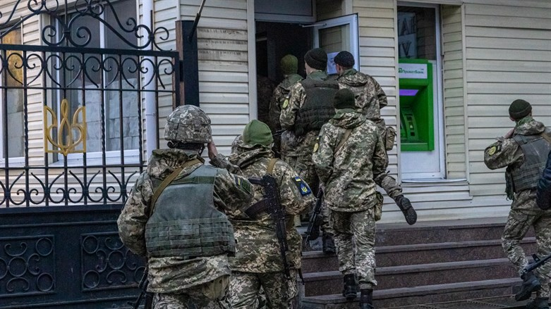
Ukrainian soldiers in Kharkiv Reuters
Explosions were heard early Sunday morning in the Ukrainian cities of Kyiv and Kharkiv, local media reported.
The explosions came after several hours of quiet in the Ukrainian capital.
Earlier, Ukraine's President Volodymyr Zelensky spoke to British Prime Minister Boris Johnson by telephone and told him that the next 24 hours are crucial for Ukraine, said a Downing Street spokesperson quoted by Reuters.
~Johnson told Zelensky that the UK and its allies would do everything possible to guarantee that defensive aid reached Ukraine, the spokesperson added.
Meanwhile, the general staff of Ukraine's armed forces described Sunday as "a difficult time" for the military, and added that troops "continue shelling in almost all directions".
In an English-language post on Facebook, the general staff said defense force members in the Vasylkiv military air base south west of Kyiv were resisting artillery strikes and Russian attacks.
On Sunday night, Russian military forces took control of the city of Berdiansk in southeastern Ukraine, the city’s mayor said.
In addition, satellite imagery taken on Sunday showed a three-mile column of Russian troops and tanks "moving towards Kyiv".
The images released by Maxar Technologies, a space technology company, showed a large deployment of Russian ground troops moving in the direction of the Ukrainian capital from approximately 40 miles (64 km) away.
The deployment consisted of hundreds of military vehicles and extended more than 3.25 miles (5 km), Maxar said, according to The Telegraph.
The convoy was situated northeast of the Ukrainian city of Ivankiv and contained fuel, logistics and armored vehicles including tanks, infantry fighting vehicles and self-propelled artillery.
Earlier, Russian forces surrounded Kyiv, cutting off the country’s largest city.
The mayor of Kyiv, Vitali Klitschko, told The Associated Press that civilians could no longer be evacuated from the city, as it has been encircled by Russian soldiers.
“We can’t do that, because all ways are blocked,” he said. “Right now we are encircled.”
Klitschko said that since the Russian invasion last Thursday, nine civilians have been killed in the city of 2.8 million, including one child.
Negotiations between Ukraine and Russia are set to commence on Monday morning at Ukraine’s border with Belarus.
Zelensky admitted that he was not confident that any progress would be made, but he insisted that he would nonetheless make the attempt.
“I’ll say frankly, like always, that I don’t believe in the result of this meeting,” he said. “But let’s try, so that no citizen of Ukraine will have any doubt that I, as President, tried to stop the war when there was even a [slight] chance.” https://www.israelnationalnews.com/news/323013

US protests Israel's refusal to back UN resolution on Russia
US Ambassador protests to Israeli Ambassador after Israel refuses to join 87 countries in backing resolution condemning Russia at Security Council.
Israel National News 28.02.22 01:06
The US Ambassador to the United Nations, Linda Thomas Greenfield, protested to Israeli Ambassador Gilad Erdan over Israel's refusal to join 87 countries in backing a US-led resolution to condemn Russia's invasion of Ukraine at the UN Security Council on Friday, Israeli officials told Barak Ravid of Axios on Sunday.
In the past week, the Prime Minister's Office and the Foreign Ministry said that the United States understands the Israeli position and is not pressuring Israel regarding its position on the Russian invasion of Ukraine. However, as it turns out there was actually American pressure on Israel behind the scenes and dissatisfaction on the part of the Biden administration with the Israeli conduct.
Israel, according to Ravid, dragged its feet as the US was gathering co-sponsors for the resolution and did not provide a clear answer before the meeting began.
After the vote, which Russia vetoed, Thomas Greenfield passed a message to Erdan stressing the Biden administration’s disappointment.
11 Security Council members voted in favor of the resolution, three (China, the United Arab Emirates and India) abstained, and Russia's was the lone "no" vote.
A Foreign Ministry official said the decision not to accept the US request to co-sponsor the resolution was due to the fact that Israel is not a member of the UN Security Council and it was clear Russia would veto.
Most close US allies and partners did back the resolution, however, noted Ravid.
Foreign Ministry spokesperson Lior Haiat told Axios in response, “We speak to the Biden administration in a wide range of channels on various aspects of the Ukrainian issue and the bottom line is that our partners are well aware of our considerations.”
The US mission to the UN declined to comment.
The UN General Assembly is expected to convene as early as Monday to vote on a resolution condemning Russia. Foreign Minister Yair Lapid told the Cabinet on Sunday that Israel will vote in favor. https://www.israelnationalnews.com/news/323011 Israel has to look after their own interest and they can’t completely alienate Russia because it would mean an attack by Iran through Syria.- rdb]

Russian forces surround Kyiv: 'Civilians are trapped'
Ukrainian capital city cut off, mayor says, leaving civilians unable to flee. 'We are encircled'.
Israel National News 27.02.22 22:15
Russian force surrounded the Ukrainian capital city Sunday evening, cutting off the country’s largest city.
The mayor of Kyiv, Vitali Klitschko, told The Associated Press Sunday that civilians could no longer be evacuated from the city, as it has been encircled by Russian soldiers.
“We can’t do that, because all ways are blocked,” he said. “Right now we are encircled.”
Klitschko said that since the Russian invasion last Thursday, nine civilians have been killed in the city of 2.8 million, including one child.
Earlier on Sunday, Ukrainian officials said Russian forces had entered Kharkiv, the second-largest city in Ukraine.
Ukrainian forces battled Russian troops in urban combat on the streets of Kharkiv, with videos posted to social media showing Russian combat vehicles moving through the city.
But Iryna Venediktova, Ukraine’s top prosecutor, claimed that the Russian army has thus far been unable to secure control of the city of 1.5 million.
During the battle in Kharkiv Sunday, Russian forces blew up a gas pipeline, Ukraine claimed, with the Ukrainian government claiming the explosion would cause an “environmental catastrophe”. https://www.israelnationalnews.com/news/323004

Bennett to ministers: Israel is not the issue, we need to keep a low profile
Energy Minister Karine Elharrar: There are no shortages at the moment but price increases are expected. We'll know more tomorrow.
Israel National News 27.02.22 23:30
The Political-Security Cabinet met on Sunday evening for about two hours. The meeting dealt with the Russian invasion of Ukraine and its implications for Israel.
Cabinet ministers received a comprehensive overview of the situation on the ground and the progress of the operation to rescue Israelis from Ukraine. It is believed that approximately 6,000 Israelis remain in Ukraine.
Prime Minister Naftali Bennett told the ministers at the cabinet meeting, "Israel is not the issue at the moment in this crisis. We need to keep a low profile." Interior Minister Ayelet Shaked said that "the Israeli interest is to remain silent at the moment."
Bennett claimed that the Americans "contained" the Israeli decision not to co-sponsor the condemnation of Russia in the UN Security Council, and the Russians on the other hand are also containing Israel’s statements so far. The ministers were asked to continue with measured statements on the conflict.
According to a report on Galei Tzahal (IDF Radio), Foreign Ministry representatives spoke about the preparations for the vote at the UN General Assembly on the resolution against Russia, and it was hinted that Israel will support this resolution.
Energy Minister Karine Elharrar (Yesh Atid) briefed the ministers on the impact the crisis is having on the energy market and warned of rising prices.
"We have supplies for weeks ahead - before we will have to use emergency supplies. There is no shortage right now but price increases are expected. Tomorrow there will be a meeting regarding the EU sanctions - and then we will be smarter," she said. https://www.israelnationalnews.com/news/323009

North Korea says it conducted test for developing satellite
North Korea says latest test was for development of a reconnaissance satellite system.
Elad Benari 28.02.22 00:04
North Korea said on Sunday that the latest missile test it conducted was for the development of a reconnaissance satellite system, Reuters reported, citing state news agency KCNA.
KCNA's report did not elaborate on what type of rocket had been used in the test, but authorities in South Korea said it appeared to be a ballistic missile fired from an area near Pyongyang where its international airport is located.
The test helped to confirm the working accuracy of a high definition photographing system, data transmission system and attitude control devices by "conducting vertical and oblique photographing of a specific area on earth" with cameras to be loaded on the reconnaissance satellite, KCNA reported.
"The test is of great significance in developing the reconnaissance satellite," the report said.
State media released two photos showing the Korean peninsula seen from space.
Sunday’s launch was the eighth test North Korea has conducted this year, and the first test since it conducted a record number of launches in January.
One of those launches was a test of a Hwasong-12 mid-range ballistic missile. This marked the first time Pyongyang has tested a weapon that powerful since 2017.
Pyongyang restarted its missile tests after denuclearization talks with the United States came to a halt.
Former US President Donald Trump tried to reach an agreement with North Korea while in office. Kim and Trump met in Hanoi in 2019 for a summit that left nuclear talks at a standstill.
The pair had met three times since June 2018 but made little progress towards denuclearization.
The Biden administration reached out to North Korea shortly after taking office, but the country did not respond to those overtures.
In Biden’s first policy speech to Congress, he said nuclear programs in North Korea and Iran posed threats that would be addressed through “diplomacy and stern deterrence”.
Responding to that speech, North Korea dismissed the idea of talks with Washington, saying Biden’s speech was “intolerable” and “a big blunder." https://www.israelnationalnews.com/news/323010

Israeli reporter: Don't shoot, this is Israeli TV
Ukrainian policemen fire warning shot in direction of Kan 11 News reporter Dov Gil-Har as he reports from outside his hotel.
Israel National News 28.02.22 04:08
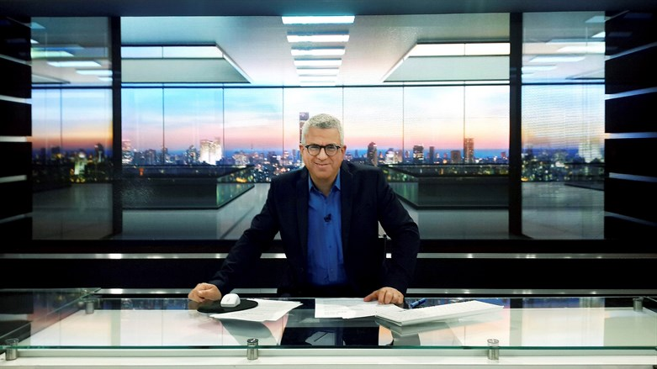
Dov Gil-Har Moshe Shai/Flash 90
Ukrainian policemen fired a warning shot in the direction of Kan 11 News reporter Dov Gil-Har, who went outside to report from outside his hotel in downtown Kyiv.
Gil-Har raised his hands, carefully took out his cell phone and presented his journalist's certificate. The police ordered him to re-enter the hotel.
"Two uniformed men got out of the car. I see them running and suddenly I understand - they are running towards me, so I raised my hands," Gil-Har recalled after the incident. https://www.israelnationalnews.com/news/323014

To be removed from this News list, Please click here and put "Unsubscribe" in the subject line.

LEV U’NESHAMA (HEART AND SOUL) – TZFAT, ISRAEL
ANNUAL TWO FOR ONE PURIM MITZVAH
Purim: Thursday, March 17, 2022

MITZVAH NUMBER ONE: Send Purim Gift Boxes to family and friends in the US. The attractive gift boxes contain an assortment of strictly kosher holiday treats.

MITZVAH NUMBER TWO: Profit from your order will help provide Passover food to needy families in Tzfat Israel. One gift box is $26 (100 NIS) including postage and handling. (Expensive postage rates and delivery problems prevent our accepting Canadian orders.)

IT’S SIMPLE TO ORDER! (DEADLINE WEDNESDAY, March 2)

Shoppers: First email your recipient list with names, addresses and brief personal messages to: mortsmo@aol.com
Payment for your order with PayPal: use the recipient email address: mortsmo@aol.com
(Tzfat shoppers may leave their cash payments at the Torah Gems Bookstore.)
Or . . . simply go to our website: www.levuneshama.com and use either PayPal or your credit card
(Israeli or US) on the "How You Can Help" page. If you use Zelle, a US to US bank transfer , you may do so by using the email: mortsmo@aol.com
US shoppers: Send checks made payable to Simcha Smolensky.
Send to: Simcha Smolensky, 6933 N Kedzie Ave, Unit 116, Chicago IL 60645
Contact me if you have questions: mortsmo@aol.com

MITZVAH OPTION: If you don’t want to order Gift Boxes, your donation in any amount will be appreciated. Send your check made payable to Simcha in Chicago or use PayPal or go to our web site, as shown above and select PayPal or use your credit card (Israeli or US). Designate on PayPal that the donation is only for the Purim program.

You can help make Passover more joyful for a needy Tzfat family.
Yaffa Smolensky, Volunteer Program Manager
Email: mortsmo@aol.com web site: www.levuneshama.com

02/27/2022 NEWS - Purimis coming - March 17 see below!

שלומי שבת - אין עוד מלבדו Shlomi Shabbat - there is no one else but him
https://www.youtube.com/watch?v=TosmJR0dAKw
1.  And know, my dear son, that I keep all -  The hardships of the road you have always traveled.  And there are no words in my mouth to describe my love - to you,  Dear son, father's treasure.  On a chair sitting and calculating all your steps,  Even if the hidden rabbi over the revelation.  And waiting for the day when our love will be fulfilled,  And in the halls I will come and see.  refrain  May the same day come that may come,  And all the streets will wear a holiday.  May the same prayer be raised,  And connect us to a new place. | 2.  And do you know my father in all the difficulties of the way,  And you want them - that's why they are there.  And with all my heart, Father,  Even out of the fog of the world.  And in the moments of descent there we are approaching,  Please hold my hands, send me the ladder.  And awaits the day when our petition will be fulfilled,  And I will come to you with everyone.  refrain

"The constitutional right of free speech has been declared to be the same in peace and war. In peace, too, men may differ widely as to what loyalty to our country demands, and an intolerant majority, swayed by passion or by fear, may be prone in the future, as it has been in the past, to stamp as disloyal opinions with which it disagrees."
-- Justice Louis D. Brandeis (1856-1941) US Supreme Court Justice
Read the Prophets & PRAY WITHOUT CEASING!
That is the only hope for this nation!
Please  Remember  These  Folks  In  Prayer-  Check often  They  Change! | Pray that the world would WAKE UP! Time for a worldwide repentance!  ALL US soldiers fighting for our freedom around the world  Pray for those in our government to repent of their wicked corrupt ways.  Pray for BB – Severe sciatic needing procedure.  Pray for EL – Had clot embolized to brain – successful ‘clot buster’ but long road to go.  Pray for BB – Severe West Nile Fever –still not mobile- improving!  Pray for RBH – cancer recurrence  Pray for Ella – Child with serious problems  Pray that The Holy One will lead you in Your preparations for handling the world problems. – Have YOU made any preparations?
Exodus 9:¹⁶But in very deed for this cause have I made thee to stand, to show thee My power, and that My name may be declared throughout all the earth. ¹⁷As yet exaltest thou thyself against My people, that thou wilt not let them go? ¹⁸Behold, tomorrow about this time I will cause it to rain a very grievous hail, such as hath not been in Egypt since the day it was founded even until now.
$$$ Hidden Camera: FDA Exec Reveals Future COVID Policy
‘Biden Wants to Inoculate As Many As Possible’ $$$$$
https://www.redvoicemedia.com/video/2022/02/hidden-camera-fda-exec-reveals-future-covid-policy-biden-wants-to-inoculate-as-many-as-possible
6 minutes PLEASE WATCH

Candace Owens - (Prepare Yourself!!) "This Is JUST THE BEGINNING”
https://www.youtube.com/watch?v=pv9Rljt5zQk&t=169s
This is 8 minutes of TRUTH – how we got here and where we are going

Russia orders troops to advance ‘from all directions’ in Ukraine
Moscow accuses Kyiv of having ‘rejected’ talks to negotiate a solution to conflict, as Ukraine’s army says it is holding back an assault on the capital
By Dave Clark and Dmitry Zaks Today, 7:35 pm
Russian military vehicles enter Ukraine, on February 24, 2022. (Video screenshot)
KYIV, Ukraine (AFP) — Russia on Saturday ordered its troops to advance in Ukraine “from all directions,” as the Ukrainian capital Kyiv imposed a blanket curfew and officials reported 198 civilian deaths.
Kyiv residents took shelter to the sound of explosions as Ukraine’s army said it had held back an assault on the capital, but was fighting Russian “sabotage groups” which had infiltrated the city.
Moscow said it had fired cruise missiles at military targets and would “develop the offensive from all directions” after accusing Ukraine of having “rejected” talks.
But, on day three of Russia’s invasion, a defiant Ukrainian President Volodymyr Zelensky vowed his country would never give in to the Kremlin.
Zelensky spoke in a video message, wearing olive green military-style clothing, and looking tired, but determined.
“I am here. We will not lay down any weapons. We will defend our state, because our weapons are our truth,” the 44-year-old said. “Our truth is that this is our land, our country, our children, and we will protect all of this.”
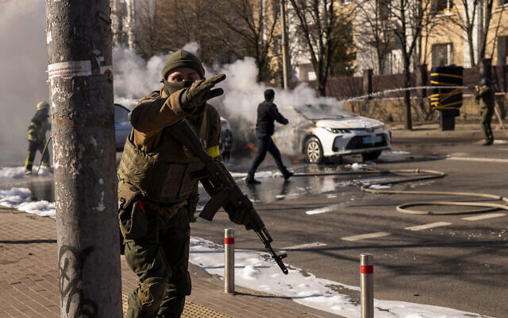
Ukrainian soldiers take positions outside a military facility as two cars burn, in a street in Kyiv, Ukraine, on Saturday, February 26, 2022. Russian troops stormed toward Ukraine’s capital Saturday, and street fighting broke out as city officials urged residents to take shelter. (AP Photo/Emilio Morenatti)
He later said Ukraine had “derailed” the Russian plan of overthrowing him and urged Russians to pressure Putin into stopping the conflict.
Ignoring warnings from the West, Russian President Vladimir Putin unleashed a full-scale invasion that the UN refugee agency said has forced almost 116,000 people to flee to neighboring countries.
WOW @fpleitgenCNN is live on CNN right now showing an enormous column of Russian tanks moving toward the border near Kharkiv as night has fallen in Russia and Ukraine pic.twitter.com/Ge14jiO51x
— Nora Neus (@noraneus) February 26, 2022
Tens of thousands more are estimated to be displaced within Ukraine, with many on the move to western areas of the country less affected by the fighting.
#Ukraine Look at these brave unarmed Ukrainians who stop Russian armored vehicles. This is a courageous and strong nation that defends its land pic.twitter.com/PkXz6wzRf5
— Hanna Liubakova (@HannaLiubakova) February 26, 2022
Ukrainian Health Minister Viktor Lyashko said 198 civilians, including three children, had been killed in the conflict and 1,115 wounded.
In Kyiv, residents took shelter in the subway system and in cellars and basements.
“We thought something like this might happen, but we were hoping until the end that it wouldn’t,” Irina Butyak told AFP in one shelter.
“We were hoping that common sense and common decency would prevail. Well, it didn’t,” the 38-year-old teacher said.
Thousands of refugees made their way to the Polish border city of Przemysl by train.

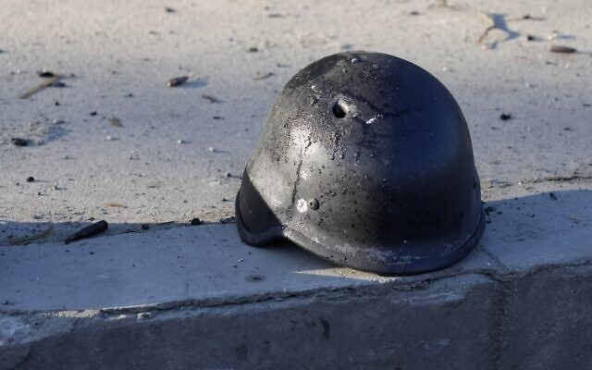
A soldier’s helmet with a bullet hole near debris of burning military trucks, in a street in Kyiv, Ukraine, on Saturday, February 26, 2022. (AP Photo/Efrem Lukatsky)
“We don’t want to be running from country to country and asking for support, but support is really needed this time,” one refugee, who only gave her first name, Anna, told AFP.
In Paris, French President Emmanuel Macron warned that the world must brace for a long war.
“This crisis will last, this war will last and all the crises that come with it will have lasting consequences,” Macron said. “We must be prepared.”
After speaking to Macron, Zelensky tweeted to thank “partners” for sending weapons and equipment.
Several NATO members have sent weapons and ammunition to Ukraine in recent weeks, including Britain, the United States and ex-communist countries in eastern Europe.
Ukrainians wrecking Russian Motorized Infantry with #Molotov cocktails at improvised roadblocks on the outskirts of #Kyiv, #Ukraine.
pic.twitter.com/A7lvr0G6Hh
— Soleyman (@soleyman_1) February 26, 2022
In the latest contribution from Washington, US Secretary of State Antony Blinken announced $350 million in additional military equipment.
NATO has said it is deploying its rapid response force of 40,000 troops to eastern Europe for the first time, but the Western military alliance has made clear it will not send any troops to Ukraine.
In the early hours of Saturday, AFP reporters in Kyiv heard occasional blasts of what soldiers said were artillery and Grad missiles being fired in an area northwest of the city center. There were also loud explosions in the center.
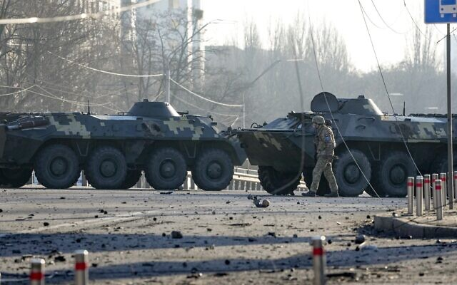
A soldier walks along Ukrainian armored vehicles blocking a street in Kyiv, Ukraine, on Saturday, February 26, 2022. (AP/Efrem Lukatsky)
Emergency services said a high-rise apartment block was hit by shelling overnight, posting a picture that showed a hole covering at least five floors blasted into the side of the building.
Kyiv’s mayor, Vitali Klitschko, said the building had been hit by a missile.
“The enemy is trying to break into the city, in particular from Gostomel, Zhytomyr, where the aggressors are neutralized,” Klitschko said, referring to two settlements to the northwest and west of the city.
“Now in Kyiv there are, unfortunately, sabotage groups, there were several clashes,” he said.
Hours later, AFP saw a destroyed Ukrainian military truck in the city center and a civilian volunteer digging a trench for soldiers.
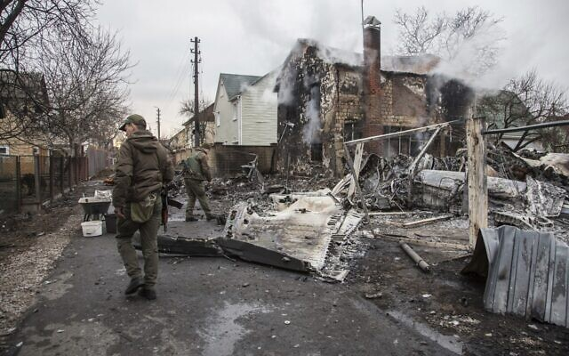
Ukrainian army tanks were also seen maneuvering all over the center but the streets were mostly empty and the center silent except for the sound of air raid sirens and birdsong.
The city said it was toughening a curfew in place and anyone on the streets after 5 p.m. (1500 GMT) would be considered “members of the enemy’s sabotage and reconnaissance groups.” The curfew will last until 8 a.m. on Monday.

Ukrainian servicemen walk near fragments of a downed aircraft seen in in Kyiv, Ukraine, on Friday, February 25, 2022. (AP Photo/Oleksandr Ratushniak)
Elsewhere in Ukraine, AFP saw traces of an airstrike on a military base near the village of Rozsishki in central Ukraine, including two destroyed trucks.
At the entrance to several villages and towns on the way to Lviv, men in civilian clothes could be seen manning improvised concrete barriers.
When he announced the beginning of the assault Thursday, Putin said it was to defend Russia-backed separatists in eastern Ukraine.
The rebels have been fighting Ukrainian government forces for eight years in a conflict in which more than 14,000 people have been killed.
Putin called the current conflict a “special military operation” and Russia’s communications regulator on Saturday told independent media to remove reports describing it as an “assault, invasion, or declaration of war.”
Russia has brushed off international condemnation and increasingly stringent sanctions adopted by the US, Canada, Britain and the European Union, including against Putin himself and Foreign Minister Sergei Lavrov.
Moscow said sanctioning the pair was “a demonstration of the complete impotence of the foreign policy” of the West.
Zelensky has called on Western allies to go further by expelling Moscow from the SWIFT banking transfer system — a move that would cripple Russia’s trade with most of the world.
Polish Prime Minister Mateusz Morawiecki slammed countries such as Germany for resisting the move.
“There is no time today for the kind of unyielding egoism that we see in certain Western countries, including here in Germany unfortunately,” Morawiecki said in Berlin ahead of a meeting with German Chancellor Olaf Scholz.
“That is why I came here… to shake the conscience of Germany. So that they finally decide on sanctions that are actually crushing,” he told Polish reporters. https://www.timesofisrael.com/russia-orders-troops-to-advance-from-all-directions-in-ukraine/

As Russians assail Kyiv, Zelensky says Ukraine has ‘derailed their plan’
US defense official says Moscow’s troops increasingly frustrated by ‘very determined resistance’; Ukrainian leader urges Russians to pressure leader Putin to stop invasion
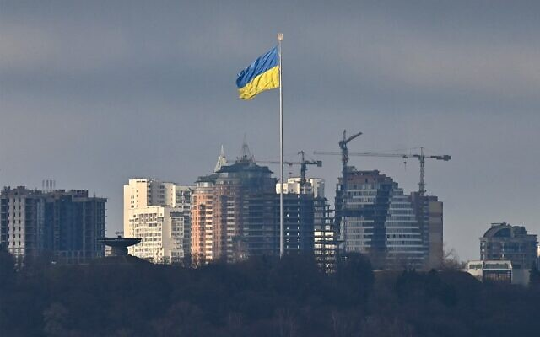
By Agencies Today, 4:54 pm

Ukraine's biggest national flag flies in Kyiv, on February 26, 2022 (Genya Savilov/AFP)
Russian troops closed in on Ukraine’s capital Saturday after a night of explosions and street fighting sent Kyiv residents seeking shelter or fleeing the city. The country’s leader claimed Ukraine’s forces had repulsed the assault and vowed to keep up the struggle.
“The real fighting for Kyiv is ongoing,” Ukrainian President Volodymyr Zelensky said in a video message, accusing Russia of hitting infrastructure and civilian targets.
“We will win,” he said.
Zelensky urged Russians to pressure Russian leader Vladimir Putin to stop the invasion. He accused Moscow of seeking to overthrow him and establish a puppet state in Ukraine.
“We’ve derailed their plan,” the 44-year-old leader said, stressing that the Ukrainian army was in control of the capital Kyiv and main cities around it.
A US defense official told Reuters there was growing frustration among the Russians “that they have not made the progress that they have wanted to make, particularly in the north.”
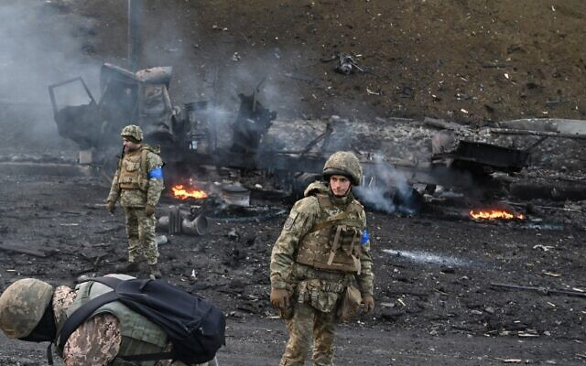
The unnamed official added: “They have been frustrated by what they have seen is a very determined resistance. It has slowed them down.”
Zelensky said Russians have deployed “missiles, fighters, drones, artillery, armored vehicles, saboteurs, and airborne forces” against Ukraine and have hit “residential areas.”
Zelensky said Ukrainians had been fighting against Russians troops in a number of cities including the southern city of Odessa, the northeastern city of Kharkiv and the capital Kyiv. The western city of Lviv and other cities in western and central Ukraine have been targeted with air strikes, he said.

Ukrainian service members look for and collect unexploded shells after fighting with Russian troops in the Ukrainian capital of Kyiv in the morning of February 26, 2022 (Sergei Supinsky/AFP)
Ukraine, Zelensky said, has “already” earned the right to join the European Union and urged the EU leaders to make that decision.
“This will be key evidence of our country’s support,” he said.
Zelensky also urged Europe to back severing Russia from the SWIFT banking system to punish Moscow for invading his country.
“There is already almost full support from the EU countries to disconnect Russia from SWIFT. I hope that Germany and Hungary will have the courage to support this decision,” Zelensky said. Hungary has since indicated it would back the move, though Germany’s position is unclear.
Central Kyiv appeared quiet Saturday, and skirmishes reported on the edge of the city suggested that small Russian units were trying to clear a path for the main forces. Britain’s defense ministry said Saturday that the bulk of Russian forces were 19 miles (30 kilometers) from the middle of the city.
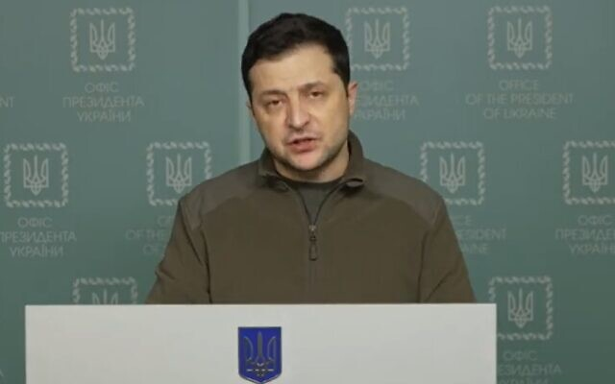
Kyiv mayor Vitali Klitschko extended a curfew he imposed two days ago to run from 5 p.m. until 8 a.m. He said “all civilians on the street during the curfew will be considered members of the enemy’s sabotage and reconnaissance groups.”

Ukrainian President Volodymyr Zelensky addresses his nation in a speech on Saturday, February 26, 2022, saying troops were successfully thwarting Russian attacks. (Screenshot/Twitter)
Russia claims its assault on Ukraine was aimed only at military targets, but bridges, schools and residential neighborhoods have been hit since the invasion began Thursday with air and missile strikes and Russian troops entering Ukraine from the north, east and south. MUCH MORE - https://www.timesofisrael.com/as-russians-assail-kyiv-zelensky-says-ukraine-has-derailed-their-plan/

Russian army deploys its TOS-1 heavy flamethrower, capable of vaporizing human bodies, near Ukrainian border, footage shows
Joshua Zitser 8 hours ago
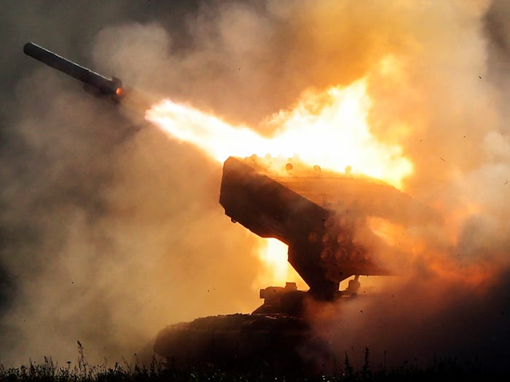
Russian heavy flamethrower system TOS-1 fires during the International Military Technical Forum Army-2018 in Alabino, outside Moscow, Tuesday, Aug. 21, 2018. Russia has displayed its latest weapons at a military show aimed at attracting more foreign customers. Pavel Golovkin/AP Images
- CNN footage shows a TOS-1 heavy flamethrower being deployed near the Ukrainian border.
- The TOS-1 heavy flamethrower is able to shoot thermobaric rockets.
- Thermobaric weapons are capable of vaporizing human bodies and crushing internal organs, say reports.
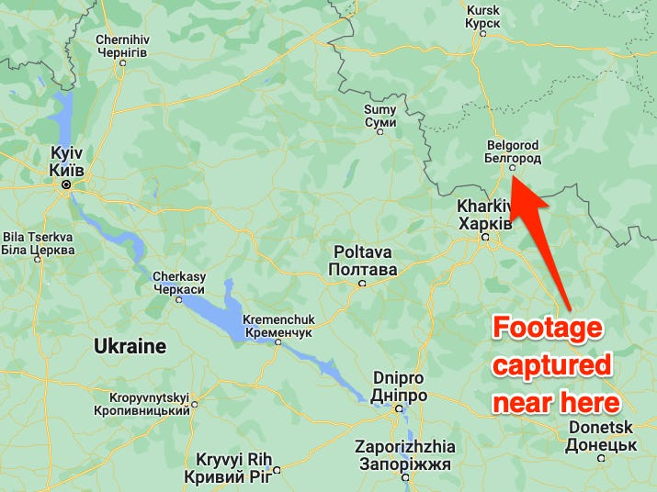
Footage from inside of Russia appears to show a thermobaric rocket launcher being deployed towards the Ukrainian border, according to The Guardian.
—Frederik Pleitgen (@fpleitgenCNN) February 26, 2022

The video, shared on Twitter by CNN correspondent Frederik Pleitgen, displays a TOS-1 heavy flamethrower, which can shoot thermobaric rockets mounted on a T-72 tank chassis.
The footage was captured south of Belgorod, Pleitgen said, which is about 45 miles away from Kharkiv, Ukraine.
The footage was captured south of Belgorod, near the Ukrainian border, according to CNN. Google Maps
The TOS-1 was first used during the Soviet war in Afghanistan, The Guardian said, and was also deployed in Chechnya and the Syrian civil war.
It can launch two types of warheads — incendiary and fuel-air explosives. The latter, also called vacuum or thermobaric rockets, work by using oxygen from the surrounding air to generate a high-temperature explosion.
The weapons system is extremely effective against entrenched personnel. The TOS-1A is used to clear out buildings, field fortifications and bunkers, according to Military-Today.com.
They are considerably more destructive than conventional explosives.
According to i News, thermobaric weapons can vaporize human bodies and crush internal organs.
Western officials first publicly expressed concern that Russian President Vladimir Putin might use thermobaric bombs to seize control of Ukraine on Friday, HuffPost reported.
"My fear would be that if they don't meet the timescales and objectives, they would be indiscriminate in the use of violence," one Western official said, per i News. "They don't adhere to the same principles of necessity and proportionality and the rule of law that Western forces do." https://www.businessinsider.com/russia-deploys-feared-tos-1-heavy-flamethrower-near-ukraine-cnn-2022-2 [This is a ‘FEARFUL WEAPON”! HUMMMMM – Zechariah 14:12 And this shall be the plague with which the LORD will strike all the people who fought against Jerusalem: Their flesh shall dissolve while they stand on their feet, Their eyes shall dissolve in their sockets, And their tongues shall dissolve in their mouths. You may have thought that a lot of what you read in the prophets is hyperbole but it isn’t. The prophets saw what would happen and what would be even if they couldn’t understand or explain it in their own limited perspective. It is now a realistic item as are many other things described in the scriptures. - rdb

Russia deploys ultra-heavy Tos-1 Buratino weapon on Day 3 of Ukraine invasion
Feb 26, 2022 @ 13:48
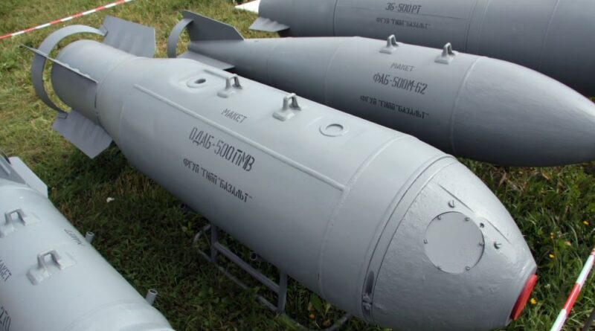
Amid heavy fighting with Ukrainian forces, the Russians brought their version of the MOAB (Mother of All Bombs) to the Ukraine battlefield on Saturday, Feb. 26, the third day of their invasion. The Tos-1 Buratino, as well as cruise missiles fired from Russia’s Black Sea fleet, targeted Kyiv and other cities where fighting rages. The Ukrainian Interior Ministry warned civilians early Saturday to stay off the streets and remain as calm as possible. “If you have a shelter stay there,” said the message. “Otherwise keep away from windows and balconies, take shelter in bathrooms and run for cover when you hear sirens.”
President Volodymyr Zelensky walked through the streets of Kiev under shelling and took selfies to broadcast a message: “I am here. We’re not laying down any arms. We will defend our state, because our weapons are our truth.” His gesture aimed at refuting Russian claims that he had fled the embattled capital.
Moscow also reported having seized the southern port of Mariupol. Fighting continues in Odessa and other Ukrainian cities. The Russian defense ministry spokesman Igor Konashenkov released the following figures of the military operation thus far: 87 Ukrainian tanks destroyed, 7 air force planes and 9 helicopters disabled; 14 military airports struck, as well as 19 command centers and 24 missile batteries. The types of missiles were not specified.
The Ukrainian defense ministry stated on Friday that the first two days of war had resulted in the deaths of 2,800 Russian soldiers, destroyed 80 tanks and downed 17 aircraft and helicopters.
Western intelligence sources Saturday morning judged that since Russian forces’ advance lagged behind planning and had so far failed to capture Kiev, President Vladimir Putin had decided to escalate the operation with the heaviest weapon deployed by his army, short of a nuclear warhead. The thermobaric Tos-1 Buratino creates a massive blast wave and negative pressure. It was formerly deployed by Moscow in Afghanistan, Chechnya and Iraq, as well as in the operation for the capture of the airfield of the northern Syrian town of Aleppo in 2016.. https://www.debka.com/russia-deploys-ultra-heavy-tos-1-buratino-weapon-on-day-3-of-ukraine-invasion/ [This is just confirmation that Russia has in fact deployed this weapon. Using this type arms is a disaster. – rdb]

‘A stand against injustice’: Thousands march for Ukraine in Tel Aviv
Immigrants from Russia and Ukraine, as well as simply concerned citizens, come together to protest Russia’s actions in eastern Europe
By Carrie Keller-Lynn and TOI staff Today, 9:58 pm
Demonstrators carry placards and flags during a protest march against the Russian invasion of Ukraine, in Tel Aviv, on February 26, 2022 (Tomer Neuberg/Flash90) | Demonstrators carry placards and flags during a protest march against the Russian invasion of Ukraine, in Tel Aviv, on February 26, 2022 (Tomer Neuberg/Flash90)
Thousands gathered in Tel Aviv’s HaBima Square and Rothschild Boulevard Saturday to protest the ongoing Russian invasion of Ukraine, as well as what they say is Israel’s lackluster response, as the war concluded its third day.
The rally-goers marched toward the Russian embassy building, where police kept them several dozen meters away from the mission.
Vyacheslav Feldman, founder of protest organization Israeli Friends of Ukraine, told The Times of Israel that the demonstration’s first priority was to “stop the war,” and the second was for the Israeli government to take a more active role.
“We’re asking the Israeli government to take a clearer step,” he said. “We want Israel to take a side.”
“Humanitarian assistance is nice, but what Ukraine needs is defensive weapons.”
As Russia attacks Ukraine, Israel has avoided taking a stance aligned too closely with either side. This is believed to be at least partly due to its need to work with the Russian military presence in neighboring Syria.
Israel has expressed concern regarding the invasion and offered humanitarian aid to the Ukrainian people, but Prime Minister Naftali Bennett has avoided condemning Russia or even mentioning the country by name in his statements since the launching of the widespread military operation across Russia’s border. Foreign Minister Yair Lapid issued a clearer condemnation of Moscow Thursday, calling the invasion “a grave violation of the international order.”
Demonstrators carry placards and flags during a protest against the Russian invasion of Ukraine, in Tel Aviv, on February 26, 2022. (Carrie Keller-Lynn/The Times of Israel) | Demonstrators carry placards and flags during a protest march against the Russian invasion of Ukraine, in Tel Aviv, on February 26, 2022 (Tomer Neuberg/Flash90)
Mila and Irena, two new immigrants from Ukraine in their twenties, held signs with Oleg, a Russian immigrant to Israel. Mila and Irena each moved to Israel alone and their families remain in Ukraine.
In particular, the three stressed the abundance of false information circulating in Russia.
הפגנה בתל אביב היום נגד התוקפנות הרוסית. (מקור לא ידוע, אוסיף קרדיט בהמשך בשאיפה) pic.twitter.com/YKgOUI44sm
— ‏Tal Schneider טל שניידר تال شنايدر (@talschneider) February 26, 2022
“They don’t know the truth of what’s going on,” Irena said, on her estimation of the war’s exposure to the broader Russian public.
While many protesters have roots in Ukraine, Russia, or the former Soviet Union, a significant contingent were Israelis without ties to any of the countries who were simply angered by Russia’s actions.
“I’m here to stand against injustice,” a protester from the latter group said.
At the rally, Ukrainian songs mixed with cheers of “glory to Ukraine” and “Putin is a dick.”
Aalona, who made aliyah from Azerbaijan 32 years ago, told Ynet it was “angering that our government is unwilling to support the Ukrainian people. The fear to clearly voice the injustice is cowardly behavior.”
Viky Lomberg, a Russian immigrant married to a Ukrainian immigrant, told the website: “Here in Israel there’s a democracy, and I’m not afraid to shout against the war. In Russia, the people are afraid of the president.” https://www.timesofisrael.com/a-stand-against-injustice-thousands-march-for-ukraine-in-tel-aviv/

Israeli diplomatic staff in Lviv to spends their nights in Poland
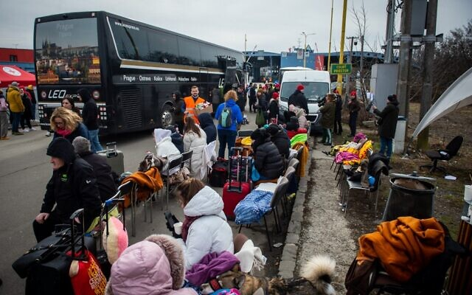
Workers will cross border to Ukraine daily to provide consular services; Foreign Ministry tells Israelis at border crossings to visibly bear ‘IL’ lettering for quick assistance
By Tal Schneider and TOI staff Today, 3:52 pm

Ukrainian refugees wait to continue their journey after they crossed the border in Vysne Nemecke, eastern Slovakia, on February 26, 2022. (Peter Lazar/AFP)
Israeli Foreign Minister Yair Lapid has instructed Israeli embassy staff in the western Ukrainian city of Lviv to cross over into Poland in the evenings, amid ongoing fighting between Ukrainian forces and Russian troops following Moscow’s invasion of its western neighbor on Thursday.
The Israeli diplomatic staff will stay in Poland and cross the border into Ukraine every day to continue their diplomatic work and provide consular services to help Israeli citizens leave Ukraine, the foreign minister said.
The Foreign Ministry said it instructed thousands of Israeli citizens still in Ukraine and arriving at border crossings to prominently display a sign bearing the letters ‘IL’ on their clothing or on vehicles so they could be identified by embassy staff in lines and crowds.
“We ask all Israeli citizens exiting Ukraine at the border crossings to display on their bodies (if pedestrians) or in their vehicle (if in a vehicle) a prominent sign with the letters ‘IL’ so that Israeli representatives can locate Israeli citizens in queues and assist them as much as possible,” the ministry said in a statement.
Israeli diplomatic staff would be present at the following crossings, the ministry said: the Medyka/Sheiny crossing into Poland, which officials said was extremely busy and crowded; the Uzhhorod/Vysne Nemescke crossing into Slovakia; the Zahony/Chop crossing into Hungary; the Siret crossing into Romania; the Palanca crossing into southern Moldova; and the Mogilev-Podolskiy crossing into northern Moldova.
The Israeli embassy employees completed their relocation from the capital of Kyiv to Lviv, closer to the Polish border, on Tuesday amid fears an invasion was imminent.
Russian troops have been pressing toward Ukraine’s capital, Kyiv, after a night of explosions and street fighting Saturday sent residents seeking shelter underground.
The country’s leader refused an American offer to evacuate, insisting he would stay. “The fight is here,” Ukrainian President Volodymyr Zelensky said.
It was not immediately clear how far Russian troops had advanced. Ukrainian officials reported some success in fending off assaults, but fighting persisted near the capital. Skirmishes reported on the edge of the city suggested that small Russian units were trying to clear a path for the main forces.
The Israeli Foreign Ministry said it reached the decision to move embassy staff out of Lviv following a situational assessment Saturday morning that Russian troops may occupy the city.
This development came as reports circulated that Russian troops attempted a landing in the Lviv region, near the city of Brody to the northeast.
Lviv Mayor Andriy Sadovy said a landing of three Russian helicopters was repelled by Ukrainian troops, a claim that was later refuted by Ukraine’s security services. MORE - https://www.timesofisrael.com/israeli-diplomatic-staff-in-lviv-to-spends-their-nights-in-poland/

Ukrainian Embassy seeks to recruit Israelis to fight Russian invasion
In now-deleted post, mission calls for volunteers to ‘participate in combat actions against the Russian aggressor’; Israeli Foreign Ministry says it’s aware of the matter
By Judah Ari Gross Today, 9:34 pm
The Ukrainian Embassy in Israel on Saturday began actively recruiting people in Israel to fight against the Russian military as its country is facing a full-scale invasion.
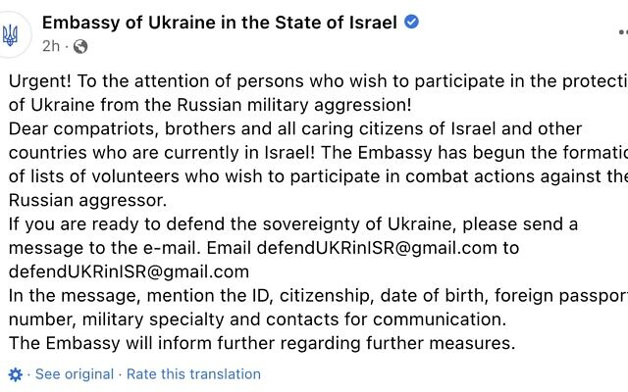
“The Embassy has begun the formation of lists of volunteers who wish to participate in combat actions against the Russian aggressor,” the embassy wrote in a public Facebook post written in Ukrainian.
In the post, the embassy asked those who wish to “participate in the protection of Ukraine from the Russian military aggression” to send an email with their personal information, including any “military specialty” they may have.
In a since-deleted Facebook post, the Ukrainian Embassy in Israel calls for volunteers to help the country against a Russian invasion, on February 26, 2022. (Screenshot)
On Friday, before the Facebook post was published, the Ukrainian ambassador to Israel told journalists that his office had checked and ensured that it was legal for Israelis to volunteer for the Ukrainian military.
Israel does not have a law forbidding citizens from volunteering for other countries’ armies.
The Ukrainian embassy’s post was later deleted from its Facebook page. No explanation was given for the move.
Israel’s Foreign Ministry said it had been aware of the Facebook post before it was deleted, but would not comment further. It did not respond when asked if the post had been taken down due to an Israeli request.
Some 500,000 Israelis are estimated to have Ukrainian roots, most of them having come to Israel in the years immediately following the collapse of the Soviet Union.
But tens of thousands have immigrated in the past few years, following Russia’s 2014 invasion of Crimea. Due to Israel’s mandatory conscription, many of these half-million Israelis with Ukrainian heritage have received local military training.
After months of building up forces along the border, in the early hours of Thursday morning, Russia launched a massive military offensive against Ukraine. Hundreds of Ukrainian soldiers and civilians have been killed in the onslaught so far, and Ukrainian officials have called for anyone in the country who is able to help fight the Russian invasion. https://www.timesofisrael.com/ukrainian-embassy-seeks-to-recruit-israelis-to-fight-russian-invasion/

Russia sees military coordination with Israel on Syria continuing
Despite expressing displeasure over Israel's apparent support of Ukraine, Russian embassy says 'deconfliction mechanism' - which prevents the two countries to clash during Israeli operations in Syria - proven to be useful and will continue to work
Reuters | Published: 02.26.22, 18:20
Russia sees its military coordination with Israel over Syria continuing, the Russian embassy said on Saturday, after Moscow signalled displeasure with Israeli statements about the Ukraine crisis.
Following the 2015 Russian intervention in the Syrian civil war, Israel set up a "deconfliction mechanism" with the big power to prevent them clashing inadvertently during Israeli strikes against Iranian deployments and arms transfers in the neighbouring Arab state.
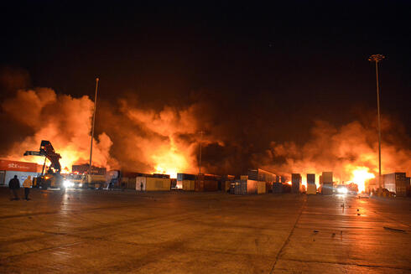
Israeli attacks in Syria (Photo: EPA)
"Our military officials discuss the practical issues of this substantively on a daily basis. This mechanism has proven to be useful and will continue to work," the Russian embassy in Israel said in a statement.
But while voicing support for Israel's security needs, it also reiterated opposition to violations of Syrian sovereignty.
The Israeli military, asked about prospects for continued coordination with Russia over Syria, said only that its forces "will act when needed to counter threats, defend the people of Israel and our sovereignty".
Israel, whose main ally is the United States, condemned the Russian invasion of Ukraine on Thursday as "a serious violation of international order" and has since remained largely muted on Moscow's actions.
In response, Moscow - which calls its actions in Ukraine a "special operation" - summoned the Israeli ambassador for talks. Russia's U.N. mission restated opposition to Israel's occupation of the Golan Heights. Israel captured the strategic plateau from Syria in a 1967 war and annexed it, a move that won U.S. recognition in 2019.
The United States said on Thursday that there were no changes in its deconfliction mechanism with Russia over Syria, though the Ukraine crisis has sent Washington-Moscow relations spiraling. MORE - https://www.ynetnews.com/article/sjxc3pplc

Israel readying for 10,000 immigrants from Ukraine in coming weeks - exclusive
An estimated 10,000 Ukrainian Jews will arrive in Israel in the coming weeks, according to Israeli government officials.
By ZVIKA KLEIN Published: FEBRUARY 26, 2022 20:50 Updated: FEBRUARY 26, 2022 21:40
New immigrants arrive from Ukraine in February 2022 (photo credit: IFCJ)
Israel's government estimates that around 10,000 Ukrainians will immigrate to Israel in the coming weeks, government officials told The Jerusalem Post on Saturday.
The Ministry of Immigration and Absorption would not comment on this estimate, but responded saying: "The Ministry of Immigration and Absorption is prepared for the emergency immigration of Ukrainian Jews, and in view of the escalation in Ukraine, the ministry, headed by Minister Tamano Shata, is preparing all sectors to assist and absorb any Jew seeking to immigrate to Israel."
Ukrainian Jews return to Israel. (credit: MARC ISRAEL SELLEM)
"In light of the drastic increase in applications for immigration from Ukraine and in view of the security situation in the region", the ministry said that Tamano-Shata and Finance Minister Avigdor Lieberman agreed on providing additional budgets to actualize the emergency immigration operation from Ukraine.
The Ministry of Immigration and Absorption convened an emergency discussion last Thursday during which Tamano-Shata assembled an inter-ministerial team to remove bureaucratic hurdles for potential olim and to issue immigration visas digitally, in light of a drastic increase in applications. This is in addition to reinforcements in the Absorption Division at Ben Gurion Airport and the cooperation with the IDF.
The Ministry concluded, "We call on the Jews of Ukraine to immigrate to Israel - your home."
In the entire year of 2021 a total of 13,006 Jews made Aliyah from Eastern Europe to Israel. Therefore, 10,000 immigrants from Ukraine in one month is substantial and dramatic. As revealed by the Jerusalem Post, Israel offers fleeing Jews from Ukraine free shelter and meals. The Ukrainian Jews will be offered to stay in hotels for a time of two weeks till one month – with possibilities to extend this time further. https://www.jpost.com/diaspora/article-698746

Close ties with Russia stop Palestinians from taking sides in Ukraine war - analysis
PA President Mahmoud Abbas is still hoping that Russia would play a major role in any future peace process between the Palestinians and Israel.
By KHALED ABU TOAMEH Published: FEBRUARY 26, 2022 19:18 Updated: FEBRUARY 26, 2022 19:55
The Palestinians, who often rush to express their views on various regional and international conflicts, have been careful not to take sides in the war between Russia and Ukraine.
The Palestinian Authority in the West Bank and Hamas in the Gaza Strip have long maintained good relations with Russia.
That’s why they have neither come out against the Russian invasion of Ukraine nor expressed any opinion about the conflict, at least not by Saturday night.
PA President Mahmoud Abbas is still hoping that Russia would play a major role in any future peace process between the Palestinians and Israel.
Late last year, Abbas held a phone conversation with Russian President Vladimir Putin.
Abbas reiterated the need for a political path to resolve the Palestinian issue “based on international legitimacy resolutions and the necessity of holding a meeting of the International Quartet Committee,” which consists of the US, the European Union, the UN and Russia.
Abbas’s appeal to Putin is consistent with his long-standing policy of trying to persuade the Russians to support his initiative to hold an international peace conference under the auspices of all the Quartet members, and not just the US alone, as has been the case in the past.
Disappointed by the “hesitancy” and “impotence” of the current US administration, Abbas and the PA leadership are hoping that Russia would agree to play a larger role in any future peace process with Israel. They do not want the US to have a monopoly over the Israeli-Palestinian conflict because of the PA-perceived US bias in favor of Israel.
Over the past few weeks, a growing number of officials in Ramallah have expressed disappointment with the failure of the US administration to fulfill its promises to the Palestinians, including the reopening of the US consulate in Jerusalem and exerting pressure on Israel to halt settlement construction in the West Bank. MORE - https://www.jpost.com/middle-east/article-698736

Iranians defy Khamenei, protest Putin outside Ukrainian embassy
Despite the Iranian regime’s ban of demonstrations against Putin, the group of Iranians declared “Death to Putin” in what might be an unprecedented move by anti-Putin Iranians.
By BENJAMIN WEINTHAL Published: FEBRUARY 26, 2022 22:07
Reports and video footage on Saturday show a group of Iranians assembled outside of Ukraine’s embassy in Tehran urging the collapse of Vladimir Putin’s government in an audacious protest against the Islamic Republic’s full-throttled support for Russia’s invasion of Ukraine.
Despite the Iranian regime’s ban of demonstrations against Putin, the group of Iranians declared “Death to Putin” in what might be an unprecedented move by anti-Putin Iranians.
“Bravo to Iranian compatriots who gathered in front of Ukrainian Embassy in Tehran to show solidarity with victims of Putin's aggression. They reminded the world that Islamic President [Ebrahim] Raisi, a Putin protege, doesn't represent the views of our people. Protesters behaved with dignity,“ wrote Amir Taheri, a prominent Iranian journalist on Twitter.
Bravo to Iranian compatriots who gathered in front of Ukrainian Embassy in Tehran to show solidarity with victims of Putin' aggression.
They reminded the world that Islamic President Raisi, a Putin protege, doesn't represent views of our people.
Protesters behaved with dignity.
— Amir Taheri (@AmirTaheri4) February 26, 2022
Taheri added “Khomeinist trolls say Iranians who demonstrated in front of Ukraine & Russian embassies in Tehran to condemn Putin's invasion & show solidarity with victims of aggression,were ‘few’. Yes. But better fewer but better. Not like rent-a-mob Hezbollah crowds of boot-lickers.”
Ali Khamenei is the Supreme Leader of the Islamic Republic of Iran. Iranian journalists on Twitter noted that protestors said “Down with the supporters of Putin, down with the warmonger.”
The US government news organization Voice of America Farsi showed footage of the anti-Putin protest in Tehran:
ویدیو ارسالی به صدای آمریکا- تجمع مردم تهران مقابل سفارت #اوکراین در #تهران و شعار علیه ولادیمیر #پوتین pic.twitter.com/QzAF9pWf1M
— VOA Farsi صدای آمریکا (@VOAIran) February 26, 2022
In a telephone call with Putin on Thursday, Iran’s president Raisi delivered support to the Russian invasion of Ukraine. Raisi said NATO’s has created "a source of tension,"by encroaching on Russia, according to Iranian regime-controlled media.
The Iranian state-controlled Mehr News Agency reported that Raisi told Putin: “The continued expansion of NATO is a serious threat against the stability and security of independent countries in various regions of the world.” Russia and Iran’s regime are allies in Syria where they united behind Syrian President Bashar Assad to stop a revolt against Assad’s regime. https://www.jpost.com/international/article-698753

Germany makes U-turn on sending weapons to Ukraine
Berlin has decided to supply Kiev with anti-tank missiles and ‘Stinger’ air defense systems, a government official confirmed
26 Feb, 2022 19:18
Germany has decided to supply Kiev with 1,000 anti-tank weapon systems as well as 500 ‘Stinger’ surface-to-air missiles from the German Army stocks, a government spokesman, Steffen Hebestreit, announced on Saturday. The weapons are to be delivered to Ukraine “as soon as possible,” he added.
Chancellor Olaf Scholz has commented on the decision by calling the ongoing Russian military operation in Ukraine a “turning point” that “threatens the entire post-war order.” It is Berlin's “duty” to support Ukraine in defense against what he called “Vladimir Putin's invading army.”
Earlier on Saturday, several German media outlets reported that Berlin had changed its position on supplying Ukraine with lethal weapons upon ur gent requests from Kiev and its NATO partners.
Germany's ARD broadcaster reported that Berlin plans to provide Kiev with portable anti-tank missile launchers “via third countries.” The German government reportedly struck a deal with the Netherlands that would see Amsterdam handing over the weapons to Ukraine.
Scholz had previously ruled out deliveries of lethal arms to Ukraine. Under the German rules for resale of its weapons to third countries, anyone who resells German-made arms has to request Berlin's approval first. Earlier, Germany removed the need for such requests when it came to Ukraine.
Germany's FAZ newspaper reported on Saturday that Berlin also greenlighted Estonia's plan to hand over self-propelled howitzers to Ukraine. The military hardware comes from the stocks of the former East Germany's National People's Army and were originally sold to Finland in the 1990s.
Estonia had already asked for approval for the transaction from Berlin in January but did not get it at that time, according to the media. Germany also plans to export 14 armored vehicles to Ukraine. The deal was approved on Saturday, according to FAZ. The vehicles that can be used for personnel transportation or evacuation purposes are to be handed over to Ukraine alongside 10,000 tons of fuel that will be delivered through Poland, the paper added.
Foreign Minister Annalena Baerbock and Vice-Chancellor Robert Habeck commented on Berlin's change of course on Saturday by saying that in the wake of “Russia's shameless attack Ukraine must be able to defend itself.” “The Federal Government is therefore also supporting Ukraine … with urgently needed materials,” the two added.
The move comes days into a large-scale military operation launched by Moscow in Ukraine. The operation is aimed at “demilitarization” and “de-Nazification” of Ukraine and has been launched in support of the Donetsk and Lugansk Republics recently recognized by Russia, the Kremlin said earlier.
The development sparked an angry reaction from Western nations and saw the US, the UK, the EU, and Canada slapping Russia with a fresh round of sanctions targeting its banks, aviation, and space industries. Now, the US and its allies are also mulling cutting Russia off from the SWIFT system.
According to Baerbock, the German government is currently working on a “targeted and functional restriction of SWIFT” that would only hit “the right people.” https://www.rt.com/russia/550723-germany-send-weapons-ukraine-operation/

New national vaccine pass quietly being implemented
200 million already can access records
By Bob Unruh Published February 25, 2022 at 7:27pm
Vaccine and mask mandates are being dropped precipitously across the United States, as the campaigning for this fall's midterm elections heats up.
Also, the number of deaths and the number of COVID cases is dropping rapidly.
Some might say the U.S. is returning to normalcy.
But a new report in Forbes suggests that new norm will include digital vaccine passports.
To be used to travel, to access venues and much more.
"A paper CDC vaccination card is not cutting it," said the report.
"While the United States government has not issued a federal digital vaccine pass, a national standard has nevertheless emerged. To date, 21 states, the District of Columbia and Puerto Rico offer accessibility to the SMART Health Card, a verifiable digital proof of vaccination developed through the Vaccination Credential Initiative (VCI), a global coalition of public and private stakeholders including Microsoft, Salesforce, Oracle, the Mayo Clinic and other health and tech heavyweights," the report explained.
Four more states are lining up their requirements now.
Brian Anderson, of VCI, said in the report, "We've seen a notable uptick in states that have officially launched public portals where individuals can get verifiable vaccination credentials in the form of SMART Health Cards with a QR code."
The report said, "More than 200 million Americans can now download, print or store their vaccination records as a QR code. When the QR code is pulled up, only the individual’s name, date of birth and vaccination information is visible. No other medical information or personal data is shared."
The report charged that the product was a "huge plus."
"Many indoor cultural attractions and performance venues in the U.S. require proof of vaccination," it said.
And Gus Warren, chief of a health verification app used by various venues, said, "The SMART Health Card is such an important development and the Vaccine Credential Initiative has been phenomenal in getting this out there."
Every Canadian province is using the system, as are "Aruba, the Cayman Islands, Singapore and Japan." Also Kenya and Rwanda.
States are offering their own portals for SMART cards, or hiring companies to do that for them.
"This isn’t a passport," South Carolina’s director of immunizations told Politico. "This is essentially a COVID card that people get at their convenience because it’s their record."
The credentials offer confirmation of vaccinations at Walmart, Sam’s Club, CVS, Duane Reade, Walgreens, Costco, Kroger, Rite-Aid or any of the dozens of other companies, the report said. https://www.wnd.com/2022/02/new-national-vaccine-pass-quietly-implemented/ [A thornbush by any other name still has stickers and this is a JAB thornbush with big stickers. RUN away fast from this.- rdb]

This man tested positive for COVID-19 over a month after dying
Even after this man died in a drowning accident, his body tested positive for COVID-19 for a month and a half.
By WALLA! Published: FEBRUARY 26, 2022 19:44
Last September, in the province of Abruzzo on the Italian coast, a 41-year-old Ukrainian man and his friend went swimming in the sea. Sixteen hours later, he was declared dead after drowning.
A sad story, but no medical mystery except that for almost six full weeks after his death, his body was found positive for the virus no less than 28 times. Researchers involved with this case state that this news is a crucial finding for pathologists.
Even more bizarre is the fact that before death, the man was "completely asymptomatic," the team wrote in a study published in BMC Journal of Medical Case Reports and reported on the iflscience website, most likely having a fairly low viral load when he died.
This case concerns one of the many questions raised during the pandemic: do people die from COVID-19 or with it?
The report notes that this finding reflects the importance of testing in all post-mortem cases and not just deaths, showing that pathologists should check for virus particles "long after the moment of death, even if low initial viral load has been assessed.”
Although the man was confirmed dead from drowning, Italian guidelines required a corona test to be performed regardless of whether he was examined and autopsied. The body was moved to the local morgue as standard but a delay in obtaining burial permits left the body there a little longer than expected. Forty-one days, to be exact.
"Twenty-eight pharyngeal surfaces were performed on the body," the case report said, and "always by the same team, properly prepared and with standard procedures according to international guidelines and established protocols." Each of the tests was positive. The staff even re-checked each of them with a different set of reagents, (reactive chemical agents) just in case.
And not only were the virus particles detectable for almost six weeks after death but until the end of the test period they were the only particles that could be identified. In fact, after 41 days had passed, these tests no longer absorbed human RNA. This means that the virus tests were still positive, while human cells became unrecognizable.
The case report has real implications for the treatment of corpses during the pandemic."There is a lack of data on the presence of the virus on corpses and the risk of infection from corpses. This is a problem because "performing a post-mortem autopsy puts different groups of workers (pathologists, technicians and so on) in contact with a possible source of biological risk, with consequences not only from a health point of view but also medically," it was written.
This is not the first case that the virus has been in the body of a dead person for a long time. About a year and a half ago, researchers from the United Kingdom performed an autopsy on the body of a 50-year-old man who died from COVID-19. Twenty-seven days after his death the virus was detected in his lungs. This is despite the long time that passed and that swabs of his nose and throat performed right after his death came out negative.
And as for the Ukrainian man - his burial permit finally came, which together with what the writers describe as "the state of decay of the body", finally led to the conclusion of the study. https://www.jpost.com/health-and-wellness/article-698740 [If these folks are dead then they don’t have the disease process know as Covid, they just have the virus. How many of those with positive tests just had the presence of the virus but not really a disease. – rdb]

CDC data: COVID infections, hospitalizations spike among vaccinated
Massive increase in cases follows emergence of omicron variant
By Art Moore Published February 26, 2022 at 2:41pm
Newly published CDC data shows a massive increase in COVID-19 infections and hospitalizations since the emergence of the omicron variant among those who have been fully vaccinated.
The data, which is used by local health departments across the nation, indicate the case rate in fully vaccinated people rose by more than 1,000% between Dec. 11, 2021, and Jan. 8, 2022, the Epoch Times reported.
People who have received two doses of the Pfizer-BioNTech or Moderna vaccines, or the single dose of the Johnson & Johnson vaccine, are considered fully vaccinated 14 days after receiving a final shot.
The COVID case rate of those who received a booster, a third shot, also spiked, by about 2,400% between the same dates.
Dr. Peter McCullough, a cardiologist and epidemiologist who is one of the leading critics of the COVID vaccines, pointed out that "reductions in hospitalization and death were never demonstrated" in randomized controlled studies.
"Now, (there is) disappointment as the data come in to support what everyone has known for months," he wrote on Twitter.
According to the CDC data, cases also rose among the unvaccinated, but at a much lower rate. Consequently, the Epoch Times reported, "people who haven’t received a vaccine were just 3.2 times more likely to test positive for COVID-19 in January" than boosted adults.
U.S. health officials are considering authorizing second boosters for the general public. https://www.wnd.com/2022/02/cdc-data-covid-infections-hospitalizations-spike-among-vaccinated/

People's Convoy hits 8 miles long as vehicles join up
Raises $850,000 to fund protest of vax and mask mandates
By WND Staff Published February 25, 2022 at 7:22pm
People's Convoy heading for D.C. Feb. 2022 (video screenshot)
U.S. truckers, in their People's Convoy, on Friday reached a mass of trucks and other vehicles eight miles long, and have raised some $850,000 to support their nationwide protest of vaccine and mask mandates.
Their goal, with convoys coming from different parts of the nation, is to converge of Washington, D.C.
The Daily Mail said the People's Convoy part of the nationwide campaign, was on I-40 in New Mexico, headed to Texas.
"The truckers have called on President Joe Biden to end the National Emergency and to lift all COVID-19 vaccine and mask mandates, despite most states already having started to roll them back," the publication explained.
The drivers intend to be in the Washington area by March 5, and some parts of the protest convoys could be on hand earlier to protest during Joe Biden's State of the Union. Motorcades actually are coming for several dozen points.
The American protest was inspired by the Freedom Convoy in Canada, which started out small on the West Coast, earning the derisive label as a "fringe" group, according to Prime Minister Justin Trudeau. It eventually eventually clogged Ottawa's streets and convinced several provinces to drop their mandates.
U.S. governors and mayors have been lifting their vaccine and mask requirements rapidly in recent days, as the 2022 midterm election campaigns are getting under way.
The Pentagon and Washington officials have assembled some 1,200 officers and soldiers to be on hand for the arrivals. One convoy leader, Bob Bolus, is bringing a small contingent from Pennsylvania and has said he'd like to shut down the Washington Beltway.
But leaders have said their intentions are all legal.
"A lot of people have asked why we're doing this – what's your reason behind it. People want a defined, clear answer. They think it's one thing," Brian Brase, who with others left from California earlier this week, said in the Mail report.
In New Mexico, residents held signs and saved American flags from overpasses as the trucks, and accompanying other vehicles, passed underneath.
Kris Young, the report said, was running the group's Facebook page, and posted, "We want to thank every one of you for your support. The welcoming on the Arizona overpasses and at Great American Pizza yesterday was absolutely amazing!!"
Leftists across the country have tried to undermine the group by saying the protests are about other issues, too, fulfilling a prediction made by several that the truckers would be demonized as they were in Canada.
U.S. Defense Secretary Lloyd Austin already has approved deploying of 700 National Guardsmen as well as 50 "large tactical vehicles" to be stationed in Washington.
City officials are reinstalling a fence around the Capitol complex.
WND reported just a day earlier that spokesman Pat Callahan of the New Jersey State Police threatened that truckers, if they stopped, would be towed – much as Trudeau did to the truckers in Ottawa.
"It's one thing to rally and travel on our interstates to get to a certain rally point," Callahan said. "Where they go when they leave New Jersey is obviously up to them. I would hope that we don't have to use our heavy-duty wreckers. If they come to a stop they will be ordered to keep moving, but we are planning for scenarios where we would have heavy-duty wreckers standing by to tow them at their expense off of our interstates."
In Canada, Trudeau declared a national emergency to use violence against truckers, arresting hundreds and confiscating trucks. https://www.wnd.com/2022/02/peoples-convoy-hits-8-miles-long-vehicles-join/ [People need to make note of the ‘anti-truckers’ and be sure those governors and mayor lose their positions. – rdb]

Bill Gates funnels $1 million to push 'math is racist' narrative
'Barriers to math equity' will actually create math illiteracy
By WND News Services Published February 26, 2022 at 2:01pm
( CAMPUS REFORM) – With a $1 million check from the Gates Foundation, leading universities and local governments are building an effort to bring “anti-racism” efforts to mathematics.
A Pathway to Equitable Instruction exists to address “barriers to math equity” by offering “guidance and resources for educators to use now as they plan their curriculum, while also offering opportunities for ongoing self-reflection as they seek to develop an anti-racist math practice.”
Among the group’s content developers are Ruth Basket, Mirna Maranda-Welsh, and Malane Morales-Van Hecke from the Los Angeles County Office of Education’s Multilingual Academic Support Unit; David Chun, the Director of K-12 Mathematics at the Sacramento County Office of Education; and Mindy Shacklett, a Coordinator of Mathematics at the San Diego County Office of Education. Multiple professors from the University of California system and Loyola Marymount University also worked on the project. https://www.wnd.com/2022/02/bill-gates-funnels-1-million-push-math-racist-narrative/ Gates is a giant slime ball.-rdb]

CNN Calls Biden's Poll Numbers 'Brutal'
By Sandy Fitzgerald | Saturday, 26 February 2022 10:52 AM
A new NPR/PBS/Marist College poll measuring President Joe Biden's first year in office revealed "brutal" numbers that could spell disaster for the Democrats' chances of holding their already-tight margins in the House and Senate in this year's midterm elections, CNN said in an analysis Saturday.
"If the public's report card on Biden's second year in office is anything like the one for his first year, Democrats can kiss their House and Senate majorities goodbye," CNN Editor-at-Large Chris Cillizza writes in his breakdown of the poll's findings.
The poll revealed that more than half of Americans, or 56%, called the president's first year in office a "failure," with 39% calling it successful.
Democrats, by 80%, called the first year a success, but 15% labeled it as a failure. In addition, two-thirds of independents panned Biden's first year, and 91% of Republicans agreed.
Cillizza noted that asking whether the president succeeded or failed in his first year left no room for nuance and that often, "a president is judged in one way during his time in office and in another after he leaves, once the impacts of his policies come into clearer focus."
But still, elections force voters to choose between parties and to choose whether to vote for an incumbent or a challenger, he writes, adding that such poll numbers are "extremely problematic" for Democrats this fall.
"We know that, historically, the first midterm election of a president’s term is a referendum on his time in office up to that point," said Cillizza.
Lee Miringoff, director of the Marist Institute for Public Opinion, which conducted the poll, said the results reveal "rock-bottom numbers" about Biden that went "about as low as you're going to see him."
The poll also revealed that 54% of respondents don't believe Biden fulfilled his campaign promises, and another 52% said the president has done more to divide the nation than to unite it, which goes against his campaign's promise to unite the country.
Overall, the results showed Biden has a 39% approval rating, with 36% approving of how he is handling the economy and 47% approval of how he has handled the coronavirus pandemic.
The poll's respondents also panned Biden for how he has been handling the situation between Russia and Ukraine. The survey was taken before Russian President Vladimir Putin's full-scale invasion of Ukraine, but just 34% approved of how he has handled the Ukraine crisis, with 50% disapproving. https://www.newsmax.com/politics/cnn-biden-polls-democrats/2022/02/26/id/1058631/

Commentary:
God or Government: Who Do You Trust?
By Guest Writer|February 26th, 2022 By Bud Hancock
Should a Believer Trust The Government?
I find it curious that so many ‘religious people’ still believe, and place their trust in, the fallacy that governments are going to make things better for them and their families. Ronald Reagan once said: “The nine most terrifying words in the English language are, ‘I’m from the government and I’m here to help’”. That old saw has made the rounds many times and still gets a few laughs, but the premise behind it is not laughable. There are literally thousands of recorded instances of people who relied on the government to help them in certain situations and they were, for the most part, greatly disappointed. That so many ‘non-believers’ have bought into the satanic deception that governments can be trusted is not surprising, but a large number of those who claim to be followers of Jesus Christ are also among those who place a great amount of trust in government.
A large number of seriously deluded Americans, both Christians and non-Christians, have the idea that “Uncle Sam”, as the US government has long been called, is a beneficent ‘rich uncle’ who needs only to be asked and he will give you whatever you need. However, one must examine that idea carefully to avoid being further deceived by such nonsense.
To begin with, the US government manufactures no goods or products, it produces absolutely nothing tangible, and therefore has no inherent monetary wealth with which to be ‘beneficent’ to anyone. In order for the government to function at any level, it must tax its citizens to get the revenue it uses to exist and function. It has been thus with all governments since at least the time of Jesus. When questioned by the Pharisees whether it was lawful to give tribute (taxes) to Caesar, Jesus asked for a coin that was used to pay the tax, and having verified that the inscription on the coin was that of Caesar, He told His disciples and the evil Pharisees to “render to Caesar what is Caesar’s and to God, what is God’s” (Mark 12:17)
I am not, and would not, advocate that any American citizen, especially those who are believers, refuse to pay the taxes levied by any ‘legitimate government’. Jesus Himself told His disciples to pay the tribute levied by the Roman government. Failure to do so would be illegal and unwise. But, though we are to “pay Caesar” (the government) what is owed to them, we do NOT owe them our trust, or our worship.
Did the Founders Trust The Government?
Abraham Lincoln called the United States, “government of the people, by the people, for the people”, and that may have been true when the government was originally formed; at least that’s what was promised to all the citizens of the new country. However, it was not very long until the words of several of the Founding Fathers rang true. The Founders may have trusted the idea of a republican form of government, but, with a strong belief in God, and an understanding of human nature, they seemed to have serious doubts about those who administer the government.
For example, Benjamin Franklin injected this note of prophetic insight after writing much of the US Constitution: “I agree to this Constitution … and I believe, further, that this is likely to be well administered for a course of years, and can only end in despotism, as other forms have done before it, when the people shall become so corrupted as to need despotic government, being incapable of any other”. Samuel Adams said: “If ever time should come, when vain and aspiring men shall possess the highest seats in Government, our country will stand in need of its experienced patriots to prevent its ruin.”
These are just a few of the comments made by early American leaders who feared that corruption would turn the ‘grand experiment’ of what should have been a beautiful republic, into a corrupt and despotic democracy. A large majority of our Founders were God-fearing men who knew that, unless the government remained solidly based on the Judeo-Christian values upon which it was founded, it would soon turn from ‘republicanism’ into a democracy. The Founding Fathers were, first and foremost, landowners who grew crops, ran businesses and engaged in profitable commerce. They were NOT politicians. They understood the difference between a republic and a democracy and desired to establish a true republic. For a while, their attempts produced a wonderful government experiment that became a real republic.
Unfortunately, we are now living in a country that only faintly resembles the original republic. Having degenerated into a corrupt, and sometimes chaotic democracy, our nation’s government has been tainted by evil and greed, and an unchecked hunger for power and control, the very definition of being ‘political.
If you actually know the meaning of ‘politics’, this comes as no great surprise.
Per Dictionary.com, this is the definition of ‘politics’: “the use of intrigue* or strategy** in obtaining any position of power^ or control^^, as in business, university, etc.”.
*The definition of ‘intrigue’ is: “the use of underhanded machinations or deceitful stratagems”.
**Strategy is defined as: a plan, method, or series of maneuvers or stratagems for obtaining a specific goal or result”. The words ‘power’ and ‘control’ should need no definition. The desire for power, especially when fulfilled, usually leads to a hunger for more power. John Emerich Edward Dalberg Acton, first Baron Acton (1834–1902) famously said: “Power corrupts, and absolute power corrupts absolutely”. We are now seeing and living in a nation that is the result of corruption based on greed for power and money, in other words, a nation whose government cannot be trusted, period.
I contend that of all the names, or entities, a person can place his or her trust in, the United States government is certainly NOT one of them.
Accepting the Lie
Anyone truly interested in knowing what is happening in almost every segment of our society is easily able to educate himself/herself with available data on the level of corruption now rampant in the US government. Those who claim otherwise are merely allowing themselves to be deceived into believing a lie, or they are a part of the corruption and are therefore complicit in the continuing deception of the American people.
Based on comments made by many college students interviewed on various campuses across America, the vast majority of them seem to have no problem with what is happening to our former republic and have seemingly bought the lie that ‘socialism is a good thing’. They seem to be in favor of implementing a system that will turn our nation into a third world socialist toilet, as it has in every place it has been tried. The evil system of socialism itself is based on a lie, as is the claim that socialism is, was, or ever could be a sound system of government.
What is that lie? That everyone should rely on government to provide for their every need from cradle to grave, and that government can actually be trusted to follow through on the promise to provide those needs. Current promoters of socialism claim that previous attempts to make socialism succeed were ‘not done right’; they insist that when socialism is allowed to grow and flourish, everyone will be better off because the ‘wealth’ will be distributed ‘more evenly’ throughout society.
Personally, I have worked hard all my life and have been greatly blessed by God with a strong work ethic and blessed by Him in all my endeavors. I learned at an early age to accept that we live in a cursed world and that the curse pronounced on Adam, and through him, on the earth, has not yet been lifted. As a result, I have been very successful in most of my endeavors, thanks to God. The very idea that someone in a government should have the right, or authority, to determine what happens to my assets is totally abhorrent to me.
Wealth redistribution is, and long has been, well-established in our government and is a regular occurrence in the US Congress whereby those who are supposed to be working for the betterment of all their constituents, are instead working on ways to enrich themselves at taxpayer expense. Nearly all the representatives in both the US House and the US Senate leave Congress much, much wealthier than when they entered it. Those who so easily and eagerly accept the ‘socialism lie’ fail to understand that the socialists’ plan for wealth redistribution requires that only a certain, small number of people, especially those who feel that, due to what they perceive as their higher ‘level of intelligence’ than all the rest of the lower class of people, will decide how all wealth is distributed. Because they have accepted the socialists lie, they still display some level of trust in those corrupt people who have been elected to political offices in Congress, or the Presidency.
In 1837, President Andrew Jackson said, “I weep for the liberty of my country when I see at this early day of its successful experiment that corruption has been imputed to many members of the House of Representatives, and the rights of the people have been bartered for promises of office.” Old Hickory would be horrified if he could see the extent of corruption that is now so much a part of our American political system today.
The members of Congress alluded to by President Jackson, as well as the majority of those who have served there since Jackson’s day, were, and still are, greatly enriched by the ‘backroom’ deals they make, lobbying each other, and FOR each other, to get money from the treasury allocated to their pet special projects, some of which money, amazingly, seems to find its way into their own pockets. The same corrupt congressional reps are privy to insider trading information and, even though it is illegal, when such information is used, it permits them to become extremely wealthy. Where did the excessive wealth of congressional veterans originate? To some extent, it came from the very treasury they were elected to oversee and safeguard.
This information is public knowledge and is available for anyone who wants to dig for it. In spite of the availability of the info proving the corruption of government and its officials, many people still have some confidence in those to whom has been entrusted the oversight of the national treasury. Even worse, with all the corruption that CAN easily be seen through simple research, much more is hidden from our sight.
The Deception of Human Government
While some believers may be deceived into accepting the lie of the world and its governments, the lie that tries to convince us that our trust can, and should, be placed in that government’s benevolence and its ability to care for all its citizen’s needs, others are now seeing the error in that acceptance. The statement, “Government big enough to give you everything you want is big enough to take everything you have”, should be remembered and memorized by every believer. Though the identification of the author of it is unverified, this famous statement has been made by many throughout the years; personally, I remember Barry Goldwater saying this in his campaign for President back in 1964. Regardless of who originally said it, it still rings true today. It is very easy to make promises, especially during the emotionally charged setting of a presidential campaign. Following through on such promises is usually a much more difficult matter. Harry Browne famously stated: “For those looking for security, be forewarned, there is nothing more insecure than a political promise”. It must be remembered that, since government is not a producer/seller of goods, all the money it promises to one group of people must be taken from a different group of people: “Hello, wealth redistribution! Hello, Socialism! Goodbye freedom and prosperity!”
The thought of receiving something that one has neither inherited nor earned, something that can be had with little to no effort on the part of the recipient, is a temptation too strong for most people to resist, and they eagerly buy into the fallacy that ‘they have a right to it’ when in fact, no one has the right to anything that was not earned by ‘the sweat of thy face”, based on the curse pronounced by God on Adam, and thus on the entire human race, in Genesis 3:18. The lure of things easily obtained thorough a promise made by a politician, if accepted by the recipient, is a destroyer of motivation, a work-ethic killer that has robbed millions of Americans of the joy of working, sometimes very hard, to obtain that which is needed for life and fulfillment. Those who mistakenly believe that they can have all their ‘things’ simply by putting their trust in human government, will find themselves disappointed, disillusioned and usually desperate at some point in their lives. Misplaced trust can lead to a state of complete confusion and a lost ability to trust anything or anyone again.
Rahm Emmanuel, a member of the administration of former president Barack Obama once said: “Never let a good crisis go to waste.” In this time of ‘crisis’, supposedly brought on by a deadly virus that has swept across the world, it is once again apparent that government wants to establish itself as the saviour of man. Due to the virus, our entire economy has been affected, with many businesses shut down and people told to ‘stay home’. While these unconstitutional lockdown orders have already destroyed many small businesses, with many others uncertain if they will reopen when ‘the crisis’ is over, government has stepped in with their offer of a ‘stimulus’, basically a government-funded handout to ‘help people’. Meanwhile our debt-ridden nation has seen another 2+ trillion dollars added to an already unpayable debt.
I research every major national event, especially the crises we face, to try to get the real facts about them, not just what the experts and government leaders tell us. Now that this crisis has been going on for several months, and after the American public has been spoon-fed many ‘so-called facts’ that have since been proven to be lies, it is time for all of us to ask: “Just what is the truth of this event, and what has actually happened?”
Medical Event or Political Event?
I am certainty not a medical doctor, so I have no factual evidence of the deadliness, or lack thereof, of this virus, but I have enough common sense to know that this event appears to be a carefully planned attempt to see how far the American people can be pushed to obey unconstitutional orders. It was pushed to us all using fear as the basis, telling us that hundreds of thousands of us, possibly millions of us, would die from this virus. We all know what a powerful motivator fear can be. It is one of the main tools Satan has used to destroy people in one way or another and he has become expert in its use.
The latest data I read concerning the total number of cases of the virus and the deaths from it indicate that the death rate is around 0.15 %, certainly much lower than the original estimate of 3-4%, or even higher, as stated by the medical experts that advise our President. The actual death rate is very close to the average death rate of seasonal influenza that we all contend with year after year. And we are now learning that the overwhelming number of people who have died as a result of this virus, are those who are elderly and/or have one or more underlying medical issues that cause the virus to be more deadly. Now, in spite of the facts about the virus, we are being told to keep fearing, that this virus will certainly return this fall to destroy us all again. Based on what we now know of the true death rate of the virus, we seem to be facing some contradictions.
Ayn Rand, in her colossal and classic novel, “Atlas Shrugged” said, “Contradictions do not exist. Whenever you think that you are facing a contradiction, check your premises. You will find that one of them is wrong.”Realizing the nature of contradictions, that they are highly illusory, every person, and especially every believer must ask himself: “What premise have I been using to determine the truth of this ‘crisis’”? If that premise is that governments can be trusted to speak the truth, then it is certainly time to examine our premises and make some changes in them.
All those who have placed their trust in government, then see how corrupt that government truly is, and how untrustworthy it is, will likely believe they are facing a ‘contradiction’. However, their original premise, that governments can be trusted, is a ‘wrong premise’. They CANNOT be trusted.
What to Do, Whom to Trust
If believers ever find themselves confused, confounded, or conflicted by what is happening around them, regarding the level of government corruption, their only recourse is to go back to the basics of God’s Word to determine what a true follower of Jesus should place his or her trust in.
One can easily find Godly direction on trust, in the Psalms: “O Lord my God, in thee do I put my trust: save me from all them that persecute me, and deliver me:” (Psalm 7:1). “In God have I put my trust: I will not be afraid what man can do unto me” (Psalm 56;11). I will say of the Lord, He is my refuge and my fortress: my God; in him will I trust” (Psalm 91:2). “Every word of God is pure: he is a shield unto them that put their trust in him” (Proverbs 30:5). Paul, writing to Timothy said: “Charge them that are rich in this world, that they be not high-minded, nor trust in uncertain riches, but in the living God, who giveth us richly all things to enjoy” (I Timothy 6:17). These are just a few of the many scriptures written in God’s Word where we are commanded to ‘trust in God’ and not in the world or any of the riches of this world.
But exactly what does it mean to trust God? How does one go about it? Is there a secret formula that can be followed to become a ‘God-truster’? I go back to my earliest childhood experiences, remembering my father, a common man, poorly-educated, albeit a hard-working man from the south. Though uneducated, he was raised by a God-fearing mother who always taught her seven children to work hard, love and worship God and to live by His word. I knew from a very young age that my father and mother loved me and wanted to provide the very best for me, to the extent they were able. I always knew that Dad and Mom would keep me fed, clothed and healthy though we were quite poor. I never lacked for the necessities growing up, and I knew it was due to the love of my Dad and Mom for me, and the fact they trusted God for provision. I learned over a short period of time during my childhood to trust my parents for my needs. Along with my trust, I learned to love Dad and Mom wholeheartedly.
Therefore, whenever I would approach my Dad to ask for something I really wanted, I knew that, when he said he would do it, he would do it no matter what the cost to him. There were times when he told me no, either because what I had asked was more than he could afford, or it was not a good thing for me. But, when he said yes to any request, he never let me down. I learned to trust his word, and trust HIM through his actions that fulfilled his words. Trusting God is no different than trusting a human parent; it starts with knowing the words that they have spoken and believing they will put the full force of their authority behind those words.
Jesus taught this same precept to His disciples: “Or what man is there of you, whom if his son ask bread, will he give him a stone? Or if he ask a fish, will he give him a serpent? If ye then, being evil, know how to give good gifts unto your children, how much more shall your Father which is in heaven give good things to them that ask him?” (Matthew 7:9-11).
When Jesus disciples’ tried to keep a group of small children away from Him, Jesus taught His disciples how anyone must relate to God in order to please Him: “Then were there brought unto him little children, that he should put his hands on them, and pray: and the disciples rebuked them. But Jesus said, Suffer(permit) little children, and forbid them not, to come unto me: for of such is the kingdom of heaven” (Matthew 19:13-15).
We must relate to our heavenly Father as we would to our earthly fathers, by developing a simple, child-like faith in the words that God has spoken, by first believing, then knowing, that He will put all His authority behind those words to provide for us when we ask anything according to those words. Over a period of years, developing such faith will bring us to a place where we can approach the Throne of Grace, boldly and, by simply asking and believing, receive from Him (Hebrews 4:16). However, just as it took some formative years in my early life to trust my Dad, building a relationship that led to trust, it takes time to build a relationship with God, through His word, to reach that place of loving Him and trusting in Him and His word.
Conclusion
The US government has multiple web sites where they post almost any information they are willing to share. Supposedly, in those postings, one can learn just what to expect from the government. But, keep in mind, that doesn’t mean that those words, though posted publicly for all to see, will always be what the government does. On the contrary. Anyone placing blind trust in any government will soon learn that the people who write all the legislation and the regulations that control so much of our lives, are experts in ‘doublespeak’. Just as I learned to trust my Dad, then God, through experiencing their ability and their willingness to make good on their words, I have learned that one can only trust a government to the extent it has proven itself trustworthy. Since there has never been a successful human government in the nearly 6000 years since Adam was created, it stands to reason that no government has earned that trust. And until Jesus returns to this earth and establishes a righteous kingdom, with Himself on the throne, that will not change.
I realize that, no matter what I write here, there will still be millions of folk, both rich and poor, who will still place all their trust in some government, expecting that, whatever that government has promised, it will bring to pass. This blind trust will likely keep them in the dark and unwilling to accept that governments are NOT to be trusted, until they experience the doublespeak of government for themselves. The world is still blindly stumbling along in the darkness and will continue to do so until a light shines in their lives, and dispels that darkness. Until then, we can only pray that someone already living in the light will share it with them.
However, true believers should not be living in any kind of darkness. With eyes, both fleshly and spiritual, wide open, they should by now know that all the governments of the world are inherently evil, totally or nearly corrupt and are under the control of Satan (Matthew 4:8-9, Luke 4:5-6) and his evil minions, both demonic and human, who have no other motivation than to steal, kill and destroy. Somehow, it seems foolish to place any trust in a government that is mostly controlled by the persons who have determined to destroy us all.
In direct opposition to Satan is Jesus, whom God’s word says is the LIGHT, and He has come to bring LIFE (John 10:10). Only by placing all our trust in Him, in simple childlike faith, will we ever experience true peace, joy and fulfillment. No earthly government can honestly make this claim, and should not be trusted to fulfill it if they do.
Loving someone and trusting them wholeheartedly go hand in hand. If you truly love them, you will trust them completely. In Exodus 20:2-17, you will find listed the ten commandments given to Moses by God on Mount Sanai. The first is: “I am the Lord your God, who brought you out of the land of Egypt, out of the house of bondage. You shall have no other gods before Me”(Exodus 20:2). God indicated that He is a jealous God who forbids the worship of any other god, in whatever form it may exist. Jesus, when asked by a lawyer, “What is the great commandment in the law?”, replied, “Thou shalt love the Lord thy God with all thy heart, and with all thy soul, and with all thy mind.This is the first and great commandment” (Matthew 22:37-38). The author of Exodus 20 doesn’t use the words “Thou shalt love the Lord thy God with all thy heart, and with all thy soul, and with all thy mind”, but simply says, “You shall have no other gods before Me”. In my mind, since love and trust go hand in hand, the Lord is saying: “the thing that you love, and trust most, has, or will, become the god you worship.” Knowing that God is indeed a jealous God, we must be extremely careful not to love and place our trust in anything that could come between us and God. If one places all his or her trust in government promises, as though the government were capable of providing a person’s needs, has that person then made the government his god? That is a question every believer must ask and answer to his own satisfaction, all the while remembering that God will not share His glory with any man or government.
I am reminded of the words reportedly spoken by Nancy Pelosi, who after being elected the first female Speaker of the House of Representatives in 2006, said: “You don’t need God anymore, you have us Democrats”. The fact that she is, once again, Speaker of the House, is a sobering reminder that anyone, other than God Himself, claiming to have godlike qualities, abilities, and attributes, is a person never to be trusted, EVER. Every person, whether saved or unsaved, has the right to choose whom to trust; as for me and my house, we will serve, and trust, the Lord.
Blessings!
© 2022 Bud Hancock – All Rights Reserved
[BIO: Bud Hancock was born and raised in a small textile town in North Carolina. After graduating from high school, Bud began an apprenticeship with General Motors. Retiring after a 30 year career. Shortly thereafter, he started a new career in the bank security/ATM business, advancing from an entry level technician to one of two North Carolina customer service managers for his employer. At age 75, Bud continues to study God’s word and write articles on Christian living and geopolitical issues from the Biblical end times perspective.] https://newswithviews.com/god-or-government-who-do-you-trust/
Biden’s Ukraine Shame
Katie Pavlich Posted: Feb 25, 2022 12:00 PM
When Joe Biden served as vice president under President Barack Obama, he was conveniently assigned the Ukraine portfolio on behalf of the administration. His job, in part, was to manage Ukraine’s requests to join NATO and deter Russia’s aggression in the country’s east.
As President years later, Biden was again pressed on the issue following a NATO summit in Brussels. Newly minted President Volodymyr Zelenskyy and reporters had questions about Ukraine’s admission status.
“The fact is they still have to clean up corruption,” Biden said. “In the meantime, we will do all that we can to put Ukraine in the position to be able to continue to resist Russian physical aggression and it will not just depend on me, whether or not we conclude Ukraine can become part of NATO, it will depend on the alliance and how they vote.”
Zelenskyy saw ongoing talks as hopeful and was given reassurance that his people would soon join the alliance, pay their fair share, and protect against the Russian threat.
“Commend @NATO partners' understanding of all the risks and challenges we face. NATO leaders confirmed that Ukraine will become a member of the Alliance & the #MAP is an integral part of the membership process. Ukraine deserves due appreciation of its role in ensuring Euro-Atlantic security,” Zelenskyy tweeted in June 2021.
According to NATO, membership is open to “any other European state in a position to further the principles of this Treaty and to contribute to the security of the North Atlantic area.” The principles of the NATO Treaty are centered on combatting Russia.
And yet, Ukraine was repeatedly kept out of the alliance. Instead of the West doubling down to help Ukraine clean up corruption, they dug in their heels by enabling it. They failed to support Ukrainians desperately turning toward the West, away from the East. Unlike many current NATO members, Ukraine has been clamoring to pay their fair share into the alliance for defense.
President Biden is one of the worst offenders. As vice president and while Biden was telling the country to work on its corruption issues, his family was heavily indulging in it.
Through notoriously corrupt Burisma, Hunter Biden was making the Biden family rich and making sure 10 percent of his checks “went to the big guy.” In 2016, Joe Biden made a push to have the prosecutor investigating Burisma for corruption, where Hunter Biden was still getting paid, fired.
“To this day, Burisma’s connection to Hunter Biden has made it much harder for Ukrainian authorities to investigate the company for corruption, current and former officials in Ukraine tell TIME. In that sense, Burisma is still getting its money’s worth for the reported $50,000 per month it paid the younger Biden to sit on its board from 2014 until earlier this year,” TIME reported in 2019.
“Hunter Biden’s role on Burisma’s board in 2014, despite a lack of prior experience in the energy sector, which came while then-vice president Joe Biden oversaw U.S. policy in Ukraine,” POLITICO adds. “Burisma was awarded valuable licenses for natural gas production while its founder, Mykola Zlochevsky, served as Ukraine’s minister of ecology and natural resources under the Russia-aligned administration of Viktor Yanukovych. Both Zlochevsky and Burisma were under suspicion of corruption while Hunter Biden sat on the board.”
For decades, Western politicians and elites used Ukraine as a non-NATO playground to easily line their pockets. After all, this kind of indulgence wouldn't be possible if Ukraine were to officially join the alliance, and therefore, they were kept out – used as a pawn in a dangerous game of real-world Russian roulette.
Now, innocent Ukrainians are paying the ultimate price as Putin bulldozes through their country in his quest to rebuild the Soviet Union.
“We’re defending our country alone. The most powerful forces in the world are watching this from a distance,” President Zelenskyy said as Ukraine's capital city came under siege this week and while Russian soldiers hunted him down. “Who is ready to fight alongside us? I don’t see anyone. Who is ready to give Ukraine a guarantee of NATO membership? Everyone is afraid.” https://townhall.com/columnists/katiepavlich/2022/02/25/bidens-ukraine-shame-n2603801
THE SHORASHIM BIBLICAL GIFT CATALOG 005
http://mad.ly/7f9f64?pact=20013931524&fe=1
Support Shorashim!

ARUTZ SHEVA
Destination Israel: First group of new Israeli immigrants leaves Ukraine for Poland
Jewish Agency opens six aliyah processing stations along the Ukrainian Border, assists first group of new Israeli immigrants in reaching Poland.
Israel National News 26.02.22 20:12 01:38
The Jewish Agency for Israel on Saturday announced that it will open six aliyah (immigration to Israel) processing stations at Ukrainian border crossings with four countries: Poland, Moldova, Romania and Hungary.
These stations, operated in conjunction with Nativ and Israel’s Ministry of Foreign Affairs, are meant to immediately assist the expected waves of immigration due to the war in Ukraine. The Jewish Agency is also standing by to immediately increase these stations, as needed.
Since the start of the war, The Jewish Agency had been operating from a central aliyah station in Lviv. This was the departure point of the first group of olim (immigrants) who crossed into Poland on Saturday with the help of Jewish Agency emissaries.
Following suit with the decision by Israel’s Ministry of Foreign Affairs, The Jewish Agency on Saturday also moved its emissaries from Ukraine to the Polish side of the border. From there, they will cross the border into Ukraine every day, together with Israel’s diplomatic teams, in order to continue assisting Ukrainian Jews who want to immigrate to Israel, in accordance with eligibility for aliyah granted by Nativ.
Expecting a significant wave of immigration in light of the ongoing war in Ukraine, The Jewish Agency is immediately increasing its presence in the field to care for the immigrants until they are able to fly to Israel.
The Jewish Agency is also preparing to temporarily house olim in hotels in the countries bordering Ukraine, with support from The Jewish Federations of North America (JFNA), Keren Hayesod and other donors from around the world.
The Jewish Agency works in coordination with the International Fellowship of Christians and Jews, which will assist with flights to Israel, and with the Ministry of Aliyah and Integration, which will assist with aliyah and provide temporary housing in Israel.
In a complex Jewish Agency operation, and after a nerve-wracking 16-hour process, the first group of immigrants from Ukraine crossed into Poland on Saturday, February 26. The immigrants are being temporarily housed in a hotel near Warsaw, where they will remain until they are flown to Israel shortly. Upon arrival in Israel, the new immigrants will receive temporary housing, with help from the Ministry of Aliyah and Integration. https://www.israelnationalnews.com/news/322936

Israeli ambassador to depart for Poland next week
Foreign Ministry thanks Polish authorities for assistance to Israelis exiting Ukraine, says it will send ambassador on Sunday.
Israel National News 26.02.22 19:48
Israeli Foreign Minister Yair Lapid (Yesh Atid) on Saturday morning ordered the departure of Israel’s designated Ambassador to Poland, Dr. Yaakov Livne, to Warsaw.
The Foreign Minister made the decision during a situational assessment at the Ministry of Foreign Affairs, with the goal of furthering assistance to Israeli citizens crossing the border from Ukraine to Poland, and in view of the importance of events and the central role which Poland is playing in them.
Since the beginning of the crisis in Ukraine, the Israeli Embassy in Warsaw has acted under the leadership of Charge D’Affaires Tal Ben Ari Ya’alon, in fruitful cooperation with Polish authorities in the effort to assist Israelis exiting Ukraine.
"We want to express our thanks to Polish authorities for their assistance," the Foreign Ministry said. "Dr. Livne is expected to depart for Warsaw tomorrow morning and to submit his Letter of Credence in the near future."
"The Foreign Minister and Director General asked to thank Israel’s Charge D’Affaires in Warsaw, Tal Ben Ari Ya’alon, for her work and leadership." https://www.israelnationalnews.com/news/322934

Israel to end flights to Dubai - starting next month
Disagreements over security protocols at Dubai airport bring Israeli flights to a screeching halt.
Ido Ben Porat 26.02.22 22:09
On March 8, flights by Israeli airlines to Dubai will cease due to disagreements regarding security procedures at Dubai's airports.
Until the disagreements are resolved, Israeli airlines will fly to Abu Dhabi instead of Dubai.
The Israeli airline Arkia said Friday, "In light of the crisis on the issue of security if there is no solution to the issue of continuing to operate Israeli flights to Dubai, Arkia will divert its flights from Dubai to the Ras Al Khaimah International Airport or to the airport in Abu Dhabi. Arkia will provide, for a fee, buses to Al Khaimah (45 minutes travel) or from Abu Dhabi to central Dubai."
In light of the disagreements regarding security at the Dubai airport, the airlines were required to reduce the number of flights to the destination from nine per week each, to just three.
El Al CEO Avigal Soreq, Israir CEO Uri Sirkis, and Arkia CEO Gadi Tepper sent a letter to Israeli Prime Minister Naftali Bennett, Foreign Minister Yair Lapid (Yesh Atid), and Transportation Minister Merav Michaeli (Labor), warning of the difficulty in executing the Israeli airlines' flight schedule to Dubai.
"Despite fulfilling all of the Dubai government's requirements, the Department for Aviation Security and the Israel Security Agency (Shabak) announced that beginning on March 8, there will no longer be approval to operate flights from the destination. Until then, a temporary solution will be provided: an allotment of three flights only for all of the Israeli airlines together," the CEOs wrote in their letter sent on February 10. https://www.israelnationalnews.com/news/322942

Russian soldier: We don’t know who to shoot
Senior US official says some Russian forces are disoriented as they take part in Ukraine invasion.
Israel National News 27.02.22 04:36
A senior US official told ABC News on Saturday that some Russian forces taking part in the invasion of Ukraine are disoriented, realizing the battles against Ukrainians are harder than they thought.
One Russian soldier was heard saying on a radio call saying, “We don’t know who to shoot, they all look like us.”
Other reports have indicated that Russian forces are becoming demoralized and hungry on the third day of the full-scale invasion of Ukraine.
Meanwhile, Ukrainian civilians have begun preparing for large-scale guerrilla action against Russian forces, as the fighting makes its way towards Ukraine's capital Kyiv.
Videos circulating on social media on Saturday showed citizens preparing stores of food, medical supplies, fire extinguishers, and improvised explosives, as well as people dividing into groups and preparing themselves for various tasks in anticipation of a Russian takeover.
Another video shows groups of welders creating tank stops out of the rubble left behind by Russian shelling.
Ukraine has published calls for any able-bodied individuals with military experience to make their way to the front to join the fight. Several countries have begun sending military supplies or humanitarian aid to Ukraine as well. https://www.israelnationalnews.com/news/322955
To be removed from this News list, Please click here and put "Unsubscribe" in the subject line.

LEV U’NESHAMA (HEART AND SOUL) – TZFAT, ISRAEL
ANNUAL TWO FOR ONE PURIM MITZVAH
Purim: Thursday, March 17, 2022

MITZVAH NUMBER ONE: Send Purim Gift Boxes to family and friends in the US. The attractive gift boxes contain an assortment of strictly kosher holiday treats.

MITZVAH NUMBER TWO: Profit from your order will help provide Passover food to needy families in Tzfat Israel. One gift box is $26 (100 NIS) including postage and handling. (Expensive postage rates and delivery problems prevent our accepting Canadian orders.)

IT’S SIMPLE TO ORDER! (DEADLINE WEDNESDAY, March 2)

Shoppers: First email your recipient list with names, addresses and brief personal messages to: mortsmo@aol.com
Payment for your order with PayPal: use the recipient email address: mortsmo@aol.com
(Tzfat shoppers may leave their cash payments at the Torah Gems Bookstore.)
Or . . . simply go to our website: www.levuneshama.com and use either PayPal or your credit card
(Israeli or US) on the "How You Can Help" page. If you use Zelle, a US to US bank transfer , you may do so by using the email: mortsmo@aol.com
US shoppers: Send checks made payable to Simcha Smolensky.
Send to: Simcha Smolensky, 6933 N Kedzie Ave, Unit 116, Chicago IL 60645
Contact me if you have questions: mortsmo@aol.com

MITZVAH OPTION: If you don’t want to order Gift Boxes, your donation in any amount will be appreciated. Send your check made payable to Simcha in Chicago or use PayPal or go to our web site, as shown above and select PayPal or use your credit card (Israeli or US). Designate on PayPal that the donation is only for the Purim program.

You can help make Passover more joyful for a needy Tzfat family.
Yaffa Smolensky, Volunteer Program Manager
Email: mortsmo@aol.com web site: www.levuneshama.com

02/26/2022 NEWS - Purimis coming - March 17 see below!

שלומי שבת - אין עוד מלבדו Shlomi Shabbat - there is no one else but Him
https://www.youtube.com/watch?v=T_x5_OnpjsI
I have seen stars that illuminate the world and in time disappear  I climbed mountain peaks on the way and also asked for advice from the sages  I did not let my eyes dazzle with the sights  And I realized that too much is sometimes less  I took to myself out of the silence, a song for the soul  there are none but Him  The whole country is honored  Blessed is the King  And I worked | In wars against instinct like a water-thirsty desert man surrenders  And again the soul asks her to hide under the wings of the Divine  I, too, stood in the doorway like everyone else  Ask for forgiveness from the King of the World  I took to myself out of the silence, a song for the soul  there are none but Him  The whole country is honored  Blessed is the King  And I worked

"Anonymous pamphlets, leaflets, brochures and even books have played an important role in the progress of mankind. Persecuted groups and sects from time to time throughout history have been able to criticize the oppressive practices and laws either anonymously or not at all... It is plain that anonymity has sometimes been assumed for the most constructive purposes."
-- Justice Hugo L. Black (1886-1971) US Supreme Court Justice
Read the Prophets & PRAY WITHOUT CEASING!
That is the only hope for this nation!
Please  Remember  These  Folks  In  Prayer-  Check often  They  Change! | Pray that the world would WAKE UP! Time for a worldwide repentance!  ALL US soldiers fighting for our freedom around the world  Pray for those in our government to repent of their wicked corrupt ways.  Pray for BB – Severe sciatic needing procedure.  Pray for EL – Had clot embolized to brain – successful ‘clot buster’ but long road to go.  Pray for BB – Severe West Nile Fever –still not mobile- improving!  Pray for RBH – cancer recurrence  Pray for GB – bad reaction from Cancer drug  Pray for Ella – Child with serious problems  Pray that The Holy One will lead you in Your preparations for handling the world problems. – Have YOU made any preparations?
Exodus 9:¹³And the LORD said unto Moses: 'Rise up early in the morning, and stand before Pharaoh, and say unto him: Thus saith the LORD, the God of the Hebrews: Let My people go, that they may serve Me. ¹⁴For I will this time send all My plagues upon thy person, and upon thy servants, and upon thy people; that thou mayest know that there is none like Me in all the earth. ¹⁵Surely now I had put forth My hand, and smitten thee and thy people with pestilence, and thou hadst been cut off from the earth.
$$$ Hidden Camera: FDA Exec Reveals Future COVID Policy
‘Biden Wants to Inoculate As Many As Possible’ $$$$$
https://www.redvoicemedia.com/video/2022/02/hidden-camera-fda-exec-reveals-future-covid-policy-biden-wants-to-inoculate-as-many-as-possible
6 minutes PLEASE WATCH

Candace Owens - (Prepare Yourself!!) "This Is JUST THE BEGINNING”
https://www.youtube.com/watch?v=pv9Rljt5zQk&t=169s
This is 8 minutes of TRUTH – how we got here and where we are going

Russia vetoes UN Security Council resolution demanding it withdraw from Ukriane
Eleven of 15 council members support resolution that was co-sponsored by almost 70 nations ‘deploring’ Russia’s aggression; China, India and UAE abstain
By AFP 26 February 2022, 1:58 am
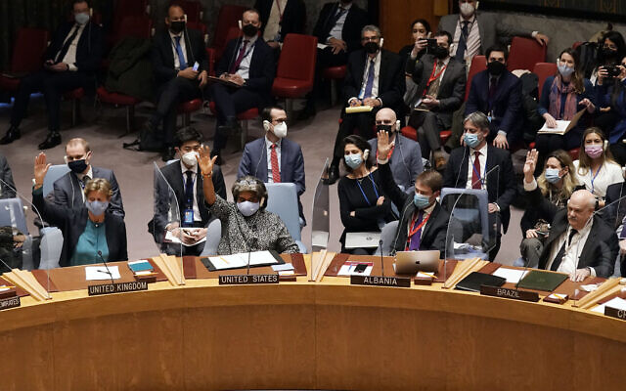
Security Council members, from left, Britain's Ambassador to the UN Barbara Woodward; US Ambassador to the UN Linda Thomas-Greenfield; Albania's UN Ambassador Ferit; Hoxha; and Brazil's Ambassador to the UN Ronaldo Costa Filho, vote in the the United Nations Security Council, Friday, Feb. 25, 2022. (AP Photo/Seth Wenig)
UNITED NATIONS — Russia, as expected, vetoed a UN Security Council resolution on Friday that deplored “in the strongest terms” the country’s “aggression” against Ukraine and demanded the immediate withdrawal of its troops.
Eleven of the council’s 15 members voted for the motion, which was co-written by the United States and Albania. China, India and the UAE abstained.
The resolution was always doomed to fail because of Moscow’s veto power as a permanent member of the council.
However, the debate offered member nations an opportunity to voice condemnation of President Vladimir Putin’s decision to launch a full-scale offensive against Russia’s neighbor.
“Let me make one thing clear,” US Ambassador to the UN Linda Thomas-Greenfield said after the vote. “Russia, you can veto this resolution, but you cannot veto our voices, you cannot veto the truth, you cannot veto our principles, you cannot veto the Ukrainian people.” MORE - https://www.timesofisrael.com/russia-vetoes-un-security-council-resolution-demanding-it-withdraw-from-ukriane/ [This is almost funny. What did these people expect? The system as established from the onset is actually a failure at preventing a war. Since the inception of the UN in 1945 we have had the Korean conflict (they didn’t want to call it a war) The Viet Nam conflict (same problem), Iraqi problem and the Afghanistan problem. This doesn’t include all the garbage that has gone on with Israel and the Arab nations. The UN is totally ineffectual. It is all blather intended to deceive people into thinking that something is done as they all progress down the path of one world governance. The fact that Thomas -Greenfield thinks their voices are so important is a joke. Pootie Poot doesn’t give a flip about their voices. Never has and never will. They are simply dimwitted actors on a stage. – rdb]

Zelenzky warns Russia plans to storm Kyiv tonight and ‘crush our defenses’
‘This night will be more difficult than the day,’ Ukraine president tells his people in a video adress after midnight, adding that several cities are under attack
By Dave Clark and Dmytro Gorshkov Saturday, 2:46 am
KYIV, Ukraine (AFP) — Ukraine’s President Volodymyr Zelensky warned early Saturday that Russian troops would attempt to take the capital Kyiv before dawn, as Western nations announced personal sanctions targeting Vladimir Putin.
Russian leader Putin unleashed a full-scale invasion on Thursday that has killed dozens of people, forced more than 50,000 to flee Ukraine in just 48 hours and sparked fears of a new Cold War in Europe.
After Ukrainian forces fought Russian troops advancing on the capital Friday, not long after midnight Zelensky warned the nation to stay on its guard. “This night will be more difficult than the day. Many cities of our state are under attack,” he said in a video address.
“Special attention on Kyiv –- we cannot lose the capital,” he added.
“I am turning to our defenders, male and female, on all fronts: this night the enemy will use all the forces it has to crush our defense in a treacherous, harsh and inhumane way,” he said. MORE - https://www.timesofisrael.com/zelenzky-warns-russia-plans-to-storm-kyiv-tonight-and-crush-our-defenses/

Ukrainian soldiers battle Russian troops in capital Kyiv as Moscow presses invasion
At the same time, the Kremlin says it is willing to meet with Ukrainian officials for talks aimed at resolving the burgeoning war
By Agencies Friday, 5:10 pm
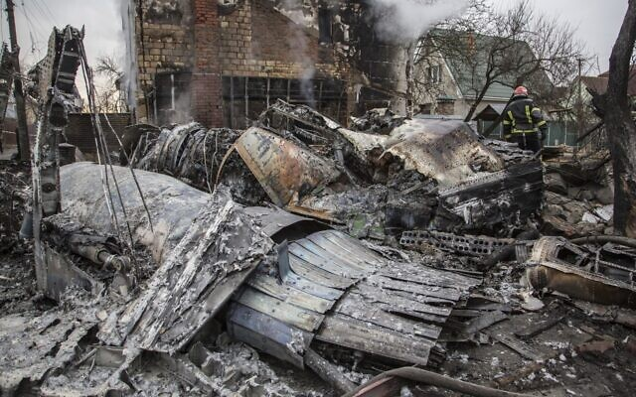  A Ukrainian firefighter walks between at fragments of a downed aircraft seen in in Kyiv, Ukraine, Friday, Feb. 25, 2022 (AP Photo/Oleksandr Ratushniak) | 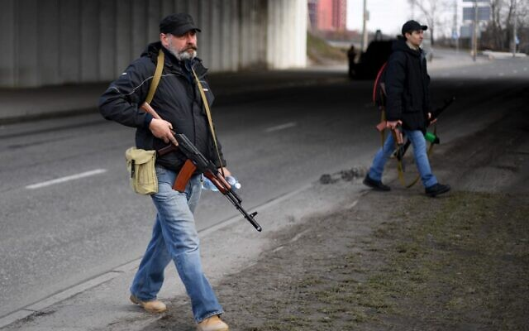  Volunteers, one holding an AK-47 rifle, protect a main road leading into Kyiv on February 25, 2022 (Daniel LEAL / AFP)
KYIV, Ukraine — Ukrainian forces fought off Russian troops in the streets of the capital Kyiv on Friday as President Volodymyr Zelensky accused Moscow of targeting civilians and called for more international sanctions.
Pre-dawn blasts in Kyiv set off a second day of violence after Russian President Vladimir Putin defied Western warnings to unleash a full-scale invasion on Thursday that quickly claimed dozens of lives and displaced at least 100,000 people.
The United States and its allies responded with a barrage of sanctions, but the Russian forces looked to press home their advantage after a string of key strategic victories in their air and ground assault.
Zelensky recalled Nazi Germany’s 1941 invasion and praised his people for “demonstrating heroism.”
In Kyiv, gunfire and explosions resonated ever closer to the government quarter.
Amid growing casualties from the deadly warfare — including shelling that sliced through the facade of a Kyiv apartment building, bridges and schools — the Kremlin said Russia was ready to talk with Ukrainian officials.
That came even as there were also increasing signs that Putin’s Russia may be seeking to overthrow Ukraine’s government, in his boldest effort yet to redraw the world map and revive Moscow’s Cold War-era influence.
The US and other global powers slapped ever-tougher sanctions on Russia as the invasion reverberated through the world’s economy and energy supplies, threatening to further squeeze ordinary households. UN officials said they were preparing for millions to flee Ukraine. Sporting authorities sought to punish Russia on global playing fields. And NATO leaders called an urgent meeting to discuss how far they can go to challenge Putin without engaging Russian forces in direct war.
Day two of Russia’s invasion focused on the Ukrainian capital, where Associated Press reporters heard explosions starting before dawn and gunfire was reported in several areas. Ukrainian authorities used armored vehicles and snowplows to defend Kyiv and limit movement, and said Russian spies were seeking to infiltrate the city.
Russia’s military said it had seized a strategic airport outside Kyiv that allows it to quickly build up forces to take the capital.
It claimed to have already cut the city off from the west — the direction many of those escaping the invasion are heading in, with lines of cars snaking toward the Polish border.
Intense fire broke out on a bridge across the Dneiper River dividing the eastern and western sides of Kyiv, with about 200 Ukrainian soldiers establishing defensive positions and taking shelter behind their armored vehicles and later under the bridge.
Ukrainian officials reported at least 137 deaths on the Ukrainian side and claimed hundreds on the Russian one. Russian authorities released no casualty figures, and it was not possible to verify the tolls.
UN officials reported 25 civilian deaths, mostly from shelling and airstrikes, and said that 100,000 people were believed to have left their homes and estimated up to 4 million could flee if the fighting escalates.
Ukrainian President Volodymyr Zelensky pleaded with Russia’s government to hold talks, and with Western powers to act faster to cut off Russia’s economy and provide Ukraine military help.
“When bombs fall on Kyiv, it happens in Europe, not just in Ukraine,” he said. “When missiles kill our people, they kill all Europeans.”
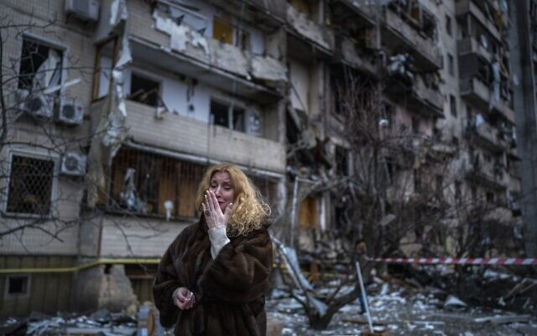  Natali Sevriukova reacts next to her house following a rocket attack on the city of Kyiv, Ukraine, Friday, Feb. 25, 2022. (AP Photo/Emilio Morenatti) | 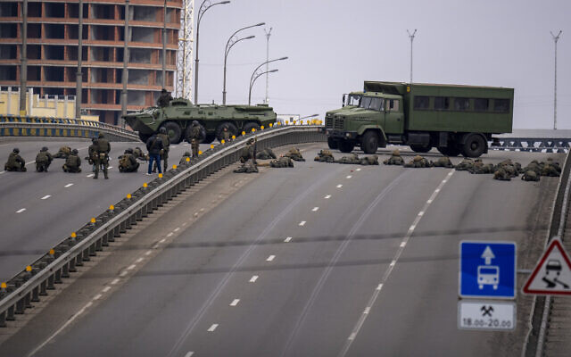  Ukrainian soldiers take position on a bridge inside the city of Kyiv, Ukraine, February 25, 2022. (AP Photo/Emilio Morenatti)
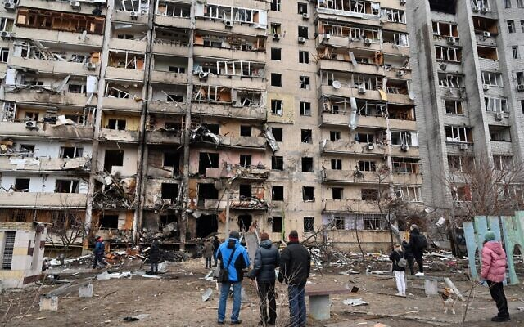  People look at a damaged residential building at Koshytsa Street, on the outskirts of the Ukrainian capital Kyiv, where a military shell allegedly hit, on February 25, 2022. (GENYA SAVILOV / AFP) | 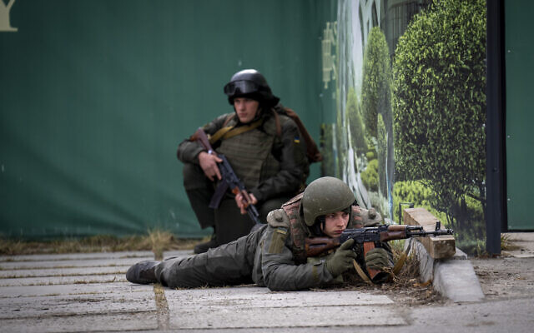  Ukrainian soldiers take positions in downtown Kyiv, Ukraine, February 25, 2022. (AP Photo/Emilio Morenatti)
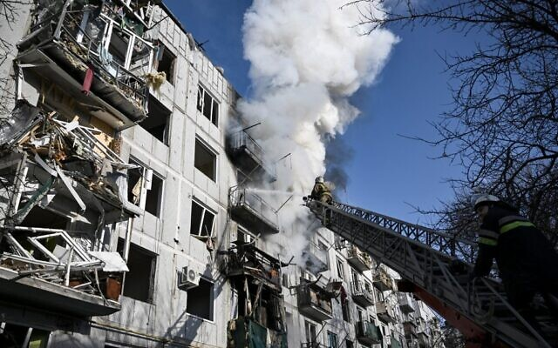
Zelensky’s whereabouts were kept secret after he told European leaders that he was No. 1 on Russia’s list of targets.
He also offered to negotiate on one of Putin’s key demands: that Ukraine declare itself neutral and abandon its ambition of joining NATO. And the Kremlin responded that Russia was ready to send a delegation to Belarus to discuss that.
After denying for weeks he planned to invade, Putin argued that the West left him no other choice by refusing to negotiate on Russia’s security demands.
The autocratic leader hasn’t said what his ultimate plans for Ukraine are. Lavrov gave a hint, saying Friday: “We want to allow the Ukrainian people to determine its own fate.” His spokesman Dmitry Peskov said that Russia recognizes Zelensky as Ukraine’s president, but wouldn’t say how long the Russian military operation could last.
Ukrainians, meanwhile, had to abruptly adjust to life under fire, after Russian forces started moving into their country from three sides in an invasion telegraphed for weeks, as they massed an estimated 150,000 troops nearby.
In a Kyiv apartment building, residents woke to screaming, smoke and flying dust. What the mayor identified as Russian shelling tore off part of the building and ignited a fire.
“What are you doing? What is this?” resident Yurii Zhyhanov asked — a question directed at Russian forces. Like countless other Ukrainians, he grabbed what belongings he could, took his mother, and set out to flee, car alarms wailing behind him.
Elsewhere in Kyiv, the body of a dead soldier lay on the ground near an underpass. Fragments of a downed aircraft smoked amid the brick homes of a residential area. Black plastic was draped over body parts found beside them. And people climbed out of bomb shelters, basements and subways to face another day of upheaval.
As air raids sirens sounded in the capital early Friday, guests of a hotel in the city center were directed to a makeshift basement shelter, lined with piles of mattresses and bottles of water.
“We’re all scared and worried. We don’t know what to do then, what’s going to happen in a few days,” said one of the workers, Lucy Vashaka, 20.
Meanwhile, the mayor of the city in the rebel-controlled east said Ukrainian shelling hit a school building.
The Ukrainian military on Friday reported significant fighting near Ivankiv, about 60 kilometers (40 miles) northwest of Kyiv, as Russian forces apparently tried to advance on the capital from the north. Russian troops also entered the city of Sumy, near the border with Russia that sits on a highway leading to Kyiv from the east.
US Secretary of State Antony Blinken said Kyiv “could well be under siege” in what US officials believe is a brazen attempt by Putin to install his own regime. [Look at this sentence carefully - Kyiv “could well be under siege”. Does Blinken not understand what has been reported in the past 24 hours? It IS not could be under siege and most likely will fall to the Russian forces. – rdb]
With social media amplifying a torrent of military claims and counter-claims, it was difficult to determine exactly what was happening on the ground.
The assault, anticipated for weeks by the US and Western allies, amounts to the largest ground war in Europe since World War II. After repeatedly denying plans to invade, the autocratic Putin launched his attack on the country, which has increasingly tilted toward the democratic West and away from Moscow’s sway.
Zelensky, whose grasp on power was increasingly tenuous, appealed to global leaders for even more severe sanctions than the ones imposed by Western allies and for defense assistance.

Firefighters work on a fire on a building after bombings on the eastern Ukraine town of Chuguiv on February 24, 2022 (Aris Messinis / AFP)
“If you don’t help us now, if you fail to offer a powerful assistance to Ukraine, tomorrow the war will knock on your door,” said the leader, who cut diplomatic ties with Moscow, declared martial law and ordered a full military mobilization that would last 90 days.
The invasion began early Thursday with a series of missile strikes on cities and military bases, and then quickly followed with a multi-pronged ground assault that rolled troops in from several areas in the east; from the southern region of Crimea, which Russia annexed in 2014; and from Belarus to the north.
After Ukrainian officials said they lost control of the decommissioned Chernobyl nuclear power plant, scene of the world’s worst nuclear disaster, Russia said Friday it was working with the Ukrainians to secure the plant. There was no corroboration of such cooperation from the Ukrainian side.
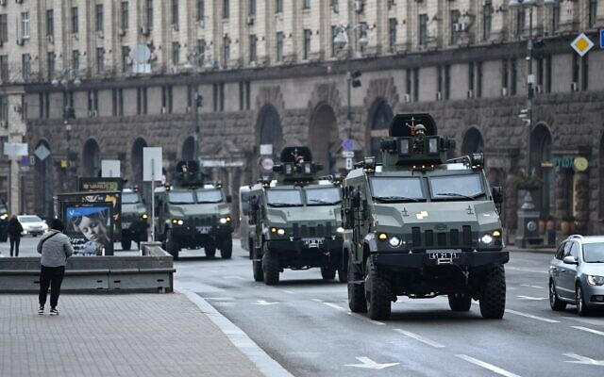
Ukrainian military vehicles move past Independence square in central Kyiv on February 24, 2022. (Daniel LEAL / AFP)
As Western leaders rushed to condemn and punish Russia, US President Joe Biden announced new sanctions that will target Russian banks, oligarchs, state-controlled companies and high-tech sectors, saying Putin “chose this war” and had exhibited a “sinister” view of the world in which nations take what they want by force. He added that the measures were designed not to disrupt global energy markets. Russian oil and natural gas exports are vital energy sources for Europe.
British Prime Minister Boris Johnson announced sanctions, freezing the assets of all large Russian banks and planning to bar Russian companies and the Kremlin from raising money on British markets.
“Now we see him for what he is — a bloodstained aggressor who believes in imperial conquest,” Johnson said of Putin. https://www.timesofisrael.com/ukrainian-soldiers-battle-russian-troops-in-capital-kyiv-as-moscow-presses-invasion/ [Do Biden and Johnson and many of those NATO leaders really think that Pootie Poot gives a flip what they think of him? Those dudes are feckless ninnies and Putin is a focused driven person with an objective. An objective which includes re-unifying the USSR and establishing a world power. – rdb]

PM talks with Ukraine’s Zelensky, again refrains from condemning Russia in statement
Bennett offers humanitarian aid as Russian army reaches capital Kyiv; Ukrainian president reportedly initiated call
By Lazar Berman and Judah Ari Gross Today, 3:51 pm
Israeli Prime Minister Naftali Bennett poses for a picture at the Prime Minister's office in Jerusalem, January 26, 2022; Ukrainian President Volodymyr Zelensky addresses the nation in Kyiv, Ukraine, February 24, 2022. (Olivier Fitoussi/Flash90; Ukrainian Presidential Press Office via AP)
Prime Minister Naftali Bennett spoke with Ukraine’s President Volodymyr Zelensky on Friday, offering to send humanitarian assistance to the embattled nation as Russian forces reached Kyiv.
The two discussed the fighting in Ukraine, especially around the capital, according to the Prime Minister’s Office.
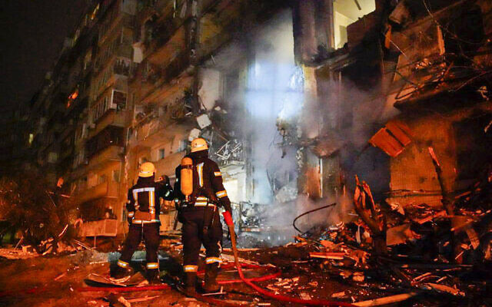
Bennett offered humanitarian aid to the country and laid out to Zelensky what Israel has provided thus far.
He told Zelensky that he hopes the war will end soon, and sent a message of support to the Ukrainian people, according to a statement from the Prime Minister’s Office.
In this handout photo taken from video published by the Ukrainian Police Department Press Service on February 25, 2022, firefighters inspect the damage at a building following a rocket attack on the city of Kyiv, Ukraine (Ukrainian Police Department Press Service via AP)
Consistent with Bennett’s address on Thursday, the statement from his office did not include any condemnation of Russian actions, nor did it mention Russia by name. [HUMMM? How do you discuss a war with a countries leader without mentioning the name of the opposition? A bit unusual. – rdb]
According to the Kan public broadcaster, the call was initiated by Zelensky. There was no immediate comment from the Ukrainian leader on the call.
Israel has so far been careful in its comments on the conflict. This is believed to be at least partly due to its need to work with the Russian military presence in neighboring Syria.
Sources in both the Foreign Ministry and in the Prime Minister’s Office told The Times of Israel on Thursday that Bennett was coordinating his statements fully with Foreign Minister Yair Lapid, who clearly condemned Russia’s invasion in a statement on Thursday.
Separately, Israel will send NIS 10 million ($3.07 million) in aid to Ukraine’s Jewish community immediately, the Diaspora Affairs Ministry said on Friday.
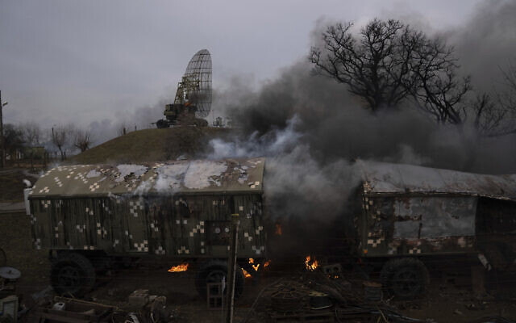
“This decision comes from the unique mandate of the State of Israel, and in particular, its Diaspora Ministry, as the nation-state of the Jewish people, to support Jewish individuals and communities in harm’s way,” the ministry said in a statement.
“It’s become quite clear at this stage that both immediate and ongoing support are needed.”

Smoke rises from an air defense base in the aftermath of an apparent Russian strike in Mariupol, Ukraine, Thursday, Feb. 24, 2022. (AP Photo/Evgeniy Maloletka)
The ministry said the aid would come in four main forms: food and medicine; funding for security guards around Jewish centers to protect them from rioting and looting; helping refugees in widescale evacuations; and transporting people to safer areas.
Ukraine said Russian forces approached Kyiv from the north and from the east on Friday. Putin launched the wide-scale attack on Ukraine in the early hours of Thursday. https://www.timesofisrael.com/pm-talks-with-ukraines-zelensky-again-refrains-from-condemning-russia-in-statement/

Israel pledges NIS 10 million in aid to Ukrainian Jews amid Russian onslaught
Diaspora Ministry says funds to go toward protecting Jewish institutions, helping refugees as situation in Ukraine deteriorates
By Judah Ari Gross Today, 2:57 pm
Israel allocated NIS 10 million ($3.07 million) in aid to Ukraine’s Jewish community on Friday as Russia’s military offensive against the country intensified, the Diaspora Affairs Ministry said.
“This decision comes from the unique mandate of the State of Israel, and in particular, its Diaspora Ministry, as the nation-state of the Jewish people, to support Jewish individuals and communities in harm’s way,” the ministry said in a statement.
Following months of tensions, Russia launched its invasion of Ukraine in the early hours of Thursday morning, striking military and civilian sites throughout the country.
More than 130 Ukrainians — soldiers and civilians — were killed on the first day of fighting, Ukrainian President Volodymyr Zelensky said Friday, as were an estimated 450 Russian soldiers, according to the British defense ministry.
Fighting continued on Friday as Russia reached the Ukrainian capital of Kyiv, which was hit by intense barrages of Russian rocket fire. Residents of the city, who were unable to flee, sought shelter in underground subway stations and basements.
“In recent weeks, [Diaspora Affairs Minister Nachman] Shai and his team have been in ongoing contact with Jewish community leaders and partners in Israel and on the ground to monitor the evolving situation and evaluate needs. It’s become quite clear at this stage that both immediate and ongoing support are needed,” the ministry said.
Shai first announced plans to send aid to the Ukrainian Jewish community on Thursday, but it was initially believed that it would take several days before the matter could be brought before the government for final approval.
However, as it became clear that the situation in the country was deteriorating rapidly, Shai gave the funding provisional approval, meaning various organizations working in Ukraine can begin spending that amount with the knowledge that the funding will eventually come, even though it will take at least several days for the NIS 10 million to be transferred to those groups, a ministry official said, speaking on condition of anonymity.
Due to the sensitive nature of this aid, the ministry would not reveal which organizations it was working through.
The ministry said the aid will come in four main forms: food and medicine; funding for security guards around Jewish centers to protect them from rioting and looting; helping refugees in widescale evacuations; and transporting people to safer areas.
“We are following developments in the area with great concern. Our hearts are with the Jewish people of Ukraine. We will continue to closely monitor the needs and developments in the field, and respond accordingly,” Shai said.
Rabbi Jonathan Markovitch, who has a congregation in Kyiv, said his primary concern was indeed security for his synagogue, where dozens of people had come to take shelter in the basement.
A private security firm he had initially hired pulled out at the last minute and others dramatically raised their fees out of his price range, he said on Thursday. Markovitch said armed guards were primarily needed to protect the building in the case of rioting, as occurred during the unrest in Kyiv in 2014, but that he also feared that the synagogue could be targeted by antisemites. MORE - https://www.timesofisrael.com/israel-pledges-nis-10-million-in-aid-to-ukrainian-jews-amid-russian-onslaught/

Israel asked to be mediator in Ukraine-Russia conflict
"We always look to Israel as one of the most prominent possible intermediaries for Mr. Putin," Ukraine's Ambassador to Israel Yevgen Korniychuk said.
By TOVAH LAZAROFF Published: FEBRUARY 25, 2022 17:42 Updated: FEBRUARY 25, 2022 23:18

Ukraine's Ambassador to Israel Yevgen Korniychuk in Tel Aviv(photo credit: TOVAH LAZAROFF)
Ukraine wants Israel to use its tight ties with Moscow to help sway Russian President Vladimir Putin to halt the invasion of Ukraine which began on Thursday morning.
"We are more looking for the Israeli diplomatic effort, as an intermediary," Ukraine's Ambassador to Israel Yevgen Korniychuk said. "We always look to Israel as one of the most prominent possible intermediaries for Mr. Putin," he added.
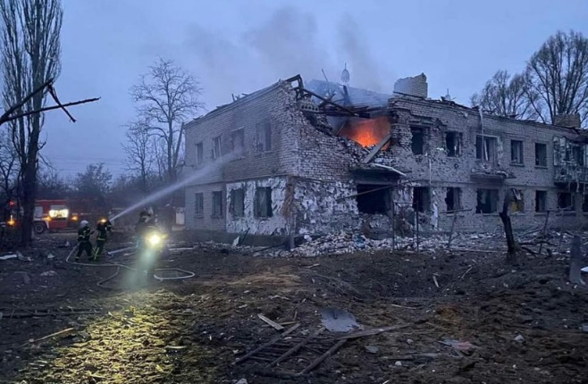
Korniychuk paused Friday from an intense round of behind-the-scenes diplomatic activity to speak with reporters, including The Jerusalem Post, from his small white stucco embassy in Tel Aviv, located just a few blocks from the beach.
He had been in touch with ambassadors from the European Union and was scheduled to converse with the United States Ambassador to Israel Tom Nides.
On Friday, Ukrainian president Volodymyr Zelensky spoke with Israeli Prime Minister Naftali Bennett. "We are knocking on every single door," Korniychuk said.
A view shows a destroyed building after shelling in the town of Starobilsk in the Luhansk region, Ukraine, in this handout picture released February 25, 2022. (credit: Press service of the Ukrainian State Emergency Service/Handout via REUTERS)
Korniychuk worried thoughts have been focused on the guns of war in his country, where his daughter, relatives and friends live. He and his staff members receive constant updates and photographs on their phones.
Israelis have been focused on the extent of their country's public support for Ukraine and the extent to which its leaders are willing to denounce Russia's military attack against Ukraine.
On Thursday Foreign Minister Yair Lapid condemned Russia, but Bennett spoke only of his support for the Ukrainian people in their hour of need.
"Lapid condemned it [Russia's attack]. We are glad to hear that," Korniychuk said. But what is more critical is the extent of the behind-the-scenes diplomacy that Israel can accomplish on behalf of Ukraine, he explained.
"That is what we value most from Israel. This is something that we believe Israel is good on," Korniychuk said.
"You [Israel] are a unique country. You are the only democracy that has great relations with both, with the Russian leadership and the Ukrainian leadership,
In the past, former prime minister Benjamin Netanyahu spoke with Russia on behalf of Ukraine, Korniychuk said, adding that Bennett had done so as well when he met with Putin in Sochi last October.
The desire to halt the hostilities is not a sign of weakness but a sign of respect for the value of human life, Korniychuk said.
"Whatever we can do to stop the bloodshed we must do," Korniychuk said. Ukraine wants "Putin to stop, to sit over the table and to speak instead of killing our people," he added.
"When military operations start that means that diplomacy is weak," he explained.
"It is always good if diplomacy will win over the military aggression," he said, adding that "there is always a compromise that can be reached."
If not, he said, "then we will fight, that is all we can do."
Korniychuk said he was grateful that Israel had offered to end humanitarian assistance, particularly medical aid and field hospitals.
In his conversation with Zelensky, Bennett spoke about the scope of humanitarian aid. According to the Prime Minister's Office, Bennett "reiterated his hope for a speedy end to the fighting and said that he stands by the people of Ukraine in these difficult days." https://www.jpost.com/israel-news/article-698659

Germany says EU will ‘severely’ sanction Putin and Russian FM Lavrov
Meanwhile, UK and North European allies say strong sanctions needed on ‘Putin’s inner circle’
By AFP Today, 5:26 pm
German Foreign Minister Annalena Baerbock on Friday said new sanctions against Russia would personally punish President Vladimir Putin and Foreign Minister Sergey Lavrov for their responsibility in the invasion of Ukraine.
“They are responsible for the death of innocent people in Ukraine. They are responsible that the international system is trampled and we as Europeans do not accept that,” Baerbock said as she arrived for talks in Brussels.
Meanwhile, British Prime Minister Boris Johnson’s office said the UK and nine other northern European defense allies agreed in a call that further sanctions were needed on Russia after its invasion of Ukraine.
The UK leader told the so-called Joint Expeditionary Force (JEF) bloc — which includes Baltic and Scandinavian states — that the crisis “was a defining moment in European history.”
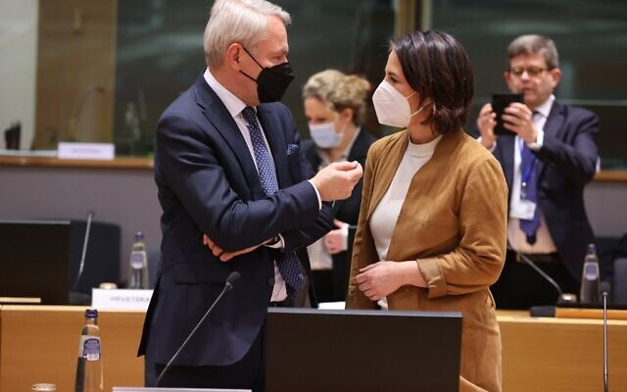
“The leaders agreed that more sanctions were needed, including focusing on [Russian] President [Vladimir] Putin’s inner circle, building on the measures that had already been agreed,” his Downing Street office said following the call.
Johnson told representatives from the nine JEF members that “the western world must keep the flame of freedom burning in Ukraine as Russian forces inflict horror on an innocent country and its people,” it added.

German Foreign Minister Annalena Baerbock (R) talks with Finland’s Foreign Minister Pekka Haavisto before an extraordinary Foreign Affairs Council meeting on Ukraine at the EU headquarters in Brussels on February 25, 2022 (François WALSCHAERTS / AFP)
He also said that “more support must be given to Ukraine, as a matter of the greatest urgency” and that Putin’s actions “could never be normalized, or his aggression against Ukraine ever accepted as a fait accompli.”
The JEF, set up in 2012, is made up of NATO members Denmark, Estonia, Iceland, Latvia, Lithuania, the Netherlands, Norway and the United Kingdom, and non-members Finland and Sweden.
It is focused on security in the “High North” region around the Arctic, the North Atlantic and the Baltic Sea area.
At a meeting of its defense ministers on Tuesday, they announced upcoming maneuvres in the Baltic Sea to demonstrate “freedom of movement” in the strategic zone.
The warnings about targeted sanctions on Kremlin leaders came as the EU agreed to freeze European assets linked to Putin and his Foreign Minister Sergei Lavrov, officials and a European diplomat told AFP.
It also followed the bloc, Britain, and the United States unveiling a range of sanctions on Thursday, further targeting the banking sector and Russian oligarchs.
Earlier Friday, Johnson pledged “further UK support to Ukraine” in a phone call with President Volodymyr Zelensky, as Russian forces closed in on the capital, Kyiv.
“President Zelensky updated the prime minister on the most recent Russian military advances… including the terrible developments in Kyiv,” Downing Street said in a statement.
Britain has said is ready to provide Ukraine with additional military support, including lethal defensive weapons but Defense Secretary Ben Wallace ruled out sending troops.
He told BBC television Britain would “hold the line in NATO,” adding: “I’m not putting British troops directly to fight Russian troops.
“That would trigger a European war because we are a NATO country, and Russia would therefore be attacking NATO.” MORE - https://www.timesofisrael.com/germany-says-eu-will-severely-sanction-putin-and-russian-fm-lavrov/ [This entire situation presents a host of problems. Ukraine is not a member of NATO and has an “association agreement” with the EU but is not actually a member. Ukraine is the second largest country of Europe (second only to Russia) and has a population of 43Million making it the 8th largest population in Europe. Since it is not in NATO or the EU officially that makes the requirement for actual military defense against ‘invaders’ a bit difficult. However, because of its size and location the EU and others could well be in jeopardy huge problems from Russia if they let the country fall. If Putin is insistent on the re-establishment of the USSR, letting Ukraine fall would open the door to Russia for incorporation of multiple states being consumed. This could very likely initiate a WWIII– rdb]

Meeting Greek leaders in Athens, Herzog stops short of criticizing Russia on Ukraine
President calls on ‘relevant sides to solve conflict’ after Moscow’s invasion; trip comes ahead of visit to Ankara next month aimed at bringing ties out of deep freeze
By Tal Schneider Today, 9:01 am

President Isaac Herzog meets in Athens with Greek President Katerina Sakellaropoulou, on February 24, 2022. (Kobi Gideon/GPO)
ATHENS — President Isaac Herzog declined to condemn Russia directly for its invasion of Ukraine during a state visit to Greece on Thursday.
Meeting Greek President Katerina Sakellaropoulou, Herzog said he was praying for a peaceful resolution to the conflict. [If he were to look at today’s news would he think there was a “peaceful situation” ? – rdb]
“This morning I feel great sadness, fearing humanitarian tragedy and God forbid harm to innocent civilians,” Herzog said, “and I pray like many around the world that peace will return in this conflict between Russia and Ukraine.”
Herzog reiterated Israel’s support for “the territorial integrity of Ukraine,” and called for Israeli citizens to “return immediately to Israel right now through land crossings.”
He also vowed to “care for the fate of the Jewish community in Ukraine,” and to offer “all possible humanitarian cooperation” to the government of Ukraine.”
“We call on the relevant sides to solve the conflict,” he added, during a separate meeting with Greek Prime Minister Kyriakos Mitsotaki.
President Isaac Herzog (left) meets with Greek Prime Minister Kyriakos Mitsotakis in Athens, on February 24, 2022. (Tal Schneider)
The lightning trip is expected to be overshadowed by his upcoming visit to Greece’s regional rival Turkey. The one-day jaunt to the Greek capital came a week before Herzog is slated to visit Cyprus, another Turkish rival, amid a potential sea change in regional alliances percolating through the eastern Mediterranean.
Herzog’s upcoming visit to Turkey, set to take place in the next few weeks though no finalized date has been announced, dominated talks in Athens, along with the nascent Eastern Mediterranean energy partnership.
Israel, Greece, and Cyprus have experienced a burgeoning friendship in recent years, partnering on energy and holding joint military drills, but a relaunch of Israel-Turkey bilateral relations could complicate the alliance.
Once allies, ties between Jerusalem and Ankara were largely frozen over the last decade; the last high-level Israeli visit to Turkey was a 2016 trip by then-energy minister Yuval Steinitz. Herzog’s trip to Turkey, which follows phone calls between leaders in both capitals and lower-level diplomatic contacts, is seen as a careful first step in restoring full diplomatic ties between the erstwhile allies.
But Greece and Cyprus remain bitterly opposed to Turkey and tensions remain over maritime boundaries and mineral exploitation rights in the Aegean Sea and the Eastern Mediterranean have recently renewed. A Turkish oil and gas survey in 2020 resulted in a tense naval standoff between the countries and hostilities renewed Wednesday when the Greek coast guard fired warning shots at a Turkish fishing vessel it said had tried to ram the patrol boat near the island of Chios in the eastern Aegean Sea.
Israel’s alliance with Greece and Cyprus had been buoyed by a $7 billion project to build a 1,900-kilometer (1,180-mile) pipeline that would carry natural gas from offshore rigs in the Mediterranean to Europe. The project had been backed by the US and vociferously opposed by Turkey, which claims some of the Turkish and Cypriot gas fields as its own. However, last month, Washington reversed its support, citing a commitment to cleaner types of energy.
Reports indicated that the US was also opposed to the plan due to the exclusion of Turkey, which it saw as contributing to regional instability. Turkish President Recep Tayyip Erdogan has in recent weeks openly broached the possibility of cooperating with Israel to transport gas to Europe.
In a statement ahead of the trip, Herzog said that “Israel, Greece and Cyprus are partners in an alliance of stability in the Mediterranean.”
“These state visits are expressions of the profound friendship between our peoples and of our strategic partnership,” Herzog said.
The president told a conference on Wednesday that climate change would be a focus of his visits, confirming his Turkey trip publicly for the first time. The climate change mantra goes on and on and is sheer foolishness. - rdb
“Over the next month I am going to visit our neighbors along the Mediterranean littoral — Greece, Cyprus and Turkey — and to meet their leaders,” he said. “In addition to them, I remain in close and warm contact with the leadership of Egypt, Jordan, the United Arab Emirates and the Palestinian Authority. I intend to get them all on board for a regional partnership confronting the climate crisis.” https://www.timesofisrael.com/meeting-greek-leaders-in-athens-herzog-stops-short-of-criticizing-russia-on-ukraine/

The coalition’s mini-crisis amid the Russian-Ukrainian crisis
POLITICAL AFFAIRS: The way the prime minister and defense minister got along once they shifted gears to security and diplomacy was proof that this dispute wouldn't end the government.
By GIL HOFFMAN
Published: FEBRUARY 24, 2022 20:16
Defense Minister Benny Gantz left a meeting of his Blue and White Knesset faction on Monday and walked determinedly two doors down to the office of Prime Minister Naftali Bennett, raising speculation that a solution could soon finally be found to end the dispute over the faction’s stalled legislation.
But then Gantz’s trusted chief of staff, Maayan Israeli, who handles political issues for him, left the room and announced that the meeting was not about the political battle in the Knesset but about the much more serious war that was about to start in Ukraine. Israeli ascended to the Knesset cafeteria to meet rebellious Yamina MK Abir Kara, while Gantz and Bennett went straight to work on Ukraine.
The political reporters in the hallway between the two offices left disappointed that the international arena had once again trumped resolving internal squabbles with much less serious ramifications. But the way the prime minister and defense minister got along so well once they shifted gears to security and diplomacy was proof that this would not be the political dispute that brings this government down.
“When they talk about Ukraine, suddenly they agree on everything and act completely professionally,” a source close to the prime minister said of Bennett and Gantz.
IF THEY could do the same when it comes to politics, their government would be able to accomplish much more. For three weeks, the Knesset has been nearly paralyzed, as one crisis has followed another.
Gantz has been frustrated for months that his party’s bills are not moving forward. Most of them are uncontroversial, like shifting the Innovation Authority to the Science and Technology Ministry, which is led by Blue and White minister Orit Farkash-Hacohen. Those in the coalition who wanted to make Gantz look bad highlighted instead a bill that would significantly raise pensions for senior IDF officers.
Aides to Bennett and Alternate Prime Minister Yair Lapid collaborated on distributing a fiercely worded statement Lapid’s office wrote mocking Gantz for caring more about pensions for his cronies than security. The statement led to speculation that Bennett and Lapid were conspiring to bring the tallest member of the cabinet down to size, and Gantz stepped right into their trap by boycotting Knesset votes over the pension bill.
Sources close to Bennett denied on Thursday that his targeting of the defense minister was planned well in advance.
“We didn’t want to make a balagan [mess],” an aide to Bennett said. “But when Gantz announced the boycott, we had to do something. We only sent out the message when it was clear that he would not agree to compromises. We wouldn’t have released it otherwise. We don’t want to fight for the sake of fighting, but boycotts are unacceptable, because they set a precedent and would lead to more boycotts from other parties.”
A meeting of Bennett with party heads in Tel Aviv Thursday night, where an effort was going to be made to solve the dispute, was postponed to Sunday, due to the outbreak of the war in Ukraine. Bennett’s aides admitted that it was frustrating for the prime minister to deal with political minutiae during a war, but they said he understood the importance of taking care of the problem before the Knesset reconvenes on Monday.
“He doesn’t want this to snowball,” a Bennett aide said. “He will fix it. He knows it’s critical for him to get involved, and he will resolve it.”
Gantz’s associates suggested that the escalation in the political battle was just as unnecessary and avoidable as the dispute in Ukraine. They said that had Bennett and Lapid met Gantz halfway on the uncontroversial issues Blue and White is advancing, he would not have been able to come out so hard on pensions.
They said Gantz had no choice but to burn bridges, after bringing up his party’s issues a dozen times with no progress. Even mild-mannered Culture and Sport Minister Chili Tropper told Gantz the time had come to go for the jugular.
“Benny sacrificed his own image to return discipline to the coalition and ensure that its decisions will be enforced and implemented,” a source close to Gantz said. “This will help everyone in the long run. When decisions are made, everyone must fall into line.”
But Gantz’s aides also sounded apologetic for the timing of the fight. They stressed that the defense minister and Blue and White leader spends 95% of his time on security and just 5% on petty politics. MUCH MORE - https://www.jpost.com/israel-news/politics-and-diplomacy/article-698577 [Incessant bitter infighting over priorities and political powers is the death knell for politics. – rdb]

After Ukraine, Russia warns Finland of 'military reprecussions' if it joins NATO
The Finnish prime minister said the debate within Finland on NATO membership "will change" following the start of a war in Ukraine.
By TAL SPUNGIN Published: FEBRUARY 25, 2022 19:56 Updated: FEBRUARY 25, 2022 22:02
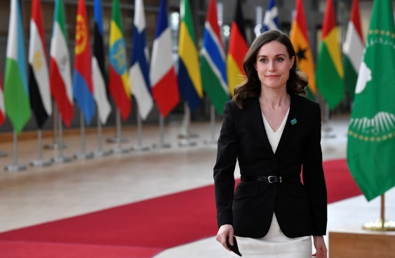
Finland's Prime Minister Sanna Marin(photo credit: VIA REUTERS)
Russia has warned neighboring Finland on Friday of "serious military and political" repercussions if the Scandanavian nation opts to join NATO following the invasion of Ukraine.
Russian foreign ministry spokesperson Maria Zakharova said during a weekly briefing that a Finnish addition to NATO could have "detrimental consequences."
Finnish prime minister Sanna Marin said on Thursday that the debate within Finland on NATO membership "will change" following the start of a war in Ukraine.
Both Marin and Finland's president Sauli Niinisto strongly condemned Russia's attack on Ukraine.
"Despite prior warnings, this morning has come as a shock for all of us and our deepest feelings are with Ukrainian people," Niinisto said.
Niinisto ruled out the possibility of Finland reacting to the events by immediately applying for NATO membership.
"(In Finland) we are now seeing quick comments for applying today and joining tomorrow. These sensitive reactions are understandable but cannot really work in the real world," he said. https://www.jpost.com/breaking-news/article-698665 [This is a very aggressive display by Russia. Finland has been independent since the time of the Russian revolution so there is a history of its association with Russia. This is most problematic and perhaps indicative of the ultimate goal of Russia dominating much of Europe. – rdb]

DHS seeks to divert officers from U.S. border crisis to Ukraine
Biden administration recruiting for 'Operation Ukraine Support'
By Art Moore Published February 25, 2022 at 10:27am
The Biden administration is seeking to divert Customs and Border Protection officers from the U.S. southern border crisis to Europe to help process U.S. citizens fleeing from the Russian invasion of Ukraine. [This is just about the straw that breaks the donkey’s back. Obviously, the Ukrainian border is more important than our border, even when there are terrorists over running the border every day. – rdb]
In a memo issued Thursday, the CBP asked for volunteers from among its ranks to deploy to Poland for "Operation Ukraine Support," Just the News reported.
"The Office of Field Operations is seeking volunteers to assist with the possible evacuation of U.S. citizens, lawful permanent residents, and their immediate family members from Ukraine," the memo said.
Addressing CBP field operations executives, the memo said eligible employees who volunteer "may be selected to serve a temporary duty assignment in Poland to facilitate travelers for entry into the U.S., to include providing guidance and problems resolution to other government agencies."
The volunteers must be ready to deploy "within 2-3 days" of selection for about one month's work in Europe.
"Once deployed employees are expected to perform all assigned duties and may be required to work irregular shifts and schedules, up to seven days per week including holidays and weekends," the memo noted.
The Biden administration, wrote Wall Street Journal columnist Jason Riley, "doesn't seem much interested in the havoc on our southern border, but the problem isn’t going away."
Over the past year, he said, amid "White House indifference," Americans have witnessed "record levels of illicit border crossings, overflowing detention centers and, more recently, video footage of illegal immigrants being ferried (in the dead of night) from the southern border to New York, Florida and other parts of the country."
Meanwhile, the New York Post reported more than 30 Americans were evacuated early Friday from the Ukrainian capital Kiev by a Florida-based nonprofit called Project Dynamo.
"The borders are jammed up right now, tons of vehicles are trying to get out of Ukraine," said James Judge, a spokesman for the group. "The roads are jammed. It may take all night, but we’re going to keep working to get people out."
Project Dynamo said that as of Friday, about 1,000 American citizens and lawful permanent residents have asked the group to help them leave Ukraine. [So the US has once again left US citizens in a very compromised situation in a foreign country – way to go Joe. You are an ineffectual doddery dolt. - rdb
"Those are our main focus and priority," Judge said.
The volunteer group was founded last August to help Americans flee Afghanistan.
Judge said the group began inserting team members in Ukraine in January to prepare for rescue operations after the Biden administration made clear the government would not help Americans evacuate.
The group's name is derived from the codename of the Dunkirk evacuation during World War II.
"This is what Dynamo does and does better than anyone else," Judge said in a statement Thursday. "They get Americans out of harm's way, and we have been watching it play out today in real-time. It is not without risk, however, and we are praying they will successfully make it safely out of the country in the next few hours." https://www.wnd.com/2022/02/dhs-seeks-divert-officers-u-s-border-crisis-ukraine/

Report: Thousands of Americans left behind in Ukraine
Vet who rescued those stranded in Kabul now on scene
By WND Staff Published February 24, 2022 at 5:25pm
An investigation by the Daily Mail from the United Kingdom has revealed that many Americans were fleeing Ukraine in buses to neighboring Romania as Vladimir Putin's military struck the nation on Thursday, but thousands still were left behind.
While the administration of Joe Biden has issued advisories for Americans to leave Ukraine in recent days the situation was reminiscent of his abrupt withdrawal of American troops from Afghanistan months ago, at a time when he left behind hundreds of Americas, thousands of U.S.-supporting nationals and some $80 billion in war machinery for the terrorists of the Taliban to have.
The Daily Mail's review explained a Project Dynamo was operating, set up by Bryan Stern, a 26-year military vet, to take Americans from Ukraine on buses on Romania.
The publication explained it spoke with individuals among 23 Americans leaving Kiev in several vehicles on Thursday.
Stern, who reportedly saved some 2,000 people trying to escape from Kabul last year, was helping American evacuees into several vehicles which were being driven to Romania while "missiles fell from the sky," the report said.
The U.S. State Department has been unable to provide a number of Americans left in Ukraine but estimates are as high as 30,000. Officials now are telling anyone still there to go by land to Poland, Romania, Hungary, Slovakia or Moldova.
"There are thousands of Americans and NATO ally-citizens that are left in Ukraine right now and it's about to be Soviet-occupied Russia," Stern, a former Navy Lt. Commander, told DailyMail.com.
He said there were 23 in two vehicles, including an American woman who arrived in Kiev for her father's funeral only days ago.

Stern said the individuals were still in Ukraine for a variety of reasons,.
"None of them thought this would happen. There is just total disbelief. Deep down, we thought 'he's not Saddam Hussein. He is not that bad.' But just like that, he achieved war criminal status," Stern said on Russia President Putin.
He explained that in some perspectives, evacuating Americans from Afghanistan wasn't has difficult since the Taliban at that time wasn't using air missiles and such.
The report explained, "Stern said he has not asked the group if they feel abandoned by Biden, but he sided with the U.S. military decision not to 'rush in to World War III.' 'I actually agree right now from the U.S. government perspective that at least for now, in these early days, that the military is not here.'"
He noted Biden went on television to say, "leave now, we will not come and get you."
"As much as that pains me to hear, I appreciate the honesty of those statements. I haven't asked them [if they've felt abandoned] ... but I can tell you at least two people have cried in my arms," he told the publication.
He said he expects "the mess and chaos of Kabul times 100."
His organization has a website presence, at www.projectdynamo.org.
Flights all were canceled in the region as the airports were shut down by the missile attacks.
The scenario in Kabul was slightly different, as American troops had been on the ground, but abruptly were pulled out on Biden's orders. [The people were told to get out and they need to learn to heed warnings when it looks like a bad situation is about to occur. – rdb]
That left at risk the hundreds of American citizens who were still there, the thousands of Afghanis who supported the U.S., as well as all that war machinery, including Black Hawk helicopters and Humvees.
Human Rights Watch then confirmed many former police and intelligence officers left behind in the pullout were being executed.
The Taliban had announced "amnesty" but the HRW's "'No Forgiveness for People Like You,' Executions and Enforced Disappearances in Afghanistan under the Taliban" report confirmed at least 100 dead at the time of that report.
"The Taliban leadership’s promised amnesty has not stopped local commanders from summarily executing or disappearing former Afghan security force members," explained Patricia Gossman, associate Asia director at Human Rights Watch. "The burden is on the Taliban to prevent further killings, hold those responsible to account, and compensate the victims’ families."
The Daily Caller News Foundation also revealed that a Taliban official was open about the terrorist group's plans to return harsh punishments to the country.
Mullah Nooruddin Turabi, who previously served as the Taliban’s justice minister and is now serving to enforce its extreme interpretation of Islam, told the Associated Press that the country will be ruled under strict Islamic law and return to executions and cutting off hands.
“Cutting off of hands is very necessary for security,” Turabi said.
At one point, a report contended "that the State Department believes as many as 14,000 United States legal permanent residents remain in Afghanistan." https://www.wnd.com/2022/02/report-thousands-americans-left-behind-ukraine/ [So very glad I am not Islamic or at least not living in an Islamic land YET. - rdb

Ukraine: Part of Biden's 'Great Collapse' before 'Great Reset'
Exclusive: Scott Lively blames Russia action on 'provocation by the Biden/Obama administration'
By Scott Lively Published February 24, 2022 at 7:17pm
For several months I have been predicting that the globalists will stage a "Great Collapse" this winter as a setup for the "Great Reset." I am writing this article in the very early hours of Feb. 24 as live-fire military conflict begins in Ukraine. The corporate media are spinning this conflict as unprovoked Russian aggression, but it's really a logical Russian reaction to deliberate un-ignorable provocation by the Biden/Obama administration. Biden has created this crisis both to deflect attention from serious political trouble at home and to create a scapegoat for the "Great Collapse," which I believe is imminent.
The start of this mess was Joe Biden's sudden, arbitrary and unilateral push to fold Ukraine into NATO, essentially to put anti-Russian nukes on the Russian border. It was the political, geographical and diplomatic equivalent of the Cuban Missile Crisis in reverse, with Vladimir Putin in the role of JFK.
Ukraine didn't ask for this. The European powers did not ask for it – and in fact Germany is in very the last stages of approving their already built and much-desired Nord Stream 2 oil pipeline to double the flow of Russian oil and gas to Europe via Germany. Some even suggest that stopping this pipeline is the real goal of the Biden administration because U.S. influence in Europe would diminish as Russia's grew – but I think this is only one contributing factor in a much larger strategy. (Political realities have forced Germany to suspend the pipeline approval – for now – but I suspect it will open as scheduled in April after things have calmed down a bit.)
Setting up Russia to have essentially no choice but to respond militarily was exactly what Obama, Biden, Clinton and Soros did in 2014 with their coup to remove Ukraine's pro-Russian president and replace him with an Obama puppet. As I've said many times before, that coup – especially regarding the Crimean Peninsula and its centuries-long military importance to Russia – was the geopolitical equivalent of Russia taking Hawaii away from the U.S. We would never accept that. To protect his legitimate national interests Putin had no choice but to annex that territory, an action overwhelmingly ratified by the mostly ethnic and culturally Russian inhabitants of Crimea.
Smug and smarmy LGBT zealot Barack Obama (who had come to hate Putin with a deep burning passion for banning "gay" propaganda to children nationally in 2013) set up these events like a row of dominoes: planning from the very start to accuse Russia of military aggression. That military "aggression" was then used both to restart the Cold War and to justify U.S. military intervention in Ukraine as a pretext for plundering it. That kicked off a campaign of Mafia-style piracy – a "protection racket" on an national scale – which was, of course, headed by Joe Biden (the big guy) in the role of Tony Soprano with son Hunter serving as his in-country head Capo.
Also in consequence of the Obama coup, two other less strategic but strongly culturally aligned Ukrainian "oblasts" or "states" (Donetsk and Luhansk) declared independence, triggering an on-and-off civil war that continued to the present. When, this month, Biden rejected Russia's demand for a promise that Ukraine would NOT become a base for anti-Russian nukes, Putin's predictable decision was to formally recognize Donetsk and Luhansk as independent countries and to enter into mutual defense agreements. That, from the Russian perspective, justifies the current military incursion into these two states, including the offensive assault on Ukraine airports, weapons and military infrastructure.
Geographically, Donetsk borders Russia and has a stretch of coastline on the Sea of Azov (with access to the Black Sea) close to Crimea. Luhansk is immediately north of Donetsk and also borders Russia. The two states/countries now essentially form a friendly buffer zone for Russia between itself and U.S.-controlled Ukraine. The Putin strategy copies what the U.S. has done in the Baltics and other places, and is thus legally comparable to similar U.S. actions under international law. I predict the international community will eventually recognize these states as nations.
The world's attention is now riveted on Ukraine, as the Biden/Obama administration intended, and, even before the outbreak of hostilities, the U.S. media this week began blaming our domestic crises on the Ukraine/Russia conflict. The U.S. elites now have their distraction and their scapegoat in the form of a Russian Bear, which most Americans (even far too many conservatives who should know better) still think of in Cold War terms.
President Trump, who would never have gotten into this situation in the first place, will be the main beneficiary of this crisis IF the MAGA movement keeps its eye on the prize of retaking the country and doesn't get caught up in anti-Russian jingoism. We may see American deaths in Ukraine (where we have had Special Forces personnel all along), triggering a pre-set full-court media blitz to gin up patriotic furor amidst a call to "rally behind our president," with accusations of treason if we don't. (The antiwar movement will stay curiously silent at best, or join the war chorus at worst). We may see some sort of false flag event on our soil blamed on Russia – my best guess is a cyber attack on our energy grid in the northern states. I have argued that Obama staged the now-forgotten fake power shutdown in Vermont in 2017 as part of a plot to start a hot war with Russia during the Obama/Trump transition – so there is precedent for this.
Through all of this, never forget the blame belongs to Biden! MORE - https://www.wnd.com/2022/02/ukraine-part-bidens-great-collapse-great-reset/

8-Year-Old Boy Dies of MIS 7 Days After Pfizer Vaccine, VAERS Report Shows
VAERS data released Friday by the Centers for Disease Control and Prevention included a total of 1,134,984 reports of adverse events from all age groups following COVID vaccines, including 24,402 deaths and 196,203 serious injuries between Dec. 14, 2020, and Feb. 18, 2022.
By Megan Redshaw 02/25/22
The Centers for Disease Control and Prevention (CDC) today released new data showing a total of 1,134,984 reports of adverse events following COVID vaccines were submitted between Dec. 14, 2020, and Feb. 18, 2022, to the Vaccine Adverse Event Reporting System (VAERS). VAERS is the primary government-funded system for reporting adverse vaccine reactions in the U.S.
The data included a total of 24,402 reports of deaths — an increase of 412 over the previous week — and 196,203 reports of serious injuries, including deaths, during the same time period — up 4,286 compared with the previous week.
Excluding “foreign reports” to VAERS, 767,083 adverse events, including 11,104 deaths and 73,088 serious injuries, were reported in the U.S. between Dec. 14, 2020, and Feb. 18, 2022.
Foreign reports are reports foreign subsidiaries send to U.S. vaccine manufacturers. Under U.S. Food and Drug Administration (FDA) regulations, if a manufacturer is notified of a foreign case report that describes an event that is both serious and does not appear on the product’s labeling, the manufacturer is required to submit the report to VAERS.
Of the 11,104 U.S. deaths reported as of Feb. 18, 18% occurred within 24 hours of vaccination, 23% occurred within 48 hours of vaccination and 60% occurred in people who experienced an onset of symptoms within 48 hours of being vaccinated.
In the U.S., 549 million COVID vaccine doses had been administered as of Feb. 18, including 323 million doses of Pfizer, 207 million doses of Moderna and 18 million doses of Johnson & Johnson (J&J).
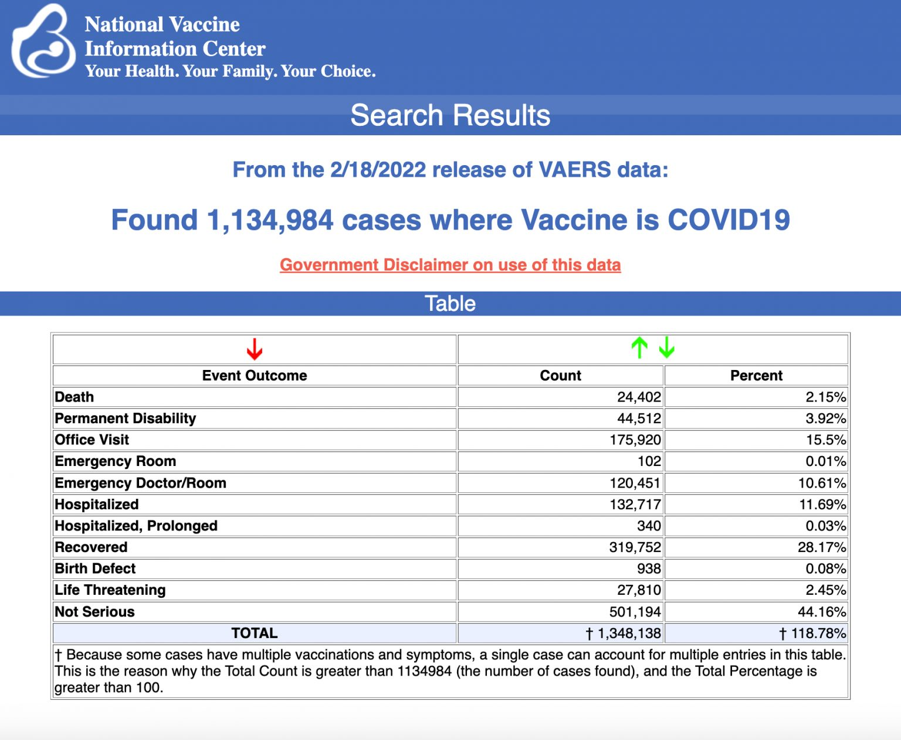
Every Friday, VAERS publishes vaccine injury reports received as of a specified date. Reports submitted to VAERS require further investigation before a causal relationship can be confirmed. Historically, VAERS has been shown to report only 1% of actual vaccine adverse events.
U.S. VAERS data from Dec. 14, 2020, to Feb. 18, 2022, for 5- to 11-year-olds show:
- 8,564 adverse events, including 188 rated as serious and 4 reported deaths.
The most recent death involves an 8-year-old boy (VAERS I.D. 2109625) from Mississippi who died 7 days after his second dose of Pfizer’s COVID vaccine when he was found blue and lifeless at home.
He was taken to the hospital with a full code in process. A pulse was detected several times, but the boy ultimately died in the ICU. It was reported to the doctor who filed the report that the boy died from multisystem inflammatory syndrome. He did not have COVID.
- 16 reports of myocarditis and pericarditis (heart inflammation).
- 30 reports of blood clotting disorders.
https://childrenshealthdefense.org/defender/vaers-cdc-8-year-old-boy-dies-pfizer-vaccine

Commentary:
Klaus Schwab’s Young Global Leaders (USA)
By Lex Greene|February 25th, 2022
If you don’t know who Klaus Schwab is, it’s high time you do.
Born Klaus Martin Schwab in Ravensburg Germany in 1938, Klaus Schwab is a highly educated and intelligent individual with a doctorate degree in mechanical engineering from the Swiss Federal Institute of Technology in Zurich, a doctorate in economics from the University of Fribourg, and a Master of Public Administration degree from the John F. Kennedy School of Government at Harvard University.
Klaus was born and remains a Citizen of Germany, after being denied application for Citizenship in Switzerland, despite living in Switzerland and having two Swiss parents. During the earlier years of his career, he served on a number of company boards, such as The Swatch Group, The Daily Mail Group, and Vontobel Holding. He is also a former member of the steering committee of the Bilderberg Group.
In 1971, Schwab founded the European Management Forum, which in 1987 became the World Economic Forum (WEF) — often referred to simply as “Davos“, the name of the town where the forum is hosted each year. First, he controlled the EU nations and now, he aims to control the world.
For 44-years, Schwab focused all of his resources and energy upon developing a plan for a new form of Global Economics and Governance, all based upon Marxist theories of a One World point of view wherein both shareholders (business investors, owners, operators) and corporate stakeholders (workers) are equal. Schwab could easily be considered the father of “sustainable development” concepts, to include not only his view towards Marxist economic world domination by a small global ruling class elite, other “sustainable development” con games like fake Climate Change, Social Engineering through education and mass media, and genetically modified foods.
He who controls everything, controls everyone!
Meeting with great resistance from sovereign nations and government throughout the world, Schwab developed a viable strategy for implementing his vision for how the entire world should be, again, based upon the economic principles of Karl Marx and Frederick Engle. He had to “win the hearts and minds of the people.” As Marx once said, “Democracy is the road to socialism.”
That’s why the USA was never meant to be a democracy, but rather a Republican form of government, as guaranteed in the U.S. Constitution.
Today, Schwab’s World Economic Forum (WEF) is a who’s who of the richest most powerful people all over the world. Members and Partners of his group have a few things in common…
They are all driven by a quest for personal wealth and power
Most of them are very wealthy and hold powerful positions
They all share a vision for world domination, on their terms
Everyone else is expendable in the search for “sustainable development”
Marxism is their political philosophy
A One World Order is their goal
The goal justifies all means of execution
They (WEF) have taken the front position on the plot for global governance worldwide, dwarfing the Rothschilds, the Bilderbergers, the Illuminati, Cecil Rhodes and all who came before them. They are not controlled by the United Nations or NATO, they control both, and much more. The WEF now has six global offices around the world, two of which are in the United States, New York, and San Francisco. The other four are in Switzerland, Beijing, Tokyo, and Mumbai.
In recent years, we have seen much written about UN Agenda 21. Although this plan is entirely aligned with Schwab’s vision for the world, it is not a plan hatched by the UN. It’s just one of many pieces of the Klaus Schwab global puzzle for how to lead (force) all sovereign nations into a global order under the WEF design for “sustainable development.”
As an example, what the world just witnessed in Canada, the gestapo-styled treatment of the most decent and peaceful political protesters in human history in Ottawa, where Prime Minister Justin Trudeau was clearly at war with his own citizens and unwilling to pay them any allegiance whatsoever…is the result of influence from the WEF.
PM Trudeau quite clearly, does NOT work for the people of Canada. But the following members of the Trudeau regime, do all work for Klaus Schwab and his WEF, and that is who Trudeau takes his orders from.
Justin Trudeau
Ailish Campbell
François-Philippe Champagne
Chrystia Freeland
Elissa Golberg
Karina Gould
Jagmeet Singh
Renée Maria Tremblay
Fifteen years ago in 2007, Schwab launched his new WEF global control brainchild, his Young Global Leaders Program. The above list of Canadian political figures are members of Klaus Schwab’s Global Leaders. They were placed in power by the WEF to bring Canada into the group of countries controlled by the WEF. Those were largely “global police” you just saw in Ottawa, robotic, without conscience or any remorse, soulless enforcers with no concern for Canadian Rights at all.
In the USA, Schwab has seated almost 300 of his “global leaders” in positions of power for the same purpose, to bring the United States under the control of the WEF. People whose names you would expect, and others you might not, such as Maria Bartiromo, Peter Buttigieg, Tulsi Gabbard, Garlin Gilchrist II, Joseph P. Kennedy III, Vanessa Kerry, and Mark Zuckerberg. (FULL LIST HERE)
But this is just the tip of the proverbial iceberg…
Hundreds, if not thousands of international corporations are also partners with Klaus Schwab and his maniacal vision of WEF world economic and political domination. Here are just a few you might know…
AIG
Amazon
AstraZeneca
Bain & Company
Bank of America
Barclays
Bill & Melinda Gates Foundation
BlackRock
Chevron
Cisco
Citi
Dow
Goldman Sachs
Google
Hewlett Packard Enterprise
HSBC
IBM
Intel
Johnson & Johnson
JPMorgan Chase & Co.
Mastercard
Meta
Microsoft
Moderna
Morgan Stanley
Nestlé
Open Society Foundations
PayPal
Pfizer
S&P Global
The Coca-Cola Company
UPS
Verizon Communications
Visa
Western Union
That’s only a small sampling… (FULL LIST HERE)
Every one of the companies on the list is cooperating with, funding, and participating in Klaus Schwab’s world domination via his “COVID19 GLOBAL RESET.” If YOU are doing business with any of these companies, then YOU TOO are funding this insane agenda for world economic and political domination.
Whether you are American, Canadian, European, African, Middle Eastern, or a citizen anywhere else in the world, this is who runs your country today, not any of the people you elected.
NOTE: Trump was the highly unwelcome exception. Not only is Trump not a WEF partner, he also categorically angered every member of the WEF when he spoke briefly at Davos. That’s why he had to go, no matter how much fraud was needed in the 2020 election. He did the same at a UN meeting.
However, these are NOT the most powerful people on earth. Most people just believe they are and that’s how they get away with everything they are doing. They also made sure that whole societies feel entirely helpless, powerless, and hopeless. That’s a very important element in “winning the hearts and minds” of the citizenry. Things are quite easy to predict once you make people think they don’t have a choice, such as, whether or not to wear a mask or take a lethal vaccine.
These are the most powerful people in any country…
Farmers – if they don’t grow, no one eats.
Truckers – if they don’t deliver, no one eats.
Workers – if they don’t work, nothing moves anywhere.
It’s a myth that politicians, lawyers, and global Marxists are the most powerful people, no matter how rich they may be. The richest corporate CEO, market player, politician and lawyer will go broke overnight, if the three above shut it all down.
Like all socialists, Klaus Schwab has decided that no one should be paid high wages or salaries, no one should own anything, and no one should be free to disagree. But he pays himself over a million a year in salary to run WEF and has an unlimited expense account like Biden and Harris with an even better golden parachute.
Does it shock you to see all four lethal vaccine-makers, Pfizer, Moderna, J&J and AstraZeneca partnered with Klaus and his WEF? Do you still wonder why these lethal injections are still being forced upon whole societies, even though they have never saved a single life and have murdered thousands already? Is it science you followed, or Schwab’s maniacal plot?
Schwab’s WEF is behind every evil we are dealing with today, and he has foot soldiers seeded in power all around the globe.
The GRAND PRIZE is the USA, for if the USA is no longer free, sovereign, or secure, no place on earth will be.
Should you stand and fight, or not?
What makes you think you even have a choice? https://newswithviews.com/klaus-schwabs-young-global-leaders-usa/
Chinese Censorship on American Soil
by Peter Schweizer February 25, 2022 at 5:00 am
Billionaire tech investor David Sacks recently summed up the present state of Communist Chinese intimidation of American business, sports leagues like the NBA, and anyone else with commercial interests in China. He sees it getting worse, not better.
Appearing on a podcast hosted by former Fox News anchor and NBC talk show host Megyn Kelly, Sacks was asked to address the backlash against his friend, Chamath Palihapitiya, for saying "no one cares" about repression and ethnic cleansing of the Uyghurs by China's communist regime. Sacks told Kelly he accepts his friend's later explanation that his words simply came out wrong. But Sacks's larger response to the question of Chinese intimidation really hit the nail on the head:
"The CCP is essentially depriving Americans of their free speech rights – not in China, but on American soil – as a condition of doing business over there."
Americans are now familiar with the sad spectacle of their own countrymen bowing to Chinese pressure publicly. We see it done by captains of industry, Wall Street's largest firms, the most elite universities, sports heroes, cultural figures, and politicians alike. It has become so common that it is news when someone instead resists the pressure from Chinese communist regime and suffers financially because of it.
The latest example of that is professional basketball player Enes Kanter Freedom, who was recently traded by the Boston Celtics to the Houston Rockets, which then promptly waived him. The Rockets have offered no reason for this move, but it is no secret that the team has a devoted following in and makes a lot of money from China. The Rockets were, you may remember, the team whose general manager, Daryl Morey, ran afoul of China's regime after he tweeted support for pro-democracy protesters in Hong Kong in 2019. His public statement angered Beijing, which banned sales of all Rockets merchandise and took NBA shows off the air until the team and the league came to heel. Morey stepped down from his job with the team a year later.
Sacks is deeply concerned about China's malevolent influence in the world. Not just the regime's persecution of the Uyghurs, but their theft of American intellectual property and cyber espionage, their belligerent relations with their neighbors and treatment of dissidents, the "social credit system" they impose on their people and, of course, their actions related to the COVID pandemic.
Still, he understands the pressures Americans are subjected to by the regime. "People's willingness to speak out about these issues tends to be related to how much business they have in China. I have no business in China, so I feel fairly unencumbered in saying what I just said. But there are a lot of people who do business in China who just won't speak out. Everyone understands that the quid pro quo of taking Chinese cash is that you never criticize them."
My latest book, Red Handed: How American Elites Get Rich Helping China Win, traces these themes across many areas of American life, and tracks with Sacks's observations. The best-selling book has received notice in the press for its revelation that Joe Biden's family made $31 million in deals with individuals connected directly to Chinese intelligence. That was in one chapter. Subsequent chapters investigate the actions and statements of powerful figures from Wall Street, Silicon Valley, and elite academia, among other targets. It is surprising how little attention those chapters have received in mainstream news outlets, apart from Fox News.
Highlighted are detailed actions and pro-Beijing statements of financial giants such as Larry Fink and Ray Dalio, who run BlackRock and Bridgewater Associates, respectively. An entire chapter catalogs similar kowtowing from Big Tech by Silicon Valley's wealthiest CEOs, including Mark Zuckerberg, Tim Cooke, and Bill Gates. From political dynasties in the US and Canada to philanthropists and Harvard professors, from sports stars to movie actors, the Chinese money talks so loudly it drowns out every other sound.
Alex Marlow of Breitbart News recently appeared on The Drill Down, and our topic quickly turned to how these same economic strings affect the largest media companies in this country as well. Marlow said he believes in "following the money," and he applied that lens to researching his own new book.
All of the large news outlets are part of corporations that owe large parts of their revenue streams to their business interests in China. "News conglomerates do not want to cover bad news about China. But it's not because of a grand conspiracy theory. It's simply because they make so much money," he said.
Indeed, it is hard to feel sorry for NBC's sports broadcasting business, which has seen viewership of its exclusive Beijing Olympics coverage plummet by 50 percent because of various boycotts and ill feelings against the Chinese Communist hosts, turncoat American athletes who are competing under the Chinese flag, and a visual spectacle that looks like something out of "The Hunger Games."
NBC, Marlow explained, is part of NBCUniversal, which is in turn owned by Comcast. Thus, they are not only the corporate sponsor of the "Genocide Games," but day to day make a lot of money in China from Universal Studios and its associated theme park there. ABC News is owned by Disney, which makes huge amounts of money in China through its theme parks and other entertainment businesses. CNN's parent is AT&T, which last year allegedly lobbied the US Commerce Department on behalf of China Telecom over a sanctions measure related to human rights violations by the Chinese.
Even smaller media outlets such as The Atlantic Monthly and Axios aren't immune, he notes in his book. Both are owned by Laurene Powell Jobs, Steve Jobs's widow, whose fortune came from Apple and Disney, two companies that owe a lot of their wealth to their business activities in China.
Michael Bloomberg, whose financial news empire has made him $50 billion, "has the most access [in China] of any major media conglomerate, and it's totally at the will of Beijing's propagandists," Marlow said. "Bloomberg News has to extend its contract every two years, so he goes over there to kiss the ring."
As Sacks noted, he has no business interests in China and can risk speaking out. NBC and others whose corporate paymasters owe massive percentages of their annual sales revenue to Chinese indulgences are not so free. What they can excuse for the sake of not offending their Chinese hosts and benefactors, they excuse or minimize. What they can ignore, they ignore.
How much longer will our large media outlets ignore the growing threat Chinese influence poses to their core principles of presenting the truth without fear or favor?
As Albert Camus, wrote, "The Welfare of the people... has always been the alibi of tyrants... giving the servants of tyranny a good conscience."
Peter Schweizer, President of the Governmental Accountability Institute, is a Gatestone Institute Distinguished Senior Fellow and author of the new book, Red Handed: How American Elites are Helping China Win. https://www.gatestoneinstitute.org/18268/chinese-censorship-american-soil

AND THEN……
Putin’s War Machine Was Made in Washington
By Cliff Kincaid|February 25th, 2022
The “experts” say Russia is a gas station with an army. Who made this army possible? The answer: politicians and corporate interests in Washington, D.C., and other Western capitals.
In our 2014 book, Back from the Dead: The Return of the Evil Empire, we quoted Michael Birnbaum, the Washington Post’s Moscow bureau chief, as noting that “after Russia’s brief war with neighboring Georgia in 2008, top leaders rethought their old habits. Although Russia ultimately prevailed in that conflict, its soldiers proved ill-equipped and disorganized, struggling with Soviet-era equipment that failed them on numerous occasions. So leaders turned to the West to boost their capabilities.” MORE - https://newswithviews.com/putins-war-machine-was-made-in-washington/
Inside the Mind of Vladimir Putin
Gina Loudon Posted: Feb 25, 2022 12:01
What’s going on in the mind of Vladimir Putin? Why did he choose this moment to invade?
The conditions are perfect right now for Putin and tyrants around the world to expand their power and territory.
Who among the Western leaders has the moral authority to demand that tyrants like Vladimir Putin resist their dictatorial urges?
For the past two plus years of the pandemic, Putin observed Western leaders repeatedly lying to their people. When they weren’t outright lying, they were hiding the data. MORE - https://townhall.com/columnists/ginaloudon/2022/02/25/inside-the-mind-of-vladimir-putin-n2603749
To Punish Russia, U.S. Must Unleash Energy Dominance Again
Gabriella Hoffman Posted: Feb 25, 2022 12:01 AM
The Russian assault on Ukraine confirmed vulnerabilities in safeguarding American energy security. With the U.S. now importing more oil and gas from the rogue nation, it’s time to pursue energy independence again.
Make no mistake: preservationist environmental policies are squarely to blame for our present situation of high gas prices and energy bills. If President Biden is serious about punishing Russia, he wouldn’t just impose harsher sanctions; he’d equally scale back his extreme climate agenda.
To punish Russia, our nation must unleash energy dominance again. Here’s how.
Revoke Executive Order 13990 MORE -
https://townhall.com/columnists/gabriellahoffman/2022/02/25/to-punish-russia-us-must-unleash-energy-dominance-again-n2603783
Of Course Vladimir Putin Invaded Ukraine Under Joe Biden's Watch
Josh Hammer Posted: Feb 25, 2022 12:01 AM
In February 2014, Russian kingpin Vladimir Putin invaded and subsequently annexed the Crimean Peninsula, which had been under Ukrainian jurisdiction. The timing was no accident, coming as it did only a handful of months after then-President Barack Obama reneged upon his own chemical weapons "red line" for Syrian dictator Bashar al-Assad, effectively leaving the resolution of the then-nascent chemical weapons crisis in Putin's hands. Putin, like a shark smelling blood, sensed weakness and acted accordingly. To this day, Crimea remains under de facto Russian control.
MORE - . https://townhall.com/columnists/joshhammer/2022/02/25/of-course-vladimir-putin-invaded-ukraine-under-joe-bidens-watch-n2603772
Biden's Putin Appeasement Has Been Years in the Making
David Harsanyi Posted: Feb 25, 2022 12:01 AM
One small thing to be thankful for is that DJT is not in the White House as the Ukraine crisis unfolds. He'd side with Russia," tweeted Francis Fukuyama, author of "The End of History and the Last Man." The headline on Eugene Robinson's Washington Post column reads, "With Biden standing firm, Putin must wonder: Where's Trump when I need him?" You could find similar sentiment from foreign-policy experts strewn across social media. MORE - . https://townhall.com/columnists/davidharsanyi/2022/02/25/bidens-putin-appeasement-has-been-years-in-the-making-n2603753
Ukraine's Fate Is Rooted in a Tragic History
Michael Barone Posted: Feb 25, 2022 12:01 AM
For those trying to keep up with the fast-moving events in Ukraine, it may be helpful to consider some lessons of history. Mistakes made in the past week, added onto developments covering the last two or three centuries, have left the United States and its European allies -- in particular the largest of them, Germany -- unable to prevent President Vladimir Putin's Russia from absorbing an as yet undetermined part of a theoretically independent Ukraine. MORE - . https://townhall.com/columnists/michaelbarone/2022/02/25/ukraines-fate-is-rooted-in-a-tragic-history-n2603763
Biden and Europe Should Respond to Russian Aggression by Scrapping Extremist Climate Policies
H. Sterling Burnett Posted: Feb 25, 2022 12:01 AM
Russia’s invasion of Ukraine was facilitated by alarmist policies enacted by the United States and Europe, meant to combat alleged runaway global warming.
Germany, for example, decided to abandon coal and nuclear energy in favor of supposed climate-friendly “renewable” energy sources. And in the United Kingdom, after briefly considering allowing fracking a few years back, the government has basically doubled down on wind and solar, erecting bans or nearly insurmountable hurdles to natural gas development on the U.K. mainland. MORE - https://townhall.com/columnists/hsterlingburnett/2022/02/25/biden-and-europe-should-respond-to-russian-aggression-by-scrapping-extremist-climate-policies-n2603780
THE SHORASHIM BIBLICAL GIFT CATALOG 005
http://mad.ly/7f9f64?pact=20013931524&fe=1
Support Shorashim!

ARUTZ SHEVA
US to sanction Putin and Lavrov
White House confirms US will sanction Russian President, Foreign Minister and other members of the Russian National Security team.
Elad Benari, Canada Published: 25.02.22 22:44 Updated: 25.02.22 23:30
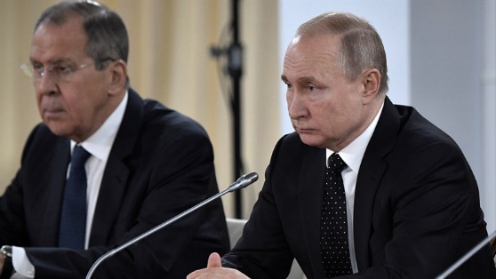
Vladimir Putin and Sergei Lavrov Sputnik/Alexei Nikolsky/Kremlin via REUTERS
White House press secretary Jen Psaki confirmed in a briefing on Friday that the US will join with European allies to impose sanctions on Russian President Vladimir Putin, Foreign Minister Sergei Lavrov, and other members of the Russian National Security team.
The sanctions against Putin and Lavrov would include a travel ban, she said.
Earlier, two people familiar with the decision told CNN that the US is planning to impose sanctions on Putin as soon as Friday.
The European Union announced earlier on Friday it would freeze the assets of Putin and Lavrov.
EU ministers said that even further sanctions were still possible, including booting Russia off SWIFT, the dominant system for global financial transactions.
“The debate about SWIFT is not off the table, it will continue,” Luxembourg Foreign Minister Jean Asselborn said.
British Prime Minister Boris Johnson followed the EU and also announced on Friday that the UK will be implementing sanctions against Putin and Lavrov effective immediately.
US President Joe Biden said on Thursday that sanctioning Putin had been an option under consideration, telling CNN's Kaitlan Collins it was "on the table."
Biden on Thursday announced sweeping sanctions targeting Russia, enacting penalties across industries, including asset freezes for the largest banks, debt and equity restrictions on critical mining, transportation and logistics firms and a large-scale effort to shut down access to critical technology for key Russian military and industrial sectors.
Psaki also warned in her remarks on Friday that “going after the head of state would be a significant, horrific act by Russian leadership,” as Moscow closes in on Kyiv where Ukrainian President Volodymyr Zelensky is holed up.
She added that Biden remains in contact with Zelensky, that the two had spoken earlier on Friday and that the Ukrainian President plans on remaining in the country.
Meanwhile, Russian Foreign Ministry spokeswoman Maria Zakharova blasted the imposition of sanctions against Putin and Lavrov, saying the move reflect the West's "absolute impotence" when it comes to foreign policy.
She added that relations with the West "have reached the line after which the point of no return begins".
Zakharova spoke before the US announced sanctions against the two men. https://www.israelnationalnews.com/news/322924

Security forces thwart weapons smuggling attempt in Jordan Valley
IDF, Israel Police, confiscate 12 Kalashnikov rifles, along with cartridges and ammunition.
Israel National News 25.02.22 13:31
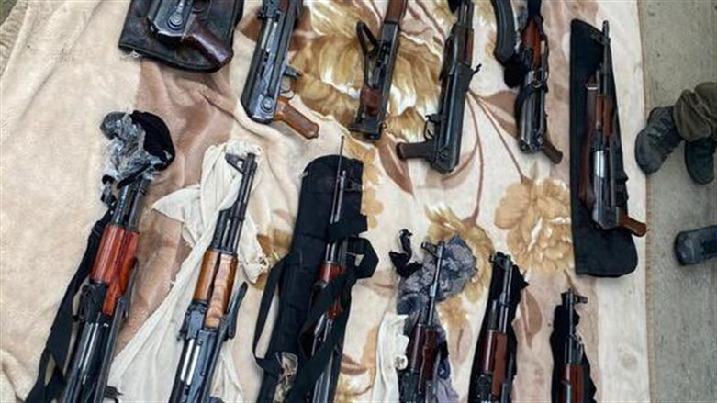
Some of the confiscated weapons IDF spokesperson
IDF and Israel Police troops on Friday spotted two suspicious vehicles adjacent to the border fence between Israel and Jordan.
The vehicles were apprehended by IDF, Israeli Border Police, and Israel Police "Yagal" and “Magen” unit troops.
Inside the vehicles, the troops discovered 12 Kalashnikov assault rifles, cartridges, and ammunition.
The suspects and weapons were transferred to the Israel Police.
Late last year a similar incident occurred along the same border. In that incident, IDF lookouts and forces of the Central Unit of the Israel Police identified two suspicious men moving along the border area and carrying bags with them. Both of the suspects were in their 20s and residents of Palestinian Authority-assigned areas of Judea and Samaria.
Police officers then ambushed the suspects and they were arrested near the border. They were found to be in possession of 11 weapons: Eight pistols, two Kalashnikov rifles and an M-16 automatic rifle. https://www.israelnationalnews.com/news/322903

Iranian official: We can resume production of highly enriched uranium at any moment
Iran's atomic energy chief says the country can enrich uranium at 60% if the US again leaves nuclear deal.
Elad Benari, Canada 25.02.22 23:38
Iran can resume production of highly enriched uranium "at any moment" if the US again pulls out of a nuclear deal with major powers, its atomic energy chief said Friday, according to a report in the AFP news agency.
Mohammad Eslami, head of the Atomic Energy Organization of Iran, was speaking as talks in Vienna on bringing Washington back into the 2015 nuclear deal it signed with world powers.
The 2015 deal set a 3.67 percent limit for Iran's uranium enrichment, sufficient for its power generation needs although not for some other civilian uses, such as the production of medical isotopes.
Iran has gradually scaled back its compliance with the 2015 deal response to former US President Donald Trump’s withdrawal from the agreement in May of 2018.
As part of that, Iran has been producing uranium enriched to 60 percent, a level that has sparked Western concern although it still falls short of weapons grade.
"Enrichment can be done at any moment when (officials) decide or there is the will for it," Eslami said on his organization’s website.
"If they [the US] do not fulfil their obligations, we will return to the previous situation. Enrichment is in place in the country with a maximum ceiling of 60 percent and this brought the West to negotiations," he added.
The comments come as indirect talks between Iran and the US in Vienna reach a critical stage.
A senior European Union official recently said that a US-Iranian deal to revive Iran's 2015 nuclear agreement was close but success depended on the political will of those involved.
French President Emmanuel Macron spoke with his Iranian counterpart Ebrahim Raisi last Saturday and urged him to agree to a deal to revive the 2015 deal.
He added that Iran should seize the opportunity to preserve the Vienna deal and avoid a major crisis, the French presidency statement said.
This week, Iran’s Foreign Minister, Hossein Amir-Abdollahian, said that negotiations to revive the Iran nuclear deal have entered a "critical" stage during which some key issues still need to be resolved. https://www.israelnationalnews.com/news/322926 [Another unworkable ‘deal’.-rdb]
To be removed from this News list, Please click here and put "Unsubscribe" in the subject line.

LEV U’NESHAMA (HEART AND SOUL) – TZFAT, ISRAEL
ANNUAL TWO FOR ONE PURIM MITZVAH
Purim: Thursday, March 17, 2022

MITZVAH NUMBER ONE: Send Purim Gift Boxes to family and friends in the US. The attractive gift boxes contain an assortment of strictly kosher holiday treats.

MITZVAH NUMBER TWO: Profit from your order will help provide Passover food to needy families in Tzfat Israel. One gift box is $26 (100 NIS) including postage and handling. (Expensive postage rates and delivery problems prevent our accepting Canadian orders.)

IT’S SIMPLE TO ORDER! (DEADLINE WEDNESDAY, March 2)

Shoppers: First email your recipient list with names, addresses and brief personal messages to: mortsmo@aol.com
Payment for your order with PayPal: use the recipient email address: mortsmo@aol.com
(Tzfat shoppers may leave their cash payments at the Torah Gems Bookstore.)
Or . . . simply go to our website: www.levuneshama.com and use either PayPal or your credit card
(Israeli or US) on the "How You Can Help" page. If you use Zelle, a US to US bank transfer , you may do so by using the email: mortsmo@aol.com
US shoppers: Send checks made payable to Simcha Smolensky.
Send to: Simcha Smolensky, 6933 N Kedzie Ave, Unit 116, Chicago IL 60645
Contact me if you have questions: mortsmo@aol.com

MITZVAH OPTION: If you don’t want to order Gift Boxes, your donation in any amount will be appreciated. Send your check made payable to Simcha in Chicago or use PayPal or go to our web site, as shown above and select PayPal or use your credit card (Israeli or US). Designate on PayPal that the donation is only for the Purim program.

You can help make Passover more joyful for a needy Tzfat family.
Yaffa Smolensky, Volunteer Program Manager
Email: mortsmo@aol.com web site: www.levuneshama.com

