04/22/2022 NEWS - DON’T Miss Yom Hashoah Program!
SHWEKEY - Yavo Hayom
https://www.youtube.com/watch?v=Cb5_V11Uauk

All I ask is equal freedom. When it is denied, as it always is, I take it anyhow."
-- H. L. Mencken (1880-1956) American Journalist, Editor, Essayist, Linguist, Lexicographer, and Critic

Read the Prophets & PRAY WITHOUT CEASING!
That is the only hope for this nation!
Please  Remember  These  Folks  In  Prayer-  Check often  They  Change! | Pray that the world would WAKE UP! Time for a worldwide repentance!  ALL US soldiers fighting for our freedom around the world  Pray for those in our government to repent of their wicked corrupt ways.  Pray for BB – Severe sciatic Had surgery and doing well  Pray for EL – Had stoke – Now having coronary angiogram  Pray for KH – diagnosed with Multiple Myeloma  Pray for BB – Severe West Nile Fever –still not mobile- improving!  Pray for RBH – cancer recurrence  Pray for Ella – Child with serious problems  Pray that The Holy One will lead you in Your preparations for handling the world problems. – Have YOU made any preparations?
Exodus 15:¹⁴The peoples have heard, they tremble; pangs have taken hold on the inhabitants of Philistia. ¹⁵Then were the chiefs of Edom affrighted; the mighty men of Moab, trembling taketh hold upon them; all the inhabitants of Canaan are melted away. ¹⁶Terror and dread falleth upon them; by the greatness of Thine arm they are as still as a stone; till Thy people pass over, O LORD, till the people pass over that Thou hast gotten.

Release of dollar & US: Israel made Chinese yuan a reserve currency - Dramatically reduces the euro!
Article writer: Vassilis Kapoulas 21/04/2022 - 14:24
Israeli economists are talking about the biggest "monetary restructuring" of the last decade, as the government has added the Chinese yuan to the country's reserve currencies.
Israeli analysts are talking about a change of "philosophy" as the inclusion of the Chinese Yuan automatically reduces the exposure to the dollar and especially to the euro.
Developments alone are not good for the United States, Israel's closest ally, which finances the Jewish state on an annual basis.
Israel is making a new opening in China, anticipating the coming end of current globalization. Most likely, this move also hides an inconvenience to Washington for not resolving the problem it hears in the name of Iran. And coincidentally, Tehran is a close ally of China.
The Chinese yuan in Israel reserves
More specifically, the central bank of Israel has made the biggest changes in the monetary distribution of its reserves in a decade. Israel has added the Chinese yuan, along with three other currencies, to a reserve that last year topped $ 200 billion for the first time.
From this year, the currency mix will expand from the trinity of the US dollar, the euro and the British pound to include the Canadian and Australian dollars, the Japanese yen and the Chinese yuan, also known as the renminbi.
The additions signal a change in the "overall investment guidelines and philosophy of the Bank of Israel," said Deputy Governor Andrew Abir. MORE - https://warnews247.gr/apodesmefsi-apo-ta-dolaria-ton-ipa-to-israil-evale-to-kineziko-gouan-sto-apothematika-nomismata-tis-choras-gkremizei-to-evro/

Israel adds Chinese RMB to Central Bank reserves for first time, cuts USD holdings
Israel, whose foreign currency reserves have traditionally been made up of Dollars, Euros and British Pounds, will add four new currencies – including the Chinese Yuan (RMB).
By BEN ZION GAD Published: APRIL 22, 2022 00:21
Israel has added four new currencies – including the Chinese Yuan (RMB) – to its central bank holdings for the first time in the country’s history, Bloomberg reports. Israel’s Central Bank will also trim US Dollar (USD) and Euro holdings in a bid to diversify their foreign reserves. MORE - https://www.jpost.com/business-and-innovation/banking-and-finance/article-704813 [This is HUGE.- rdb]

Palestinians, cops clash at Temple Mount as Jews make last visits until Ramadan ends
Police arrest 7 suspects for throwing firebombs at officers from Al-Aqsa Mosque on Wednesday; clashes come hours after IDF strikes targets in Gaza in response to rocket fire
By TOI staff Today, 10:26 amUpdated at 10:54 am
Palestinians and Israeli police engaged in fresh skirmishes Thursday morning on Jerusalem’s Temple Mount, amid increased tensions in the city that have fueled concerns of a larger flare-up.
According to police, dozens of masked rioters entered al-Aqsa Mosque and sealed the doors before starting to hurl rocks and fireworks at officers, who responded with riot dispersal means.
The Red Crescent said 20 Palestinians were wounded in the clashes. Several were believed to have been injured by tear gas. Earlier, Palestinian media reports claimed that one man was wounded by a rubber bullet.
The clashes come amid heightened tensions on the final day that Jewish visitors are allowed to access the site ahead of a closure until the end of Ramadan.

Palestinians and police clash at the Al-Aqsa Mosque as Jewish visitors tour the Temple Mount on April 21, 2022. (Screen capture: Twitter)
Palestinian media reported that one person was injured by a rubber bullet
The clashes came as Jews were allowed to visit the Temple Mount for the last time until Ramadan ends on May 2, as part of a years-long policy of barring non-Muslims from the site during the final 10 days of the Muslim holy month.
Video showed Jewish visitors touring the site as Thursday’s clashes raged, with smoke and the sound of blasts coming from the direction of the mosque.
MORE - https://www.timesofisrael.com/palestinians-cops-clash-at-temple-mount-as-jews-make-last-visits-until-ramadan-ends/

Hamas calls for Palestinian ‘mobilization’ ahead of Friday’s Al-Aqsa prayers
In phone call with Russian FM, terror group’s leader hails Moscow for support; Lavrov reportedly condemns Israel’s ‘excessive’ force in Jerusalem clashes
By TOI staff Today, 6:19 pm
The Hamas terror group on Thursday called on Palestinians to “mobilize” for Friday prayers at the Al-Aqsa Mosque, in defense of the holy site and Jerusalem.
In a statement, the organization hailed the steadfastness of protesters who “repelled the incursions of the occupation and its settlers with courage and pride, assuring everyone far and wide that Al-Aqsa has men who protect it and defend its purity, despite the ugliness of aggression and terrorism of the occupiers.”
At the same time, Hamas chief Ismail Haniyeh held a phone call with Russian Foreign Minister Sergey Lavrov on security developments in the Gaza Strip and Jerusalem, his office said.
According to the Palestinian Shehab news agency, Haniyeh expressed appreciation for Moscow’s support of Palestinian rights at the Al-Aqsa Mosque.
The head of the terror group accused Israel of preventing worshipers from reaching the Jerusalem holy site, assaulting and arresting worshipers and vandalizing property.
Meanwhile, Shehab reported, Lavrov said Russia has “always been on the side of the Palestinian people in their right to self-determination and their right to establish their Palestinian state.”
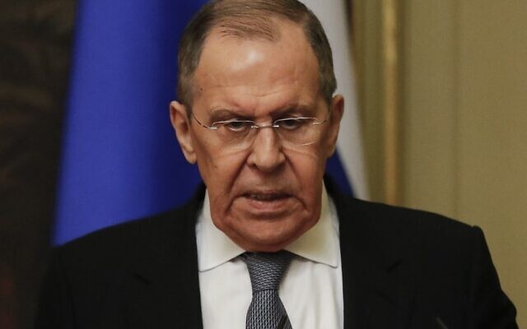
Russian Foreign Minister Sergei Lavrov in Moscow, on March 5, 2022. (Psergei Ilnitsky/Pool/AFP)
He denounced what he called Israel’s excessive use of force against civilians in the capital.
Thursday morning saw Palestinians and Israeli police engage in fresh skirmishes on the Temple Mount and Al-Aqsa.
According to police, dozens of masked rioters entered the mosque and sealed the doors before starting to hurl rocks and fireworks at officers, who responded with riot dispersal means.
The Red Crescent said 20 Palestinians were wounded in the clashes.
Thursday was the final day that Jewish visitors were allowed to access the site ahead of a closure until the end of Ramadan on May 2, as part of a years-long policy of barring non-Muslims from the site during the final 10 days of the Muslim holy month.
Video showed Jewish visitors touring the site as Thursday’s clashes raged, with smoke and the sound of blasts coming from the direction of the mosque.
The Temple Mount is a frequent flashpoint of Israeli-Palestinian tensions, with clashes there last year helping precipitate the 11-day military conflict between Israel and terror groups in the Gaza Strip after the enclave’s Hamas rulers fired rockets at Jerusalem. The site is the most sacred place for Jews as the location of the biblical temples, and Al-Aqsa Mosque, which sits atop the Temple Mount, is the third-holiest site for Muslims.
הר הבית: מתפללים יהודים עולים להר; פורעים מיידים לעברם זיקוקים מתוך המסגד pic.twitter.com/d84oUDgyfI
— יערה אברהם | Yaara Avraham (@yaara_avraham) April 21, 2022
Jerusalem has been a tinderbox in recent weeks as Palestinians scraped with police on the flashpoint Temple Mount, the Ramadan and Passover holidays drew thousands to holy sites, Israeli security forces cracked down on terror in the West Bank, and Gaza terror groups stoked the flames.
On Thursday, Haniyeh said that “we are still at the beginning of the battle” and warned Israel over the Temple Mount.
“As we defeated the so-called Flag March, we will defeat the policy of invading [Al-Aqsa],” Ismail Haniyeh said, after police barred Jewish nationalists from marching through the Old City’s Damascus Gate on Wednesday.
His comments came after Israel and Gaza-based terrorists clashed in the largest exchange of fire since last year’s fighting, with the military carrying out air raids in the Strip in response to rocket fire and the launch of anti-aircraft missiles.
No Israelis were directly injured by the rocket fire earlier in the night, but three people were lightly wounded in falls that took place while running to bomb shelters.
No Gaza group immediately took responsibility for either of the night’s launches, as had been the case after the week’s first rocket launch on Monday evening. However, several media reports citing Israeli security officials pegged Hamas-rival Palestinian Islamic Jihad as responsible for the Monday rocket fire.
This week’s rocket fire ended an almost four-month period of quiet on the Gaza border. https://www.timesofisrael.com/hamas-calls-for-palestinian-mobilization-ahead-of-fridays-al-aqsa-prayers/

Arab FMs: End Jewish prayer on Temple Mount; Lapid: Israel committed to status quo
Foreign minister meets Biden officials Yael Lempert and Hady Amr in Israel on their regional de-escalation tour, says Israel ‘dealing with extremist Islamist terror’
By Jacob Magid Today, 7:58 pm
Foreign Minister Yair Lapid (second from L) meets with a US delegation that includes Ambassador to Israel Tom Nides (4th from right), Acting Assistant Secretary of State for Near Eastern Affairs Yael Lempert (third from right) and Deputy Assistant Secretary of State for Israeli and Palestinian Affais Hady Amr in Tel Aviv, on April 21, 2022. (David Azoulay/US Embassy in Israel)
Foreign Minister Yair Lapid told a delegation of visiting US officials that Israel is committed to maintaining the status quo at the Temple Mount, as the Biden administration continued its regional tour aimed at lowering tensions in Jerusalem.
“Israel is preserving and will continue to preserve the status quo on the Temple Mount, and we have no intention of changing it whatsoever,” Lapid said according to a readout from his office, which referenced the policy that allows Muslims to visit and pray at what they refer to as the Haram al-Sharif, whereas Jews can visit but are barred from praying. The most vile mistake of Moshe Daynn was allowing Islamic control over the temple mount. When they won the war and got the mount back in their hands they should have held it and controlled it completely. – rdb]
During a Wednesday briefing with Israeli journalists, Lapid brushed off the widely-reported reality of recent months and years in which Jews have been allowed to quietly pray as they’re ushered through the compound by police and employees of the Jordanian Waqf. The foreign minister insisted the official policy barring Jewish prayer on the Temple Mount remains and that it is backed by the security establishment.
But Israel’s Arab neighbors are not convinced. After a regional meeting on the Jerusalem tensions in Jordan, Ammans’s foreign minister told reporters that his counterparts were demanding an end to Jewish prayer at the Temple Mount. “Our demands are clear that Al-Aqsa and Haram al Sharif in all its area is a sole place of worship for Muslims,” he said.
For his part, Lapid told the visiting US delegation on Thursday that “the only people who have disturbed them were extremists and Hamas supporters who took control of the mosque, desecrated it, disrupted prayer, launched fireworks, and threw Molotov cocktails and rocks.”
“We are acting only in order to prevent violence and to enable prayer to continue as normal.”
Jerusalem has sought to stress its commitment to the status quo in recent weeks as Palestinians and their supporters in the Arab world accuse Israel of violating it and of seeking to “divide” the Al-Aqsa Mosque compound.
“The State of Israel is dealing with extremist Islamist terror whose entire goal is to sow violence, fear, and chaos. We call on all leaders in the region to act and speak responsibly in order to calm the situation,” Lapid said, emphasizing the feeling in Jerusalem that countries such as Jordan have been elevating fake reports regarding Israeli conduct on the Temple Mount.
Palestinians seen on the holy month of Ramadan at the Al-Aqsa Mosque compound atop the Temple Mount in Jerusalem’s Old City, on April 17, 2022. (Jamal Awad/Flash90)
The US delegation included Ambassador to Israel Tom Nides, Acting Assistant Secretary of State for Near Eastern Affairs Yael Lempert and Deputy Assistant Secretary of State for Israeli and Palestinian Affairs Hady Amr.
Israel was the second stop on Lempert and Amr’s regional tour aimed at de-escalating the situation surrounding Jerusalem. They were slated to travel to Ramallah for meeting with Palestinian officials later Thursday followed by a trip to Egypt. The US delegation was in Jordan on Wednesday and met with Jordanian Foreign Minister Ayman Safadi.
But it was unclear whether Washington’s efforts to convince parties to tone down their rhetoric were bearing fruit, as Jordan on Thursday hosted an emergency meeting of a regional ministerial committee, which Amman used to lambast Israel for its “illegal policies and measures” in Jerusalem, according to a readout from the Royal Court.
Share ➡️ 5 facts about the Temple Mount – instead of the disinformation being spread online.
1. Israel is preserving and will continue to preserve the status quo on the Temple Mount. We have no intention of changing it whatsoever.
— יאיר לפיד – Yair Lapid???? (@yairlapid) April 21, 2022
The committee condemned actions taken by Israel on the Temple Mount, calling them provocative, and said Israel must ensure that only Muslims worship at the site.
“The committee warned that these attacks and violations represent a blatant provocation to the feelings of Muslims,” according to Jordan’s Petra news agency, adding that it “threatens to ignite a cycle of violence.”
Addressing the ministers, Jordan’s King Abdullah stressed the importance of observing the status quo at Jerusalem holy sites. Participants expressed their support for Jordan’s custodial role in charge of administering those sites — a position Jordan has sought to leverage in recent weeks.
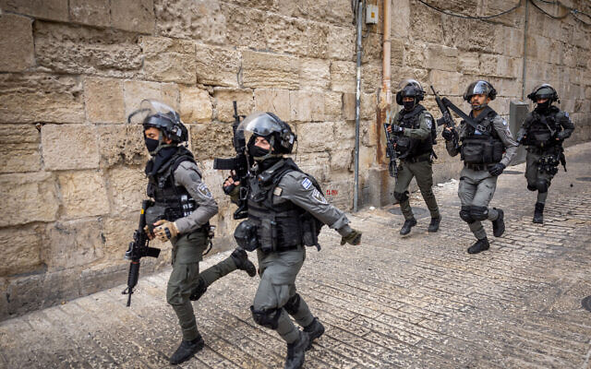
Israeli police officers during clashes outside the Al Aqsa Mosque, in Jerusalem’s Old City, on April 17, 2022. (Yonatan Sindel/Flash90)
Joining the meeting were representatives from Tunisia, Algeria, Saudi Arabia, Qatar, Egypt, Morocco, the Palestinian Authority and the United Arab Emirates.
Israel Police have entered the compound several times over the past week in order to quash Palestinian rioters. The most intensive clashes took place last Friday, when officers breached the flashpoint site amid fears that youth stockpiling stones in the Al-Aqsa Mosque were gearing to target Jewish worshipers at the Western Wall and stage mass clashes during evening prayers when tens of thousands of other Muslims would be present on the compound. Over 150 Palestinians were wounded and some 400 were arrested in the rioting that ensued. Footage also showed instances of police brutality during which officers beat journalists, women and children for no apparent reason.
Clashes have continued on a near-daily basis since, as the week of Passover brought a record number of over 4,600 Jewish visitors to the site., according to Channel 12. Ahead of their arrival on Thursday morning, police sought to forcefully clear Muslim worshipers from the path allotted to Jewish visitors, sparking the latest round of clashes. The Red Crescent said 20 Palestinians were wounded in the fighting. Several were believed to have been injured by tear gas, but one man was hit by a rubber bullet.
Thursday was the last day Jewish visitors were allowed on the Temple Mount until the end of Ramadan on May 2. The holy month coincides with the Passover holiday for the first time in roughly a decade — a confluence identified by the Biden administration months in advance as a possible recipe for renewed tensions in Jerusalem. The policy of barring Jewish visitors on the last 10 days of Ramadan has been standard for years as the end of the holy month brings an uptick of Muslim worshipers to the site.
Palestinians and police clash at the Al-Aqsa Mosque as Jewish visitors tour the Temple Mount, on April 21, 2022. (Screen capture: Twitter)
Nonetheless, Jerusalem is likely to remain on edge into the weekend as Israel plans to significantly limit the number of Christian worshipers who will be able to enter the Church of the Holy Sepulchre for the Holy Fire ceremony on Saturday due to safety fears, following last year’s deadly crush that killed 45 ultra-Orthodox pilgrims celebrating the Lag B’Omer holiday in Meron last year.
The Holy Fire ceremony usually brings 10,000 pilgrims into the church, and police sought to limit the number to 1,000, leading Christian leaders to petition the High Court of Justice against the move. Ultimately, the judges ordered police to allow 4,000 people inside while granting access to the general area to all worshipers, in line with traffic regulations. The Palestinian Authority warned Thursday that Israeli restrictions risked further escalation.
Lapid also updated the US officials on the steps Israel has taken to allow Muslim freedom of worship on the Al-Aqsa compound, noting that hundreds of thousands of them have visited during the first two weeks of Ramadan.
Lapid stressed that Israel would not accept rocket fire from Gaza and would do what was necessary to defend its citizens.
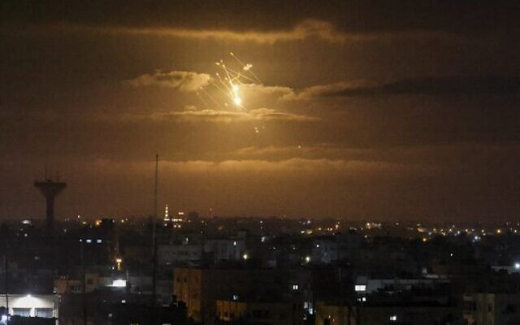
A missile from Israel’s Iron Dome air defense system lights the sky over the Gaza Strip, on April 21, 2022. (Said Khatib/AFP)
Gaza terror groups have twice fired rockets at southern Israeli towns this week, ending what had been a nearly-four month period of calm.
Separately on Thursday, Defense Minister Benny Gantz held a meeting with mayors of towns near the Gaza border, assuring them that IDF “forces and preparedness in the area has expanded and that the policy of a harsh response to all terror activities will continue,” according to his office.
Gantz told the mayors that “Israel is prepared to take any action necessary to maintain the security of its citizens.” https://www.timesofisrael.com/lapid-to-us-were-committed-to-temple-mount-status-quo-arab-fms-pan-provocation/ [Lets talk about apartheid. OK for Islamics to be on themount and pray but not for Jews or Christians? So who is really the biased prejudiced group. It should be obvious. – rdb]

Russian envoy: We’ll ‘respond accordingly’ if Israel gives Ukraine defensive gear
Ambassador Anatoly Viktorov issues vague warning after Gantz announces shipment of helmets and flak jackets to Ukrainian emergency services
By TOI staff Today, 4:17 pm
Russia’s envoy to Israel warned Thursday that Moscow will respond if Jerusalem supplies Kyiv with defensive gear amid his country’s invasion of Ukraine.
Speaking with Russian state television, Ambassador Anatoly Viktorov noted Defense Ministry Benny Gantz’s announcement a day earlier that Israel will provide Ukraine with helmets and flak jackets.
Gantz’s office stressed the equipment will go to Ukrainian civilian rescue and medical forces, not the military.
“We are carefully checking this information and will respond accordingly if it is confirmed,” Viktorov said.
It was not clear from Viktorov’s remarks what such a response might entail.
Gantz’s announcement Wednesday marked a policy shift for Israel, which first weighed Ukrainian requests for some defensive equipment in March. More recently, devastating images coming out of the Kyiv suburb of Bucha galvanized many countries against the Russian effort and led to a change of tone from Israeli politicians.
Israel has avoided aligning too closely with either side since Russian troops invaded Ukraine on February 24. It is one of the few countries that maintains relatively warm relations with both Ukraine, a fellow Western democracy, and Russia.
However, the rhetoric coming from Jerusalem shifted in the wake of the reports of widespread civilian killings by the Russians. Foreign Minister Yair Lapid even explicitly accused Russia of war crimes earlier this month, in the strongest comments yet by a top Israeli official against Moscow.
Advertisement
While Jerusalem might have somewhat shifted its tone to align more with Western powers, it has so far steadfastly declined to contribute to the Ukrainian military effort. Instead, Israel has sent a 100-ton humanitarian aid package to Ukraine and built a field hospital in the west of the country. https://www.timesofisrael.com/russian-envoy-well-respond-accordingly-if-israel-gives-ukraine-defensive-gear/ [Israel is dancing with the devil and may get stung if they aren’t careful – rdb]

Putin claims ‘liberation’ of Mariupol, but orders troops not to storm last holdout
PMs of Spain, Denmark visit Kyiv in latest show of Western support as Biden hails Ukraine for resisting invasion: ‘They’re tougher and more proud than I thought’
By Joris FIORITI and Joshua MELVIN Today, 2:54 pm
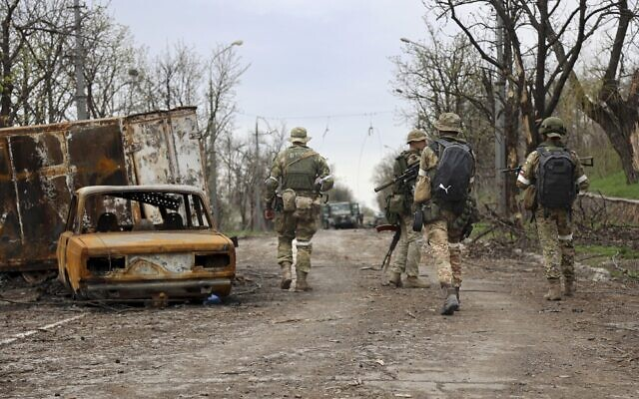
Servicemen of Donetsk People's Republic militia walk past damaged vehicles during heavy fighting in an area controlled by Russian-backed separatist forces in Mariupol, Ukraine, on April 19, 2022. (AP Photo/Alexei Alexandrov)
ZAPORIZHZHIA, Ukraine (AFP) — Russian President Vladimir Putin on Thursday claimed the “liberation” of the flattened city of Mariupol after nearly two months of fighting, but signaled he would forgo a final bloody offensive against beleaguered Ukrainian defenders there.
The fate of the besieged port has become totemic as Russia battles to complete a land bridge covering territories of Ukraine already under its control, including Crimea.
The West staged another show of support for Ukrainian President Volodymyr Zelensky with a visit to Kyiv by the Spanish and Danish prime ministers, a day after European Council leader Charles Michel came and vowed the EU would do “everything possible” to help Ukraine win the war.
Zelensky said Ukraine still did not have enough weapons, despite billions in Western military aid that has forced Russia to refocus its offensive away from Kyiv and towards the east of the country.
In morgues around the capital, the bodies of some 1,020 civilians are being stored after Russian troops withdrew from the region, Ukrainian Deputy Prime Minister Olga Stefanishyna told AFP.
The bodies of nine civilians, some showing signs of torture, have been found in the town of Borodyanka outside Kyiv, the region’s police chief Andriy Niebytov said.
“The Russian military knowingly shot civilians who did not put up any resistance,” he said, adding that one of the victims was a 15-year-old girl.
Biden ‘proud’
While the West remains nervous about igniting a direct conflict with nuclear-armed Russia, US President Joe Biden said he was “amazed” by Ukrainian resistance since the invasion began on February 24.
“They’re tougher and more proud than I thought,” he said, adding that Western “weapons and ammunition are flowing in daily.”
The Pentagon had said Ukraine was receiving fighter planes to bolster its air force — but it later said only aircraft parts had been delivered.
However, the flow of hardware, including anti-tank missiles, has not prevented Russia from carving a trail of destruction across Ukraine, not least in Mariupol on the shores of the Sea of Azov in the southeast.
“Mariupol has been liberated,” Russian Defense Minister Sergei Shoigu told Putin during a televised meeting. “The remaining nationalist formations took refuge in the industrial zone of the Azovstal plant.”
In this photo released by the Russian Presidential Press Service, Russian President Vladimir Putin, left, and Russian Defense Minister Sergei Shoigu look at each other during their meeting in the Kremlin in Moscow, Russia, on April 21, 2022. (Russian Presidential Press Service via AP)
Shoigu said around 2,000 Ukrainian soldiers remained inside the giant steel plant, where the last pocket of Ukrainian resistance has been sheltering in a network of underground tunnels.
Thousands of civilians are believed to have died in the besieged city, and up to 2,000 others are also sheltering in the plant without access to drinking water or food, according to Ukrainian authorities.
Putin said the “liberation” of Mariupol was a “success” for Russian forces but ordered Shoigu to call off the planned storming of the industrial area, dismissing it as “impractical.”
“There is no need to climb into these catacombs and crawl underground through these industrial facilities. Block off this industrial area so that not even a fly can escape,” Putin said.
Bodies pile up
The Ukrainian defenders said they were refusing to surrender but appealed for security guarantees.
“We are pleading so we can collect the bodies of the dead, so the civilians can calmly walk out from Azovstal,” said Captain Sviatoslav Palamar, deputy commander of the far-right Azov Regiment.
A humanitarian corridor reopened on Wednesday, with Ukrainian authorities reporting that four buses had left Mariupol carrying women, children and the elderly.
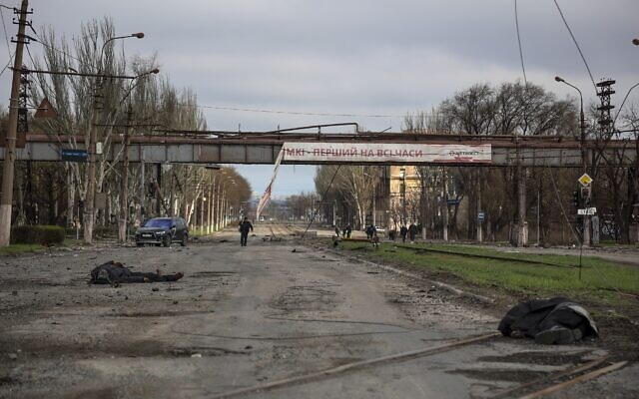
Bodies of civilians lie on the ground as local residents walk past a destroyed part of the Illich Iron & Steel Works Metallurgical Plant, the second largest metallurgical enterprise in Ukraine, in an area controlled by Russian-backed separatist forces in Mariupol, Ukraine, on April 16, 2022. (AP Photo/Alexei Alexandrov)
Further from the frontlines, residents were still reeling weeks after Russian forces withdrew from the area around Kyiv.
At a morgue in Bucha, families carefully searched body bags and examined corpses, looking for missing loved ones.
Four hundred bodies have been discovered there since the Russians withdrew on March 31, local police chief Vitaly Lobas told AFP. Around a quarter of them are still unidentified.
International snubs
Meanwhile, Russia’s international isolation has deepened.
At a meeting of G20 finance ministers in Washington, the US led a walkout of Western allies as Russian officials spoke.
“The world’s democracies will not stand idly by in the face of continued Russian aggression and war crimes,” Canadian Deputy Prime Minister Chrystia Freeland tweeted.
In London, organizers of the Wimbledon tennis tournament banned Russian and Belarusian players from the 2022 event in response to the invasion.
World tennis authorities criticized the announcement, which particularly affects Russian men’s world number two Daniil Medvedev and Belarusian female world number four Aryna Sabalenka.
But the All England Lawn Tennis Club said it was acting to “limit Russia’s global influence through the strongest means possible.”
More than five million Ukrainians have now fled their country since the Russian invasion, the United Nations said, in Europe’s worst refugee crisis since World War II.
But returns have also accelerated in recent weeks, reaching over one million, according to a spokesman for Kyiv’s border force.
Those returning must often take huge risks. Olena Klymenko said Ukrainian soldiers had been demining her pummeled village of Moshchun.
“We found a booby trap in our garden. It seems it was disarmed. We don’t know,” said Klymenko, whose home was destroyed. “Still, we need to look for our stuff.”
‘History will not forget’
Many have fled into Russia. Ukraine accused the International Committee of the Red Cross (ICRC) of working “in concert” with Moscow to manage the refugees, who it says have been forcibly deported.
Citing data from the UN, ombudswoman Lyudmyla Denisova said that about 550,000 Ukrainians, including 121,000 children, have been taken to Russia during the course of the war.
“Where are they? In filtration camps? In temporary facilities?” Denisova asked. “The International Red Cross is not fulfilling its mandate.”
The ICRC rejected Kyiv’s accusation of collusion with Moscow.
Putin has said he launched his “military operation” to save Russian speakers in eastern Ukraine from a “genocide” carried out by a “neo-Nazi” regime.
But his forces have faced allegations of war crimes — most recently from the EU’s Michel, who toured the devastated town of Borodianka on Wednesday.
“History will not forget the war crimes that have been committed here,” Michel wrote on Twitter. https://www.timesofisrael.com/putin-claims-liberation-of-mariupol-but-orders-troops-not-to-storm-last-holdout/ [When the dust settles (and if the NATO and US group continues it will be nuclear dust) things may not be at all what has been reported on the US media propaganda group. – rdb]

Satellite images reveal mass graves dug outside of Mariupol, Ukraine
Russian forces have been accused of making these graves shortly after capturing the city.
By GADI ZAIG Published: APRIL 21, 2022 22:16 Updated: APRIL 21, 2022 22:30
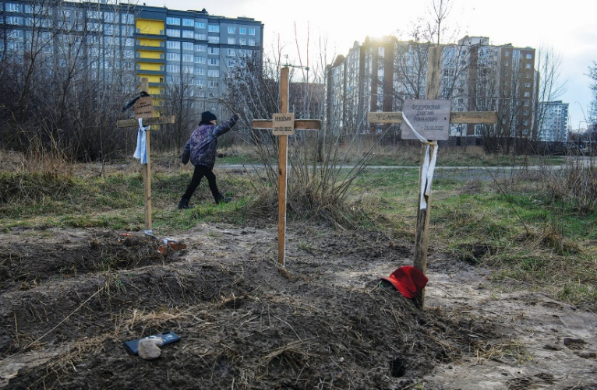
A BOY walks past graves of civilians who, according to local residents in Bucha, were killed by Russian soldiers. The inscription on the cross in the middle reads: 'Unknown'. (photo credit: REUTERS/VLADYSLAV MUSIIENKO)
Russian forces reportedly built several mass graves in Mariupol and deposited hundreds of corpses of Ukrainian war victims there, according to Ukrainian media. Satellite imagery from near the besieged Ukrainian city shows a mass grave site that has expanded in recent weeks to contain more than 200 new graves, a private US company said on Thursday.
Ukrainian officials identified the location of the mass graves two days earlier, CNN reported, as Russian forces have nearly captured Mariupol as of Thursday, and have backed Ukrainian forces and civilians to the Azovstal power plant.
Maxar Technologies MAXR.N said a review of images from mid-March through mid-April indicates the expansion of the graves began between March 23-26. The site lies adjacent to an existing cemetery in the village of Manhush, 20 kilometers west of Mariupol, Maxar said. MORE - https://www.jpost.com/international/article-704810

Russia slaps travel ban on Kamala Harris, Mark Zuckerberg
Foreign ministry says list of prominent Americans and Canadians comprised of people responsible for the countries’ ‘Russophobic’ policies
By AFP and TOI staff Today, 11:31 pm
Russia on Thursday slapped travel bans on US Vice President Kamala Harris, Facebook chief Mark Zuckerberg and dozens of prominent Americans and Canadians in retaliation for sanctions imposed over Ukraine.
The Russian foreign ministry said the travel restrictions on 29 Americans and 61 Canadians — which also includes defense officials, business leaders and journalists from both countries — would remain in effect indefinitely.
The US list includes ABC News television presenter George Stephanopoulos, Washington Post columnist David Ignatius, and the Russia-focused Meduza news site’s editor Kevin Rothrock.
The US defense officials include Pentagon spokesman John Kirby and Deputy Secretary of Defense Kathleen Hicks.
The list of Canadians is headed by Cameron Ahmad, who serves as director of communications to Prime Minister Justin Trudeau, and Canadian Special Operations Forces Commander Steve Boivin. MORE - https://www.timesofisrael.com/russia-slaps-travel-ban-on-kamala-harris-mark-zuckerberg/

Biden announces artillery, weapons for Ukraine after Russia claims Mariupol victory
$800 million package includes 144,000 rounds of ammunition and drones for escalating battle in Donbas and builds on roughly $2.6 billion in military aid already approved by US
By AAMER MADHANI, Robert Burns and DARLENE SUPERVILLE 21 April 2022, 10:32 pm
WASHINGTON (AP) — US President Joe Biden pledged an additional $1.3 billion Thursday for new weapons and economic assistance to help Ukraine in its strong but increasingly difficult battle against the Russian invasion, and he promised to seek much more from Congress to keep the guns, ammunition and cash flowing.
The latest military aid, Biden said, will be sent “directly to the front lines of freedom.”
“Putin is banking on us losing interest,” Biden said. The Russian president is betting that “Western unity will crack… and once again we’re going to prove him wrong.”
The new package includes $800 million in military aid for much-needed heavy artillery, 144,000 rounds of ammunition and drones for the escalating battle in the Donbas region of eastern Ukraine. It builds on roughly $2.6 billion in military assistance that Biden previously approved.
There’s also a fresh $500 million in direct economic assistance to Ukraine for government salaries, pensions and other programs. That raises the total US economic support to $1 billion since Russia’s invasion began nearly two months ago.
Biden underscored a need for the US and Western allies to remain resolved in their support for Ukraine amid signs that Americans may be becoming more wary of the war. https://www.timesofisrael.com/biden-announces-artillery-weapons-for-ukraine-after-russia-claims-mariupol-victory/ Digging a deeper pit day by day. – rdb]

Obama scolds unvaxxed: Hey, we 'clinically tested' shots on billions of people
'Around 1 in 5 Americans is still going to put themselves at risk'
By Art Moore Published April 21, 2022 at 7:27pm
In a direct appeal to the Silicon Valley tech giants to censor "misinformation" on social media, former President Obama on Thursday unwittingly affirmed the contention of critics of the COVID-19 vaccines that the fact that clinical trials have not been completed makes the people who have received the shots part of an experiment.
"Despite the fact that we have now essentially clinically tested the vaccine on billions of people worldwide, around one in five Americans is still willing to put themselves at risk, and put their families at risk, rather than get vaccinated," he said in a speech at Stanford University. [You still only have 2 years of data and the data is rather fragmented so you don’t have any long term studies about the JAB. - rdb
"People are dying because of misinformation." Tell another lie. – rdb]
The former president's remarks illustrate the danger of censoring "misinformation," if only because one person's misinformation might well be another person's evidence-based opinion or eventually become common knowledge.
Twitter, YouTube, Facebook and other social media platforms notoriously have censored the voices of some of the world's most highly qualified medical scientists because their views don't align with the ever-evolving government and establishment media position on the pandemic and related issues.
President Biden and CDC Director Rochelle Walensky, for example, assured Americans when the vaccines were rolled out that if you get vaccinated – for a disease that the CDC says has a survival rate of nearly 100% for people without chronic comorbidities – you won't get infected and you won't transmit the virus.
That hasn't turned out to be true, confirming the censored warnings of scientists such as Dr. Robert Malone and Dr. Peter McCullough, who in January observed the "crumbling" establishment narrative that included "false statements regarding asymptomatic spread, reliance on lockdown and masks – which obviously didn't work – the suppression of early treatment, the mass promotion of vaccines that failed."
And Walensky had to admit at a forum last month that the CDC exercised "too little caution and too much optimism" about the effectiveness of the vaccines in preventing infection, transmission and deaths. And she acknowledged science isn't "black and white," it's "gray," and "sometimes it takes months and years to actually find out the answer."
In February, suggesting Americans can't handle the "answer," unnamed CDC officials told the New York Times that the agency had withheld most of its data regarding COVID-19 for fear it would be misinterpreted by critics.
Regarding the vaccine "experiment," Obama and Biden administration officials don't mention the fact that clinical trials are ongoing for vaccines that came to market under emergency use authorization in less than one year while vaccines normally require a process that takes five to 10 years, in part because of the need to test for long-term side effects.
Among the thousands of pages of FDA documents on the Pfizer trials – which the agency was forced to release after pressing for a 75-year delay – is evidence the agency had concern about many serious side effects that a growing number of people now are reporting to have suffered.
Obama's comment Thursday about the clinical testing of the vaccines on the global population echoed a revealing remark by a member of the FDA vaccine panel last fall prior to a vote on whether to recommend the Pfizer vaccine for children ages 5-11.
Dr. Eric Rubin, editor-in-chief of the New England Journal of Medicine, reflected the reluctance of members to recommend the Pfizer vaccine for young children because of the lack of safety data. Rubin said that, for example, myocarditis is “a side effect that we can’t measure yet.” But he concluded the shots should be given to children anyway.
"We're never going to learn about how safe the vaccine is unless we start giving it," he argued. "That’s just the way it goes."
See Obama's remarks:
The New York Times reported on Thursday ahead of Obama's Stanford appearance that "in many private meetings and public appearances over the last year, the former president has waded deeply into the public fray over misinformation and disinformation, warning that the scourge of falsehoods online has eroded the foundations of democracy at home and abroad."
In his Stanford speech, the paper said, he was "expected to add his voice to demands for rules to rein in the flood of lies polluting public discourse."
It was under Obama that the Justice Department and the FBI pursued the Trump-Russia collusion hoax adopted by establishment media as the unassailable truth, while it now appears that it was Hillary Clinton who colluded with Russia to try to win the 2016 election, suggests evidence in a special counsel investigation.
Letting the data speak
Meanwhile, CDC and U.K. government data have indicated that the COVID-19 vaccines not only are ineffective in preventing cases and transmission, they rapidly lose protection against severe illness or death while posing risks.
A newly published long-term study by the prestigious British journal The Lancet that followed up on participants in the Moderna and Pfizer trials found the vaccines had no effect on overall mortality.
Last month, a former adviser to the FDA commissioner who continues to serve in an oversight role said the agency is ignoring its requirement to disclose clear safety and efficacy problems with the COVID-19 vaccines. Also in March, an Army flight surgeon testified in federal court that she was ordered by high-level command not to discuss the controversy over Department of Defense data indicating a massive spike in serious injuries and illnesses among military personnel when the vaccines were rolled out in 2021. And, mounting reports of serious injury and death on the CDC's vaccine-injury website, an analysis of CDC data by a former Wall Street executive an an insurance industry expert shows an alarming rise in excess deaths among Millennials over the past year coinciding the COVID vaccine rollout.
In April, the Food and Drug Administration released a briefing document that says the composition of the current COVID-19 vaccines might need to be changed to ensure high levels of protection. https://www.wnd.com/2022/04/obama-scolds-unvaxxed-hey-clinically-tested-shots-billions-people/ More federal lying.- rdb]

‘It just keeps going up’: Inflation drives up Passover food prices for US Jews
Grocery prices rise 10%, the most in 41 years, leaving some families struggling to pay for eggs, gefilte fish and matzah
By LUIS ANDRES HENAO and MAE ANDERSON Today, 8:41 pm
NEW YORK (AP) — Shopping for Passover on a recent day at a kosher supermarket in the Hasidic Jewish section of Brooklyn’s Williamsburg neighborhood, Moshe Werzberger worried about how inflation is driving up prices during one of the most important holidays for Jews.
“It affects us very much,” said the 23-year-old, who recently canceled plans to vacation in Florida with his wife and 2-year-old son because of skyrocketing prices. Inflation has become a main topic of debate for worshippers at his synagogue and also in his extended family as they share the celebratory Passover meals, Seders.
“It just keeps on going up and up…” he said as announcements rang out in Yiddish on the store’s intercom. “And at some point, it’s going to have to stop, or no one is going to be able to afford to go shopping.”
As households feel the squeeze of surging consumer prices, some US Jewish families observing Passover have struggled to pay for eggs, gefilte fish and the unleavened bread known as matzahs, which represents their ancestors’ exodus from slavery in Egypt.
The need is so great that the Met Council, which runs the country’s largest kosher food pantry, expects to supply a record of nearly 3 million pounds of food in Passover packages and $500,000 in emergency food cards among the Jewish community in greater New York City and New Jersey.
“We’ve been doing charitable work for 50 years, and we’ve never seen anything like this,” said David Greenfield, the council’s executive director. He added that there’s “no question” that hundreds of thousands of families are eating less meat during Passover, which this year falls from April 15 to 23.
https://www.timesofisrael.com/it-just-keeps-going-up-inflation-drives-up-passover-food-prices-for-us-jews/

Former head of state-run Chinese newspaper claims 'high probability’ of war with US
Jane Nam Wed, April 20, 2022, 4:26 PM·2 min read
Hu Xijin Chinese journalist
The prominent former editor-in-chief of the Global Times, a highly popular state-run Chinese media outlet, published a commentary on Saturday urging Chinese citizens to “prepare for a military struggle” in the near future.
The commentary, written by journalist Hu Xijin, came after U.S. senator Lindsey Graham (R-SC) and six other U.S. officials visited Taiwan’s capital, Taipei, last Thursday. The visit was strongly denounced by Chinese Foreign Ministry spokesperson Zhao Lijian, who warned that China is “firmly opposed to any form of official exchange between the U.S. and Taiwan.”
Hu, who resigned from his post at the end of last year after three decades at the newspaper, remains a vocal and influential state media figure with around 460,000 Twitter followers.
Earlier this month, Hu wrote an article for the Global Times stating that Pelosi’s visit to Taiwan, which China claims as a part of its territory, would be “the most serious provocation by Washington to China on the Taiwan question since the island's then regional leader Lee Teng-hui visited the US in 1996.”
On Twitter, he simultaneously wrote that Pelosi was “playing with fire” and that “there must be serious consequences for her visit.”
Pelosi is playing with fire, so is the US. There must be serious consequences for her visit. pic.twitter.com/ZmQG1NUyyv
— Hu Xijin 胡锡进 (@HuXijin_GT) April 7, 2022
In his most recent comments about the highly tense U.S.-China-Taiwan situation, as reported by Newsweek, Hu asserted that there is a “very high probability” that there will “ultimately” be a “direct military confrontation.” He noted there was a "sense of crisis" in Taiwan.
"As the situation in the Taiwan Strait deteriorates, we must prepare for a military struggle," Hu wrote.
Regardless of who starts the confrontation, Hu added that any kind of “high-intensity military crisis,” even if not war, would be highly consequential.
As to whether the U.S. would aid Taiwan with military support in the event of a Chinese invasion, Sen. Graham declared on Friday during his meeting with President Tsai Ing-Wen that “every option is on the table.”
Tensions have continued to rise between China and Taiwan since the start of Russia’s invasion of Ukraine, which triggered heightened speculation about the possibility of China invading Taiwan. The U.S. continues to showcase support for Taiwan by sending high-profile envoys to the island nation’s capital. https://news.yahoo.com/former-head-state-run-chinese-212615468.html

Iran says won’t abandon avenging Soleimani killing to end sanctions
Comments by IRGC commander come after US official says ‘If Iran wants sanctions lifting that goes beyond JCPOA, they’ll need to address concerns of ours’
By AFP and TOI staff Today, 10:19 pm
Iranians lift national flags during a ceremony in the capital Tehran, on January 3, 2022, commemorating the second anniversary of the killing in Iraq of top Iranian commander Qassem Soleimani (portrait) and Iraqi commander Abu Mahdi al-Muhandis in a US raid. (Atta Kenare/AFP)
Iran’s Revolutionary Guards said Thursday they will not stop efforts to avenge a top general killed in a US attack as a condition to end some sanctions.
General Qassem Soleimani, who headed the Quds Force, the foreign operations arm of the Revolutionary Guards, was killed in a US drone strike in Iraq’s capital Baghdad in January 2020.
“Enemies have asked us several times to give up avenging the blood of Qassem Soleimani, for the lifting of some sanctions, but this is a fantasy,” Guards navy commander Rear Admiral Alireza Tangsiri says, quoted by the Guards’ Sepah News website. The Guards are the ideological arm by Washington, even if it meant coaxing Tehran back into compliance with the JCPOA. MORE - https://www.timesofisrael.com/iran-says-wont-abandon-avenging-soleimani-killing-to-end-sanctions/

Complaint charges more than 300,000 Georgia ballots unverified
'No court could legally accept' flood of votes
By WND Staff Published April 21, 2022 at 12:55pm
In a state where the 2020 Electoral College votes were given to Joe Biden by only 11,779 votes, a new complaint filed with the Georgia State Election Board charges that more than 300,000 ballots were unreliably recorded on unverified poll closing tapes, reports Just the News.
"Fulton County's Advance Voting poll closing tapes are a fraudulent, un-certified, unsigned, and un-checked false representation of over 311,000 ballots that no court could legally accept," the complaint, filed recently by David Cross, who runs the "Election Truth in Georgia" website, and independent journalist Kevin Moncla, charges.
The allegations are based on their open records request to Fulton County, which followed reporting by Just the News in 2020 that memory cards were prematurely, and improperly, removed from vote tabulating machines during that election because of ballot storage limits.
The complaint explains that Fulton County violated state law over the closing of ballot scanner polls and tampering with ballot scanners, Just the News revealed.
"At the end of early voting in the 2020 election, on October 30th, 'with the ballot scanner polls still open, the seals were broken and the flashcards were removed,' according to the recent complaint," the report confirmed.
The rules require that a flashcard is used for only one specific tabulator and cannot be removed until 7 p.m. on election night. And the report said state law calls for at least three copies of each poll tape with the total number of ballots stored on the card, and three witnesses must sign each copy.
The report explains there were 148 flashcards for early voting in the county, and responding to the open records case, the county released 138 poll tapes, 136 of which were not signed, "Meaning the identities of the persons who checked the ballot numbers are unknown," Just the News said.
Further, the 136 poll tapes indicated the corresponding flashcards "were closed on 12 different ballot scanners," a violation of state law, the investigators charged.
During an interview on "Just the News, Not Noise," Moncla explained that the county took the flashcards from 109 tabulators and "closed them out" on different machines, which would leave them unsecure and open to manipulation.
"If those flashcards were put into another machine, then we would never know it. They could have scanned — added additional votes, and we would have no idea," he warned.
Just the News said it first learned about the complaint from Real America's Voice correspondent Heather Mullins.
Part of the issue is that Georgia was using Dominion Voting Systems machines for the first time, and while the company originally claimed the cards would hold 10,000 ballots, a later advisory reduced that to 5,000, and eventually Dominion said they should be replaced at 3,000 ballots, Just the News reported. But apparently none of those advisories was accurate, and some held 7,000.
The complaint raises several challenges, MORE - : https://www.wnd.com/2022/04/complaint-charges-300000-georgia-ballots-unverified/

Commentary:
New World Disorder: What the UN Vote on Russia Really Reveals About Global Politics
by Ahmed Charai April 21, 2022 at 4:00 am
The latest battle zone in the Russia-Ukraine war was in the quiet, mostly mannerly halls of the United Nations. There, in the UN's iconic New York headquarters, the world voted on Russia's largest invasion since World War II -- revealing fractures and fissures in global support for democracy.
Suspending Russia from the UN Human Rights Council was technically the issue put before the delegates. But every diplomat knew it was really a vote on Russia's assault on Ukraine. The consensus for democracy and self-determination was fragile: only 93 states (out of 193) voted for removing Russia from the UNHRC, and therefore condemning its actions against its smaller, weaker neighbor. Another 24 nations (including China) voted with Russia. Most worrisome, 58 countries abstained, refusing to take sides in what many see as a duel between the great powers. Others feared that energy, food, and fertilizer prices might continue to climb if the conflict escalates. (Both Russia and Ukraine are major producers of oil, gas, wheat, and fertilizing petrochemicals -- all of which are a matter of life and death for developing nations.) Fear and food are more important to many developing nations than democratic ideals.
American and European policy makers will have to face a hard truth: while Russia is diplomatically isolated, it is not entirely alone, and many countries do not side with Ukraine and its democratic hopes.
The view from the rubble of Kyiv's suburbs isn't hopeful. Ukraine's democratically elected leaders know that they could be captured, wounded, or killed. And they also know that the history of sanctions, the weapon of choice of the Western coalition, shows that they almost always fail to tame invaders. All of these facts were known to the UN delegates. Indeed, they would have heard them directly from Ukrainian diplomats. But high ideals and real desperation didn't move them.
Let's look more closely at why 100 nations decided not to support Ukraine in the UN vote.
In Africa, Russia has forged long-standing relations with Libya, the Democratic Republic of Congo, and Mali, and often deploys a postcolonial pattern, which suggests that Russia supports the independent, emerging nations over their former colonial masters. This line of rhetoric is a continuation of the theme first promoted in the days of the Soviet Union, particularly from the 1950s onwards.
In Latin America, a form of anti-Americanism among the educated classes has translated into a reluctance to openly criticize Putin. This is amplified by messages vocally propagated by Cuba and Venezuela.
China's initial abstention is seen more as a sign of embarrassment in the face of the belligerent aims of its Russian partner, than as a show of their interest in a rapprochement with the West. In Western capitals, many want to believe that Beijing has an interest in an early ceasefire, so as not to hinder its economic growth. In reality, China sees no reason to anger Russia, a major supplier of oil, gas, and coal, especially since Western nations are discouraging the production of the very fossil fuels that China needs. Policy-making circles in Beijing are not crowded with idealists, and its decisions are invariably self-interested and pragmatic.
India, for its part, is a long-standing ally of Russia, one of its major arms suppliers. New Delhi believes that it will need those weapons in the face of the Chinese military build-up in the region, as well as in the face of unresolved issues with Pakistan.
Arab nations do not intend to abandon their relations with Russia, which has established itself as a force to be reckoned with when it saved Syria's President Bashar al-Assad through its military intervention; nor with China, the largest buyer of oil and gas from Saudi Arabia and the United Arab Emirates.
Indeed, Arab leaders are unhappy with the Biden administration for its precipitous withdrawal from Afghanistan last year, its ongoing negotiations with the threatening regime in Iran, and its laxity in the face of the Yemen-based Houthi terrorist and rocket attacks. For the first time, Arab leaders are asking questions, publicly, about the sustainability of the American political system and the coherence of American foreign policy.
On the Iranian nuclear dossier, Israel, one of the firmest allies of the US in the region, fears that the Biden administration wants at all costs to conclude an agreement with the Iranian regime without taking into account the possible impact on the regional aggression of Tehran. The Israeli minister of defense even called for the implementation of a "solid plan B" to deal with the Iranian nuclear program. As a result, neither the Arabs nor the Israelis were enthusiastic about supporting the US at the UN -- although they did line up in the end.
What has been eroding for some years now is the commitment of American leaders to defend, maintain, and advance an international order in which states observe common rules and standards, embrace liberal economic systems, renounce territorial conquests, respect the sovereignty of national governments, and adopt democratic reforms.
In today's increasingly complex global environment, the US can only achieve its goals by leveraging its strength through a cohesive foreign policy that responds to the challenges posed by Russia and China. To do this, the US must deliberately strengthen and cultivate productive relationships with its allies, partners, and other nations with common interests.
The US must offer attractive political, economic, and security alternatives to China's influence in the Indo-Pacific, Africa, and beyond.
At the same time, the US must maintain a productive strategic dialogue with China that will clearly communicate US concerns and strive to understand Chinese interests and objectives.
Universal principles must be combined with the reality of other regions' outlooks. Western leaders must recognize that non-Western leaders aren't just living in another place, but rather, they are coming from another place intellectually. Henry Kissinger put it best in 2014: "The celebration of universal principles must go hand in hand with the recognition of the reality of other regions' histories, cultures, and points of view on their security."
The UN vote showed that universal principles aren't quite universal yet. Rather than condemn the nations that abstained from voting against Russia, America must seek to understand why they thought sitting out the vote was their best option. Next, America must make clear that it still supports the rule of law and the ideal of democracy and put steel behind its ideals.
Ahmed Charai is the chairman and CEO of a media conglomerate and a Middle East adviser in the United States and abroad. He is on the board of numerous think tanks and NGOs, including the Atlantic Council, the International Center for Journalists, International Crisis Group, and the Jerusalem Institute for Strategy and Security. His articles have appeared in leading American and Israeli publications.
This letter from the publisher of the Jerusalem Strategic Tribune is being reprinted here by the kind permission of the author. https://www.gatestoneinstitute.org/18462/un-vote-russia

NY’s BLM Lt. Gov Who Backed Police Defunding Busted for Bribery
Daniel Greenfield April 20, 2022
Sen. Brian Benjamin wanted to defund the NYPD, but he should have fought to defund the FBI because it was the feds that busted the “progressive politician” on bribery charges.
“Last year we made historic strides towards ending mass incarceration with major reforms," Sen. Benjamin had boasted when he was in the legislature. “But there is still more work to do.”
Benjamin’s current work will be avoiding incarceration on five bribery charges.
The busted radical had fought to end bail, turning arrests into a revolving door, close down the Rikers Island prison, limit police enforcement options, and protect parole violators.
While the leftist crook has claimed that there is a school-to-prison pipeline, the real pipeline is the politics-to-prison pipeline in Albany. Governor Spitzer was forced out in a prostitution scandal, his Lt. Governor, David Paterson, was pushed to the door in a sex scandal, and his successor, Andrew Cuomo, well you may have heard that story.
No sooner did Cuomo’s Lt. Gov, Kathy Hochul step into his shoes, then she decided to pick Benjamin, a prog with impeccable police-hating credentials to stay on the right side of the Left.
Now, Hochul, who courted the pro-crime vote, is stuck with a criminal on her ticket.
"I'm going to name someone that I believe the state will be familiar with and very proud of," Hochul had said, announcing Benjamin as her pick for her old job after Cuomo stepped down.
There’s a lot to be proud of. Benjamin has set a new state record of being on the job for only 8 months before having to resign to, in his own words, "focus his energies on explaining in court why his actions were laudable-- not criminal."
Also, like Cuomo, Spitzer and Weiner, Benjamin "looks forward to when this case is finished so he can rededicate himself to public service."
At the rate New York Dems are going, his replacement will have also been indicted by then freeing up a spot for Benjamin to just go right back to his old job of helping criminals.
Asked by reporters now about Benjamin's arrest, Hochul piously scolded, “Let’s focus on the fact that there are people in a hospital right now fighting for their lives.”
And some of those people were even shot because of her opposition to bringing back bail.
You can understand why Hochul and the Dem Albany establishment oppose bringing back bail for criminals or enforcing the law. The only people who support criminals… are criminals.
The New York Dem campaign slogan might as well be, "Vote for Us, Until We're Indicted."
Cuomo began his career as Attorney General of New York. His predecessor was Eliot Spitzer, his successor, Eric Schneiderman was forced to resign after multiple women accused him of choking and assaulting them. And that’s without delving into the conflicts of interest.
And now Hochul will be forced to run for the top spot with Benjamin’s name right after hers.
“I have utmost confidence in my lieutenant governor,” Gov. Hochul told reporters on Thursday.
On Tuesday, her confidence may have waned after Benjamin turned himself in to face justice.
Why did Hochul pick Benjamin? Let’s look at his credentials. In his failed bid for State Comptroller, the Harlem politician ran on a platform of defunding the police.
"I support the movement to defund the police," he had declared. After a wave of shootings, the indicted pol falsely claimed that, “more police don’t lead to more community safety”.
Benjamin's anti-police crusade was backed by former Women's March leader Tamika Mallory who claimed that, “Brian has already been an important leader in the Black Lives Matter movement."
The politician in turn presented an official state proclamation honoring the Farrakhan supporter while hailing Mallory as a “freedom fighter like the ones we read about in the history books”.
When Benjamin helped to bring a Black Lives Matter mural to Harlem, Al Sharpton was there. He was endorsed by Calvin Butts and the rest of the race-baiting royalty at the heart of city politics. By embracing him, Hochul hoped to get the support of Sharpton and the gang.
But it’s not as if the charges could have possibly come as a surprise to anyone with a pulse.
There have been lawsuits, ethics charges, and allegations around him ever since Benjamin won a 4% turnout election that took him to the State Senate and then an appointment as Lt. Gov, a position he was as qualified to hold as Hochul, his former boss, or a small ball of earwax.
Many of those scandals involved Benjamin's relationship with Harlem real estate developers and finance people whom he berated in press releases, but cozied up to and profited from.
“I want to thank the entire village of Harlem who helped create this young man who’s going to help us lead the state into better days and prosperity,” Hochul said when picking Benjamin.
Harlem hasn’t been a village since the 17th century.
And the last Harlem politician to become Lt. Governor was David Paterson who had boasted, "The only way I'm not going to be governor next year is at the ballot box and the only way I'll be leaving office before is in a box" before he had to leave office anyway. Unboxed.
Now Benjamin has made everyone proud by, among other things, accepting a $250 campaign donation from a 2-year-old. It may take a village to raise a child, but it takes a child to write a $250 check to the progressive enabler of criminals who is now allegedly a criminal.
And the pro-crime movement once again loses one of its own to crime on the perpetrating end.
That’s nothing new for New York politicians who couldn’t be left alone in a room with a locked safe or a baby with a lollipop without making off with the safe’s contents and the lollipop.
But as New Yorkers wrestle with an unprecedented crime wave brought on by the dismantling of the criminal justice system by police defunders like Benjamin who worked to eliminate bail, shut down prisons, and set criminals loose, this case is a reminder of why they love criminals.
The Black Lives Matter movement and the Left are thick as thieves because they are thieves.
Fighting for the rights of criminals was never really about race, it was about the entitlement of the sorts of people who lie, steal, and kill their way to the top and then want to help their own.
In the wake of escalating violent attacks due to Democrat pro-crime policies, like eliminating bail, Hochul and Benjamin co-wrote an op-ed titled, "Don’t Blame Bail Reform; Do Improve It".
Since Benjamin’s arrest, there has been no word on bail for the police defunder.
When Governor Hochul’s turn comes, maybe she’ll be luckier.
Daniel Greenfield is a Shillman Journalism Fellow at the David Horowitz Freedom Center. This article previously appeared at the Center's Front Page Magazine. https://www.danielgreenfield.org/2022/04/nys-blm-lt-gov-who-backed-police.html

Change the Words, Change the World
By Dave Daubenmire|April 21st, 2022
Note: This was originally published in 2009. It is more pertinent today and worthy of a redo.
“A nation can survive its fools, and even the ambitious. But it cannot survive treason from within. An enemy at the gates is less formidable, for he is known and carries his banner openly. But the traitor moves amongst those within the gate freely, his sly whispers rustling through all the alleys, heard in the very halls of government itself.
For the traitor appears not a traitor; he speaks in accents familiar to his victims, and he wears their face and their arguments, he appeals to the baseness that lies deep in the hearts of all men. He rots the soul of a nation, he works secretly and unknown in the night to undermine the pillars of the city, he infects the body politic so that it can no longer resist. A murderer is less to fear.” — Cicero (106-43 BC)
A coup has taken place in America. Our nation is no longer controlled by “the people.” Our domestic enemies are now officially in power. We are no longer free, we just think we are — and it has happened on our watch.
What we have failed to realize is that the Spiritual War and the Cultural War were one and the same. Because of our ignorance, the Church has engaged in the former but has ignored the latter. We did not understand that the “war in the heavenlies” manifests in the world. Our failure to fight for Truth has given us a nation ruled by liars.
We are a sin-laden nation because we have codified evil into the law. Content to focus on the “saving of souls” we have neglected Jesus’ admonition to occupy until He comes. As evil flourished, the Church retreated. We have failed to recognize that the battle in the heavenlies was for control of the earth. Jesus prayed that His Kingdom would come ON EARTH. We have yielded the earth and submitted to evil.
Cicero was right. Evil did not come dressed up in a red suit and carrying a pitchfork. It has come clothed in a three-piece suit and brandishing an Ivy League degree. While we looked for an army riding tanks and planes, we have been overrun by a force promoting education and arts. Using guns and bullets would have been too obvious. This war has been fought and won with words. Language was their weapon of mass deception.
Paul warned us of this in Colossians 2:8 “Beware lest any man spoil you through philosophy and vain deceit, after the tradition of men, after the rudiments of the world, and not after Christ.”
They called it multi-culturalism and it was promoted in our schools, but the formal name is Cultural Marxism. It gave birth to “political correctness” where thoughts became crimes. But it did not happen by accident. The only thing standing between Communism and world dominance was Western Civilization and its underpinnings of the Christian value system. The only way Communism could advance would be if Christianity could be rendered powerless; or, as Jesus said, if the salt was to lose his savor.
Do you remember the cries of the hippies? “Hey Hey, Ho Ho, Western Civ has got to go.” It was the fight song of Communism. The only thing preventing government from being god was the fact that the throne was already occupied. Twentieth century American’s believed that Jesus was God. The followers of Marx and his acolytes knew that in order to ascend to the throne they would have to overthrow God. They would advance gradually. “Make haste slowly” was their mantra and they would be patient.
They seized our public schools and infiltrated the universities. They captured the media, Hollywood, music, art, literature, science, history, civic organizations, and the seminaries. They changed the world by changing the way we thought about words; tolerance, social justice, economic justice, peace, reproductive rights, sex education and safe sex, safe schools, inclusion, diversity, and sensitivity were their linguistic weapons. (Is it just me or are those words permeating all of society today?) Do you think this happened by accident?
They would use our children to impeach God. Applying Critical Theory they would attack all things Christian. The Boy Scouts were bigots, the Ten Commandments were judgmental, Christmas was exclusive, and traditional marriage was discriminatory. They brainwashed us to think that real Christians were inclusive and tolerant, that truth was relative, that all cultures were the same and that homosexuality was not a sin.
They didn’t have to kill Jesus, only His influence. To be considered a good citizen in this new America, one only had to be tolerant of everything and believe in nothing. In fact, to be sure that you kept your thoughts to yourself they began to call certain thoughts “crimes.” They attacked you and even destroyed you if you dared to speak against them. Slowly, the voice of Jesus was muted.
Into the void the god-haters slinked. A different Christianity and a different America emerged. The God of judgment and wrath was dead and a resurrected “non-judgmental” Jesus became the new god that the new America embraced.
“Democracy is the road to socialism.” said Karl Marx. “Democracy is indispensable to socialism,” said his buddy Vladimir Lenin. “Give us the child for eight years and it will be a Bolshevik forever. Give me four years to teach the children and the seed I have sown will never be uprooted. A lie told often enough becomes the truth,” Lenin went on to say.
Elected officials call America a democracy. Our school books teach the same. Yet we are not a democracy. We are a Constitutional Republic, a nation of limited government chained down by a Constitution. Kill the Constitution and the Marxists can create or ignore the law. Change the words, change the world.
Communism can only thrive in the absence of the Gospel. Where the Spirit of the Lord is there is Liberty. Lady Liberty has been nearly decapitated.
But the battle is far from over. Each one of us is going to have to make a decision on just how valuable we think liberty is. Are you willing to sit silently as the chains of slavery are forged for your children? Ben Franklin warned us, “Anyone who trades liberty for security deserves neither liberty nor security.” We should heed his words.
Washington DC is rapidly becoming the enemy. It is the terrorists with Ivy League degrees that should scare us. The ideological wars are really a religious war. Intellectual terrorism has reaped more havoc on this land than Al Qaeda ever will. Will the God of the Bible and the Principles that He declares rule on earth? Or will we give in to the “tradition of men, after the rudiments of the world.” Our generation will make the decision.
Marxists are in control of America. They are not liberals, they are not progressives, they are Communists. Their godless system has failed every place it has been tried. America is their beachhead. Will she be overthrown? Will Jesus lose this Spiritual battle? Will He yield the world once again to the Devil? I think not. “For the earth is the Lord’s, and the fullness thereof.”
We are His ambassadors on the earth. It is time to do our duty.
So here is a good place to start. Let’s take back our language. Stop allowing the cultural Marxists to create new labels. We must call things what they are.
- “Progressives” and “liberals” are Marxists.
- “Conservativism” is counterfeit salt.
- “Pro-choice” means pro-baby murder.
- A “fetus” is an unborn child.
- “Tolerance” means acceptance of sin.
- “Gays” are sodomites.
- “Affirmative Action” is white male discrimination.
- An “undocumented worker” is an illegal alien.
- The “mainstream media” are Marxists.
- The “religious left” are humanistic socialists.
- “Social justice” means advancement of homosexuality.
- “Reproductive rights” is a buzz word for abortion.
- “Sex education” is destruction of natural childhood modesty.
- “Economic justice” is welfare.
- “Government investment” means taxation.
- “Sensitivity” means keep your mouth shut.
- “Diversity” validates deviant ways to engage in sex.
- A “Republican” is a socialist and a “Democrat” is a communist.
- An “expert” is an academician with no practical experience.
- “Public education” is atheistic, humanistic indoctrination.
- “Separation of church and state” legalizes Christian discrimination.
- Supreme Court “decisions” are opinions and are not laws.
- “Christianity” is not a religion; it is a kingdom.
- “Change” means Communism.
America can be saved if Americans will wake up. Stop using their words. Words have power. Let’s call a Marxist a Marxist. Stand up and speak up. Our kids are depending on us. Change the words and you can change the world.
https://newswithviews.com/change-the-words-change-the-world-2/

THE SHORASHIM BIBLICAL GIFT CATALOG 005
http://mad.ly/7f9f64?pact=20013931524&fe=1
Support Shorashim!

ARUTZ SHEVA
Stray bullet from Egypt hits Israeli town near border
Residents of town of Shlomit report that a bullet hit the town. IDF: This is a spillover of gunfire from Egypt.
Elad Benari, Canada 21.04.22 21:00
Residents of the town of Shlomit, located in southern Israel around 700 meters from the Egyptian border, on Thursday evening reported that a bullet hit the town.
IDF forces conducted searches in the area and concluded that the bullet was a stray bullet and the incident was a result of a spillover of gunfire from the direction of Egypt.
There were no injuries. The incident is unrelated to the tensions with Gaza of recent days.
On Wednesday evening, sirens were sounded in the city of Sderot and in the localities of Ibim and Nir Am in the Sha'ar HaNegev Regional Council.
Terrorists from the Gaza Strip fired one rocket that exploded in an open area near Sderot. Shrapnel from the rocket hit a yard and a car in Sderot. A fire broke at the scene. There were no physical injuries, but four people were treated for anxiety.
Hours after the rocket attack, IAF fighter jets carried out significant air strikes in Gaza, attacking a military post and the opening of a terrorist tunnel which leads to a central underground structure with chemical raw materials used to manufacture rocket engines.
On Monday, for the first time in about six months, a rocket was fired at Israel from Gaza, setting off red color sirens in multiple communities in the Gaza envelope.
The rocket was intercepted by the Iron Dome missile defense system, and there were no casualties.
Hours later, in retaliation for the rocket attack, IAF fighter jets attacked a number of Hamas targets in the Gaza Strip and destroyed a workshop for the production of weapons used by the organization. https://www.israelnationalnews.com/news/326244
To be removed from this News list, Please click here and put "Unsubscribe" in the subject line.

04/21/2022 NEWS
Mordechai Shapiro - Achas
https://www.youtube.com/watch?v=-oxT_jvf8_c
Psalm 27:4 One thing I have asked from the LORD, that I shall seek: That I may dwell in the house of the LORD all the days of my life, To behold the beauty of the LORD And to meditate in His temple.

"Everything is backwards; everything is upside down.
Doctors destroy health, lawyers destroy justice, universities destroy knowledge, governments destroy freedom, the major media destroy information, and religions destroy spirituality."
-- Michael Ellner

Read the Prophets & PRAY WITHOUT CEASING!
That is the only hope for this nation!
Please  Remember  These  Folks  In  Prayer-  Check often  They  Change! | Pray that the world would WAKE UP! Time for a worldwide repentance!  ALL US soldiers fighting for our freedom around the world  Pray for those in our government to repent of their wicked corrupt ways.  Pray for BB – Severe sciatic Had surgery and doing well  Pray for EL – Had stoke – Now having coronary angiogram  Pray for KH – diagnosed with Multiple Myeloma  Pray for BB – Severe West Nile Fever –still not mobile- improving!  Pray for RBH – cancer recurrence  Pray for Ella – Child with serious problems  Pray that The Holy One will lead you in Your preparations for handling the world problems. – Have YOU made any preparations?
Exodus 15:¹¹Who is like unto Thee, O LORD, among the mighty? who is like unto Thee, glorious in holiness, fearful in praises, doing wonders? ¹²Thou stretchedst out Thy right hand - the earth swallowed them. ¹³Thou in Thy love hast led the people that Thou hast redeemed; Thou hast guided them in Thy strength to Thy holy habitation.

Gazan rocket hits near Sderot home after day of Jerusalem tensions
No injuries reported in second attack this week, but four treated for anxiety; unclear why Iron Dome missile defense battery not utilized; house lightly damaged
By Emanuel Fabian Today, 11:48 pm
A rocket fired from the Gaza Strip on Wednesday evening landed in the southern city of Sderot, causing slight damage, officials said.
It was the second rocket fired by terrorists in Gaza at Israel since Monday. The Israel Defense Forces only confirmed that a rocket was launched from the Hamas-run coastal enclave, without explaining why the Iron Dome air defense system was not activated to intercept it.
Footage from the scene showed damage to a car and a wall, as well as what appeared to be part of the rocket. “Police sappers are handling the item in order to safely remove it from the scene,” the Israel Police said in a brief statement.
The rocket apparently landed outside of the city, but a large section of it ricocheted and impacted near the home. According to Hebrew-language media reports, hundreds of ball bearings that were loaded into the rocket were found at the scene.
Four people were being treated for anxiety, including a 70-year-old man who was taken to a hospital, but there were no physical injuries, according to the Magen David Adom ambulance service.
Incoming rocket sirens also sounded in the adjacent towns of Ibim and Nir Am, near the border with the Strip. The Sha’ar Hanegev regional council said there was no change in instructions for residents.
The rocket was launched at the tail end of a tension-filled day in Jerusalem, where Israeli nationalists were prevented by police from marching on the Old City’s Damascus Gate, where Palestinians converge for Ramadan. Hamas, the terror group that rules the Gaza Strip, had threatened to attack if the march went ahead.
More from the scene in Sderot pic.twitter.com/XZzrnmxb06
— Emanuel (Mannie) Fabian (@manniefabian) April 20, 2022
There was no immediate claim by any of the Gaza-based terror groups for the rocket fire on Wednesday and on Monday, though Monday’s attack was blamed on the Palestinian Islamic Jihad by several media reports.
Following Monday’s rocket, the IDF said that it bombed a number of targets, including a site used by Hamas to manufacture weapons in the Gaza Strip.
In the past, Israel has responded with airstrikes against Hamas sites regardless of the identity of the group launching the attack. More rarely, it has directed its response at Islamic Jihad, if the terror group claimed responsibility.
The last few days have seen violent clashes between Palestinian rioters and police on the Temple Mount in Jerusalem, leading to the injury of dozens of Palestinians and several police officers.
Hamas and other Gaza-based terror groups have repeatedly invoked the flashpoint holy site as a red line. Police actions to quell riots there last year were among the triggers of an 11-day war in Gaza last May. https://www.timesofisrael.com/gazan-rocket-hits-near-sderot-home-after-day-of-jerusalem-tensions/

IDF to shutter West Bank, Gaza crossings to Palestinians on last days of Passover
Worshipers to still be allowed into Jerusalem’s al-Aqsa Mosque, subject to existing restrictions; officials to reconvene to determine exact hour closure ends
By Emanuel Fabian Today, 9:17 pm
The Israel Defense Forces on Wednesday announced the closure of crossings from the West Bank and Gaza Strip to Palestinians for the final days of the Passover holiday.
The closure will begin Thursday at 5 p.m., and remain in effect until Saturday, April 23, at an hour yet to be determined.
Palestinian worshipers will still be allowed to enter Israel for Friday Ramadan prayers in Jerusalem, subject to existing restrictions, the military’s liaison to the Palestinians said.
The border crossings for Palestinians are set to reopen “subject to a situational assessment and in accordance with the usual operating hours,” the IDF said.
Exceptions will be made for humanitarian and other outstanding cases, but will require the approval of the liaison, known as the Coordinator of Government Activities in the Territories.
Such closures are standard practice during Jewish festivals and holidays. The military says they are a preventative measure against attacks in periods of increased tension.
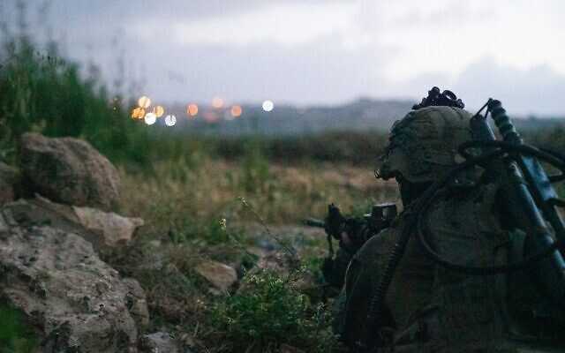
IDF soldiers are seen operating in the West Bank on April 20, 2022. (Israel Defense Forces)
A closure was imposed during the first day of Passover but was not extended over the entire holiday, and during the holiday of Purim in March the military skipped it altogether for the first time in five years.
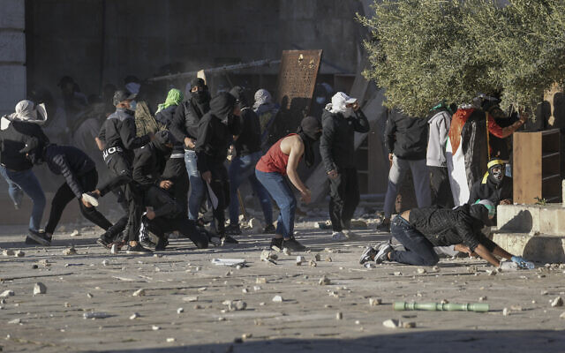
Recently, security forces have ramped up operations as 14 people were killed in a series of terror attacks carried out by Arab Israelis and Palestinians.
Troops have been carrying out extensive raids in the West Bank in response to the attacks, with at least 17 Palestinians killed in clashes with Israeli forces.
Attendance at Friday prayers at the Al-Aqsa Mosque is limited to women, children and men over 50, as per Defense Ministry orders issued earlier this month.

Palestinians clash with Israeli security forces at the Al-Aqsa Mosque compound atop the Temple Mount in Jerusalem’s Old City Friday, April 15, 2022. (AP Photo/Mahmoud Illean)
The Temple Mount, which houses the mosque and is the third holiest site in Islam and the holiest in Judaism, is a frequent flashpoint for Israeli-Palestinian tensions, including earlier Wednesday and over the past week.
Similar unrest surrounding Ramadan last May led Hamas to fire rockets toward Jerusalem, setting the stage for 11 days of combat between Israel and the terror group that also sparked widespread Jewish-Arab violence in mixed cities.
The tensions this year have already sparked a minor flareup in the south, with a rocket fired from Gaza on Monday night and intercepted by the Iron Dome air defense system — the first launch from the strip in four months. Israel hit Hamas targets in Gaza hours later in response. https://www.timesofisrael.com/idf-to-shutter-west-bank-gaza-crossings-to-palestinians-on-last-days-of-passover/

Jerusalem ‘flag march’ curbed as police block nationalists from Damascus Gate
Police presence and strategic roadblocks contain protest crowd of several hundred, including far-right MK Itamar Ben Gvir, who vows to erect a temporary office at site
By Carrie Keller-Lynn Today, 8:46 pm
MK Itamar Ben Gvir joins right-wing activists participating in a 'flag march,' planned to reach Jerusalem's Old City, but ultimately stopping beforehand at Tzahal Square, on April 20, 2022. (Yonatan Sindel/Flash90)
The Israel Police successfully contained several hundred nationalist protesters who planned a “flag march” through Jerusalem flashpoints to oppose the current government and reaffirm Jewish presence in the city and its holy sites.
Tensions in Jerusalem have peaked over the past week, and the protest had the potential to reverberate across Israel’s flailing coalition and its international relations with Muslim countries, and to escalate tensions with the Hamas terror group, which earlier in the day said it had its “finger on the trigger” ahead of the march.
Far-right MK Itamar Ben Gvir also attended the march, and upon its frustration, announced that he would be setting up a temporary office in Jerusalem’s Tzahal Square, near the Old City.
Organizers of the event originally planned to enter the Old City through Damascus Gate directly into the Muslim Quarter, and continue through there to the Western Wall.
Had they been successful, the marchers would have been met head-on by crowds of Muslim worshipers, packed into the Old City in the immediate hours before breaking the Ramadan fast.
With a minimal but growing presence, the Israel Police successfully contained the protest by blocking the road from Tzahal Square to Damascus Gate. While only several hundred meters away, the strip of road separates Jerusalem’s western and eastern sides.
Police block the road to prevent Jersualem ‘flag march’ protesters from reaching Damascus Gate, April 20, 2022. (Carrie Keller-Lynn / The Times of Israel)
Several police officers at the scene confirmed that protesters could advance through Jaffa Gate, a popular entrance to the Old City’s Jewish Quarter, and from there continue to the Western Wall. But they would be prohibited from entering the Muslim Quarter.
Protesters rejected the compromise suggestion, and their demonstration route was cut short. In all, they marched only a few dozen meters from their gathering point in Safra Square to Tzahal Square, where they remained gathered for about 90 minutes before the crowd significantly thinned.
“We want to get to Damascus Gate, where the extremist Muslims are, and the police aren’t letting us,” said Menashe Issacharof, 18, from Jerusalem.
“Jaffa Gate is calm, so we’re staying here,” he said, from the protest’s terminus in Tzahal Square.
המפגינים מנסים לפרוץ את החסימה המשטרתית, עימותים במקום. ברקע קריאות ״נקמה״. pic.twitter.com/voWNwFtV6K
— סולימאן מסוודה سليمان مسودة (@SuleimanMas1) April 20, 2022
Calm, however, did not pervade among the protesting crowd. In addition to chants of “Arabs, get out,” “Revenge,” “Bibi is the King,” in reference to former prime minister Benjamin Netanyahu and “Bennett, go home,” in reference to the current premier, the crowd intermittently became hostile.
In several bursts over the course of an hour, the crowd pushed against police barricades and took swings at officers.
Right-wing protesters scuffle with police at Jerusalem’s Tzahal Square, April 20, 2022. (Yonatan Sindel/Flash90)
The police had previously denied organizers’ demands to approve the protest, including an offer to march through the mostly Arab Christian Quarter, and the truncated march was ultimately conducted without police cooperation.
“There’s no legal prohibition against walking here, so [trying to block us] is a political decision,” said Noam Nisan, one of the march’s organizers.
The hastily organized “flag march” was planned at a time of heightened municipal and international tensions over the Old City and the Temple Mount, which have both been flashpoints for increased violence at the confluence of Passover, Ramadan, and Easter.
“We saw this week the pictures of rocks thrown at buses on their way to the Western Wall and of Jews attacked in the Old City,” says Nisan, referring to two recent incidents in Jerusalem that circulated in the Israeli press. “We wanted to do it in the place where rocks were thrown on buses.”
Among the overwhelmingly religious Zionist participants were groups of young men, families and lone protesters.
Ovadia Ben Abu, 17, from Beitar Ilit said that he “came to show Hamas and all the left-wingers that we’re here and it’s our country.”
Ovadia Ben Abu, 17, from Beitar Ilit, waves a flag during the ‘flag march’ in Jerusalem, April 20, 2022. (Carrie Keller-Lynn / The Times of Israel)
Shlomo, 25, from Givatayim, said that he, his wife and young children came to “give support to Jerusalem,” because “Jews are afraid to come pray in Jerusalem during Passover,” against a backdrop of increased terror.
The imperiled government coalition is currently trying to bring the Islamist Ra’am party back into the fold, after it announced a freeze on its membership on Sunday following clashes between Palestinians and police on the Temple Mount.
“The fear that the coalition might fall — that’s what’s motivating our policy right now,” said Shlomo, who asked to withhold his last name because he currently serves in a Military Intelligence unit.
His comment was in reference to Ra’am and what he perceived as coalition capitulations to please Muslim members.
Earlier Wednesday, Prime Minister Naftali Bennett announced that he intended to bar Ben Gvir from entering Damascus Gate.
The government has in recent days tried to walk a fine line between reaffirming Jewish sovereignty over the whole of Jerusalem and its holy sites and not inflaming further tensions with Arab Israelis and Palestinians and souring diplomatic relations with Arab allies.
Amid the conflict between Palestinians and Israeli security forces on the Temple Mount, known as Haram Al-Sharif to Muslims and hope to the Al-Aqsa Mosque, both Jordan and the United Arab Emirates have called their Israeli ambassadors for dressing-downs. Turkish President Recep Tayyip Erdogan called his Israeli counterpart Tuesday to similarly express concern about tensions on Al-Aqsa, which have captured the attention of the Muslim world.
Wednesday’s flag march was an homage to an annual event tied to Jerusalem Day, during which right-wing Israelis march through the Old City and its Muslim Quarter, waving Israeli flags and dancing to commemorate Israel’s 1967 capture of East Jerusalem during the Six Day War.
Palestinians say the event is a provocation. Last year’s Jerusalem Day flag march was conducted immediately in the run-up to Hamas firing rockets at Jerusalem, the impetus for an 11-day conflict between Israel and Hamas.
https://www.timesofisrael.com/jerusalem-flag-march-foiled-as-police-block-nationalists-from-damascus-gate/

Shin Bet said to warn allowing Ben Gvir at Damascus Gate would start a Gaza War
During security assessment on whether to bar firebrand MK from flashpoint, officials reportedly say rising tensions in Jerusalem could spill over like they did last year
By TOI staff Today, 10:44 pm
Itamar Ben Gvir speaks to the media at Safra Square in Jerusalem ahead of a right-wing march on April 20, 2022. (Yonatan Sindel/Flash90)
Security officials on Wednesday warned that allowing Religious Zionism MK Itamar Ben Gvir to march on Jerusalem’s Damascus Gate as part of a nationalist protest could lead to a “second war with Gaza,” according to TV reports Wednesday.
Channel 12 reported that during security consultations ahead of the unauthorized event, the Shin Bet urged officials present to bar the far-right lawmaker from the area, calling him a “detonator” for further tensions.
“Ben Gvir’s arrival is a detonator and a detonator must be defused,” a Shin Bet official reportedly said during the meeting. “These provocations could lead to further violence and a ramping up of tensions to the point of setting the whole region in flames.”
A security source told Channel 12 that the firebrand lawmaker’s actions are “playing into the hands of Hamas,” after the terror group said earlier in the day that it had its “finger on the trigger” ahead of the march.
Officials warned that Ben Gvir’s arrival at Damascus Gate could lead to “Operation Guardian of the Wall 2,” with Gaza terror groups Hamas and Palestinian Islamic Jihad “being forced” to respond to such an event, the report said.
Prime Minister Naftali Bennett eventually declared that Ben Gvir would be barred from Damascus Gate.
“Sovereignty and governance, yes; provocations, no,” Bennet reportedly said during the meeting.Last year’s Jerusalem Day flag march, which was also attended by Ben Gvir, was conducted immediately in the run-up to Hamas firing rockets at Jerusalem, the impetus for an 11-day conflict with Hamas the Israel dubbed “Operation Guardian of the Walls.”
Officials also reportedly said that flaring tensions in Jerusalem could lead to sectarian violence in mixed cities in Israel, just as occurred during the fighting last May, requiring security forces to divert major resources from the fight against terrorism.
Ben Gvir arrived at the march’s starting point on Wednesday but was blocked, along with all the protestors in attendance, from reaching the Damascus Gate by police.
Organizers of the event originally planned to enter the Old City through Damascus Gate directly into the Muslim Quarter, and continue through there to the Western Wall.
Had they been successful, the marchers would have been met head-on by crowds of Muslim worshipers, packed into the Old City in the immediate hours before breaking the Ramadan fast.mr- https://www.timesofisrael.com/shin-bet-said-to-warn-allowing-ben-gvir-at-damascus-gate-would-start-a-gaza-war/ [To quote a very old saying “It was a Hot time in the Old town Today(or actually tonight). The firing of rockets near Sderot and the threats and recent terror activity with the Jordanians and actually even the Russians chiming in simply is one more indication of the extraordinary tenuous situation that currently exists. I makes you wonder just how “stable and enduring” is the so called peace and relationships that were developed during the Trump years. The coalescence of Passover, Ramadan ad Easter all at about the same time is simply a set up for trouble. – rdb]

Senior Israeli diplomat takes Jordan to task for harsh Temple Mount criticism
Official says Jerusalem willing to tolerate Amman’s ‘double game’ but Jordanian PM crossed a line when he hailed Palestinian stone-throwers
By Jacob Magid Today, 9:12 pm
Palestinians seen on the holy month of Ramadan at the Al-Aqsa Mosque compound in Jerusalem's Old City, on April 17, 2022. (Jamal Awad/Flash90)
A senior Israeli diplomatic official on Wednesday accused Jordan of playing a “double game” with its responses to the recent unrest in Jerusalem — haranguing Israel in public while speaking more reasonably behind closed doors.
“They tell us that this is the way that they keep those calling for Jordan to sever its ties with Israel at bay,” the diplomatic official said during a briefing with Israeli reporters, part of which was held on condition of anonymity.
More than half of Jordan’s population is of Palestinian descent, and its 1994 peace treaty with Israel is heavily unpopular, particularly during periods of violence between Israelis and Palestinians. Ties hit a nadir under former prime minister Benjamin Netanyahu, but there have been notable improvements since the new Israeli government was sworn in last June. Jordan’s King Abdullah has hosted Prime Minister Naftali Bennett, President Isaac Herzog, Foreign Minister Yair Lapid and Defense Minister Benny Gantz for a meetings in recent months as coordination has expanded.
Israel and Jordan have also inked a UAE-brokered agreement that will see the construction of a major solar power plant in the Hashemite Kingdom to generate electricity for the Jewish state while a desalination plant established in Israel will send water to Jordan. The senior Israeli diplomat said he didn’t expect the recent tensions to impact that deal.
But Jordan has taken some steps against Israel in recent days, albeit largely symbolic ones. Amman summoned Israel’s ambassador for a dressing down after police entered the flashpoint Al-Aqsa Mosque site multiple times in recent days to quash Palestinian rioters.
Jordan has accused Israel of violating the status quo at the site, under which Muslims are allowed to visit and pray while Jews cannot pray and may only visit during restricted time slots.
Israel insists that it is committed to the status quo and is safeguarding the rights of followers of all three religions in Jerusalem. But police have also in recent years allowed for Jews to quietly pray as they’re ushered through the site by employees of Jordan’s Islamic Waqf, in what amounts to a subtle violation of the fragile status quo on the site.
“I’m prepared to accept this double game up to a certain point, but the line was crossed with the prime minister’s speech in parliament,” the official said, referring to Bisher Al-Khasawneh’s remarks earlier this week in which he praised Palestinians hurling stones at the “Zionist sympathizers defiling the Al-Aqsa Mosque.”
The senior diplomatic official said no country can put up with this kind of speech from an ally and that the message was passed along to Amman at a level of assertiveness that the Jordanians are not used to.
The official went on to lament the UAE’s response to the recent unrest, while predicting that there would not ultimately be any damage to the bilateral ties that began just a year and a half ago.
The UAE summoned Israel’s ambassador to Abu Dhabi on Tuesday and issued a statement afterward blasting the conduct of Israeli police on the Temple Mount. The UAE also spoke out aggressively against Israel at Tuesday’s closed-door meeting of the UN Security Council on the issue, according to two diplomats familiar with the matter.
The senior diplomatic official sought to downplay the issue, and said that the actual content of the discussion between UAE Minister of State for International Cooperation Reem bint Ibrahim Al Hashemy and Israeli Ambassador Amir Hayek differed significantly from the subsequent Emirati readout.
Regardless, Israel passed along its dissatisfaction with the Emirati response. “I don’t see what happened as damaging our relations,” the diplomatic official said.
As for Russia, the top diplomat claimed Moscow is staking out a position criticizing Israel for the recent unrest in Jerusalem as a way to retaliate for the latter’s stance in favor of Ukraine.
“Russia is not happy about our position on Ukraine so it is coming out against us on the Palestinian front,” the official told reporters.
He then clarified that the Russian stance on the Palestinians is actually consistent with Moscow’s principles over the years, while noting that the Kremlin’s readout from President Vladimir Putin’s call with Palestinian Authority President Mahmoud Abbas earlier this week did not include a condemnation of Israeli actions on the Temple Mount as Ramallah had hoped and expected.
“We didn’t think the Russians would be satisfied with our position on Ukraine. We’re also not satisfied with their attack on a sovereign nation,” the official said, adding that Israel will continue its policy on Ukraine that seeks to balance the need to align with the Western world with security interests in Syria, where Israel has long enjoyed a green light from Moscow to attack Iranian proxies from Russia-controlled airspace.
Turning to the status of the nuclear talks in Vienna, the top Israeli diplomat revealed that Biden administration officials have notified their European counterparts that Washington does not plan on delisting Iran’s Islamic Revolutionary Guard Corps as part of the negotiations
The official said that the nuclear talks are currently at a standstill, largely due to the Iranian demand that Washington remove the IRGC from the State Department’s list of Foreign Terrorist Organizations. Israel has lobbied publicly and privately against the move.
Despite the message the US has passed along to European negotiators, the Biden administration is still considering delisting part of the IRGC while keeping its elite Quds force on the FTO list, the Israeli official claimed. “We’re part of this conversation, but there isn’t a final answer yet.”
US State Department spokesman Ned Price did indeed appear to reject the Iranian demand when pressed on it during a Monday press briefing.
“If Iran wants sanctions lifting that goes beyond the JCPOA, they’ll need to address concerns of ours that go beyond the JCPOA,” State Department spokesman Ned Price said when asked about the Revolutionary Guards’ delisting. “They will need to negotiate those issues in good faith with reciprocity.”
As Iran has not expressed a willingness to budge on non-nuclear-related issues, Price’s remarks appeared to put to bed the possibility of a unilateral delisting by Washington, even if Tehran was making it a condition for returning to compliance with the JCPOA. https://www.timesofisrael.com/senior-israeli-diplomat-takes-jordan-to-task-for-harsh-temple-mount-criticism/ [Sooner or later when you walk a tightrope you are very likely to fall off. – rdb]

Turkey's top diplomat to visit Israel in May in effort to mend fences
Turkish Foreign Ministers tells CNN Turk he will travel to Israel to discuss the appointment of ambassadors with his Israeli counterpart
Reuters | Published: 04.21.22, 00:04
Turkey's Foreign Minister Mevlut Cavusoglu said he will visit Israel on May 24 amid increasing efforts between the regional rivals to mend ties, four years after they expelled ambassadors.
Speaking to broadcaster CNN Turk, Cavusoglu said he will travel to Israel with Energy Minister Fatih Donmez on May 24 and would discuss the appointment of ambassadors with his Israeli counterpart during the visit, which comes amid diplomatic efforts to mend the long-strained Israel-Turkey ties.
President Tayyip Erdogan said last month he was "very, very hopeful" for energy cooperation with Israel, and he hoped to discuss the issue with Prime Minister Naftali Bennett.
Earlier this week, Erdogan condemned Israel for the violent clashes that broke out between security forces and Palestinian rioters inside the Al-Aqsa Mosque compound, the latest outbreak in an upsurge of violence that has raised fears of a slide back to wider conflict.
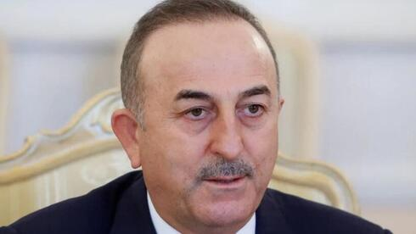
On Tuesday, Erdogan said he told his Palestinian counterpart Mahmoud Abbas that he condemned Israeli "intervention on worshippers" at Jerusalem's Al-Aqsa Mosque and threats to its "status or spirit."

Turkish Foreign Minister Mevlut Cavusoglu (Photo: Reuters)
The Turkish President added that he had also talked with Israeli counterpart Isaac Herzog, to whom he told he was "very upset" by Palestinians injured or killed in the West Bank and Al-Aqsa Mosque during the Muslim holy month of Ramadan.
The two countries expelled ambassadors in 2018 and have often traded barbs over the Palestinian conflict, Turkish support of the Hamas militant group, which runs Gaza, and other issues. https://www.ynetnews.com/article/syxec10v9

Coalition roiled anew after lawmaker says Ra’am Temple Mount demands being mulled
Yamina lashes out at Yair Golan, MK asks if he is trying to break coalition apart by proclaiming he’s ‘proud’ Islamist party’s ultimatum is under consideration
By TOI staff Today, 9:48 pm
In a new instance of infighting within the coalition, the Yamina party on Wednesday launched an attack on deputy minister Yair Golan, after he said the government was “proudly” considering demands made by the Ra’am party regarding the Temple Mount.
The Islamist Ra’am froze its participation in the coalition earlier this week as pressure mounted on it over the ongoing tensions in Jerusalem. The party also issued a list of demands to be met for it to rejoin, including returning the Temple Mount to a pre-2000 status quo, in which police and the Jordanian-controlled Waqf administering the site would have control over whether non-Muslims can visit.
Asked by Channel 12 whether the government’s recent decisions aimed at easing tensions at the Jerusalem holy site were influenced by the Arab party’s membership in the coalition, the Meretz MK said that “their considerations and interests are certainly taken into account — and we are proud of that.”
Golan also said that Ra’am’s demands need to be considered, adding that there was no need “to fear saying this out loud, we are proud of it.”
Fellow coalition members from the right-wing Yamina quickly lashed out at Golan.
“Yair, let me understand. Are you trying to dismantle the government?” tweeted Nir Orbach, a Yamina MK who last week issued his own list of demands and threatened to dismantle the coalition. His post was retweeted by Interior Minister Ayelet Shaked, also of Yamina.
In a statement, the Yamina party rejected the comments from Golan, a former general who is one of the government’s most dovish members.
“The Temple Mount is under total Israeli sovereignty, and any decisions made will be done so in light of the security considerations of the state of Israel as a Jewish and democratic state, which enshrines freedom of religion for all,” it said, accusing Golan of “doing all he can to dismantle the government.”
The government is already on the brink of collapse after MK Idit Silman, a member of Yamina, bolted the coalition, erasing its razor-thin majority. The 120-member Knesset is now deadlocked, with both the coalition and opposition holding 60 seats apiece. https://www.timesofisrael.com/coalition-roiled-anew-after-lawmaker-says-raam-temple-mount-demands-being-mulled/

After two years, Israel scrapping indoor mask mandate from Saturday night
Move must still be okayed by Knesset; comes after US judge struck down mask rule on public transit; Israelis have been subject to requirement for all but 10 days since April 2020
By Alexander Fulbright Today, 1:23 pm
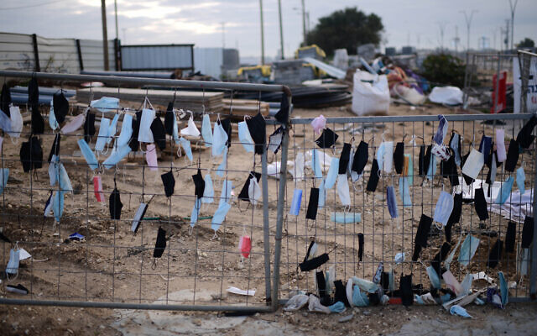
Face masks hang on a fence in Glilot, central Israel, on February 14, 2022. (Tomer Neuberg/Flash90)
Prime Minister Naftali Bennett’s office said Wednesday that Israel’s indoor mask mandate, one of the few remaining coronavirus restrictions still in place, will be lifted at the end of the week.
Citing the decline in morbidity, a statement from the Prime Minister’s Office said Bennett and Health Minister Nitzan Horowitz had agreed that the widely flouted masking requirement will be scrapped as of 8 p.m. on Saturday.
The mandate had officially been set to expire on May 1.
The statement said masking will still be required “at places with high contagion potential,” among which it listed hospitals, senior living facilities and air travel. Those headed to quarantine must also continue to don a mask.
The decision to end the mandate must still be approved by the Knesset Health Committee. MORE - https://www.timesofisrael.com/israel-to-scrap-indoor-mask-mandate-on-saturday-night/

Report: Israel is the world's 8th nuclear power
According to nonprofit policy research and advocacy organization American Federation of Scientists, France and Israel have relatively stable inventories while others - China, Russia and Pakistan - increasing stockpiles
i24NEWS | Published: 04.20.22, 21:45
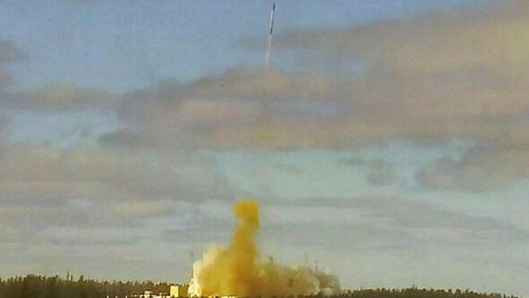
Israel is the world's eighth nuclear power, according to a report published by the American Federation of Scientists, a nonprofit policy research and advocacy organization, which tracks global nuclear arsenals, titled "Status of the World's Nuclear Forces."
The ranking is dominated by Russia and the United States, who possess in 2022 respectively 5,428 and 5,977 nuclear warheads, out of 13,000 units in the world.

Russia tests ballistic missile capable of carrying nuclear warhead on Wednesday (Photo: Reuters)
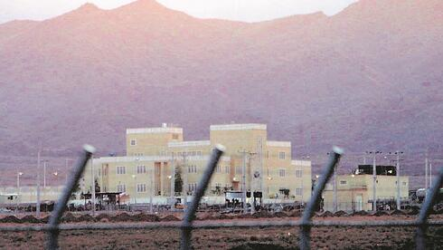
China follows with 350 nuclear warheads, France (290), the United Kingdom (225), Pakistan (165), India (160), Israel (90) and North Korea (20).
For its part, Iran has been striving for several years to become the tenth nuclear power in the world.
In 1987, at the end of the Cold War, the world had more than 70,000 nuclear warheads, or 5.5 times more than today.

Iran's uranium enrichment facility in Natanz (Photo: EPA)
"Globally, the overall inventory of nuclear weapons is declining, but the pace of reductions is slowing compared with the past 30 years. Moreover, these reductions are happening only because the United States and Russia are still dismantling previously retired warheads," the report said.
"The United States is still reducing its nuclear stockpile slowly. France and Israel have relatively stable inventories. But China, India, North Korea, Pakistan and the United Kingdom, as well as possibly Russia, are all thought to be increasing their stockpiles." https://www.ynetnews.com/article/hkeb6t64c

In policy shift, Israel to send flak jackets and helmets to Ukraine
After speaking to his counterpart Oleksii Reznikov, Defense Minister Gantz says protective equipment will be provided to civilian rescue and medical forces, though not military
By Emanuel Fabian Today, 5:18 pm
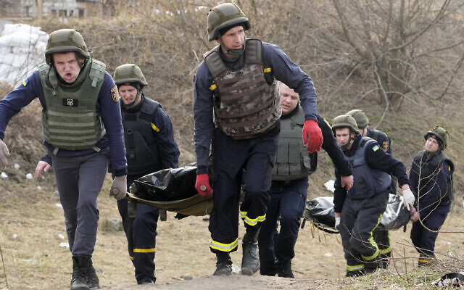
Ukrainian emergency services carry bodies of civilians killed by the Russian troops over the destroyed bridge in Irpin close to Kyiv, Ukraine, March 31, 2022. (AP Photo/Efrem Lukatsky)
After long refusing to provide defensive equipment to Ukraine, Defense Minister Benny Gantz said Wednesday that Israel will supply helmets and flak jackets to the beleaguered nation’s emergency services amid Russia’s invasion.
Gantz spoke to his Ukrainian counterpart, Defense Minister Oleksii Reznikov, following several requests for such equipment, and updated him on Israel’s decision, his office said in a statement.
Gantz “approved the purchase of protective equipment… which will be transferred to the Ukrainian rescue forces and civilian organizations,” the statement read. [So just how far can Israel go before they are going to feel a backlash from Russia. The NATO group and US are both pushing to the limit and to be honest I think pretty soon Pootie Poot is going to get fed up and let all Hell break loose. – rdb]
His office added that the helmets and flak jackets Israel intends to send to Ukraine are “in the process of being procured.”
Jerusalem first weighed Ukrainian requests for some defensive equipment in March. More recently, devastating images coming out of the Kyiv suburb of Bucha galvanized many countries against the Russian effort and led to a marked change of tone for Israeli politicians.
Western leaders united in outrage when dozens of bodies were found on the streets and in mass graves in Bucha after Russian troops retreated from the devastated town, laying bare the horrors of a 55-day war that has killed thousands.
Ukraine and Western nations have accused Russian troops of war crimes, prompting vows of action at the International Criminal Court.
Israel has avoided aligning too closely with either side since Russian troops invaded Ukraine on February 24. It is one of the few countries that maintains relatively warm relations with both Ukraine, a fellow Western democracy, and Russia.
However, the rhetoric coming from Jerusalem shifted in the wake of the reports of widespread civilian killings by the Russians. Foreign Minister Yair Lapid even explicitly accused Russia of war crimes earlier this month, in the strongest comments against Moscow yet by a top Israeli official.
Gantz’s office on Wednesday said that “the defense minister wished to emphasize that Israel stands by the side of the citizens of Ukraine, and the need to continue to assist the country and to act to end the war.”
While Jerusalem might have somewhat shifted its tone to align more with Western powers, it has so far steadfastly declined to contribute to the Ukrainian military effort. Instead, Israel has sent a 100-ton humanitarian aid package to Ukraine and built a field hospital in the west of the country.
The Defense Ministry said sending flak jackets and helmets was “part of Israel’s extensive humanitarian efforts, including the establishment of a field hospital, the absorption of immigrants and refugees, providing food, humanitarian aid, medical assistance and more.”
Kyiv has long asked for Israel to sell it defensive military equipment, including the Iron Dome air defense system, but so far has been rebuffed by Jerusalem. Ukraine has also requested cyber weaponry to use against Russia, including the NSO Group’s controversial Pegasus hacking software, according to Channel 12 news. https://www.timesofisrael.com/in-policy-shift-israel-to-send-flak-jackets-and-helmets-to-ukraine/

Holocaust survivor dies sheltering from Russian strikes on Mariupol
Vanda Semyonovna Obiedkova, who survived Nazi occupation of the port city in 1941, spent weeks in basement without water or heating
By TOI staff Today, 10:55 pm
Holocasut survivor Vanda Semyonovna Obiedkova, 91, died in Mariupol earlier in April. (CHABAD OF MARIUPOL / CHABAD.ORG)
A Holocaust survivor died while sheltering from Russian strikes in the besieged Ukrainian port of Mariupol.
The bedridden 91-year-old Vanda Semyonovna Obiedkova died on April 4 after spending weeks in a basement without water or heating, her daughter Larissa told Chabad.org.
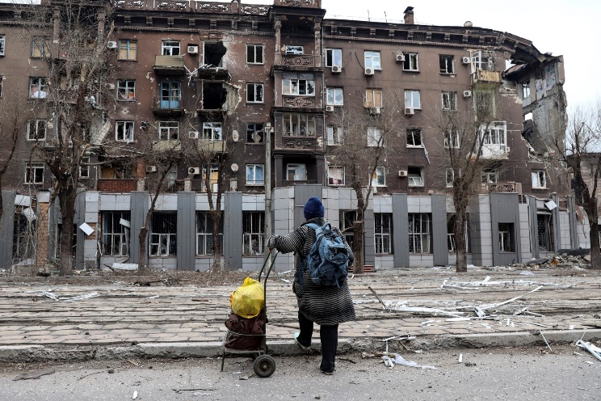
“Mama didn’t deserve such a death,” she said.
“There was no water, no electricity, no heat, and it was unbearably cold,” added Larissa, who was in the basement hiding with her mother. “There was nothing we could do for her. We were living like animals.”
A local resident looks at the damage during a heavy fighting apartment building near the Illich Iron & Steel Works Metallurgical Plant, the second largest metallurgical enterprise in Ukraine, in an area controlled by Russian-backed separatist forces in Mariupol, Ukraine, April 16, 2022. (AP Photo/Alexei Alexandrov)
Larissa said that in her final days, her mother was comparing the conflict to the Nazi occupation of the city in 1941.
“Every time a bomb fell, the entire building shook. My mother kept saying she didn’t remember anything like this during the Great Patriotic War [World War Two],” she said.
Larissa told Chabad that she buried her mother in a local park before escaping with her family.
Obiedkova was 10 years old when the Nazis occupied Mariupol in October 1941. They began rounding up the city’s Jews soon after.
While she was able to evade the round-ups by hiding in a basement, the same fate did not befall her mother, who was taken away and shot. MORE - https://www.timesofisrael.com/holocaust-survivor-dies-sheltering-from-russian-strikes-on-mariupol/

Russia tests nuclear-capable ballistic missile that Putin says has no peer
Russian president says new heavy Intercontinental Ballistic Missile provides food for thought for anyone trying to threaten Russia; test comes amid extreme geopolitical tension over Ukraine
Reuters | Updated: 04.20.22, 19:40
Russia said on Wednesday it had test-launched its Sarmat intercontinental ballistic missile, a new addition to its nuclear arsenal which President Vladimir Putin said would give Moscow's enemies something to think about.
Putin was shown on television being told by the military that the missile had been launched from Plesetsk in the country's northwest and hit targets in the Kamchatka peninsula in the far east.
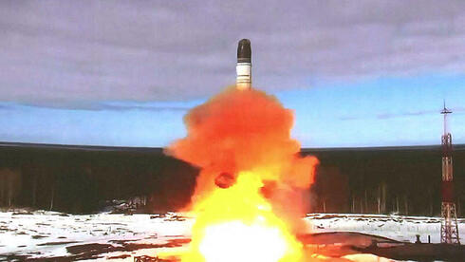
Russian nuclear ballistic missile test on Wednesday (Photo: AFP)
"The new complex has the highest tactical and technical characteristics and is capable of overcoming all modern means of anti-missile defense. It has no analogues in the world and won't have for a long time to come," Putin said.
"This truly unique weapon will strengthen the combat potential of our armed forces, reliably ensure Russia's security from external threats and provide food for thought for those who, in the heat of frenzied aggressive rhetoric, try to threaten our country."
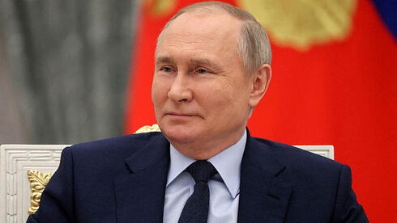
Russian President Vladimir Putin at the Kremlin on Wednesday (צילום: רויטרס)
The Sarmat is a new heavy Intercontinental Ballistic Missile which Russia is expected to deploy with 10 or more warheads on each missile, according to the U.S. Congressional Research Service.
It has been under development for years and so its test-launch is not a surprise for the West, but it comes at a moment of extreme geopolitical tension due to Russia's war in Ukraine. https://www.ynetnews.com/article/h1gzbhtn5

IMF to expedite $5 billion loan to Ukraine
The head of the fund said the aid would keep Ukrainian economy afloat
20 Apr, 2022 15:50
Ukraine likely needs $5 billion a month in financial assistance to keep its economy operating and the immediate priority was finding ways to fill that gap in the next three months, according to International Monetary Fund (IMF) Managing Director Kristalina Georgieva.
The Washington-based financial institution will start work on a future loan program, but it was “unfair” to expect Ukraine to implement a far-reaching package of reforms at the moment, Georgieva told a news conference on Wednesday.
On Sunday, Kiev requested $50 billion in financial support from the Group of Seven (G7) nations and the International Monetary Fund (IMF) to cover a budget deficit largely created by the military conflict with Russia.
Ukraine is also considering issuing 0% coupon bonds to bridge the fiscal gap, as the country is currently facing an estimated $7 billion deficit a month, according to Oleg Ustenko, the top economic adviser to Ukrainian President Volodymyr Zelensky.
The IMF and World Bank have approved more than $2 billion in loans to Ukraine since the beginning of Russia’s military operation in the country. Meanwhile, the World Bank said it was preparing nearly $1.5 billion in extra funds to allow essential Ukrainian government services to continue. https://www.rt.com/business/554237-imf-loan-ukraine/ [They need to charge this one off to Soros and Schwab. – rdb]

Foreign reserves freeze a ‘violation of sovereignty’ – China
Beijing’s UN ambassador has blasted arbitrary seizures of countries’ assets
20 Apr, 2022 14:21
China has called on Western states to refrain from freezing the foreign reserves of other nations, saying that the measure undermines world economic stability.
The Chinese ambassador to the UN, Zhang Jun, made the remarks at a UN Security Council meeting on Ukraine on Tuesday. The call comes a month after roughly half of Russia’s foreign exchange reserves, worth over $300 billion, were frozen by Western countries as part of sanctions over Moscow’s military operation in Ukraine.
“Arbitrary freezes of foreign exchange reserves of other countries also constitute a violation of sovereignty, and is tantamount to weaponizing economic interdependence,” Zhang said.
“Such practices undermine the foundation of world economic stability, and bring new uncertainties and risks to international relations,” the envoy said, adding that they should be abandoned as soon as possible.
Zhang also called for “eliminating the negative impact of sanctions,” saying that all-dimensional and limitless economic penalties entail “serious spillover effects, with developing countries bearing the brunt.” The envoy criticized unnecessary export restrictions as well.
The diplomat called on the West to stop sending offensive weapons to Ukraine, warning that this would only escalate the current conflict and worsen the humanitarian crisis in the country.
In early March, Zhang Jun criticized Washington’s “ruthless freezing or misappropriation” of Afghan assets. The US froze over $9 billion worth of assets belonging to the Afghan central bank after the Taliban seized control of the country last August. In April, US President Joe Biden ordered that half of the assets should be diverted to compensate the victims of the 9/11 terrorist attacks in the country, triggering protests across Afghanistan. https://www.rt.com/business/554226-china-west-freezing-assets-violation/ [You have China actually defending Russia in this issue and it should wake up people to the fact that there is now a Sino-Russian axis standing against the west. – rdb ]

Iran claims it caught 3 Mossad spies in southeast of country
The three were involved in "disseminating classified information and documents."
By JERUSALEM POST STAFF Published: APRIL 20, 2022 21:54 Updated: APRIL 20, 2022 22:32
Iranian intelligence claimed that it caught three Mossad spies in the Sistan and Baluchestan Province in southeast Iran near the border with Pakistan and Afghanistan on Wednesday, according to the semi-official Fars News Agency.
The three were involved in "disseminating classified information and documents," according to the report.
According to Iranian news agency IRNA, more details about the case will be released at a later date.
Clashes with smugglers and militants in the province are common.
In March, the Iranian Intelligence Ministry in West Azerbaijan claimed that it caught an Israeli spy network in Iran, according to IRNA.
The ministry claimed that the spy network was trying to carry out acts of sabotage inside Iran by hiring locals. The ministry added that "those who threaten the security of the people and society must either die, be injured or surrender to the law," according to IRNA.
In July of last year, Iran’s Intelligence Ministry claimed that it had arrested a network of Mossad agents and seized a heavy shipment of weapons and ammunition after they entered Iran through its western border, according to Fars News Agency. https://www.jpost.com/breaking-news/article-704747

US Army doctor reveals medics were told not to report adverse COVID jab reactions
Dr. Peter Chambers also gave informed consent briefs to 3,000 soldiers, after which only six received the COVID jabs.
MichaelHaynes Wed Apr 13, 2022 - 4:14 pm EDT
(LifeSiteNews) – A U.S. Army lieutenant colonel and combat physician has described how fellow medics in the Army were told not to enter records of COVID jab adverse reactions into official databases.
“They either look the other way or they just say, ‘Well, I can’t do that. It doesn’t exist’,” said Dr. Peter Chambers, a lieutenant colonel in the U.S. Army, Special Forces Green Beret, and combat physician.
Chambers made the comments as part of the Truth For Health Foundation’s ninth online conference, which saw the announcement of the Foundation’s new global reporting system for COVID jab injuries.
Dr. Chambers’ jab reactions
Discussing the armed forces COVID jab rollout along with Dr. Elizabeth Lee Vliet, the Foundation’s president and CEO, Chambers shed light on his recent experience as a taskforce surgeon for Operation Lone Star, a border security mission of the Texas military at the U.S.-Mexico border.
Chambers, a veteran of 39 years and a Purple Heart recipient, received Moderna’s COVID jab in January 2021, unaware of the potential side effects. He now counts himself as an advocate for the “vaccine wounded” due to the adverse reactions he experienced afterwards.
He swiftly developed “brain fog” of a kind which he had not experienced even while suffering aftershock from rockets while on active duty, and experienced loss of eyesight.
Following an eventual MRI scan, after bouts of vertigo, dizziness, and nausea which caused him to crash a truck while returning from night patrol, Chambers was diagnosed with demyelination, a disease which affects the nerve tissue.
Army medics ‘told not to enter’ adverse events into database
He recounted how he had seen “multiple soldiers” also suffering similar side effects from the injections, along with “six soldiers that have been in the ICU,” and one soldier who was forced to take a second jab despite having suffered micro-clotting after her first.
Dr. Chambers took down the details from these service personnel and entered them into the CDC’s Vaccine Adverse Events Reporting System (VAERS). However, he revealed to Dr. Vliet that “surgeons at the military hospitals were not letting them in. They were told not to enter people into VAERS.”
“Doctors told me personally in the active duty system that worked at Fort Sam Houston, that they were not to enter people into the VAERS system,” he added.
Due to the COVID jabs’ collective nature of being experimental vaccines, Chambers noted how “we can’t even enter it [COVID jab injuries] into our own defense, medical, epidemiological databse.” https://www.lifesitenews.com/news/us-army-doctor-reveals-medics-were-told-not-to-report-adverse-covid-jab-reactions/
FDA official: We can't keep 'boosting' for COVID-19
Dr. Peter Marks sees 4th shot as 'stopgap measure'
By Art Moore Published April 20, 2022 at 7:41pm
A top FDA official says a fourth COVID booster shot should be seen as a "stop gap" measure, concluding "we simply can't be boosting people as frequently as we are."
Dr. Peter Marks, director of the Center for Biologics Evaluation and Research, made the remark at the recent meeting of the FDA's Vaccine and Related Biological Products Advisory Committee, TrialSite reported.
"I think we are very much on board with the idea that we simply can’t be boosting people as frequently as we are," said Marks, a New York University-trained molecular biologist and hematologist/medical oncologist.
Marks said he's the "first to acknowledge that an additional fourth booster dose that was authorized was a stopgap measure until we got things in place for the next potential booster, given the emerging data researching ... advanced vaccines, mucosal vaccines, pan coronavirus vaccines."
"But we are not going to get there for this coming year," he continued. "And so this is really, trying to do the best we can with the knowledge we have at hand, which is something that we had to do a fair amount of over the past two years."
Last month, the FDA expanded emergency use authorization for a fourth shot – a second booster – for people people age 50 and older without a vote of its expert panel.
At the time, Johns Hopkins University professor Dr. Marty Makary condemned the move in a series of tweets.
"There is no greater slap in the face of science than bypassing the customary FDA external expert voting process over an authorization with insufficient supporting clinical data," Makary wrote.
The FDA vaccine panel met later, April 6, to discuss boosters, but no vote was taken.
Dr. Peter Marks, director of the Center for Biologics Evaluation and Research within the Food and Drug Administration. (Wikimedia Commons)
Marks was at the center of the resignations of the two top FDA scientists last summer, Marion Gruber and Philip Krause, Politico reported. The news site cited a former FDA official who said the two officials quit because they were angered by the agency's lack of autonomy regarding its approval of the vaccines.
A current official told Politico at the time that the resignations were due to differences with Marks.
Makary recalled that "political interference over boosters" by the White House was the issue behind the resignations of two the high-level FDA officials.
He argued there is "zero clinical data that a 4th dose reduces hospitalization risk."
"There isn't even any evidence that a 3rd dose reduces hospitalization risk in young people," he said.
Meanwhile, the CDC and U.K. government data have indicated that the COVID-19 vaccines not only are ineffective in preventing cases and transmission, they rapidly lose protection against severe illness or death while posing risks.
A newly published long-term study by the prestigious British journal The Lancet that followed up on participants in the Moderna and Pfizer trials found the vaccines had no effect on overall mortality.
Last month, a former adviser to the FDA commissioner who continues to serve in an oversight role said the agency is ignoring its requirement to disclose clear safety and efficacy problems with the COVID-19 vaccines. Also in March, an Army flight surgeon testified in federal court that she was ordered by high-level command not to discuss the controversy over Department of Defense data indicating a massive spike in serious injuries and illnesses among military personnel when the vaccines were rolled out in 2021. And, among many other safety signals, an analysis of CDC data by a former Wall Street executive an an insurance industry expert shows an alarming rise in excess deaths among Millennials over the past year amid the COVID vaccine rollout.
In April, the Food and Drug Administration released a briefing document that says the composition of the current COVID-19 vaccines might need to be changed to ensure high levels of protection. https://www.wnd.com/2022/04/fda-official-cant-keep-boosting-covid-19/ [This entire debacle has been a terrible fraud by the governments and pharmaceutical group who all need to be charged with mass murder and genocide. – rdb]
Teacher fired for telling parents of daughter's 'transition'
School counselor 'told her teachers to hide this information'
By Bob Unruh Published April 20, 2022 at 5:05pm
A schoolteacher who shared with parents a statement from their daughter about her purported gender "transition" was fired for the communication, according to a report from Just the News.
That's even though the parents had told the school district not to have any gender-oriented conversations with their daughter, and officials refused to cooperate.
The report said the case now is the focus of a lawsuit against the district by multiple parents.
It was parents Stephen Foote and Marissa Silvestri who learned the school in Ludlow, Massachusetts, also was treating their son as a girl in accord with his wishes, according to their complaint against several current and former district and school officials for violating their parental rights.
Interim Superintendent Lisa Nemeth told Just the News the district had no comment.
But the report explained how Baird Middle School teacher Bonnie Manchester started a GiveSendGo fundraiser more than a year ago when she was first put on paid leave for notifying the girl's parents of her gender transition.
She has not yet filed litigation against the school, but her lawyer said it was being considered.
Just the News explained, "While it's increasingly common for districts to implement procedures to socially transition students without parental notification, Ludlow's alleged actions stand out for violating a direct request from parents and making an example of a whistleblower."
The report explained how "B.F.," the daughter, was coached by the school, which initially contacted the parents. But when Foote and Silvestri instructed that their daughter was getting professional help and school officials must not have conversations with her on the topic, school officials declined to comply even though they had promised to obtain parental consent moving forward.
Shortly after, "School counselor Marie-Claire Foley told her teachers to hide this information from Foote and Silvestri, and a week later reiterated the directive to staff," the report said.
But Manchester forwarded an email from the daughter concerning the situation to her parents.
When the parents confronted school officials, Manchester was put on leave for "inappropriate communications" and she was terminated shortly after.
WND reported when the legal action developed it was the Massachusetts Family Institute that brought the case on behalf of two families.
A commentary at PJMedia described the situation as a "groomer school" where officials coached children into transgender ideologies while hiding their actions from parents.
The institute said it is working with the Child & Parental Rights Campaign on the lawsuit on behalf of two Ludlow families against public school officials there.
"The families are suing for violations of their parental rights stemming from a district policy prohibiting school staff from sharing information with parents about a student's discordant gender identity and efforts to promote that identity in school. In the case of one of the families named in the suit, school officials were actively transitioning their 11-year-old daughter and 12-year-old son without their parents' knowledge and against their wishes," the group confirmed.
The organizations said in a statement that school officials were told by the parents not to speak to their children about gender identity, but actively "dismissed" the instructions and "not only continued having such conversations with their daughter, but began addressing her in school by an alternative name and pronouns."
School staff members used the girl's real name only in communication with her parents, "intentionally concealing their affirmation of her gender transition at school."
Commentator Megan Fox at PJMedia explained Vernadette Broyles, general counsel of CPRC, said, "We are seeing this type of concerted effort by school officials across the country. School officials are making decisions about the lives of children that they are not qualified or authorized to make and doing it without telling, and often deceiving, parents.
"This is a clear violation of the parents’ rights to control the education, health, and upbringing of their children."
https://www.wnd.com/2022/04/teacher-fired-telling-parents-daughters-transition/ [This is very obvious criminal child abuse by the school and they all need to lose their license to teach and be brought up on charges of child endangerment. Schools have absolutely no right to countermand parents wishes on these subjects. – rdb]

Move aside Joe: 26 states form border security 'strike force'
GOP governors react to chaos they blame on Biden's policies
By Art Moore Published April 20, 2022 at 7:11pm
Reacting to the border chaos they blame on President Biden's policies, 26 Republican governors are uniting to address the consequent threats to their communities.
Through the newly formed American Governors Border Strike Force, the governors will share intelligence and analysis of state-level crimes connected to border security, the Washington Times reported.
Of major concern is the financing and mobility of cartels that smuggle people and drugs across the border to states across the nation, effectively making every state a border state. Fentanyl, in particular, has been flowing across the southern border amid record-high numbers of drug overdose deaths.
The coalition is led by Arizona Gov. Doug Ducey and Texas Gov. Greg Abbott, who say they have been forced to intervene to plug holes in border security created by President Biden's reversal of President Trump's policies.
Ducey said the American Governors’ Border Strike Force "will serve as a force multiplier in the fight against criminal activity directly tied to our border."
"My thanks to my fellow governors who saw the problem and chose to be part of the solution," he said.
Along with Arizona and Texas, the Times reported, the governors in the strike force are from Alabama, Alaska, Arkansas, Florida, Georgia, Idaho, Indiana, Iowa, Maryland, Mississippi, Missouri, Montana, Nebraska, New Hampshire, North Dakota, Ohio, Oklahoma, South Carolina, South Dakota, Tennessee, Utah, Virginia, West Virginia and Wyoming.
Meanwhile, a source told Axios on Tuesday that Biden and his top agency officials are considering not ending Title 42 on May 23, as planned. The measure has allowed border agents to turn away an about 1 million asylum seekers in the last year who come from countries plagued by an epidemic, such as COVID-19.
The Biden administration officials, according to Axios, acknowledged that ending Title 42 could bring about an unprecedented wave of illegal immigration.
At the White House on Wednesday, Fox News correspondent Peter Doocy asked press secretary Jen Psaki if the president is discussing delaying the removal of Title 42.
Psaki said Title 42 is a health authority, which means the decision is up to the CDC, and the administration is preparing for it to end. She noted some Democrats oppose the expiration of Title 42 and there are other ideas that will be part of the debate.
Doocy also asked why Biden has confidence in Vice President Kamala Harris as his border czar despite the fact that March 2022 has seen 28% more migrant encounters at the border than March 2021, when she was assigned the task.
Psaki said Harris has been working on bilateral agreements with "transit countries" through which migrants travel and their home countries as well as Mexico. https://www.wnd.com/2022/04/move-aside-joe-26-states-form-border-security-strike-force/ [The entire DC group of demon-rats are flagrantly incompetent boobs who are either completely mismanaging everything or are doing so on purpose to destroy the country – rdb]

Commentary:
The Biden Administration’s Seder Makes a Mockery of Passover and the Jews
Daniel Greenfield April 19, 2022
"Good evening to the thousands of you who are joining us from around the country," Doug Emhoff, the Hollywood lawyer serving as Kamala's husband, intoned.
The sign language interpreter on the small box next to him spread her arms in what was either an attempt to 'sign' Passover or a gesture of disbelief and contempt.
The "People's Seder" was about to begin with its apostrophe in the right place and heart in the wrong place.
As the Biden White House rushes to enable Iran's nuclear program and the modern day pharaonic mullahs plotting, like the original, to wipe out the Jews, it put on a "People's Seder" to distract American Jews from its complicity in the latest acts of terror from Iran to Israel.
The People's Seder sounds like a Berkeley commune. A day before the eve of Passover, the administration’s second virtual seder served no function except to give Emhoff something to do. Perhaps knowing that, Emhoff claimed, with a mostly straight face, that he had traveled the country hearing from people “how much last year’s virtual seder had meant to them”.
Emhoff made no mention of the over a dozen Israelis recently killed in terror attacks. Neither, seemingly, did so many of the speakers who rambled on about the importance of “empathy”.
Empathy applies to everyone except the Israeli Jews mourning their dead.
Passover, to Emhoff, proved to be about Ukraine, about the pandemic, and “protecting democracy”. Maybe Emhoff can tell me which democratic process elected Moses.
Then a particularly haggard Biden, looking awkwardly at things off camera, boasted that this was the “first time in three years that families sit around the seder table.”
That might be true in Washington D.C., but it certainly isn’t true in America.
Biden then declared that during Passover, his hearts were “with the people of Ukraine”.
The camera cut to the White House's bewildered Jewish liaison.
Passover, so far, was about Ukraine.
The previous seder, featuring an anti-Israel activist, was apparently so popular that Emhoff decided to recycle his shtick about “gelatinous gefilte fish” from last year. Then he declared that “ever since I was a kid, I have been inspired by the story of Exodus.”
Indeed, who could forget the time Moses went back to Egypt, married Pharaoh’s sister, and settled down to the business of assisting in the genocide of the Jews.
Emhoff’s presentation was followed by a long list of speakers eager to delve into Passover as a metaphor and uninterested in it as a substantial reality.
There was Andrew Rehfeld, the first "non-rabbinic" head of the Reform Movement's Hebrew Union College seminary, who had defended BDS supporters against claims of antisemitism.
"Some students have been attracted to the BDS movement because of their love of Israel, and their repugnance of what they see as its unjust treatment of Palestinians," Rehfeld had argued. "BDS is not the answer. But that does not mean that their concerns are without merit."
Rehfeld appeared with a large placard behind him declaring, "Another Jew for LGBTQ Equality".
The non-rabbinic head of a movement that denies the existence of the G-d of the Torah made no mention of the Creator of the Universe, but spoke about “bullying” and “civil society”.
That was followed by J Street’s Deborah Lipstadt, who talked about Ukraine, and Jeopardy host Mayim Bialik who… also talked about Ukraine. An ignorant viewer might have concluded that in the Bible, the Jews had left Ukraine, rather than Egypt. After a brief interjection by an Orthodox Rabbi who actually had a seder plate on display, next up was Afroculinaria's Michael W. Twitty, a black gay social justice chef who had previously accused Israel of racism.and who explained that in his seder molasses "represented the transatlantic slave trade."
Dayenu!
The People’s Seder was dedicated to philosophical abstractions that erased Jews and negated the fundamental truths of the Passover story. Attaching the "People's" to something is a negation. That's why the various democratic people's republics were anything but and why the People's Seder isn't a seder, or at least not a Jewish one, but a People’s Republic of Seder.
Less than two minutes into his virtual farce, Emhoff had declared that "even though the Exodus tells the story of a particular people, its message is universal." Everything about Judaism to secularists is universal, and nothing is particular or relevant to the actual Jews.
It would be dangerous to focus on the particular people currently being killed once again in their own country because Emhoff’s wife’s boss chooses to stand with Islamic terrorism.
After the People’s Seder was done, Ambassador Tom Nides, who had been caught praising a BDS group and boasting of trying to keep Jews out of Jerusalem, issued a press release in English, Arabic, and Hebrew (in that order) which urged “Jews, Muslims and Christians” (also in that order) to avoid "actions that further escalate tensions" during "this sacred holiday period".
That would include concluding the seder with the traditional call, “Next Year in Jerusalem”, signifying a return to a city that Biden and Nides deny is Jewish and want to keep Jews out of.
Nides, Emhoff, and other administration enablers of Jewish descent, erase Jews from Passover and Jerusalem, and replace the real people and their history with social justice abstractions.
Part of the problem is that Emhoff, like your average leftist of Jewish ancestry knows as much about Judaism as I do about dating Kamala. And cares just as little. Stripping Judaism of its particularism appears liberating to someone like Emhoff because it also frees him of what he and his family see as a limitation on their identities and their potential social aspirations.
The People’s Seder is not a Jewish people’s seder because that’s the last thing Emhoff wants.
Liberation to lefties of Jewish descent means the ability to be less Jewish. That is at odds with the message of Passover and of Judaism which is that liberation comes from being more Jewish. The Jews who had tried to fit into Pharaoh’s tyranny had become slaves, while the slaves who defied an empire by conducting a seder that mocked Egyptian beliefs were set free.
Universalism is enslaving while particularism is liberating.
The Passover seder’s message, with its careful recreation of the particular experiences, sensory, emotional, and intellectual, of Egyptian slavery and liberation, is a painstaking excercise in particularism. The People’s Seder, like virtually all lefty religious practices, is an equally painstaking exercise in rejecting the particular for the universal by turning the events into metaphors that can be glibly made to mean anything as long as it’s unrelated to the Jews.
It’s all very well to turn the story of Passover into a metaphor, but Moses didn’t arrive to talk to Pharaoh about abstractions like empathy and emotional growth, but with a simple message.
“Let My People Go.”
The People’s Seder claims to be about liberation, but actually enslaves. It rejects “the four languages of liberation” whose four steps "I will take you out", "I will save you", "I will redeem you" and "I will take you" develop it as relationship between G-d and the Jewish people, to universalize it into hollow self-help empowerment in which there is no relationship with G-d.
Instead there is a relationship with the leftist deity of government all too familiar to Pharaoh.
Worshipping government isn’t liberation, it’s slavery.
Daniel Greenfield is a Shillman Journalism Fellow at the David Horowitz Freedom Center. This article previously appeared at the Center's Front Page Magazine. https://www.danielgreenfield.org/2022/04/the-biden-administrations-seder-makes.html

The Middle East: An American Vision
Review of Behind the Silken Curtain
by Amir Taheri April 20, 2022 at 4:00 am
Behind the Silken Curtain: A personal account of Anglo-American diplomacy in Palestine and the Middle East
by Bartley C. Crum
New York: Simon and Schuster, 1947. 297 pp. $3.00
In 1946, with the tragic memory of the Second World War still very much alive, few Americans could have imagined, or would have wanted to admit that far away Middle East would soon develop into one of the top concerns of US foreign policy.
One American who realized this before many others was Bartley C. Crum, recruited by President Harry Truman to serve as a member of the American team on a United States-United Kingdom mission on Palestine. Although a Republican, Crum enjoyed enough of a reputation as a man who could transcend partisan boundaries to serve under a Democrat president, in the interest of the nation.
Prior to his mission, Crum had had little interest in the Middle East that, to most Americans, was not the popular, and often passion-arousing, subject it has since become. This enabled Crum to embark on his mission with an open mind and certainly no hidden agenda.
For Crum, the mission that took several months and covered more than a dozen countries in the Middle East and Europe became an introductory course on the politics of a region that has dominated the headlines to this day.
Crum writes:
"If my experiences in the days and weeks devoted to this problem have taught me any one thing, it is that everywhere the need is felt for an American foreign policy -- a foreign policy so firmly embedded on principle that it will hold equally for United States troops in China or the atom bomb, or Palestine."
However, no one had told Crum what that policy was supposed to be. And his account of the mission clearly shows that President Truman, who always relied on his own instincts and sided with the forces of freedom and progress, was often opposed by his own State Department that practiced a value-free diplomacy in the name of preserving the status quo.
Crum states that the US faces a choice in the Middle East:
"We can throw our lot in with the forces of reaction who prop up feudalistic regimes in the Arab states in the hope that these will serve as a cordon sanitaire against the Soviet; who believe they can successfully continue the same processes of exploitation in the future which have proved successful in the past. Or we can throw our lot in with the progressive forces in the Middle East. We can recognize that there is a slow rising of the peoples, and that we must place ourselves on the side of this inevitable development toward literacy, health, and a decent way of life."
Crum had no doubts as to where his own sentiments lay. He was against a status quo that subjected the nations of the region to despotism and poverty. He also realized that Arab despots and their hangers-on used the issue of Palestine as a means of diverting attention from their own misdeeds, wasting Arab energies on xenophobia and religious bigotry. The irony in all this was that Great Britain, then under a Socialist Labour government, sided with the Arab despots, and did all it could to discourage and weaken the very forces of reform and change that Crum saw as the natural allies of Western democracies.
Before winning power in the general election of 1945, The British Labour Party had passed a key resolution on the Middle East, in effect endorsing the creation of a Jewish homeland in mandate Palestine. Once in power, however, Prime Minister Clement Attlee and Foreign Secretary Ernest Bevin were convinced by the Foreign and Colonial Office, where British policy was made, that any change in Britain's traditional policy could weaken the Western position vis-à-vis the Soviet Union in the context of a looming Cold War.
The British establishment's policy on the Middle East was based on three assumptions.
The first was that it is natural for Arabs to be ruled by a "strongman". The second was that the Arab "strongman" had no principles apart from a keen desire to stay alive and in power. The third was that, if handled intelligently, the Arab "strongman" could be useful to the West.
The "strongman" could take decisions that no democratic government, subject the vagaries of public opinion and the pressure of elections, would be able to contemplate.
Within days of the start of the Anglo-American mission, it had become clear to Crum that some members of the American team found the British analysis irresistible. Loy Henderson, the senior State Department diplomat and head of the Middle East desk at Foggy Bottom, was one example. At times, he sounded more British than the British themselves. (Henderson was to become US Ambassador to Iran in the early 1950s.)
When the Anglo-American mission ended, it had become clear that the British colonialist view had triumphed over American idealism as echoed by Crum and a few other members of the US team. This meant that the two allies were committed to preventing change in the Middle East.
At the time change also included the creation of a Jewish homeland in Palestine.
Crum's account refutes one of the most persistent fables in the Middle East: that Britain and the United States created Israel as an outpost of the "Imperialist West" in the Muslim world. Crum shows that, far from creating Israel as a state, the two Western powers did what they could to prevent its birth. It was the Jews' determination and their readiness to fight that forced both powers to admit the emergence of Israel as a state.
The history of the past six decades shows that Crum was right. Betting on the Arab "strongmen" was morally wrong and politically shortsighted. Five years after the Anglo-American mission, Egypt's feudalist monarchy had been replaced by a leftist military regime that regarded Britain and the US as guarantors of the ancien regime, and quickly turned to the Soviets for support. Six years after that the second pillar of the British policy in the Middle East collapsed when another group of leftist army officers toppled the British-installed monarchy in Iraq. In between, the Syrian "strongmen" had also found their way into the dustbin of history. By 1960, the switch that the British had tried to prevent in the Middle East had taken place almost everywhere, leaving the Western powers with no reliable ally but Israel, the very state whose emergence they had tried to prevent.
The tragic irony in all this is that while the British assumed that the Arab masses would not accept a Jewish state in Palestine, Crum found evidence to the contrary. Both Arabs and Jews in Palestine told him that they could, and in some cases actually desired, to live and work together. It was up to Britain and to a lesser extent the US to show leadership and help Arabs and Jews create the post-colonial state structures required for their coexistence.
Crum quotes a senior Arab supporter of reform:
"If they were sure that Britain and America wished the Jews and Arabs to get together, we would. But they are not convinced, these Arab leaders: they wish to maintain their position of power, and they know that depends upon toeing the {British} Colonial Office line."
While opposing the creation of a Jewish state, Britain moved quickly to create an Arab state in mandate Palestine. However, this was not a state for the Palestinians. It was an emirate carved out for the Hashemite family of Hejaz as a reward for their collaboration with Great Britain during the First World War. The newly created state was named the Emirate of Trans-Jordan, ignoring that its territory covered almost 90 per cent of mandate Palestine while 90 per cent of its inhabitants were Arabs from the British Mandate of Palestine.
Crum saw this as a scandalous example of colonial cynicism, and recommended that the United States reject the admission of Trans-Jordan to the United Nations. He writes: "There is no question that the removal of Trans-Jordan from the terms of the mandate was a violation of its original purpose."
One could only guess Crum's sense of outrage. While Britain used its military and diplomatic power to prevent the entry of Jewish survivors of the Nazi Holocaust into Palestine, the Colonial Office, was creating an emirate for a wealthy Arab family whose members lived in Britain in golden exile and hardly felt homeless.
Crum is saddened by what he regarded as Britain's change of course in the name of Realpolitik. However, he is not censorious. Major powers make their biggest mistakes in the name of realism and expediency. He writes:
"It is tragic that Great Britain today seems to have forgotten the original intent of her own men of vision who knew what they were building and why. However, we must be careful, in judging Britain, to remember that here we Americans, too, have compromised with the basic principle of freedom for reasons of expediency. We have taken our cue from those British statesmen who have based their policy in undeveloped regions of the earth upon cooperation with local potentates rather than upon promotion of the genuine interests of the masses. Our course has been one of duplicity, with conflicting public and private pledges. I am sure our policymakers have been able to do this only because of lack of clear popular understanding of the issues involved."
Crum makes no claims to prophethood. However, it seems that having spent time in the Middle East where prophecy has been an export item for millennia, he acquired a vision that most of his fellow mission-members lacked. In a series of policy proposals at the end of the book, he foresees the so-called two-state solution that became official US policy only in 2004 under President George W Bush. He also insists that it must be made "fundamentally clear that Arab states have no special position in relation to Palestine."
Crum's wish was granted in 1980 at the Khartoum Summit when the League of Arab States eventually gave up its claims with regard to Palestine, accepting that the matter be left to Israel and the Palestinians. Thanks to Crum's exceptional powers of observation and the meticulous notes he took, we catch telling glimpses of a number of interesting figures who were to play bigger roles in later years.
Appearing in cameo roles here are such figures as Habib Bourguiba, the future father of Tunisia's independence. A French citizen at the time and a lawyer, he was enlisted by the Arabs to argue the case against a Jewish homeland at a series of hearings organized by the Anglo-American mission. A decade later, the same Bourguiba was to become the first Arab leader to recommend full Arab recognition of Israel. We also meet Hassan al-Banna, the mysterious Egyptian schoolteacher who had founded the Muslim Brotherhood, a rightwing religious outfit the British often used against the Left in Egypt. Here, al-Banna is fielded to back the British position and argue for the inclusion of Palestine into an undefined "Arab world."
Crum describes the grandfather of present-day Islamist terrorism as "a dark-headed, heavy-set figure with glowing eyes."
Echoing British claims, Banna tells the Anglo-American commission that Muslims will never accept a Jewish state in their midst.
Crum writes:
"El-Banna insisted that the Koran mentioned Christians and Moslems favorably, but had nothing good to say about the Jews, and that religious bonds between Jews and Palestine meant nothing because these bonds were diametrically opposed to the Koran and Moslem practices."
Incidentally, Crum describes the Muslim Brotherhood as "a Fascist religious organization", thus refuting the claim that "neo-cons" invented the concept of an Islamic fascism in the 21st century.
Other characters fielded by the British in what looked like a theatrical production included His Eminence Sheikh Ahmad Murad al-Bakri who bore the lofty title of The Grand Chief of the Sufis but was on British Colonial Office's payroll. We also meet Muhammad Fadil al-Jamali who was to become Iraq's Prime Minister thanks to the British before being put to death by pro-Soviet officers who seized power in 1958. At the time al-Jamali wanted the coastal part of mandate Palestine to be handed over to Iraq.
Then there was Azzam Pasha, an Egyptian grandee, who told the commission that it was not the Jew but the West that Arabs regarded as evil. He said European Jews were being brought to the Middle East as "Westerners in disguise" and "with imperialist ideas." In the next breath, however the same Azzam was calling on Britain to let Egypt annex the Sudan!
The Syrians testifying at the commission denied that a Palestinian entity ever existed, and argued that the mandate Palestine should be handed over to the military regime in in Damascus.
Remarkably, while all Arabs opposed the creation of a Jewish state in any part of the mandate area, few were prepared to hint at the possibility of creating a state for Arab Palestinians. The Syrians insisted that Palestine was part of Syria while the Egyptians had claims of their own. The Iraqis believe that Palestine actually belonged to them because, in al-Jamali's words "the coastline of Palestine represents the seaport of Iraq."
In his book, Crum makes no secret of whose side he is on. He is on the side of the Jews who came to Palestine to build a new country. However, he is not on their side solely, or even largely, because they are Jews. Nor is he supporting them only because so many Jews had suffered at the hands of the Nazis. Crum believes that Jews in Palestine could bring the modern world to the Arabs as well, a vision first raised by Theodor Herzl in his "New-Old State", one of the founding texts of Zionism.
A Jewish state could be a model of modernity and democracy that Arabs could adopt. Arabs, Crum believed, needed a dose of the same creative spirit, love of hard work, social solidarity and egalitarianism that marked out Jewish settlements alongside poor and insalubrious Arab villages. Crum was shocked to see that none of the Arab witnesses testifying to the mission showed the slightest interest in improving the lives of the Arab masses.
He writes:
"One felt their ever-present sense of fatalism. A child born crippled limps through life; a child made blind by trachoma is a victim of Allah's will, not man's. And, who is to say that Allah chose wrongly in singling out this child?"
To Crum the blame rests with nature and the imperial powers that dominated the Arabs for centuries. He writes:
"I did not blame the Arabs: they were the products of a cruel physical environment where nature sapped strength and vitality. They were the products of a political and social environment that only complicated their helplessness. For four centuries under Turkish rule, they had been subject to every pressure of ignorance. Human welfare had no part in the Ottoman Empire. It was truly pointed out to us that as far as the Middle East was concerned, the French and American revolutions might never have taken place. The doctrine of human rights and personal liberty -- the concept that man had dignity as human being and the latent power to lift himself from the mire of animal existence- had not penetrated the citadels of Islamic authoritarianism. "
Crum could not have known that the Anglo-American decision to effectively side with the Arab despots would in time breed four major wars and seven decades of tension and conflict in a region of vital importance to the Western powers. However, he knew full well that Arab ruling elites were not prepared to accept the existence of a Jewish state and that they would continue to use the Palestine issue as a means of diverting the attention of their own people from real problems such as tyranny, terror and poverty. Many Arab leaders still use the same arguments and excuses they did 70 years ago. The reason is that many Arab states have failed to modernize and democratize. In many cases, they remain as despotic as they were at the end of Second World War. Regimes of this type cannot conceive of rivals or adversaries in the normal political sense of the terms. What they need is an "enemy" who could be vilified on religious, ethnic and ideological grounds. Israel continues to fit the bill on all those scores.
The Human Development reports prepared by Arab intellectuals in the past few years paint a picture that is strikingly similar to the one that shocked Crum six decades ago. Israel remains the enemy because, being democratic, modern, economically successful and self-confident, it is the quintessential "other" to states that remain despotic, semi-medieval, economically underachieving, and ridden by self-doubt. Real peace, that is to say durable and "warm" peace, is possible only between states organized on similar principles and subscribing to similar values. Only like with like could live together in warm peace. The best that states based on divergent principles could hope for is a ceasefire or "cold" peace."
This means that as long as Arab states have not democratized, that is to say not transformed themselves into modern societies based on the rule of law, they cannot live in warm peace with Israel or any other democracy. In other words, real peace and thus Israel's ultimate security depends on reform and democratization in the region. In the meantime, while every effort should be made to promote peace, even in its "cold" version, that is to say a ceasefire with a more attractive label, armed vigilance remains necessary. Although war has a bad name these days, there are occasions when it is the only reasonable means of preventing even greater tragedies. For Israel, it is important to understand that it is involved in a long game in which patience and steadfastness are keys to ultimate success that in its case means survival. Building policies on quick fixes or looking for miracle solutions could generate even more complications, as did the rehabilitation of Yasser Arafat through the Oslo accords.
Crum's valuable book clearly shows that no amount of politics and diplomacy would have saved the still fragile Jewish "homeland" from total destruction, an eventuality that the British Colonial Office would not have regretted.
What saved the Jews was their readiness to fight even when the odds seemed heavily stacked against them. And, as Crum shows they were ready to fight because they knew they were fighting for themselves not for a despotic lord and master. David Ben Gurion's adamant quest for statehood was based on the understanding that the ideal could be an enemy of the real. This is why he accepted to build his dream state on a tiny chunk of land as full of holes as Swiss cheese. What mattered was to transform a cause into a state as quickly as possible.
The Middle East conflict has been and, to a large extent remains, a struggle between the future and the past, democracy versus tyranny, and an open society against closed ones. It also illustrates a fight between the ideal, which for many Palestinian elders is the destruction of Israel, and the possible reality of coexistence by two nations even in the context of a cold peace. Much of what Crum wrote 70 years ago remains true today.
Amir Taheri was the executive editor-in-chief of the daily Kayhan in Iran from 1972 to 1979. He has worked at or written for innumerable publications, published eleven books, and has been a columnist for Asharq Al-Awsat since 1987. https://www.gatestoneinstitute.org/18437/middle-east-american-vision

Biden's Middle East: Saudi Arabia Embraces China; Will They Topple the Dollar?
by Judith Bergman April 20, 2022 at 5:00 am
Saudi Arabia is considering selling oil to China -- which buys more than 25% of Saudi oil exports -- in exchange for yuan (China's currency), according to a recent report by the Wall Street Journal. The move would be unprecedented. Saudi Arabia, ever since its 1974 agreement with US President Richard Nixon, has been selling oil in exchange for US dollars.
The change, if realized, would be significant. The status of the US dollar, including as the world's reserve currency, depends on its dominance of global markets, especially the oil market, where 80% of sales are done in US dollars. If Saudi Arabia were to break the tradition of pricing its oil in dollars, as it is contemplating doing, others could well start to price oil in yuan or other currencies -- negatively affecting the US dollar's status and potentially the entire US economy.
Shortly after the news broke about the Chinese-Saudi talks on selling oil in yuan, according to Bloomberg, China's currency "surged". If Saudi Arabia were to sell its oil to China in yuan, it would be a victory for China, which is anyhow actively seeking to undermine the US dollar's global dominance.
"China must brace for a full-blown escalation of the struggle with the United States and prepare to gradually decouple the Chinese yuan from the US dollar," Zhou Li, a former deputy director of the Communist Party's International Liaison Department wrote in July 2020.
That Saudi Arabia now seems to be seriously considering selling its oil in yuan signifies the extent to which the Biden administration's Middle East policies have left countries such as Saudi Arabia hedging their bets on China as the ascendant power in the Middle East. China, on the other hand, is simply taking advantage of the current US administration's deprioritization of the region and its alienation of strategic US allies such as Saudi Arabia. That alienation has mainly come, according to reports, because of Saudi "security concerns" -- a diplomatic euphemism, presumably, for America's enabling Iran to acquire nuclear weapons.
This game-changer is doubtless seen by Saudi Arabia and other oil-rich Sunni Gulf states as a mortal danger. It was signaled through America's negotiations to reactivate what is reported to be a worse version of the 2015 JCPOA "nuclear deal," which the Trump administration pulled out of after evidence kept emerging of massive Iranian cheating. In addition, last year, the US officially took Yemen's Iranian-sponsored Houthi terrorist group off the list of Foreign Terrorist Organizations – and refused to put it back even after the Houthis resumed missile and drone attacks on their neighbors in the Gulf.
The vacuum that the US left behind -- the second one after Afghanistan -- is rapidly being filled by China. Not only is Saudi Arabia one of China's most important energy suppliers, but the kingdom is an important link in China's Belt and Road Initiative (BRI). The BRI is a gigantic global development project that Chinese President Xi Jinping launched in 2013 to build an economic and infrastructure network connecting Asia with Europe, Africa and beyond. The BRI seeks dramatically to enhance China's global influence from East Asia to Europe by making countries worldwide increasingly dependent on China. China has signed cooperation agreements with 19 Arab countries for construction projects under the BRI.
China is also Saudi Arabia's largest trading partner -- an arrangement that extends to military cooperation, which China's Minister of National Defense, Wei Fenghe and Saudi Arabia's Deputy Defense Minister, Khalid bin Salman, agreed to boost in a virtual meeting in January. China, which has been selling weapons to Saudi Arabia for years, has reportedly also helped the Saudis to start manufacturing their own ballistic missiles.
The news about the Saudis considering switching oil sales to the yuan came after US President Joe Biden found himself snubbed by Saudi Arabia, which refused to take his phone call to discuss the current energy crisis, the spiraling prices of oil, and apparently what was to be a request for the kingdom to pump more oil so that the US, which has plenty, would not have to. "There was some expectation of a phone call, but it didn't happen," a US official said about a planned conversation between Saudi Crown Prince Mohammed bin Salman and Biden. "It was part of turning on the spigot [of Saudi oil]."
OPEC, already in November, was showing perfunctory signs of being fed up with being betrayed by the US in favor of an expansionist Iran. "If you want more oil," OPEC said then, "pump it yourself." The snub clearly showed that America's standing in the Middle East, under Biden, has become -- unnecessarily -- immensely diminished.
"So the relationship is very strained," the Wall street Journal's Middle East correspondent Stephen Kalin said recently about the Saudi-US relationship.
"It's hard to really say exactly how bad it is. It might be the worst it's been in 20 years... What we hear from the Saudis is they feel like American politics is so unpredictable and so polarized that they can't really be sure whether the next administration is going to be friendly to them or hostile to them. Whereas with a place like China that has a leader who's been there for years, there's a bit more predictability, and that sort of matches the Saudi model of government, which obviously doesn't have elections and has a long sustained leadership."
While Saudi Arabia rebuffs the US president, it has invited President Xi Jinping to visit the kingdom in May. "Riyadh is planning to replicate the warm reception it gave to former President Donald Trump in 2017 when he visited the kingdom on his first trip abroad," according to the Wall Street Journal. "The crown prince and Xi are close friends and," according to one unnamed Saudi official, "both understand that there is huge potential for stronger ties... It is not just 'They buy oil from us and we buy weapons from them'." In January, Saudi Arabian Foreign Minister Faisal bin Farhan Al Saud visited China, where he met with Foreign Minister Wang Yi.
Saudi Arabia will be hosting the first China-Arab summit, scheduled to take place in Saudi Arabia later in 2022. "Going forward, China is ready to make good preparations for the China-Arab Summit, inject more momentum into bilateral ties and join hands to build a China-Arab community with a shared future in the new era," Zhao Lijian, spokesperson of China's Foreign Ministry, recently said.
In March 2021, Chinese Foreign Minister Wang Yi and Secretary-General of the League of Arab States, Ahmed Aboul Gheit, issued a joint statement, declaring that the China-Arab summit will, "constitute a qualitative leap to advance Arab-Chinese relations and the Arab-Chinese strategic partnership to broader horizons..." Both sides stressed "the necessity for a long-term cooperation with higher level and quality between China and Arab states, particularly in the fields of trade, investment, industry, transportation, energy, agriculture, tourism, culture, education, science, health, media, sports and so on." China is constantly looking to deepen relations with the Arab world. In August 2021, the fifth China-Arab States Expo took place in China; during it, agreements worth an estimated $24 billion in investments between China and Arab countries were made.
Judith Bergman, a columnist, lawyer and political analyst, is a Distinguished Senior Fellow at Gatestone Institute. https://www.gatestoneinstitute.org/18450/saudi-arabia-china-dollar-yuan
THE SHORASHIM BIBLICAL GIFT CATALOG 005
http://mad.ly/7f9f64?pact=20013931524&fe=1
Support Shorashim!

ARUTZ SHEVA
After rocket fire: IAF attacks structure with chemical materials
IAF attacks terror targets in Gaza Strip following rocket attack on Sderot. Meanwhile, sirens again sound in south.
Elad Benari Published: 21.04.22 01:14 Updated: 21.04.22 05:55
IAF fighter jets on Wednesday night attacked a military post and the opening of a terrorist tunnel which leads to a central underground structure with chemical raw materials used to manufacture rocket engines.
The IDF Spokesperson’s Unit said that the attack would lead to significant damage to the rocket production process in the Gaza Strip. The attack was carried out in response to the rocket attack on Sderot on Wednesday evening.
"The Hamas terrorist organization is responsible for what is happening in the Gaza Strip," the IDF statement said.
In a subsequent Israeli air strike, fighter jets attacked a military compound used by the Hamas terrorist organization's air defense force, in response to a Hamas anti-aircraft fire that occurred during the IDF’s first attack.
“The attempt to hit the planes failed, no damage was done to the aircraft and there were no injuries,” the IDF said.
The IDF also attacked and destroyed positions for launching anti-aircraft missiles in response to Hamas' attempts to fire at fighter jets attacking the Gaza Strip.
Meanwhile, sirens were once again sounded in Sderot and the area shortly after 2:00 a.m. local time. The IDF initially said that four rocket launches were identified which were intercepted by the Iron Dome, but a subsequent investigation revealed that only one rocket was fired during the night, and that the sirens were activated due to bullet fire.
Around 2:40 a.m., additional sirens were heard in Sderot and the Gaza envelope. The IDF said that the sirens were sounded as a result of firing that was non-rocket related.
Sirens were sounded on Wednesday evening in the city of Sderot and in the localities of Ibim and Nir Am in the Sha'ar HaNegev Regional Council.
Terrorists from the Gaza Strip fired one rocket that exploded in an open area near Sderot. Shrapnel from the rocket hit a yard and a car in Sderot. A fire broke at the scene. There were no physical injuries, but four people were treated for anxiety.
Police announced that sappers were called to evacuate a "rocket-type item" from a yard in the city of Sderot. https://www.israelnationalnews.com/news/326181

Israel Airports Authority website taken down by hackers
Pro-Iranian hackers from Iraq take down Israel Airports Authority website. The site returns to regular activity after about half an hour.
Ido Ben Porat 21.04.22 04:48
The website of the Israel Airports Authority went offline for about 30 minutes on Wednesday evening, following a cyber attack by a pro-Iranian group that apparently originated in Iraq.
The hackers took down the site through a denial-of-service (DDoS) attack and “flooded” the site with many requests to the point that it crashed. After more than half an hour, the site went back online.
Ofer Lefler, a spokesman for the Israel Airports Authority, said that "in the last few minutes, the Airports Authority's website experienced a multi-user attack. There is no damage or intrusion into the Airports Authority's operational systems."
Earlier on Wednesday, the websites of both Channel 9 television and Kan, the Israeli Public Broadcasting Corporation, were down for a short time as a result of a cyber attack. The hackers who attacked those websites claimed that the attacks were carried out in retaliation for the elimination of Qassem Soleimani, commander of the Quds Force of the Iranian Revolutionary Guards, who was killed in a US drone strike in Iraq about two years ago.
Meanwhile, Iranian media reported on Wednesday that three Mossad spies had been captured in the Sistan and Balochistan Province of Iran.
Iranian intelligence is accusing the three of disseminating classified information and documents. https://www.israelnationalnews.com/news/326184
To be removed from this News list, Please click here and put "Unsubscribe" in the subject line.

04/20/2022 NEWS
Six13 - The Red Sea Shanty: A Pirate Passover
https://www.youtube.com/watch?v=VQON0ipv6iI

"Banks have done more injury to the religion, morality, tranquility, prosperity,
and even wealth of the nation than they can have done or ever will do good."
-- John Adams (1735-1826) Founding Father, 2nd US President

Read the Prophets & PRAY WITHOUT CEASING!
That is the only hope for this nation!
Please  Remember  These  Folks  In  Prayer-  Check often  They  Change! | Pray that the world would WAKE UP! Time for a worldwide repentance!  ALL US soldiers fighting for our freedom around the world  Pray for those in our government to repent of their wicked corrupt ways.  Pray for BB – Severe sciatic Had surgery and doing well  Pray for EL – Had stoke – Now having coronary angiogram  Pray for KH – diagnosed with Multiple Myeloma  Pray for BB – Severe West Nile Fever –still not mobile- improving!  Pray for RBH – cancer recurrence  Pray for Ella – Child with serious problems  Pray that The Holy One will lead you in Your preparations for handling the world problems. – Have YOU made any preparations?
Exodus 15:⁸And with the blast of Thy nostrils the waters were piled up - the floods stood upright as a heap; the deeps were congealed in the heart of the sea. ⁹ he enemy said: 'I will pursue, I will overtake, I will divide the spoil; my lust shall be satisfied upon them; I will draw my sword, my hand shall destroy them.' ¹⁰Thou didst blow with Thy wind, the sea covered them; they sank as lead in the mighty waters.

Gantz threatens Gaza if rockets continue, vows Temple Mount status quo protected
Defense minister says benefits for Palestinians could be rolled back if Hamas harms stability; Gaza terror groups holding ‘urgent’ meeting after overnight airstrikes on Strip
By Emanuel Fabian Today, 8:10 pm
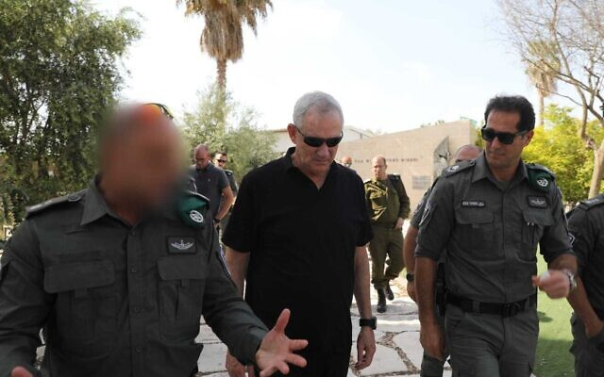
Defense Minister Benny Gantz, center, tours a Border Police base in the West Bank, with the commander of the Border Police, Amir Cohen, right, on April 19, 2022. (Elad Malka/Defense Ministry)
Defense Minister Benny Gantz warned Palestinians in the Gaza Strip on Tuesday that steps Israel has taken to boost its economy are being threatened by terror groups ramping up incitement and launching rockets attacks.
There have been violent clashes between Palestinians and police in recent days at the Al-Aqsa Mosque compound, which sits atop the Temple Mount in Jerusalem’s Old City. Israel has accused terror groups of inciting the clashes over what it says are false claims that the long-standing policy of not allowing Jews to pray in the area has been changed.
“As I have also told leaders from countries in the region, we are maintaining the status quo on the Temple Mount, and we will not allow terrorists or provocateurs to harm the holy places,” Gantz said during a tour of a Border Police base in the West Bank.
Many Jews head to the Western Wall and the Old City during the current weeklong Passover holiday. Non-Muslims can only visit the Temple Mount during certain hours and are officially barred from praying at the site, which is considered the holiest in Judaism and the third-holiest in Islam.
However, recent reports have shown that police sometimes turn a blind eye to such prayers taking place.
In a statement released by his office, Gantz mentioned a rocket attack from Gaza on southern Israel on Monday evening. “Yesterday, the Israel Defense Forces struck Gaza following [rocket] fire into Israeli territory, for which Hamas leaders are responsible,” he said.
Palestinians clash with Israeli security forces at the Al Aqsa Mosque compound atop the Temple Mount in Jerusalem’s Old City, on Friday, April 15, 2022. (AP Photo/Mahmoud Illean)
“The IDF is ready with a wide range of means and targets, to ensure that peace and stability will continue,” Gantz warned.
“If the incitement and [rocket] fire continue, the terror organizations will be severely harmed, as will the residents of Gaza, who are currently benefiting from the moves we have taken to develop the economy,” Gantz added.
Israel recently okayed increasing the number of Palestinians who can enter Israel for work to the highest quota since a blockade was imposed on the coastal enclave more than 15 years ago.
“These are moves we are planning to expand if stability is maintained, or we can roll them back, if the leaders of Hamas choose to hurt them,” Gantz added.
On Monday, before the rocket attack, the secretary-general of the Palestinian Islamic Jihad terror group dismissed apparent threats to end such measures.
“The enemy’s threats to stop facilitations for Gaza cannot make us remain silent about what is happening in Jerusalem and the occupied West Bank,” Ziad Nakhala said in a brief statement.
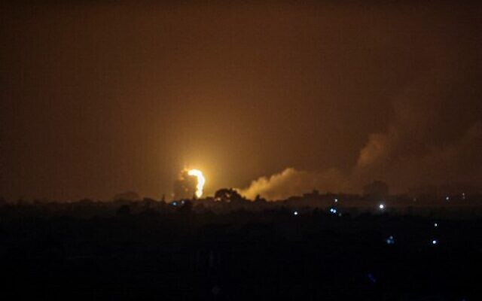
Flames and smoke rise during Israeli airstrikes in Rafah in the southern Gaza Strip, April 19, 2022. (Photo by SAID KHATIB / AFP)
Gantz’s comments came as various Palestinian factions in the Gaza Strip were set to hold an emergency meeting, according to the Safa news agency, which is close to the Hamas terror group.
Citing an unnamed source, the agency said the “urgent” meeting was to be held at the office of Hamas leader Yahya Sinwar. The report said the source refused to disclose the reasons for the meeting, but it came amid the heightened tensions in Jerusalem, and following airstrikes in the coastal enclave over the rocket attack. MORE -
https://www.timesofisrael.com/gantz-threatens-gaza-if-rockets-continue-vows-temple-mount-status-quo-protected/

Bennett, Netanyahu trade barbs over Gaza rocket fire
‘You failed against Hamas,’ PM charges after opposition chief calls his coalition ‘weak’ following first launch of projectile from Strip in months
By Tobias Siegal Today, 1:25 pm

Former prime minister Benjamin Netanyahu (left) and current Prime Minister Naftali Bennett. (Menahem Kahana/AFP; Yonatan Sindel/Flash90)
Prime Minister Naftali Bennett on Tuesday traded barbs with Opposition Leader Benjamin Netanyahu over their respective policies toward the Gaza Strip, after terrorists in the coastal enclave fired a rocket at Israel late Monday for the first time in months.
“Mr. Netanyahu, on your watch, terrorists launched 13,000 (!) rockets toward the residents of southern Israel, carried out 1,500 terrorist attacks, burned down 45,000 dunams [11,120 acres] of our lands, killed 238 Israelis and injured 1,700 others,” Bennett said in a statement.
“And what do you do? You transfer suitcases full of dollars to Hamas,” he added, referring to the hundreds of millions in monthly payments that Qatar has sent to Gaza since 2018.
He also tore into Netanyahu over last year’s fighting in Gaza, which began after Hamas fired several rockets toward Jerusalem, and corresponding ethnic violence in Israeli cities with mixed Jewish and Arab populations.
“Your legacy: Hamas rockets targeting Jerusalem, lynches in Acre and Lod. Israel in flames. You failed against Hamas. We’re fixing the situation,” Bennett charged.
The comments came in response to a social media post by Netanyahu on Monday, shortly after the Iron Dome missile defense system intercepted a rocket launched from Gaza. The military later carried out retaliatory strikes on sites linked to Gaza’s Hamas rulers.
“We must immediately establish a strong, right-wing government that will restore peace and security for Israel’s citizens,” the former premier said.
The rocket attack, which reports said was believed to have been carried out by Palestinian Islamic Jihad, was the first in nearly four months, ending one of the longest periods of quiet on the Gaza border in years. MORE - https://www.timesofisrael.com/bennett-netanyahu-trade-barbs-over-gaza-rocket-fire/

UAE reproves Israeli envoy over Temple Mount violence
Abu Dhabi chides ambassador for what it sees as 'attacks on civilians and invasion of holy places', calls on Jerusalem to kickstart long-defunct peace talks with the Palestinians
Elior Levy, Itamar Eichner | Published: 04.19.22, 21:06
The United Arab Emirates summoned Israeli Ambassador Amir Hayek to protest the recent unrest and violent clashes between security forces and Palestinian rioters on Jerusalem’s Temple Mount.
During the talk, Emirati International Cooperation Minister Reem Ebrahim Al-Hashimi gave Hayek a dressing down, and told him that the kingdom was strongly opposed to what it called Israel’s “attacks on civilians and invasion of holy places that injured several civilians."
Riots in the Temple Mount (Photo: Reuters)
Al-Hashimi — known for her critical views towards Israel — further underlined the need to provide “full protection” to worshipers and respect the right of Palestinians to perform their religious ceremonies, as well as stop any practice that desecrates the sanctity of the al-Aqsa Mosque.
The minister added that Israel must respect Jordan’s role as custodian of Muslim holy places in Jerusalem in accordance with international law and the existing historical situation, and not infringe on the authority of the Waqf — the Islamic religious trust which controls and manages the Islamic edifices on and around the Temple Mount.
She also called to kickstart the long-defunct peace talks between Israel and the Palestinians and bring about a two-state solution that will lead to the establishment of an independent Palestinian state within the 1967 borders with East Jerusalem as its capital.

Abu Dhabi Crown Prince Mohamed bin Zayed; the riots in Al-Aqsa Mosque (Photo: AP)
Israel seized the West Bank and East Jerusalem from Jordan in the 1967 Six-Day War. The Hashemite Kingdom later relinquished its claims over the territories in the late 1980s.
Meanwhile, the Israeli Pilots' Association said on Tuesday that the UAE walked back on its decision to partake in the traditional Independence Day flyby next month.
"We regret the decision. The Independence Day flyby with the participation of Israeli airlines will take place as planned immediately after the Air Force flyby and will cross Israel at low altitude,” a statement read.
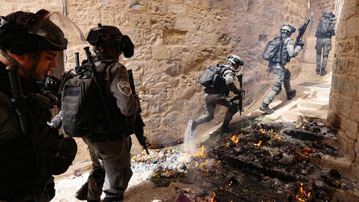
Police forces in the Old City of Jerusalem during riots
(Photo: AFP)
Also on Tuesday, U.S. Secretary of State Anthony Blinken spoke with Foreign Minister Yair Lapid, Palestinian Authority Chairman Mahmoud Abbas, and Jordanian Foreign Minister Ayman Safadi in a bid to deescalate simmering tensions around Jerusalem.
During their talk, Lapid stressed that Israel's actions aimed to allow freedom of worship for all religions in Jerusalem despite "the fake news being spread by extremists who incite violence instead of bringing calm."
For his part, Blinken said that the White House understands well the efforts that Israel is making, adding that they will help Jerusalem explain the situation to neighboring countries and in international forums. https://www.ynetnews.com/article/syjpgv349

Turkey says Erdogan, Herzog to speak after Jerusalem clashes
Despite calling Israel's restrain of rioters in Jerusalem 'unacceptable' and threatening to the 'status or spirit' of the Al-Aqsa Mosque, Turkish president set to hold a call with Israeli counterpart to discuss the ongoing tensions
Reuters | Published: 04.19.22, 15:38
Turkish President Tayyip Erdogan will hold a call with President Isaac Herzog on Tuesday, after Israeli interventions on Palestinian worshippers at Jerusalem's Al-Aqsa mosque last week, Turkey's foreign minister said.
On Friday, at least 152 Palestinians were wounded in clashes with Israeli police inside the Al-Aqsa Mosque compound, marking the latest outbreak in an upsurge of violence that has raised fears of a slide back to wider conflict.
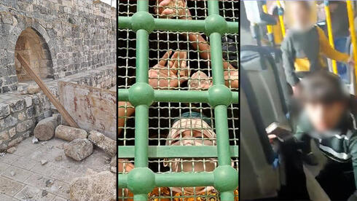
Clashes in Jerusalem
"We have already made our statements and we are continuing our contacts in response to the unacceptable attacks by Israeli security forces in the West Bank and Al-Aqsa," Foreign Minister Mevlut Cavusoglu told a news conference in Ankara.
" Our president will have a phone call with Israeli President Isaac Herzog as well," he added.
The call comes after Erdogan on Sunday told his Palestinian counterpart Mahmoud Abbas that he condemned Israeli "intervention on worshippers" at Jerusalem's Al-Aqsa mosque and threats to its "status or spirit". It also comes amid recent efforts by Turkey and Israel to repair their long-strained ties. https://www.ynetnews.com/article/hjkfux3v5

Non-Muslims to be barred from visiting the Temple Mount during the end of Ramadan
Widely reported move, which occurs every year, aimed at de-escalating tensions as diplomacy ramps up, but angry nationalists accuse government of folding to terror
By TOI staff 20 April 2022, 1:02 am
Israel Police will bar non-Muslims from visiting the Temple Mount and the Al-Aqsa Mosque compound from Friday until the end of the Muslim holy month of Ramadan on May 2.
The plan was leaked to a number of Hebrew media outlets on Tuesday evening, sparking immediate outcry from right-wing lawmakers and pundits, who blasted the government for “caving to terror” following days of clashes between Palestinians and Israeli police on the Temple Mount.
The policy of barring non-Muslims from visiting the Temple Mount during the last roughly ten days of Ramadan has been in place for years, however.
Last year, former prime minister Benjamin Netanyahu ordered the site closed to non-Muslims for 19 days during Ramadan. He came under heavy criticism when he barred the site from reopening to Jewish worshipers on Jerusalem Day, a nationalist holiday celebrating Israel taking control of the capital in 1967, which coincided with Ramadan.
His government said the move was evidence it was committed to maintaining calm as tensions spiked in Jerusalem, leading to an 11-day war with Gaza terrorists.
This year’s 10-day ban on non-Muslim visitors is viewed as part of the status quo on the Temple Mount, which allows Muslims to visit and pray, while Jews are only allowed to visit during limited time slots and cannot pray. The site is the most sacred place for Jews as the location of the biblical temples, and the Al-Aqsa Mosque, which sits atop the Temple Mount, is the third holiest site for Muslims. MORE - https://www.timesofisrael.com/non-muslims-will-be-barred-from-visiting-the-temple-mount-during-the-end-of-ramadan/

Blinken pushes for Temple Mount calm in calls with Israel, Jordan, PA
Israel has faced criticism across the board following recent tensions on the Temple Mount.
By TOVAH LAZAROFF Published: APRIL 19, 2022 16:59 Updated: APRIL 19, 2022 22:08
US Secretary of State Antony Blinken worked to restore calm to Jerusalem’s Temple Mount and Old City in a series of telephone calls on Tuesday with Israeli, Palestinian and Jordanian leaders.
“I emphasized Israel’s responsible and measured efforts in the face of riots by hundreds of Islamic extremists on the Temple Mount,” Foreign Minister Yair Lapid said after the call.
Lapid tweeted that he explained to Blinken that it was “falsehoods and disinformation spread by extremists that are fanning the flames of violence instead of bringing about calm. I told [Blinken] that Israel will not tolerate calls in support of violence, and I emphasized the need for international support for returning calm to Jerusalem.”
Lapid cut short his vacation in Madrid and returned to Israel late on Tuesday because of the unrest, which began with Ramadan prayers on Friday and has continued with five straight days of Palestinian riots.
Palestinians clashed with the IDF in the West Bank on Tuesday, and a rocket fired from Gaza toward Israel was intercepted by the Iron Dome missile-defense system on Monday night. MORE - https://www.jpost.com/breaking-news/article-704594

Palestinians clash with troops in West Bank as settlers march to former settlement
Organizers say some 20,000 marching to dismantled Homesh outpost, including right-wing politicians Smotrich and Ben Gvir, after IDF reaches deal on securing shortened event
By TOI staff Today, 4:47 pm
Samaria Regional Council head Yossi Dagan, center, leads a march to Homesh alongside MKs Itamar Ben Gvir, second right, Idit Silman, right, and Bezalel Smotrich, left. (Samaria Regional Council)
Several thousand right-wing Israelis on Tuesday marched in the northern West Bank to the dismantled Homesh settlement, as Palestinians opposed to the rally clashed with Israeli forces in an adjacent village.
Several opposition politicians participated, notably including former coalition whip Idit Silman, who quit the government two weeks ago, and who some in the coalition were still hoping could be persuaded to return.
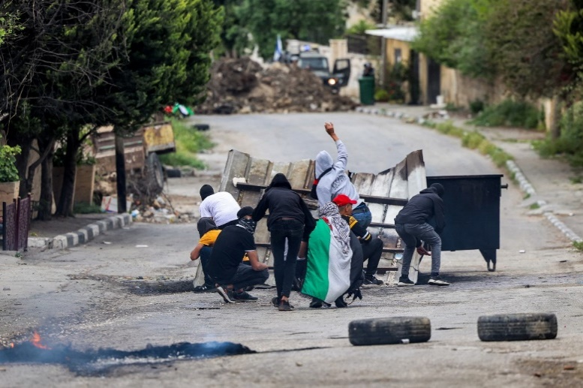
The military sealed off the roads to several Palestinian villages in the area as part of security measures reportedly reached between the Defense Ministry and Homesh yeshiva organizers of the event. The Israel Defense Forces initially opposed the march over concerns it could spark further clashes in the West Bank.
The IDF had warned organizers that it would not be able to secure the event, which was set to start at the Shavei Shomron settlement at 11 a.m. and run along 14 kilometers (some 8.5 miles) past several Palestinian villages.
Organizer Bareleh Kromby earlier told Radio 103 FM that they had reached a deal with the army to shorten the route by 3 kilometers (1.9 miles).
Palestinians throw stones at Israeli forces in the West Bank village of Burqa during clashes to protest a march by Israelis to the wildcat settlement outpost of Homesh, on April 19, 2022. (Jaafar Ashitiyeh/AFP)
“Not only is this not a provocation, but these marches are also conducted in an astonishing and dignified manner,” Kromby said. “The goal is to go back to the Homesh, we do not hide this. The greatest folly of the [2005] disengagement is manifested in northern Samaria. This is an area we did not even leave, it is also open to Israeli Arabs so there is no reason not to be open to Jews.”
Organizers had planned for thousands at the event and claimed that 20,000 people showed up.
Video from the march showed hundreds making their way along the route to Homesh, which was evacuated in 2005, but to which settlers regularly return.
Among the marchers were senior nationalist politicians, including Religious Zionism party head Bezalel Smotrich and MK Itamar Ben Gvir, as well as Yamina lawmaker Silman.
Clashes erupted near the route of the march between security forces and Palestinians opposing the event.
In Burqa, near Nablus, videos showed protesters hurling stones and setting garbage alight as troops shoot tear gas in their direction.
The Palestinian Red Crescent said 32 Palestinians in Burqa were treated during the clashes, 25 of them for tear gas inhalation.
Homesh returned to the headlines last December, when a Palestinian terrorist opened fire at a convoy ferrying students back from the yeshiva, killing Israeli Yehuda Dimentman.
The deadly attack prompted renewed calls by ultra-nationalist lawmakers to resurrect the settlements dismantled in 2005. MORE - https://www.timesofisrael.com/palestinians-clash-with-troops-in-west-bank-as-settlers-march-to-former-settlement/

Police reject plan by right-wing activists for march Wed. around Jerusalem Old City
Officers meet with organizer to discuss alternative date and format, amid concerns of rising tensions surrounding Temple Mount
By TOI staff Today, 12:37 pm
Jewish men dance with Israeli flags during the March of Flags near Jerusalem's Old City, on June 15, 2021. (Yonatan Sindel/Flash90)
Police on Tuesday rejected a plan by right-wing activists to stage a march outside Jerusalem’s Old City on Wednesday following recent clashes there between Palestinians and police.
The planned march was announced amid heightened tensions surrounding the Temple Mount as Passover, Ramadan and Easter intersect. It also came on the heels of several deadly terror attacks in Israel and subsequent Israeli counter-terror operations in which numerous Palestinians have been killed during skirmishes in the West Bank.
A police statement said the request to hold the march was submitted Monday “with short notice” and that one of the organizers was summoned for a talk with officers to discuss an alternative date and format. The statement noted organizers announced the march even though it had not been approved.
Police said they discussed alternatives with the organizer and clarified their commitment to upholding “freedom of expression and protest by law, while maintaining the wellbeing and security of the march’s participants and the entire public.”
“Presenting things in a different manner is a distortion and transgression from the truth,” the statement said.
The head of Im Tirtzu, a right-wing group helping organize the march, denounced the police decision.
“All those who wanted to come to the capital [during Passover] suffered a moral blow,” Matan Peleg told Army Radio. “We want to show there’s nothing to fear.”
Nationalists traditionally hold a “flag dance” in parts of the Old City for Jerusalem Day, which marks the reunification of the city after Israeli forces captured East Jerusalem, including the Old City and its holy sites, from Jordan in the 1967 Six Day War. MORE - https://www.timesofisrael.com/police-refrain-from-approving-planned-right-wing-march-around-jerusalems-old-city/

Lapid cuts vacation short amid Jerusalem tensions, Jordan’s hostile response
Criticized for going abroad, foreign minister says he held assessment on situation in capital; controversial Islamic leader visits Temple Mount
By TOI staff Today, 3:42 pm
Foreign Minister Yair Lapid will cut his vacation to Madrid short and return to Israel on Tuesday evening amid rising tensions over Jerusalem’s Temple Mount compound.
Lapid’s decision to take time off overseas was met with criticism as clashes between security forces and Palestinian rioters in the capital have drawn international condemnations of Israel, primarily from Jordan and Turkey.
“This morning, I held a situation evaluation meeting,” Lapid said in a statement, noting that he was updated about the latest intelligence and political developments regarding Jerusalem.
“I’ve instructed participants to continue with dialogue at all political ranks to deescalate the tensions and emphasize Israel’s efforts to allow freedom of worship for all religions,” he said.
Lapid also said preparations for the upcoming UN Security Council meeting on the Jerusalem unrest were discussed during the meeting. MORE - https://www.timesofisrael.com/lapid-cuts-vacation-short-amid-jerusalem-tensions-jordans-hostile-response/

Putin aide says Jerusalem Old City property dispute at top of Russian agenda
Kremlin spokesman Dmitry Peskov says he expects Israel to aid in custody transfer of Alexander’s Courtyard to Moscow, after recent court decision set back move
By TOI staff Today, 7:33 pm
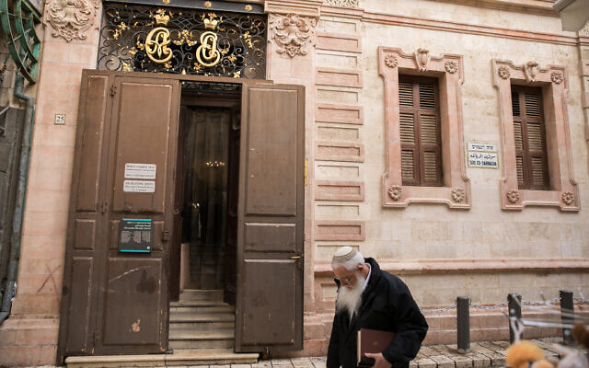
People walk outside the Alexander Nevsky Church in Jerusalem's Old City, on January 20, 2020. (Olivier Fitoussi/Flash90)
A top aide to Russian President Vladimir Putin said on Tuesday that the transfer of church property in Jerusalem’s Old City to Moscow’s hands is at the top of the Israeli-Russian diplomatic agenda.
“The topic of Alexander’s Courtyard has long been at the top of the agenda of Russian-Israeli relations,” Kremlin spokesman Dmitry Peskov told reporters, a day after Hebrew media reported that Putin had sent a letter to Prime Minister Naftali Bennett demanding that the property be handed over.
“We expect the Israeli leadership to assist us in order to complete the process as is necessary,” Peskov added.
Moscow has for years been seeking to secure the Alexander’s Courtyard church compound, but a recent court decision set back its plans by nullifying recognition of its claims to the complex, located near the Church of the Holy Sepulchre.
Officials in Jerusalem are worried the subject could exacerbate tensions with Russia, already on the rise over its invasion of Ukraine.
Bennett has been criticized for showing deference to Russia vis-a-vis Ukraine, refusing to send weapons and refraining from blaming Moscow for alleged atrocities. The moves are thought to be aimed at keeping Russia from targeting Israeli planes on bombing runs over Syria. Foreign Minister Yair Lapid, meanwhile, has been more vocally critical of Russia, and Israel has voted against Moscow at the UN several times lately.
Last month, the Jerusalem District Court annulled a decision giving the Russian government control of Alexander’s Courtyard.
The verdict was given following a petition by the Orthodox Palestine Society of the Holy Land, which owned the property until last year.
Advertisement
In 1859, Czar Alexander II purchased the land on which Alexander’s Court — also known as the Alexander Nevsky Church — was built. Until the Russian Revolution of 1917, the area was under the control of the Russian Imperial government.
Former prime minister Benjamin Netanyahu approved giving Alexander’s Courtyard to Russia in 2020. The move was seen as a goodwill gesture following Russia’s release of Naama Issachar, a young Israeli woman who was imprisoned after a small quantity of marijuana was found in her backpack during a layover in Moscow. MORE - https://www.timesofisrael.com/putin-aide-says-jerusalem-old-city-property-dispute-at-top-of-russian-agenda/

Israeli astronaut Eytan Stibbe set for return to Earth following weather delay
Businessman and former fighter pilot spent his extra time aboard the International Space Station doing a reading of the Hebrew children’s book ‘Beautiful World’
By TOI staff Today, 6:13 pm
Eytan Stibbe pictured by SpaceX before the April 8 launch of the Dragon spacecraft at Cape Canaveral, Florida. (SpaceX)
Israeli astronaut Eytan Stibbe is set to make his return to Earth’s atmosphere on Tuesday night, after his planned return earlier in the day — along with three others aboard the International Space Station — was delayed by NASA.
NASA informed SpaceX and Axiom that the delay was due to bad weather at the planned splashdown spot for the Dragon Endeavour, which was slated to bring the members of the first private space mission back home.
The return ship was now slated to depart the ISS at 10 p.m. EDT Tuesday (5 a.m. Wednesday in Israel) and hit the water at 3:24 p.m. EDT (10:24 p.m. IDT) the next day.
During a farewell ceremony at the station, Stibbe lauded the international cooperation that took place during the mission, adding that the 10 days he spent there were “one of a kind.”
“We learned a lot, I still feel like I just started, and I’m ready to stay here for another month,” he said.
Stibbe spent his extra day in the heavenly firmament by reading aloud the Hebrew children’s book “Beautiful World” while floating around, in a video designed for children.
The businessman and former fighter pilot was one of four astronauts who took off 10 days ago on the privately-funded Rakia mission that successfully docked at the ISS the next day.
Advertisement
During their stay on the space station, the group stuck to a regimented schedule, which included about 14 hours per day of activities, including scientific research.
NASA has hailed the three-way Rakia partnership with US company Axiom Space and SpaceX as a key step towards commercializing the region of space known as “Low Earth Orbit,” leaving the agency to focus on more ambitious voyages deeper into the cosmos.
Businessmen Stibbe, American Larry Connor of Ohio, and Canadian Mark Pathy have paid $55 million apiece for the rocket ride.
The visitors’ tickets include access to all but the Russian portion of the space station. Three Americans and a German also live up there. MORE - https://www.timesofisrael.com/israeli-astronaut-eytan-stibbe-set-for-return-to-earth-following-weather-delay/

Volvo invests in Israeli maker of fast-charging battery tech StoreDot
Swedish carmaker joins Series D round of some $80m to help Israeli company reach mass production
By Ricky Ben-David Today, 5:23 pm
An illustrative photo provided by Volvo cars showing a battery propulsion system. (Volvo Car Group)
Swedish carmaker Volvo has made a strategic investment in StoreDot, an Israeli developer of extreme fast-charging (XFC) battery technology for electric vehicles (EVs), according to a joint announcement Tuesday.
The amount was not disclosed but comes less than a month since a major Indian electric scooter maker and ride-hailing service, Ola Electric, made a multi-million-dollar investment in the Israeli company as part of its Series D investment round of some $80 million.
StoreDot has been working with strategic investors such as BP Ventures, the venture arm of the British multinational oil and gas firm BP plc, Daimler AG, the maker of the Mercedes Benz cars, Japanese electronic multinational TDK, and South Korea’s Samsung Ventures, to move ahead with its technologies.
The Israeli company announced the Series D round in January, led by Vietnamese electric vehicle manufacturer VinFast, a unit of Vietnamese conglomerate VinGroup.
StoreDot said the funding will be used for research and development and to reach mass production for its silicon-dominant anode XFC lithium-ion cells, which it says will be capable of delivering 100 miles (160 kilometers) of driving range in five minutes of charging by 2024. MORE - https://www.timesofisrael.com/volvo-invests-in-israeli-maker-of-fast-charging-battery-tech-storedot/

Gaza militants prepare tunnels as next conflict looms
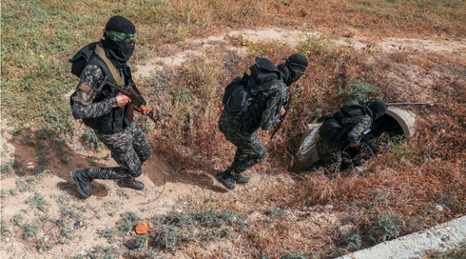
Territory's terror groups counting on the extensive network of underground passageways to seize Israeli personnel or civilians for use as bargaining chips in prisoner exchanges
AFP | Published: 04.19.22, 20:03
In a "tunnel city" under the sandy soils of southern Gaza, Palestinian militants are preparing for the next conflict with Israel, as tensions in Jerusalem threaten to escalate.
~The underground passageways leave no trace on the surface.

Members of the Palestinian Islamic Jihad militant group enter a tunnel in the Gaza Strip, during a media tour amid escalating tensions with Israel (Photo: AFP)
But in a wooded area near Khan Yunis, seven masked men in military fatigues carried a collection of machine guns and grenade launchers into a tunnel entrance discretely tucked into the foot of a small hill.
The fighters wear headbands of the Al-Quds Brigade, the armed branch of Islamic Jihad which is the second-largest armed faction in Gaza, after the Hamas Islamist movement that rules the territory.
The tree branches covering the hole reveal a narrow passageway walled and topped with concrete blocks.
Complete with electric lights, a ventilation system and telecoms cables, the tunnels also have small rooms for storing weapons and ammunition.
An Islamic Jihad official told AFP during a media tour that the movement has both defensive and offensive tunnel systems.
The latter "is used for taking Israeli soldiers captive, repelling Israeli ground offensives and carrying out various field operations", said the commander.
As he was talking, he received a radio alert of a "security incident" east of Gaza City — a false alarm.
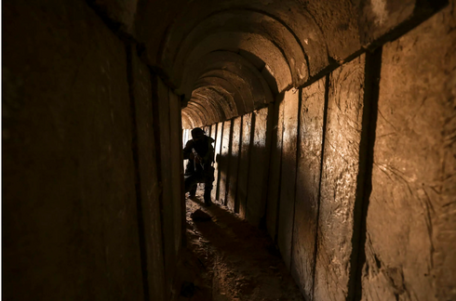
(Photo: AFP)
Last May during an 11-day war, Israel launched multiple strikes against what it called the "Gaza Metro", a network of tunnels that had allowed fighters to move around without being spotted by Israeli drones and to take Israeli targets by surprise.
Residents of Gaza, a cramped, besieged coastal territory home to 2.3 million people, have long experience using tunnels since 2007, when Israel imposed a crippling blockade in response to Hamas seizing power in the Strip.
A member of the Palestinian Islamic Jihad militant group sets up a mortar in a tunnel in the Gaza Strip
Smugglers established a network of tunnels on the border with Egypt, enabling them to import everything from desperately needed household goods to cars and even Kentucky Fried Chicken — as well as weapons.
In recent years, Egypt has destroyed most of those tunnels.
Israel, for its part, has boosted its forces around the territory, reinforcing a hyper-secure barrier with an underground steel wall it hopes will prevent tunnels from reaching into Israeli territory.
Israeli commanders fear militants could use such tunnels to seize Israeli personnel or civilians for use as bargaining chips in prisoner exchanges.
But even if Islamic Jihad's tunnels cannot reach Egypt or Israel, they are still "a strategic weapon for the resistance", said Al-Quds Brigade spokesman Abu Hamza.
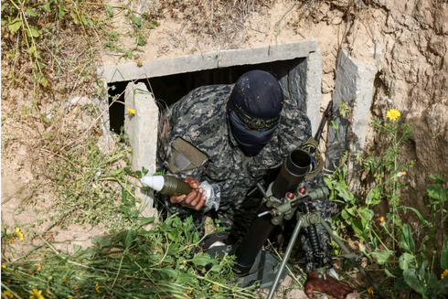
A member of the Palestinian Islamic Jihad militant group sets up a mortar in a tunnel in the Gaza Strip (Photo: AFP)
"We will let the days and the battles to come do the talking about the ability of the resistance to break through this so-called (Israeli) barrier," he told AFP.
Weeks of deadly violence including angry demonstrations and a police crackdown around Jerusalem's Al-Aqsa Mosque have prompted Islamic Jihad to threaten an escalation.
After two deadly attacks in the coastal Israeli city of Tel Aviv, the Israeli army carried out large-scale raids in the West Bank, notably the Jenin area from which the attackers hailed.
Those operations sparked intense firefights which killed several fighters from Islamic Jihad, which is supported by Israel's nemesis Iran.
And on Monday evening, a rocket was fired from Gaza into Israel, prompting an Israeli airstrike against a weapons factory.
No faction has yet claimed responsibility, but the incident — the first of its type since January — heightened fears of a further escalation.
A couple of hours' drive from Gaza City, "the tunnels have been repaired and the rocket stocks have been replenished" since last year's war, according to Abu Hamza, who praised Iran for its support. MORE - https://www.ynetnews.com/article/hkdgqdhv9

Russia pours in troops, assails eastern Ukraine in potentially pivotal battle
Ukrainian cities attacked along a front hundreds of miles long in new phase of the war; hospital reportedly shelled in town of Bashtanka, 4 civilians killed in Kharkiv bombardment
By Adam Schreck 20 April 2022, 1:56 am
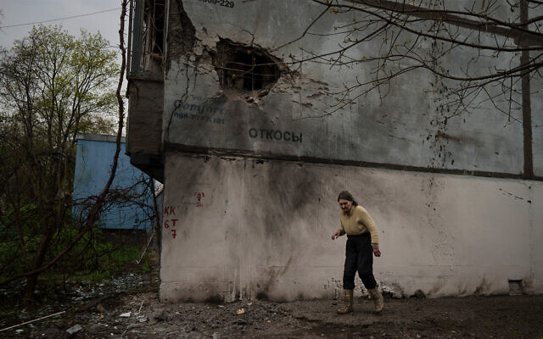
A woman walks next to a damaged building after a Russian bombardment in Kharkiv, Ukraine, April 19, 2022. (AP Photo/Felipe Dana)
KYIV, Ukraine (AP) — Russia assaulted cities and towns along a boomerang-shaped front hundreds of miles long and poured more troops into Ukraine on Tuesday in a potentially pivotal battle for control of the country’s eastern industrial heartland of coal mines and factories.
If successful, the Russian offensive in what is known as the Donbas would essentially slice Ukraine in two and give President Vladimir Putin a badly needed victory following the failed attempt by Moscow’s forces to storm the capital, Kyiv, and heavier-than-expected casualties nearly two months into the war.

Russian military vehicles move on a highway in an area controlled by Russian-backed separatist forces near Mariupol, Ukraine, on April 18, 2022. (AP Photo/Alexei Alexandrov)
The eastern cities of Kharkiv and Kramatorsk came under deadly attack, and a hospital was reported shelled in the southern town of Bashtanka. Russia also said it struck areas around Zaporizhzhia and Dnipro west of the Donbas with missiles.
Russian Defense Ministry spokesman Maj. Gen. Igor Konashenkov said Moscow’s forces bombarded numerous Ukrainian military sites, including troop concentrations and missile-warhead storage depots, in or near several cities or villages. Those claims could not be independently verified.
In what both sides described as a new phase of the war, the Russian assault began Monday along a front stretching more than 300 miles (480 kilometers) from northeastern Ukraine to the country’s southeast. Ukraine’s military said Russian forces tried to “break through our defenses along nearly the entire front line.”
Weeks ago, after the abortive Russian push to take Kyiv, the Kremlin declared that its main goal was the capture of the mostly Russian-speaking Donbas, where Moscow-backed separatists have been fighting Ukrainian forces for eight years.
A Russian victory in the Donbas would deprive Ukraine of the industrial assets concentrated there, including mines, metals plants and heavy-equipment factories.
A senior US defense official, speaking on condition of anonymity to discuss the Pentagon’s assessments of the war, said the Russians had added two more combat units, known as battalion tactical groups, in Ukraine over the preceding 24 hours. That brought the total number of units in the country to 78, all of them in the south and the east, up from 65 last week, the official said.
That would translate to about 55,000 to 62,000 troops, based on what the Pentagon said at the start of the war was the typical unit strength of 700 to 800 soldiers. But accurately determining Russia’s fighting capacity at this stage is difficult.
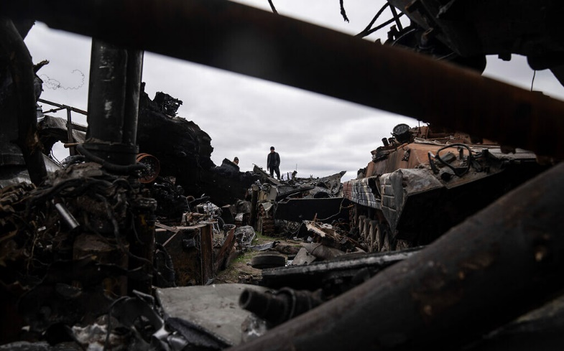
A local man stands on a destroyed Russian armored vehicle in Bucha, Ukraine, April 19, 2022. (AP Photo/Evgeniy Maloletka)
A European official, also speaking on condition of anonymity to discuss military assessments, said Russia also has 10,000 to 20,000 foreign fighters in the Donbas. They are a mix of mercenaries from Russia’s private Wagner Group and Russian proxy fighters from Syria and Libya, according to the official.
While Ukraine portrayed the attacks on Monday as the start of the long-feared offensive in the east, some observers noted that an escalation has been underway there for some time and questioned whether this was truly the start of a new offensive.
The US official said that the offensive in the Donbas has begun in a limited way, mainly in an area southwest of the city of Donetsk and south of Izyum.
Justin Crump, a former British tank commander now with the strategic advisory company Sibylline, said the Ukrainian comments could, in part, be an attempt to persuade allies to send more weapons. MORE - https://www.timesofisrael.com/russia-pours-in-troops-assails-eastern-ukraine-in-potentially-pivotal-battle/

In latest ultimatum, Russia urges Ukrainian troops to lay down arms ‘immediately’
Russian defense ministry calls on Kyiv ‘to show reason’ and surrender, as Moscow ramps up plans to ‘liberate’ eastern Ukraine; Kremlin refuses to shed light on sunken flagship
By AFP Today, 4:31 pm
Russian military vehicles move on a highway in an area controlled by Russian-backed separatist forces near Mariupol, Ukraine, on April 18, 2022. Mariupol, a strategic port on the Sea of Azov, has been besieged by Russian troops and forces from self-proclaimed separatist areas in eastern Ukraine for more than six weeks. (AP Photo/Alexei Alexandrov)
MOSCOW, Russia — Russia on Tuesday called on Ukrainian forces to “immediately” lay down arms and issued a new ultimatum for the defenders of the besieged port city of Mariupol to give up.
The Russian defense ministry’s warning came after Ukrainian President Volodymyr Zelensky announced late on Monday the start of a new offensive by Moscow that is focused on the east of the former Soviet state.
“We once again call on the Kyiv authorities to show reason and give the corresponding orders to fighters to cease their senseless resistance,” the Russian defense ministry said in a statement.
“But, understanding that they will not get such instructions and orders from the Kyiv authorities, we call on [the fighters] to voluntarily take this decision and to lay down their arms.”
The statement made no direct mention of a new ground offensive in eastern Ukraine.
But Russian Defense Minister Sergei Shoigu confirmed that his forces were “gradually implementing our plan to liberate” eastern Ukraine.
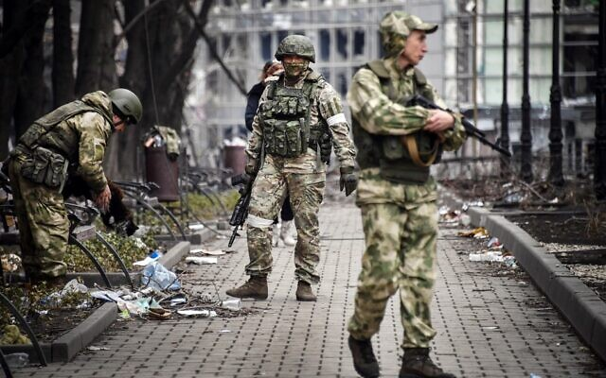
Russian soldiers walk along a street in Mariupol, on April 12, 2022. (Alexander Nemenov/AFP)
“We are taking measures to restore peaceful life,” he said in a televised meeting with Russian military commanders.
Some of the heaviest fighting of the Russian campaign has focused around the strategic Sea of Azov port city of Mariupol.
The port offers a land bridge between Moscow-controlled parts of eastern Ukraine and the Kremlin-annexed peninsula of Crimea.
The Russian defense ministry said Ukrainian forces still holed up inside the devastated city’s main metallurgical plant were facing a “catastrophic situation.”
“The Russian armed forces once again offer the nationalist battalions and foreign mercenaries a chance to stop all military activity and to lay down their arms, starting at noon,” the Russian ministry said.
“Everyone who lays down their arms will be guaranteed survival.” MORE - https://www.timesofisrael.com/in-latest-ultimatum-russia-urges-ukrainian-troops-to-lay-down-arms-immediately/

Ukraine uses website to train fighters remotely
The site provides varied articles and instructional videos on various topics, from basic first aid and steps to take during chemical attacks to operating an FGM-148 javelin rocket.
By ROMAN MEITAV Published: APRIL 19, 2022 18:49 Updated: APRIL 19, 2022 19:01
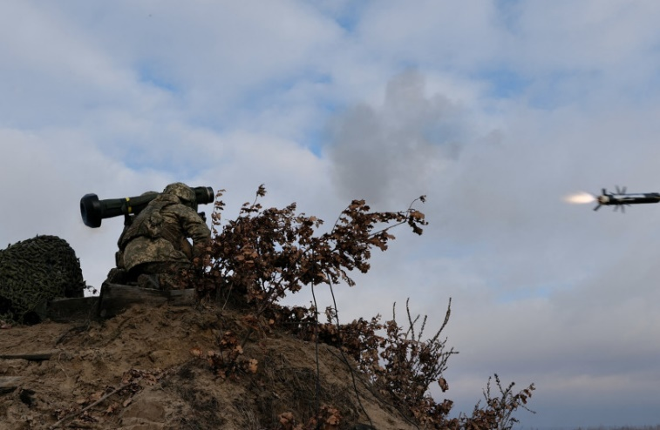
Service members of the Ukrainian Armed Forces fire a Javelin anti-tank missile during drills at a training ground in an unknown location in Ukraine, in this handout picture released February 18, 2022. (photo credit: UKRAINIAN JOINT FORCES OPERATION PRESS SERVICE/HANDOUT VIA REUTERS)
The Training Department (G7) of the Territorial Defense Forces (TDF) Command of the Armed Forces of Ukraine launched an instructional website "to provide Ukrainian citizens with basic military knowledge necessary to protect the country."
The site provides varied articles and instructional videos on various topics, from basic first aid to handling chemical attacks to operating an FGM-148 javelin rocket.
While being open to all citizens of Ukraine, the site is primarily aimed at fighters of Ukraine's Territorial Defense Forces, serving as an effective military info databank to assist in training that recruits may not have access to otherwise.
A "how-to" in confronting Russia
“Every territorial defense forces fighter will undergo the necessary training to effectively confront the enemy,” the head of the headquarters of the Territorial Defense Forces, Brigadier General Sergey Sobko said.
"The site and platform will allow thousands of defenders across the country to increase their qualifications and provide the knowledge they need in a short term. In the future, we will use these resources also to prepare Ukrainian citizens for national resistance," he explained. MORE - https://www.jpost.com/international/article-704601

Biden pushes plan to force physicians to do abortions, trans mutilations
Strategy is to cancel constitutional 'conscience' rights for health-care workers
By Bob Unruh Published April 19, 2022 at 3:40pm
Joe Biden is ramping up his attack on religious rights – including those protected by the First Amendment – with a new plan to cancel any "conscience" protections for any health-care workers at any time – which would force unwilling physicians to perform abortions and mutilating transgender surgeries on children – on demand.
It is Politico that reported Biden is preparing to destroy a Trump-era rule allowing medical workers to decline to violate their faith by doing those surgeries.
"A spokesperson for the Department of Health and Human Services confirmed that the policy change is underway, saying: 'HHS has made clear through the unified regulatory agenda that we are in the rulemaking process,'" Politico reported.
A spokeswoman for Planned Parenthood, which has gained millions of dollars in income through changes Biden already has proposed or made in his pro-abortion agenda, said it's not right that "state politicians" are stripping "people of their sexual and reproductive rights and freedoms."
Jacqueline Ayers claimed doctor's religious rights to decline to perform operations which violate their consciences is amounts to a "discriminatory" practice.
The rule was proposed during the Trump administration and finalized in 2019 but later was blocked by federal courts without being implemented.
The concept wasn't complicated: It recognized the constitutional protections for religious rights – even of physicians – and would have allowed them to decline to perform unborn baby-killing or body mutilation procedures that violated their faith.
Politico explained killing the rule "is seen by progressive advocates as a key part of dismantling the Trump administration’s legacy on reproductive rights, which Democrats promised to do once they took control of Washington."

Biden already has been busy promoting abortion through the nation's Title X family planning program and foreign aid.
The rule now is under review at the Office of Management and Budget.
The Washington Examiner reported the American Civil Liberties Union was fully supportive of requirements that would violate individuals' religious rights.
"Everyone is entitled to their religious beliefs, but religious beliefs do not include a license to discriminate, to deny essential care, or to cause harm to others," the organization claimed when the original judge halted Trump's regulation.[Since when is performing a murder – “essential care”? This is the most bogus piece of garbage I have ever seen. – rdb]
The rule, however, may not be the final word on the dispute, which is part of the larger fight that was created when the Supreme Court several years ago created, in a ruling that Chief Justice John Roberts said was unrelated to the Constitution, the status of same-sex marriage.
Since then LGBT promoters have been pursuing a campaign to punish anyone who, because of their faith, does not support advocacy for the alternative sexual lifestyle choices.
Included have been attacks on bakers who declined to promote homosexuality with their artistry – a case that was resolved in favor of Denver baker Jack Phillips at the Supreme Court. But that decision was made on the narrow grounds of Colorado's official state "hostility" to Christianity, and not the more comprehensive religious rights issue.
Recently, however, the Supreme Court agreed to hear another Colorado case, this one involving Lorie Smith and her 303 Creative firm which is under assault again by Colorado because she declines to violate her faith by promoting same-sex weddings.
The question in the case accepted by the Supreme Court is whether a state can, through its so-called "non-discrimination" laws, order a person to violate his or her Christian faith.
The result is expected to clarify exactly what authority a government has to impose demands that are in contradiction to an individual's religious beliefs.
The substance of the dispute is that LGBT promoters believe the court's creation of same-sex marriages overrides all constitutional protections for religion and religious faith.
The 3030 Creative case is typical of the fights. The state of Colorado demands she "design and publish websites promoting messages that violate her religious beliefs."
And she's even banned from explaining her faith-based objections, because to do so would involve "discriminating" against people who are participating in events and campaigns that the Bible teaches are sinful.
"The government shouldn’t weaponize the law to force a web designer to speak messages that violate her beliefs. This case involves quintessential free speech and artistic freedom, which the 10th Circuit dangerously cast aside," said Kristen Waggoner, an ADF lawyer working on the case..
"Colorado cake artist Jack Phillips has been harassed for years, and now Lorie Smith is being told that she must speak views she opposes and can’t post about her beliefs on her own business website. The 10th Circuit’s reasoning turns free-speech protections on their head by saying that the more ‘unique’ speech is, the more the government can compel it. That kind of dangerous, unconstitutional reasoning is why we have asked the U.S. Supreme Court to take Lorie’s case."
Colorado, in the last 10 or 15 years or so, has turned into a haven for leftist extremism. Its extreme antagonism to issues of faith was exemplified in the Phillips case, in which the U.S. Supreme Court scolded Colorado for its "hostility" to Christianity. MORE - https://www.wnd.com/2022/04/biden-pushes-plan-force-physicians-abortions-transgender-mutilations/

Kavanaugh, Barrett reject appeal of Airman who refuses COVID shot
Trump appointees again side with court's left flank in vaccine-mandate case
By Art Moore Published April 19, 2022 at 7:39pm
President Trump appointees Brett Kavanaugh and Amy Coney Barrett joined the Supreme Court's left flank in rejecting an emergency appeal from an Air Force Reserve officer who was punished for his refusal to take the COVID-19 vaccine.
Lt. Col. Jonathan Dunn was appealing to the high court after the Air Force rejected his request for a religious exemption and removed him from command.
Dunn argues in his April 9 emergency appeal that he "acquired natural immunity to the disease" after contracting COVID-19 last summer. Further, he "has sincere religious objections to the COVID-19 vaccine."
The officer's immunity argument is backed by more than 150 scientific studies showing naturally acquired immunity from contracting COVID-19 is equal to or superior to existing vaccines.
Justices Clarence Thomas, Samuel Alito and Trump appointee Neil Gorsuch said they would have granted the request to temporarily halt Dunn's punishment while the case continued.
The Pentagon began implementing its vaccine mandate for all service members last August.
Last month, the Supreme Court ruled against 35 Navy SEALs who challenged the vaccine mandate. In that case, Justices Thomas, Alito and Gorsuch sided with the SEALs.
Alito wrote that the officers "appear to have been treated shabbily by the Navy, and the Court brushes all that aside."
Kavanaugh said he had a "simple overarching reason" for siding with the majority.
"Under Article II of the Constitution, the President of the United States, not any federal judge, is the Commander in Chief of the Armed Forces," he wrote.
Judicial Watch President Tom Fitton reacted on Twitter to the rejection of Dunn's appeal.
"Justices Kavanaugh and Barrett have too often refused to step up to defend the civil rights of citizens being abused by vindictive and abusive vaccine mandates," he wrote.
Last August, Barrett rejected a request for emergency relief from students to block a COVID-19 vaccine mandate at Indiana University.
Two months later, Justice Sonia Sotomayor rejected an emergency request from a group of teachers in New York City seeking to block the city’s requirement that they receive a COVID-19 shot or be fired. https://www.wnd.com/2022/04/kavanaugh-barrett-reject-appeal-airman-refuses-covid-shot/ [Once again by listening to the establishment Washington group for his nominees for appointments The Donald has screwed over the American people. If there was one area of major deficiency in the Trump administration it was relying too heavily on those within the system for advise and information. None of the insiders should have been included in any decision making and that includes some of his family members as well. – rdb]

Stacey Abrams Increased Her Net Worth 3,000% in Less than 4 Years – What Is the Real Source of Her Income?
By Joe Hoft Published April 17, 2022 at 12:00pm
Stacey Abrams has increased her net worth by 3,000% in a couple of years. How did this happen?
In the age of corruption and stolen elections, Stacey Abrams may have eaten the cake.
The Daily Caller reports that Abrams increased her net worth by millions in the past few years.
Democratic Georgia gubernatorial candidate Stacey Abrams has become a millionaire.
Abrams is worth $3.17 million, according to the state disclosures she filed in March, The Associated Press reported Tuesday. When she first ran for the Georgia governorship in 2018, Abrams was dealing with a “hefty bill from the IRS” and was worth only $109,000, the outlet noted.
The “hefty” tax bill from the IRS was $54,000, with a further $410,000 in liabilities, according to Fox News. She owed $96,000 in student loan debt and $83,000 in credit card debt, AP reported.
The Daily Caller reports that Abrams received $5-6 million in speeches and book deals. (This is one way Democrats launder money to their politicians.) The Caller also notes that Abrams has been paid, “paid $700,000 over her three years as executive director of the Southern Economic Advancement Project”. And,it is unknown how much Abrams has received from related entity Fair Fight Action:
Though Abrams did not disclose any payments from her 501(c)(4) Fair Fight Action, the group raised almost $62 million in dark money donations, according to Newsmax. Ninety-six percent of those donations “came from only 252 unidentified, large-dollar donors,” the outlet reported.
We reported on Abrams’s astronomical growth in income back in June of 2021. We uncovered the following:
Stacey Abrams, former Georgia State Rep, nonprofit czar, Hillary Clinton darling, and 2020 board member of John Podesta’suber-powerful, “charitable” nonprofit, the Center for American Progress think tank, has been revealed by CD Media as being an owner of ‘NowAccount,’ the firm financing Happy Faces Personnel Group, the temp agency used in Fulton County, Georgia’s elections in November 2020 and January 2021.
We reported extensively on her activities related to the 2020 Election. MORE - https://www.thegatewaypundit.com/2022/04/stacey-abrams-increased-net-worth-3000-times-less-4-years-real-source-money/ [You wonder why the politicians want inroads to Ukraine and other foreign countries? It is because they can launder huge sums of money back to themselves from the aid they provide. Most of DC needs to be flushed and the septic cleaned and then the entire system rebooted with entirely new people. There is little if any character in the vast majority of those occupying their privileged chairs today and those who have been inbred in the deep state system. – rdb]

Fed-up sheriff running for Congress tells off major U.S. newspaper in epic fashion
'They would rather bend a story to fit their own narrative than report facts'
By Joe Kovacs Published April 19, 2022 at 12:28pm

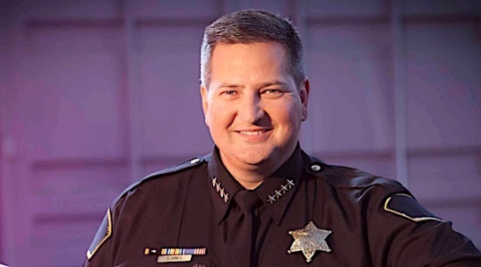
Sacramento County Sheriff Scott Jones (courtesy Scott Jones for Congress)
At a time when millions of Americans have a problem with slanted news coverage, one fed-up sheriff running for U.S. Congress is telling his local newspaper to, in essence, go fly a kite for its biased reporting.
It's the Sacramento Bee in California's capital city that is drawing the ire of Scott Jones, the Republican sheriff of Sacramento County for the past 12 years.
The newspaper's editorial board had invited Jones to participate in an "endorsement interview" for California's 3rd congressional district.
But on Monday, the sheriff shot a scathing letter at the paper, holding nothing back as he voiced what was on his mind.
"I will not seek – nor do I want – The Bee's endorsement," Jones wrote.
"Let me be clear, I value free, fair, and thorough journalism. Unfortunately, with rare exception, The Bee and their Editorial Staff have proven time and time again that they do not share the same values."
"I have always welcomed honest critique; however, The Bee has resorted to name calling, mischaracterizations, and demonstrated multiple times that they would rather bend a story to fit their own narrative than report facts.

Sacramento County Sheriff Scott Jones and his wife Christy at the Tahoe Cattlemen's Association Spring Round-Up, Dinner and Dance on Saturday, March 19, 2022. (courtesy Scott Jones on Facebook)
"Perhaps most publicly, you've continuously resorted to personal attacks and name-calling, including labeling me as 'Mini-Trump' simply from me working to secure our borders, and refusing to back down on soft-on-crime politicians. ...
"I will always sit down with honest reporters who try to understand the complex issues facing our communities, and report on them in balanced tones. I do not share the same desire to sit down with The Bee's Editorial Board."
Scott Jones and his family (courtesy Scott Jones for Congress)
Jones noted he was actually proud to receive the Bee's endorsement when he ran for sheriff back in 2010, "when the newspaper still demonstrated a semblance of journalistic integrity. Unfortunately the direction and priories of The Bee have changed."
One editorial writer at the Bee, Jack Ohman, has been quite vocal in his disdain for Jones.
"He's been a dreadful sheriff" who once "threw a hissy fit," Ohman wrote in a January editorial titled: "Sacramento Sheriff Scott Jones kowtowed to Trump and cost us dearly. Next stop: Congress!"
But he'll fit right into the GOP caucus as a truly accomplished and enabling careerist." MORE - https://www.wnd.com/2022/04/fed-sheriff-running-congress-tells-off-major-u-s-newspaper-epic-fashion/

Florida lawmakers eye plan to yank Disney's control over Disney World
In session this week, will review status of company's special taxing district
By Bob Unruh Published April 19, 2022 at 2:20pm
Lawmakers in Florida, responding to the Disney corporation's abrupt support for a pro-LGBT agenda for its children's products, are considering this week a move that would withdraw the entertainment giant's authority to make decisions for its own parks there.
Back when Disney moved to the state, a special district was set up, essentially giving the company its own government for its parks.
Now that status is in danger.
WFTV in Orlando reported this week lawmakers, in special session, are to be considering an end to the special provision given to the Walt Disney World Resort.
Republican Gov. Ron DeSantis confirmed the fate of the special district is now on the lawmakers' agenda
The report explained, "The purpose of the special session, which starts at noon on Tuesday and continues through Friday, is to redraw the state’s congressional maps after DeSantis vetoed the maps passed by the legislature during its regular session and called for a special legislative session to draw them again."
But the report said the "last-minute addition" of an option to "terminate" the special district follows tension created by the company when it blasted the state's Parental Rights in Education Law.
Critics have slammed it as the "Don't Say Gay" law even though it doesn't say that.
It bans teaching children gender-identity lessons in kindergarten through third grade.
It is the Reedy Creek Improvement District that gives Disney authority to govern itself like a city.
A repeal would mean that authorities in Orange and Osceola counties suddenly would have oversight of the park and its activities.
USA Today reported the move would "end special privileges the company has long enjoyed."
It explained Disney's special district "was created by the Legislature in 1967. It spans two counties and 25,000 acres, and gives the company broad powers to control what happens on Disney property. Reedy Creek levies taxes and controls everything from roads to the water and electric systems in a 38.5-square-mile area covering four theme parks, two water parks, more than 40,000 hotel rooms and a slew of restaurants and retail stores."
State Rep. Spencer Roach, R-North Fort Myers, suggested a possible repeal a few weeks ago.
"If Disney wants to embrace woke ideology, it seems fitting that they should be regulated by Orange County," Roach wrote at the time.
The state's law explains: "Classroom instruction by school personnel or third parties on sexual orientation or gender identity may not occur in kindergarten through grade 3 or in a manner that is not age appropriate or developmentally appropriate for students in accordance with state standards."
Multiple Disney officials have lashed out angrily at the state's effort to protect young children.
The Daily Caller recently reported that four Disney employees were among those arrested in a successful human-trafficking sting.
And WND reported Disney's "embrace of radical transgender activism largely is influenced not by disgruntled and activist employees but by the entertainment giant's biggest investors."
That's according to entrepreneur and political commentator Vivek Ramaswamy.
The author of 2011 New York Times bestseller "Woke, Inc.: Inside Corporate America’s Social Justice Scam" explained in a Fox News interview what he believes prompted Disney CEO Bob Chapek to speak out against Florida's parental rights legislation, which was mischaracterized by opponents as the "Don't Say Gay" bill.
He pointed out that the company's three largest shareholders are the nation's three largest asset managers, BlackRock, State Street and Vanguard Group. Together they manage more than $20 trillion, which is more than the GDP of the United States.
"Actually, if you’re a CEO in a public company today, you find yourself sandwiched not just between your progressive, woke employees," he said, but also the shareholders, who are "quietly whispering in your ear that they want to see you doing the same things too."
"So it runs far deeper, and it's far more complicated," said Ramaswamy, the executive chairman of the biopharmaceutical company Roivant Sciences. https://www.wnd.com/2022/04/florida-lawmakers-eye-plan-yank-disneys-control-disney-world/
Kids of Michelle Obama's brother booted from school, lawsuit now filed
Educators say parents 'repeatedly engaged in disrespectful and demanding communications'
By Bob Unruh Published April 19, 2022 at 1:17pm
A lawsuit has been filed against a Milwaukee school by Michelle Obama's brother and his wife after their children were disenrolled from the academy over their parents' "disrespectful and demanding" communications.
The Daily Mail reported Craig Robinson, Michelle Obama's brother, and his wife, sued the school over the dismissals.
They had complained multiple times to the school about alleged racism at the school, and the school responded with a letter charging they "repeatedly engaged in disrespectful and demanding communications with our teachers and administrators."
The letter said "it has only become more evident that there has been a complete breakdown in your family's trust of and respect for USM."
Their target in the lawsuit is University School of Milwaukee. They claim in the complaint that the private school retaliated against them because they accused the school of a racist bias in the school – which they overheard during virtual learning during COVID.
Their sons are 9 and 11 years old.
Craig and Kelly Robinson complained to the school in January and March 2021 about what was being taught. The report explained they had concerns about "racial and socio-economic bias."
Craig Robinson told GMA, "We heard what was going on in the classroom because of COVID. 'There were repeated use of racial and ethic (sic) stereotypes that were in actual assignments. The use of the word plantation, and things of that nature."
He continued, "In addition…there was an insensitivity to socio-economic status as well as a disregard for the children who weren’t physically in the classroom."
The report explained they had "conversations" with the school to offer suggestions, but were "stunned when the school dismissed their children."
The Daily Mail said, "The parents thought that conversations with the school would help, but instead they received a termination letter for the boys."
The tuition at the school is about $24,000 a year per student.
WND previously reported in 2014 when Oregon State dismissed Craig Robinson from his position as men's basketball coach. https://www.wnd.com/2022/04/kids-michelle-obamas-brother-booted-school-lawsuit-now-filed/ [Anyone surprised? Rdb]

Commentary
Misconceptions and Deceptions Re: the Ukrainian Conflict
By Sidney Secular|April 19th, 2022
The truth has been the first casualty of this war
The West lives in “The Matrix,” a fabricated reality created by the Deep State through propaganda created by its mouthpiece, the main stream media (MSM). As a result, the whole Ukrainian invasion narrative is the latest example of the complete web of lies that surround us and being used to hasten the descent of Western man into the abyss of global tyranny. The failing mental faculties of We the Sheeple together with our ever-decreasing attention spans have led to Americans being in the thrall of these controllers, making it infinitely easy to hose the people with one false narrative and horror story after another. We are sitting ducks for the tyranny that is fast enclosing us.
The narrative presented to the public by the mainstream media on the situation in the Ukraine has no relationship to reality. It should collapse quicker than the Covid narrative except that that useful fiction has yet to fully collapse being kept alive against the time that it is again necessary. However, the entire “war” issue will be dropped in favor of the next crisis cooked up by our creepy controllers once the Russians complete what they started out to do. But you can be sure that there will be no hiatus between the various crisis chronicles so as to prevent Americans catching our collective breaths! Such a strategy is ill-served by the opportunity to use our God-given commonsense in considering the current crisis whatever it may be!
Meanwhile, out-of-control inflation taken together with some(possibly) newly concocted – and released – pathogen (perhaps created in the Ukrainein American biolabs?) – along with incipient food shortages will temporarily short circuit all other concerns still lurking in the background such as voter fraud and the accelerating replacement of Americans by a new group of third world invaders, these being more amenable to the Kallergi Plan designed to replace whites with those self-same third-worlders!
The causes of events in Ukraine are hidden and hard to fathom. Indeed, the events themselves have an aura of unreality about them. One has to peel away the layers of “cover-ups” similar to a Russian onion to get to the motives of the players. As in all conflicts, there are competing “authorative” narratives having equally authoritative writers promoting them but that appear to be mutually exclusive and contradictory! However, I will attempt to extract kernels of truth from them all and combine them into a (relatively) coherent picture.
As is the case in all such “strategies,” Vladimir Putin is putting the West“on” in certain respects while telling the truth in others. The Russians are not thoroughly corrupt despite their long communist nightmare. Indeed, that history and the support by the Kremlin of the Russian Orthodox Church gives hope to what was once the foundation of Western Civilization. On the other hand, the Western elites have picked up the hammer and sickle thrown off by the Russians and become psychopaths incapable of telling the truth about anything! Under the circumstances, we have more reason to put our faith in Putin than in our own Deep State that has proven to be both tyrannous and murderous. In a moment of quiet sanity, any decent person must deeply question who is most likely to be the enemy of humanity when one compares Russia to what has become of the United States and the rest of the West!
Let us look at some aspects of the case: those who support the Ukraine allege that Putin is a closet globalist and that his Ukrainian incursion occurred just as the Covid narrative was disintegrating, that evidence was mounting that the jabs were deadly, and that public response to over-reaching Western government “mandates” such as trucker-led freedom convoys was developing into a problem for the Great Reset. How better to defuse the diffuse Covid ruse and distract the news-addicted masses than with a war stoked with all the Hate-Russia conditioning still going on full “farce?” The question then becomes, is Putin cooperating with the Great Reset agenda after all? As matters now stand, it would appear that way. Vladimir Putin is a long-time associate of numerous globalists. His friendship with NWO ghoul Henry Kissinger started decades ago and the two continue to meet for regular lunches as Kissinger acts as adviser to multiple branches of the Kremlin. Putin also maintains a relationship with economic ogre Klaus Schwab of the odious World Economic Forum (WEF). As this is indeed the case, how can we believe that Putin is not on the same side as Biden and merely attempting to get a better position in the coming New World Order?
In truth, Putin does have his own Russian Deep State of embedded bureaucracies just as we do, all allied in one world-wide web of deceit and conceit and that could be pulling Putin’s strings just as Biden’s are being pulled. Russia is – or appears to be – cooperating with NWO efforts such as international artificial intelligence, the Internet of Things, and the other Global Reset projects such as total surveillance of populations, promotion of digital currencies, driverless vehicles, “smart cities,” the “green new spiel,” Agenda 21/2030, “sustainable development” etc., etc. When Covid hit and the WHO issued its declaration, Russia enacted the same lockdowns as did the Western nations. Moscow was locked down as recently as October 2021 and unvaccinated Russians were ordered to stay home for four months! Russia created its own gene therapy injections — different from Pfizer, AstraZeneca, and the rest, but apparently serving the same purposes. The Bank of Russia is developing a central bank digital currency (CBDC) not essentially different from that being developed by other central bankers. A CBDC in whatever form will enable technocratic surveillance of all transactions once cash has been eliminated. The war in the Ukraine is accelerating these efforts allegedly in order to track transactions by Russians outside of Russia.
So, what are we to make of all this? It would appear Putin cut a deal with the globalists many years ago. Part of this deal is for Russia and Putin to be demonized by the Western establishment and put up with the attendant discomfort in order to be given a place in the coming corporate-controlled world government – providing he continues to play along. All the so-called “sanctions” against Russia hurt only the West and served to solidify the Russia-China-Iran axis of cooperation. The anti-Russian sanctions have become a means to destroy the dollar as the primary world currency and establish the Russian ruble as much more prominent and thus more utilized around the world than is the case now. Of course, such an outcome can only enlarge Russia’s coffers – and power! – significantly. This is the case as many countries around the world are tired of US hegemony and will now more willingly engage in trade and economic relations with Russia as Russia reaches out to them in an appeal for their cooperation and assistance to deflect the supposed harm of anti-Russian sanctions. The nations involved have been waiting for an excuse and opportunity to get out from under America’s present insane governing structure.
Putin is at heart a Russian nationalist rather than a globalist and has that country’s best interests at heart. As a result, he must play along with the globalists to achieve what he wants in the long run just as he “cooperated” with the commies during that era. Thus, we see all the moves that apparently make Russia part of GloboCorp aforementioned. And this, of course, puts the Ukrainian invasion in a new light. It’s not – and has never been – an attempt to reconquer the “republics” Russia lost with the breakup of the USSR as the Western power brokers allege, albeit the Eastern provinces do very much wish to return to Mother Russia. All the daily drivel the MSM is spewing out on the happenings of the so-called War in Ukraine is a lie, something anyone with half a brain would both understand and expect. Rather, the “war” began with the deployment of some 100,000 Ukrainian troops at the borders of the pro-Russian areas that were intended to forestall any attempt by those areas to return to Russia. That was the action that precipitated the Russian invasion!
The American puppet and NWO “gay” lackey who “governs” Ukraine was put in place by the globalists in 2014 to keep pro-Russian areas from breaking away and returning to Russia, taking their strengths with them. This becomes obvious when one notes that the Donbass area had already voted to rejoin Mother Russia and why “the war” is concentrated in these pro-Russian areas! Putin has no designs or intentions to take over all of Ukraine though he is also responding to the possibility of that nation entering NATO, something he has warned against for some time.
Because Putin has no intention of “annexing” the Ukraine, he has deliberately avoided the use of heavy weapons in affected areas to protect civilian lives and property. Even so, the Ukrainian military infrastructure, air force and navy have apparently been completely decimated despite repeated media claims that the Russians are losing badly. According to more believable sources, the Ukrainian army is incapable of action – it has no communication or no air cover and has been cut off from essential supplies. Of course, as anyone hearing, reading or seeing our slant on the matter, this is completely contrary to what the MSM has been spewing out. Furthermore, there is no chance of a NATO military invasion to offset Putin and certainly no chance of a nuclear confrontation as will now be shown. Russia has all the economic cards to prevent any such responses or significant harm to itself by any economic actions the West may take. Indeed, it would be suicide for the West to annoy Putin any more than it already has.
Ukraine (or “Kyiv” as the MSM has renamed Kiev for “effect”) has devoted considerable efforts to building financial and political links to the Western elites. Ukraine has provided a huge stash of cash to the Demonrats and the leftist foundations as has been illustrated by the millions paid to Hunter Biden as a direct quid pro quo in cultivating influence with Joe Biden when he was Obama’s second crook in command. Papa Joe, in an unprecedented move, put a freeze on the assets of the Central Bank of Russia. The assets weren’t confiscated but they can’t be sold or transferred. Russian gold is safe in physical form inside Russia, but it can’t be converted into dollars or euros. Of course, the Russians would be foolish to do so anyway, because the value of gold is ready to skyrocket partly as a result of our crooked government’s “fiscal” policies. And, of course, as gold goes, so goes the Russian ruble but an economic ignoramus like Biden and his fellow trans-stupid Dems don’t or refuse to understand that.
In the same way, other suggested sanctimonious sanctions will only react to the detriment of the West as well as being the cause of retaliatory blows such as the prohibition of sales of high-tech equipment to Russia to which Russia promptly and intelligently responded! Foreign owners of stock in Russian companies are now prohibited from selling those shares. This, of course, makes enemies for this country of those who otherwise would find such sanctions profitable as they have in the past. People don’t like losing money and the amounts of money involved in this matter are enormous. The consequences of this brainless“tit for tat” creates long term damage to the United States and the West, regardless of the outcome of the Ukrainian conflict.
Outside of the US-Russian conflict, these moves have further attacked already badly damaged global supply chains. Understanding the importance of Ukraine to the global energy market begins with an overview of Ukraine’s role as the major conduit for the shipment of natural gas from Russia to western Europe. While the Ukraine is not a major energy producer, it may be the most important energy transshipment location in the world. The dependence of western Europe on Russian natural gas is critical. The 27 members of the EU receive 40% of their imported natural gas from Russia, most of this commodity passing through Ukraine. Western (American) sanctions are destroying this natural gas supply system and Russia is compounding the situation by physically blowing up the natural gas pipelines making it impossible for a simple change of policy and strategy to undo the damage already done. This structural damage will not be easily fixed even if the war ends quickly. Finland and Latvia receive over 90% of their natural gas from Russia; Germany receives nearly 50% of its natural gas from Russia; and while other European countries receive less than 50% of their natural gas from Russia, the amounts are still significant. European nations have other energy sources but these will not cumulatively provide the energy needed to run modern industrial economies or to provide adequate heat and light to their populations.
To appease the Greens, Germany stupidly shut down almost all of its coal and nuclear generating capacity over the last ten years at the urging of these climate alarmists, leaving it dependent on Russia for all practical purposes. Of course, Russia timed its invasion of Ukraine to maximize increases in energy prices. Those prices were already rising steeply due to basic supply and demand factors many of which were exacerbated by the Biden Administration’s stupid energy policies, but now they will go “out of sight.” The impact of the Ukrainian war on world energy prices is only beginning to be felt. There are numerous suggestions on how Europe could deal with the energy shortage but they could not be implemented for at least four years. Of course, the US could help alleviate the global energy shortage by reversing Biden’s suicidal attack on the gas and oil industry but to do so would go against his overweening pride, stupidity and cupidity and, more important, against the will of his communist handlers, so it won’t happen. The so-called United States Government is wholly in the pocket of the globalists who care for nothing but the Great Reset and their own power. To add fuel to the fire of energy dependence(in a manner of speaking), major oil companies are reducing their investments in exploration and development of oil and gas resources due to the clamor of the climate alarmists and the need to appear virtuous at any price no matter what happens to the price of their product. Expect persistent energy shortages and much higher gasoline and energy prices “going forward” (or, rather, “going backward” as that would be a far more accurate scenario).
As we have already been made aware, food shortages are coming. While energy concerns are making the headlines, the food supply is in jeopardy. It’s important to appreciate that the food on your table is one end of long, complex and now tortuous supply chain. This supply chain includes fertilizers, farms and farmers, food processors, distribution centers, and grocery stores. Any break or bottleneck in this chain will result in higher prices and probably empty food shelves. Discontinuities and breaks in the food supply chain began with Covid and are now seeming set to become a hundred times worse. Russia and Ukraine together provide over 25% of the world wheat and 20% of global corn sales. Ukrainian exports are already in disarray because of the war and Russian exports will be handicapped by the West’s ridiculous financial sanctions. With some of the most fertile farmland on Earth, Ukraine has been Europe’s breadbasket for centuries. It’s fast growing exports of grains, vegetable oils, corn, barley, and rye are crucial in feeding populations from Africa to Asia having become the world’s fifth largest exporter of wheat.
Ukraine’s customers include China and the EU, but it is in the developing world where Ukrainian wheat has become essential. If the fighting continues for any length of time and spreads, its farmers will flee, it’s wheat won’t be harvested, it’s farming infrastructure and equipment will be destroyed resulting in the region’s economy being paralyzed. Paul Craig Roberts, an impeccable source of sense and inside knowledge, says the Russians could obliterate every building in Ukraine if desired. As well, they could basically take the world down economically if we were suicidal enough to directly attack them. Of course, the counterfeit, unfit and treasonous Biden regime is senseless and wicked enough to do just that in the belief that it alone offers humanity a brilliant globalist future. Many of the necessities of large-scale farming – especially nitrogen fertilizer – are traded on the world markets. If fertilizer exports are diminished, prices will soar producing a global raising the cost of agricultural products on US farms. Yet, despite this dire warning, our government is already apparently demanding that American farmers destroy their harvests using the lure of federal payments for what is being destroyed! And, parenthetically, we are selling our farms and farmlands wholesale to the Chinese!
But the problem is not on the farms alone. Most of our food is transported by truck or train, both of which require diesel fuel or electricity generated through the use of oil or natural gas. The situation regarding the shortage of natural gas that is developing was discussed above. Of course, higher transportation costs, especially when added to higher food production costs,must result in higher prices at the grocery store. The food costs shock arising from the Ukrainian war will be as severe as the oil costs shock of the 1970s the only difference being not everybody needs gas and oil while everybody does need food!
On top ofthe above economic crisis, a further calamity involving semiconductor and other hi-tech manufacturing is waiting in the wingsas a result of the Ukrainian situation. Much of the development and manufacturing capacity of high-tech products located in the former USSR was based in the Ukraine. Today, that country plays an important role in the global manufacturing supply chains both in terms of finished products and intermediate manufacturing as is the case in supplying parts to German auto manufacturers and other key industries in Western Europe. Many of the components used to make semiconductors are seriously endangered by the Ukrainian crisis. Volkswagen has already said the Ukrainian conflict could force it to halt production that could result in the furlough of 8,000 workers. There are very few products of any complexity today that do not contain semiconductors. A typical new car now has over 1,400 semiconductors. Any disruption in the semiconductor supply chain will have an adverse effect on every supply chain in the world. Meanwhile the ignorant and deranged Biden – who wouldn’t know a semiconductor from a railroad conductor – has threatened to cut off exports of both semiconductors and sophisticated machinery to Russia. Such an actmight well be the coup de grâce to the world’s supply chains.
Everything in the modern world seems chained together for better or worse via these supply chains and it seems we will soon be shackled in one long chain of misery if the new world orderlies have their way. One of the key processes in creating semiconductors involves the etching of minute circuits upon silicon wafers by precision lasers powered with a processed form of neon gas. Ninety percent(90%)of this processed neon gas comes from – you guessed it! – Russia and Ukraine. Over 65% of it is produced by just one company in Odessa, in the Ukraine. In essence, if the US and EU embargo semiconductor exports to Russia, Russia will seize control of the area involved and retaliate by stopping the export of this essential gas. This would cripple semiconductor production internationally and bring the production of consumer goods including durables, cars, and electronics to a halt shutting down a large part of the global economy!
As if the ability to disrupt energy, food, and semiconductors were not enough, Russia also has a choke hold on many of the most critical strategic metals in the world. Russia is home to the third largest titanium producer in the world run by a friend of Putin. Russia and Ukraine together control 30% of the world’s output of titanium. This metal is critical to aircraft manufacturing. Both Boeing and Airbus (the major European aircraft manufacturer) get large portions of their titanium from Russia. If Russia cuts off exports of this crucial metal, it will devastate global aircraft production. And the same situation obtains with respect to aluminum. Aluminum prices have already risen 20% in just the past two months and will go much higher while the current uncertainties and insecurities remain. And, of course, the market will explode if supplies of aluminum are cut off. These severe problems, insecurities and admittable price spikes also obtain with respect to palladium, platinum, nickel, cobalt and vanadium as, once again, the world depends upon Russia and Ukraine for these metals. Remember, nickel and cobalt are critical to the manufacture of electric vehicle batteries while palladium is a key input for catalytic converters. The only positive note is the fact that the “Green New Deal” could be dealt a death blow if supplies of these essential “green” materials are cut off by the continuing unrest or, in the alternative, if Russia decides to get back at the West for all the hostility and abuse that country has endured from NATO and the US for decades! This assault on Russia by NATO has been ongoing as that country has been incrementally encircled and threatened by both NATO countries andthose who are candidates for NATO membership – like the Ukraine.
To add further gloom to his gloomy scenario, where the world has alternate sources of supply for the aforementioned commodities, such sources cannot be implemented on short notice. Supply chain participants prefer long-term contracts and stable logistic channels, a situation that prevents suppliers immediately taking on new customers and shippers being able to easily redirect vessels to new destinations. Such adjustments – especially if the scale is sufficiently large – could take months or even years to implement and in the meantime, shortages and prices would continue to increase even faster than they are doing at present. The long term legacy of the war in Ukraine could be the end of US and Western hegemony internationally and even the ruination of the entire world economy and all the horrible results such a catastrophe would entail! It is apparent that no direct military attack on Russia is in the cards unless the rest of the world wishes to commit suicide.
Of course, given Sleepy Joe Biden and the rest of the insane “leaders” in the West now, we no longer have the comfort of rationality to fall back on. If these globalists want to destroy perhaps the only nation in the world that seems to reject the Great Reset, we can take no comfort in the belief that nobody in their right mind would do so – simply because most of these people aren’t in their right minds! Furthermore, to initiate such a disaster is not difficult! It could come through any of the means used in the past to start a desired war whether it be a false flag claim of alleged (but false) Russian atrocities or the hack of computer and cyberspace networks – especially those related to intelligence activities – or any of the other tried and true methods of plunging mankind into war! And sadly, as the power of ordinary intelligent people is replaced by the tyranny of the many world-wide Deep States, there is less and less that those same ordinary intelligent people can do to prevent what might destroy us all.
Sources and Resources:
NewswithViews.com article by Steven Yates of April 2, 2022, “Our Lying Corporate Media III: Is Putin “One of Them”?
The Unz Review, Ukrainian Update #9, by Paul Craig Roberts, April 1, 2022.
Jim Rickards’ Strategic Intelligence newsletter report for March 2022.
https://newswithviews.com/misconceptions-and-deceptions-re-the-ukrainian-conflict/
Deja Vu All Over Again, Part 2
By Dr. Dennis Cuddy|April 19th, 2022
A perfect example of “Deja Vu All Over Again” is the early April FBI investigation of 2 men impersonating federal officials (connected with the Secret Service) and claiming to have ties to Pakistani intelligence (the ISI) when the FBI found them in possession of drones among other things. What makes this “Deja Vu” is that in my September 14, 2021 NewsWithViews column, “Secret Communist Plan Fulfillment: China’s Role, Part 2,” I wrote: “The head of the Pakistani Intelligence Service at the time of the 9/11 attacks was General Mahmoud Ahmad, who on August 1, 2001 had wired $100,000 to 9/11 ringleader Mohammed Atta. It would be very easy for (men) using Pakistani passports to enter the U.S., acquire drones, fill them with explosives, and use them to attack simultaneously planes landing or taking off from American airports.”
Relevant to the current crisis concerning the Ukraine, Power Elite agent for David Rockefeller and adviser to President Carter, Clinton and Obama, Zbigniew Brzezinski (ZB) “presciently” (according to the Power Elite’s plan) remarked in 2008: “If Georgia (the nation) is subverted,…we can logically anticipate that Putin, if not resisted, will use the same tactics toward the Ukraine.” When ZB was talking (2008), George W. Bush was president, and remember that when Bush first met Putin, Bush said he looked into Putin’s soul and could trust him! Actually, one can trust Power Elite puppets Putin and Biden to follow the Power Elite’s plan for a World Socialist Government. Remember that as you see events play out according to script “all over again.”
Also, remember that in ZB’s BETWEEN TWO AGES, he referred to “the fiction of sovereignty” as “clearly no longer compatible with reality.” And in his THE GRAND CHESSBOARD, he revealed his support of the Power Elite by stating that “America should even yield some of its sovereignty.” And relevant to the future, he stated: “Deliberate management of the American future will become widespread, with the planner…the key social legislator and manipulator.” He also presciently referred to “the increasing availability…of the means to inflict massive casualties—by the use of bacteriological weapons (like Covid-19?)—also increases the probability of their employment.” In ZB’s BETWEEN TWO AGES (1970), he revealed regarding the future that in the technetronic society to come “trends seem to be toward…effectively exploiting the latest communication techniques to manipulate emotions and control reason….Human beings become increasingly manipulable and malleable….The increasing availability of biochemical means of human control…the possibility of extensive chemical mind control….”
I have written before about how the Nazis in the 1930s used hydrofluorosilicic acid in the water of occupied countries like Czechoslovakia to narcotize a particular part of the brain, and many American cities have had this same chemical in their water for decades. This is one reason Americans have become dumber and dumber. Think not? Here are a few items from an 1885 Jersey High School admissions test: Write a homogeneous quadrinomial of the third degree. New York is nearly 75 degrees west of London. When it is noon in the former, what time is it in the latter? Parse for, had fallen, that, saw.
Instead of being alarmed that in mid-March the Saudis began talking with Beijing to price some of its oil sales in China in the Yuan instead of the American dollar, Americans are more concerned about what teams reached the Final Four in the NCAA national basketball tournament. They are oblivious to the fact that Power Elite member Klaus Schwab had named in the past Russian dictator Vladimir Putin as a Y9oung Global Leader (along with Larry Page, founder of Google with seed money from the CIA). And in 2017, Schwab said “We penetrate the Cabinets (of nations’ governments). Americans are also clueless about the importance of President Biden’s quick withdrawals from Afghanistan and Putin’s invasion of the Ukraine. Biden and his son, Hunter, have been bought by the Chinese Communists, who now have hegemony over the mineral rich nation of Afghanistan. And the Ukraine is the 4th nation of the world in the value of its natural resources along with being considered in “the breadbasket of the world” in terms of wheat production!
But why did Russia invade the Ukraine now rather than earlier or later? It’s because now is the beginning of the 2022 national election campaign for Congress. Since President Trump is still a potent force concerning the upcoming election, Democrats need something to “dirty him up” in the minds of his supporters. Thus, don’t be surprised if you see a chorus of Democrats reminding voters that in 2019, Trump withheld already approved $400 million in military aid from the Ukraine unless its President Zelensky could dig up some dirt on Joe Biden (regarding his son Hunter Biden’s relation with the Ukrainian gas company Burisma). That military aid could have made a big difference in the Ukraine’s ability to fend off the Russian invasion today!
But there is an even more insidious reason the Russia-Ukraine War is occurring now. It provides what Brandon Smith called “the perfect cover” for the Power Elite’s plan for a Techno-Feudal World Federal Socialist Government (see my NewsWithViews article “Our Feudal Future,” Dr. Dennis Cuddy — Our Feudal Future ). With the war plus the pandemic, there are economic problems (e.g., supply chain problems, the fed printing more money leading to inflation, which will lead to stagflation and the decline of the dollar as the world’s reserve currency, leading to a world digital currency described by Klaus Schwab as early as 2014 for the Great Reset). For the world digital currency to work, everyone’s financial transactions have to be monitored, which means a loss of economic privacy, which allows the Chinese Social Credit system to be implemented globally, coercing people to censor themselves regarding what they say and do. In other words, the perfect voluntarily accepted global dictatorship. Remember, Klaus Schwab said people would own nothing, but everyone would be happy—-a dictatorial World Federal Socialist Government, not imposed, but voluntarily accepted by nearly everyone! As Orwell wrote in his book, 1984, “You will come to love Big Brother!” He actually got the idea from Jack London’s THE IRON HEEL (1907) in which London said the model the oligarchs and plutocrats will use for their global control is W.J. Ghent’s OUR BENEVOLENT FEUDALISM (see Our Feudal Future and Dr. Dennis Cuddy — Economic Coercion ).
What has made a difference for the Ukraine in its war with Russia is the use of American made drones called “Switchblade 300,” which I mentioned in My December 21, 2021 NewsWithViews column “Drone Wars, Part 2” before the Russian invasion of the Ukraine began. Also, in Julian Borger’s March 28 article in THE GUARDIAN, he related: “One week into its invasion of Ukraine, Russia massed a 40-mile mechanized column in order to mount an overwhelming attack on Kyiv from the north. But the column of armored vehicles and supply trucks ground to a halt within days, and the offensive failed, in significant part because of a series of night ambushes carried out by a team of 30 Ukrainian special forces and drone operators on quad bikes….The drone operators were drawn from an air reconnaissance unit, Aerorozvidka….”
Dr. Dennis Cuddy — Economic Coercion
Dr. Dennis Cuddy — Our Feudal Future
So how will the Russo-Ukraine War end? Don’t be surprised if it ends similarly to the Russo-Georgian War which began in 2008. Just as in the Russo-Georgian War, Putin recognized the independence from Georgia of Abkhazia and South Ossetia, in the Russo-Ukraine War, he will recognize the independence of Donetsk and Lubansk. Putin will then start a withdrawal of forces from the Ukraine, and the European Court of Human Rights will rule just as it did in 2021 regarding the Russo-Georgian War, and that is (according to Wikipedia) “that Russia maintained ‘direct control’ over the separatist regions and was responsible for grave human rights abuses taking place there.” However, no punishment of Putin was administered. This is why Putin is not worried. It will be “Deja Vu All Over Again.”
But how will the war end as far as the Power Elite is concerned? It will be one step closer to a World Federal Socialist Government. What the Power Elite does is use crises and then use the public’s reaction to further its goals. Remember how the public’s reaction to 9/11 was to be willing to give up some freedoms to gain security? Today, the global public will say in order to prevent another war by Putin or anyone else, the world will have to present a unified front with global sanctions followed by military action if necessary. And to be sure the response is global, there will have to be a global enforcement mechanism. Remember how President Reagan in 1981 (unlike President Biden today) was quick to impose sanctions on the Soviet Union when it threatened Poland, thus preventing a Soviet invasion? That non-global reaction did not deter Putin from recently invading the Ukraine. The Power Elite unfortunately has all this all well-planned.
https://newswithviews.com/deja-vu-all-over-again-part-2/

THE SHORASHIM BIBLICAL GIFT CATALOG 005
http://mad.ly/7f9f64?pact=20013931524&fe=1
Support Shorashim!
ARUTZ SHEVA
To be removed from this News list, Please click here and put "Unsubscribe" in the subject line.

04/19/2022 NEWS
Sound The Trumpet
https://www.youtube.com/watch?v=jEdzKBkdKmU

"The man who craves disciples and wants followers is always more or less of a charlatan.
The man of genuine worth and insight wants to be himself; and he wants others to be themselves, also."
-- Elbert Hubbard (1856-1915)

Read the Prophets & PRAY WITHOUT CEASING!
That is the only hope for this nation!
Please  Remember  These  Folks  In  Prayer-  Check often  They  Change! | Pray that the world would WAKE UP! Time for a worldwide repentance!  ALL US soldiers fighting for our freedom around the world  Pray for those in our government to repent of their wicked corrupt ways.  Pray for BB – Severe sciatic Had surgery and doing well  Pray for EL – Had stoke – Now having coronary angiogram  Pray for KH – diagnosed with Multiple Myeloma  Pray for BB – Severe West Nile Fever –still not mobile- improving!  Pray for RBH – cancer recurrence  Pray for Ella – Child with serious problems  Pray that The Holy One will lead you in Your preparations for handling the world problems. – Have YOU made any preparations?
Exodus 15:⁴Pharaoh's chariots and his host hath He cast into the sea, and his chosen captains are sunk in the Red Sea. ⁵The deeps cover them - they went down into the depths like a stone. ⁶Thy right hand, O LORD, glorious in power, Thy right hand, O LORD, dasheth in pieces the enemy. ⁷And in the greatness of Thine excellency Thou overthrowest them that rise up against Thee; Thou sendest forth Thy wrath, it consumeth them as stubble.

Rocket fired from Gaza, intercepted over southern border communities – IDF
Sirens sound in Kissufim and Ein HaShlosha; local authorities say no injuries reported; PM and top defense officials hold meeting on possible response
By Emanuel Fabian Today, 8:37 pm
A rocket fired from the Gaza Strip on Monday evening was intercepted by the Iron Dome air def ense system, the military said.
Incoming rocket sirens sounded in the towns of Kissufim and Ein HaShlosha, near the border with the Strip.
The Eshkol regional council and the Magen David Adom ambulance service said there were no reports of injuries following the rocket attack. Local residents were told to stay in sealed rooms amid concerns over more potential attacks. The regional council later said there was no change in instructions for residents.
Prime Minister Naftali Bennett, Defense Minister Benny Gantz, and military chief Aviv Kohavi were slated to hold a meeting to discuss a potential response to the rocket attack, according to Hebrew-language media reports.
A video posted to social media purported to show the moment the rocket was intercepted by the Iron Dome.
The rocket fire came amid escalating Israeli-Palestinian tensions, following clashes and violence in the Old City of Jerusalem, a series of deadly Palestinian terror attacks, and stepped up IDF activity against terror groups in the West Bank.
השיגור לעוטף עזה: תיעוד יירוט הרקטה@ItayBlumental pic.twitter.com/tm6mIXxDZt
— כאן חדשות (@kann_news) April 18, 2022
There was no immediate claim by any of the Gaza-based terror groups for the rocket fire. Palestinian sources cited by the Kan public broadcaster and the Ynet news site said the Palestinian Islamic Jihad was believed to be behind the attack.
In the past, Israel has responded with airstrikes against sites belonging to Gaza’s rulers, Hamas, regardless of the group launching the attack. More rarely, it has directed its response at Islamic Jihad, if the terror group claimed responsibility.
The last time rockets were fired from the coastal enclave toward Israel was on January 1, 2022. At the time, no sirens sounded as the two rockets landed in the sea off the coast of Tel Aviv. Still, the IDF responded with a series of airstrikes against Hamas targets.
On Sunday afternoon, sirens sounded in the town of Nahal Oz, in what the IDF said was a false alarm.
The last few days have seen violent clashes between Palestinian rioters and police on the Temple Mount in Jerusalem, leading to the injury of dozens of Palestinians and several police officers.
Hamas and other Gaza-based terror groups have repeatedly invoked the flashpoint holy site as a red line. Police actions to quell riots there last year were among the triggers of an 11-day war in Gaza last May. https://www.timesofisrael.com/rocket-fired-from-gaza-intercepted-over-southern-border-communities-idf/

IDF says it struck Hamas weapons depot in Gaza in response to 1st rocket in 4 months
While IDF reportedly doesn’t believe terror group’s members launched rocket, army says it holds enclave-ruling group responsible; no immediate reports of injuries or damages
By TOI staff and Emanuel Fabian 19 April 2022, 2:00 am
The Israeli military struck targets in the Gaza Strip after midnight on Tuesday in response to a rocket fired from the Hamas-controlled enclave hours earlier.
The rocket attack was the first in nearly four months, ending one of the longest periods of quiet on the Gaza border in years.
The Israeli military said in a statement that it bombed a number of targets, including a site used by Hamas to manufacture weapons. Hamas-affiliated media reported that the Israeli airstrikes targeted a site operated by Palestinian factions west of Khan Younis in the southern Gaza Strip.
There were no immediate reports of injuries or damages.
“The IDF considers Hamas responsible for what unfolds in the Gaza Strip,” the army said.
Hamas spokesman Hazem Qassem sought to downplay the strikes, “the Zionist bombing of some empty sites [is] a failed attempt to prevent our Palestinian people from defending the city of Jerusalem.”
شاهد طائرات الاحتلال تستهدف محيط موقع القادسية غرب محافظة خانيونس pic.twitter.com/DlYtnjBitL
— حسن اصليح | Hassan (@hassaneslayeh) April 18, 2022
Hamas’s military wing claimed it launched anti-aircraft missiles at the incoming Israeli warplanes. The IDF did not mention any damages to its own aircrafts in the attack.
The rocket fired at southern Israel on Monday evening was intercepted by the Iron Dome air defense system.
There were no reports of injuries as a result of the attack. The Eshkol regional council said there was no change in instructions for residents.
Following the rocket firing, Prime Minister Naftali Bennett, Defense Minister Benny Gantz, and military chief Aviv Kohavi held a meeting to discuss a potential response, according to Hebrew-language media reports.
The attack came amid escalating Israeli-Palestinian tensions, following clashes and violence in the Old City of Jerusalem, a series of deadly Palestinian terror attacks and stepped up IDF activity against terror groups in the West Bank.
There was no immediate claim by any of the Gaza-based terror groups for the rocket fire. Palestinian sources cited by the Kan public broadcaster and the Ynet news site said the Palestinian Islamic Jihad was believed to be behind the attack. MORE - https://www.timesofisrael.com/idf-strikes-targets-in-gaza-hours-after-rocket-fired-at-south-ends-four-month-lull/

Rejecting Jordan’s praise for rioters, Bennett decries ‘incitement to violence’
Amman summons Israeli envoy, urges end to ‘violations’ at Al-Aqsa Mosque; Justice Minister Sa’ar calls comments by Jordanian officials ‘grave and unacceptable’
By TOI staff Today, 8:34 pm
Amid escalating diplomatic tensions with Jordan over recent clashes on Jerusalem’s Temple Mount, Prime Minister Naftali Bennett said on Monday that he views “with utmost severity” comments blaming Israel for the violence.
Bennett spoke after Israel’s Foreign Ministry directly accused Jordan of “backing those who… resort to violence.”
Alluding to comments made earlier in the day by Jordan’s prime minister, Bennett lashed out at “the remarks accusing Israel of the violence directed against us,” and fumed that “there are those who are encouraging rock-throwing and the use of violence against the citizens of the State of Israel.
This is unacceptable to us,” he said. “This is a reward for the inciters, especially Hamas, which are trying to ignite violence in Jerusalem. We will not allow this to happen.”
Bennett vowed, “The State of Israel will continue to provide for and safeguard the dignity of all of us, to enable everyone to celebrate in Jerusalem. And, most of all, he said, “our forces will continue to provide security for the citizens of the State of Israel.”
While Bennett’s statement did not specifically name Jordan, relations between Amman and Jerusalem have appeared to deteriorate rapidly over the past few days, following violent clashes between Palestinians and Israeli police at the holy site.
Earlier Monday, Jordanian Prime Minister Bisher Khasawneh hailed Palestinian rioters and used unusually hostile language to condemn “Zionist sympathizers” and what he called Israel’s “occupation government.”
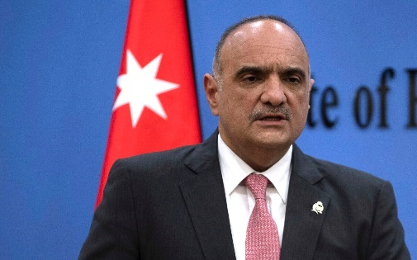
“I salute every Palestinian, and all the employees of the Jordanian Islamic Waqf, who proudly stand like minarets, hurling their stones in a volley of clay at the Zionist sympathizers defiling the Al-Aqsa Mosque under the protection of the Israeli occupation government,” Khasawneh told a session of the Jordanian parliament.
Jordanian Prime Minister Bishr Khasawneh speaks during a press conference with Palestinian Prime Minister Mohammad Shtayyeh, in the West Bank city of Ramallah, December 9, 2021. (AP Photo/Majdi Mohammed, File)
Justice Minister Gideon Sa’ar directly responded to the Jordanian prime minister’s remarks, tweeting that “statements made by senior officials in the Kingdom of Jordan are grave and unacceptable.”
“The sovereignty of Israel in Jerusalem as its capital is the guarantee of freedom of worship for members of all religions in the city. The attempts of extremist and terrorist elements, such as Hamas, to ignite the territory through a false anti-Israel campaign are transparent and should be condemned,” he added.
Jordan’s foreign ministry summoned the Israeli envoy in the kingdom, Deputy Ambassador Sami Abu Janeb, to reprimand him over the actions of Israeli security forces at Al-Aqsa Mosque, on the Temple Mount in Jerusalem’s Old City.
The foreign ministry “summoned the charge d’affaires of the Israeli embassy in Amman… to deliver a message of protest over illegitimate and provocative Israeli violations at the blessed Al-Aqsa Mosque,” it said in a statement.
“The charge d’affaires was informed of a message of protest to be delivered immediately to his government, including calls for an immediate stop to Israeli violations and attempts targeting a change of the historic and legal situation” at Al-Aqsa, the ministry added. MORE - https://www.timesofisrael.com/rejecting-jordans-praise-for-rioters-bennett-decries-incitement-to-violence/

In call with PA’s Abbas, Putin said to criticize Israeli policies at Al-Aqsa Mosque
Russian leader backs Palestinians amid violence in Jerusalem, PA news agency reports; also says Moscow will provide Ramallah with food and materials amid rising global prices
By TOI staff Today, 5:48 pm
Russian President Vladimir Putin held a phone call Monday with Palestinian Authority President Mahmoud Abbas to discuss tensions in Jerusalem and negotiations between Russia and Ukraine, the Russian state-owned news agency RIA reported.
According to the report, Putin updated Abbas on “Russia’s special military operation to defend the Donbas region” in eastern Ukraine. The phone call reportedly took place at the Palestinian leader’s behest.
With the war in Ukraine driving up food prices globally, Putin also assured Abbas during the phone call that Moscow will provide the Palestinians with “Russian wheat, materials, and crops.”
The Palestinian official news agency Wafa said that Putin “stressed Russia’s firm position in support of the rights of the Palestinian people, and that Russia will continue to accord its political support to the Palestinian cause in all international forums, and what is happening in Jerusalem and Al-Aqsa Mosque.”
Wafa also reported that the Russian leader rejected “the Israeli practices that prevent worshipers from freely accessing the Al-Aqsa Mosque,” adding that Israel must “respect the existing historical status quo” at the holy site.
Russia has long been a champion of the Palestinian cause, with PA hoping Moscow will play a more central role in mediating between it and Israel.
Abbas updated Putin on the “daily incursions into Al-Aqsa Mosque by extremist Israelis under the protection of the Israeli occupation forces,” according to Wafa. MORE - https://www.timesofisrael.com/putin-and-pas-abbas-discusses-jerusalem-tensions-war-in-ukraine/ [Putin and Russia are much more openly siding with the “PA” terrorist element than in the past. This is most concerning in light of the ‘cast of characters” in the Ezekiel war. – rdb]

Israel’s balancing act still not enough for Russia
Israel has tiptoed between Western allies and Moscow, but its vote to remove Russia from the UNHCR could sour relations.
By KSENIA SVETLOVA/THE MEDIA LINE Published: APRIL 18, 2022 22:43
Since the beginning of Russia’s war on Ukraine, Israel has been struggling with a balancing act: tiptoeing between pleasing its Western allies and keeping in check its powerful Russian-influenced neighbor on its northern border, Syria.
Today it seems that Israel’s attempt to stay as neutral as possible on the conflict between Russia and Ukraine – for example, Israel did not join the Western countries’ sanctions against Russia and declined to sell weapons to Ukraine – has not succeeded in pleasing Moscow.
Earlier this month, Israel voted at the United Nations General Assembly in favor of removing Russia from the UN Human Rights Council.
“There was a poorly camouflaged attempt to take advantage of the situation in Ukraine to distract the international community’s attention from one of the oldest unresolved conflicts – the Palestinian-Israel one,” Russia’s Foreign Ministry said in a statement over the weekend, reacting to Israel’s vote and to Foreign Minister Yair Lapid’s statements regarding the suspension of Russia’s membership in the UNHRC.
Lapid said Russia’s “unjustified invasion” of Ukraine and the “killing of innocent civilians” were the reason that Israel voted in favor of the motion and that the vote “doesn’t change our view of the UN Human Rights Council, which is a radical, morally flawed, biased and anti-Israeli body.” https://www.jpost.com/israel-news/article-704536

Western Wall Passover prayer event ends peacefully, with relatively low turnout
Semi-annual priestly blessing event draws only a few thousand Jewish worshipers to Old City, as police face ongoing threat of Palestinian violence in capital
By TOI staff Today, 6:42 amUpdated at 11:45 am
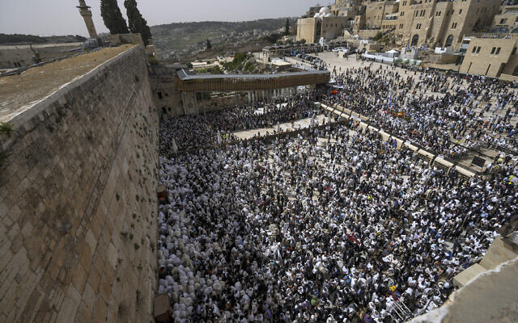
Jewish worshipers participate in prayers for Passover at the Western Wall in Jerusalem's Old City, Monday, April 18, 2022. (AP Photo/Tsafrir Abayov)
Jerusalem was on edge Monday morning as a prayer ceremony went ahead at the Western Wall for the Passover holiday, with authorities still facing the ongoing threat of Palestinian violence around the Jewish holy site.
The semi-annual priestly blessing event, known in Hebrew as “birkat hacohanim,” was held without incident.
The ceremony usually draws tens of thousands to the Western Wall plaza. However, turnout appeared to be quite low on Monday compared to previous years, amid heightened tensions in the capital.
Several Hebrew media reports estimated that attendance was in the low thousands.
This year’s event was being split into two sessions, with the first on Monday and the second on Wednesday, to reduce crowding for security reasons. A stampede at an overcrowded religious event at Mount Meron in northern Israel killed 45 people last year in Israel’s worst-ever peacetime disaster.
Monday’s prayer session began at 8:45 a.m., though worshipers were expected in the area after the ceremony as well.
Jewish worshippers cover themselves with prayer shawls as they pray in front of the Western Wall, Judaism’s holiest prayer site, in Jerusalem’s Old City, April 18, 2022. (Yonatan Sindel/Flash90)
Around 2,500 police officers were securing the area around the time of the prayers.
Jewish pilgrims make their way to the ceremony on the intermediate days of the Passover and Sukkot festivals, with crowds spilling out from the wall’s plaza into the surrounding areas.
The ceremony, which sees male descendants of the Kohanim priestly caste gather to bestow a benediction, involves the raising of hands to perform the blessing, with those conducting the blessing wrapped in prayer shawls.
Pictures from Monday’s prayer session showed some worshipers covered with Ukrainian flags amid the Russian offensive in the eastern European country.
A Jewish worshipper draped in a Ukrainian flag, takes part in the Cohanim prayer (priest’s blessing) during the Passover holiday at the Western Wall in Jerusalem’s Old City on April 18, 2022. (GIL COHEN-MAGEN / AFP)
The Western Wall is one of the retaining walls of the Old City’s massive Temple Mount complex, the location of the two ancient Jewish temples and the most sacred place for Jews. The Western Wall is revered due to its proximity to the site of the temples, and is the closest spot to the Temple Mount where Jews can pray. Though they may visit the Mount, Jews are not allowed to pray at the holy site, which is overseen by a Jordanian custodian.
The Al-Aqsa Mosque on the Temple Mount is the third-holiest place for Muslims.
The site’s religious significance has made it a frequent flashpoint, including in recent weeks, and the emotional epicenter of the Israeli-Palestinian conflict. MORE - https://www.timesofisrael.com/jerusalem-on-edge-ahead-of-massive-passover-prayer-ceremony-at-western-wall/

PA’s Abbas ‘outraged’ as Hamas takes center stage in mediation efforts
Abbas “did not hide his anger” over being sidelined during the mediation efforts with his rivals in Hamas, according to an unnamed official.
By KHALED ABU TOAMEH Published: APRIL 18, 2022 19:03
Palestinian Authority President Mahmoud Abbas is enraged because Egypt, Qatar and other parties chose to hold direct contacts on ways of preventing further escalation with Israel in the aftermath of the recent tensions in Jerusalem and the West Bank, a senior official with the ruling Fatah faction said.
The official, who was not identified by name, told the London-based pan-Arab media outlet Al-Araby Al-Jadeed that Abbas “did not hide his anger” over being sidelined during the mediation efforts with his rivals in Hamas.
“These efforts show that President Abbas is no longer the only party that Arabs turn to when talking about the escalation in al-Aqsa Mosque and the West Bank,” the official added. MORE - https://www.jpost.com/arab-israeli-conflict/article-704516

Thousands plan march to dismantled West Bank settlement over IDF’s initial objection
After brigade commander warns organizers of Tuesday parade to Homesh they’re knowingly putting their lives at risk, Defense Ministry reaches deal to have army secure event
By TOI staff 18 April 2022, 10:37 pm
Thousands of people plan to take part Tuesday in a march to the dismantled West Bank settlement of Homesh, despite the initial objections of the military.
Among the expected participants are lawmakers from the far-right Religious Zionism party, including its chairman Bezalel Smotrich.
The IDF had warned organizers that it would not be able to secure the event, which is set to start at the Shavei Shomron settlement at 11 a.m. and run along 14 kilometers (some 8.5 miles) past several Palestinian villages.
But later Monday, Haaretz reported that Homesh yeshiva organizers reached an agreement with the Defense Ministry, which will see to it that the IDF secures the march as the settlers pass the Palestinian villages, despite the military’s concern that the event will spark further West Bank clashes.
Homesh returned to headlines last December, when a Palestinian terrorist opened fire at a convoy ferrying students back from the yeshiva, killing Israeli Yehuda Dimentan.
The deadly attack prompted renewed calls by ultranationalist lawmakers to resurrect the settlements dismantled in 2005.

Yehuda Dimentman. (Courtesy)
The march will amount to a violation of military law, which bars Israelis from returning to the grounds of the four settlements the government vacated in 2005 as part of the Gaza Disengagement. In practice, the law has barely been upheld, with the yeshiva operating illegally at the Homesh hilltop for the past 15 years, often receiving protection from the IDF. Court rulings granting access to Palestinian farmers to reach their lands at the evacuated settlements have also rarely been implemented.
In a recent letter to the march’s organizers at the Homesh yeshiva, the Samaria Regional Brigade Commander Maj. Roy Zweig warned that forces were stretched too thin securing various Passover events, due to the high alert for terror attacks across the West Bank. MORE - https://www.timesofisrael.com/thousands-plan-west-bank-march-to-dismantled-settlement-over-armys-objections/

Islamic State supporter indicted for murder of three Jerusalem residents
Wasim a-Sayed, 34, a Palestinian from Hebron, was detained last month; he is accused in killings of Kaduri couple in 2019 and Moldovan foreign worker Ivan Tarnovski in 2022
By Tobias Siegal and Emanuel Fabian Today, 3:32 pm
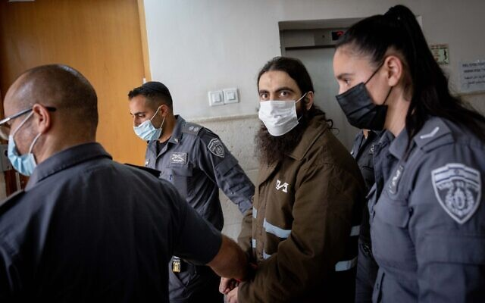
Wasim a-Sayed arrives for a court hearing on murder charges at the District Court in Jerusalem, April 18, 2022. (Yonatan Sindel/Flash90)
An Islamic State supporter was indicted Monday for the murders of three Jerusalem residents and the attempted murders of two others, over the past three years.
Police last week said they believed Wasim a-Sayed was responsible for the 2019 double homicide of an elderly couple in Jerusalem, as well as the killing of a Moldovan foreign worker last month.
According to the indictment submitted to the Jerusalem District Court, a-Sayed, 34, a Palestinian from the city of Hebron in the West Bank, joined the Salafia Jihadia jihadist group in 2011 and swore allegiance to Islamic State in 2014.
After his release from a Palestinian prison in January 2019, he decided to carry out attacks against Jews in Jerusalem, the indictment read.
The indictment accuses him of the murder of Yehuda and Tamar Kaduri in their Jerusalem apartment in January 2019, a crime police had struggled for years to crack.
The investigation also found that a-Sayed was responsible for the attempted murder of teenager Hadar Betzalel days before murdering the Kaduri couple, with the attack on Bezalel marking his first attempted killing.
The indictment said a-Sayed was actually arrested and placed in Israeli administrative detention, without trial, for around two years at some point following these crimes due to his affiliation with Islamic State — though he was not suspected at the time of the Kaduri murders. No details were provided on when exactly his detention began.
He was released in March 2022, it said, and within days committed his next murder: on March 20, a-Sayed crossed into Israel illegally and looked for a target in Jerusalem’s Armon Hanatziv neighborhood. He eventually randomly entered an apartment building and the unlocked home of several sleeping foreign workers.
Advertisement
Believing them to be Jews, he stabbed the two in their sleep, killing Ivan Tarnovski, a foreign worker from Moldova, and critically injuring his roommate.
A-Sayed was arrested hours later, while trying to cross the security fence near Jerusalem again. The knife he was carrying, and his history of administrative detention, led him to be transferred to the custody of the Shin Bet for further questioning.
At the time of a-Sayed’s arrest, police were not aware that he was responsible for any of the murders.
פני הרוע! המחבל מדאעש שרצח באכזריות את הזוג כדורי. pic.twitter.com/ffEmtArxIb
— Yossi Eli יוסי אלי (@Yossi_eli) April 18, 2022
Following a joint investigation carried out by police and the Shin Bet, police concluded that a-Sayed was behind the murders of Tarnovski, as well as Yehuda and Tamar Kaduri in 2019.
The investigation also found that a-Sayed was responsible for the attempted murder of Betzalel. MORE - https://www.timesofisrael.com/islamic-state-supporter-indicted-for-murder-of-three-jerusalem-residents/

Raisi: If Zionists make ‘tiniest move’ against us, we’ll target center of regime
Iran’s president tells military parade Iranians are watching Israel closely, adds that the strength of the armed forces deters Tehran’s enemies
By AP and TOI staff Today, 10:26 am
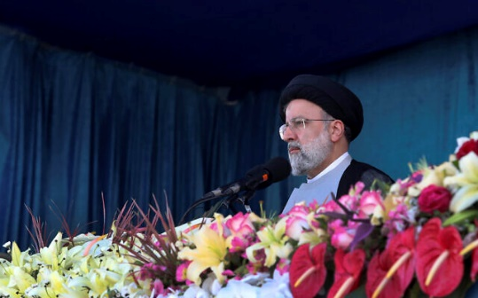
Iran's President Ebrahim Raisi reviews the army troops parade commemorating National Army Day in front of the mausoleum of the late revolutionary founder Ayatollah Khomeini, outside Tehran, Iran, April 18, 2022. (Iranian Presidency Office via AP)
Iranian President Ebrahim Raisi Monday warned that Israel will be targeted by his country’s armed forces if it makes “the tiniest move” against Iran.
Raisi addressed Israel directly during a speech at an annual parade of Iran’s armed forces.
“If you make the tiniest move against the nation of Iran, the center of the Zionist regime will be the target of our armed forces,” Raisi said, referring to Tel Aviv.

Raisi did not elaborate, but said Iran watches any move by Israel “closely.”
He spoke as talks stalled in Vienna over a deal to rein in Iran’s nuclear capabilities. European-sponsored talks hope to save the 2015 Joint Comprehensive Plan of Action, which gave Iran relief from sanctions in return for curbs on its nuclear program aimed at preventing it from obtaining a weapon.
The deal has crumbled following a US exit in 2018 after which Iran dropped some of its own commitments, vastly expanding its nuclear work and enriching uranium to levels the UN nuclear watchdog has said are only pursued by nations seeking nuclear weapons.
Israel opposes a deal, saying it does not do enough to curb Iran’s nuclear program or its military activities across the region. Israeli officials have said they will unilaterally do what’s necessary to protect their country.
Raisi also said that “The greatest component of power in our system is the people and the revolutionary armed forces.”
Advertisement
He said the armed forces’ readiness brings hope “to the lovers of the Islamic Revolution… and its message to the enemy is that our armed forces have the power to deter any movement of the enemy.”
Iran has not recognized Israel since the 1979 Islamic Revolution that ousted the pro-West monarchy and brought Islamists to power. It supports anti-Israeli terror groups such as Hamas and the Lebanon-based Hezbollah.
Raisi said the army has managed to improve its capabilities, despite years of sanctions on the country over Tehran’s nuclear program. Monday’s parade showcased jet fighters, helicopters, drones and air defense systems as well as military tanks, missiles and naval vessels.
Israel in recent years improved relations with neighboring Arab nations in the Persian Gulf, which has angered Iran’s leaders. Tehran also has blamed Israel for the sabotage of its nuclear sites and the assassinations of its nuclear scientists.
US intelligence agencies and the IAEA believe Iran had an organized military nuclear program until 2003. Iran insists its nuclear program is aimed at generating power and for medical purposes. https://www.timesofisrael.com/raisi-if-zionists-make-tiniest-move-against-us-well-target-center-of-regime/

Moment Putin’s nuclear bomber flies close to Ukraine border in major war escalation
Will Stewart Adrian Zorzut 5:48 ET, Apr 18 2022 Updated: 10:24 ET, Apr 18 2022
THIS is the chilling moment one of Vladimir Putin's nuclear bombers was caught flying close to the Ukrainian border in a major military escalation.
The TU-160 strategic bomber was seen in the skies over Western Russia amid huge pressure on the Kremlin over the sinking of the Moskva flagship in the Black Sea.
One of Vladimir Putin’s TU-160 nuclear bombers (ringed) is seen today in the skies over western Russia | The TU-160 is being accompanied by four Russian fighter jets and a refuelling planeCredit: East2West
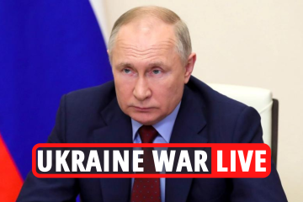
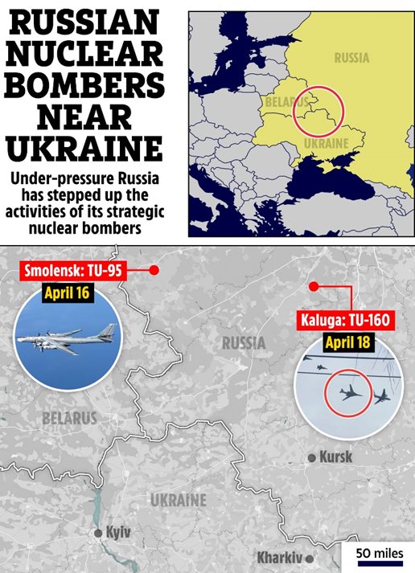
Videos today caught four aircraft - one used to carry nuclear bombs - over Kaluga region, between Moscow and the Ukrainian border.
The Defence Ministry in Moscow had not immediately announced the purpose of the mission.
Larger Tu-95s have been used a number of times to strike targets in Ukraine with non-nuclear weapons, notably Kh-55 and Kh-101 air-launched cruise missiles.
Latest attacks by Russia have concentrated on major cities including Kyiv and Lviv.
MORE ON WAR IN UKRAINE
More footage emerged showing a mission by the Tu-95s on Saturday over Smolensk region, also in western Russia.
The super-loud Tu-95 is the only propeller-powered strategic bomber still in operational use today, and the plane first flew 70 years ago.
Putin has deployed the Tu-95s to buzz Britain at moments of high tension, for example in February this year when the Royal Air Force scrambled Typhoon fighters to escort two Bears off northern Scotland. MORE - https://www.the-sun.com/news/5145610/putins-sends-nuclear-bomber-close-to-ukraine-border/ [Folks this should bother you a whole lot. This is not good and could well be a portent of evil things to come. The NATO/US group has constantly been buggering and prodding at the Russian Bear trying to get him to aggressively go further and further. He has been specific, NO NATO weapons or installations on his border. That is just like our problem with the Cuban Missile crisis years ago. We didn’t want Russian presence on our border. He doesn’t either and the US has been working to push this. The US wants their presence there because it has been a major revenue generator for the DC crooked crowd for years. We send aid and it comes back to the politicians pockets. That how they get rich – rdb]
Ukrainian president: Russia’s large-scale offensive in eastern Ukraine has started
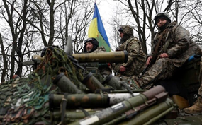
‘We can now confirm that Russian troops have begun the battle for the Donbas,’ Zelensky says. ‘No matter how many Russian soldiers are brought here, we will fight’
By DAPHNE ROUSSEAU Today, 11:32 pm

Ukrainian soldiers stand on their armored personnel carrier (APC), not far from the front-line with Russian troops, in Izyum district, Kharkiv region on April 18, 2022, during the Russian invasion of Ukraine. (Anatolii Stepanov / AFP)
KYIV (AFP) — Russia launched a major offensive into eastern Ukraine on Monday, authorities in Kyiv said, as Moscow opened a new phase of its invasion after being thwarted in efforts to capture the capital.
In recent weeks, Russia’s military campaign has refocused on the eastern region of Donbas, which pro-Moscow separatists have partly controlled since 2014.
“We can now confirm that Russian troops have begun the battle for the Donbas, which they have been preparing for a long time,” Ukrainian President Volodymyr Zelensky said on Telegram late Monday.
“No matter how many Russian soldiers are brought here, we will fight. We will defend ourselves.”
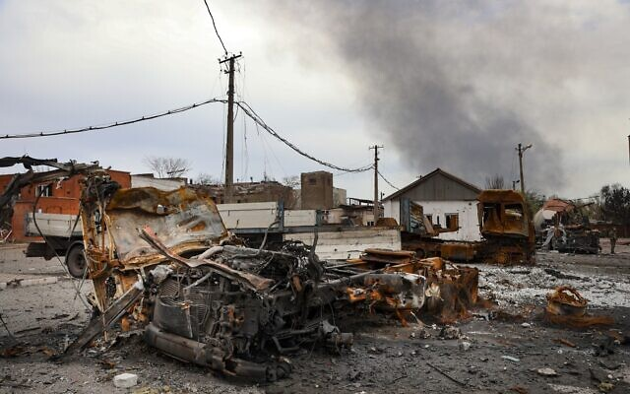
Ahead of the widely anticipated advance, Ukrainian authorities had urged people in Donbas to flee west to escape.
Control of Donbas would allow Moscow to create a southern corridor to the occupied Crimean peninsula.

Burned vehicles are seen at the destroyed part of the Illich Iron & Steel Works Metallurgical Plant, as smoke rises from the Metallurgical Combine Azovstal during heavy fighting, in an area controlled by Russian-backed separatist forces in Mariupol, Ukraine, Monday, April 18, 2022. (AP Photo/Alexei Alexandrov)
In the south of Donbas, Russia continued its push to capture the besieged port city of Mariupol, where the last remaining Ukrainian forces have taken a final stand.
Russia on Monday also pounded targets across the country, killing at least seven people in the far western city of Lviv. MORE - https://www.timesofisrael.com/ukrainian-president-russias-large-scale-offensive-in-eastern-ukraine-has-started/

Spain may cut electricity to France – media
Madrid can’t keep prices down at home without shutting off exports to its northern neighbor, a major newspaper claims
18 Apr, 2022 19:57
Spain has informed the European Commission that a joint price reduction plan with Portugal may entail restricting energy sales to France, El Pais reported on Monday. Madrid is its northern neighbor's largest single supplier of imported electricity, and the potential restriction comes as the entire EU grapples with soaring energy costs.
Spain and Portugal agreed in late March to cap the price of gas used in electricity generation to the equivalent of 30 euros per megawatt/hour ($32.50). While Brussels granted both countries an exception to its normal rules and allowed this arrangement to go ahead, Madrid and Lisbon then delivered some bad news to Eurocrats.
According to the documents cited by the newspaper, Spain and Portugal will need to impose “some restrictions” on energy sales to France as a result.
Under an alternative system originally proposed by Madrid, electricity exported to France would be charged at a higher rate than that consumed on the Iberian Peninsula. According to El Pais, officials in Brussels are concerned that this arrangement would breach the bloc’s market rules, and Germany and the Nordic countries are reported to be fiercely opposed to this idea.
The College of EU Commissioners will reportedly discuss the issue at their next meeting, which typically takes place weekly.
Although France is a net exporter of electricity, it still imports around 34% of its power, according to figures from 2020. Spain, more than any other single country, provides most of this.
Electricity prices have soared throughout the EU, with customers paying 45% more in March than a year previously. The soaring prices have been driven by uncertainty over whether the EU will embargo Russian gas imports, and shocks to global energy markets as a result of the conflict in Ukraine. Skyrocketing inflation throughout the Western world has also pushed electricity bills higher. https://www.rt.com/news/554112-spain-restrict-electricity-france/

Western ‘economic blitzkrieg’ has failed – Putin
The Russian economy has withstood the sanctions pressure, according to the president
18 Apr, 2022 15:51
Western nations have failed in their attempts to destabilize the Russian economy with sanctions, Russian President Vladimir Putin said at a government meeting on economic issues on Monday.
“The situation is stabilizing, the ruble exchange rate has returned to the levels of the first half of February and is supported by a strong balance of payments… Foreign cash is returning to the country’s banking system, and the volume of deposits by citizens is growing. As for the consumer market, after a short rush to buy a number of goods… retail demand has returned to normal. Commodity stocks in retail chains are recovering,” Putin said.
Overall, he noted that sanctions have failed to break the country’s economy.
“The goal [of sanctions] was to quickly undermine the financial and economic situation in our country, provoke a panic in the markets, trigger a collapse of the banking system and a large-scale shortage of goods in stores. But this policy has failed – the economic blitzkrieg has run aground,” the Russian president stated.
Meanwhile, according to Putin, the sanctions have backfired on the countries that introduced them, namely the US and the EU, leading to a spike in inflation and unemployment in these countries, a worsening of the standard of living of its citizens, and devaluation of their savings.
Putin acknowledged that Russians have also felt the impact of the sanctions on their family budgets, as prices in the country over the past month and a half have jumped by 9.4%, and annual inflation surged to 17.5% as of April 8. The president noted, however, that prices are now showing signs of stabilizing, and he vowed to introduce further measures to help the population.
“We need to support our citizens, help them cope with the inflationary wave. In this regard, let me remind you that we made a decision to raise all social payments, pensions and salaries of residents employed in the public sector,” he said.
According to Putin, restrictions placed on the country have negatively affected businesses, complicating the logistics of export and import deliveries and creating obstacles for making payments. The president noted that in order to improve the situation, Russia needs to speed up the transition to national currencies in foreign trade settlements.
“It is necessary to provide maximum assistance to entrepreneurs in solving these problems, including speeding up the transition of foreign trade to settlements in rubles and in the national currencies of countries that are reliable business partners,” he said.
According to the president, the key task for the government at the moment is the long-term stability of the financial system at both the federal and regional levels.
Russia has faced unprecedented sanctions from the US and its allies in retaliation to Moscow’s military operation in Ukraine. In less than two months, Russia has become the most sanctioned country in the world. Moscow says it is now subject to more than 6,000 different targeted restrictions. That is more than Iran, Venezuela, Myanmar, and Cuba combined. https://www.rt.com/business/554079-western-sanctions-russia-failed/
Wang Wen: The world has become more dangerous and the chances of WW3 are increasing
More and more scholars estimate that the possibility of a new worldwide сonflict are getting higher
By Wang Wen, Executive Dean of Chongyang Institute for Financial Studies (RDCY), Deputy Dean of Silk Road School, Renmin University of China. 18 Apr, 2022 16:57
The Russian-Ukrainian armed conflict has become protracted, making the world a more dangerous place. On the surface, it is a military struggle between Kiev and Moscow's forces in the western and southern theaters. However, in essence, it's a total outbreak of a Cold War-esque confrontation in Eastern Europe, and it is also a full-scale counterattack by Russia against the endless strategic expansion of the US and its NATO military bloc.
Despite not formally sending troops, the US and NATO have used almost all means of mixed warfare such as financial sanctions, an information blockade, intelligence support, satellite navigation, and air and space technology to comprehensively strangle Russia.
In the almost two months since the conflict began, the West has imposed more than 5,000 sanctions on Russia, which is 50% more than the US has imposed on Iran over the past 40 years. More military assistance and financial sanctions from the NATO states are still on the way. This is undoubtedly adding fuel to the flames, stimulating Russia to fight back more. In particular, President Joe Biden’s words about his Russian counterpart Vladimir Putin leaving power have made Moscow see this as a threat to its survival.
More and more scholars estimate that the possibility of the outbreak of World War III is increasing, and have even concluded that this could lead to a nuclear war. The situation is moving in the direction of global disaster. Putin cannot tolerate failure, and Biden is unwilling to give up, which will could compel Russia to use nuclear weapons.
Besides war, more disasters are happening. The war has displaced millions of Ukrainian farmers from their homes and led them to miss the spring sowing season, resulting in a decline in Ukrainian agricultural exports. Ukraine was previously one of the world’s important exporters of agricultural products, with its wheat and corn respectively accounting for 10% and 15% of the globe's exports of these staple crops. Fourteen countries are more than 25% dependent on Ukrainian wheat imports. They include Libya at 43% and Bangladesh at 28%. Without adequate affordable import substitutes, cities in some developing countries are likely to face a severe famine.
Food shortages and the rise in energy prices, caused by the fighting, have limited the production of more and more countries. The US, the EU, Argentina, and Turkey have experienced serious price increases, and the inflation rate in Europe and the US has reached its highest in 40 years. If we continue, will Elon Musk’s prediction of an economic crisis “maybe happening around spring or summer 2022, but no later than 2023” become a fulfilled prophecy?
Over the past two years, more than 6 million people have died from Covid-19. Many Western countries have opened up and announced that they will no longer isolate patients with the coronavirus. But as a World Health Organization expert has warned, this is too optimistic. Covid-19 is not over, and deaths still occur. Since last month, the number of infections has soared, and about 1,000 people die from Covid-19 every day. People believe in the vaccine and the idea of coexisting with the virus. But can it prevent more deaths? Can medicine and vaccines keep up with the speed of virus mutation? All of this is still unknown. MORE - https://www.rt.com/news/554056-possibility-world-war-nuclear/
Wall Street bank raises alarm over US economy
Goldman Sachs predicts a 35% chance of a recession within the next two years
18 Apr, 2022 13:34
The Federal Reserve will face a difficult task in tightening monetary policy enough to cool inflation without causing a recession in the United States, Goldman Sachs Chief Economist Jan Hatzius wrote in a research report on Sunday and seen by Bloomberg. The analyst sees the odds of economic contraction at about 35% within the next two years.
According to the report, the regulator’s main challenge is to narrow the gap in what is a plentiful supply of jobs but scarce labor supply. The Fed also needs to slow wage growth to a pace consistent with its 2% inflation goal by tightening financial conditions enough to reduce job openings without sharply raising unemployment.
Achieving a so-called soft landing may be tough, because historically large declines in the job-worker gap in the United States have only occurred during recessions, Hatzius said. “Taken at face value, these historical patterns suggest the Fed faces a hard path to a soft landing.”
However, the chief economist said that a recession isn’t inevitable because the post-Covid-19 normalizations in labor supply and durable goods prices will help the Federal Reserve. There are more examples of other countries in the Group of 10 advanced economies that have pulled off such a soft landing, he said.
According to Hatzius, 11 out of 14 tightening cycles in the United States since World War II were followed by a recession within two years. However, only eight of them can be even partially attributed to Fed tightening -- and soft or ‘softish’ landings have been more common in recent times, he said. He has forecast the odds of a US recession in the next 12 months at about 15%. https://www.rt.com/business/554072-goldman-raises-us-economy-alarm/
Famous Democrat consultant: FDA knew vaccine not safe and effective
'They rolled it out anyway'
By Art Moore Published April 18, 2022 at 8:32pm
Longtime Democratic consultant and feminist author Naomi Wolf has teamed with health experts and attorneys to mobilize people to pore through the thousands of documents on the Pfizer vaccine trials that the FDA was forced to release through a lawsuit.
On Monday, she summarized for Steve Bannon on "War Room" the biggest news from the findings, which are compiled on the website of her company Daily Clout.
"It looks to me – this is not an overstatement from what I've seen – that this was a clinical trial that by August 2021, Pfizer and the FDA knew was failed, the vaccines were not safe and effective. That they weren’t working. That the efficacy was waning ... and that they were seriously dangerous," Wolf said. "And they rolled it out anyway."
The FDA, the documents show, knew that the 100 microgram doses being administered during the trial suppressed the immune system, the white blood cells, Wolf said.
The Pfizer trials, which are ongoing, have found that the mRNA-produced spike protein and the lipid nanoparticles used to deliver it were making people sick.
Wolf said the data tables show that Pfizer and the FDA knew they could anticipate vaccinated people suffering joint pain and muscle pain, which, she said, "loved ones of mine have now," and extensive fevers and cardiac problems.
'The danger and the lasting damage that they knew about are clearly on display," she said.
Further, Pfizer has told the public that the vaccines have no effect on a person's DNA. But the company cited two peer-reviewed studies showing that is not the case.
The FDA had evidence in May 2021 that about 35 children had suffered permanent heart damage a week after being vaccinated.
Yet, in September, Wolf noted, members of the FDA's vaccine advisory panel argued that they needed to give children the vaccines immediately because it was unethical to give half the population the vaccine and half a placebo.
In light of what is known now, she said, that aim was "unbelievably reckless."
And that is in spite of the fact that, statistically, COVID-19 poses no risk to children of severe illness or death.
"We need to see what the FDA knew and when they knew it, because this is such a serious crisis for the American people, that this was allowed to happen," Wolf said https://www.wnd.com/2022/04/famous-democrat-consultant-fda-knew-vaccine-not-safe-effective/ [These are criminal charges and the Fed agencies and Pharm companies need to be held accountable. – rdb]
Biden planning Global COVID Summit to 'vaccinate the world'
'Calling on' world leaders, NGOs, philanthropists and the private sector
By Art MoorePublished April 18, 2022 at 7:33pm
Despite the failure of the COVID-19 vaccines to stop infection and transmission of the virus mid alarming safety signals, President Biden is calling on the world's political and private sector leaders to meet for a second COVID "summit" to "make new commitments and bring solutions to vaccinate the world." [Maybe – JUST MAYBE people will wake up to the fact that this JAB has absolutely NOTHING to do with helping the Covid debacle that grouchy fauchi and his Chinese friends created. It has everything to do with the great reset and the world depopulation agenda. If people don’t wake up real soon it will be too late and your immune system will be trashed forever. – rdb]
The White House said in a statement Monday that the second second Global COVID-19 Summit will be held virtually May 12.
"The Summit will redouble our collective efforts to end the acute phase of the COVID-19 pandemic and prepare for future health threats."
The U.S., as the chair of the first summit last September, is co-hosting the upcoming meeting with Belize, as CARICOM (Caribbean Community) chair; Germany, holding the G7 presidency; Indonesia, holding the G20 presidency; and Senegal as African Union chair.
The summit, the White House said, will "redouble our collective efforts to end the acute phase of the COVID-19 pandemic and prepare for future health threats."
The hosts "are calling on world leaders, members of civil society, non-governmental organizations, philanthropists, and the private sector to make new commitments and bring solutions to vaccinate the world, save lives now, and build better health security — for everyone, everywhere."
The White House said the summit, among other "commitments," will emphasize "getting shots into arms" and "deploying tests and treatments, especially for the highest-risk populations."
Meanwhile, CDC and U.K. government data have indicated that the COVID-19 vaccines not only are ineffective in preventing cases and transmission, they rapidly lose protection against severe illness or death while posing risks.

A newly published long-term study by the prestigious British journal The Lancet that followed up on participants in the Moderna and Pfizer trials found the vaccines had no effect on overall mortality.
Last month, a former adviser to the FDA commissioner who continues to serve in an oversight role said the agency is ignoring its requirement to disclose clear safety and efficacy problems with the COVID-19 vaccines. Also in March, an Army flight surgeon testified in federal court that she was ordered by high-level command not to discuss the controversy over Department of Defense data indicating a massive spike in serious injuries and illnesses among military personnel when the vaccines were rolled out in 2021. And, among many other safety signals, an analysis of CDC data by a former Wall Street executive an an insurance industry expert shows an alarming rise in excess deaths among Millennials over the past year amid the COVID vaccine rollout.
In April, the Food and Drug Administration released a briefing document that says the composition of the current COVID-19 vaccines might need to be changed to ensure high levels of protection. https://www.wnd.com/2022/04/biden-planning-global-covid-summit-vaccinate-world/
Commentary:
Passover - From Slavery to Freedom
Daniel Greenfield April 17, 2022
As the first days of another Passover conclude with the echoes of "Once we were slaves and now we are free" and "Next year in Jerusalem" recited at the Seder nights ringing in our ears, we know that freedom is a lot more than being able to board a plane and fly off to Jerusalem.
Slavery did not end with the fall of Pharaoh. Since then we have become slaves again, lived under the rule of iron-fisted tyrants and forgotten what the very idea of freedom means. And that will likely happen again and again until the age of oppression ends. What is this freedom that we gained with the fall of a Pharaoh, his drowning armies, and the last sight of his pyramids?
Freedom, like slavery, is as much a state of mind as a state of being. It is possible to be legally free, yet to have no freedom of action whatsoever. And it is possible to be legally a slave and yet to be free in defiance of those restrictions. External coercion alone does not make a man free or slave.
Slavery, as all our ancestors learned at one time or another, is a state of mind.
What is a slave? A slave is complicit in his own oppression. His slavery has become his natural state and he looks to his master, not to free him, but to command him. He does not want to be free and he resents the very idea of freedom. The Jews in Egypt were not merely restrained by chains and guards. If they had been, then the task of their liberation would have been much simpler. But just as an addictive drug crosses the barrier from physical to psychological dependency, they were enslaved not just with external, but internal chains. They moaned not at the fact of slavery, but at the extremity of it. When their taskmasters complained to Pharaoh, it was not about being enslaved, but of not being given the straw with which to build the bricks that had become their duty.
The worst slavery is of the most insidious kind. It leaves the slave able to think and act, but not as a free man. It leaves him with cunning, but not courage. He is able to use force, but only to bring other slaves into line. And most hideously, this state of affairs seems moral and natural to him. This is his freedom.
The true slave has come to love big brother, to worship at the foot of the system that oppresses him. It is this twisted love that must be torn out of him. It is this idolatry of the whip before which he kneels, this panting to know who his superiors and who his inferiors are, this love of a vast order that allows him to be lost in its wonders, to gaze in awe at the empire of tomorrow which builds its own tombs today, that must be broken. These are his gods and he must kill them within himself to be free.
The Exodus is not the story of the emergence of free men who were enslaved, but the slow painful process by which slaves became a nation of free men, a long troubled journey which has not yet ended. That is why we celebrate Passover, not as an event of the past, but as of a road that we still travel on our long journey from slavery to freedom. Not just the journey of the Jews, but of humanity.
Having escaped from Pharaoh, the Jews built a glittering calf, and having left the desert behind, they sought out a king. Every idol and tyrant was another token of slavery, a desire to put one's ear up against the doorpost and become slaves for life. The idols have changed, but their meaning has not. There is still the pursuit of the master, the master of international law, of a global state, the expert gods of the superstate who rule over the present and the future and dispose of the lives of men.
There are far too many synagogues that worship the Democratic Party, rather than G-d, that bow to the ghost of FDR, and whose scriptures are to be found in the smeared ink of the New York Times. And in Jerusalem far too many eyes look longingly to Washington and to Brussels, to the cities on the hill which offer order, truth and peace.
It is easy to slip into this kind of slavery. The pyramids are grand, the slogans are clever and the future seems assured. It is only when the dusty messenger comes along to whisper that "He has remembered". that those who have not forgotten gather and some among those who have forgotten, remember that they are slaves.
In Egypt the system of the state had to be smashed, not just smashed, but discredited. The war between slavery and freedom could not end until the system of slavery had become ridiculous, until Pharaoh appeared a buffoon and his power no more than organized madness. And yet even so for a generation liberated from slavery, this majestic system, the only one they had ever known, remained their template, and in times of crisis, their immediate instinct was to retreat back to the only civilization they had known.
The slavery of the present is a more subtle thing. It grips the mind more tightly than the body. It still remembers that men enslave themselves best. It knows also that true power comes from making all complicit in its crimes so that they are also complicit in their own degradation. The system only asks that each man enslave himself and kill his own children. And once he has done that, he will only feel it right to demand that everyone else do likewise.
Do it for the environment, for social justice, for the Pharaoh of every age and his ideology. Enslave your mind. Kill your children.
This is the slavery of the system. It requires few whips and many words. It nudges men to be their own taskmasters and to reach out their hands to the new Pharaoh in the hope that he will save them. It is this slavery which is so pervasive, which Passover wakes us from, if it has not already been perverted into the Passover of the slave, into civil rights seders and eco-matzas with donations to Planned Parenthood which will do what the midwives did not.
"Once we were slaves," the ancient words call on us to remember that we have been freed. That it is no longer Pharaoh who enslaves us, but we who enslave ourselves. "Now we are free men." But what is freedom really? Is it the freedom to worship G-d or to worship the system? The system proclaims that it is god. And that is the great lie which ends in the death of the system and its slaves.
Like the slaves of ancient Egypt, we are shaken, dragged out of our everyday routine and commanded to be free. But how do you command men and women to be free? You can lead them through the habits of free men and women who think of themselves as kings and queens, who drink wine while reclining, who sing loudly in defiance of all oppressors, who boldly proclaim "Next year in Jerusalem" while the pharaohs and czars of D.C. and the EU bare their teeth at the Jews living in Jerusalem.
You can unroll the scroll of history and show them how they were taken out, but all this routine is useless unless they understand and are sensible that they are free. Free not in their habits, but in their minds. Ritual is the gateway to a state of mind. A ritual of freedom only succeeds when it invokes a state of mental freedom. Otherwise it is a rite, a practice, a habit whose codes may help some future generation unlock its meaning, but which means little today.
Passover is the beginning and the end. It is the start of the journey and the end of it and we are always in the middle, on the long road out of Egypt, discovering that there are more chains in our minds than we realized a year earlier or a hundred or a thousand years ago. Each step we take toward freedom also reminds us of how far we still have to go.
It is the ritual that reminds us that we are still on the journey, that though we have been lulled by the routine of the system, the trap of the present that like the soothing warmth of an ice storm or the peaceful feeling of a drowning swimmer, embraces us in the forgetfulness of the dying moment, concealing from us the truth that the journey is not over. The desert still lies before us.
This journey is the human journey. It is the recreation of what mankind lost when it defied G-d, when it turned with weapons on each other, when it built towers, created systems and tried to climb to heaven on the backs of slaves and pyramids. It is a transformative road that requires us to not only endure, but to learn.
Surrounded by willing slaves who preach the creed of slavery, we must speak for freedom. Though few seem to remember the journey or the chains, it is our duty to remind ourselves. The message of Passover fully begins only when the holiday ends and its habits carry over into our daily lives.
Once we were slaves, now we are free https://www.danielgreenfield.org/2022/04/passover-from-slavery-to-freedom.html

Deterring China: U.S. Should Arm Taiwan to the Hilt – Now
by Gordon G. Chang April 18, 2022 at 5:00 am
That is what the Eastern Theater Command of China's People's Liberation Army said on April 15, referring to Washington's encouragement of Taiwan. That day, the Chinese military sent fighter and bomber aircraft as well as frigates near the island republic.
China's exercises, said Foreign Ministry spokesperson Zhao Lijian, were "a countermeasure to the U.S. negative actions recently, including the lawmakers' visit to Taiwan." Beijing, he said, would "continue to take strong measures to resolutely safeguard its sovereignty and territorial integrity."
As he spoke, six American lawmakers, led by Senator Lindsey Graham, the South Carolina Republican, and Robert Menendez, the New Jersey Democrat chairing the Senate Foreign Relations Committee, met with Taiwan's President Tsai Ing-wen and other senior officials of the self-governing island. They arrived on a U.S. Air Force plane, a not-so-subtle signal to Beijing. The two-day visit was unannounced, "sneaky" in the words of China's Defense Ministry.
The Global Times, a tabloid controlled by China's official People's Daily, was even more direct. It said the drills were not only a "warning" to other lawmakers planning to visit the island but also went "beyond deterrence by preparing for potential, real actions that would resolve the Taiwan question once and for all when necessary."
"Real actions"? Whether or not China plans to invade Taiwan now, it is time for the United States to ditch decades of misguided policy. Among other things, Washington should, on an emergency basis, begin arming the island with the weapons it urgently needs.
The People's Republic of China reserves for itself the right to use force to annex the Republic of China, Taiwan's formal name. "Taiwan is a sacred and inalienable part of Chinese territory," the Eastern Theater Command declared in a statement. "There is no room for any foreign interference on the Taiwan issue."
Many analysts have surmised that the heroic Ukrainian resistance to Russian invaders has made China's invasion of Taiwan less likely. For various reasons, few if any outsiders know how the Chinese leadership in fact views the situation.
Unfortunately, Xi Jinping, the extraordinarily ambitious and bold Chinese ruler, may feel encouraged by recent events in Eastern Europe. As Wang Dan, a Tiananmen Square-era student leader, wrote late last month, "We should not expect rational decision-making from dictators and totalitarian regimes."
Xi could very well decide that the Ukraine war shows he now has a green light to invade Taiwan. After all, the United States, the 27 nations of the European Union, and Great Britain — combined, these 29 states had an economy more than 25 times larger than Russia's last year — could not exercise their power to deter Vladimir Putin, so Xi may feel they will similarly fail with regard to China.
Moreover, the sanctions placed on Moscow after the invasion were not comprehensive, and they are, incredibly, still not comprehensive. Xi, therefore, could believe that no nation would dare impose meaningful costs on his magnificent state.
Finally, Xi might think that Vladimir Putin's invasion has created enough chaos and distraction that others would be in no position to oppose his acts of aggression.
China's leaders give the impression they have been emboldened by recent events. As Kabul was falling last year, for instance, Beijing was pushing the point that the U.S. was incapable. The Global Times asked how America could stand up to mighty China when it could not even deal with the Taliban. The semi-official tabloid also stated this, referring to America: "It cannot win a war anymore."
Moreover, Communist Party propaganda talked about Taiwan as Kabul fell. In an editorial in August, the Global Times declared that once a war breaks out in the Taiwan Strait, the island's defense will collapse in hours and the U.S. military won't come to help.
None of this is to say China will invade— there are many reasons why it will not — but nowhere is deterrence now more important than in the Taiwan Strait. Taiwan, after the fall of Afghanistan and invasion of Ukraine, is considered around the world as the test of American credibility.
The United States for decades has had a policy of "strategic ambiguity," not telling either China or Taiwan what it would do in the case of imminent conflict.
Ambiguity worked in a benign period, but, especially after the Ukraine invasion, the world is no longer in a benign period. Chinese leaders say America no longer deters them. Washington has to take them at their word, which means the U.S. must now adopt measures once considered extreme. As American policymakers consider what to do, they must remember that three decades of misguided Taiwan policy have left them with no risk-free options.
To prevent a Chinese invasion, President Biden should publicly declare that America will defend Taiwan. In addition, the U.S. should work with allies Japan and Australia and offer a multilateral defense treaty to Taipei.
Moreover, as former Secretary of State Mike Pompeo proposed last month while visiting Taipei, the U.S. should recognize Taiwan for what it is: a sovereign state.
Recognition of Taiwan would require a change in America's One-China Policy. Pursuant to that policy—often confused with Beijing's One-China Principle — the U.S. recognizes Beijing as the legitimate government of China. In other words, Washington has pronounced the Communist Party the winner of the Chinese Civil War. Nonetheless, America does not, like China's One-China Principle, accept Beijing's position that Taiwan is part of the People's Republic. The U.S. merely acknowledges that Beijing makes that claim.
The U.S. instead takes the position that Taiwan's status remains unresolved and that the resolution of the status must be peaceful, in other words, with the consent of Taiwan's people.
To make sure the resolution of Taiwan's status is peaceful, the Biden administration should start shipping weapons to Taiwan, especially long-range missiles that can hold China's regime hostage.
Moreover, America and friends, to back up their words, should base forces on the island.
Deterrence is the best guarantee of peace.
The United States did not send sufficient weapons to Ukraine before the February 24 invasion, thereby failing to maintain deterrence in Eastern Europe.
By openly bolstering Taiwan's defenses, Washington would be declaring that America was no longer afraid of offending Beijing. That is transmitting the "right signal" for Chinese leaders to ponder.
Gordon G. Chang is the author of The Coming Collapse of China, a Gatestone Institute distinguished senior fellow, and a member of its Advisory Board. https://www.gatestoneinstitute.org/18435/us-arm-taiwan
A Scam So Nice They Tried It Twice
Derek Hunter Posted: Apr 18, 2022 12:01 AM
A rule of thumb in the con artist game is don’t repeat yourself – the more you repeat yourself, the more likely you are to get caught, as some of your previous victims will remember what you’d pulled. But in the world of Democrat Party fundraising, there appears to be little interest in this rule, or at least no fear any of their donor will be smart enough to catch on to the scam.
On Saturday, I got an email from the uber-leftist group “Stop Republicans” about the upcoming Senate election in Arizona. The display name attached to the email address was “heart wrenching loss [Arizona]” and the subject line was “There’s nothing left to say.” The problem for this group is I save every email they send, and on March 23 they’d sent the exact same email.
“Derek, there’s nothing left to say,” the email this weekend opens. “When we said Mark Kelly was our only hope at saving our RAZOR-THIN Senate Majority, we thought Democrats would RUSH to boost Turnout in Arizona… But we were WRONG. Not a SINGLE Democrat donated. We’re sobbing.”
The March 23 email opened, “Derek, there’s nothing left to say. When we said Mark Kelly was our only hope at saving our RAZOR-THIN Senate Majority, we thought Democrats would RUSH to boost Turnout in Arizona… But we were WRONG. Not a SINGLE Democrat donated. We’re sobbing.”
That’s a lot of sobbing, right?
In fact, the entire email is a repeat, they didn’t even have enough respect for their donors to change a single thing about it. The paragraph, “We only have ONE DAY LEFT to get 11,875 gifts to save Arizona. If we fall short, we’ll have to pack up and abandon Mark Kelly. Can you donate??” appears in both emails. They couldn’t even be bothered to change the number of fake donations they need before all is lost.
Both close out, “And we’re days from abandoning Arizona because we’re flat out BROKE!” Maybe they’re really, really bad at money management or their donors are a special kind of suckers.
Speaking of tears, another grifting group called the Democratic Strategy Institute is, if you’re to believe their messages, is another emotionally and mentally unstable group. Just so far this year they’ve send 5 emails with the subject line, “we’re crying HAPPY tears!!” Sounds like a chemical imbalance.
What got them crying? One email is about Joe Biden’s agenda where they were “only 2,000 donations short of our 100,000 donation goal. And with only 6 hours left until our midnight deadline, we need you to step up!” In another about “Biden’s majorities,” they were “only 2,500 donations short of our 100,000 donation goal. But with only 8 hours left until our midnight deadline, we need you to step up!” And in still another, this one about the filibuster, they were “only 500 donations short of our 100,000 donation goal. But with only 9 hours left until our midnight deadline, we need you to step up!”
They play with the numbers, but the messaging must work of else they wouldn’t use it in every email under the same subject line. How little recall must someone have to not realize they’re getting the same words, the same sales pitch, repeatedly? How vacant must that audience be if they don’t realize it?
These groups are relentless, nothing will stand between them and their sucker’s, I mean donor’s, money.
When they’re not scamming, they’re crying, and they’re crying a lot, if their words are to be believed. Granted, they’re leftists so their words are not to be believed. It’s just informative about the lengths to which they will go for money.
What do they actually do with that money? That’s a good question. They pay themselves, that much is certain. But ask yourself if you’ve ever heard the names of either group in a tagline on a TV commercial or even at the bottom of a meme? Maybe they’ve produced some, but I’d be willing to bet they haven’t made that many. Someone is getting rich off these scams, which is enough to make their donors sob uncontrollably. So at least some of the tears are real. https://townhall.com/columnists/derekhunter/2022/04/18/a-scam-so-nice-they-tried-it-twice-n2605972
THE SHORASHIM BIBLICAL GIFT CATALOG 005
http://mad.ly/7f9f64?pact=20013931524&fe=1
Support Shorashim!
Arutz Sheva
US official: We're looking at possibly labeling Russia a state sponsor of terrorism
State Department spokesperson says officials are looking at every tool available to hold Russia accountable for war in Ukraine.
Elad Benari 19.04.22 04:07
US State Department officials are looking at every tool available to them to hold Russia accountable for the war in Ukraine, including the possibility of labeling Russia a state sponsor of terrorism, a senior administration official said on Monday, according to CNN, adding the process could take weeks before a determination is made.
“We're taking a close look at the facts. We're taking a close look at the law,” said State Department spokesperson Ned Price on CNN when asked about the possibility of designating Russia as a state sponsor of terrorism.
“Whether it is this authority, whether it's any other authority available to us under the law, we will apply it if it's effective and appropriate,” he added.
The definition of a state sponsor of terrorism is a country that has “repeatedly provided support for acts of international terrorism,” according to the State Department. There are only four countries that are currently labeled state sponsors of terrorism by the US: North Korea, Iran, Cuba and Syria.
Price’s comments follow a Washington Post report last week which said that Ukrainian President Volodymyr Zelenskyy made a direct appeal to US President Joe Biden for the United States to designate Russia a state sponsor of terrorism.
Zelenskyy’s request, the report said, came during a recent phone call with Biden that centered on the West’s multifaceted response to Russia’s invasion of Ukraine.
Biden did not commit to specific actions during the call, sources said, adding that Biden told his Ukrainian counterpart he is willing to explore a range of proposals to exert greater pressure on Moscow.
Last week, Biden toughened his criticism of Russian President Vladimir Putin, and said Putin is committing genocide in Ukraine.
Biden, while delivering remarks in Menlo, Iowa, accused Putin of committing genocide in Ukraine as he blamed the Russian President for recent price hikes at the pump.
"Your family budget, your ability to fill up your tank, none of it should hinge on whether a dictator declares war and commits genocide half a world away," he said.
Zelenskyy later praised Biden and tweeted, “True words of a true leader. Calling things by their names is essential to stand up to evil. We are grateful for US assistance provided so far and we urgently need more heavy weapons to prevent further Russian atrocities.” https://www.israelnationalnews.com/news/326059

Smotrich seeks plenum session to dissolve the Knesset
Smotrich seeks to use Ra'am's stepping aside from the coalition to convene the Knesset to vote on its dissolution.
Israel National News 19.04.22 00:59
The chairman of the Religious Zionist Party, MK Bezalel Smotrich, wrote a letter to Knesset Speaker Mickey Levy on Monday requesting that the Knesset plenum convene during its recess to promote a bill to dissolve the 24th Knesset, Channel 12 News political commentator Amit Segal revealed.
Smotrich decided to go for this move because he realized that after the Ra’am party’s announcement of the freezing of its membership in the coalition, Prime Minister Naftali Bennett and Foreign Minister Yair Lapid do not have a majority in the government and the Knesset.
"As you probably know very well, after your partner from the Ra’am party stepped aside from the coalition, the government and the coalition do not have a majority. The current situation, in which the government is in fact a minority government that does not win a majority in the Knesset, severely harms democracy and as a result also harms public trust. As such, there is no choice but to dissolve the 24th Knesset and go to democratic elections," Smotrich wrote to Levy.
He added, "Since there are 61 Knesset members who are not members of the coalition, we call on you to convene the Knesset plenum immediately after the holiday to discuss bills to dissolve the Knesset."
According to estimates in the political system, the goal is to take advantage of Ra’am’s membership freeze to pass the law to dissolve the Knesset in a preliminary reading, or get its members to come and reveal that they support the coalition.
The letter was sent following the Shura Council's decision that Ra’am will freeze its membership in the coalition, a decision that includes, among other things, a freeze on its parliamentary activities and non-participation in voting. https://www.israelnationalnews.com/news/326056

04/18/2022 NEWS
Sound The Trumpet
https://www.youtube.com/watch?v=jEdzKBkdKmU

"The test of every religious, political, or
educational system is the man that it forms."
-- Henri-Frédéric Amiel (1821-1881) Swiss philosopher, poet

Read the Prophets & PRAY WITHOUT CEASING!
That is the only hope for this nation!
Please  Remember  These  Folks  In  Prayer-  Check often  They  Change! | Pray that the world would WAKE UP! Time for a worldwide repentance!  ALL US soldiers fighting for our freedom around the world  Pray for those in our government to repent of their wicked corrupt ways.  Pray for BB – Severe sciatic Had surgery and doing well  Pray for EL – Had stoke – Now having coronary angiogram  Pray for KH – diagnosed with Multiple Myeloma  Pray for BB – Severe West Nile Fever –still not mobile- improving!  Pray for RBH – cancer recurrence  Pray for Ella – Child with serious problems  Pray that The Holy One will lead you in Your preparations for handling the world problems. – Have YOU made any preparations?
Exodus 15:¹Then sang Moses and the children of Israel this song unto the LORD, and spoke, saying: I will sing unto the LORD, for He is highly exalted; the horse and his rider hath He thrown into the sea. ²The LORD is my strength and song, and He is become my salvation; this is my God, and I will glorify Him; my father's God, and I will exalt Him. ³The LORD is a man of war, The LORD is His name.

Jordan’s Abdullah, Turkey’s Erdogan condemn Israel over Temple Mount clashes
Hashemite king calls on Jerusalem to respect ‘historical and legal status quo’ at holy site; Turkish leader slams ‘intervention against worshipers at Al-Aqsa Mosque’
By TOI staff Today, 9:08 pm
Jordan’s King Abdullah II and Turkish President Recep Tayyip Erdogan on Sunday condemned Israel amid clashes between Palestinians and Israeli police on Jerusalem’s Temple Mount.
Abdullah slammed Israel for allowing Jewish pilgrims to enter the site and called upon it to respect “the historical and legal status quo” there, according to a statement from the Royal Hashemite Court.
“His Majesty King Abdullah II directs the government to continue regional and international efforts to stop Israeli escalation and lobby for an international position that exerts pressure on Israel,” the statement said.
Police entered the Temple Mount complex on Sunday morning, as hundreds of Palestinians allegedly sought to block Jewish visitors from visiting the holy site in the Old City, just two days after a previous round of clashes there.
Israeli police officers are seen during clashes outside the Temple Mount in Jerusalem’s Old City, on April 17, 2022. (Yonatan Sindel/Flash90)
Also Sunday morning, Palestinian rock-throwers attacked several Egged buses just outside the Old City en route to the Western Wall, smashing windows and leaving several passengers lightly wounded, including a 13-year-old girl. Ten buses were reportedly attacked, over a two-hour period.
According to police, hundreds of Palestinian youths — many of them masked — stockpiled rocks in the Al-Aqsa compound that they planned to use along with iron bars and makeshift barricades to riot and try to prevent non-Muslims from touring the compound.

According to the Red Crescent, 17 Palestinians were treated for injuries sustained in clashes with police at the site Sunday morning, five of whom were taken to the hospital. Police said that nine Palestinians were arrested.
Police said officers worked to distance the Palestinians to allow the Temple Mount visits to go ahead, and Jewish visitors were later seen touring the site. MORE - https://www.timesofisrael.com/jordans-abdullah-turkeys-erdogan-condemn-israel-over-temple-mount-clashes/

Ra’am freezes its coalition and Knesset membership amid Temple Mount tensions
Move coordinated with Bennett and will last two weeks, in bid to ease pressure on the Arab party while preventing permanent break with government
By TOI staff Today, 6:36 pm
The Islamist Ra’am party on Sunday decided to temporarily freeze its membership in both the Knesset and the coalition amid mounting pressure in the wake of clashes between Palestinians and police on the Temple Mount.
The decision is largely declarative at this stage, because parliament is in recess, though opposition sources said they saw it as a further opportunity to weaken the coalition, encourage defections, and bring down the government.
According to sources quoted in Hebrew media Sunday, the measure — which will last for two weeks and is coordinated with Prime Minister Naftali Bennett and Foreign Minister Yair Lapid — is aimed to ease the pressure on the party, as well as prevent a permanent break with the government.
Ra’am denounced Israeli security forces over the violence at the Jerusalem holy site, and one of the Islamist party’s lawmakers threatened to quit the coalition. Ra’am chief Mansour Abbas, however, has downplayed such a prospect and issued repeated calls for calm.
The decision on the temporary freeze was reached during a Sunday meeting of the Shura council of the Southern Islamic Movement — Ra’am’s umbrella organization — to address the violence at the Jerusalem holy site.
The council can make decisions regarding the party and also has the authority to order Knesset members to resign from the coalition.
Founded in the 1980s, the Islamic Movement has been thrust into the spotlight over the past year after Ra’am, which has four Knesset seats, joined the coalition government, the first Arab party to do so in decades.
The movement is informally divided between its more radical “northern” branch and the “southern” leadership, which is considered more moderate. Israel banned the northern branch for alleged terror ties in 2015. MORE - https://www.timesofisrael.com/raam-mulls-coalition-membership-freeze-amid-temple-mount-tensions/

Palestinians hurl rocks at Old City buses; cops enter Temple Mount to prevent riots
7 wounded as stones shatter windows of buses en route to Western Wall; 17 wounded, 9 arrested as police clear way for Jewish visitors atop holy site
By TOI staff Today, 8:41 amUpdated at 2:52 pm
Palestinians throw rocks at an Israeli bus outside Jerusalem's Old City on April 17, 2022. (Screen capture: Twitter) | 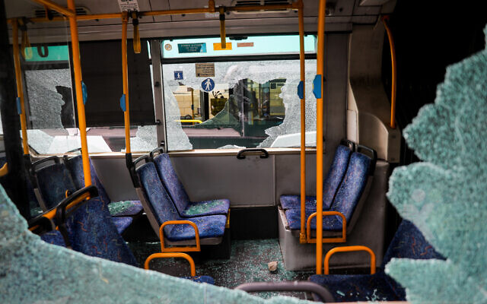  The interior of an Egged bus attacked by Palestinian rock-throwers outside Jerusalem's Old City on April 17, 2022. (Yonatan Sindel/Flash90)

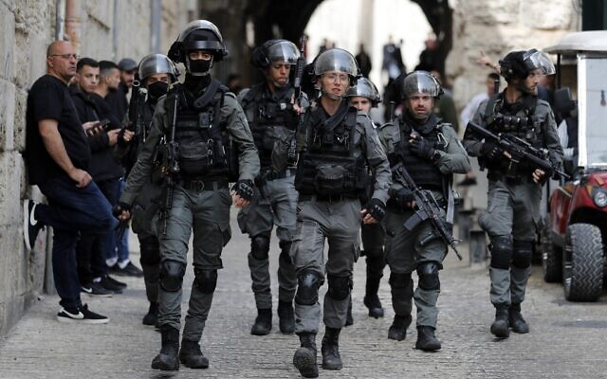  Border Police patrol in front of the Lion's Gate in Jerusalem's Old City, as Palestinians wait to be allowed to enter the al-Aqsa mosque compound, on April 17, 2022. (Ahmad GHARABLI / AFP) | Nahum Appleboim, a passenger on an Egged bus who was injured when a hail of rocks were hurled at the bus, April 17, 2022 (Ynet video screenshot)
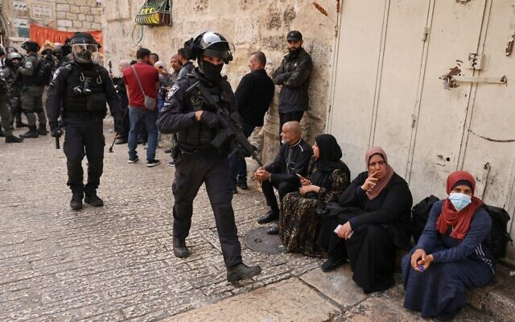  Israeli border police patrol near of the Lion's Gate in Jerusalem's Old City, as Palestinians wait to enter the Temple Mount compound, on April 17, 2022. (Ahmad Gharabli/AFP) | 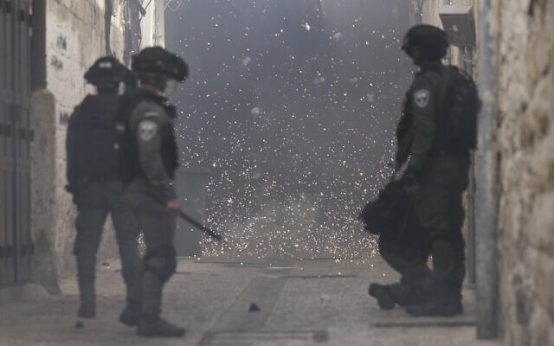  Palestinians shoot fireworks at Israeli police officers in the Old City of Jerusalem, April 17, 2022. (AP Photo/Mahmoud Illean)
Palestinians flash victory signs beneath the dome of the Al-Aqsa Mosque, on the Temple Mount in Jerusalem's Old City, on April 17, 2022. (Yonatan Sindel/Flash90) | 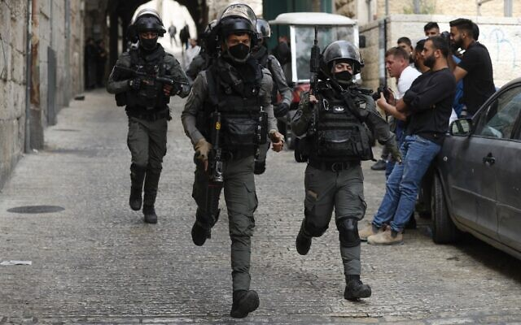  Israeli border police react as they patrol the area in front of the Lion's Gate in Jerusalem's Old City, on April 17, 2022. (Photo by Ahmad GHARABLI / AFP)
Israeli police entered the Temple Mount complex on Sunday morning as hundreds of Palestinians allegedly sought to block Jewish visitors from visiting the holy site in Jerusalem’s Old City, just two days after significant clashes there.
Also Sunday morning, Palestinian rock-throwers attacked several Egged buses just outside the Old City en route to the Western Wall, smashing windows and leaving several passengers lightly wounded, including a 13-year-old girl. Ten buses were reportedly attacked, over a two-hour period.
According to police, hundreds of Palestinians youths — many of them masked — stockpiled rocks in the Al-Aqsa compound which they planned to use along with iron bars and makeshift barricades to riot and try to prevent non-Muslims from touring the compound.
According to the Red Crescent, 17 Palestinians were treated for injuries amid clashes with police at the site Sunday morning, five of whom were taken to hospital. Police said that nine Palestinians were arrested.
Police said officers worked to distance the Palestinians to allow the visits to go ahead, and Jewish visitors were later seen touring the site.
“Alongside the visits, freedom of worship will continue to be fully preserved for the worshipers on the Temple Mount,” a police statement said. “The Israel Police will continue to act against lawbreakers and rioters.”
Also Sunday morning, rocks were hurled by Palestinians at Israeli buses just outside the Old City that were heading to the Western Wall. MORE - https://www.timesofisrael.com/meeting-resistance-cops-enter-temple-mount-to-thwart-obstruction-of-jewish-visitors/

Bennett says Israeli forces have ‘free rein’ to maintain security
Amid Temple Mount clashes, PM says officials working to ensure calm; Jordan says Israeli police does not have right to allow Jewish pilgrims into holy site
By TOI staff Today, 4:56 pm
Amid violent clashes in Jerusalem, Prime Minister Naftali Bennett on Sunday said that Israeli forces have “free rein” to continue operations to maintain security, while stressing that officials were working to restore calm.
Following a situational assessment with defense officials and ministers, Bennett said that an effort should be made to allow members of all religions to celebrate their holidays in Jerusalem, while at the same time “continuing to deal with rioters who violate public order.”
He added that he instructed that security for buses heading to the Western Wall and the Old City be bolstered, and that police prevent the distribution of doctored videos and false news that he said were intended to rile up tensions in the area and disrupt the routine during the Muslim holy month of Ramadan. He stressed that “security forces are prepared for any scenario.”
Sunday morning saw Israeli police enter the Temple Mount complex as hundreds of Palestinians allegedly sought to block Jewish visitors from visiting the site in Jerusalem’s Old City, just two days after significant clashes there.
Also Sunday morning, Palestinian rock throwers attacked several Egged buses just outside the Old City en route to the Western Wall, smashing windows and leaving several passengers lightly wounded, including a 13-year-old girl. MORE - https://www.timesofisrael.com/bennett-says-israeli-forces-have-free-rein-to-maintain-security/

Islamic State calls on supporters in Israel to launch more terror attacks
In Ramadan address, jihadist group criticizes ‘secular terrorists’ of Fatah and Palestinian Islamic Jihad, says Jerusalem can only be liberated through return of the caliphate
By TOI staff and AFP Today, 11:31 pm
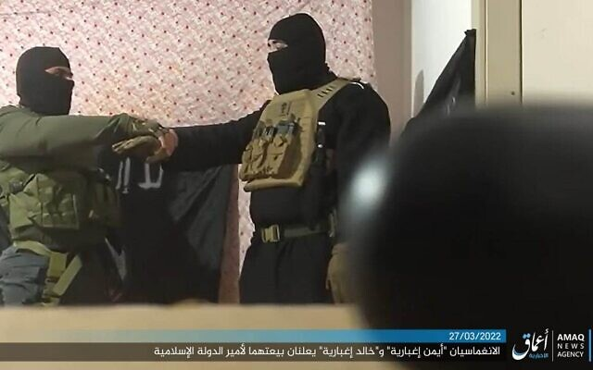
A screen grab from an undated video in which the two terrorists who killed four Israelis in Hadera on March 27, 2022, swear allegiance to the Islamic State terror group (Screen grab)
Islamic State on Sunday urged its supporters in Israel to launch additional terror attacks, the first such call since two deadly terror attacks were carried out last month by Arab Israelis thought to have been inspired by the jihadist group.
Islamic State claimed responsibility for both attacks, though it did not appear the terrorists had been instructed by it to commit them.
In a long address for the holy month of Ramadan, the jihadist group’s new spokesperson Abu-Omar al-Muhajjir called for a new “global offensive” in retaliation for the death of its leader, Abu Ibrahim al-Qurayshi, last February.
Al-Qurayshi died when he detonated a bomb to avoid capture during a US raid in northwest Syria, the White House and US defense officials said.
“Fight them all and Allah will answer and punish them at your hands,” al-Muhajjir said, referring to “heathen states.”
The Ramadan address came as Israel has moved to crack down on Islamic State, after six Israelis were killed in a pair of terror attacks in Beersheba and Hadera by Arab Israeli supporters of the jihadist group. MORE - https://www.timesofisrael.com/islamic-state-calls-on-supporters-in-israel-to-launch-more-terror-attacks/

Tel Aviv pilots shade-giving, solar-powered fabric that lights up at night
City installs award-winning Lumiweave system at Atidim Park, home to high-tech, finance, medical companies
By Ricky Ben-David and Sue Surkes Today, 4:13 pm
Lumiweave, designed by Anai Green, is a self-lighting, solar-cell packed, outdoor fabric, that won one of four prizes in 2020's international Women4Climate Tech challenge. (Courtesy: Anai Green)
The municipality of Tel Aviv-Jaffa is piloting a new, environmentally friendly system designed to provide shade during the day and serve as a lighting installation once the sun sets in the city’s Atidim Park, an industrial area in Ramat Hahayal that is home to dozens of high-tech, financial, media, and medical companies.
The award-winning system, Lumiweave, was created by Anai Green, an Israeli industrial and product designer who nabbed international recognition for her work in 2020 as part of a global climate tech competition for women. The challenge was organized by Women4Climate, an organization that brings together mayors, entrepreneurs, innovators, students, scientists, and activists to enhance women’s participation and leadership in building a sustainable future.
In 2020, Tel Aviv was one of four hosts of C40 Cities, a network of municipality leaders collaborating to address climate change. C40 brings together close to 100 world cities.
Last week, Tel Aviv set up the Lumiweave for a trial period at Atidim, during which Green and the municipality will monitor the system’s performance with an eye toward more installations across the city. The project is also coordinated with the municipality’s Cityzone organization, a smart city and urban tech lab where technologies are vetted and tested under real-city conditions.
The municipality said Lumiweave was a “unique project” that addresses “climate change and the growing challenge of shading in urban areas with a technological solution that operates based on renewable and clean energy, and enables the supply of lighting without the polluting fuels.”
The soft fabric is embedded with solar, organic photovoltaics (PV) cells for off-the-grid light and shade, with a number of possible applications from stand-alone, localized shade umbrellas, to canopies, and shading enclosures.
The system requires no electrical infrastructure, saving on costs, and can provide lighting at night for up to three days without sun. But Tel Aviv, and Israel generally, get plenty of sunshine with an average of about 300 sunny days for the city every year. MORE - https://www.timesofisrael.com/tel-aviv-pilots-shade-giving-solar-powered-fabric-that-lights-up-at-night/

Moscow summons Israel's envoy to Russia over Ukraine remarks
The move comes a little over a week after Foreign Minister Yair Lapid voiced his support of the UN General Assembly's decision to suspend Russia from the UN Human Rights Council over its invasion of Ukraine
Itamar Eichner | Published: 04.17.22, 21:19
Moscow on Sunday summoned the Israeli envoy to Russia to clarify statements of Israel's senior official, condemning the ongoing invasion of Ukraine.
Israel's Ambassador to Russia Alexander Ben Zvi was summoned to Russia's Foreign Ministry days after Kremlin lambasted Foreign Minister Yair Lapid for his vocal support of the UN General Assembly's decision to suspend the Russian Federation from the UN Human Rights Council for its apparent war crimes in Ukraine.
In its statement, Moscow's Foreign Ministry said that Lapid’s condemnation on April 7 was "a thinly-disguised attempt to exploit the situation in Ukraine in order to divert the attention of the international community from one of the longest-running unresolved conflicts - the Israeli-Palestinian conflict."
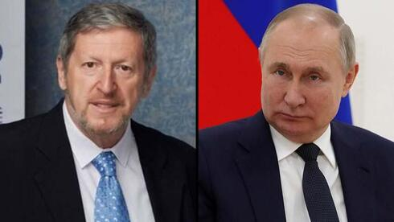
Israel's Ambassador to Russia Alexander Ben Zvi, Russian President Vladimir Putin (Photo: EPA)
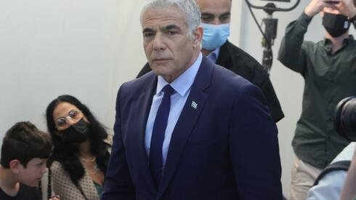
Moscow further added it "regrets" Lapid's "aggressive statement" in which he voiced his support of the UN General Assembly’s decision and in which he called Russia's invasion of Ukraine "unjustified," accusing Russian forces for "killing innocent civilians".

Foreign Minister Yair Lapid (Photo: Motti Kimchi)
"The Israeli government continues to illegally occupy and slowly annex Palestinian territories, resulting in more than 2.5 million Palestinians in the West Bank living in scattered enclaves cut off from the outside world,” said Russia's Foreign Ministry in a statement.
Lapid’s office said it will not respond to Moscow’s condemnation. [This is once more a slam at Israel for being in the Golan and having cities in the Judea/Samaria area by Russia. This type comments were rarely heard in the past. This may indicate a significant alteration of Russian policy. – rdb]
Unlike Lapid - who over the past few weeks issued several condemnations of Russia - Prime Minister Naftali Bennett took a much more cautious approach, which saw him effectively refrain from condemning Moscow for its hostility toward it neighbor. MORE - https://www.ynetnews.com/article/ryryshy49

Exodus slowed: Huge Passover congestion at airport and crossings to Egypt, Jordan
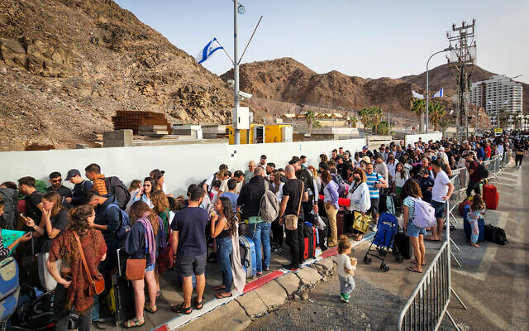
Long lines reported at Aqaba border; Amman shuts down terminal without prior warning due to masses of people, stranding hundreds of Israelis
By TOI staff Today, 7:34 pm

Israelis cross into Egypt through the Taba Border Crossing, in the southern Israeli city of Eilat, April 17, 2022. (Flash 90)
Extreme congestion was seen on Sunday at Ben Gurion Airport, as well as at the border crossings with Egypt and Jordan, as hundreds of thousands of Israelis left the country to vacation abroad over the Passover holiday, after two years of pandemic isolations and cancellations.
Long lines were seen at the Taba border crossing with Egypt, even in the early morning hours of Sunday. Thousands of Israelis waited for hours to cross en route to Sinai.
The National Security Council recently scaled back its travel warning for parts of Sinai for the first time in over a decade.
According to the Israel Airports Authority (IAA), some 5,000 Israelis were expected to enter Sinai over the course of Sunday, with at least 40,000 expected to pass through in the coming days.
“Whoever showed up in the early morning found themselves in a massive line. It’s completely crazy,” Israeli tourist Hila told Channel 12 news. MORE - https://www.timesofisrael.com/passover-brings-heavy-congestion-at-egypt-and-jordan-border-crossings/

In first, UAE to participate in Israel's Independence Day flyby
Israel Air Line Pilots Association says 2 Emirati companies - Etihad Airways and Wizz Air Abu Dhabi - and all the Israeli civil airlines will take part in May 5 aerial exhibition
Daniel Salami | Published: 04.17.22, 22:01
For the first time in history, the United Arab Emirates will take part in Israel's 74 Independence Day civilian flyby, it was announced Sunday.
Israel Air Line Pilots Association, which was behind the initiative, said all the Israeli airlines and two UAE companies will take part in the May 5 flyby.
Etihad Airways plane (Photo: Shutterstock)
The Israeli airlines that will take part in the flyby include El-AL, Israir Airlines, Arkia, CAL Cargo Air Lines, and Ayit Aviation and Tourism. The Emirati airlines include Etihad Airways and Wizz Air Abu Dhabi.
The civilian planes will join the flyby at 12:45pm after the Israeli Air Force will finish its traditional aerial exhibition.
The flyby set to stretch along the coast of Israel from north to south, from Acre to Ashdod, and will return for another flight from west to east. The flyby is expected to be conducted at a very low altitude of only 1000 feet, giving Israelis the chance for a close glance at the event.
Israel's Independence Day flyby (Photo: Sahar Berger)
The flyby is due to be completed by 13:20pm. The final component of the flyby will be a three-plane structure consisting of a jumbo CAL jet with two Embraer E-Jet family aircraft.
Head of the Israel Air Line Pilots Association Captain Midan Bar said: "First and foremost, it is a flyby of pilots, which proves that regional cooperation is practical, and not just an announcement.
"I welcome the Gulf State's pilots who will come to participate in our flyby of peace to increase our cooperation. Furthermore, this flyby points unequivocally to the strength of Israeli civilian aviation. The companies that have been forced to deal with COVID-19 have now returned to full activity, even more than before. The range of participating aircrafts points to the central role the Israeli aviation plays in the world, and its enormous potential." https://www.ynetnews.com/article/skxugayvq

Iran confirms moving centrifuge facility allegedly hit by Israel to underground site
Iranian atomic energy organization says Tehran ‘obliged to intensify security measures’ by shifting some machinery to Natanz, which was also a target of reported Israeli attacks
By AP Today, 11:26 am
TEHRAN, Iran — Iran has confirmed it relocated a centrifuge facility to its underground Natanz nuclear site, state media reported, days after the UN atomic watchdog said it installed surveillance cameras to monitor the new workshop at Tehran’s request.
The late Saturday report by the official IRNA news agency comes as diplomatic efforts to restore Iran’s tattered nuclear deal appear stalled.
The news agency quoted the spokesman for Iran’s atomic energy organization, Behrouz Kamalvandi, as saying authorities had moved the operation to a safer place.
Iran’s centrifuge facility in Karaj found itself targeted in what Iran described as a sabotage attack in June. Natanz itself has twice been targeted in sabotage attacks amid uncertainty over the nuclear deal, assaults that Iran has blamed on Israel.
“Unfortunately because of a terrorist operation that took place against Karaj, we were obliged to intensify security measures under which we moved an important part of the machines and transferred the rest to Natanz and Isfahan,” said Kamalvandi. Isfahan is the location of another Iranian nuclear facility.
On Thursday, the Vienna-based International Atomic Energy Agency said it installed cameras and removed seals from machines at the new workshop in Natanz two days earlier. Those machines will be used to make centrifuge rotor tubes and bellows, crucial parts for the devices that spin at very high speeds to enrich uranium gas.
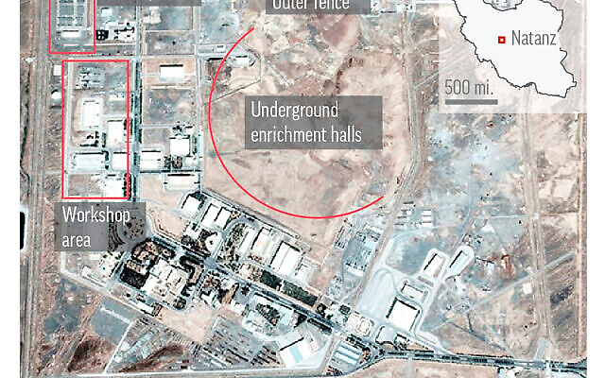
Natanz, in Iran’s central Isfahan province, hosts the country’s main uranium enrichment facility. (AP)
Talks between Iran and world powers in Vienna to revive the 2015 nuclear deal have stalled. There is concern that Iran could be closer to being able to construct an atomic weapon if it chose to pursue one.
The nuclear deal collapsed four years ago when former US president Donald Trump withdrew the United States and imposed crushing sanctions on Iran. In the meantime, Iran has vastly expanded its nuclear work
Iran’s Supreme Leader Ayatollah Ali Khamenei last week insisted negotiations over the deal “are going ahead properly,” even after repeated comments by American officials that an agreement to restore the accord may not happen.
The nuclear deal saw Iran put advanced centrifuges into storage under the watch of the IAEA, while keeping its enrichment at 3.67% purity and its stockpile at only 300 kilograms (661 pounds) of uranium.
As of February 19, the IAEA says Iran’s stockpile of all enriched uranium was nearly 3,200 kilograms (7,055 pounds). Some have been enriched up to 60% purity — a short technical step from weapons-grade levels of 90%. Meanwhile, Iran has stopped the IAEA from accessing its surveillance camera footage.
Kamalvandi reiterated Iran’s stance that Tehran will not provide data from the cameras to the UN nuclear agency if a deal is not concluded.
Iran has long insisted that its nuclear program is for peaceful purposes. However, US intelligence agencies and the IAEA believe Iran had an organized military nuclear program up until 2003, while Israel has alleged that Tehran has continued to pursue nuclear weapons since then. MORE - https://www.timesofisrael.com/iran-confirms-moving-centrifuge-facility-allegedly-hit-by-israel-to-underground-site/

Shanghai lockdown stalls launch of China's most advanced aircraft carrier
Following a lockdown, shipyards in Shanghai are now running out of workers as Chinese authorities have ordered all Shanghai state-owned enterprises to send employees to fight COVID-19.
By ROMAN MEITAV Published: APRIL 17, 2022 18:05 Updated: APRIL 17, 2022 18:10
The People’s Liberation Army Navy of China had been planning to launch the new carrier, currently named "Type 003", around the navy’s 73rd anniversary, on April 23. The major lockdown of Shanghai due to COVID-19, however, has stalled China's plans.
The Shanghai outbreak is, so far, China’s most serious since the beginning of the pandemic; a staggering 200,000 cases have been reported since the outbreak began in March, though with China's reputation for accurate COVID-19 numbers, the actual number could be much higher, according to The New York Times.
“Many Shanghai people blame the local government officials for mishandling the crisis, the coordination problems, lack of contingency planning, these issues. Which might be true,” Yanzhong Huang, a senior fellow for global health at the Council on Foreign Relations said, according to the report.
“But it is interesting how, within a month, Shanghai degenerated from a poster child of the pandemic control to a pariah of the COVID response.”
Shanghai, the world’s biggest container port, is dealing with a shipping backlog as the COVID-19 outbreak takes its toll, China is attempting to deal with the situation through a combination of lockdowns and mass testing, an approach known as “dynamic zero-COVID”. MORE - https://www.jpost.com/international/article-704412

Ukrainians defy deadline to surrender in Mariupol or die
Russian military estimates that about 2,500 fighters holding out at a steel plant are the last pocket of resistance in the coastal city
By Adam Schreck and MSTYSLAV CHERNOV Today, 4:50 pm
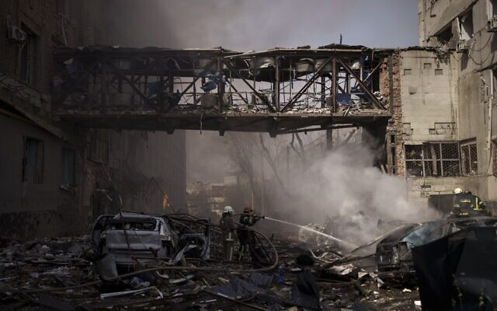  Firefighters work to extinguish multiple fires after a Russian attack in Kharkiv, Ukraine, on April 16, 2022. (AP Photo/Felipe Dana) | 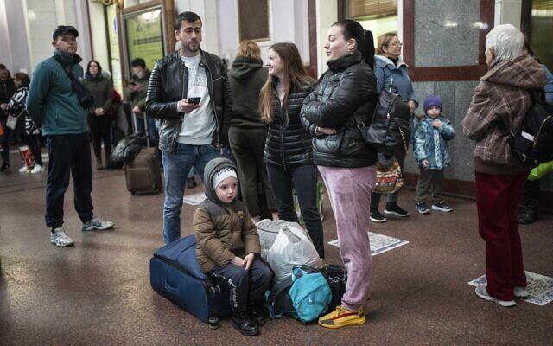  Families gather inside the train station in Lviv, Ukraine, April 17, 2022. (AP Photo/Rodrigo Abd)
Performer Ben Dusing, from Fort Mitchell, Kentucky, US, wears an Easter rabbit costume as he prepares to embrace Lilia at the Medyka border crossing in Poland on April 17, 2022. (AP Photo/Rodrigo Abd) | A Russian military convoy moves on a highway in an area controlled by Russian-backed separatist forces near Mariupol, Ukraine, April 16, 2022. (AP Photo/Alexei Alexandrov)
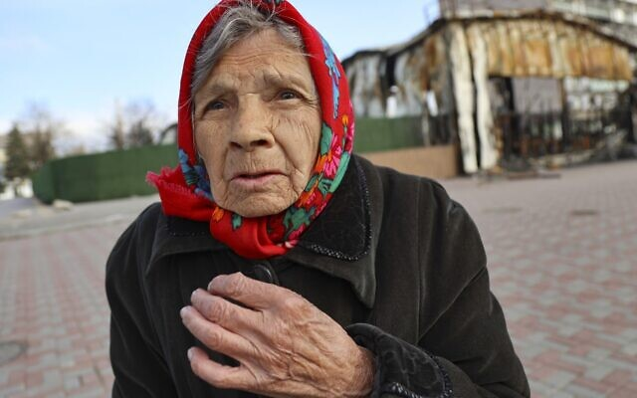  An elderly local resident speaks to a journalist near a destroyed part of the Illich Iron & Steel Works Metallurgical Plant, the second largest metallurgical enterprise in Ukraine, in an area controlled by Russian-backed separatist forces in Mariupol, Ukraine, April 16, 2022. (AP Photo/Alexei Alexandrov) | 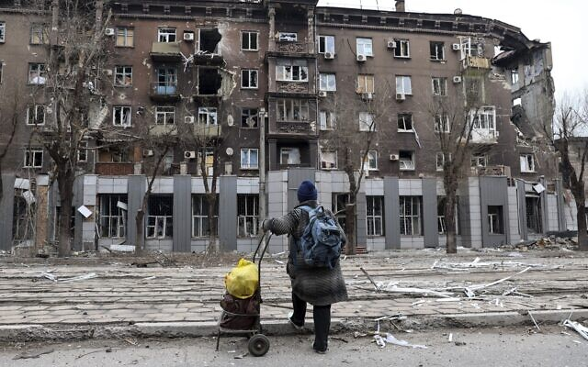  A local resident looks at a damaged during a heavy fighting apartment building near the Illich Iron & Steel Works Metallurgical Plant, the second largest metallurgical enterprise in Ukraine, in an area controlled by Russian-backed separatist forces in Mariupol, Ukraine, April 16, 2022. (AP Photo/Alexei Alexandrov)
KYIV, Ukraine (AP) — The battered port city of Mariupol appeared on the brink of falling to Russian forces Sunday after seven weeks under siege, a development that would give Moscow a crucial success in Ukraine following Russia’s failure to storm the capital and the loss of its Black Sea flagship.
~The Russian military estimated that about 2,500 Ukrainian fighters holding out at a hulking steel plant with a warren of underground passageways provided the last pocket of resistance in Mariupol. Russia gave a deadline for their surrender, saying those who put down their weapons were “guaranteed to keep their lives,” but the Ukrainians did not submit.
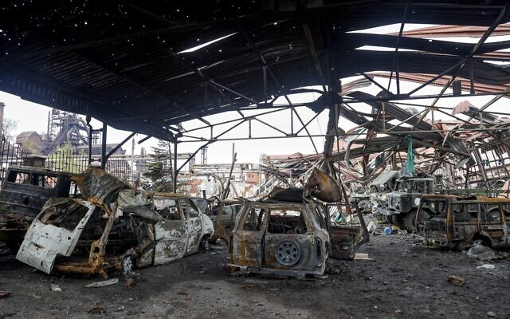  The gutted remains of vehicles are seen at the Illich Iron & Steel Works Metallurgical Plant, the second largest metallurgical enterprise in Ukraine, in an area controlled by Russian-backed separatist forces in Mariupol, Ukraine, April 16, 2022. (AP Photo/Alexei Alexandrov) | Russian trenches and firing positions in the highly radioactive Red Forest stuffed with radioactive remnants near the Chernobyl nuclear power plant in Chernobyl, Ukraine, April 16, 2022. (AP Photo/Efrem Lukatsky)
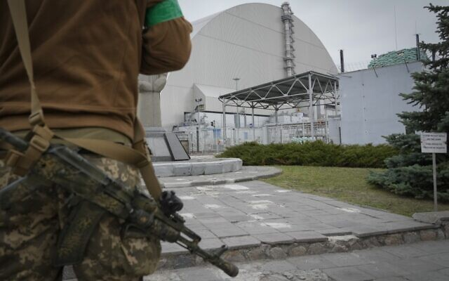  A Ukrainian soldier stands against the background of a shelter above the sarcophagus covering the exploded reactor at the Chernobyl nuclear power plant in Chernobyl, Ukraine, April 16, 2022. (AP Photo/Efrem Lukatsky) | 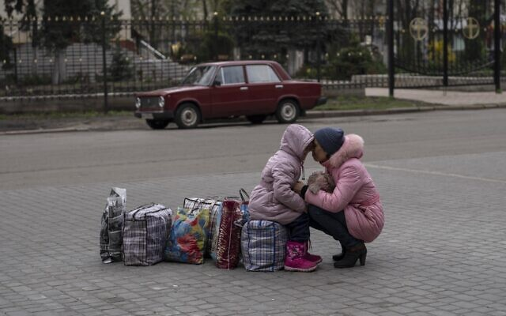  A mother hugs her daughter as they wait for a bus to flee from Sloviansk city, in Donetsk district, to travel to Rivne , western Ukraine, on April 16, 2022. (AP Photo/Petros Giannakouris)
“All those who will continue resistance will be destroyed,” Maj. Gen. Igor Konashenkov, the Russian Defense Ministry’s spokesman, said. He said intercepted communications indicated there were about 400 foreign mercenaries along with the Ukrainian troops at the Azovstal steel mill, a claim that couldn’t be independently verified.
Seizing Mariupol would free up Russian forces to weaken and encircle Ukrainian forces in eastern Ukraine, where Russia has focused its war aims for now and is deploying personnel and equipment withdrawn from the north after a botched attempt to take Kyiv.
Ukrainian Deputy Defense Minister Hanna Malyar described Mariupol as a “shield defending Ukraine” as Russian troops prepare for a full-scale offensive in Donbas, the country’s eastern industrial heartland where Moscow-backed separatists already control some territory.
In a reminder that no part of Ukraine was immune until the war ends, Russian forces carried out new missile strikes Sunday near Kyiv and elsewhere in an apparent effort to weaken Ukraine’s military capacity before the anticipated assault in the east. MORE - https://www.timesofisrael.com/ukrainians-defy-deadline-to-surrender-in-mariupol-or-die/

Russia warns of potential run-ins with NATO in Arctic
Growing activities of the US-led alliance bring both security and ecology risks for the region, a top official has said
17 Apr, 2022 21:29
Moscow is concerned with the growing activities of the US-led NATO bloc in the Arctic region, which may have grave security and ecology implications, a senior Russian representative to the Arctic Council, Nikolay Korchunov, has said. The official made the remarks to TASS news agency in an interview published Sunday.
“The internationalization of the alliance’s military activities in high latitudes, involving non-Arctic NATO states, causes nothing but concern. It raises the risks of unintentional incidents, which, in addition to security risks, can also cause serious damage to the fragile Arctic ecosystem,” Korchunov stated.
The US-led bloc has ramped up its activities in the region, staging increasingly massive military exercises, the official added. “Recently, another large-scale military exercise of the alliance took place in the north of Norway, which, in our opinion, does not contribute to ensuring security in the region,” Korchunov said, referring to the two-week “Cold Response” exercise that took place back in March.
The drills involved 1,500 US troops as well as forces from eight other NATO countries and “partner nations” numbering 15,000 in total. The exercise was marred by a crash of a US Marine Corps MV-22B Osprey aircraft. The tilt-rotor went down in a remote mountain range, killing four on board.
Apart from direct military activities of the bloc, its potential expansion further into the north creates additional risks for the Arctic region, Korchunov believes. Both Sweden and Finland, which have maintained non-alignment polices for decades while enjoying close ties with the US-led alliance, are considering to formally join it in wake of the conflict between Russian and Ukraine.
“NATO expansion at the expense of traditionally non-bloc countries will not contribute to security and mutual trust in the Arctic, the strengthening of which Russia has consistently advocated,” Korchunov said.
The large-scale Russian military offensive that kicked off in Ukraine late in February has also been used as an excuse to disrupt the work of the Arctic Council. “In early March 2022, the United States, Canada, Denmark, Iceland, Norway, Sweden and Finland suspended their participation in the Council, citing Russia's special military operation in Ukraine,” Korchunov said, adding that there is no way for development in the Arctic region without Russia. https://www.rt.com/russia/554036-nato-arctic-security-threats/

‘We have’ Hunter Biden’s laptop, Republican congressman says
Rep. Darrell Issa said the president’s son’s computer is a “treasure trove” of incriminating information
17 Apr, 2022 20:47
California Rep. Darrell Issa (R) told Fox News on Sunday that the GOP is in possession of Hunter Biden’s laptop, and is poring over the “treasure trove” of data within it. Meanwhile, party leaders are already laying plans to investigate the contents of the laptop – which the White House initially wrote off as “Russian disinformation” – if they return to power in November.
“It’s gotta be followed all the way back to the big guy,” Issa said, referring to an email from the laptop that described a business deal in China where “the big guy,” apparently a reference to Joe Biden, would stand to gain 10%.
“We’re going to need a special prosecutor, but in the meantime we’re investigating it,” he continued. “We have the laptop, and the laptop is a treasure trove of obviousness.”
Issa said that the computer contains evidence of direct communication between Joe and Hunter Biden while the former was serving as vice president, evidence that Joe Biden was making “sure his business deals went forward,” including in Russia and China, and evidence of Hunter’s drug use that could have made the VP’s son vulnerable to blackmail by foreign intelligence agencies. MORE - https://www.rt.com/news/554042-republicans-hunter-biden-laptop/

Riots spread in Sweden amid far-right plans to burn Koran
Mobs of youths clashed with police and set fire to vehicles in a bid to disrupt an anti-immigration party’s rallies
17 Apr, 2022 10:45
Chants of ‘Allahu Akbar’, police cars set on fire, and officers injured – this is what the run-up to Easter looked like in multiple towns and cities across Sweden this week, after the authorities gave a far-right anti-immigration group the go-ahead to stage rallies, which included plans to burn the Koran.
Unrest broke out on Thursday in the city of Linkoping, where gangs of youths clashed with police, injuring three officers. At least two people were detained.
The violence was sparked by the Swedish authorities’ decision to grant permission for a series of anti-Islam rallies. Organized by Rasmus Paludan – a right-wing Danish politician who has spent time in prison on racism-related charges – the events in various places across Sweden were intended to feature the burning of Islam’s holy book, the Koran.
Tensions came to a head on Friday when the Danish firebrand descended on the city of Orebro.
While Paludan and his supporters were initially allowed to hold their rally, it eventually had to be “dissolved” in light of the “serious security situation.” Mobs of rioters protesting against the far-right group pelted police with stones and set fire to four law enforcement vehicles. MORE - https://www.rt.com/news/554010-sweden-riots-koran-burning/
US intelligence satellite launched from California
KIRO 7 Seattle 4 hours ago
Spy Satellite Launch A SpaceX Falcon 9 rocket carrying National Reconnaissance Office mission (NROL-85) launches from Space Launch Complex-4 East at Vandenberg Space Force Base, Calif., on Sunday morning, April 17, 2022. NROL-85 is the first NRO mission to reuse a SpaceX rocket booster, and is the second Falcon 9 launch procured through the National Security Space Launch (NSSL) contract to launch from the Western Range. The Falcon 9's first stage booster returned and landed successfully at the California base's Landing Zone 4. (Michael Peterson/Space Launch Delta 30 Public Affairs/USNORTHCOM via AP) (Michael Peterson)
VANDENBERG SPACE FORCE BASE, Calif. — (AP) — A classified satellite for the U.S. National Reconnaissance Office was launched into space from California on Sunday.
The NROL-85 satellite lifted off at 6:13 a.m. from Vandenberg Space Force Base aboard a two-stage SpaceX Falcon 9 rocket.
It was the first mission by the NRO to reuse a SpaceX rocket booster, Vandenberg said in a statement.
The Falcon’s first stage flew back and landed at the seaside base northwest of Los Angeles.
The NRO only described the NROL-85 satellite as a “critical national security payload.”
Its launch was one of three awarded by the Air Force to SpaceX in 2019 for a combined fixed price of $297 million.
The NRO is the government agency in charge of developing, building, launching and maintaining U.S. satellites that provide intelligence data to senior policymakers, the intelligence community and the Defense Department.
Copyright 2022 The Associated Press. All rights reserved. This material may not be published, broadcast, rewritten or redistributed without permission. https://www.newsbreak.com/news/2575329016069/us-intelligence-satellite-launched-from-california?s=web_push_manual_activation_topdoc

Russia warns US to stop arming Ukraine, sends formal letter warning | World News | https://www.youtube.com/watch?v=ddrnHf-zeIg

Gravitas Plus: The story of Ukraine's President Volodymyr Zelensky
https://www.youtube.com/watch?v=Kn2TCq6R8Tw

Look which country has a virtual airline of drones surveilling U.S.
Watching law enforcement activity, hauling fentanyl
By Bob Unruh Published April 17, 2022 at 12:35pm
Mexican cartels have a virtual airline of drones being flown over the United States to observe law enforcement and border security operations, according to a new report.
The Washington watchdog Judicial Watch said in a special Corruption Chronicles report the cartels have completed more than 9,000 drone flights into U.S. airspace in the last year.
That comes from a "senior Homeland Security official" who was interviewed, the report said.
"The drones are observing federal, state, county, and city agencies near the Mexican border, including the U.S. Border Patrol, Texas Department of Public Safety, Texas National Guard, county sheriffs and local police. The Border Patrol, which operates under Customs and Border Protection (CBP), has captured about a dozen of the drones, and accessed the Unmanned Aerial Vehicles’ (UAVs) guidance and memory systems to gain intelligence information, according to a high-level official at the agency," the report explained.
The watchdog explained it learned of the drone flights on a recent visit to the southern border and specifically while interviewing federal officials at the CBP Rio Grande Valley sector.
"Judicial Watch is further investigating the matter and has filed a Freedom of Information Act (FOIA) request with CBP, the 60,000-member agency charged with keeping terrorists and their weapons out of the U.S., for all records regarding the use of drones by criminal organizations operating along the U.S.-Mexico border for the purpose of surveilling U.S. law enforcement officials or otherwise facilitating illegal activity," Judicial Watch reported.
Judicial Watch reported that federal officials on the scene said that cartels use the drone programs to make sure their human smuggling and drug trafficking programs are a success.
"Specifically, they help identify gaps in border coverage and assist the cartels in overwhelming certain areas to create a diversion for moving sensitive or high value loads through alternate border locations," Judicial Watch said.
The watchdog, which frequently files Freedom of Information cases – both requests and lawsuits – said Brandon Judd, chief of the union representing thousands of Border Patrol agents, said the drones also are used to smuggle small amounts of drugs into the U.S.
"They are dropping fentanyl,” Judd told Judicial Watch. "They fly into certain locations, drop them to the ground and fentanyl is taken off of them and they take back off into Mexico."
The report explained reports of drones being used surfaced only a few years ago, when agents in the El Paso sector reported witnessing what they believed to be a drone being used to act as a "lookout.'
"An agent monitoring the border with an infrared camera discovered the drone traveling north into the U.S. from Mexico," Judicial Watch said the report documented.
And then, "Last year Mexico’s largest newspaper reported that some of the country’s most notorious cartels, including Jalisco Nueva Generación, used drones with explosives to attack police in the western part of the country." https://www.wnd.com/2022/04/look-country-virtual-airline-drones-surveilling-u-s/

National media 'won't mention' U.S. city where shootings are non-stop
'The reason for this is obvious'
By Joe Kovacs Published April 17, 2022 at 3:54pm
While the Biden administration pushes for tighter gun control in America, the national news media are apparently ignoring one major city where strict gun control is already in place, yet shootings are incessant.
"More people were shot in Chicago this weekend than anywhere else but corporate media won't mention it," splashed a headline Sunday on The Liberty Daily.
Breitbart News reported at least 14 people were shot with one fatality in the Democrat-run stronghold from Friday into Sunday morning.
Last weekend, 27 people were shot, six of them fatally.
And according to the Chicago Tribune, some 145 homicides occurred in the Windy City from the first of this year through April 9, with 2021 being the deadliest year the city experienced in a quarter century.
"Chicago Police Department reported 797 homicides in the city in 2021, the most in Chicago since 1996 and more than any other city in the country," the Hill reported.
J.D. Rucker at the Liberty Daily explains, "America's corporate media only covers the stories that go along with the narrative they've been instructed to propagate by the powers-that-be. When it comes to shootings, for example, they will either offer wall-to-wall coverage for weeks or they'll completely ignore the story altogether, depending on what the prevailing circumstances were.
"We've seen a few 'mass shootings' over the past week that conveniently happened right when the Biden regime announced their push for gun control. A conspiratorial person might think it's all by designed considering how we went so long without much news of 'mass shootings' and now it's almost a nightly event.
"What they won't tell you is that shootings happen constantly in Chicago and other Democrat hellhole cities across the country. There were more people shot in Chicago this weekend than any of the 'mass shootings' that took place, yet you don't hear about it. The reason for this is obvious. Chicago already has the most draconian gun control laws in the nation and as easily predicted by anyone who pays attention to such things, they have resulted in MORE shootings.
"Where guns are free to be carried, criminals are more reluctant to engage in violent crimes because they know they could get shot by anyone around them. In cities like Chicago, the only people who concern criminals because they might have a gun are other criminals." https://www.wnd.com/2022/04/national-media-wont-mention-u-s-city-shootings-non-stop/

This is a rather long but most interesting expose on the FBI and their plethora of illegal SS patterned activities. Well worth the time. – rdb]
Abolish the FBI or Face an American Putin
Since J. Edgar Hoover founded it, the FBI has never really been a law enforcement agency. It’s a clearing house for kompromot and intimidation.
By Adam Mill April 10, 2022
Following the death of Stalin, the Soviet secret police pivoted from heavy-handed mass arrests to a subtler, but still sinister, system of mass spying and accumulation of “kompromot,” or compromising material, on its citizens. The Soviets maintained control by prioritizing spying on religious figures, political activists, journalists, and public officials. We’re now finding out that the FBI in America has a similar program of mass surveillance of similar targets. And, as with the Soviets, much of the spying has nothing to do with investigating crime.
According to a Justice Department internal audit report, the FBI maintained an active caseload of 24,584 cases during the 18 months between January 2018 and June of 2019. A grossly disproportionate share of those cases involved surveillance of influential Americans such as candidates for office, public officials, journalists, religious leaders, and political activists. When the FBI targets an individual wielding high social influence, it categorizes the case as “sensitive.”
To prevent the FBI from abusing investigations to capture the levers of government and subverting democracy, the Justice Department has established rules. Most important among these rules is that the FBI isn’t supposed to start investigating a public official unless it has reason to suspect a crime. Nearly every “sensitive case” evidenced violations of the rules. In fact, the office of inspector general identified an average of two violations for every reviewed sensitive case.
Vladimir Putin, not unlike our current FBI Director Christopher Wray, got his start as a “reformer” known for mouthing reform slogans to parry public outrage over the many abuses of the national police organization. Like Putin, Wray has used the smokescreen of cosmetic reforms to amass great power at the expense of the democratic process he is supposed to protect. The FBI has proven over and over again to be totally immune to reform. It consistently fails to punish employees for violating the rules, so changing those rules has no effect.
The existence of the FBI has had no effect on the crime wave plaguing America. Contrary to the many dramatized depictions of the FBI, the Bureau solves an insignificant minority of crimes in America.
The FBI is more than a dysfunctional agency. If it merely failed to fulfill its mandate, it might be a tolerable nuisance. Instead, the FBI has proven to be the single greatest threat to the very Constitution it is supposed to serve and protect. Its domestic spying program and its network of unaccountable informants lead to few bonafide criminal cases but many wholesale violations of constitutional principles.
As we seek to create a bulwark for our nation’s cherished constitutional freedoms with a robust national defense, the FBI works as a totalitarian fifth column from within our nation. Below are five reasons why the FBI is beyond the reach of reform and should be abolished as a matter of civic integrity. MUCH MORE - https://amgreatness.com/2022/04/10/abolish-the-fbi-or-face-an-american-putin/

Commentary:
Do Not Lose Your Soul
Marc Little Posted: Apr 17, 2022 12:01 AM
Darkness either overcomes you or it compels you to shine your light to repel it. Americans face this choice as we are bombarded with social issues that require us to examine the core of the nation’s soul. Whether you believe the United States is a Christian nation founded on Judeo-Christian principles or not, the universally accepted norms of right and wrong remain until they are upended. The far left in our nation is actively attempting to eradicate core beliefs by confusing children of their gender and God-given sex, by emasculating men, by making race an idol, and by worshipping at the altar of abortion. The movement to eradicate foundational biblical principles is influenced by the demonic (darkness) and Maryland and California now lead the way.
As if the horrors created by abortion-on-demand causing the slaughter of 60+ million babies since Roe v. Wade in 1973 were not enough, Maryland and California legislators drafted bills moving through their legislatures that go a step further – they attempt to create laws that avoid civil and criminal liability for the murder of children. In these bills, they attempt to shield from prosecution a mother and any third parties who assist her in murdering her child from 7 to 28 days after birth (“perinatal period”). This is called infanticide and getting away with murder. These bills are indecent and should not even be considered in a moral society. And there’s the rub.
What must also be highlighted is the history of infanticide around the ancient and contemporary world. From the ancient Romans, ancient Greeks, China, Queensland Australia, Australian Aboriginals, Nazi Germany, Victorian Britain, Nigeria, and Japan, newborns have been disposable throughout history. Child sacrifice likewise has it place in the history books.
I submit that the guiding principles that exalted the Great Experiment, known as the United States of America, are rooted in our recognizing the intrinsic value of the individual from the time of conception in the womb. We stand on the Declaration of Independence that states, “We hold these truths to be self-evident, that all men are created equal, that they are endowed by their Creator with certain unalienable Rights, that among these are Life, Liberty, and the pursuit of Happiness.” Notwithstanding the stains of slavery, discrimination against ethnic groups and women, and legalized abortion, the United States has risen above its imperfections and consequently is the hope of the world. Many believe the United States Supreme Court is on the verge of overturning its ruling in Roe v. Wade (in the Dobbs case). But California and Maryland now threaten to plunge us all into an abyss of depravity heretofore reserved for uncivilized cultures.
What is unspoken and most diabolical is that the proposed laws in these states will have a disproportionate impact on black babies.
In the United States, 44% of abortions are performed on black babies. Consequently, it stands to reason that the infanticide bills proposed in Maryland and California will disproportionately murder black babies after they are born. The far left is quick to denounce anyone who opposes indoctrinating children with critical race theory in schools as racists, but they are eerily quiet when it comes to the wholesale slaughter of black babies in and out of the womb, as proposed. The objective reality is that California Assembly Bill 2223 and Maryland Senate Bill 669 are the kind of discriminatory bills that should be deemed unconstitutional under the Fourteenth Amendment (Equal Protection Clause) of the U.S. Constitution.
In December 2021, California Gov. Gavin Newsom formed the Future of Abortion Council to ensure that California becomes the abortion sanctuary of the nation. The Council intends to ensure, in part, that any out-of-state mother can have an abortion, that all abortions are free, that minors are able to have abortions free from parental consent, and that no one could ever be held civilly or criminally liable for participating in the infanticide.
The governors and legislators of California and Maryland may lead the nation into the kind of depravity never imagined if these bills are passed. The very soul of America, already on the slippery slope from its bourgeoning abortion industry, may soon be lost forever if we now decriminalize murdering (black) babies with impunity. All Americans must prevent this from happening. We must behave like we truly believe ALL life matters.
Marc T. Little is the Executive Director of CURE America Action, Inc., headquartered in Washington, DC, advocating messages of Christianity, Capitalism, and the Constitution across the nation. Little is a pastor, attorney, political commentator. https://townhall.com/columnists/marclittle/2022/04/17/do-not-lose-your-soul-n2605957

The Cost of New Energy in Europe, but Not in Money
by Giulio Meotti April 17, 2022 at 5:00 am
As Europe turns from its masochistic energy dependence on Russia, and the potential blackmail that came with it, will it now fall into the open arms of other dictatorships that stand ready to pump gas into its markets, such as such as Algeria? Even more dangerous might be a new partnership formed between Germany and Qatar. They have just agreed on a huge long-term energy partnership to reduce dependence on Russian gas, according to German Economy Minister Robert Habeck, who last month visited the Persian Gulf and met with the Emir of Qatar, Sheikh Tamim bin Hamad al-Thani. Italy was the first to negotiate with Qatar, a country that, according to Freedom House, numbers 25 out of 100 on its the freedom score, only slightly above Russia, at 19.
Qatar is now saying that it stands "in solidarity" with Europe.
Solidarity?
Qatar is an Islamist state where "Islam is the official religion... and Sharia is the main source of legislation", claims its constitution. Qatar is governed as an absolute monarchy. Political parties are banned and elections are sham, and it is illegal to be homosexual. According to Open Doors, there are only 18 states in the world where a Christian is worse off than in Qatar. As for the billion euros that Qatar has spent on building mosques and Koranic schools in Europe, perhaps the champions of "progressivism" feel expansively "diverse" with that. However, even the newspaper of the French left, Libération, has referred to "Qatar, financier of European Islam".
"Qatar and Turkey are the two main supporters of the Muslim Brotherhood ideology in the world," Elie Chouraqui told i24NEWS.
"They presented themselves well and proclaimed themselves privileged interlocutors of the political world which welcomed them with open arms to the point of entrusting them with the training of imams of France".
At the same time as the economy minister of Germany went to the sheikh to implore him for more gas, in France the ambassador of Qatar was receiving an award from the mayor of Nice, Christian Estrosi.
Qatar has been extremely active in France. The emirate graciously financed the Islamic Center of Villeneuve-d'Ascq and France's first state-funded Muslim faith school, the Lycée-Collège Averroès. Unfortunately, the Lycée Averroès soon became the center of a scandal. One of its teachers resigned after writing that the school was "a hotbed of anti-Semitism and 'promoting Islamism' to pupils". Qatar, meanwhile, has financed many mosques in France, including the Great Mosque of Poitiers, which sits in the vicinity of the site of the Battle of Tours (also known as the Battle of Poitiers), where Charles Martel, ruler of the Franks, stopped the advancing Muslim army of Abdul al-Rahman in the year 732.
The Assalam mosque in Nantes and the Grand Mosque of Paris are other examples of Qatari generosity. Qatar, in fact, has been funding many mega-mosques across Europe. One might even be forgiven for thinking that Qatar's ultimate goal was to Islamize Europe. In the words of a television documentary, it is Qatar's "war of influence".
"Woman's month for the city of Nantes, a veiled woman on the streets of the city. Unacceptable complacency towards Islamism! This is the real threat that hangs over France!" is how Eric Ciotti, a senior leader of the Les Republicans party, described the municipal billboards in a large city that he sees as lost to Islamization.
Nantes is the city of the Dukes of Brittany, steeped in history on the Loire estuary. Its story is emblematic of how Europe is sinking. Ivan Rioufol wrote in Le Figaro:
"Having been a journalist in Nantes for a long time, I know this city where I was born very well. When I left Nantes in 1984, it was tranquility itself, even in the traditionally more working-class neighborhoods... Immigrants were a minority... Today Nantes has become Lebanonized. And its history is that of France...
"The Malakoff mosque... seats 1,200 and has erected a 17-meter minaret. In addition to this 'cathedral mosque' there are four other mosques in the city, not to mention those in neighboring communities. This influence of Islam accompanied the new settlement of the working-class neighborhoods, under the encouragement of the socialist municipalities".
Today, in Nantes alone, there are ten mosques.
The Assalam Mosque was constructed with Qatari money -- but not only. The Assalam mosque," Le Figaro recounts, "was built on land sold by the municipality, benefiting from a 'cultural' contribution of 200,000 euros and a loan guarantee of 346,800 euros". The city financed its own self-conquest. And who was the mayor of the city at the time of the financing and the agreement with Qatar? Jean-Marc Ayrault, mayor of Nantes from 1989 to 2012 and socialist prime minister of France from 2021 to 2014 ...
Pierre Vermeren , in his book Déni français (French Denial), noted:
"In Nantes, Jean-Marc Ayrault practiced a patronage that led to the construction of three, four, community mosques distributed among the Muslim Brotherhood, Morocco and Turkey, as well as a Salafi mosque on the outskirts of his city. He is accused, like the former mayor of Paris, of violating the religious funding law. In Bordeaux, Alain Juppé (former prime minister) canceled the Great Mosque project when it was discovered that the funds came from Qatar and Azerbaijan..."
The magazine L'Incorrect explains how Qatari money is changing the French landscape.
"When you think of Alsace, you imagine a thousand small flowered villages lost in the vineyards on the side of the Vosges mountains, whose names give you a headache. We are (for the moment) in Christian land, as evidenced by the chapels that line roads and paths. But mosques sprout like mushrooms after the rain, even in villages with a few thousand inhabitants. This phenomenon reveals a slow but sure Islamization of this region".
We are in the region where the other capital of the EU, Strasbourg, is located.
"The European capital has among its buildings the most important mosque in Europe, the center of An-Nour. The largest building of its kind in France, this center is not just a place of worship, but a cultural and political one, funded by Qatar".
This is happening not only in France. The Great Mosque of Copenhagen received a donation of 30 million euros from Hamad bin Khalifa al Thani, former Emir of Qatar, who is also a leading supporter of the Muslims in Belgium. Europe's Parliament was also asked to investigate Qatari mosques in Kosovo.
Russian gas is not free; Qatari gas as well.
The German website Tichys Einblick comments that "instead of Putin's war, we will finance Islamic terrorism". The unconditional will to shine morally has harmful consequences -- all because nuclear power is "haram" (forbidden).
Former German Foreign Minister Sigmar Gabriel provided a glimpse of the relativism that dominates our ruling classes:
"Qatar does not threaten anyone, does not finance terrorist organizations, but hosts Hamas and the Taliban at the request of the USA (!) in order to be able to negotiate with them in Doha. Qatar is simply a reliable partner of the West.".
Shortly before his death, Christophe de Margerie, the late head of French oil giant Total, said: "Anything can be bought, including men, it's just a question of price".
What is Europe's price?
"This tiny Persian Gulf kingdom is emerging as one of Europe's best hopes for weaning itself off Russian natural gas, in another sign of how the war in Ukraine is changing the world's energy relationships", The Wall Street Journal reported. "Germany, France, Belgium and Italy are in talks with Qatar to buy liquefied natural gas on a long-term basis, said Qatari and European officials". The EU last month dropped antitrust investigations into Qatar Petroleum, the state energy company, clearing the way for the country to pursue more long-term contracts with Europe.
Le Figaro tells one of these extraordinary evenings in which Qatar supported the French cultural élite:
"Dozens of guests flocked to Place de l'Étoile... home to the Qatari embassy. In the rooms with gilded panels with mosaics and frescoes of languid nymphs, His Excellency Mohamed al-Kuwari awarded cartoonist Jean Plantu and Amirouche Laïdi, president of the Averroes Club, with the 'Doha Arab Cultural Capital' award. The ambassador awarded André Miquel (famous Arabist from the Collège de France), Dominique Baudis (writer), Bernard Noël (art critic) and the poet Adonis. From former Culture Minister Jack Lang to Nouvel Observateur founder Jean Daniel, a total of 66 French cultural figures have been decorated by Qatar".
Making fun of the deal with Qatar, the German newspaper Die Welt ironically proclaimed:
"The relief in Germany is enormous. They are finally no longer dependent on gas supplies from an autocratically-ruled country that makes life difficult for homosexuals and does not always take human rights very seriously."
Before the suspicion arises however, that German environmentalist-progressive-woke circles are throwing their noble principles overboard, it must be said that Qatar is willing to make major concessions to the German "Greens". The emirate has promised to install wind turbines in the desert and to host the next COP26 conference about how to create a "sustainable world".
Giulio Meotti, Cultural Editor for Il Foglio, is an Italian journalist and author. https://www.gatestoneinstitute.org/18421/europe-energy-cost
Will America Be Hit With Food Shortages, Part 2
By Roger Anghis|April 17th, 2022
Leaders around the world are preparing for a shortage of food supplies and it makes you wonder why. There’s been a labor shortage that could easily be solved by stop paying people to not work. Another thing we could do is access the oil under our feet, which is more than most countries in the Middle East. Another thing we could do is find a way to work with the environmentalist so we can build reservoirs to store the water we need to service our cities, grow crops, and simply live life. If they won’t compromise then ignore them. People are the most important form of life on this planet and they should be taken care of.
As far as getting food from other countries such as wheat, we have supplied the world with wheat for decades. We have to remember that America can feed the world and has fed the world for decades. Then the government started paying farmers to NOT grow crops. That never sounded very intelligent to me and it still sounds stupid when people are crying about not having enough food to feed everybody and then we pay farmers to not grow their crops. Of course, this was done in a mafia-style request. If they grew the crop anyway they would get nothing for it. I don’t believe that that is actually part of a free market system. It sounds more like price control at the farmer’s expense.
The Russian-Ukraine war will have an effect on the food market in Europe and we should be allowed to fill in that void. That’s what free markets do. We’ve allowed ourselves to become too dependent on nations hostile to the United State for too many of the everyday products that we need. Trump made an attempt to reverse that but had to fight Congress at every turn. We should be in a position where if a crisis hits us or anywhere in the world we will be marginally affected by that crisis. Even the programs established to not grow should be suspended in a crisis situation but I don’t see that happening even though we see a situation coming on us that could be very catastrophic if not properly addressed. Some people see this as a viable approach to what we see coming: The Department of Agriculture established its farmland conservation program in 1985 to stop soil erosion and protect wildlife, according to the agency. Farmers participate voluntarily by signing up to receive annual payments from the government in exchange for stopping all production on the protected land and planting “species that will improve environmental health.”
Rubio and Lummis cited the rising price of corn as one reason why the Biden administration should free up farmers who previously enrolled in the program to use their conserved lands.[1]
We can see around the world that many nations are planning for food shortages. They are planning for the shortage but not doing anything to stop it which makes me believe that what we are really seeing is their last big push to establish the famed New World Order. Prices have begun to rise around the world[2], rationing has begun in Spain and Greece[3], fertilizers have increased, for no obvious reason, in some places 300%[4], 13 million chickens in Iowa have been pit down because of the bird flu[5].
We not only have a situation with truckers and exorbitant gas and diesel prices now we are seeing rail carriers refusing to deliver goods they’vecontracted to deliver: US rail carriers, we have learned, are right now declaring force majeure and cancelling contracts on their obligations to deliver hundreds of thousands of rail cars of bulk grains to cattle and dairy operations in America. Right now, tens of thousands of dairy animals face starvation within weeks, and grain supplies will be gone in many areas in just a few days. Importantly, if dairy animals are culled because of a lack of grain, it will take many years to rebuild dairy operations to the present level.
Say goodbye to affordable milk, cheese, yogurt and whey protein. Don’t forget this also affects infant formula.
This is all being done on purpose to create mass chaos and civil unrest, of course.
CHEAP meat in the short term due to the mass slaughter of animals that farmers can’t afford to feed
As this logistics catastrophe unfolds, you’re going to see meat prices plummet for a very short period. That’s because farmers and dairy operators will be forced to sell their cows to the slaughter houses because they can’t afford to feed them. This can be caused either be a lack of feed supply or sky-high feed prices.[6]
The predictions that are out there are not really promising for us. But there are things we can do to make it easier. The politicians that we have in Washington are the biggest reason we are in this situation. It will be several months before we can replace them but that is the first step we need to take. All members of the House are up for re-election and there is only a handful at best that are worth keeping. I can’t think of any of the Democrats we need to keep. Remember, we’re in an economic crisis with inflation at the highest in 40 years, gas prices at an all-time high, chaos at the border, and all of it is because of their policies. They put us in this hole and now they want us to keep them in office to fix it. We can’t trust them to do that. Seventy members of the House, all but one in the Democrat party, belong to the Democrats Socialists of America. It is socialist policies that got us here. Their policies won’t get us out. We need people who want to take us back to what made us great. America first people. If we don’t stop them now we’ll never stop them.
© 2022 Roger Anghis – All Rights Reserved
E-Mail Roger Anghis: roger@buildingthetruth.org
Foot Notes
Lawmakers scramble to avert global food shortage
2, 3, 4, 5. 20 facts about the emerging global food shortage that should chill you to the core
Planned starvation: grain deliveries by rail to be partially halted devastating dairy herds and meat operations nationwide
https://newswithviews.com/will-america-be-hit-with-food-shortages-part-2/

THE SHORASHIM BIBLICAL GIFT CATALOG 005
http://mad.ly/7f9f64?pact=20013931524&fe=1
Support Shorashim!

ARUTZ SHEVA
To be removed from this News list, Please click here and put "Unsubscribe" in the subject line.

04/17/2022 NEWS TODAY is RESSURECTION SUNDAY
RISEN - New Easter song by Shawna Edwards
https://www.youtube.com/watch?v=xCQsK1t9EKY

"The fiercest serpent may be overcome by a swarm of ants."
-- Admiral Isoroku Yamamoto (1884-1943) Japanese Naval Marshal General and commander-in-chief of the Combined Fleet during World War II, a graduate of the Imperial Japanese Naval Academy and a student of Harvard University (1919–1921)

Read the Prophets & PRAY WITHOUT CEASING!
That is the only hope for this nation!
Please  Remember  These  Folks  In  Prayer-  Check often  They  Change! | Pray that the world would WAKE UP! Time for a worldwide repentance!  ALL US soldiers fighting for our freedom around the world  Pray for those in our government to repent of their wicked corrupt ways.  Pray for BB – Severe sciatic Had surgery and doing well  Pray for EL – Had stoke – Now having coronary angiogram  Pray for KH – diagnosed with Multiple Myeloma  Pray for BB – Severe West Nile Fever –still not mobile- improving!  Pray for RBH – cancer recurrence  Pray for Ella – Child with serious problems  Pray that The Holy One will lead you in Your preparations for handling the world problems. – Have YOU made any preparations?
Exodus 14:²⁸And the waters returned, and covered the chariots, and the horsemen, even all the host of Pharaoh that went in after them into the sea; there remained not so much as one of them. ²⁹But the children of Israel walked upon dry land in the midst of the sea; and the waters were a wall unto them on their right hand, and on their left. ³⁰Thus the LORD saved Israel that day out of the hand of the Egyptians; and Israel saw the Egyptians dead upon the sea-shore. ³¹And Israel saw the great work which the LORD did upon the Egyptians, and the people feared the LORD; and they believed in the LORD, and in His servant Moses.

Laura Logan dropping truth bombs on Ukraine
https://rumble.com/vxlgqz-laura-logan-dropping-truth-bombs-on-ukraine.html
This is 9 minutes of actual truthful history of Ukraine and the involvement of America’s deep state and the World groups in preparing for this engagement we are in. One of the few to tell the truth. Hopefully you will understand that much of the reporting here is drenched in distortion. RDB

Israel to lift West Bank, Gaza closure after calm first day of Passover
With no major incidents reported, defense minister and top military officials agree to not extend restrictions on Palestinians at border crossings for rest of Jewish festival
By Emanuel Fabian Today, 8:59 pm
The Israeli military will lift a closure on border crossings with the West Bank and Gaza Strip imposed at the start of the Passover holiday, at just after midnight between Saturday and Sunday, officials said.
The West Bank and Gaza closure began at 4 p.m. Friday and security officials had agreed to convene Saturday evening to decide whether or not to extend the closure for the entire Jewish festival. Passover began Friday evening and ends a week later.
Border crossings in the northern West Bank — which were closed completely a week ago due to recent attacks committed by terrorists from the Jenin area — also reopened earlier Saturday for Israeli Arabs to enter.
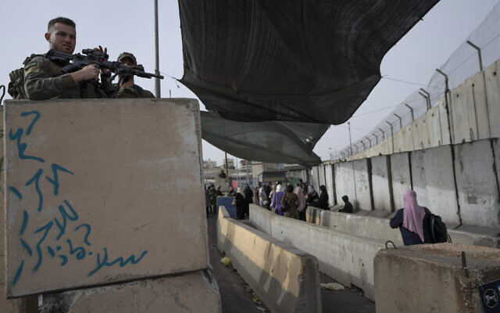
Israeli troops secure a checkpoint used by Palestinian to cross from the West Bank into Jerusalem, for the first Friday prayers in the Muslim holy month of Ramadan at the al-Aqsa mosque compound, at the Qalandiya checkpoint, west of Ramallah, on April 8, 2022. (AP Photo/Nasser Nasser)
Defense Minister Benny Gantz’s office announced the decision to open the crossings, following a situational assessment he held with top military and defense officials.
“The defense minister decided, at the recommendation of the security bodies, that no closure will be imposed on Judea and Samaria during Hol Hamoed [the intermediate days of the Passover festival] and that situational assessments will continue to take place, in accordance with developments,” his office said.
The closure, standard practice during festivals and holidays, comes amid increased tensions around the convergence of the Passover, Ramadan and Easter holidays that have set the region on edge. This follows weeks that have seen an uptick in West Bank clashes as Israeli forces have attempted to crack down on Palestinian terror following a rash of deadly attacks.
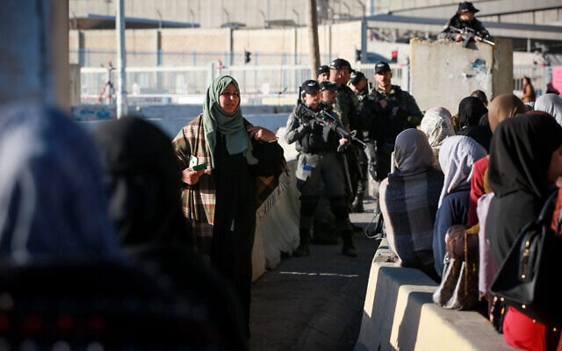
Palestinian women cross the Qalandiya checkpoint, outside of the West Bank city of Ramallah, on April 15, 2022. (Flash90)
The military said the closures were a preventative measure against attacks in periods of increased tension. But during the holiday of Purim in March, the military skipped the usual closure for the first time in five years.
~Also during Saturday’s assessment, which took place via a phone call, Gantz “expressed his appreciation for all the security forces’ precise and extensive activities over the weekend, in all areas,” his office said.
“The defense minister also noted that Israel will continue to act in a focused manner against terror and stop anyone who seeks to violate public order. At the same time, the defense minister emphasized the importance of continuing to preserve freedom of worship and the economy,” it added.
Defense Minister Benny Gantz shakes hands with an IDF soldier in the West Bank, on April 1, 2022. (Ariel Hermoni/Defense Ministry)
Friday saw violent clashes at the Al-Aqsa Mosque compound on the Temple Mount in Jerusalem’s Old City, during which over 158 Palestinians were hurt and 470 were arrested. Most were released by Saturday evening.
Ramadan is typically a period of high tension, as tens of thousands of worshipers, including many West Bank Palestinians, attend services at Al-Aqsa Mosque, which sits atop the Temple Mount complex. The site is Judaism’s holiest place, and the mosque is Islam’s third-holiest.
The site is the emotional epicenter of the Israeli-Palestinian conflict and tensions there can easily snowball into wider conflagrations. Hamas and other Gaza-based terror groups have repeatedly invoked the flashpoint holy site as a red line. Police actions to quell riots there last year helped trigger the 11-day war in Gaza in May.
In addition to the holiday friction, Israeli troops have been carrying out extensive raids in the West Bank following the deadliest outbreak of terror in Israel in years. Though there were no major incidents in the West Bank overnight Friday and on Saturday, a military spokesperson said to The Times of Israel. https://www.timesofisrael.com/israel-to-lift-west-bank-gaza-closure-after-calm-first-day-of-passover/

UAE, Bahrain join condemnation of police actions during Temple Mount clashes
Gulf states slam ‘provocation to Muslims’ during Ramadan and underscore ‘need for self-restraint,’ after 185 injured in crackdown on rioting at Al-Aqsa mosque
By TOI staff Today, 5:09 pm
Palestinian protesters face off against Israeli security forces during clashes at the Al-Aqsa mosque compound, atop the Temple Mount in Jerusalem's Old City on April 15, 2022. (Jamal Awad/Flash90)
The United Arab Emirates and Bahrain on Saturday joined in the condemnation of Israel over the previous day’s violence at the Al-Aqsa Mosque compound, where hundreds of Palestinians clashed with Israeli police in scenes akin to those that prefaced last May’s Gaza war.
“The UAE strongly condemned today Israeli forces’ storming of Al-Aqsa Mosque, which resulted in the injury of a number of civilians,” the Gulf state’s Foreign Ministry said in a statement, adding that it “underscored the need for self-restraint and protection for worshipers.”
The statement said it “stressed the UAE’s position that the Israeli authorities should respect the right of Palestinians to practice their religious rites and halt any practices that violate the sanctity of Al-Aqsa Mosque.
“Furthermore, the UAE underscored the need to respect the custodial role of the Hashemite Kingdom of Jordan in accordance with international law and the historical context at hand and not to compromise the authority of the Jerusalem endowment that manages the affairs of Al-Aqsa Mosque,” the statement continued, referring to the Waqf Muslim authorities who administer the religious sites on the Temple Mount.
Bahrain’s Foreign Ministry on Saturday issued a similar statement saying “the Israeli police’s storming of the Al-Aqsa Mosque” and subsequent injury and arrest of Palestinian rioters was “a provocation to Muslims, especially in the holy month of [Ramadan].”
The Gulf states’ condemnations came after the United States expressed its “deep concern” over the violence in Jerusalem, and Israel’s Mideast neighbors, including Jordan, Egypt, Saudi Arabia and Turkey all issued statements of fierce condemnation. MORE - https://www.timesofisrael.com/uae-bahrain-join-condemnation-of-police-actions-amid-temple-mount-clashes/

Tourism in Israel picking up as COVID slows
Despite the increase in tourists and signs industry's resurgence, some hotels and tour companies still struggle to get back on their feet, with many still too nervous to travel over economic instability, among other things
TheMediaLine | Published: 04.16.22, 18:10
The tourism industry in Israel, which has reopened in late 2021 after nearly two years of tough pandemic restrictions, continues to grow as we edge closer to summer.
During the industry’s busiest months of April and May, the numbers are not as high as they were pre-pandemic but are gradually increasing.
Jerusalem (Photo: Uri Davidovitz)
Lydia Weitzman, foreign press adviser to the Tourism Ministry, said: “The Tourism Ministry estimates that approximately 30,000 tourists will arrive in Israel this week for the April holidays of Passover, Easter, and Ramadan. The gradual increase in tourism since the reopening of Israel’s skies last month can be seen and heard in the tourist, religious and cultural sites around the country.”
There have been drastic changes in tourism over the last several years, as expected with tourism heavily restricted until late 2021. Ministry reports show that tourism is down by 84% in the first quarter (Q1) of 2022 compared with 2019. There was a 65% decrease in Q1 for 2022 compared with 2020, and only 16,000 tourists entered Israel in Q1 of 2021. That number was 1,052,600 in Q1 of 2019.
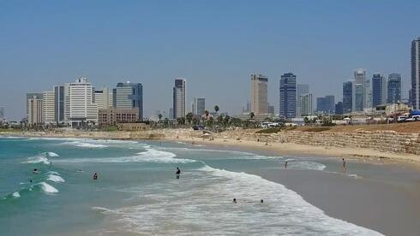
Tel Aviv (Photo: Yaron Sharon)
The Health Minsitry imposed COVID-19 travel restrictions as early as February 2020. Over one year later, in late May of 2021, vaccinated foreign nationals were allowed to enter Israel for the first time. Tourist visas were not granted until August of 2021 for tour groups, and then under strict guidelines. The ministry announced that all tourists, under specific COVID-19 regulations, could enter the country beginning on November 1, 2021.
PCR tests are still required for international travelers upon arrival at an Israeli airport or border crossing under Health Ministry rules. Holders of an Israeli passport are exempt from this test. Tourists are required to isolate until they receive a negative COVID-19 test, whether or not they are vaccinated.

'Check to Fly' booth for COVID testing in the Ben Gurion airport (Photo: Ohad Zwigenberg)
Tamir Kobrin, general manager of the King David Hotel in Jerusalem, said that bookings are up “threefold” compared to last year. However, the hotel is only filled up to 60% of the volume it saw in March 2019, before the global pandemic hit, he said.
Kobrin shared that the hotel is welcoming a variety of travelers, rebooked tours, evangelical groups, donors, and political and government delegations. He believes that the war in Ukraine is not significantly impacting visits to the hotel.
The King David in Jerusalem, named 2021 Travelers’ Choice Hotel by Tripadvisor, is receiving daily cancellations due to cases of the coronavirus, according to Kobrin. The recent security threats are also having a small impact on hotel business, he added, but COVID-19 is the main cause of booking cancellations and it seems it will continue to be around a while longer. MORE - https://www.ynetnews.com/travel/article/bj0jzdn45

Netanyahu's prime minister's office was bugged for a decade - report
The recording device, found in 2019, is reportedly connected to similar devices uncovered during the Harpaz Affair.
By BEN CASPIT/MAARIV Published: APRIL 16, 2022 08:34 Updated: APRIL 16, 2022 13:26
A decade-old recording device was found in the Israeli prime minister's office three years ago, during opposition head Benjamin Netanyahu's tenure.
The device, reportedly installed back in 2008 when Ehud Olmert was prime minister, was left unnoticed by Netanyahu until three years ago, meaning it recorded 11-years'-worth of the opposition head's conversations during his 12-year reign as prime minister.
The recording device found in 2019 is reportedly connected to similar devices installed in the offices of former IDF chief of staff Gabi Ashkenazi and defense ministers Amir Peretz and Ehud Barak during their tenures in their respective roles, as part of the Harpaz Affair.
The Harpaz Affair dates back to August 2010 and started as the result of fighting between Barak and Ashkenazi over a variety of security issues and powers. The two sides allegedly spied on each other. IDF officer Boaz Harpaz initiated an elaborate plot to forge a document and use it to undermine Yoav Gallant, Barak’s first choice to succeed Ashkenazi as IDF chief, who Ashkenazi opposed.
Harpaz pleaded guilty to the plot in 2018 as part of a plea deal that saw him sentenced to 220 hours of community service. MORE - https://www.jpost.com/israel-news/article-704326

Reports that revealed payments to terrorists now hidden
Middle East power accused of withholding required documents
By WND Staff Published April 16, 2022 at 3:57pm
The Palestinian Authority, responsible for governing a large piece of territory in the Middle East, long has run its government operations with substantial financial support from other nations.
In the range of hundreds of millions of dollars a year.
And as part of the agreements that provide that funding, it is required to publish its budgets and other financial reports.
Only now it isn't.
The report is from Palestinian Media Watch, which is reporting the move is, "In an effort to hide its practices and prevent any external scrutiny."
The move actually is that the "PA has blocked access to all the financial reports it used to publish. Since 2008, as part of an agreement to receive funding from the World Bank, the Palestinian Authority has been required to publish a range of financial documents, including its annual budget and monthly budget performance reports," the PMW report revealed.
"While the PA temporarily honored the commitment to publish its annual budget, it has not done so since 2019. In contrast, with the exception of a few minor incidents (exposed by Palestinian Media Watch and then rectified), the PA had been relatively meticulous in publishing its monthly budget performance reports," PMW reported.
The report said the last PA budget performance report was dated January 2022, but now "even this option has been blocked." MORE - https://www.wnd.com/2022/04/reports-revealed-payments-terrorists-now-hidden/

Report: Only 16% of patients at Israel’s field hospital in Ukraine are refugees
The rest, according to Channel 12, are local Ukrainians near Lviv seeking general care
By TOI staff Today, 7:52 pm
Some three weeks after it opened, Israel’s field hospital in western Ukraine is barely treating war refugees and mostly handling general care of locals, according to a new report.
Channel 12 news said that only 16 percent of cases (500 of 3,000) treated at the Kochav Meir hospital in Mostyska, outside Lviv, are those relating to the war. The rest are residents of the area who appear to prefer the free high-level care at the facility to Ukrainian options.
The Health Ministry told the network that the hospital “provides medical care to any patient who requires it, and cooperates with the local healthcare system. The system does not mark patients’ place of origin.”
It said it did thus not have statistics on the number of refugees treated.
The hospital is currently set to remain active until April 30.
The hospital opened on March 22, with the decision to operate in western Ukraine based on safety considerations.
The hospital is intended for civilians, and always expected most of its traffic to be for chronic conditions and pediatric care.
Housed on the grounds of an elementary school in Mostyska, outside Lviv, the NIS 21 million ($6.5 million) facility fills 10 outdoor tents and has also converted multiple classrooms into hospitalization wards.
The project has 100 staff members, 80 of whom are doctors and nurses who flew out to Ukraine earlier this week after a ceremony at Ben Gurion Airport attended by Prime Minister Naftali Bennett and Lapid.
Many members of the delegation were chosen for their abilities to speak Ukrainian or Russian.
Last week, Health Minister Nitzan Horowitz visited the hospital, becoming the first cabinet member to enter the war-torn country since the start of the Russian invasion.
Horowitz thanked medical staff for their “holy work” treating thousands of women and children.
“Israel is the only country that has established such a facility within Ukraine. This is the real face of the Israeli health system,” he said.
He added that his visit sends a message of Israel’s “solidarity with Ukraine in the face of a brutal Russian invasion and in the face of the massacres and war crimes that are being uncovered these days across the country.” https://www.timesofisrael.com/report-only-16-of-patients-at-israels-field-hospital-in-ukraine-are-refugees/

Russia hits out at Lapid for backing its suspension from UN rights council
Moscow’s foreign ministry accuses FM of ‘anti-Russian attack,’ claims Israel using invasion of Ukraine to ‘distract’ from conflict with Palestinians
By TOI staff Today, 12:15 pm
Moscow on Friday lashed out at Foreign Minister Yair Lapid over a week after Israel joined with other countries to suspend Russia from the UN Human Rights Council over its invasion of Ukraine.
A Russian Foreign Ministry statement accused Lapid of an “anti-Russian attack” with his comments after the General Assembly vote last week, which marked only the second time a country has been stripped of its membership rights on the council.
“There is an effort to take advantage of the situation around Ukraine to distract the international community from one of the longest unresolved conflicts — the Palestinian-Israeli,” the ministry said.
The statement went on to rail at Israel for “the illegal occupation and creeping annexation of Palestinian territories.” It also bashed the blockade of the Hamas-ruled Gaza Strip, which Israel says is needed to prevent arms from reaching terror groups in the enclave.
“It is also noteworthy that… the longest occupation in the post-war world history is carried out with the tacit connivance of the leading Western countries and the actual support of the United States,” the statement charged.
It was not clear what specifically Lapid — who has accused Russia of war crimes in Ukraine — said following the April 7 vote to draw Moscow’s ire.
A Foreign Ministry statement at the time denounced the “unjustified invasion” of Ukraine and accused Russian forces of “killing innocent civilians.” The statement quoted Lapid saying there was no change in Israel’s stance toward the Human Rights Council, which Jerusalem alleges has an anti-Israel bias, without referring to Russia or its invasion of Ukraine.
There was no response from Lapid or the Foreign Ministry to the Russian statement.
Israel has avoided aligning too closely with either side since Russian troops invaded Ukraine on February 24. It is one of the few countries that maintains relatively warm relations with both Ukraine, a fellow Western democracy, and Russia, which controls the airspace over Syria, in which Israel operates to target Iranian proxies.
However, after irking the Biden administration by declining to co-sponsor the first UN Security Council resolution against Moscow’s invasion of Ukraine in February, Israel has since joined the West in condemning Russia in several UN resolutions. MORE - https://www.timesofisrael.com/russia-hits-out-at-lapid-for-backing-its-suspension-from-un-rights-council/

Ukraine's prime minister, finance officials to visit US next week
Thursday's event will be the first chance for key Ukrainian officials to meet in person with a host of financial officials from advanced economies since Russia's invasion of Ukraine on February 24.
By REUTERS Published: APRIL 16, 2022 02:52 Updated: APRIL 16, 2022 07:01
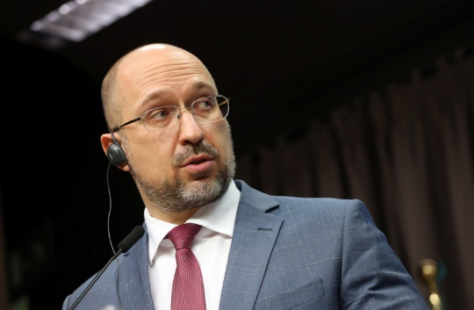
Ukrainian Prime Minister Denys Shmyhal (photo credit: FRANCOIS WALSCHAERTS/POOL VIA REUTERS)
Ukrainian Prime Minister Denys Shmyhal and top Ukrainian finance officials will visit Washington next week during the spring meetings of the International Monetary Fund and World Bank, sources familiar with the plans said on Friday.
Shmyhal, Finance Minister Serhiy Marchenko and central bank governor Kyrylo Shevchenko are slated to meet bilaterally with finance officials from the Group of Seven countries and others, and take part in a roundtable on Ukraine to be hosted by the World Bank on Thursday, the sources said.
Thursday's event will be the first chance for key Ukrainian officials to meet in person with a host of financial officials from advanced economies since Russia's invasion of Ukraine on February 24. MORE -
https://www.jpost.com/breaking-news/article-704314

Russia renews strikes on Ukraine capital, hits other cities
Ukrainian president’s office reports missile strikes and shelling over the past 24 hours in eight regions across the country
By Adam Schreck and MSTYSLAV CHERNOV 17 April 2022, 12:00 am
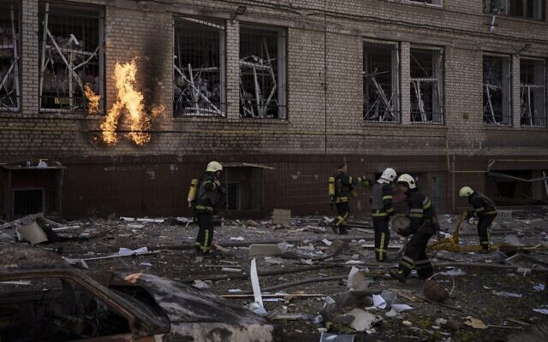
Firefighters work to extinguish multiple fires after a Russian attack in Kharkiv, Ukraine, on Saturday, April 16, 2022. (AP Photo/Felipe Dana)
KYIV, Ukraine (AP) — Russian forces accelerated scattered attacks on Kyiv, western Ukraine and beyond Saturday in an explosive reminder to Ukrainians and their Western supporters that the whole country remains under threat despite Moscow’s pivot toward mounting a new offensive in the east.
Stung by the loss of its Black Sea flagship and indignant over alleged Ukrainian aggression on Russian territory, Russia’s military command had warned of renewed missile strikes on Ukraine’s capital. Officials in Moscow said they were targeting military sites, a claim repeated — and refuted by witnesses — throughout 52 days of war.
The toll reaches much deeper. Each day brings new discoveries of civilian victims of an invasion that has shattered European security. As Russia prepared for the anticipated offensive, a mother wept over her 15-year-old son’s body after rockets hit a residential area of Kharkiv, a city in northeast Ukraine. An infant and at least eight other people died, officials said.
In the Kyiv region, authorities have reported finding the bodies of more than 900 civilians, most shot dead, since Russian troops retreated two weeks ago. Smoke rose from the capital again early Saturday as Mayor Vitali Klitschko reported a strike that killed one person and wounded several.
The mayor advised residents who fled the city earlier in the war not to return.
“We’re not ruling out further strikes on the capital,” Klitschko said. “If you have the opportunity to stay a little bit longer in the cities where it’s safer, do it.”
on the southeastern edge of the capital contains a mixture of Soviet-style apartment blocks, newer shopping centers and big-box retail outlets, industrial areas and railyards MORE - https://www.timesofisrael.com/russia-renews-strikes-on-ukraine-capital-hits-other-cities/

US invokes famous Lend-Lease Act
The Ukraine war has been leading to some peculiar historical reminiscences: The US Senate has now unanimously reactivated the famous Lend-Lease Act from World War II in order to be able to deliver weapons and other goods faster and more efficiently – this time to the most corrupt country in Europe: Ukraine. A corresponding bill was just passed in the US Senate.
Published: April 13, 2022, 8:50 am
During World War II, the law allowed the US to provide military and non-military supplies to its allies without time-consuming procedural hurdles. Above all, Stalin’s Soviet Union benefited from this, as it only survived the German advance in 1941/42 thanks to flows of American aid supplies.
Even today, the “Ukraine Democracy Defense Lend-Lease Act of 2022” is intended to accelerate the transfer of war equipment and other militarily relevant goods to Ukraine by removing bureaucratic hurdles. Such a law effectively allows war supplies to be given away – the only provision being that the recipient country repays the United States at some point in the future.
This week, the US State Department announced an additional $100 million for the delivery of Javelin anti-tank guided missiles and other material to Ukraine. This brings US military aid to a total of $2,4 billion since the Russian operation began on February 24. MORE - https://freewestmedia.com/2022/04/13/us-reinvokes-famous-lend-lease-act/

Russia says it destroyed tank factory in Kiev
Moscow reported hitting 16 targets in Ukraine overnight
16 Apr, 2022 14:10
Russia used high-precision strikes to destroy an armored-vehicle manufacturing plant in Kiev and a military repair depot in the city of Nikolaev in southern Ukraine, Defense Ministry spokesman Major General Igor Konashenkov said on Saturday.
He added that 16 targets were hit overnight, including Ukrainian military units, weapons and ammunition depots, and radar facilities.
Moscow warned that it would step up strikes on Kiev after accusing Ukraine of shelling Russian territory on Thursday. Kiev has denied launching attacks on Russian soil.
Russia confirmed on Thursday that the cruiser Moskva, the flagship of the country’s Black Sea Fleet sank after a fire and detonation of ammunition onboard. Ukraine, however, claimed that it hit the Russian vessel with anti-ship missiles.
Russia attacked the neighboring state in late February, following Ukraine’s failure to implement the terms of the Minsk agreements, first signed in 2014, and Moscow’s eventual recognition of the Donbass republics of Donetsk and Lugansk. The German and French brokered protocols were designed to give the breakaway regions special status within the Ukrainian state.
The Kremlin has since demanded that Ukraine officially declare itself a neutral country that will never join the US-led NATO military bloc. Kiev insists the Russian offensive was completely unprovoked and has denied claims it was planning to retake the two republics by force. MORE - https://www.rt.com/russia/553986-russia-hits-tank-factory/

Russian military publishes Ukrainian casualty numbers
Moscow claims Kiev has lost 23,367 combatants combined from the army, national guard and foreign mercenaries
16 Apr, 2022 17:45
Ukraine has suffered the “irretrievable losses” of 23,367 troops since Russia launched its military offensive in February, the Ministry of Defense in Moscow stated on Saturday.
The casualty figures were revealed by Defense Ministry spokesman Major General Igor Konashenkov, who said that in the city of Mariupol alone Ukraine has lost more than 4,000 people, including “foreign mercenaries” and “Nazis” associated with the notorious Azov and Aidar regiments.
Konsahenkov said that Russia has obtained documents proving Ukraine's losses, and would soon publish more detailed information from these files.
Ukraine claims to have lost between 2,500 and 3,000 soldiers across its entire territory. This was the figure Zelensky gave to CNN in an interview on Friday, while claiming that the Russian military had suffered as many as 20,000 casualties of its own. Moscow heavily disputes Zelensky’s claims. According to a casualty count published by the Russian government last month, Russia had lost just over 1,350 troops. MORE - https://www.rt.com/russia/553998-russia-ukraine-casualties/

Court Document: 221K Illegal Migrants Encountered at Border in March
By Charles Kim | Friday, 15 April 2022 10:37 PM
According to a court document filed Friday in the federal lawsuit between Texas and Missouri against the administration of President Joe Biden, Customs and Border Protection agents encountered more than 221,000 illegal migrants along the southern border in March.
"For the month of March 2022, [Department of Human Services] reported 221,303 total encounters at the Southwest Border," the court filing states. "This figure combines statistics reported by the CBP Office of Field Operations, which deals with noncitizens seeking to enter at land ports of entry, with statistics from the U.S. Border Patrol, which apprehends noncitizens seeking to enter between [ports of entry]."
The filing is a court mandated monthly report as part of the lawsuit.
The number of illegal individuals encountered is the highest for that month since March 2000, when 220,063 illegal migrants were encountered at the Southwest border, according to the U.S. Border Patrol, and seven times higher than 2020.
The March total is a 24% increase from the same month a year earlier, when 169,000 migrants were picked up at the border, the start of a rise in migration that left thousands unaccompanied children stuck in crowded border patrol stations for days while they awaited placement in overwhelmed government-run shelters.
Biden, a Democrat who took office in January 2021, pledged to reverse many of the hardline immigration policies of his Republican predecessor, former President Donald Trump, but has struggled both operationally and politically with high numbers of attempted crossings. MORE - https://www.newsmax.com/newsfront/texas-missouri-biden-border/2022/04/15/id/1065955/

US congressman reveals seats on committees are ‘literally’ bought
Seats on Congress’ most powerful committees are literally offered for sale to special interest groups, said Representative Mo Brooks
15 Apr, 2022 21:52
In a video that circulated online on Friday, Alabama Representative Mo Brooks told supporters that an entrenched system of corruption prevents Congress from passing legislation that would benefit the average American. Brooks said that both parties charge their members $1 million and beyond for chairmanships of committees, and that only those taking donations from lobbyists can afford these seats.
“Special interest groups run Washington, and I don’t mean that metaphorically. I mean literally,” Brooks told supporters at an event in March, video footage of which was shared on Friday by conservative pundit Lauren Windsor.
NEW: GOP Rep Mo Brooks says prime committee chairmanships cost a minimum of $1 million and are paid by special interest groups as "a quid pro quo" for favored legislation#ALsenpic.twitter.com/SswSObhpf7
— Lauren Windsor (@lawindsor) April 15, 2022
According to Brooks, lawmakers who want to be chairman of a major committee “have to purchase it.” Either the National Republican Congressional Committee (NRCC) or Democratic Congressional Campaign Committee (DCCC) will charge members of Congress a fee to chair a committee for two years.
The fee varies depending on how important the committee is, but bidding for a top-tier chairmanship starts at $1 million, Brooks claimed. One unnamed candidate running to lead the NRCC literally showed representatives “a brochure” of his prices, Brooks claimed, explaining that the prospective NRCC chief had broken his pricing down into three tiers, and boasted that he would charge less than other candidates.
Those who can’t afford to cough up a million dollars take donations from special interest groups, and are then beholden to these lobbyists once in office, Brooks continued.
“Now you understand how the public policy debate is so corrupted,” he said.
Party officials deny that payments are linked to committee assignments, and refer to this system as paying “dues.” However, it has come under criticism before.
“They told us right off the bat as soon as we get here, ‘These committees all have prices and don’t pick an expensive one if you can’t make the payments,’” Kentucky Representative Thomas Massie (R) said in 2016, referring to the payments as “extortion” and refusing to pay up.
Massie also described in 2016 how, earlier in his political career, a lobbyist from “the medical device sector” offered to pay for his seat on the House Ways and Means Committee, a powerful slot that would see the Kentucky Republican shape tax policy. The unspoken implication, Massie wrote, was that he would then owe the lobbyist his favor.
“It was one of the scummiest meetings I’ve ever been in,” Massie said. “I left just reeling, thinking about the implications for how this place works, when you realize that the lobbyists pick who goes on which committee.”
Neither Brooks nor Massie represent the mainstream of the Republican Party. Brooks, who is currently running for the US Senate, is viewed as a “MAGA” candidate by establishment Republicans, yet has also been sidelined by Donald Trump himself, who withdrew his endorsement of the Alabama lawmaker last month due to Brooks’ insistence that the GOP move past Trump’s claims of fraud in the 2020 election.
Massie has quarreled with Trump before, but has drawn particular ire from hawkish establishment Republicans in recent weeks over his refusal to back a resolution promising open-ended military aid to Ukraine and sanctions on Russia, which he argued would hurt “innocent people in Russia.” https://www.rt.com/news/553964-lobbyists-buy-congress-seats-brooks/ [The party system to keep their bureaucracy going has become one of the most foul and corrupt factors in politics. – rdb]

18-month, data-driven probe concludes 2020 election was stolen
Smartphone pings, video reveal at least 4.8 million fraudulent votes
By Art Moore Published April 15, 2022 at 9:14pm
Catherine Engelbrecht and Gregg Phillips have been engaged in the battle for election integrity for more than a decade, and the day after the contested November 2020 vote, they made a pact.
"Catherine looked at me and said, 'What are we going to do?'" Phillips recounted in an in-depth video interview with Turning Point USA founder Charlie Kirk.
"I said, Let’s go," Phillips recalled. "She said, Let's go all in."
They eventually hired a dozen people who have put in 16-hour days for 15 months, combing tediously through cellphone geolocation data, surveillance videos and documents to see if the evidence supports their hypothesis.
Their hypothesis is that amid the many "dirty," out-of-date voter rolls and the unprecedented distribution of mail-in ballots, a highly coordinated operation in the key battleground states collected ballots and paid "mules" to literally stuff them in the unattended drop boxes that became a center of controversy.
Phillips, the founder of a health-care-data company, began lending his tech savvy to Engelbrecht's non-profit True the Vote in 2013 to analyze voter records across the nation, helping officials remove duplicates and registrations of non-residents, non-citizens and deceased voters.
They say they have the hard evidence to back their finding that there were 4.8 million fraudulent votes in the states they targeted – including Arizona, Wisconsin, Michigan, Pennsylvania and Georgia – but they've been shunned by authorities, and media won't touch it.

Much of the evidence of criminal behavior is indisputable. In Georgia, for example, it's illegal for any person to place more than one ballot in a drop box unless he or she has registered as an "assistor." In Gwinnett County, where there is video footage of people with latex gloves stuffing multiple ballots in a drop box then recording the deed with a photograph, there were no "assistors" registered for the 2020 election.
Engelbrecht and Phillips eventually took their two petabytes of data (the next highest measurement for data storage after terabytes, equalling 1,024 terabytes or 1 million gigabytes) to filmmaker Dinesh D'Souza, whose feature "2000 Mules" is in post-production.
After the movie comes out and the inevitable attacks come, Phillips said the investigative team will "pull the rip cord" and release all of the data.
Engelbrecht said they want to be totally transparent" and "give it all to the American people."
"Now you can see what nobody is showing you to this point," she said.
Phillips noted there's a lot of fear surrounding the raising of any questions about the 2020 election.
"Everybody’s afraid right now. They’re afraid of getting canceled," he said, but "on the other side of fear is freedom."
"All you've got to do is step up," he said. "Let’s go."
'Prayerful consideration'
Kirk recalled that Engelbrecht was targeted by the Obama administration after her group exposed the IRS discrimination against conservative non-profits in their application for tax-exempt status. The IRS, Justice Department, FBI, ATF and OSHA launched a total of 23 audits, investigations and inquiries against True the Vote.
She said that experience "steeled me for this moment."
Ten years ago, she said, "I really had to do some prayerful consideration," asking herself if "that really" was "what True the Vote was about."
She decided to "fight it out" in court and sue the IRS, emerging victorious more than six years later.
"I think this is what True the Vote’s been put here to do," Engelbrecht said, "to take us into the other side of the mountain." https://www.wnd.com/2022/04/18-month-data-driven-probe-concludes-2020-election-stolen/

Students at Methodist institution pray to 'Great Queer One'
'Inevitable that Leftist divinity students would end up making gods in their own image'
By Bob Unruh Published April 16, 2022 at 12:01pm
A report from Hope Rawlson at the blog for the Institute on Religion & Democracy has documented that students at Duke Divinity School, which is affiliated with the United Methodist Church, have held a "Pride" worship service to pray to the "Great Queer One."
She revealed, "Divinity Pride, a student group affirming the 'dignity, faithfulness, and strength of Lesbian, Gay, Bisexual, Trans, Queer/Questioning, Intersex, Asexual, and gender/sexuality non-conforming Christians,'" held the event.
The posting explained, "Criticizing the church, Justis Mitchell, a first-year M.Div student, stated, 'In the pews we listen to the pastor who preaches about commandments, condemning those who disobey, predicating a future of fire and turmoil.' However, Mitchell believes that 'We can become holy, we can become worthy, we can become valued…even as we remain queer, even as we discover our own queer God whose presence is within these walls.'"
Renowned Islam expert Robert Spencer wrote in a column at PJMedia, "It was inevitable that Leftist divinity students, marinating as they are in the relentless insanity of the Left’s pet causes, would end up making gods in their own image: gay, woke, and whatever else the Left is idolizing at the moment. Duke Divinity School is affiliated with the United Methodist Church, which is already like being affiliated with the Maoists (gay, gender-fluid Maoists, that is), so it was the perfect place for a recent 'Pride worship service' in which participants offered prayers to 'the Great Queer One.'" MORE - https://www.wnd.com/2022/04/students-methodist-institution-pray-great-queer-one/ [This is blasphemy. 0 rdb]

'Affirming LGBT lifestyles is not sacred, it's sinful'
Christian leader goes where others fear to tread
By Bob Unruh Published April 16, 2022 at 2:16pm
A Christian leader in the United Kingdom has gone where many others fear to tread, warning that the promotion of LGBT lifestyle choices is "sinful."
Ciaran Kelly of the Christian Institute posted online a video of his response to claims from former Archbishop of Canterbury Rowan Williams that becoming transgender is "a sacred journey of becoming whole."
That nation is embroiled right now in a massive war over the left's attempts to censor any and call counseling that can persuade people to live according to their sex. They want to declare that any such talk therapy actually is violence.
But Kelly disagreed:
"Being converted to Christ means we stop living for ourselves, and we start living for Him," Kelly explained.
And he explained "we have the Bible" to learn what that is.
"The Bible tells us about the nature of ourselves, the nature of God and what pleases Him. It says we are made male and female in the image of God. it says sexual activity is only for marriage, and marriage is only between one man and one woman.
"To reject these truths isn't sacred, it's sinful," he said. MORE - https://www.wnd.com/2022/04/affirming-lgbt-lifestyles-not-sacred-sinful/

Commentary:
Tackling the Iranian Regime's Nuclear Threat
by Majid Rafizadeh April 16, 2022 at 5:00 am
If we closely examine the Iranian regime's nuclear file, it reveals that no deal will stop the ruling mullahs of Iran from pursuing their nuclear ambitions.
A few years after the 1979 revolution, the Islamic Republic appeared to make the advancement of a nuclear program a top item on its agenda after consolidating power in 1984. In the decade after, the Islamic Republic began its nuclear program with the help of some intermediaries such as Russia, China and Pakistan.
At the time, the head of Iran's Atomic Energy Organization, Gholamreza Aghazadeh, acknowledged that Pakistan assisted Tehran. He pointed out "I do have information that some years ago, through intermediaries, we received pieces for centrifuges". According to the United States intelligence, A.Q. Khan, who was known as "the father of Pakistan's nuclear bomb", sold expertise and equipment to North Korea, Libya and Iran, and made more than $50 million.
Since then, the Iranian regime has been progressing steadily and investing in its nuclear program for more than three decades. Currently, it has reached a point near the "nuclear threshold." The regime is perhaps weeks away from obtaining the weapons-grade materials necessary for a nuclear weapon. According to a report in the New York Times:
"Iran has come within roughly a month of having enough material to fuel a single nuclear weapon, crossing a threshold that may raise pressure on the United States and its allies to improve the terms of a potential deal to restore the 2015 nuclear agreement."
Israeli Defense Minister Benny Gantz, during a briefing at the Foreign Ministry in Jerusalem, told ambassadors from countries on the United Nations Security Council that Iran "is only around 10 weeks away from acquiring weapons-grade materials necessary for a nuclear weapon".
The only times the Iranian regime has supposedly scaled back its nuclear program was due to two critical reasons. The first was linked to the drastic economic sanctions which threatened the ruling clerics' hold on power, forcing the leadership to recalculate its priorities. The sanctions prior to the 2015 nuclear deal, for example, were significant, as they endangered the power of the ruling clergy and ultimately brought Iranian leaders to the negotiating table between 2013 and 2015.
There were four rounds of sanctions. The five permanent members of the UN Security Council unanimously called on all countries to freeze the financial assets of Iranian entities linked to the nuclear program, to ban Iran's import and export of "sensitive nuclear material and equipment," and to sanction the supply or sale of nuclear-related equipment and technology. They also imposed restrictions on Iranian bank transactions and called on countries to inspect Iranian ships and cargo planes where there were reasonable grounds to believe that the regime was smuggling prohibited products.
After the Iranian regime was able to make the world powers lift the major economic sanctions, however, Iran began clandestinely pursuing its nuclear ambitions even during the term of the nuclear deal. For instance, the detection of radioactive particles in Turquz Abad, Iran's reluctance to answer simple questions about the secret facility, and non-partisan evidence about Iran's nuclear activities at the location, all point to the fact that Tehran was most likely violating the 2015 nuclear deal since it was reached.
The second reason the Iranian regime may have scaled back on achieving its nuclear ambitions was linked to the fear of military operations against Tehran. After the US invaded Iraq in 2003, Iranian leaders rushed to offer the Bush administration a deal that would reportedly have curtailed their nuclear program. That was probably because the Islamic Republic was concerned that the Bush administration might next attack Iran or its nuclear facilities. then US President George W. Bush did in fact debate bombing Iran, as he pointed out in his memoir, Decision Points, "I directed the Pentagon to study what would be necessary for a strike." He added, "This would be to stop the bomb clock, at least temporarily."
The only way to deter or stop Iran is to impose drastic economic sanctions on the regime again, thereby cutting the flow of funding to the Islamic Revolutionary Guard Corps and -- one hopes for the sake of the repressed Iranian people as well as any stability in the region -- bringing the regime financially to its knees.
Dr. Majid Rafizadeh is a business strategist and advisor, Harvard-educated scholar, political scientist, board member of Harvard International Review, and president of the International American Council on the Middle East.
https://www.gatestoneinstitute.org/18418/iran-nuclear-threat

ERIC, The Largest Components of The National Voter Fraud Issue
By Kate Stansell|April 16th, 2022
How the ERIC Beast is Fed And How Your Community Can Starve It
The Electronic Registration Information Center, ERIC, is one of the largest components of the national voter fraud issue. The more I learn about ERIC and the action of its 30 member states, the more sure I am that the construct of the organization was designed for it, with words of plausible deniability, of course.
Massive lists of human data are required of each member state, to be submitted to ERIC’s centralized computers. Because of the way the data is gathered and sorted, the names of millions of people who are ineligible to vote are automatically on the lists. This is how the beast gets fed.
Be patient for a few paragraphs of review. If you have already read up on the ERIC beast, this may be redundant, but everyone will need to understand these details in order to be effective against the perpetrators of the system in your community.
We know that ERIC requires that bi-monthly updates of each states’ voter rolls, and motor vehicle records be submitted to its centralized AI system. These records necessarily include the names of ineligibles along with citizens because of the sources of the list given to ERIC – the DMV and Dept of Elections, where the voter rolls may not have been culled for years.
The DMV issues learner’s permits to youth who are not of voting age and drivers licenses to illegals. It also, in most states, issues ID cards to those without driving licenses, including illegals. Green card holders are – by definition – not citizens of the US, yet most have licenses to operate motor vehicles, so they appear on the lists provided to ERIC as well. All of these names are then mixed with USPS address data and Social Security death records from the state.
While each state is mandated, by ERIC membership requirements, to reach out and register people from these lists, no rule actually requires culling of ineligible names.
All of the 30 member states offer some form of identification to people who are not qualified to vote, whether in the form of driving licenses or identification cards. These names end up on the ERIC lists, I believe, by design.
SO, as I understand it, here’s the recipe for how the Beast gets fed.
Take
♦ rolls of registered voters, then, add
♦ holders of drivers’ licenses, plus
♦ green card holders, plus
♦ ID cards issued to illegals and other “undocumented”
♦ underaged driver and work permit applicants. Stir in
♦ all names at postal addresses, then flavor it with
♦ Social Security death lists.
This creates amazing fodder to fill the belly of the ERIC beast. The end-product (what comes out) more resembles the end product of the human digestive system (aka, excrement), than it ever could, legitimate voter rolls. As with the human byproduct, ERIC lists stink, and must be flushed.
The only way to stop the Beast is to stop feeding it. There is where local citizens groups come in.
The only way to stop the Beast is to stop feeding it. There is where local citizens groups come in. Activists in each community need to confront state officials and let them know that YOU know about the fraud created by ERIC constructs, and demand their state withdraw from membership. Some may know about the fraud, and are in it for that reason. Others may just be using ERIC so that they have the mandatory voter rolls called for by the National Voter Registration Act of 1993. Others may have given their souls to staying in office, and will side with whomever screams the loudest. Let that be the citizen activist, or we may forever be forced to hold our peace.
Here’s what to do to get started: (because the officials will need the fraud “in their faces” to listen)
1. Work with a group of like-minded people, from your church, family, club or neighborhood, who care about losing their country. Make sure everyone has a basic understanding of what ERIC is, and how it operates, and why it is so dangerous to our
freedoms, to voters from all sides.
2. Know your election officials in your county, and contact them. Tell them WHY you are calling/writing. Not just with a single contact, but by repeated phone calls and emails. Learn
how much time you will have to alter the rolls before the next election, in which you will be able to work. This varies by state.
3. Demand to be provided the voter rolls in your area, county or municipality. It is your legal right to have them, per the NVRA of 1993. Make sure they know that you know this. Don’t give your election officers long to produce, and don’t accept any excuses as to how long it will take them, or how short-handed they are, or whatever. In this case patience is NOT a virtue. You are facing a short time line, which for most states is 90-days before a federal election, in which the voter lists may not be altered – even if they contain thousands of ineligible voters. Contact your officials daily if necessary, until you receive the lists.
4. Canvass from those lists. This is the quickest and most direct way to learn how many illegitimate names are hidden there. Verify the names and ages of residents of voting age who live at that address. (The subject of canvassing is sometimes debated because it can be thought of an “an intrusion”, or a “danger to the canvassers” , but it is neither.) When you get to the addresses, check first how many voters are registered at a single address. For example, a single family home or duplex seldom would house more than a few voting residents. If there are 16 or 20 or 60 registrants at that one address, it is, of course, a red flag for fraud. Go in groups, if you want to knock on doors, and have the polite but firm smile on your faces. Help the resident to understand that you are neither “R” nor “D” but an American concerned with maintaining our freedom to chose our governance. Tell all that every fraudulent ballot negates a legitimate one. It is scary to realize how many people have never thought of that simple fact!
5. Canvass from the internet. This can be utilized to narrow your lists, before you begin the door-to-door, and is also an excellent way to include volunteers who have physical disabilities and/or someone at home for whom they must care. Look up the addresses on Google Earth or similar satellite services, and ascertain if a structure actually exists at that locale. Many a graveyard or vacant lot has been listed as a voter’s address. This hint was passed along to me by a very smart activist in Florida, who loves her America. It will save time and cover more ground, faster. Thanks, my new Florida friend!
6. Make your efforts public, in every way possible. Be sure to post everything on social media. If you have any Twitter or Facebook aficionados, put them to work reporting out on a daily basis. If you have trouble getting to, or working with, your local officials, post it. If this continues, make friends with someone from a local paper or news outlet. Publicity is the life blood OR the death knell for politicians, and it usually makes they more responsive. Reveal how many vacant lots have become registered addresses, or how many people support what you are doing and want to help. Keep your activities front and center any way you can.
7. Go to county board meetings, request agenda time, and speak out about your mission and the reasons for it. The more left-leaning is your particular board, the more reticent they will be to let you speak. If they disallow it, post THAT!
8. Appoint several members of your group to keep track of your findings and to publicize them anywhere and everywhere.
9. Request meetings with your officials, local and/or state. Have your friendly media person along to take notes, record, or whatever may be allowed. Show them what you’ve found, and what you know about ERIC. Publicize the responses of each elected or appointed official!
Your goal is to get your state to withdraw from ERIC. The state of Louisiana did just that because of the pressure from citizen groups, whose requests for the voter rolls were denied and ignored. The Public Interest Legal Foundation, founded by J. Christian Adams, sued the Secretary of State, Kyle Ardoin, on behalf of the voters, which forced Ardoin to look into the rolls and ERIC, and he suspended the LA membership. See [Link]
You can do it in your state, too!
May you be blessed in your efforts. I will be continuing to dig into each ERIC member state, to highlight the fraud which has been discovered, and I want to hear from you at www.americanpolicy.org about what is happening in your state as you work to starve the ERIC beast . We will help wherever we can. We’ve got a country to save! https://newswithviews.com/eric-the-largest-components-of-the-national-voter-fraud-issue/
“Control Your Soul’s Desire for Freedom”
By Lex Greene|April 16th, 2022
This is the message being echoed by drones throughout Shanghai China today in yet another massive total city lockdown of over 26-million Chinese citizens. Thousands are screaming from their balconies as others leap from their balconies to their death. They are being starved to death.
If you have not seen what is happening in Shanghai right now, watch this video and many others like it. This is how 2020 started under the COVID19 bioweapon attack on humanity all over the globe. It only took days for similar anti-freedom policies to reach the United States, ahead of the 2020 elections.
We can’t afford to make the same mistakes that most Americans made in COVID 2020. Those lockdowns started in China as well and very quickly spread all around the world and across the United States. People all over the world were immediately stripped of all freedoms and liberties, along with their ability to work and earn, or even protect their own family members.
Millions of Americans accepted tyrannical COVID restrictions and orders that lasted for over 18-months in the USA, and millions are still accepting lethal injections (called vaccines and boosters) as a tide of unexplained deaths rises in all age groups.
If you “go-along to get-along” this time, it will be the end of everything you ever knew or dreamed of for your future. What’s happening in Shanghai right now will rapidly spread to the USA and around the globe, just in time for the next fraudulent elections this November.
It’s no secret that the current U.S. Government has the lowest approval rating in decades and that in any legitimate election, leftist democrats would be slaughtered in the upcoming mid-terms. That’s why something even worse than COVID 2020 must happen, in order to make it possible for leftist democrats to maintain power.
There’s no more time to sugar coat anything, or waste time trying to educate those who will refuse to be educated until there is nothing left. I will put a very fine point on our problem here, the reason why nothing is being addressed or fixed in the USA right now, and what must happen to change that dynamic.
WHY WE HAVEN’T STOPPED THIS ALREADY
Of course, there are a number of reasons, such as about 30% of Americans believing that global Marxism is better than USA Freedom and Liberty. But that’s a minority of American Citizens and in time, they can be brain-flushed to the truth about the Marxism and Communism that they were dog-whistle trained in government controlled education, news, and entertainment.
It’s the other 70% that are the real problem, and this is why…
More than 80% of Americans make all decisions strictly on the basis of how each decision will affect their personal financial status. Very few make decisions on the basis of what’s right, moral, ethical or in the best interest of freedom and liberty. Money isn’t the root of all evil. “The love of money is the root of all evil” – when you put money above everything else, including freedom and liberty.
If you think this isn’t you…then you are not being honest with yourself. Very few Americans locked down, wore a mask, or took a so-called vaccine in the best interest of their health, freedom, or liberty. Almost all who followed these unconstitutional fatal commands did so to protect their financial interests, keeping their jobs, their friends…going-along to get-along.
None of the COVID protocols ever made scientific or medical sense…it was all backwards to known science and medicine. People didn’t follow their orders to “follow the science.” They followed those orders despite all known science, to protect their financial interests…temporarily!
None of the events of the past several years have been about securing your health or freedom. All of it has been designed to convince you or force you to “Control Your Soul’s Desire for Freedom.”
As of this writing, the CDC is still reporting COVID cases in the USA at 82,119,222. But the CDC long ago admitted in public that over 80% of all COVID testing resulting in “false positives,” which means the real number of cases is approximately 16.4 million Americans, not 82.1 million Americans.
According to the CDC today, 1,012,796 Americans have died of COVID19. But the CDC has also admitted publicly that 94% of these deaths were due to other causes, with only 6% having actually died “of COVID,” 60,767 instead of more than a million being reported.
Meanwhile, the CDC has been hiding the fact that far more Americans have died within seven days after taking a “vaccine or booster,” many more dying beyond the seven day mark.
So, although COVID19 itself turned out to be no more a risk to American lives than the average flu season, and the so-called “vaccines” have proven to be far more dangerous than the original illness, the COVID19 event has indeed served the great global Marxist cause of getting Americans to “Control Your Soul’s Desire for Freedom.”
The simple fact is, this has been allowed to happen and continue because unlike our Founders who were proud to put everything they had, treasure and lives, on the line for our freedom, most modern Americans won’t even give up a happy meal, a pack of cigarettes or a six pack of beer for their freedom or liberty.
Of course, if we can’t even afford to go to war, we can never afford to win that war. It takes resources to fight any war, much less win it. It’s also critical to not waste any resources, on things that are not real viable solutions.
The following are in fact, very dangerous FAKE SOLUTIONS
Amending the Constitution or Bill of Rights
Another fraudulent election
Secession from the Constitution and Bill of Rights
Leaving Party control to anti-American criminals
Hoping someone else will do something
Praying as though you have no personal responsibility
Pretending as though freedom ever existed without a fight
Thinking we can win without the resources to fight
Thinking you can survive alone in a collapsed nation
Putting money before freedom
In case you have not figured it out yet, no matter how much money you have, how many guns, or how much ammo and stored food you have in your prepper fox hole, when the USA is no more, you too, will have nothing. When freedom is gone, tyranny is all that’s left.
The inescapable fact is a massive global cabal is intent upon destroying every nation and every citizen on earth via their maniacal COVID19 GLOBAL RESET agenda. Citizens of the USA are the only possible solution on earth, for freedom and liberty, anywhere on earth.
If you believe in the USA, freedom, liberty, prosperity, sovereignty, and security as a free society, then you will have to make these things an immediate priority in your life. If we don’t, fast, all of it will soon be gone.
Don’t mistake me for some doomsday negative fearmonger. If I thought it wasn’t still possible for the American people to overcome the many threats we face today, I wouldn’t still be talking to you. If we have the will, there is a way.
But we must turn the possible into the certain.
We can only do this together and only if we have the resources to win and put every horse at the front of our cart, no longer pulling in opposite directions on a laundry list of already failed fake solutions.
We have the power, but we are not yet united, organized, and committed to making our future even brighter than our past.
Something bigger (and worse) than what has happened so far is on the horizon. The global left will not retreat without being forced to retreat. The timeline is between now and our November elections. So, we don’t have much time.
If you are intent upon being part of the solution, I encourage you to write me now.
https://newswithviews.com/control-your-souls-desire-for-freedom/
THE SHORASHIM BIBLICAL GIFT CATALOG 005
http://mad.ly/7f9f64?pact=20013931524&fe=1
Support Shorashim!

ARUTZ SHEVA
Jews violently attacked in Old City of Jerusalem
Security camera footage shows gang of Arabs attacking Jews on their way to pray at the Western Wall today.
Israel National News 17.04.22 12:50
Arabs attacked a group pf Jews wrapped in prayer shawls this morning who were walking in the Old City on their way to morning prayers at the Western Wall.
Border Police officers responded to the attack and chased down the attackers, arresting two of them.
Meanwhile, police arrested six people who threw stones from the roofs of houses in the Muslim Quarter at police officers and passers-by. Fireworks were also seized. The suspects were taken for questioning by police.
Since this morning, a total of 18 suspects have been arrested for stone-throwing and fireworks, violent riots and assaults against police and civilians. https://www.israelnationalnews.com/news/325991

To be removed from this News list, Please click here and put "Unsubscribe" in the subject line.

04/16/2022 NEWS -Very short abbreviated news today and tomorrow! - rdb

Tonight begins Passover day 2
Aryeh Kunstler - "Passing Over"
https://www.youtube.com/watch?v=IVPXz0lp8cQ

"I am not unmindful that some of you have come here out of great trials and tribulations. Some of you have come fresh from narrow cells. Some of you have come from areas where your quest for freedom left you battered by the storms of persecution and staggered by the winds of police brutality. You have been the veterans of creative suffering. Continue to work with the faith that unearned suffering is redemptive."
-- Rev. Dr. Martin Luther King, Jr. (1929-1968) US civil rights leader

Read the Prophets & PRAY WITHOUT CEASING!
That is the only hope for this nation!
Please  Remember  These  Folks  In  Prayer-  Check often  They  Change! | Pray that the world would WAKE UP! Time for a worldwide repentance!  ALL US soldiers fighting for our freedom around the world  Pray for those in our government to repent of their wicked corrupt ways.  Pray for BB – Severe sciatic Had surgery and doing well  Pray for EL – Had stoke – Now having coronary angiogram  Pray for KH – diagnosed with Multiple Myeloma  Pray for BB – Severe West Nile Fever –still not mobile- improving!  Pray for RBH – cancer recurrence  Pray for Ella – Child with serious problems  Pray that The Holy One will lead you in Your preparations for handling the world problems. – Have YOU made any preparations?
Exodus 14:²⁵And He took off their chariot wheels, and made them to drive heavily; so that the Egyptians said: 'Let us flee from the face of Israel; for the LORD fighteth for them against the Egyptians.' ²⁶And the LORD said unto Moses: 'Stretch out thy hand over the sea, that the waters may come back upon the Egyptians, upon their chariots, and upon their horsemen.' ²⁷And Moses stretched forth his hand over the sea, and the sea returned to its strength when the morning appeared; and the Egyptians fled against it; and the LORD overthrew the Egyptians in the midst of the sea.

Laura Logan dropping truth bombs on Ukraine
https://rumble.com/vxlgqz-laura-logan-dropping-truth-bombs-on-ukraine.html
This is 9 minutes of actual truthful history of Ukraine and the involvement of America’s deep state and the World groups in preparing for this engagement we are in. One of the few to tell the truth. Hopefully you will understand that much of the reporting here is drenched in distortion. RDB
Afternoon Ramadan prayers end peacefully at Al-Aqsa following morning melee
Some 50,000 worshipers pray at flashpoint compound hours after clashes as international parties urge calm and condemn fighting
By TOI staff Today, 5:19 pm
Afternoon prayers at the Al-Aqsa Mosque compound concluded without incident Friday, in sharp contrast to widespread violence that erupted at the flashpoint holy site earlier in the day.
Some 50,000 Muslim worshipers took part in the afternoon prayers, but though some marched and waved nationalist flags while leaving, there were no outbreaks of fighting.
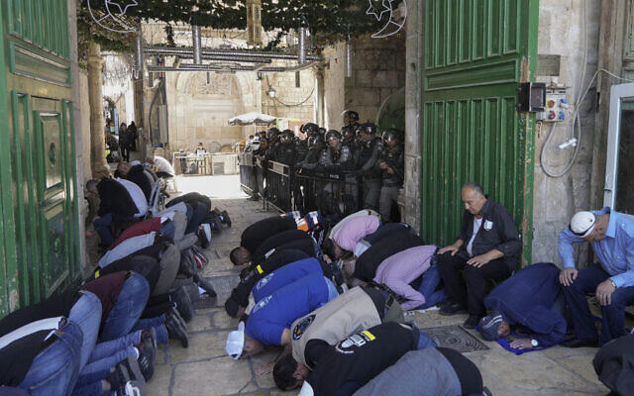
Israeli security forces stand guard as Palestinian men pray on the second Friday of the holy Islamic month of Ramadan in front of the Dome of the Rock shrine at the Temple Mount compound in Jerusalem's Old City, Friday, April 15, 2022. (AP/Mahmoud Illean)
Tensions Friday began bubbling at around 4 a.m. after thousands of Palestinians gathered at the compound known to Jews as the Temple Mount, due to reports of plans by Jewish extremists to perform a Passover animal sacrifice at the site.
Israeli authorities insisted that they would not allow such a ceremony to take place and arrested several suspects on Thursday and Friday in order to ensure as much. Such fears of Israeli violation of the status quo on the Temple Mount peak around Passover every year, but the new government in Jerusalem was particularly keen to quash them in recent weeks. This did not stop rumors from swirling around a possible sacrifice, given the overall lack of trust in Israeli law enforcement among Palestinians.
Dozens of young people began marching in the area before dawn on Friday. Some bore the Palestinian flag, while others carried green banners associated with the Hamas terror group, according to police. The marchers threw stones and set off fireworks, while stockpiling rocks and other objects to prepare for further clashes.
Police said they waited for morning prayers to end before entering the Temple Mount to disperse the rioters, and that some of them threw stones at the Western Wall below. Some Palestinians barricaded themselves inside the Al-Aqsa Mosque, hurling stones toward officers. Three officers were lightly hurt after being pelted with stones, two of whom required medical treatment.
The Palestinian Red Crescent emergency group reported 158 people were hurt in the clashes. It said the vast majority were treated at East Jerusalem’s al-Makassed Hospital or at a field hospital set up by medics, without giving details on the nature of the injuries. In footage from the police raid circulated on social media, officers could be seen hitting some Palestinians with clubs for no apparent reason.
Israel’s Foreign Ministry released a statement insisting that officers did not enter the Al-Aqsa Mosque, the third holiest site in Islam. The Temple Mount is the holiest site in Judaism. But later Friday morning, footage showed officers doing just that in order to detain several Palestinians.
כניסת מתפללים למתחם מסגד אל אקצא לתפילת יום השישי השני בחודש הרמדאן. בכמה מוקדים בעיר העתיקה מדווחים פלסטינים על עיכובים. אלפים מגיעים מהגדה המערבית וגם מתוך מיישובי החברה הערבית בתוך הקו הירוק. הסהר האדום עדכן 152 פצועים טופלו משעות הבוקר בעקבות העימותים שפרצו במתחם. pic.twitter.com/OHdW1XUIhv
— Jack khoury.جاك خوري (@KhJacki) April 15, 2022
Police said in a statement that it was committed to allowing prayers to take place at the holy site. “We call on the worshipers to maintain order and observe the prayers in an orderly manner. The Israel Police will not allow rioters to disrupt the prayers and disrupt public order,” police said.
A police source quoted by the Kan public broadcaster said some 400 people were arrested.
Joint List MK Ahmad Tibi sought to reach the site in order to supervise the police’s behavior, but officers were filmed barring him from entering the compound. A couple of officers shoved the lawmaker before their superior shouted at them for treating an elected official in such a manner.
לא יודע מה הסיבה.גיל , ניסיון , אולי עוד שיקולים ואולי הוא בכלל בן מיעוטים , אבל שימו לב לקצין עם הכומתה הירוקה ואופי התגובה. אני לא יודע אם יקבל צל"ש או נזיפה. אבל יש פה גם מסר ומי מציבים בשטח ונקודות חיכוך. pic.twitter.com/atUI48M32P
— Jack khoury.جاك خوري (@KhJacki) April 15, 2022
Police said it reopened the site to worshipers roughly six hours after clashes began and after “all the violators of public order were dispersed and arrested.”
Prime Minister Naftali Bennett held a situational assessment with police chiefs on Friday morning, during which he said security forces were “working to calm tensions on the Temple Mount as well as throughout Israel, and we are preparing for any scenario,” according to a statement from his office.
But police conduct against the protesters enraged Israel’s Mideast neighbors, with Jordan, Egypt, Saudi Arabia and Turkey all issuing statements of fierce condemnation.
The UN, EU and the US were all more measured in their responses, instead focusing on calling for calm and urging the parties to act with restraint.
Hamas chief Ismail Haniyeh spoke on the phone with Egyptian officials and United Nations Middle East envoy Tor Wennesland on Friday following the clashes, according to the terror group.
Security forces gather after Palestinians and Israeli police clashed at the Temple Mount in Jerusalem’s Old City on April 15, 2022. (Ahmad Gharabli/AFP)
In Haniyeh’s call with Wennesland, the Hamas leader demanded the Israelis fulfill several conditions: allow worshippers to pray at Al-Aqsa and end police operations there, release those detained after Friday’s clashes and definitively prevent extremist Jews from sacrificing at the hilltop, as a tiny minority had hoped to do.
Haniyeh also demanded that Israel cease “its killing and assassination operations in Jenin and across the West Bank,” according to the Hamas statement. Sixteen Palestinians have been killed by Israeli fire as the IDF stepped up security activity in the West Bank over the past two weeks.
At 4 p.m. on Friday, the IDF’s closure of the West Bank and Gaza Strip for Palestinians went into effect. The policy is standard for holidays, but the Defense Ministry said it would reevaluate the situation on Saturday evening, possibly lifting the lockdown then instead of maintaining it for the entire week-long holiday. https://www.timesofisrael.com/afternoon-ramadan-prayers-end-peacefully-at-al-aqsa-following-morning-melee/

Over 150 injured, 400 arrested as Palestinians clash with cops on Temple Mount
Officers enter flashpoint holy site on 2nd Friday of Ramadan after morning prayers, as Muslim worshipers throw stones at Western Wall; 3 Israeli police also hurt in skirmish
By Emanuel Fabian, Aaron Boxerman and TOI staff Today, 6:47 amUpdated at 10:09 am
Palestinians clash with Israeli security forces at the Temple Mount in Jerusalem's Old City, April 15, 2022. (AP Photo/Mahmoud Illean)
Clashes broke out between Palestinians and Israeli police at the Temple Mount early Friday morning, as spiking tensions, threats of terror and the observance of major holidays all converge around the flashpoint holy site.
Skirmishes between police and worshipers at the site were reported around 6:30 a.m., with officers entering the compound and clashing with people barricaded inside.
Police said in a statement that at around 4 a.m., dozens of young people began marching in the area. Some bore the Palestinian flag, while others carried green banners associated with the Hamas terror group.
The marchers threw stones and set off fireworks, while stockpiling rocks and other objects to prepare for further clashes, according to police.
Police said they waited for morning prayers to end before entering the Temple Mount to disperse the rioters, and that some of them threw stones at the Western Wall below.
According to police, some Palestinians barricaded themselves inside the Al-Aqsa Mosque, from where they hurled stones toward officers. The police statement said the rioting was preventing prayers at the mosque and “thus harming a large number of Muslims” seeking to worship there.
Police said three officers were lightly hurt after being pelted with stones, two of whom required medical treatment.
The Palestinian Red Crescent emergency group reported 158 people were hurt in the clashes. It said the vast majority were treated at East Jerusalem’s al-Makassed Hospital or at a field hospital set up by medics, without giving details on the nature of the injuries.
Advertisement
Police released video footage from the scene.
Israel’s Foreign Ministry released a statement clarifying officers did not enter the Al-Aqsa Mosque, the third holiest site in Islam. The Temple Mount is the holiest site in Judaism.
“Masked men hurl stones and set off fireworks, desecrating Al-Aqsa Mosque,” it said. “Contrary to FAKE reports, police forces DID NOT enter the mosque.”MORE - https://www.timesofisrael.com/jerusalem-on-edge-clashes-break-out-between-police-and-palestinians-at-al-aqsa/

Amid violence on Temple Mount, Ra’am warns coalition in danger; PM holds assessment
‘Continued harm to al-Aqsa is red line for us,’ Islamist party head says after 100 hurt, 400 arrested at Jerusalem holy site; PA, Palestinian terror groups, Jordan condemn police
By TOI staff Today, 11:14 amUpdated at 11:23 am
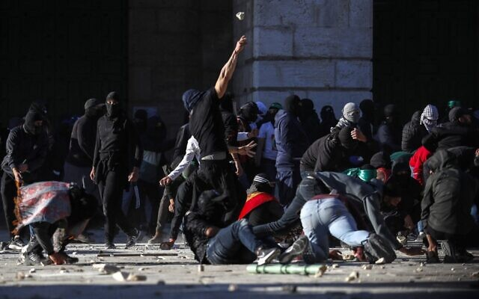
Palestinians clash with Israeli security forces at the Temple Mount in Jerusalem's Old City on April 15, 2022. (Ahmad Gharabli/AFP)
The leader of the Islamist Ra’am party said Friday that he had informed his coalition partners that violent clashes on the Temple Mount in Jerusalem were a “red line” that could further harm Israel’s unstable government.
“The continued harm to Al-Aqsa is a red line for us, including in the context of coalition stability,” Mansour Abbas said in an interview on Radio Al-Shams.
“In the case of Al-Aqsa, there are no political considerations,” he added, referring to the holy site by the name of the mosque there.
The current Israeli government has been brought to the brink of collapse in recent days after a member of Prime Minister Naftali Bennett’s Yamina party quit the coalition, causing it to lose its razor-thin majority. The 120-member Knesset is now deadlocked, with both the coalition and opposition comprising 60 seats apiece.
The Ra’am chief’s comments came as clashes broke out between Palestinians and Israeli police at the Temple Mount early Friday morning. Over 150 Palestinians were injured according to the Red Crescent; Israel said three officers were also hurt. The Muslim Waqf authorities said hundreds were arrested, while a police source quoted by the Kan public broadcaster said 400 were detained.
The Ra’am party sharply condemned the police response, repeating that “Al-Aqsa is [part of] the faith and there is no place for political considerations regarding it.”
“Muslims have the exclusive right to the Al-Aqsa Mosque. The daily invasions are an aggression against that exclusive right,” Ra’am added.
Ra’am MK Mazen Ghnaim later threatened to quit the coalition “if the actions of the security forces at the blessed Al-Aqsa Mosque aren’t halted immediately.”
“A government that acts this way… has no right to exist,” he said in a statement addressed to Bennett.
Amid the clashes, police said in a statement that it was committed to allowing prayers to take place at the holy site. “We call on the worshipers to maintain order and observe the prayers in an orderly manner. The Israel Police will not allow rioters to disrupt the prayers and disrupt public order,” the statement said.
Meanwhile, Bennett held a meeting with Police Commissioner Kobi Shabtai and Public Security Minister Omer Barlev at a Border Police base in Jerusalem. “[We are] working to provide security for Israeli citizens,” Bennett tweeted.
In this government handout photo, Prime Minister Naftali Bennett (2nd-R) visits the base of an undercover Border Police unit that operates in the West Bank, April 15, 2022. (Kobi Gideon/GPO)
“We have repeatedly said that we will do our best to allow freedom of worship on the Temple Mount, and this reality has not changed,” Barlev wrote on Twitter. “The policemen who are there are acting with great courage and in difficult conditions, while they have had to confront violent elements who have collected stones and iron bars in order to infringe on the freedom of worship on the Mount and at the Western Wall.”
Shabtai said: “We won’t allow any handful [of people] to disturb the calm or freedom of worship.”

“Israel is committed to freedom of worship for people of all faiths in Jerusalem, and our goal is to enable peaceful prayer for believers during the Ramadan holiday,” Foreign Minister Yair Lapid said in a statement, published in Hebrew and Arabic as well. MORE - https://www.timesofisrael.com/raam-warns-temple-mount-violence-threatens-teetering-coalition-pm-holds-assessment/

Haifa man moderately hurt in suspected terror stabbing; teen girl arrested
47-year-old found wounded in park near city hall; police say assault likely a nationalistic attack after questioning 15-year-old; father says she planned attack in Jerusalem
By Emanuel Fabian Today, 2:26 pm
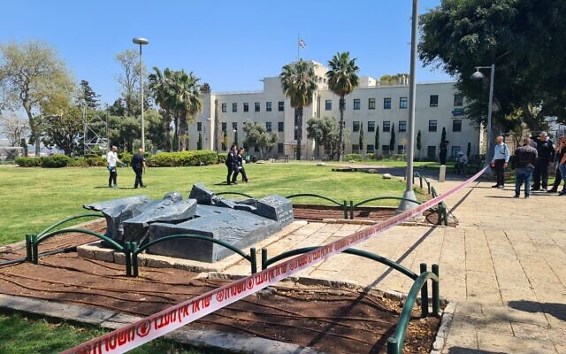
Police officers and medics at the scene of a stabbing in Haifa, April 15, 2022. (Israel Police)
A 47-year-old man was stabbed and moderately hurt in a suspected terror stabbing attack in the northern city of Haifa on Friday, police and medics said.
Officers who arrived at the scene at the HaZikaron Garden, adjacent to Haifa’s city hall, arrested a 15-year-old girl suspected of the attack.
Police said the incident was likely a nationalist-motivated attack, citing a preliminary investigation. It said in a statement that the girl’s father called police earlier Friday to inform them that his daughter said she intended to carry out an attack in Jerusalem.
According to police, the suspect is a local resident.
Medics said they found the wounded man — also a resident of Haifa who was not immediately named — in the garden, fully conscious.
He was taken to the city’s Rambam Medical Center by the Magen David Adom ambulance service, in a stable condition.

A knife used in a stabbing in Haifa, April 15, 2022. (Israel Police)
The suspected terror attack comes amid heightened tensions in Israel and the West Bank, following a string of deadly attacks in Israeli cities that left 14 dead, and clashes between Israeli troops and Palestinians.
At least 16 Palestinians have been killed in clashes with Israeli soldiers in the past two weeks alone, including a 17-year-old who died Friday morning of wounds sustained the day before.mr- https://www.timesofisrael.com/haifa-man-moderately-hurt-in-suspected-terror-stabbing-teen-girl-arrested/

Long-term Lancet study shows vaccines don't prevent death
Follow-up of trial participants found 'no effect on overall mortality'
By Art Moore Published April 14, 2022 at 9:51pm
A long-term study published by the prestigious British journal The Lancet that follows up on participants in the Moderna and Pfizer trials found the vaccines had no effect on overall mortality.
Among 74,000 trial participants, there were 31 all-cause deaths among the vaccinated and 30 among the placebo groups as of January, reported Daniel Horowitz of The Blaze.
Curiously, as Horowitz noted, the authors of the Danish-government-funded study state: "Based on the RCTs with the longest possible follow-up, mRNA vaccines had no effect on overall mortality despite protecting against fatal COVID-19."
Horowitz asked: "So how is it that mRNAs had no effect on all-cause mortality but protect against fatal COVID?"
He supposed that either the vaccines "don't really protect against COVID, or the nominal benefit is washed away by the mortality from adverse events."
Horowitz noted that the authors concede that the clinical trials were mainly conducted on healthy adults.
"They surmise that for sicker adults, the mRNAs might have induced a better mortality result, but that is pure speculation," he wrote.
"What is clear, however, is that the mRNA vaccine makers understood that there was no mortality benefit for healthy people and pushed the shots on them anyway, even though they came with substantial non-COVID risk of adverse events."

Horowitz pointed out that epidemiological data also indicate the shots are ineffective in reducing mortality overall.
New Zealand is a good case study, he wrote, because the island state had very few COVID deaths for the first two years of the pandemic. Further, nearly every age bracket had a vaccination rate higher than 90%, except for those ages 5-11. And more than half of all adults, especially those in vulnerable categories, received a booster shot.
Nevertheless, New Zealand experienced nearly all of its deaths after all of that was accomplished. As of Nov. 4, 2021, New Zealand recorded just 29 COVID deaths, but the country now has 469. And that spike has happened, Horowitz pointed out, during the wave dominated by omicron, a variant that largely produces an upper respiratory infection with mild symptoms.
About 98% of all confirmed COVID cases in New Zealand occurred after February 2022.
Other data
CDC and U.K. government data also have indicated that the COVID-19 vaccines not only are ineffective in preventing cases and transmission, they rapidly lose protection against severe illness or death while posing risks.
Dr. Meryl Nass, a clinician and epidemiologist, presented on her Substack page an analysis of CDC data on 30 million adults in California and New York, three-quarters of whom were vaccinated. Nass compared COVID hospitalization and case rates in those who were vaccinated and had no prior COVID illness with adults who were never vaccinated but had recovered from COVID and presumably had natural immunity. The data were collected from June to November 2021, before the Omicron wave appeared.
She found vaccinated Californians and New Yorkers were three times more likely to develop COVID than those who had prior immunity and were unvaccinated.
Further, vaccinated Californians had a higher rate of hospitalizations (severe illness) than those who were unvaccinated but had prior immunity. New York did not provide hospitalization data.
In the U.K., the age-standardized data from the Office of National Statistics indicated the double-vaccinated were protected against death for most of 2021. But in December 2021 and January 2022, COVID death rates in the doubly vaccinated but unboosted were higher than in those who had never been vaccinated.
Meanwhile, a former adviser to the FDA commissioner who continues to serve in an oversight role says the agency is ignoring its requirement to disclose clear safety and efficacy problems with the COVID-19 vaccines. Last month, an Army flight surgeon testified in federal court that she was ordered by high-level command not to discuss the controversy over Department of Defense data indicating a massive spike in serious injuries and illnesses among military personnel when the vaccines were rolled out in 2021. And, among many other safety signals, an analysis of CDC data by a former Wall Street executive an an insurance industry expert shows an alarming rise in excess deaths among Millennials over the past year amid the COVID vaccine rollout.
Earlier this month the Food and Drug Administration released a briefing document that says the composition of the current COVID-19 vaccines might need to be changed to ensure high levels of protection. MORE -
https://www.wnd.com/2022/04/long-term-lancet-study-shows-vaccines-dont-prevent-death/

More Than 1 Million COVID Vaccine Injuries, Nearly 27,000 Deaths Reported to VAERS, CDC Data Show
VAERS data released Friday by the Centers for Disease Control and Prevention included a total of 1,226,314 reports of adverse events from all age groups following COVID vaccines, including 26,976 deaths and 219,865 serious injuries between Dec. 14, 2020, and April 8, 2022.
By Megan Redshaw 04/15/22
The Centers for Disease Control and Prevention (CDC) today released new data showing a total of 1,226,314 reports of adverse events following COVID vaccines were submitted between Dec. 14, 2020, and April 8, 2022, to the Vaccine Adverse Event Reporting System (VAERS). VAERS is the primary government-funded system for reporting adverse vaccine reactions in the U.S.
The data included a total of 26,976 reports of deaths — an increase of 277 over the previous week — and 219,865 serious injuries, including deaths, during the same time period — up 2,564 compared with the previous week.
Excluding “foreign reports” to VAERS, 805,921 adverse events, including 12,471 deaths and 79,811 serious injuries, were reported in the U.S. between Dec. 14, 2020, and April 8, 2022.
1 Million Copies Sold — ‘The Real Anthony Fauci’ — The book that launched a movement. BUY TODAY!
Foreign reports are reports foreign subsidiaries send to U.S. vaccine manufacturers. Under U.S. Food and Drug Administration (FDA) regulations, if a manufacturer is notified of a foreign case report that describes an event that is both serious and does not appear on the product’s labeling, the manufacturer is required to submit the report to VAERS.
Of the 12,471 U.S. deaths reported as of April 8, 17% occurred within 24 hours of vaccination, 21% occurred within 48 hours of vaccination and 59% occurred in people who experienced an onset of symptoms within 48 hours of being vaccinated.
In the U.S., 564 million COVID vaccine doses had been administered as of April 8, including 334 million doses of Pfizer, 212 million doses of Moderna and 19 million doses of Johnson & Johnson (J&J).
Every Friday, VAERS publishes vaccine injury reports received as of a specified date. Reports submitted to VAERS require further investigation before a causal relationship can be confirmed.
Historically, VAERS has been shown to report only 1% of actual vaccine adverse events.
U.S. VAERS data from Dec. 14, 2020, to April 8, 2022, for 5- to 11-year-olds show:
- 10,216 adverse events, including 242 rated as serious and 5 reported deaths.
- 18 reports of myocarditis and pericarditis (heart inflammation).
The CDC uses a narrowed case definition of “myocarditis,” which excludes cases of cardiac arrest, ischemic strokes and deaths due to heart problems that occur before one has the chance to go to the emergency department.
- 39 reports of blood clotting disorders.

https://childrenshealthdefense.org/defender/1-million-covid-vaccine-injuries-27000-deaths-reported-vaers-cdc-data/

Commentary:

THE SHORASHIM BIBLICAL GIFT CATALOG 005
http://mad.ly/7f9f64?pact=20013931524&fe=1
Support Shorashim!

ARUTZ SHEVA

To be removed from this News list, Please click here and put "Unsubscribe" in the subject line.

