How to handle a traffic stop while traveling in your automobile.
Not,
How to handle a traffic stop while OPERATING A MOTOR VEHICLE.
There is a Difference.
First. If you have a state issued license plate on your car, you are presumed to be operating
"IN COMMERCE" which gives an officer jurisdiction to stop you and administer Uniform Commercial Code (UCC) upon you. This is SO important. Instead, use a sign that lets police know you are operating in the private and NOT in commerce. There are graphics here in this channel you can download, have printed and laminated to put on your car in place of a state issued license plate. You can keep your license, registration, tag and insurance in the car for those times you ARE operating in commerce (if it makes you feel more comfortable).
If an officer is cordial to start.
When they come to the window, you speak first. Remember, you are their employer, but not their boss.
***"Good afternoon officer, what is the reason for the stop?"***
(COP) I clocked you doing 140 MPH back there!
It took my squad car 15 minutes to catch up to you.
***(Must have been a Charger)😁.
(COP) Can I see your license and registration please?"
*** "I'm just traveling in my private car, do I need those things?" ***
(COP) "Yes, you need them to operate a motor vehicle in this “STATE”
*** But I'm not operating a “Motor Vehicle” in this “STATE”, nor am I engaged in Commerce. I'm just traveling in my automobile. I’m sorry, you must think I am in the “STATE OF ARIZONA” the corporation.
I am not. I am in the Republic of Arizona where we DO still have the "Unalienable" right to travel afforded us by God and the Constitution and the bill of rights***
(COP) State law XXX says you have to have X,X,X and X, do you have a valid license, registration and insurance?"
*** As I mentioned, I'm just traveling in the Republic of Arizona, not the De facto all caps “STATE OF ARIZONA”, I'm not operating a “Motor Vehicle” in the “STATE” or in commerce. Why would I need any of these things? Do you understand the difference between Traveling and Operating, The Republic and the “STATE”, or between a “Motor Vehicle and a Private Automobile?
(SHOW CARDS)
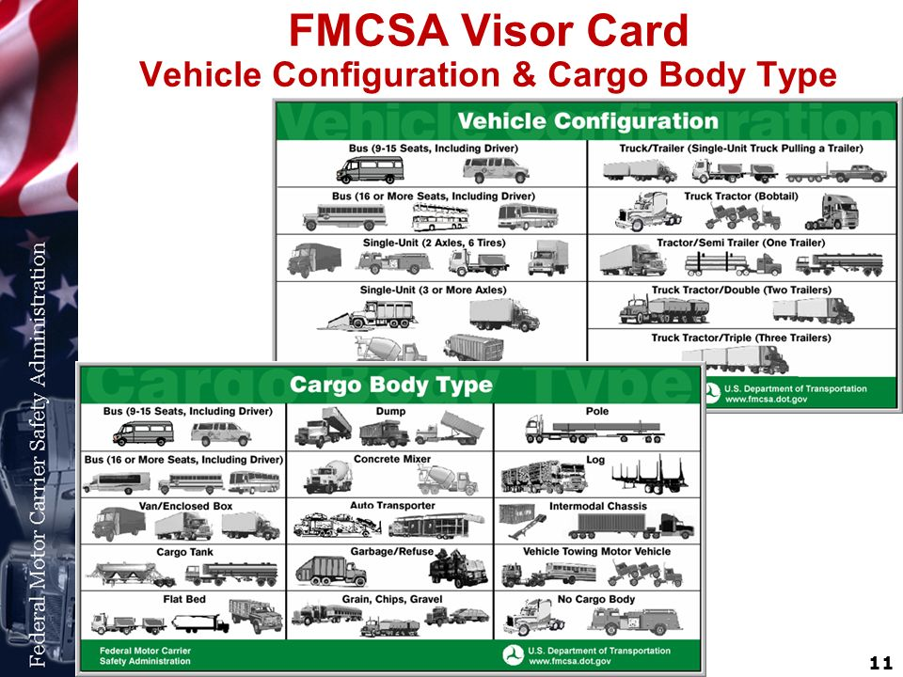
***Are you Familiar with these from your training? ***
(COP) Are you going to give me your license and information or not?
***We'll we haven't established a need for them. Can you show me the law that says I need them to travel in my personal car?***
(If he sites a UCC statute, whip out your paperwork folder with the law and case law).
***Well, it says right here “USC 18 §242; DEPRIVATION OF RIGHTS UNDER COLOR OF LAW: Whoever, under color of any law, statute, ordinance, regulation, or custom, willfully subjects any person in any State the deprivation of any rights shall be fined under this title or imprisoned not more than one year, or both;” .
***Also, "Statutes apply only to state created creatures known as corporations no matter whether [creatures of statute and offices of] state, local, or federal [government]." (Colonial Pipeline Co. v. Traigle, 421 US 100. (1975) )”.
“A statute will not be presumed to have extra territorial effect... outside the [territorial] jurisdiction of the legislature.. over persons residing outside the (territorial) jurisdiction of the legislature." (Bond v Jay, 7 Cranch 350, 3 L Ed 367).
" A “Statute’ is not a Law,” (Flournoy v. First Nat. Bank of Shreveport, 197 La. 1067, 3 So.2d 244, 248),”
“A “Code’ or Statute’ is not a Law,” (Flournoy v. First Nat. Bank of Shreveport, 197 La. 1067, 3 So.2d 244, 248),
A “Code’ is not a Law,” (In Re Self v Rhay Wn 2d 261), in point of fact in Law,)
A concurrent or ‘joint resolution ‘of legislature is not “Law,” (Koenig v. Flynn, 258 N.Y. 292, 179 N. E. 705, 707; Ward v State, 176 Okl. 368, 56 P.2d 136, 137; State ex rel. Todd v. Yelle, 7 Wash.2d 443, 110 P.2d 162, 165).
…lacking due process[of law], in that they are ‘void for ambiguity’ in their failure to specify the statutes’ applicability to ‘natural persons,’ otherwise depriving the same of fair notice, as their construction by definition of terms aptly identifies the applicability of such statutes to “artificial or fictional corporate entities or ‘persons’, creatures of statute, or those by contract employed as agents or representatives, departmental subdivisions, offices, officers, and property of the government, but not the ‘Natural Person’ or American citizen Immune from such jurisdiction of legalism. (Rodriques v. Ray Donavan, U.S. Department of Labor, 769 F.2d 1344, 1348 (1985));
All codes, rules, and regulations are for government authorities only, not human/Creators in accord with God’s Laws. “All codes, rules, and regulations are unconstitutional and lacking due process of Law..”(Rodriques v. Ray Donavan, U.S. Department of Labor, 769 F.2d 1344, 1348 (1985)); …lacking due process of law, in that they are ‘void for ambiguity’ in their failure to specify the statutes’ applicability to ‘natural persons,’ otherwise depriving the same of fair notice, as their construction by definition of terms aptly identifies the applicability of such statutes to “artificial or fictional corporate entities or ‘persons’, creatures of statute, or those by contract employed as agents or representatives, departmental subdivisions, offices, officers, and property of the government, but not the ‘Natural Person’ or American citizen Immune from such jurisdiction of legalism.
So as you can see, I am a Natural Person and not an all Caps Corporation like Walmart and I am not operating in that capacity. I am merely traveling in my private automobile as is my right.
I am su juris (Your Name in Upper Lower-Case Name, Opposite your DRIVER’S LICENCE in all CAPS)
Are you going to give me your license and registration or not?
Well sir, The law says I'm not required to have these things "UNLESS" I am operating as an employee of the “STATE OF ARIZONA” in commerce an “Operating a “Motor Vehicle”, and I have stated 3 times that I am not operating a “Motor Vehicle” in commerce or otherwise in the “STATE OF ARIZONA”.
I am traveling in my automobile in the Republic of Arizona.
(The UNITED STATES and its subsidiaries, (THE ARIZONA STATE TROOPERS) for example are a foreign Corporation operating on United States soil. You must learn the difference).
*** Am I under arrest?
(COP) No
Am I free to go?
(COP) Yes and I am very sorry to have disturbed you. Please have a great rest of your day.
***This is the point where he lets you go peacefully or he violates your rights.
*** If you are not under arrest you MUST be free to go, but DO NOT LEAVE a traffic stop until "an" officer releases you.
If he continues badgering you for license, ask for a supervisor to come to the scene. If he claims he is the supervisor (he isn't) ask to see his superior officer. Stand on that request. Be nice, Cops are Compartmentalized legal idiots, as we all were, until were not. Teach them. They don’t know much of this.

