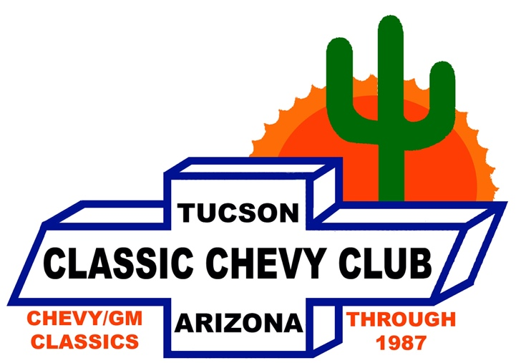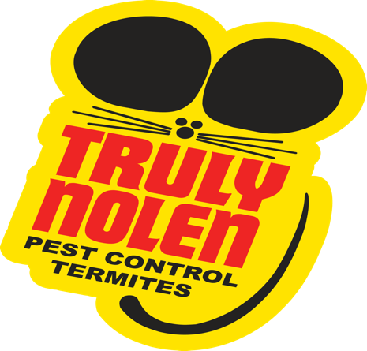

OUR MISSION STATEMENT
To have a good time loving, restoring, and preserving classic Chevy and other GM vehicles through 1987
______________________________________________________________________________

The Classic Chevy Club of Tucson Thanks These Businesses & Our Own Members for Their Generosity and Support of the 2023 Chevy Showdown Raffle

Curacao Auto Zone (W. Valencia)
Home Depot (Spectrum location) Golden Corral (E. 22nd St.)
The Main Event (at the Landing) Clarissa’s Logo Embroidery (W. District St.)
Stoner Car Care Octopus Car Wash (W. Valencia)
Royal Buick, GMC, Cadillac (Auto Mall) National Auto Collision Centers (W. Grant)
Window Depot (Alvernon & Irvington) Golden Corral (Thornydale & Ina)
Ace Hardware (W. Valencia) Brother John’s Restaurant (N. Stone Ave.)
National Auto Collision Centers (W. Valencia) Big “O” Tires (S. 6th Ave.)
Lowe’s (W. Valencia) Mister Car Wash (E. 5th Ave.)
Dwight’s Auto Glass (W. Valencia) O’Rielly Chevrolet
Total Wine (N. Oracle Rd.) Tractor Supply (W. Valencia)
Interstate Batteries (W. Grant Rd.) B J’s Brewhouse (Broadway & Craycroft)
Dr. Steve Watson-Chiropractic USA (Oro Valley) Dennis & Georgette Rich
Royal Plating (W. Lester) Peter Piper Pizza (E. Broadway)
Native Wings (The Spectrum) Culver’s (W. Valencia)

And Our 55 + Members of the Classic Chevy Club of Tucson

Thank You!

